Part I

Answer all questions in this part. Each correct answer will receive 2 credits. No partial credit will be allowed. For each question, write on the separate answer sheet the numeral preceding the word or expression that best completes the statement or answers the question.

What is the value of
(1) 58 (3) 53
(2) 54 (4) 50

For all values of x for which the expression is defined, is equivalent to
(1) (3)
(2) (4)

In the accompanying diagram, the length of is radians.
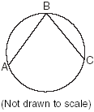
What is ?
(1) 36 (3) 53
(2) 45 (4) 72

In the accompanying diagram of .
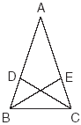
Triangle EBC can be proved congruent to triangle DCB by
(1) SAS SAS (3) SSS SSS
(2) ASA ASA (4) HL HL

The path of a rocket is represented by the equation . The path of a missile designed to intersect the path of the rocket is represented by the equation . The value of x at the point of intersection is 3. What is the corresponding value of y?
(1) –2 (3) –4
(2) 2 (4) 4

On a standardized test, the distribution of scores is normal, the mean of the scores is 75, and the standard deviation is 5.8. If a student scored 83, the student’s score ranks
(1) below the 75th percentile
(2) between the 75th percentile and the 84th percentile
(3) between the 84th percentile and the 97th percentile
(4) above the 97th percentile

Which statement is true for all real number values of x?
(1) |x – 1| >0 (3)
(2) |x – 1| > (x – 1) (4)

If x is a positive integer, is equivalent to
(1) (3)
(2) (4)

What is the equation of a parabola that goes through points (0,1), (–1,6), and (2,3)?
(1) (3)
(2) (4)

If and , which number satisfies ?
(1) (3)
(2) (4)

A linear regression equation of best fit between a student’s attendance and the degree of success in school is h = 0.5x + 68.5. The correlation coefficient, r, for these data would be
(1) 0 <  r < 1 (3) r = 0
(2) –1 <  r < 0 (4) r = –1

What is the solution set of the equation ?
(1) { } (3) {–6}
(2) {4,–6} (4) {4}

Which equation represents a function?
(1) (3)
(2) (4)

What is the solution set of the equation ?
(1) { } (3) {6}
(2) {2} (4) {2,6}

What is the sum of and ?
(1) (3)
(2) (4)

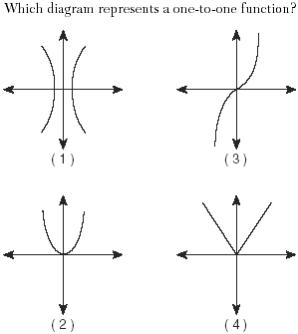

Point is the image of point P(–3,4) after a translation defined by $T_{(7,−1)}\text{.}$ Which other transformation on would also produce ?
(1) (3)
(2) (4)

Which transformation does not preserve orientation?
(1) translation (3) reflection in the y-axis
(2) dilation (4) rotation

The roots of the equation are
(1) real and irrational (3) real, rational, and unequal
(2) real, rational, and equal (4) imaginary

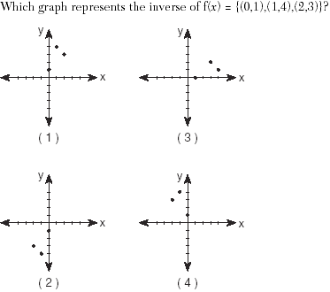

Part II

Answer all questions in this part. Each correct answer will receive 2 credits. Clearly indicate the necessary steps, including appropriate formula substitutions, diagrams, graphs, charts, etc. For all questions in this part, a correct numerical answer with no work shown will receive only 1 credit.

On a nationwide examination, the Adams School had a mean score of 875 and a standard deviation of 12. The Boswell School had a mean score of 855 and a standard deviation of 20. In which school was there greater consistency in the scores? Explain how you arrived at your answer.

Is the same expression as ? Justify your answer.

After studying a couple’s family history, a doctor determines that the probability of any child born to this couple having a gene for disease X is 1 out of 4. If the couple has three children, what is the probability that exactly two of the children have the gene for disease X?

Growth of a certain strain of bacteria is modeled by the equation , where:
G = final number of bacteria
A = initial number of bacteria
t = time (in hours)
In approximately how many hours will 4 bacteria first increase to 2,500 bacteria? Round your answer to the nearest hour.

The equation represents the power (W), in watts, of a 120-volt circuit having a resistance of 12 ohms when a current (I) is flowing through the circuit. What is the maximum power, in watts, that can be delivered in this circuit?

Island Rent-a-Car charges a car rental fee of $40 plus $5 per hour or fraction of an hour. Wayne’s Wheels charges a car rental fee of $25 plus $7.50 per hour or fraction of an hour. Under what conditions does it cost less to rent from Island Rent-a-Car? [The use of the accompanying grid is optional.]


Part III

Answer all questions in this part. Each correct answer will receive 4 credits. Clearly indicate the necessary steps, including appropriate formula substitutions, diagrams, graphs, charts, etc. For all questions in this part, a correct numerical answer with no work shown will receive only 1 credit.

An electronics company produces a headphone set that can be adjusted to accommodate different-sized heads. Research into the distance between the top of people’s heads and the top of their ears produced the following data, in inches:
4.5, 4.8, 6.2, 5.5, 5.6, 5.4, 5.8, 6.0, 5.8, 6.2, 4.6, 5.0, 5.4, 5.8
The company decides to design their headphones to accommodate three standard deviations from the mean. Find, to the nearest tenth, the mean, the standard deviation, and the range of distances that must be accommodated.

A pelican flying in the air over water drops a crab from a height of 30 feet. The distance the crab is from the water as it falls can be represented by the function , where t is time, in seconds. To catch the crab as it falls, a gull flies along a path represented by the function. Can the gull catch the crab before the crab hits the water? Justify your answer. [The use of the accompanying grid is optional.]


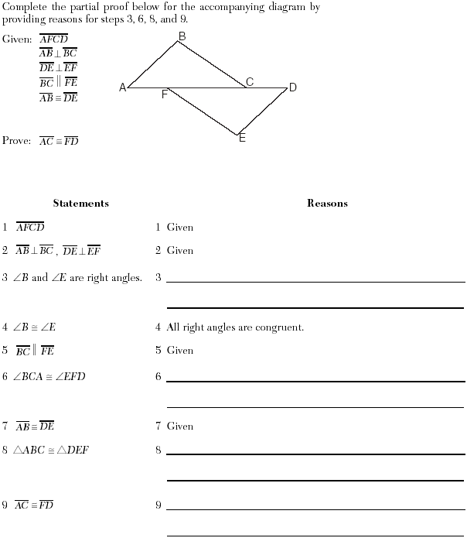

Solve for x: ${\text{log}}_{4}(x^{2}+3x)−{\text{log}}_{4}(x+5)=1$

A ship at sea heads directly toward a cliff on the shoreline. The accompanying diagram shows the top of the cliff, D, sighted from two locations, A and B, separated by distance S. If , and S = 30 feet, what is the height of the cliff, to the nearest foot?

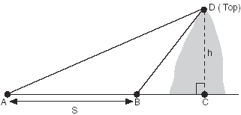

Kieran is traveling from city A to city B. As the accompanying map indicates, Kieran could drive directly from A to B along County Route 21 at an average speed of 55 miles per hour or travel on the interstates, 45 miles along I-85 and 20 miles along I-64. The two interstates intersect at an angle of 150° at C and have a speed limit of 65 miles per hour. How much time will Kieran save by traveling along the interstates at an average speed of 65 miles per hour?
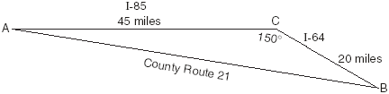

Part IV

Answer all questions in this part. Each correct answer will receive 6 credits. Clearly indicate the necessary steps, including appropriate formula substitutions, diagrams, graphs, charts, etc. For all questions in this part, a correct numerical answer with no work shown will receive only 1 credit.

On a monitor, the graphs of two impulses are recorded on the same screen, where . The impulses are given by the following equations:
Find all values of x, in degrees, for which the two impulses meet in the interval . [Only an algebraic solution will be accepted.]

The table below, created in 1996, shows a history of transit fares from 1955 to 1995. On the accompanying grid, construct a scatter plot where the independent variable is years. State the exponential regression equation with the coefficient and base rounded to the nearest thousandth. Using this equation, determine the prediction that should have been made for the year 1998, to the nearest cent.
