Part I

Answer all questions in this part. Each correct answer will receive 2 credits. No partial credit will be allowed. For each question, write on the separate answer sheet the numeral preceding the word or expression that best completes the statement or answers the question.

An archer shoots an arrow into the air such that its height at any time, t, is given by the function $h(t)=−\text{16}t^{2}+\text{kt}+3\text{.}$ If the maximum height of the arrow occurs at time t = 4, what is the value of k?
(1) 128 (3) 8
(2) 64 (4) 4

The magnitude (R) of an earthquake is related to its intensity (I) by$R=\text{log}(\frac{I}{T}),$ where T is the threshold below which the earthquake is not noticed. If the intensity is doubled, its magnitude can be represented by
(1) 2(log I – log T)
(2) log I – log T
(3) 2 log I – log T
(4) log 2 + log I – log T

Jacob is solving a quadratic equation. He executes a program on his graphing calculator and sees that the roots are real, rational, and unequal. This information indicates to Jacob that the discriminant is
(1) zero (3) a perfect square
(2) negative (4) not a perfect square

Camisha is paying a band $330 to play at her graduation party. The amount each member earns, d, varies inversely as the number of members who play, n. The graph of the equation that represents the relationship between d and n is an example of
(1) a hyperbola (3) a parabola
(2) a line (4) an ellipse

A modulated laser heats a diamond. Its variable temperature, in degrees Celsius, is given by f(t) = T sin at. What is the period of the curve?
(1) (3)
(2) (4)

The circumference of a circular plot of land is increased by 10%. What is the best estimate of the total percentage that the area of the plot increased?
(1) 10% (3) 25%
(2) 21% (4) 31%

Which equation states that the temperature, t, in a room is less than 3° from 68°?
(1) |3 – t| < 68 (3) |68 – t| < 3
(2) |3 + t| < 68 (4) |68 + t| < 3

Fractal geometry uses the complex number plane to draw diagrams, such as the one shown in the accompanying graph.

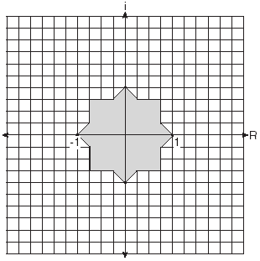

Which number is not included in the shaded area?
(1) –0.5i (3) –0.9
(2) –0.5 – 0.5i (4) –0.9 – 0.9i

The relationship of a woman’s shoe size and length of a woman’s foot, in inches, is given in the accompanying table.
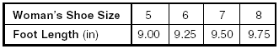
The linear correlation coefficient for this relationship is
(1) 1 (3) 0.5
(2) –1 (4) 0

The center of a circular sunflower with a diameter of 4 centimeters is (–2,1). Which equation represents the sunflower?
(1)
(2)
(3)
(4)
Melissa and Joe are playing a game with complex numbers. If Melissa has a score of 5 – 4i and Joe has a score of 3 + 2i, what is their total score?
(1) 8 + 6i (3) 8 – 6i
(2) 8 + 2i (4) 8 – 2i

In a science experiment, when resistor A and resistor B are connected in a parallel circuit, the total resistance is . This complex fraction is equivalent to
(1) 1 (3) A + B
(2) (4) AB

A store advertises that during its Labor Day sale $15 will be deducted from every purchase over $100. In addition, after the deduction is taken, the store offers an early-bird discount of 20% to any person who makes a purchase before 10 a.m. If Hakeem makes a purchase of x dollars, x > 100, at 8 a.m., what, in terms of x, is the cost of Hakeem’s purchase?
(1) 0.20x – 15 (3) 0.85x – 20
(2) 0.20x – 3 (4) 0.80x – 12

A bug travels up a tree, from the ground, over a 30-second interval. It travels fast at first and then slows down. It stops for 10 seconds, then proceeds slowly, speeding up as it goes. Which sketch best illustrates the bug’s distance (d) from the ground over the 30-second interval (t)?

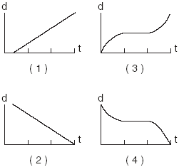

The inverse of a function is a logarithmic function in the form. Which equation represents the original function?
(1) (3)
(2) (4)

On her first trip, Sari biked 24 miles in T hours. The following week Sari biked 32 miles in T hours. Determine the ratio of her average speed on her second trip to her average speed on her first trip.
(1) (2)
(2) (4)

What is the value of ?
(1) 15 (3) 57
(2) 55 (4) 245

If is an obtuse angle and sin = b, then it can be concluded that
(1) tan > b (3) cos 2> b
(2) cos > b (4) sin 2< b

Main Street and Central Avenue intersect, making an angle measuring 34°. Angela lives at the intersection of the two roads, and Caitlin lives on Central Avenue 10 miles from the intersection. If Leticia lives 7 miles from Caitlin, which conclusion is valid?
(1) Leticia cannot live on Main Street.
(2) Leticia can live at only one location on Main Street.
(3) Leticia can live at one of two locations on Main Street.
(4) Leticia can live at one of three locations on Main Street.

Through how many radians does the minute hand of a clock turn in 24 minutes?
(1) 0.2π (3) 0.6π
(2) 0.4π (4) 0.8π

Part II

Answer all questions in this part. Each correct answer will receive 2 credits. Clearly indicate the necessary steps, including appropriate formula substitutions, diagrams, graphs, charts, etc. For all questions in this part, a correct numerical answer with no work shown will receive only 1 credit.

Gregory wants to build a garden in the shape of an isosceles triangle with one of the congruent sides equal to 12 yards. If the area of his garden will be 55 square yards, find, to the nearest tenth of a degree, the three angles of the triangle.

At a certain intersection, the light for eastbound traffic is red for 15 seconds, yellow for 5 seconds, and green for 30 seconds. Find, to the nearest tenth, the probability that out of the next eight eastbound cars that arrive randomly at the light, exactly three will be stopped by a red light.

The cost of a long-distance telephone call is determined by a flat fee for the first 5 minutes and a fixed amount for each additional minute. If a 15-minute telephone call costs $3.25 and a 23-minute call costs $5.17, find the cost of a 30-minute call.

A rectangular prism has a length of , a width of , and a height of . For all values of x for which it is defined, express, in terms of x, the volume of the prism in simplest form.

The scientists in a laboratory company raise amebas to sell to schools for use in biology classes. They know that one ameba divides into two amebas every hour and that the formula can be used to determine how long in hours, t, it takes to produce a certain number of amebas, N. Determine, to the nearest tenth of an hour, how long it takes to produce 10,000 amebas if they start with one ameba.

Professor Bartrich has 184 students in her mathematics class. The scores on the final examination are normally distributed and have a mean of 72.3 and a standard deviation of 8.9. How many students in the class can be expected to receive a score between 82 and 90?

Part III

Answer all questions in this part. Each correct answer will receive 4 credits. Clearly indicate the necessary steps, including appropriate formula substitutions, diagrams, graphs, charts, etc. For all questions in this part, a correct numerical answer with no work shown will receive only 1 credit.

A wooden frame is to be constructed in the form of an isosceles trapezoid, with diagonals acting as braces to strengthen the frame. The sides of the frame each measure 5.30 feet, and the longer base measures 12.70 feet. If the angles between the sides and the longer base each measure 68.4°, find the length of one brace to the nearest tenth of a foot.

A homeowner wants to increase the size of a rectangular deck that now measures 15 feet by 20 feet, but building code laws state that a homeowner cannot have a deck larger than 900 square feet. If the length and the width are to be increased by the same amount, find, to the nearest tenth, the maximum number of feet that the length of the deck may be increased in size legally.

Two parabolic arches are to be built. The equation of the first arch can be expressed as , with a range of 0 ≤ y ≤ 9, and the second arch is created by the transformation T_{7,0}. On the accompanying set of axes, graph the equations of the two arches. Graph the line of symmetry formed by the parabola and its transformation and label it with the proper equation.

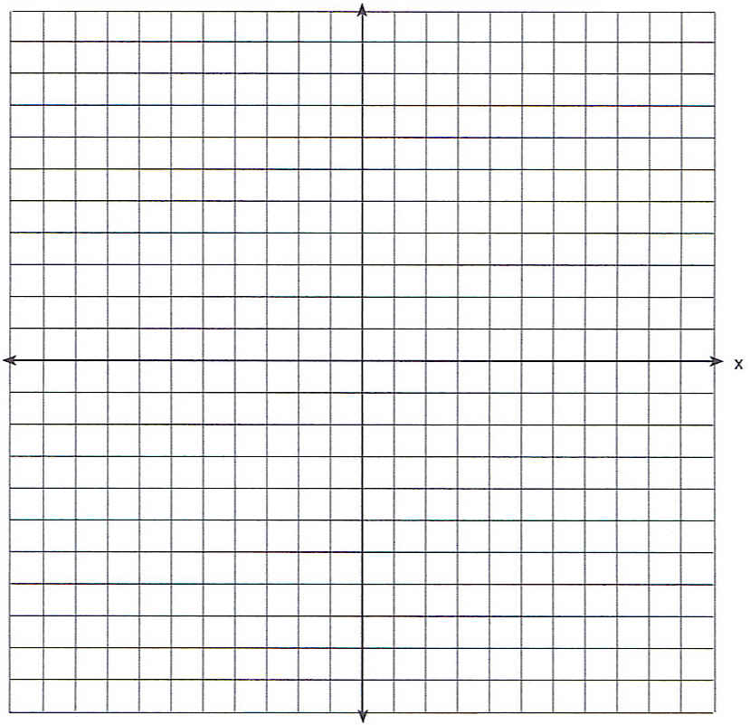

Draw and in the interval 0 ≤ x ≤ 2 on the accompanying set of axes. State the coordinates of the points of intersection.

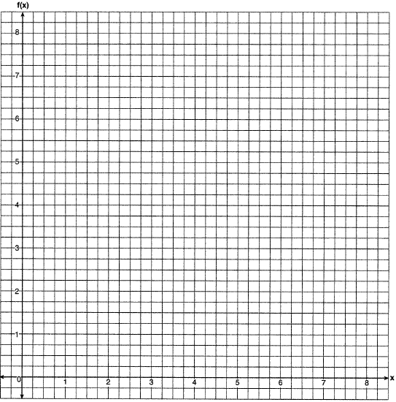

In the interval 0° ≤ A < 360°, solve for all values of A in the equation .

Point P lies outside circle O, which has a diameter of . The angle formed by tangent and secant measures 30°. Sketch the conditions given above and find the number of degrees in the measure of minor arc CB.

Part IV

Answer all questions in this part. Each correct answer will receive 6 credits. Clearly indicate the necessary steps, including appropriate formula substitutions, diagrams, graphs, charts, etc. For all questions in this part, a correct numerical answer with no work shown will receive only 1 credit.

Given: chords and of circle O intersect at E, an interior point of circle O; chords and are drawn.

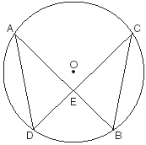

Prove: (AE)(EB) = (CE)(ED)

The 1999 win-loss statistics for the American League East baseball teams on a particular date is shown in the accompanying chart.

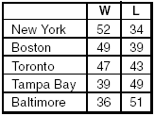

Find the mean for the number of wins, , and the mean for the number of losses, , and determine if the point (, ) is a point on the line of best fit. Justify your answer.

