1 If , what is the value of x?
1) | 11 | 3) | 45
2) | 18 | 4) | 53

2 The coordinates of are , , and . If is the result of the transformation , then is
1) | similar to | 3) | a right triangle
2) | congruent to | 4) | an equilateral triangle

3 What is the value of 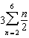?
1) | 10 | 3) | 30
2) | 13 | 4) | 60

4 An equation of a parabola that has as its axis of symmetry is
1) |  | 3)
2) |  | 4)

5 What is the solution set for the equation ?
1) |  | 3)
2) |  | 4)

6 A central angle of radians intercepts an arc whose degree measure is
1) | 48 | 3) | 96
2) | 72 | 4)

7 If , a value of is
1) | 45º | 3) | 180º
2) | 90º | 4) | 270º

8 If and , the terminal side of angle x is located in Quadrant
1) | I | 3) | III
2) | II | 4) | IV

9 The graph of the equation is best described as
1) | a circle | 3) | an ellipse
2) | two lines | 4) | a hyperbola

10 The image of function is found by mapping each point on the function to the point . This image is a reflection of in
1) | the x-axis | 3) | the line whose equation is
2) | the y-axis | 4) | the line whose equation is

11 What is the inverse of the function ?
1) |  | 3) | 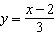
2) | 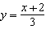 | 4)

12 Which equation represents the circle whose center is and whose radius is ?
1) |  | 3)
2) |  | 4)

13 Which expression is equivalent to 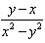?
1) | 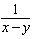 | 3) | 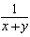
2) | 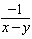 | 4) | 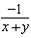

14 If , then x is equal to
1) |  | 3)
2) |  | 4)

15 Which expression is equivalent to b in the equation 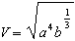?
1) |  | 3)
2) |  | 4)

16 In the binomial expansion of , what is the coefficient of the term containing ?
1) | 15 | 3) | 56
2) | 28 | 4) | 70

17 If R is inversely proportional to A, and when , what is the value of R when ?
1) | 0.625 | 3) | 10
2) | 1.6 | 4) | 6,250

18 If , , and , how many different triangles can be constructed?
1) | No triangles can be constructed. | 3) | one right triangle, only
2) | two triangles | 4) | one obtuse triangle, only

19 In a right triangle where one of the angles measures 30º, what is the ratio of the length of the side opposite the 30º angle to the length of the side opposite the 90º angle?
1) |  | 3)
2) |  | 4)

20 If zero is the value of the discriminant of the equation , which graph best represents ?
1) | 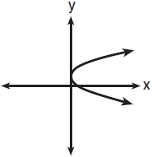
2) | 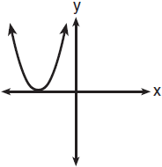
3) | 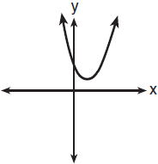
4) | 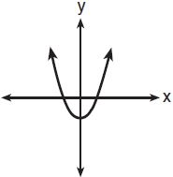

21 If and , find .

22 In and , and . Write one additional statement that could be used to prove that the two triangles are congruent. State the method that would be used to prove that the triangles are congruent.

23 Given the complex numbers and . Find and graph the result on the accompanying set of axes.

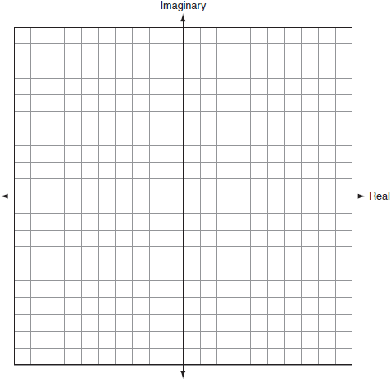

24 The function, f, is drawn on the accompanying set of axes. On the same set of axes, sketch the graph of , the inverse of f.

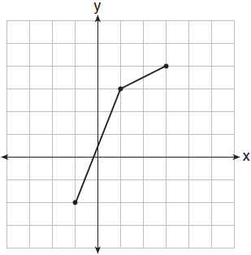

25 Express the sum of and in simplest radical form, in terms of i.

26 Express the reciprocal of in simplest radical form with a rational denominator.

27 In the accompanying diagram of , centimeters, , and . Find the area of , to the nearest square centimeter.

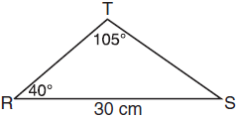

28 The mid-September statewide average gas prices, in dollars per gallon, (y), for the years since 2000, (x), are given in the table below.

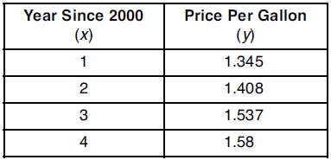

Write a linear regression equation for this set of data. Using this equation, determine how much more the actual 2005 gas price was than the predicted gas price if the actual mid-September gas price for the year 2005 was $2.956.

29 Given: , ,
Prove: is an isosceles right triangle.
[The use of the grid is optional.]



30 According to a federal agency, when a lie detector test is given to a truthful person, the probability that the test will show that the person is not telling the truth is 20%. If a company interviews five truthful candidates for a job and asks about thefts from prior employers, what is the probability a lie detector test will show that at most one candidate is not telling the truth?

31 Currently, the population of the metropolitan Waterville area is 62,700 and is increasing at an annual rate of 3.25%. This situation can be modeled by the equation , where represents the total population and t represents the number of years from now. Find the population of the Waterville area, to the nearest hundred, seven years from now. Determine how many years, to the nearest tenth, it will take for the original population to reach 100,000.
[Only an algebraic solution can receive full credit.]

32 A tractor stuck in the mud is being pulled out by two trucks. One truck applies a force of 1,200 pounds, and the other truck applies a force of 1,700 pounds. The angle between the forces applied by the two trucks is 72. Find the magnitude of the resultant force, to the nearest pound.

33 In the accompanying diagram, is tangent to circle O at A, chord and secant are drawn, and chords and intersect at E. If and , find , , and .

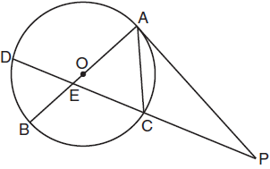

34 Solve for all values of x, to the nearest tenth: 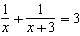
1 ANS: 4 PTS: 2 REF: 011001b STA: A2.A.22
TOP: Solving Radicals

2 ANS: 1 PTS: 2 REF: 011002b STA: G.G.59
TOP: Compositions of Transformations

3 ANS: 3 PTS: 2 REF: 011003b STA: A2.A.35
TOP: Summations

4 ANS: 3 PTS: 2 REF: 011004b STA: A.A.41
TOP: Identifying the Vertex of a Quadratic Given Equation

5 ANS: 1 PTS: 2 REF: 011005b STA: A2.A.1
TOP: Absolute Value Equations

6 ANS: 1 PTS: 2 REF: 011006b STA: A2.M.2
TOP: Radian Measure

7 ANS: 3 PTS: 2 REF: 011007b STA: A2.A.68
TOP: Trigonometric Equations

8 ANS: 2 PTS: 2 REF: 011008b STA: A2.A.60
TOP: Finding the Terminal Side of an Angle

9 ANS: 4 PTS: 2 REF: 011009b STA: A2.A.52
TOP: Properties of Graphs of Functions and Relations

10 ANS: 3 PTS: 2 REF: 011010b STA: A2.A.44
TOP: Inverse of Functions

11 ANS: 2 PTS: 2 REF: 011011b STA: A2.A.44
TOP: Inverse of Functions

12 ANS: 4 PTS: 2 REF: 011012b STA: G.G.71
TOP: Writing Equations of Circles

13 ANS: 4 PTS: 2 REF: 011013b STA: A.A.16
TOP: Rational Expressions

14 ANS: 2 PTS: 2 REF: 011014b STA: A2.A.19
TOP: Properties of Logarithms

15 ANS: 1 PTS: 2 REF: 011015b TOP: Transforming Formulas

16 ANS: 3 PTS: 2 REF: 011016b STA: A2.A.36
TOP: Binomial Expansions

17 ANS: 2 PTS: 2 REF: 011017b STA: A2.A.5
TOP: Inverse Variation

18 ANS: 4 PTS: 2 REF: 011018b STA: A2.A.75
TOP: Law of Sines - The Ambiguous Case

19 ANS: 2 PTS: 2 REF: 011019b TOP: 30-60-90 Triangles

20 ANS: 2 PTS: 2 REF: 011020b STA: A2.A.2
TOP: Using the Discriminant

21 ANS:
10

PTS: 2 REF: 011021b STA: A2.A.42 TOP: Compositions of Functions

22 ANS:
and ASA, or and AAS, or and SAS

PTS: 2 REF: 011022b STA: G.G.27 TOP: Congruency Proofs

23 ANS:
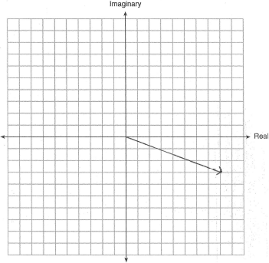

PTS: 2 REF: 011023b TOP: Graphing Complex Numbers

24 ANS:
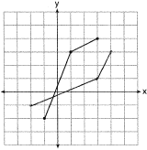

PTS: 2 REF: 011024b STA: A2.A.44 TOP: Inverse of Functions

25 ANS:

PTS: 2 REF: 011025b STA: A2.N.6 TOP: Square Roots of Negative Numbers

26 ANS:
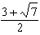

PTS: 2 REF: 011026b STA: A2.N.5 TOP: Rationalizing Denominators

27 ANS:
172

PTS: 4 REF: 011027b STA: A2.A.74 TOP: Using Trigonometry to Find Area

28 ANS:
, 1.28

PTS: 4 REF: 011028b STA: A2.S.7 TOP: Linear Regression

29 ANS:
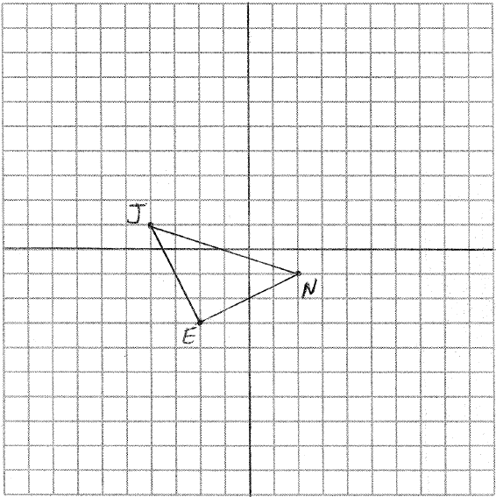 To prove that is a right triangle, prove that its legs are perpendicular by showing their slopes are opposite reciprocals: 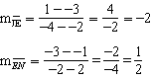
To prove that is an isosceles triangle, prove that it legs are congruent by using the distance formula: 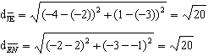

PTS: 4 REF: 011029b STA: G.G.69 TOP: Coordinate Proofs

30 ANS:
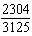

PTS: 4 REF: 011030b STA: A2.S.15 TOP: Binomial Probability
KEY: at least or at most

31 ANS:
78,400, 14.6

PTS: 4 REF: 011031b STA: A2.A.6 TOP: Exponential Growth

32 ANS:
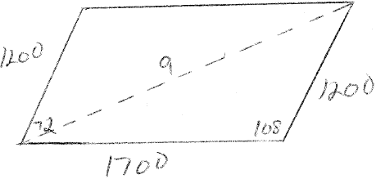 2364

PTS: 4 REF: 011032b STA: A2.A.73 TOP: Law of Cosines

33 ANS:
25, 115, 115

PTS: 6 REF: 011033b STA: G.G.51 TOP: Chords, Secants and Tangents

34 ANS:
0.4 and

PTS: 6 REF: 011034b STA: A2.A.23 TOP: Solving Rationals
KEY: irrational and complex solutions

