Part I

Answer all questions in this part. Each correct answer will receive 2 credits. No partial credit will be allowed. For each question, write on the separate answer sheet the numeral preceding the word or expression that best completes the statement or answers the question.

If and then $f(g(3))$ is equal to
(1) –7 (3) –1
(2) –3 (4) 7

The shaded portion of the accompanying map indicates areas of night, and the unshaded portion indicates areas of daylight at a particular moment in time.
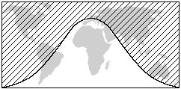
Which type of function best represents the curve that divides the area of night from the area of daylight?
(1) quadratic (3) tangent
(2) cosine (4) logarithmic

If R varies inversely as S, when S is doubled, R is multiplied by
(1) (3)
(2) (4)

What is the domain of the function ?
(1) $\left\{x|x∈ \text{real} \text{numbers}, x≠7\right\}$
(2) $\left\{x|x∈ \text{real} \text{numbers}, x≠±7\right\}$
(3) $\left\{x|x∈ \text{real} \text{numbers}\right\}$
(4) $\left\{x|x∈ \text{real} \text{numbers}, x≠0\right\}$

The value of is
(1) 5 (3) 25
(2) 10 (4) 45

The product of $(5\text{ab})$ and $(−2a^{2}b)^{3}$ is
(1) (3)
(2) (4)

Which transformation is an example of an opposite isometry?
(1) (x,y) (x + 3,y – 6) (3) (x,y) (y,x)
(2) (x,y) (3x,3y) (4) (x,y) (y,–x)

The expression is equivalent to
(1) (3)
(2) (4)

Which graph represents the solution set of the inequality ?
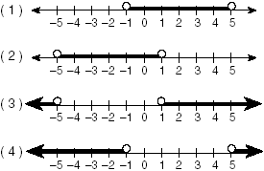

A small fragment of something brittle, such as pottery, is called a shard. The accompanying diagram represents the outline of a shard from a small round plate that was found at an archaeological dig.
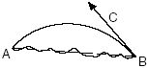
If ray BC is a tangent to arc AB at B and , what is the measure of arc AB, the outside edge of the shard?
(1) 45° (3) 135°
(2) 90° (4) 225°

Which graph is not a function?
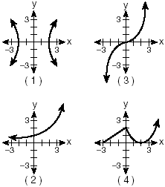
If A is a positive acute angle and sin A = , what is cos 2A?
(1) (3)
(2) (4)

The roots of the equation are
(1) imaginary
(2) real, rational, and equal
(3) real, irrational, and unequal
(4) real, rational, and unequal
What is the equation of a circle with center (–3,1) and radius 7?
(1) $(x−3)^{2}+(y+1)^{2}=7$
(2) $(x−3)^{2}+(y+1)^{2}=\text{49}$
(3) $(x+3)^{2}+(y−1)^{2}=7$
(4) $(x+3)^{2}+(y−1)^{2}=\text{49}$

Which scatter diagram shows the strongest positive correlation?
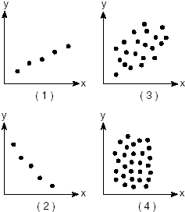

The expression is equivalent to
(1) (3)
(2) (4)

The accompanying diagram shows the construction of a model of an elliptical orbit of a planet traveling around a star. Point P and the center of the star represent the foci of the orbit.
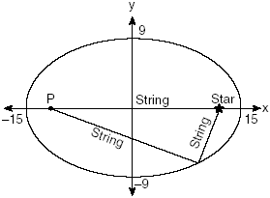
Which equation could represent the relation shown?
(1) (3)
(2) (4)

The expression is equivalent to
(1) 1 (3) i
(2) -1 (4) –i

If , what is the value of
(1) (3)
(2) (4)

If the coordinates of point A are (–2,3), what is the image of A under
(1) (–6,–9) (3) (5,6)
(2) (9,–6) (4) (6,9)

Part II

Answer all questions in this part. Each correct answer will receive 2 credits. Clearly indicate the necessary steps, including appropriate formula substitutions, diagrams, graphs, charts, etc. For all questions in this part, a correct numerical answer with no work shown will receive only 1 credit.

The accompanying diagram shows the graph of the line whose equation is
On the same set of axes, sketch the graph of the inverse of this function.
State the coordinates of a point on the inverse function.
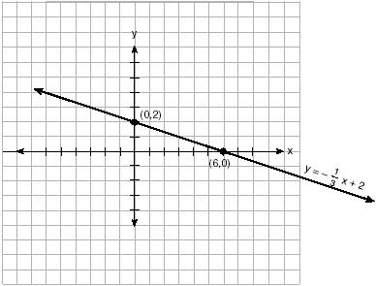

If 2 + 3i is one root of a quadratic equation with real coefficients, what is the sum of the roots of the equation?

Solve the following equation algebraically for all values of in the interval$0°≤θ≤\text{180}°\text{.}$
If the probability that it will rain on any given day this week is 60%, find the probability it will rain exactly 3 out of 7 days this week.

On January 1, 1999, the price of gasoline was $1.39 per gallon. If the price of gasoline increased by 0.5% per month, what was the cost of one gallon of gasoline, to the nearest cent, on January 1 one year later?

An arc of a circle that is 6 centimeters in length intercepts a central angle of 1.5 radians. Find the number of centimeters in the radius of the circle.

Part III

Answer all questions in this part. Each correct answer will receive 4 credits. Clearly indicate the necessary steps, including appropriate formula substitutions, diagrams, graphs, charts, etc. For all questions in this part, a correct numerical answer with no work shown will receive only 1 credit.

On the accompanying grid, solve the following system of equations graphically:


To measure the distance through a mountain for a proposed tunnel, surveyors chose points A and B at each end of the proposed tunnel and a point C near the mountain. They determined that AC = 3,800 meters, BC = 2,900 meters, and . Draw a diagram to illustrate this situation and find the length of the tunnel, to the nearest meter.

From 1984 to 1995, the winning scores for a golf tournament were 276, 279, 279, 277, 278, 278, 280, 282, 285, 272, 279, and 278. Using the standard deviation for the sample, Sx, find the percent of these winning scores that fall within one standard deviation of the mean.

A real estate agent plans to compare the price of a cottage, y, in a town on the seashore to the number of blocks, x, the cottage is from the beach. The accompanying table shows a random sample of sales and location data.
Write a linear regression equation that relates the price of a cottage to its distance from the beach.
Use the equation to predict the price of a cottage, to the nearest dollar, located three blocks from the beach.
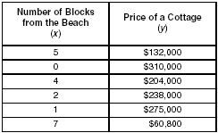

The heights, h, of the students in the chorus at Central Middle School satisfy the inequality when h is measured in inches. Determine the interval in which these heights lie and express your answer to the nearest tenth of a foot. [Only an algebraic solution can receive full credit.]

The number of people, y, involved in recycling in a community is modeled by the function , where x is the number of months the recycling plant has been open.
Construct a table of values, sketch the function on the grid, and find the number of people involved in recycling exactly 3 months after the plant opened.
After how many months will 940 people be involved in recycling?

Part IV

Answer all questions in this part. Each correct answer will receive 6 credits. Clearly indicate the necessary steps, including appropriate formula substitutions, diagrams, graphs, charts, etc. For all questions in this part, a correct numerical answer with no work shown will receive only 1 credit.

Jim is experimenting with a new drawing program on his computer. He created quadrilateral TEAM with coordinates T(–2,3), E(–5,–4), A(2,–1), and M(5,6). Jim believes that he has created a rhombus but not a square. Prove that Jim is correct. [The use of the grid is optional.]


A sign 46 feet high is placed on top of an office building. From a point on the sidewalk level with the base of the building, the angle of elevation to the top of the sign and the angle of elevation to the bottom of the sign are 40° and 32°, respectively. Sketch a diagram to represent the building, the sign, and the two angles, and find the height of the building to the nearest foot.

