Part I

Answer all questions in this part. Each correct answer will receive 2 credits. No partial credit will be allowed. For each question, write on the separate answer sheet the numeral preceding the word or expression that best completes the statement or answers the question.

The expression cos 40° cos 10° + sin 40° sin 10° is equivalent to
(1) cos 30° (3) sin 30°
(2) cos 50° (4) sin 50°

The expression is equivalent to
(1) (3)
(2) (4)

An overhead view of a revolving door is shown in the accompanying diagram. Each panel is 1.5 meters wide.
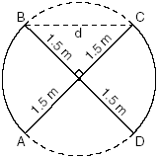
What is the approximate width of d, the opening from B to C?
(1) 1.50 m (3) 3.00 m
(2) 1.73 m (4) 2.12 m

What is a positive value of x for which ?
(1) 30° (3) 60°
(2) 45° (4) 90°

The expression is equivalent to
(1) (3)
(2) (4)

Jean’s scores on five mathematics tests were 98, 97, 99, 98, and 96. Her scores on five English tests were 78, 84, 95, 72, and 79. Which statement is true about the standard deviations for the scores?
(1) The standard deviation for the English scores is greater than the standard deviation for the math scores.
(2) The standard deviation for the math scores is greater than the standard deviation for the English scores.
(3) The standard deviations for both sets of scores are equal.
(4) More information is needed to determine the relationship between the standard deviations.

In Which statement can be used to find the value of
(1) (3)
(2) (4)

If and , then is equal to
(1) (3)
(2) (4)

If log x = a, log y = b, and log z = c, then is equivalent to
(1) (3)
(2) (4)

The accompanying diagram shows the elliptical orbit of a planet. The foci of the elliptical orbit are and .
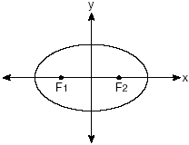
If a, b, and c are all positive and which equation could represent the path of the planet?
(1) (3)
(2) (4)

Battery lifetime is normally distributed for large samples. The mean lifetime is 500 days and the standard deviation is 61 days. Approximately what percent of batteries have lifetimes longer than 561 days?
(1) 16% (3) 68%
(2) 34% (4) 84%

The expression is defined for all values of x such that
(1) (3)
(2) (4)

The expression is equivalent to
(1) $\frac{1}{(\sqrt[3]{b})^{2}}$ (3) $−(\sqrt{b})^{3}$
(2) $\frac{1}{(\sqrt{b})^{3}}$ (4) $(\sqrt[3]{b})^{2}$

The graph below represents .
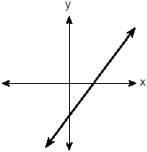
Which graph best represents ?
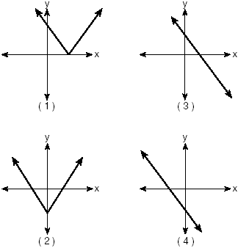

If then is equivalent to
(1) –2 + i (3) 2 + i
(2) –2 – i (4) 2 – i

Which statement must be true if a parabola represented by the equation does not intersect the x-axis?
(1)
(2)
(3) , and is a perfect square.
(4) , and is not a perfect square.

A garden in the shape of an equilateral triangle has sides whose lengths are 10 meters. What is the area of the garden?
(1) (3)
(2) (4)

If x is an acute angle and then cos 2x equals
(1) (3)
(2) (4)

What is the axis of symmetry of the graph of the equation ?
(1) x-axis (3) line y = x
(2) y-axis (4) line y = –x

The cells of a particular organism increase logarithmically. If g represents cell growth and h represents time, in hours, which graph best represents the growth pattern of the cells of this organism?
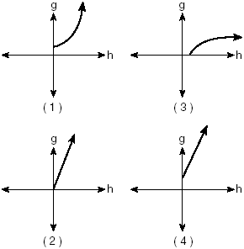

Part II

Answer all questions in this part. Each correct answer will receive 2 credits. Clearly indicate the necessary steps, including appropriate formula substitutions, diagrams, graphs, charts, etc. For all questions in this part, a correct numerical answer with no work shown will receive only 1 credit.

Kristine is riding in car 4 of the Ferris wheel represented in the accompanying diagram. The Ferris wheel is rotating in the direction indicated by the arrows. The eight cars are equally spaced around the circular wheel. Express, in radians, the measure of the smallest angle through which she will travel to reach the bottom of the Ferris wheel.
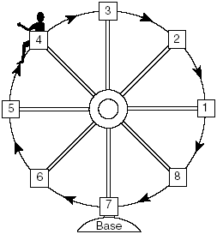

In the accompanying diagram, point P(0.6,–0.8) is on unit circle O. What is the value of , to the nearest degree?
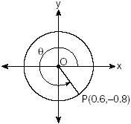

A pulley that has a diameter of 8 inches is belted to a pulley that has a diameter of 12 inches. The 8-inch-diameter pulley is running at 1,548 revolutions per minute. If the speeds of the pulleys vary inversely to their diameters, how many revolutions per minute does the larger pulley make?

When a current, I, flows through a given electrical circuit, the power, W, of the circuit can be determined by the formula . What amount of current, I, supplies the maximum power, W?

The brightness of the star MIRA over time is given by the equation , where x represents time and y represents brightness. What is the period of this function, in radian measure?

A landscape designer is designing a triangular garden with two sides that are 4 feet and 6 feet, respectively. The angle opposite the 4-foot side is 30°. How many distinct triangular gardens can the designer make using these measurements?

Part III

Answer all questions in this part. Each correct answer will receive 4 credits. Clearly indicate the necessary steps, including appropriate formula substitutions, diagrams, graphs, charts, etc. For all questions in this part, a correct numerical answer with no work shown will receive only 1 credit.

Solve algebraically:

A board game has a spinner on a circle that has five equal sectors, numbered 1, 2, 3, 4, and 5, respectively. If a player has four spins, find the probability that the player spins an even number no more than two times on those four spins.

The equation for radioactive decay is , where p is the part of a substance with half-life H remaining radioactive after a period of time, t.
A given substance has a half-life of 6,000 years. After t years, one-fifth of the original sample remains radioactive. Find t, to the nearest thousand years.

One force of 20 pounds and one force of 15 pounds act on a body at the same point so that the resultant force is 19 pounds. Find, to the nearest degree, the angle between the two original forces.

An acorn falls from the branch of a tree to the ground 25 feet below. The distance, S, the acorn is from the ground as it falls is represented by the equation , where t represents time, in seconds. Sketch a graph of this situation on the accompanying grid.
Calculate, to the nearest hundredth of a second, the time the acorn will take to reach the ground.


In the accompanying diagram of circle O, is drawn tangent to the circle at A. Place B on anywhere between P and A and draw , , and . Prove that is not perpendicular to .
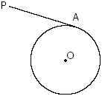

Part IV

Answer all questions in this part. Each correct answer will receive 6 credits. Clearly indicate the necessary steps, including appropriate formula substitutions, diagrams, graphs, charts, etc. For all questions in this part, a correct numerical answer with no work shown will receive only 1 credit.

The accompanying table shows the average salary of baseball players since 1984. Using the data in the table, create a scatter plot on the grid and state the exponential regression equation with the coefficient and base rounded to the nearest hundredth.
Using your written regression equation, estimate the salary of a baseball player in the year 2005, to the nearest thousand dollars.
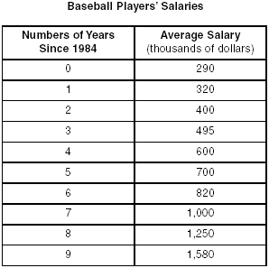


Express in simplest form:

