1 For what value of x will 8 and x have the same mean (average) as 27 and 5?
1) | 1.5
2) | 8
3) | 24
4) | 40

2 If , then x equals
1)
2)
3) | 1.25
4) | 2.5

3 The image of point when reflected in the y-axis is
1)
2)
3)
4)

4 If is an even integer, what is the next larger consecutive even integer?
1)
2)
3)
4)

5 If is subtracted from , the result is
1)
2)
3)
4)

6 Which is a factor of ?
1)
2)
3)
4)

7 When is divided by , the quotient is
1)
2)
3)
4)

8 If 0.0154 is expressed in the form , n is equal to
1)
2) | 2
3) | 3
4)

9 How many integer values of x are there so that x, 5, and 8 could be the lengths of the sides of a triangle?
1) | 6
2) | 9
3) | 3
4) | 13

10 In the diagram below, and . What is ?

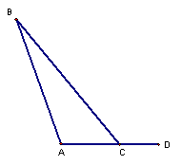
1) | 50
2) | 70
3) | 110
4) | 150

11 What is the distance between points and ?
1)
2)
3)
4)

12 “If Tom and Mary are classmates, then they go to the same school.” Which statement below is logically equivalent?
1) | If Mary and Tom do not go to the same school, then they are not classmates.
2) | If Mary and Tom are not classmates, then they do not go to the same school.
3) | If Mary and Tom go to the same school, then they are classmates.
4) | If Mary and Tom go to the same school, then they are not classmates.

13 For what value of t is 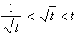 true?
1) | 1
2) | 0
3)
4) | 4

14 There are 12 tomato plants in a garden. Each plant has 7 branches and each branch has four (4) tomatoes growing on it. If one-third of the tomatoes are picked, how many tomatoes were picked?
1) | 23
2) | 112
3) | 224
4) | 336

15 In the diagram below, is parallel to . Transversal intersects and at G and H, respectively. If and , what is the value of x?

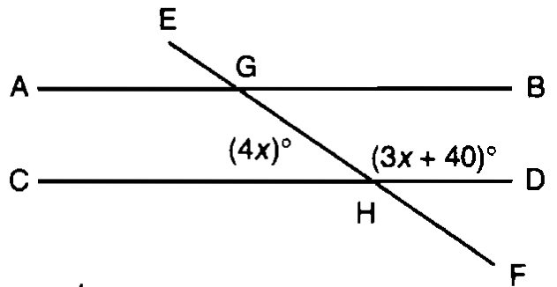
1) | 20
2) | 40
3) | 80
4) | 160

16 Laura goes shopping. She spends one-fourth of her money on a pair of shorts, and one-third of her remaining money on a belt. If Laura has $42 left after these two purchases, how much money did she have when she started shopping?
1) | $84
2) | $126
3) | $144
4) | $504

17 The distance between points P and Q is eight (8) units. How many points are equidistant from P and Q and also three (3) units from P?
1) | 1
2) | 2
3) | 0
4) | 4

18 The accompanying histogram shows the scores of students on a Math A test.

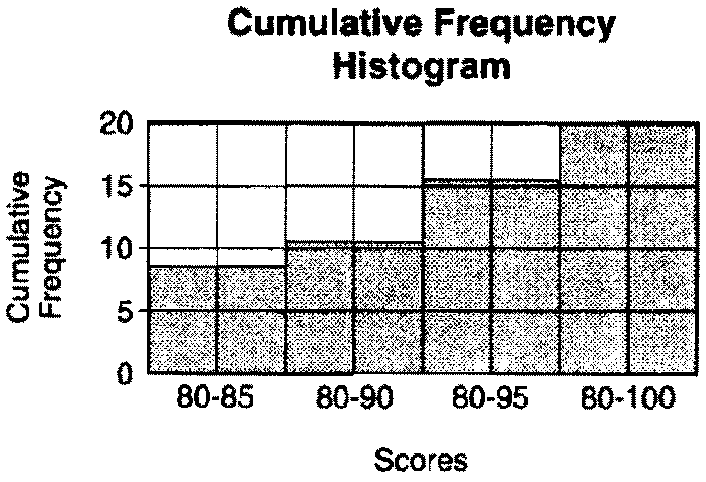

How many students have scores of 96 to 100?
1) | 55
2) | 20
3) | 5
4) | 4

19 The expression is equivalent to
1)
2)
3)
4)

20 Erica cannot remember the correct order of the four digits in her ID number. She does remember that the ID number contains the digits 1, 2, 5, and 9. What is the probability that the first three digits of Erica’s ID numbers will all be odd numbers?
1)
2)
3)
4)

21 The graph below shows the hair colors of all the students in a class.

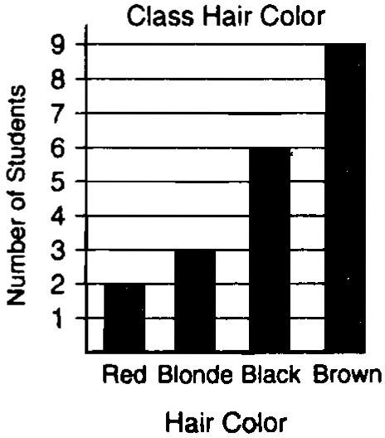

What is the probability that a student chosen at random from this class has black hair?

22 In the figure shown below, each dot is one unit from an adjacent horizontal or vertical dot.

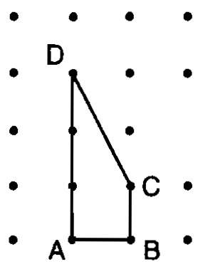

Find the number of square units in the area of quadrilateral ABCD. Show how you arrived at your answer.

23 A design was constructed by using two rectangles ABDC and . Rectangle is the result of a translation of rectangle ABDC. The table of translations is shown below. Find the coordinates of points B and .

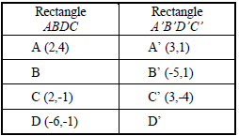

24 Mr. Cash bought d dollars worth of stock. During the first year, the value of the stock tripled. The next year, the value of the stock decreased by $1200.
(a) Write an expression in terms of d to represent the value of the stock after two years.
(b) If an initial investment is $1,000, determine its value at the end of 2 years.

25 The tailgate of a truck is 2 feet above the ground. The incline of a ramp used for loading the truck is 11°, as shown below.

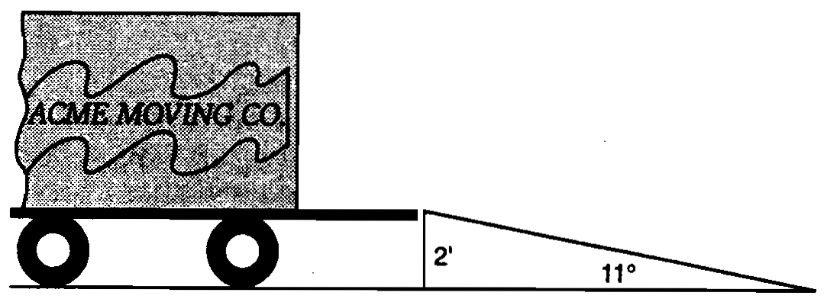

Find, to the nearest tenth of a foot, the length of the ramp.

26 On his first 5 biology tests, Bob received the following scores: 72, 86, 92, 63, and 77. What test score must Bob earn on his sixth test so that his average (mean score) for all six tests will be 80? Show how you arrived at your answer.

27 The figure below represents the distances traveled by car A and car B in 6 hours.

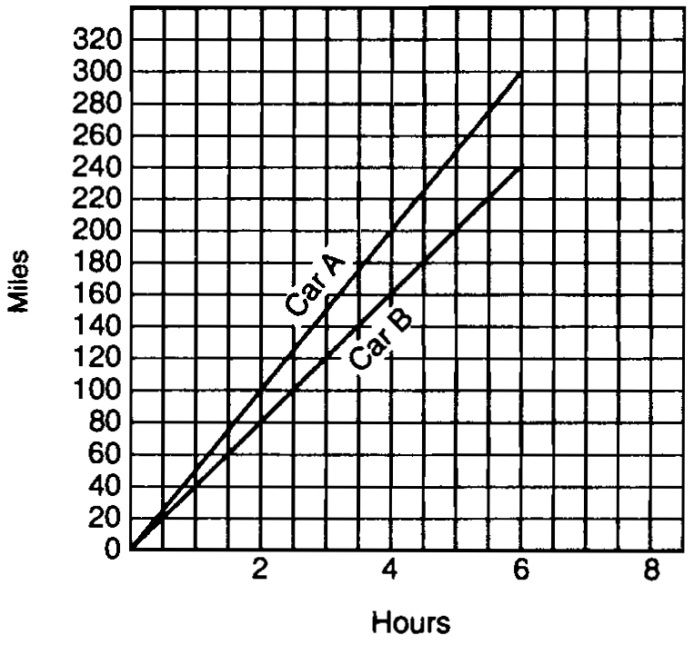

Which car is going faster and by how much? Explain how you arrived at your answer.

28 A total of 800 votes were cast in an election. The table below represents the votes that were received by the candidates. Candidate D got at least 30 votes more than Candidate E. What is the least number of votes that Candidate D could have received? Show how you arrived at your answer.

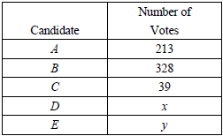

29 In a school of 320 students, 85 students are in the band, 200 students are on sports teams, and 60 students participate in both activities. How many students are not involved in either band or sports? Show how you arrived at your answer.

30 Ms. Brown plans to carpet part of her living room floor. The living room floor is a square 20 feet by 20 feet. She wants to carpet a quarter-circle as shown below.

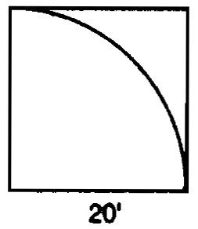

Find, to the nearest square foot, what part of the floor will remain uncarpeted. Show how you arrived at your answer.

31 Two video rental clubs offer two different rental fee plans: Club A charges $12 for membership and $2 for each rented video. Club B has a $4 membership fee and charges $4 for each rented video. The graph below represents the total cost of renting videos from Club A.

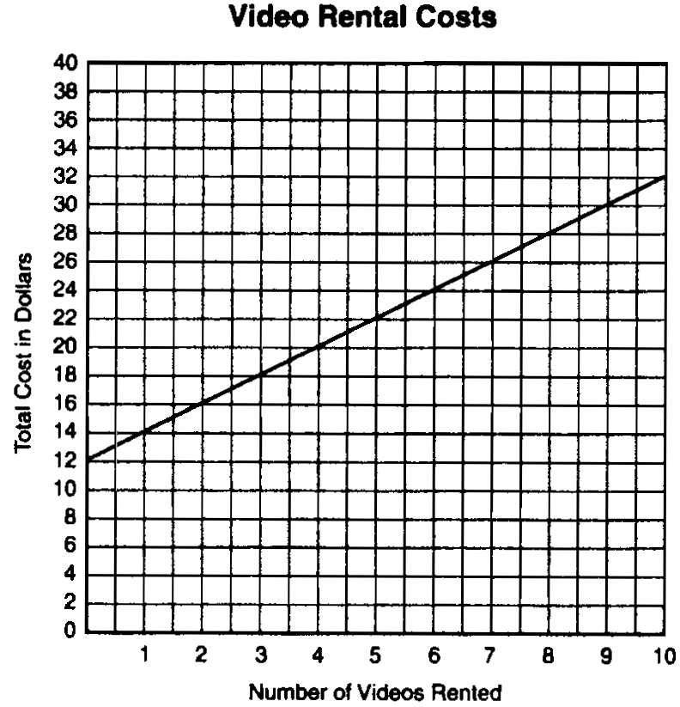

(a) On the same set of xy-axes, draw a line to represent the total cost of renting videos from Club B.
(b) For what number of video rentals is it less expensive to belong to Club A? Explain how you arrived at your answer.

32 Jed bought a generator that will run for 2 hours on a liter of gas. The gas tank on the generator is a rectangular prism with dimensions 20 cm by 15 cm by 10 cm as shown below.

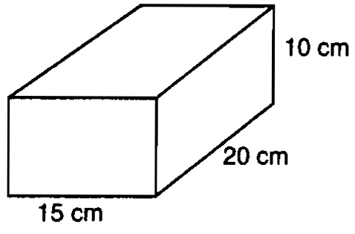

If Jed fills the tank with gas, how long will the generator run? Show how you arrived at your answer. [Note: 1000 cm³ = 1 liter]

33 A clothing store offers a 50% discount at the end of each week that an item remains unsold. Patrick wants to buy a shirt at the store and he says, “I’ve got a great idea! I’ll wait two weeks, have 100% off, and get it for free!” Explain to your friend Patrick why he is incorrect and find the correct percent of discount on the original price of a shirt.

34 A 10-foot ladder is placed against the side of a building as shown in figure 1 below. The bottom of the ladder is 8 feet from the base of the building. In order to increase the reach of the ladder against the building, it is moved 4 feet closer to the base of the building as shown in figure 2.

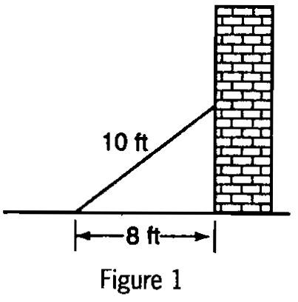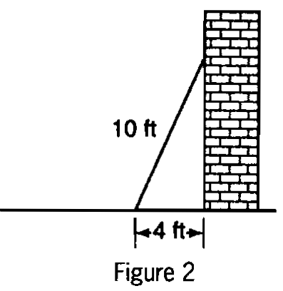

To the nearest foot, how much further up the building does the ladder now reach? Show how you arrived at your answer.

35 A corner is cut off a 5” by 5” square piece of paper. The cut is x inches from a corner as shown below.

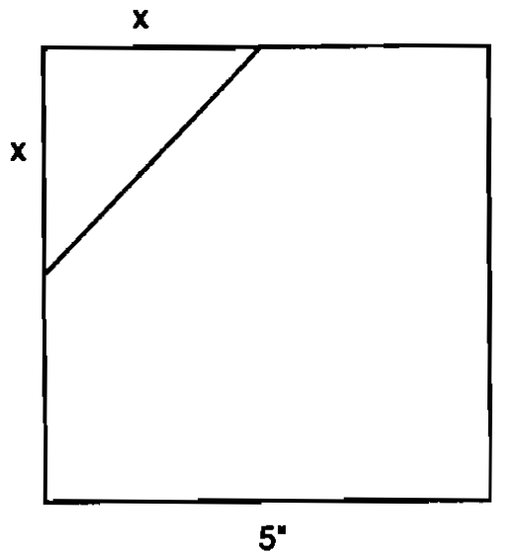

(a) Write an equation, in terms of x, that represents the area, A, of the paper after the corner is removed.
(b) What value of x will result in an area that is of the area of the original square piece of paper? Show how you arrived at your answer.
1 ANS: 3
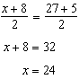

PTS: 2 REF: spring9801a STA: A.S.16 TOP: Average Known with Missing Data

2 ANS: 4
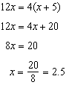

PTS: 2 REF: spring9802a STA: A.A.22 TOP: Solving Equations

3 ANS: 2 PTS: 2 REF: spring9803a STA: G.G.54
TOP: Reflections KEY: basic

4 ANS: 2
The distance between consecutive odd integers is 2.

PTS: 2 REF: spring9804a STA: A.A.1 TOP: Expressions

5 ANS: 2 PTS: 2 REF: spring9805a STA: A.A.13
TOP: Addition and Subtraction of Polynomials KEY: subtraction

6 ANS: 4

PTS: 2 REF: spring9806a STA: A.A.20 TOP: Factoring Polynomials

7 ANS: 3 PTS: 2 REF: spring9807a STA: A.A.14
TOP: Division of Polynomials

8 ANS: 1 PTS: 2 REF: spring9808a STA: unassigned
TOP: Scientific Notation

9 ANS: 2
and . There are 9 integers between 3 and 13.

PTS: 2 REF: spring9809a STA: G.G.33 TOP: Triangle Inequality Theorem

10 ANS: 3 PTS: 2 REF: spring9810a STA: G.G.32
TOP: External Angle Theorem

11 ANS: 4

PTS: 2 REF: spring9811a STA: G.G.67 TOP: Distance

12 ANS: 1 PTS: 2 REF: spring9812a STA: G.G.26
TOP: Contrapositive

13 ANS: 4 PTS: 2 REF: spring9813a STA: unassigned
TOP: Comparing Reals

14 ANS: 2 PTS: 2 REF: spring9814a STA: A.N.7
TOP: Multiplication Counting Principal

15 ANS: 2 PTS: 2 REF: spring9815a STA: unassigned
TOP: Angles Involving Parallel Lines

16 ANS: 1
If x represents the amount of money Laura had when she started shopping, she has left after she buys the shorts. 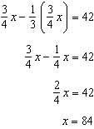

PTS: 2 REF: spring9816a STA: A.N.5 TOP: Fractions

17 ANS: 3 PTS: 2 REF: spring9817a STA: G.G.22
TOP: Locus

18 ANS: 4 PTS: 2 REF: spring9818a STA: A.S.9
TOP: Frequency Histograms, Bar Graphs and Tables

19 ANS: 3

PTS: 2 REF: spring9819a STA: A.N.2 TOP: Simplifying Radicals

20 ANS: 1
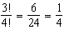

PTS: 2 REF: spring9820a STA: A.S.19 TOP: Sample Space

21 ANS:
. 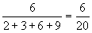

PTS: 2 REF: spring9821a STA: A.S.21 TOP: Experimental Probability

22 ANS:
2. 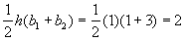

PTS: 2 REF: spring9822a STA: unassigned TOP: Area of Polygons

23 ANS:
.

PTS: 2 REF: spring9823a STA: G.G.54 TOP: Translations

24 ANS:
, 1800. .

PTS: 2 REF: spring9824a STA: A.A.1 TOP: Expressions

25 ANS:
10.5. 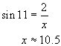

PTS: 2 REF: spring9825a STA: A.A.44 TOP: Using Trigonometry to Find a Side
KEY: graphics

26 ANS:
90. 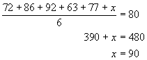

PTS: 3 REF: spring9826a STA: A.S.16 TOP: Average Known with Missing Data

27 ANS:
Car A is going faster. After 6 hours, it has gone 60 miles farther than car B, so is traveling 10 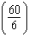 mph faster.

PTS: 3 REF: spring9827a STA: A.M.1 TOP: Speed

28 ANS:
125. 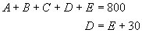. 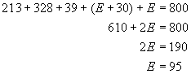. 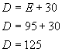

PTS: 3 REF: spring9828a STA: A.A.7 TOP: Writing Linear Systems

29 ANS:
95. 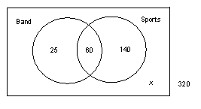. Start with 60 in the intersection of the two circles to represent the students that participate in both band and sports. From this, you calculate that 25 (85–60) participate in band, only, and that 140 (200–60) participate in sports, only. 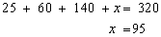

PTS: 3 REF: spring9829a STA: A.RP.11 TOP: Venn Diagrams

30 ANS:
86. Area of square–area of quarter circle = 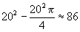

PTS: 3 REF: spring9830a STA: A.G.1 TOP: Compositions of Polygons and Circles

31 ANS:
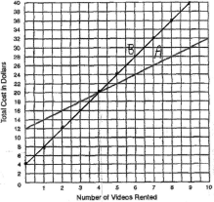. It is less expensive to rent 5 or more videos from Club A, as indicated from the graph above.

PTS: 4 REF: spring9831a STA: A.A.7 TOP: Break Even

32 ANS:
6 hours. . If the generator runs for 2 hours on 1 liter, the generator will run for 6 hours on 3 liters.

PTS: 4 REF: spring9832a STA: G.G.12 TOP: Volume

33 ANS:
The 50% discount is applied to the net amount at the end of each week, not to the original price. After two weeks, the percent of discount is 75% (50% + (0.5)(50%)).

PTS: 4 REF: spring9833a STA: A.N.5 TOP: Percents

34 ANS:
3. Figure 1: . Figure 2: .

PTS: 4 REF: spring9834a STA: A.A.45 TOP: Pythagorean Theorem
KEY: graphics

35 ANS:
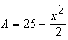, 2.5. 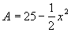. 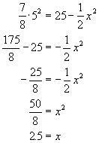

PTS: 2 REF: spring9835a STA: A.G.1 TOP: Compositions of Polygons and Circles

