Part I

Answer all questions in this part. Each correct answer will receive 2 credits. No partial credit will be allowed. For each question, write on the separate answer sheet the numeral preceding the word or expression that best completes the statement or answers the question.

A roll of candy is shown in the accompanying diagram.



The shape of the candy is best described as a
(1) rectangular solid
(2) pyramid
(3) cone
(4) cylinder

The expression can be simplified to
(1) (3)
(2) (4)

The transformation of ABC to AB’C’ is shown in the accompanying diagram.

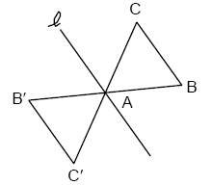

This transformation is an example of a
(1) line reflection in line
(2) rotation about point A
(3) dilation
(4) translation

Which expression is equivalent to ?
(1) (3)
(2) (4)

The Pentagon building in Washington, D.C., is shaped like a regular pentagon. If the length of one side of the Pentagon is represented by n + 2, its perimeter would be represented by
(1) 5n + 10 (3) n + 10
(2) 5n + 2 (4) 10n

The product of and is
(1) (3)
(2) (4)

Which equation is an illustration of the additive identity property?
(1) (3) x – x = 0
(2) x + 0 = x (4)

The formula can be used to find the Celsius temperature (C) for a given Fahrenheit temperature (F). What Celsius temperature is equal to a Fahrenheit temperature of 77°?
(1) 8° (3) 45°
(2) 25° (4) 171°

In the accompanying diagram of rectangle ABCD, and

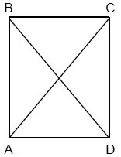

What is m∠CAD?
(1) 12 (3) 40
(2) 37 (4) 50

On June 17, the temperature in New York City ranged from 90° to 99°, while the temperature in Niagara Falls ranged from 60° to 69°. The difference in the temperatures in these two cities must be between
(1) 20° and 30° (3) 25° and 35°
(2) 20° and 40° (4) 30° and 40°

Which expression is equivalent to ?
(1) (3)
(2) (4)

What is true about the statement “If two angles are right angles, the angles have equal measure” and its converse “If two angles have equal measure then the two angles are right angles”?
(1) The statement is true but its converse is false.
(2) The statement is false but its converse is true.
(3) Both the statement and its converse are false.
(4) Both the statement and its converse are true.

If 6 and x have the same mean (average) as 2, 4, and 24, what is the value of x?
(1) 5 (3) 14
(2) 10 (4) 36

In a hockey league, 87 players play on seven different teams. Each team has at least 12 players. What is the largest possible number of players on any one team?
(1) 13 (3) 15
(2) 14 (4) 21

In the accompanying diagram of equilateral triangle ABC, DE = 5 and .

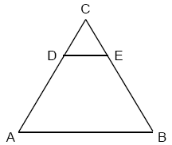

If AB is three times as long as DE, what is the perimeter of quadrilateral ABED?
(1) 20 (3) 35
(2) 30 (4) 40

At a concert, $720 was collected for hot dogs, hamburgers, and soft drinks. All three items sold for $1.00 each. Twice as many hot dogs were sold as hamburgers. Three times as many soft drinks were sold as hamburgers. The number of soft drinks sold was
(1) 120 (3) 360
(2) 240 (4) 480

How many different 6-letter arrangements can be formed using the letters in the word “ABSENT,” if each letter is used only once?
(1) 6 (3) 720
(2) 36 (4) 46,656

The ratio of the corresponding sides of two similar squares is 1 to 3. What is the ratio of the area of the smaller square to the area of the larger square?
(1) 1: (3) 1:6
(2) 1:3 (4) 1:9

What is the slope of the line whose equation is 3x – 4y – 16 = 0?
(1) (3) 3
(2) (4) –4

What is the perimeter of an equilateral triangle whose height is ?
(1) 6 (3)
(2) 12 (4)

Part II

Answer all questions in this part. Each correct answer will receive 2 credits. Clearly indicate the necessary steps, including appropriate formula substitutions, diagrams, graphs, charts, etc. For all questions in this part, a correct numerical answer with no work shown will receive only 1 credit.

Solve for x: 2(x – 3) = 1.2 – x

The Grimaldis have three children born in different years.
a Draw a tree diagram or list a sample space to show all the possible arrangements of boy and girl children in the Grimaldi family.
b Using your information from part a, what is the probability that the Grimaldis have three boys?

Paloma has 3 jackets, 6 scarves, and 4 hats. Determine the number of different outfits consisting of a jacket, a scarf, and a hat that Paloma can wear.

In a recent poll, 600 people were asked whether they liked Chinese food. A circle graph was constructed to show the results. The central angles for two of the three sectors are shown in the accompanying diagram.
How many people had no opinion?

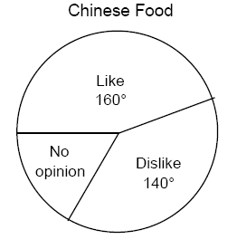

Maria’s backyard has two trees that are 40 feet apart, as shown in the accompanying diagram. She wants to place lampposts so that the posts are 30 feet from both of the trees. Draw a sketch to show where the lampposts could be placed in relation to the trees. How many locations for the lampposts are possible?

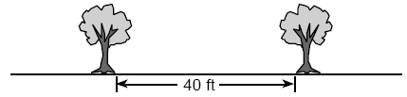

Part III

Answer all questions in this part. Each correct answer will receive 3 credits. Clearly indicate the necessary steps, including appropriate formula substitutions, diagrams, graphs, charts, etc. For all questions in this part, a correct numerical answer with no work shown will receive only 1 credit.

Solve for x:

A person standing on level ground is 2,000 feet away from the foot of a 420-foot-tall building, as shown in the accompanying diagram. To the nearest degree, what is the value of x?

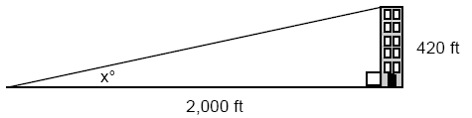

Bob and Ray are describing the same number. Bob says, “The number is a positive even integer less than or equal to 20.” Ray says, “The number is divisible by 4.” If Bob’s statement is true and Ray’s statement is false, what are all the possible numbers?

Line contains the points (0,4) and (2,0). Show that the point (–25, 81) does or does not lie on line .

A painting that regularly sells for a price of $55 is on sale for 20% off. The sales tax on the painting is 7%. Will the final total cost of the painting differ depending on whether the salesperson deducts the discount before adding the sales tax or takes the discount after computing the sum of the original price and the sales tax on $55?

Part IV

Answer all questions in this part. Each correct answer will receive 4 credits. Clearly indicate the necessary steps, including appropriate formula substitutions, diagrams, graphs, charts, etc. For all questions in this part, a correct numerical answer with no work shown will receive only 1 credit.

The profits in a business are to be shared by the three partners in the ratio of 3 to 2 to 5. The profit for the year was $176,500. Determine the number of dollars each partner is to receive.

If asphalt pavement costs $0.78 per square foot, determine, to the nearest cent, the cost of paving the shaded circular road with center O, an outside radius of 50 feet, and an inner radius of 36 feet, as shown in the accompanying diagram.

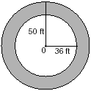
An arch is built so that it is 6 feet wide at the base. Its shape can be re presented by a parabola with the equation , where y is the height of the arch.
a Graph the parabola from x = 0 to x = 6 on the grid below.

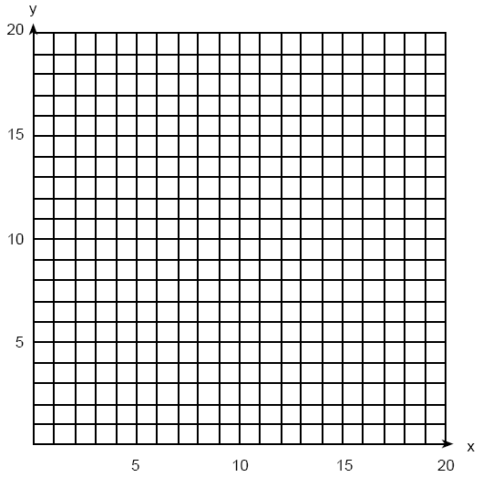

b Determine the maximum height, y, of the arch.

Mr. Gonzalez owns a triangular plot of land BCD with DB = 25 yards and BC = 16 yards. He wishes to purchase the adjacent plot of land in the shape of right triangle ABD, as shown in the accompanying diagram, with AD = 15 yards. If the purchase is made, what will be the total number of square yards in the area of his plot of land, ACD?

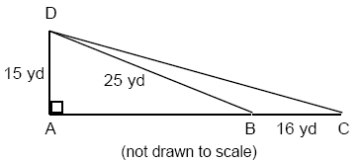

Two health clubs offer different membership plans. The graph below represents the total cost of belonging to Club A and Club B for one year.

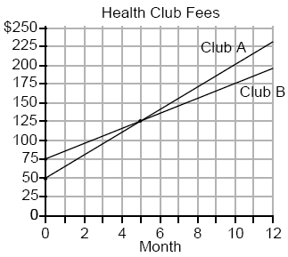

a If the yearly cost includes a membership fee plus a monthly charge, what is the membership fee for Club A?
b (1) What is the number of the month when the total cost is the same for both clubs?
(2) What is the total cost for Club A when both plans are the same?
c What is the monthly charge for Club B?

