Part I

Answer all questions in this part. Each correct answer will receive 2 credits. No partial credit will be allowed. For each question, write on the separate answer sheet the numeral preceding the word or expression that best completes the statement or answers the question.

Which diagram shows a dotted line that is not a line of symmetry?
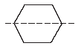  (1) | 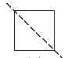  (3)
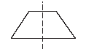  (2) | 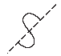  (4)

Rosario and Enrique are in the same mathematics class. On the first five tests, Rosario received scores of 78, 77, 64, 86, and 70. Enrique received scores of 90, 61, 79, 73, and 87. How much higher was Enrique’s average than Rosario’s average?
(1) 15 points (3) 3 points
(2) 2 points (4) 4 points

Which diagram represents the figure with the greatest volume?
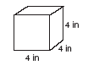  (1) | 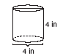  (3)
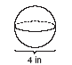  (2) | 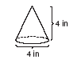  (4)

The school cafeteria offers five sandwich choices, four desserts, and three beverages. How many different meals consisting of one sandwich, one dessert, and one beverage can be ordered?
(1) 1 (3) 3
(2) 12 (4) 60

When is divided by , the quotient is
(1) (3)
(2) (4)

What is the value of n in the equation
(1) –0.4 (3) –4
(2) 5 (4) 4

intersect at point E, , and . What is the value of x?
(1) (3) 10
(2) 5 (4)

If x = –4 and y = 3, what is the value of ?
(1) –13 (3) –31
(2) –23 (4) –85

What are the coordinates of P′, the image of P (–4, 0) under the translation (x – 3, y + 6)?
(1) (–7,6) (3) (1,6)
(2) (7,–6) (4) (2,–3)

The accompanying graph show the amount of water left in Rover’s water dish over a period of time.

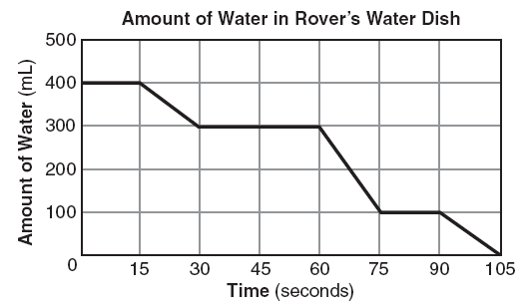

How long did Rover wait from the end of his first drink to the start of his second drink of water?
(1) 10 sec (3) 60 sec
(2) 30 sec (4) 75 sec

Which inequality is represented in the accompanying graph?

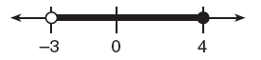

(1) –3 ≤ x < 4 (3) –3 < x < 4
(2) –3 ≤ x ≤ 4 (4) –3 < x ≤ 4

The ratio of Tariq’s telephone bill to Pria’s telephone bill was 7:5. Tariq’s bill was $14 more than Pria’s bill. What was Tariq’s bill?
(1) $21 (3) $35
(2) $28 (4) $49

Which equation illustrates the distributive property of multiplication over addition?
(1) 6(3a + 4b) = 18a + 4b
(2) 6(3a + 4b) = 18a + 24b
(3) 6(3a + 4b) = (3a + 4b)6
(4) 6(3a + 4b) = 6(4b + 3a)

Which ratio represents cos A in the accompanying diagram of ABC?

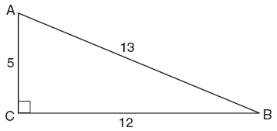

(1) (3)
(2) (4)

A rocket car on the Bonneville Salt Flats is traveling at a rate of 640 miles per hour. How much time would it take for the car to travel 384 miles at this rate?
(1) 36 minutes (3) 256 minutes
(2) 245 minutes (4) 1.7 hours

What is the inverse of the statement “If I do not buy a ticket, then I do not go to the concert”?
(1) If I buy a ticket, then I do not go to the concert.
(2) If I buy a ticket, then I go to the concert.
(3) If I go to the concert, then I buy a ticket.
(4) If I do not go to the concert, then I do not buy a ticket.

If the value of dependent variable y increases as the value of independent variable x increases, the graph of this relationship could be a
(1) horizontal line (3) line with a negative slope
(2) vertical line (4) line with a positive slope

What is the image of point (–3,–1) under a reflection in the origin?
(1) (3,1) (3) (1,3)
(2) (–3,1) (4) (–1,–3)

Seventy-eight students participate in one or more of three sports: baseball, tennis, and golf. Four students participate in all three sports; five play both baseball and golf, only; two play both tennis and golf, only; and three play both baseball and tennis, only. If seven students play only tennis and one plays only golf, what is the total number of students who play only baseball?
(1) 12 (3) 56
(2) 44 (4) 60

Which linear equation represents the data in the accompanying table?

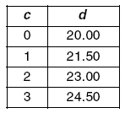

(1) d = 1.50c (3) d = 20.00c + 1.50
(2) d = 1.50c + 20.00 (4) d = 21.50c

The accompanying diagram shows a football player crossing the 20-yard line at an angle of 30° and continuing along the same path.

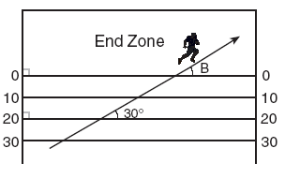

What is the measure of angle B, where the player crosses into the end zone?
(1) 30° (3) 150°
(2) 60° (4) 180°

For which value of x is the expression undefined?
(1) –2 (3) 7
(2) 2 (4) 0

The expression is equivalent to
(1) (3)
(2) (4)

The number is equivalent to
(1) 156 (3) 0.0156
(2) 0.156 (4) 0.00156

Which set can not represent the lengths of the sides of a triangle?
(1) {4,5,6} (3) {7,7,12}
(2) {5,5,11} (4) {8,8,8}

Which equation represents the locus of points 4 units from the origin?
(1) x = 4 (3) x + y = 16
(2) (4)

What is the contrapositive of the statement “If I study, then I pass the test”?
(1) I pass the test if I study.
(2) If I do not study, then I do not pass the test.
(3) If I do not pass the test, then I do not study.
(4) If I pass the test, then I study.

What is the sum, in degrees, of the measures of the interior angles of a stop sign, which is in the shape of an octagon?
(1) 360 (3) 1,440
(2) 1,080 (4) 1,880
What point is the intersection of the graphs of the lines 2x – y = 3 and x + y = 3?
(1) (2,1) (3) (3,0)
(2) (1,2) (4) (3,3)

Selena and Tracey play on a softball team. Selena has 8 hits out of 20 times at bat, and Tracey has 6 hits out of 16 times at bat. Based on their past performance, what is the probability that both girls will get a hit next time at bat?
(1) 1 (3)
(2) (4)

Part II

Answer all questions in this part. Each correct answer will receive 2 credits. Clearly indicate the necessary steps, including appropriate formula substitutions, diagrams, graphs, charts, etc. For all questions in this part, a correct numerical answer with no work shown will receive only 1 credit.

Two angles are complementary. One angle has a measure that is five times the measure of the other angle. What is the measure, in degrees, of the larger angle?

Given:
Identify the expression that is a rational number and explain why it is rational.

Dylan says that all isosceles triangles are acute triangles. Mary Lou wants to prove that Dylan is not correct. Sketch an isosceles triangle that Mary Lou could use to show that Dylan’s statement is not true. In your sketch, state the measure of each angle of the isosceles triangle.

Factor completely:
The accompanying circle graph shows the favorite colors of the 300 students in the ninth grade. How many students chose red as their favorite color?

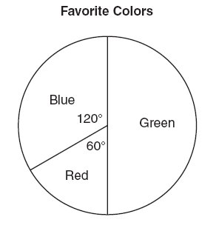

Part III

Answer all questions in this part. Each correct answer will receive 3 credits. Clearly indicate the necessary steps, including appropriate formula substitutions, diagrams, graphs, charts, etc. For all questions in this part, a correct numerical answer with no work shown will receive only 1 credit.

Walter is a waiter at the Towne Diner. He earns a daily wage of $50, plus tips that are equal to 15% of the total cost of the dinners he serves. What was the total cost of the dinners he served if he earned $170 on Tuesday?

The following set of data represents the scores on a mathematics quiz:
58, 79, 81, 99, 68, 92, 76, 84, 53, 57,
81, 91, 77, 50, 65, 57, 51, 72, 84, 89
Complete the frequency table below and, on the accompanying grid, draw and label a frequency histogram of these scores.

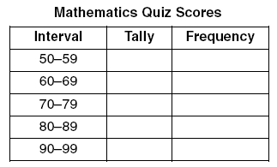



Part IV

Answer all questions in this part. Each correct answer will receive 4 credits. Clearly indicate the necessary steps, including appropriate formula substitutions, diagrams, graphs, charts, etc. For all questions in this part, a correct numerical answer with no work shown will receive only 1 credit.

In the accompanying diagram, right triangle ABC is inscribed in circle O, diameter AB = 26, and CB = 10. Find, to the nearest square unit, the area of the shaded region.

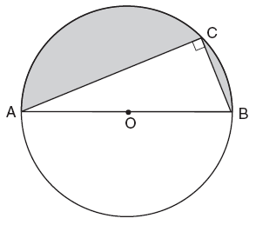

Solve for all values of x that satisfy the equation .

