Part I

Answer all questions in this part. Each correct answer will receive 2 credits. No partial credit will be allowed. For each question, write on the separate answer sheet the numeral preceding the word or expression that best completes the statement or answers the question.

On a map, 1 centimeter represents 40 kilometers. How many kilometers are represented by 8 centimeters?
(1) 5 (3) 280
(2) 48 (4) 320

In the accompanying diagram of parallelogram ABCD, diagonals and intersect at E, AE = 3x – 4, and EC = x + 12.

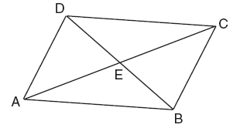

What is the value of x?
(1) 8 (3) 20
(2) 16 (4) 40

What is the total number of points equidistant from two intersecting straight roads and also 300 feet from the traffic light at the center of the intersection?
(1) 1 (3) 3
(2) 2 (4) 4

Juan has three blue shirts, two green shirts, seven red shirts, five pairs of denim pants, and two pairs of khaki pants. How many different outfits consisting of one shirt and one pair of pants are possible?
(1) 19 (3) 130
(2) 84 (4) 420

Given the statement: “If two lines are cut by a transversal so that the corresponding angles are congruent, then the lines are parallel.” What is true about the statement and its converse?
(1) The statement and its converse are both true.
(2) The statement and its converse are both false.
(3) The statement is true, but its converse is false.
(4) The statement is false, but its converse is true.

If the area of a square garden is 48 square feet, what is the length, in feet, of one side of the garden?
(1) (3)
(2) (4)

The sum of , is
(1) (3)
(2) (4)

The number 0.14114111411114 . . . is
(1) integral (3) irrational
(2) rational (4) whole

When is subtracted from , the result is
(1) (3)
(2) (4)

If 0.0347 is written by a scientist in the form , the value of n is
(1) –2 (3) 3
(2) 2 (4) –3

If x = –2 and y = –1, which point on the accompanying set of axes represents the translation ?

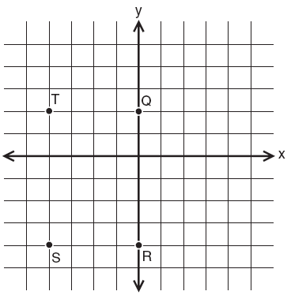

(1) Q (3) S
(2) R (4) T

In the accompanying diagram, which transformation changes the solid-line parabola to the dotted-line parabola?

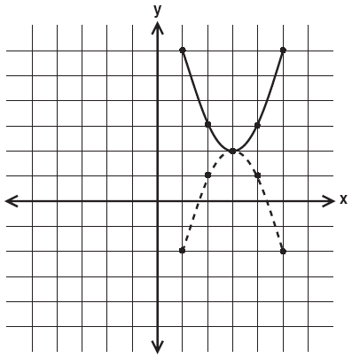

(1) translation (3) rotation, only
(2) line reflection, only (4) line reflection or rotation

How many times larger than x is 5x?
(1) 20 (3)
(2) 9 (4)

If the lengths of two sides of a triangle are 4 and 10, what could be the length of the third side?
(1) 6 (3) 14
(2) 8 (4) 16

Which piece of paper can be folded into a pyramid?
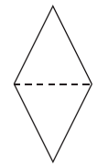  ( 1 ) | 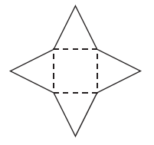  ( 3 )
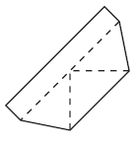  ( 2 ) | 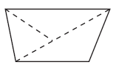  ( 4 )

What is the measure of the largest angle in the accompanying triangle?

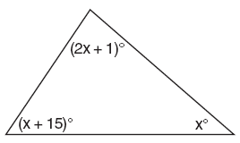

(1) 41 (3) 56
(2) 46.5 (4) 83

M is the midpoint of . If the coordinates of A are (–1,5) and the coordinates of M are (3,3), what are the coordinates of B?
(1) (1,4) (3) (7,1)
(2) (2,8) (4) (–5,7)

If 2m + 2p = 16, p equals
(1) 8 – m (3) 16 + 2m
(2) 16 – m (4) 9m

If 2x + 5 = –25 and –3m – 6 = 48, what is the product of x and m?
(1) –270 (3) 3
(2) –33 (4) 270

In the graph of , which quadrant is completely shaded?
(1) I (3) III
(2) II (4) IV

Part II

Answer all questions in this part. Each correct answer will receive 2 credits. Clearly indicate the necessary steps, including appropriate formula substitutions, diagrams, graphs, charts, etc. For all questions in this part, a correct numerical answer with no work shown will receive only 1 credit.

In the accompanying diagram ofBCD, ABC is an equilateral triangle and AD = AB. What is the value of x, in degrees?

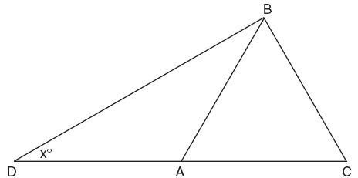

In the addition table for a subset of real numbers shown below, which number is the inverse of 3? Explain your answer.

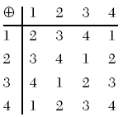

An image of a building in a photograph is 6 centimeters wide and 11 centimeters tall. If the image is similar to the actual building and the actual building is 174 meters wide, how tall is the actual building, in meters?

A doughnut shop charges $0.70 for each doughnut and $0.30 for a carryout box. Shirley has $5.00 to spend. At most, how many doughnuts can she buy if she also wants them in one carryout box?

In bowling leagues, some players are awarded extra points called their “handicap.” The “handicap” in Anthony’s league is 80% of the difference between 200 and the bowler’s average. Anthony’s average is 145. What is Anthony’s “handicap”?

Part III

Answer all questions in this part. Each correct answer will receive 3 credits. Clearly indicate the necessary steps, including appropriate formula substitutions, diagrams, graphs, charts, etc. For all questions in this part, a correct numerical answer with no work shown will receive only 1 credit.

In a telephone survey of 100 households, 32 households purchased Brand A cereal and 45 purchased Brand B cereal. If 10 households purchased both items, how many of the households surveyed did not purchase either Brand A or Brand B cereal?

Tamika could not remember her scores from five mathematics tests. She did remember that the mean (average) was exactly 80, the median was 81, and the mode was 88. If all her scores were integers with 100 the highest score possible and 0 the lowest score possible, what was the lowest score she could have received on any one test?

There are 28 students in a mathematics class. If of the students are called to the guidance office, of the remaining students are called to the nurse, and, finally, of those left go to the library, how many students remain in the classroom?

On a bookshelf, there are five different mystery books and six different biographies. How many different sets of four books can Emilio choose if two of the books must be mystery books and two of the books must be biographies?

On the accompanying grid, graph a circle whose center is at (0,0) and whose radius is 5. Determine if the point (5,–2) lies on the circle.



Part IV

Answer all questions in this part. Each correct answer will receive 4 credits. Clearly indicate the necessary steps, including appropriate formula substitutions, diagrams, graphs, charts, etc. For all questions in this part, a correct numerical answer with no work shown will receive only 1 credit.

In the accompanying diagram, x represents the length of a ladder that is leaning against a wall of a building, and y represents the distance from the foot of the ladder to the base of the wall. The ladder makes a 60° angle with the ground and reaches a point on the wall 17 feet above the ground. Find the number of feet in x and y.

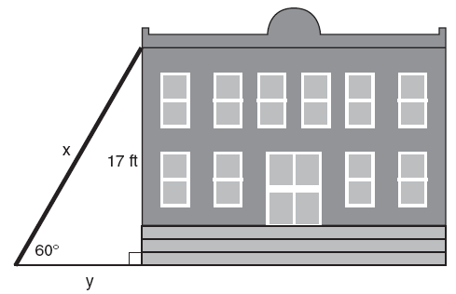

A rectangular park is three blocks longer than it is wide. The area of the park is 40 square blocks. If w represents the width, write an equation in terms of w for the area of the park. Find the length and the width of the park.

Tanisha and Rachel had lunch at the mall. Tanisha ordered three slices of pizza and two colas. Rachel ordered two slices of pizza and three colas. Tanisha’s bill was $6.00, and Rachel’s bill was $5.25. What was the price of one slice of pizza? What was the price of one cola?

Greg is in a car at the top of a roller-coaster ride. The distance, d, of the car from the ground as the car descends is determined by the equation , where t is the number of seconds it takes the car to travel down to each point on the ride. How many seconds will it take Greg to reach the ground?
For an algebraic solution show your work here.
For a graphic solution show your work here.

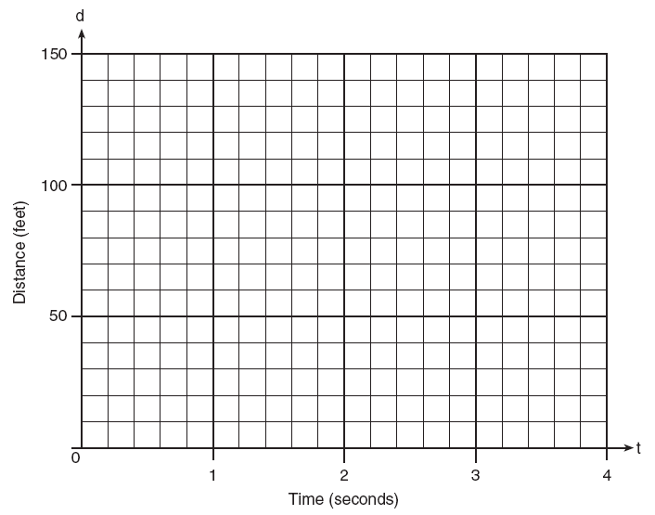

Determine the distance between point A(–1,–3) and point B(5,5). Write an equation of the perpendicular bisector of . [The use of the accompanying grid is optional.]



