Part I

Answer all questions in this part. Each correct answer will receive 2 credits. No partial credit will be allowed. For each question, write on the separate answer sheet the numeral preceding the word or expression that best completes the statement or answers the question.

The perimeter of an equilateral triangle varies directly as the length of a side. When the length of a side is doubled, the perimeter of the triangle is
(1) halved (3) multiplied by 3
(2) doubled (4) divided by 3

Which expression is rational?
(1) (3)
(2) (4)

Written in simplest factored form, the binomial can be expressed as
(1) 2(x – 5)(x – 5) (3) (x – 5)(x + 5)
(2) 2(x – 5)(x + 5) (4) 2x(x – 50)

Which statement is logically equivalent to “If I did not eat, then I am hungry”?
(1) If I am not hungry, then I did not eat.
(2) If I did not eat, then I am not hungry.
(3) If I am not hungry, then I did eat.
(4) If I am hungry, then I did eat.

In the accompanying diagram, a circle with radius 4 is inscribed in a square.

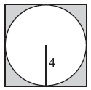

What is the area of the shaded region?
(1) 64 – 16π (3) 64π – 8π
(2) 16 – 16π (4) 16 – 8π

Which letter below has point symmetry, but does not have line symmetry?
(1) H (3) A
(2) N (4) E

The value of 5! is
(1) (3) 20
(2) 5 (4) 120

What is the approximate circumference of a circle with radius 3?
(1) 7.07
(2) 9.42
(3) 18.85
(4) 28.27

The sum of the measures of the interior angles of an octagon is
(1) 180° (3) 540°
(2) 360° (4) 1,080°

The exact average of a set of six test scores is 92. Five of these scores are 90, 98, 96, 94, and 85. What is the other test score?
(1) 92 (3) 89
(2) 91 (4) 86

A certain car comes in three body styles with a choice of two engines, a choice of two transmissions, and a choice of six colors. What is the minimum number of cars a dealer must stock to have one car of every possible combination?
(1) 13 (3) 42
(2) 36 (4) 72

The operation element @ is determined by the following table:

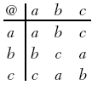

What is the identity element of this operation?
(1) a, only (3) c
(2) b, only (4) a and b

If n represents an odd number, which computation results in an answer that is an even number?
(1) 2 n + 1 (3) 3 n – 2
(2) 2 n – 1 (4) 3 n + 1

In his will, a man leaves one-half of his money to his wife, one-half of what is then left to his older child, and one-half of what is then left to his younger child. His two cousins divide the remainder equally, each receiving $2,000. What was the total amount of money in the man’s will?
(1) $40,000 (3) $24,000
(2) $32,000 (4) $16,000

If a + b is less than c + d, and d + e is less than a + b, then e is
(1) less than c (3) less than d
(2) equal to c (4) greater than d

Which statement is the converse of “If it is a 300 ZX, then it is a car”?
(1) If it is not a 300 ZX, then it is not a car.
(2) If it is not a car, then it is not a 300 ZX.
(3) If it is a car, then it is a 300 ZX.
(4) If it is a car, then it is not a 300 ZX.

In a class of 450 students, 300 are taking a mathematics course and 260 are taking a science course. If 140 of these students are taking both courses, how many students are not taking either of these courses?
(1) 30 (3) 110
(2) 40 (4) 140

What is the solution set of ?
(1) {5,–2} (3) {3,–10}
(2) {2,–5} (4) {3,10}

Which expression is equivalent to ?
(1) (3)
(2) (4)

What is the smallest integer greater than 1 that is both the square of an integer and the cube of an integer?
(1) 8 (3) 36
(2) 9 (4) 64

Part II

Answer all questions in this part. Each correct answer will receive 2 credits. Clearly indicate the necessary steps, including appropriate formula substitutions, diagrams, graphs, charts, etc. For all questions in this part, a correct numerical answer with no work shown will receive only 1 credit.

Triangle ABC, with side extended to D, is shown in the accompanying diagram. If mABC = 63 and mBCD = 92, what is mBAC?

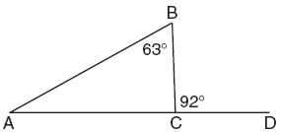

How many feet from the base of a house must a 39-foot ladder be placed so that the top of the ladder will reach a point on the house 36 feet from the ground?

Subtract from .

An engineer measured the dimensions for a rectangular site by using a wooden pole of unknown length x. The length of the rectangular site is 2 pole measures increased by 3 feet, while the width is 1 pole measure decreased by 4 feet. Write an algebraic representation, in terms of x, for the perimeter of the site.

Simplify:

Part III

Answer all questions in this part. Each correct answer will receive 3 credits. Clearly indicate the necessary steps, including appropriate formula substitutions, diagrams, graphs, charts, etc. For all questions in this part, a correct numerical answer with no work shown will receive only 1 credit.

Megan decides to go out to eat. The menu at the restaurant has four appetizers, three soups, seven entrees, and five desserts. If Megan decides to order an appetizer or a soup, and one entree, and two different desserts, how many different choices can she make?

There are four students, all of different heights, who are to be randomly arranged in a line. What is the probability that the tallest student will be first in line and the shortest student will be last in line?

On the accompanying set of axes, graph ABC with coordinates A(–1,2), B(0,6), and C(5,4). Then graph A′B′C′, the image of ABC after a dilation of 2.

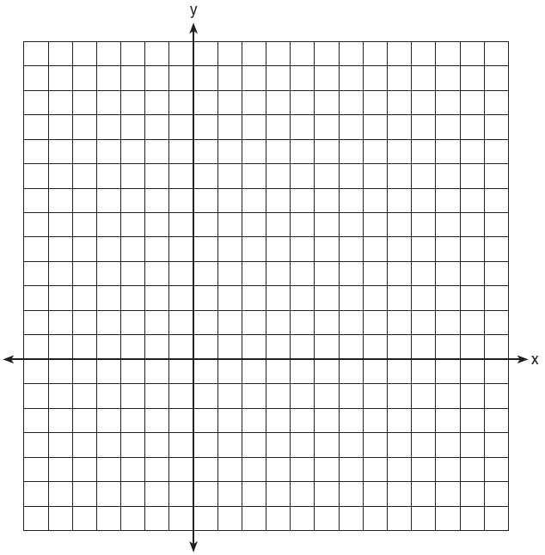

Ramón said that the set of integers is not closed for one of the basic operations (addition, subtraction, multiplication, or division). You want to show Ramón that his statement is correct.
For the operation for which the set of integers is not closed, write an example using:
• a positive even integer and a zero
• a positive and a negative even integer
• two negative even integers
Be sure to explain why each of your examples illustrates that the set of integers is not closed for that operation.

Shanaya graphed the line represented by the equation y = x – 6.
Write an equation for a line that is parallel to the given line.
Write an equation for a line that is perpendicular to the given line.
Write an equation for a line that is identical to the given line but has different coefficients.

Part IV

Answer all questions in this part. Each correct answer will receive 4 credits. Clearly indicate the necessary steps, including appropriate formula substitutions, diagrams, graphs, charts, etc. For all questions in this part, a correct numerical answer with no work shown will receive only 1 credit.

Point P is located on .
a Describe the locus of points that are
3 units from
5 units from point P
b How many points satisfy both conditions in part a?

The ninth graders at a high school are raising money by selling T-shirts and baseball caps. The number of T-shirts sold was three times the number of caps. The profit they received for each T-shirt sold was $5.00, and the profit on each cap was $2.50. If the students made a total profit of $210, how many T-shirts and how many caps were sold?

A ship on the ocean surface detects a sunken ship on the ocean floor at an angle of depression of 50°. The distance between the ship on the surface and the sunken ship on the ocean floor is 200 meters. If the ocean floor is level in this area, how far above the ocean floor, to the nearest meter, is the ship on the surface?

The following data consists of the weights, in pounds, of 30 adults:
195, 206, 100, 98, 150, 210, 195, 106, 195, 168, 180, 212, 104, 195, 100,
216, 195, 209, 112, 99, 206, 116, 195, 100, 142, 100, 135, 98, 160, 155
Using the data, complete the accompanying cumulative frequency table and construct a cumulative frequency histogram on the grid below.

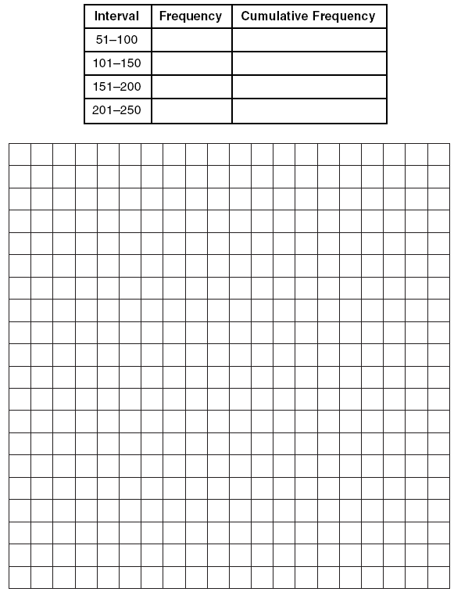

Solve the following system of equations algebraically.
y = + 4x – 2
y = 2x + 1

