Part I

Answer all questions in this part. Each correct answer will receive 2 credits. No partial credit will be allowed. For each question, write on the separate answer sheet the numeral preceding the word or expression that best completes the statement or answers the question.

A fair coin is thrown in the air four times. If the coin lands with the head up on the first three tosses, what is the probability that the coin will land with the head up on the fourth toss?
(1) 0 (3)
(2) (4)

The statement “If x is divisible by 8, then it is divisible by 6” is false if x equals
(1) 6 (3) 32
(2) 14 (4) 48

What is the image of point (2,5) under the translation that shifts (x,y) to $(x+3,y−2)?$
(1) (0,3) (3) (5,3)
(2) (0,8) (4) (5,8)

The sum of and can be expressed as
(1) (3)
(2) (4)

The direct distance between city A and city B is 200 miles. The direct distance between city B and city C is 300 miles. Which could be the direct distance between city C and city A?
(1) 50 miles (3) 550 miles
(2) 350 miles (4) 650 miles

Expressed as a single fraction, what is ?
(1) (3)
(2) (4)

How many different three-member teams can be formed from six students?
(1) 20 (3) 216
(2) 120 (4) 720

If x = –3 and y = 2, which point on the accompanying graph represents (–x,–y)?

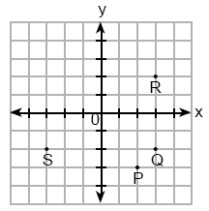

(1) P (3) R
(2) Q (4) S

The larger root of the equation (x + 4)(x – 3) = 0 is
(1) –4 (3) 3
(2) –3 (4) 4

Linda paid $48 for a jacket that was on sale for 25% of the original price. What was the original price of the jacket?
(1) $60 (3) $96
(2) $72 (4) $192

The expression $2^{3}⋅4^{2}$ is equivalent to
(1) (3)
(2) (4)

In the accompanying diagram of ABC, is extended to D, exterior angle CBD measures 145°, and m∠C = 75.

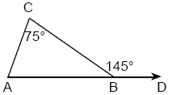

What is m∠CAB?
(1) 35 (3) 110
(2) 70 (4) 220

A total of $450 is divided into equal shares. If Kate receives four shares, Kevin receives three shares, and Anna receives the remaining two shares, how much money did Kevin receive?
(1) $100 (3) $200
(2) $150 (4) $250

What is the diameter of a circle whose circumference is 5?
(1) (3)
(2) (4)

During a recent winter, the ratio of deer to foxes was 7 to 3 in one county of New York State. If there were 210 foxes in the county, what was the number of deer in the county?
(1) 90 (3) 280
(2) 147 (4) 490

In the accompanying figure, ACDH and BCEF are rectangles, AH=2, GH=3, GF=4, and FE=5.

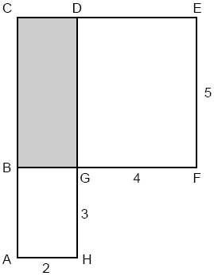

What is the area of BCDG?
(1) 6 (3) 10
(2) 8 (4) 20

If , then t could be
(1) (3)
(2) 0 (4) 4

What is the slope of line shown in the accompanying diagram?

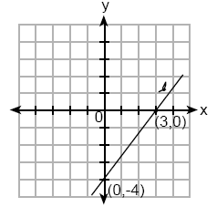

(1) (3)
(2) (4)

In a class of 50 students, 18 take music, 26 take art, and 2 take both art and music. How many students in the class are not enrolled in either music or art?
(1) 6 (3) 16
(2) 8 (4) 24

The expression is equivalent to
(1) (3)
(2) (4)

Part II

Answer all questions in this part. Each correct answer will receive 2 credits. Clearly indicate the necessary steps, including appropriate formula substitutions, diagrams, graphs, charts, etc. For all questions in this part, a correct numerical answer with no work shown will receive only 1 credit.

Draw all the symmetry lines on the accompanying figure.

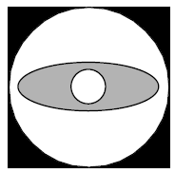

Shoe sizes and foot length are related by the formula S = 3F – 24, where S represents the shoe size and F represents the length of the foot, in inches.
a Solve the formula for F.
b To the nearest tenth of an inch, how long is the foot of a person who wears a size shoe?
Which number below is irrational?
Why is the number you chose an irrational number?

Simplify:

Sara’s telephone service costs $21 per month plus $0.25 for each local call, and long-distance calls are extra. Last month, Sara’s bill was $36.64, and it included $6.14 in long-distance charges. How many local calls did she make?

Part III

Answer all questions in this part. Each correct answer will receive 3 credits. Clearly indicate the necessary steps, including appropriate formula substitutions, diagrams, graphs, charts, etc. For all questions in this part, a correct numerical answer with no work shown will receive only 1 credit.

During a 45-minute lunch period, Albert (A) went running and Bill (B) walked for exercise. Their times and distances are shown in the accompanying graph. How much faster was Albert running than Bill was walking, in miles per hour?

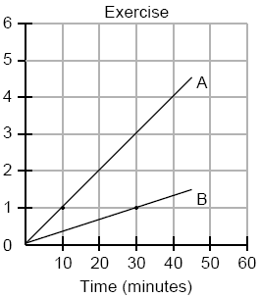

The dimensions of a brick, in inches, are 2 by 4 by 8. How many such bricks are needed to have a total volume of exactly 1 cubic foot?

A swimmer plans to swim at least 100 laps during a 6-day period. During this period, the swimmer will increase the number of laps completed each day by one lap. What is the least number of laps the swimmer must complete on the first day?

The mean (average) weight of three dogs is 38 pounds. One of the dogs, Sparky, weighs 46 pounds. The other two dogs, Eddie and Sandy, have the same weight. Find Eddie’s weight.

In the accompanying diagram, ABC and ABD are isosceles triangles with m∠CAB=50 and m∠BDA=55. If AB=AC and AB=BD, what is m∠CBD?

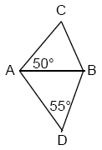

Part IV

Answer all questions in this part. Each correct answer will receive 4 credits. Clearly indicate the necessary steps, including appropriate formula substitutions, diagrams, graphs, charts, etc. For all questions in this part, a correct numerical answer with no work shown will receive only 1 credit.

A target shown in the accompanying diagram consists of three circles with the same center. The radii of the circles have lengths of 3 inches, 7 inches, and 9 inches.

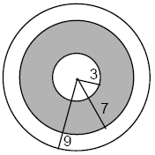

a What is the area of the shaded region to the nearest tenth of a square inch?
b To the nearest percent, what percent of the target is shaded?

A bookshelf contains six mysteries and three biographies. Two books are selected at random without replacement.
a What is the probability that both books are mysteries?
b What is the probability that one book is a mystery and the other is a biography?

The cross section of an attic is in the shape of an isosceles trapezoid, as shown in the accompanying figure. If the height of the attic is 9 feet, BC = 12 feet, and AD = 28 feet, find the length of to the nearest foot.

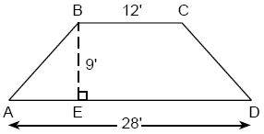

Joe is holding his kite string 3 feet above the ground, as shown in the accompanying diagram. The distance between his hand and a point directly under the kite is 95 feet. If the angle of elevation to the kite is 50°, find the height, h, of his kite, to the nearest foot.

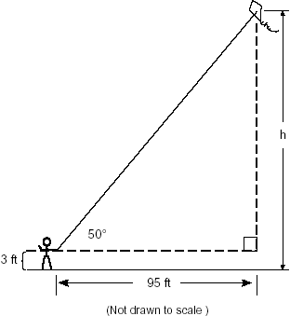

Solve the following system of equations algebraically or graphically for x and y:
For an algebraic solution, show your work here.
For a graphic solution, show your work here.



