Part I

Answer all questions in this part. Each correct answer will receive 2 credits. No partial credit will be allowed. For each question, write on the separate answer sheet the numeral preceding the word or expression that best completes the statement or answers the question.

Jeremy's bedroom has two doors leading into the hallway. His house has four doors leading to the outside. Using the doorways, in how many different ways can Jeremy leave his room and go outside?
(1) 8 (3) 5
(2) 6 (4) 4

The amount of time, t, in seconds, it takes an object to fall a distance, d, in meters, is expressed by the formula Approximately how long will it take an object to fall 75 meters?
(1) 0.26 sec (3) 3.9 sec
(2) 2.34 sec (4) 7.7 sec

Which equation illustrates the distributive property?
(1) 5(a + b) = 5a + 5b (3) a + (b + c) = (a + b) + c
(2) a + b = b + a (4) a + 0 = a

The mass of an orchid seed is approximately 0.0000035 gram. Written in scientific notation, that mass is equivalent to What is the value of n?
(1) -8 (3) -6
(2) -7 (4) -5

A cake recipe calls for 1.5 cups of milk and 3 cups of flour. Seth made a mistake and used 5 cups of flour. How many cups of milk should he use to keep the proportions correct?
(1) 1.75 (3) 2.25
(2) 2 (4) 2.5

When is divided by the result is
(1) (3)
(2) (4)

The accompanying diagram shows the graphs of a linear equation and a quadratic equation.

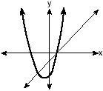

How many solutions are there to this system of equations?
(1) l (3) 3
(2) 2 (4) 0

A picture held by a magnet to a refrigerator slides to the bottom of the refrigerator, as shown in the accompanying diagram.

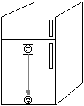

This change of position is an example of a
(1) translation (3) rotation
(2) dilation (4) reflection

Jorge made the accompanying stem-and-leaf plot of the weights, in pounds, of each member of the wrestling team he was coaching.

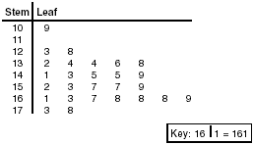

What is the mode of the weights?
(1) 145 (3) 152
(2) 150 (4) 168

Tina wants to sew a piece of fabric into a scarf in the shape of an isosceles triangle, as shown in the accompanying diagram.

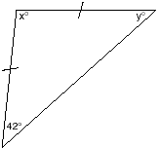

What are the values of x and y?
(1) x = 42 and y = 96 (3) x = 90 and y = 48
(2) x = 69 and y = 69 (4) x = 96 and y = 42

The expression $(x^{2}−5x−2)−(−6x^{2}−7x−3)$ is equivalent to
(1) (3)
(2) (4)

The expression is equivalent to
(1) (3)
(2) (4)

If then x is equivalent to
(1) (3)
(2) (4)

What is the solution set of the equation
(1) {-7,4} (3) {3,4}
(2) {-7,-4} (4) {-3,-4}

Which set could not represent the lengths of the sides of a triangle?
(1) {3,4,5} (3) {5,10,12}
(2) {2,5,9} (4) {7,9,11}

The accompanying figure represents a section of bathroom floor tiles shaped like regular hexagons.

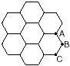

What is the measure of angle ABC?
(1) 60° (3) 120°
(2) 90° (4) 150°

The statement "If x is prime, then it is odd" is false when x equals
(1) 1 (3) 3
(2) 2 (4) 4

If then $\frac{(x^{2})^{3}}{x^{5}}⋅\text{1000}$ is equivalent to
(1) (3)
(2) (4)

If and the value of y is
(1) (3)
(2) (4)

What is the converse of the statement "If it is Sunday, then I do not go to school"?
(1) If I do not go to school, then it is Sunday.
(2) If it is not Sunday, then I do not go to school.
(3) If I go to school, then it is not Sunday.
(4) If it is not Sunday, then I go to school.

If point (-1,0) is on the line whose equation is y = 2x + b, what is the value of b?
(1) 1 (3) 3
(2) 2 (4) 0

If r = 2 and s = -7, what is the value of
(1) 5 (3) 9
(2) -5 (4) -9

Which graph represents the equation x = 2?

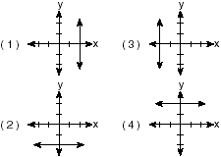

On a scale drawing of a new school playground, a triangular area has sides with lengths of 8 centimeters, 15 centimeters, and 17 centimeters. If the triangular area located on the playground has a perimeter of 120 meters, what is the length of its longest side?
(1) 24 m (3) 45 m
(2) 40 m (4) 51 m

If a and b are both odd integers, which expression must always equal an odd integer?
(1) (3) $a⋅b$
(2) (4)

Which quadrilateral must have diagonals that are congruent and perpendicular?
(1) rhombus (3) trapezoid
(2) square (4) parallelogram

The length of a side of a square window in Jessica's bedroom is represented by Which expression represents the area of the window?
(1) (3)
(2) (4)

Which equation represents a line that is perpendicular to the line whose equation is
(1) (3)
(2) (4)

The probability that the Cubs win their first game is . The probability that the Cubs win their second game is . What is the probability that the Cubs win both games?
(1) (2)
(3) (4)

A storage container in the shape of a right circular cylinder is shown in the accompanying diagram.

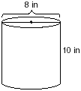

What is the volume of this container, to the nearest hundredth?
(1) (3)
(2) (4)

Part II

Answer all questions in this part. Each correct answer will receive 2 credits. Clearly indicate the necessary steps, including appropriate formula substitutions, diagrams, graphs, charts, etc. For all questions in this part, a correct numerical answer with no work shown will receive only 1 credit.

A ribbon 56 centimeters long is cut into two pieces. One of the pieces is three times longer than the other. Find the lengths, in centimeters, of both pieces of ribbon.

The manufacturer of Ron's car recommends that the tire pressure be at least 26 pounds per square inch and less than 35 pounds per square inch. On the accompanying number line, graph the inequality that represents the recommended tire pressure.

In a survey of 400 teenage shoppers at a large mall, 240 said they shopped at Abernathy's, 210 said they shopped at Bongo Republic, and 90 said they shopped at both stores. How many of the teenage shoppers surveyed did not shop at either store?

An algebra class of 21 students must send 5 students to meet with the principal. How many different groups of 5 students could be formed from this class?

Factor completely: $3x^{2}+\text{15}x−\text{42}$

Part III

Answer all questions in this part. Each correct answer will receive 3 credits. Clearly indicate the necessary steps, including appropriate formula substitutions, diagrams, graphs, charts, etc. For all questions in this part, a correct numerical answer with no work shown will receive only 1 credit.

Mr. James wanted to plant a garden that would be in the shape of a rectangle. He was given 80 feet of fencing to enclose his garden. He wants the length to be 10 feet more than twice the width. What are the dimensions, in feet, for a rectangular garden that will use exactly 80 feet of fencing?

On the accompanying set of axes, draw the reflection of ABCD in the y-axis. Label and state the coordinates of the reflected figure.

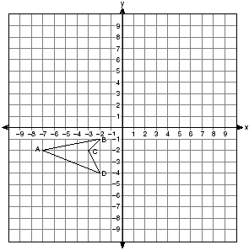

Part IV

Answer all questions in this part. Each correct answer will receive 4 credits. Clearly indicate the necessary steps, including appropriate formula substitutions, diagrams, graphs, charts, etc. For all questions in this part, a correct numerical answer with no work shown will receive only 1 credit.

In a class of 24 students, 10 have brown hair, 8 have black hair, 4 have blond hair, and 2 have red hair. On the accompanying diagram, construct a circle graph to show the students' hair color.

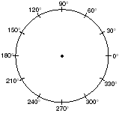

The accompanying diagram shows a flagpole that stands on level ground. Two cables, r and s, are attached to the pole at a point 16 feet above the ground. The combined length of the two cables is 50 feet. If cable r is attached to the ground 12 feet from the base of the pole, what is the measure of the angle, x, to the nearest degree, that cable s makes with the ground?

