Part I

Answer all questions in this part. Each correct answer will receive 2 credits. No partial credit will be allowed. For each question, write on the separate answer sheet the numeral preceding the word or expression that best completes the statement or answers the question.

The test scores for 10 students in Ms. Sampson’s homeroom were 61, 67, 81, 83, 87, 88, 89, 90, 98, and 100. Which frequency table is accurate for this set of data?

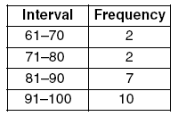  (1) | 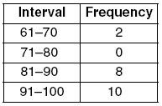  (3)
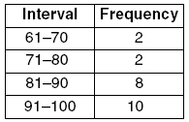  (2) | 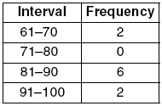  (4)

What is the image of (x,y) after a translation of 3 units right and 7 units down?
(1) (x + 3, y – 7) (3) (x – 3, y – 7)
(2) (x + 3, y + 7) (4) (x – 3, y + 7)

How many different outfits consisting of a hat, a pair of slacks, and a sweater can be made from two hats, three pairs of slacks, and four sweaters?
(1) 9 (3) 24
(2) 12 (4) 29

If 3(x – 2) = 2x + 6, the value of x is
(1) 0 (3) 12
(2) 5 (4) 20

Which statement is logically equivalent to “If a triangle is an isosceles triangle, then it has two congruent sides”?
(1) If a triangle does not have two congruent sides, then it is an isosceles triangle.
(2) If a triangle does not have two congruent sides, then it is not an isosceles triangle.
(3) If a triangle is not an isosceles triangle, then it has two congruent sides.
(4) If a triangle is an isosceles triangle, then it does not have two congruent sides.

Parking charges at Superior Parking Garage are $5.00 for the first hour and $1.50 for each additional 30 minutes. If Margo has $12.50, what is the maximum amount of time she will be able to park her car at the garage?
(1) hours (3) 6 hours
(2) hours (4) hours

If the temperature in Buffalo is 23° Fahrenheit, what is the temperature in degrees Celsius? [Use the formula.]
(1) –5 (3) –45
(2) 5 (4) 45

Tara buys two items that cost d dollars each. She gives the cashier $20. Which expression represents the change she should receive?
(1) 20 – 2d (3) 20 + 2d
(2) 20 – d (4) 2d – 20

At the beginning of her mathematics class, Mrs. Reno gives a warm-up problem. She says, “I am thinking of a number such that 6 less than the product of 7 and this number is 85.” Which number is she thinking of?
(1) 11 (3) 84
(2) 13 (4) 637

Which type of transformation is illustrated in the accompanying diagram?

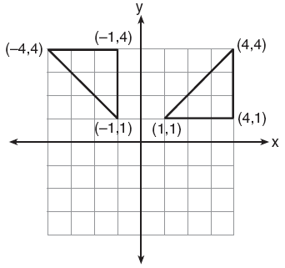

(1) dilation (3) translation
(2) reflection (4) rotation

Delroy’s sailboat has two sails that are similar triangles. The larger sail has sides of 10 feet, 24 feet, and 26 feet. If the shortest side of the smaller sail measures 6 feet, what is the perimeter of the smaller sail?
(1) 15 ft (3) 60 ft
(2) 36 ft (4) 100 ft

What is the least common denominator of ?
(1) 9x (3) 14x
(2) 2x (4)

Which property of real numbers is illustrated by the equation ?
(1) additive identity
(2) commutative property of addition
(3) associative property of addition
(4) additive inverse

The ratio of two supplementary angles is 2:7. What is the measure of the smaller angle?
(1) 10° (3) 20°
(2) 14° (4) 40°

Mary chooses an integer at random from 1 to 6. What is the probability that the integer she chooses is a prime number?
(1) (3)
(2) (4)

The statement “x is not the square of an integer and x is a multiple of 3” is true when x is equal to
(1) 9 (3) 32
(2) 18 (4) 36

Which phrase does not describe a triangle?
(1) acute scalene
(2) isosceles right
(3) equilateral equiangular
(4) obtuse right

The number of people on the school board is represented by x. Two subcommittees with an equal number of members are formed, one with x – 5 members and the other with members. How many people are on the school board?
(1) 20 (3) 8
(2) 12 (4) 4

The angle of elevation from a point 25 feet from the base of a tree on level ground to the top of the tree is 30°. Which equation can be used to find the height of the tree?
(1) tan 30° = (3) sin 30° =
(2) cos 30° = (4)

Rashawn bought a CD that cost $18.99 and paid $20.51, including sales tax. What was the rate of the sales tax?
(1) 5% (3) 3%
(2) 2% (4) 8%

If 3x is one factor of , what is the other factor?
(1) 3x (3) x – 3
(2) (4) x + 3

The accompanying circle graph shows how the Marino family spends its income each month.

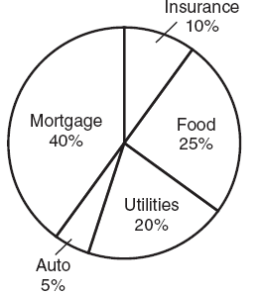

What is the measure, in degrees, of the central angle that represents the percentage of income spent on food?
(1) 25 (3) 90
(2) 50 (4) 360

Melissa is walking around the outside of a building that is in the shape of a regular polygon. She determines that the measure of one exterior angle of the building is 60°. How many sides does the building have?
(1) 6 (3) 3
(2) 9 (4) 12

Which expression is an example of the associative property?
(1) (x + y) + z = x + (y + z)
(2) x + y + z = z + y + x
(3) x(y + z) = xy + xz
(4) x • 1 = x

A farmer has a rectangular field that measures 100 feet by 150 feet. He plans to increase the area of the field by 20%. He will do this by increasing the length and width by the same amount, x. Which equation represents the area of the new field?
(1) (100 + 2x)(150 + x) = 18,000
(2) 2(100 + x) + 2(150 + x) = 15,000
(3) (100 + x)(150 + x) = 18,000
(4) (100 + x)(150 + x) = 15,000

In a game, each player receives 5 cards from a deck of 52 different cards. How many different groupings of cards are possible in this game?
(1) 52P5 (3)
(2) 52C5 (4) 5!

A box in the shape of a cube has a volume of 64 cubic inches. What is the length of a side of the box?
(1) in (3) 8 in
(2) 16 in (4) 4 in

The line 3x – 2y = 12 has
(1) a slope of and a y-intercept of –6
(2) a slope of – and a y-intercept of 6
(3) a slope of 3 and a y-intercept of –2
(4) a slope of –3 and a y-intercept of –6

If the mass of a proton is gram, what is the mass of 1,000 protons?
(1) (3)
(2) (4)

If (x – 4) is a factor of , then the value of w is
(1) 12 (3) 3
(2) –12 (4) –3

Part II

Answer all questions in this part. Each correct answer will receive 2 credits. Clearly indicate the necessary steps, including appropriate formula substitutions, diagrams, graphs, charts, etc. For all questions in this part, a correct numerical answer with no work shown will receive only 1 credit.

In the accompanying diagram of BCD, mC = 70, mCDE = 130, and side is extended to A and to E. Find mCBA.

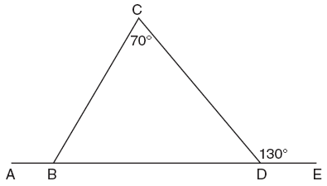

Brett was given the problem: “Evaluate when x = 3.” Brett wrote that the answer was 41. Was Brett correct? Explain your answer.

Kyoko’s mathematics teacher gave her the accompanying cards and asked her to arrange the cards in order from least to greatest. In what order should Kyoko arrange the cards?

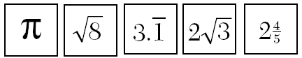

The coordinates of the midpoint of are (2,4), and the coordinates of point B are (3,7). What are the coordinates of point A? [The use of the accompanying grid is optional.]



Using only a compass and a straightedge, construct the perpendicular bisector of and label it c. [Leave all construction marks.]
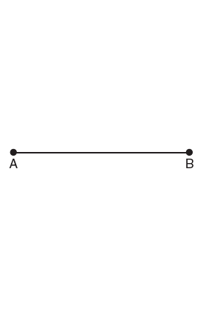

Part III

Answer all questions in this part. Each correct answer will receive 3 credits. Clearly indicate the necessary steps, including appropriate formula substitutions, diagrams, graphs, charts, etc. For all questions in this part, a correct numerical answer with no work shown will receive only 1 credit.

The senior class at South High School consists of 250 students. Of these students, 130 have brown hair, 160 have brown eyes, and 90 have both brown hair and brown eyes. How many members of the senior class have neither brown hair nor brown eyes?

Express both the perimeter and the area of the rectangle shown in the accompanying diagram as polynomials in simplest form.

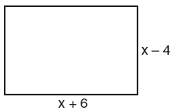

Part IV

Answer all questions in this part. Each correct answer will receive 4 credits. Clearly indicate the necessary steps, including appropriate formula substitutions, diagrams, graphs, charts, etc. For all questions in this part, a correct numerical answer with no work shown will receive only 1 credit.

On the first six tests in her social studies course, Jerelyn’s scores were 92, 78, 86, 92, 95, and 91. Determine the median and the mode of her scores. If Jerelyn took a seventh test and raised the mean of her scores exactly 1 point, what was her score on the seventh test?

Solve the following system of equations algebraically or graphically:
3y – 4x = 0
[The use of the accompanying grid is optional.]

