Part I

Answer all questions in this part. Each correct answer will receive 2 credits. No partial credit will be allowed. For each question, write on the separate answer sheet the numeral preceding the word or expression that best completes the statement or answers the question.

The number is equivalent to
(1) 0.0008375 (3) 0.08375
(2) 0.008375 (4) 8,375

The accompanying diagram shows a square with side y inside a square with side x.

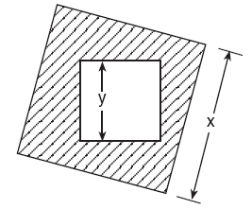

Which expression represents the area of the shaded region?
(1) (3)
(2) (4)

Which expression represents an irrational number?
(1) (3) 0.17
(2) (4) 0

Which shape does not have rotational symmetry?
(1) trapezoid (3) circle
(2) regular pentagon (4) square

Bob and Laquisha have volunteered to serve on the Junior Prom Committee. The names of twenty volunteers, including Bob and Laquisha, are put into a bowl. If two names are randomly drawn from the bowl without replacement, what is the probability that Bob’s name will be drawn first and Laquisha’s name will be drawn second?
(1) (3)
(2) (4)

Tori computes the value of $8⋅\text{95}$ in her head by thinking . Which number property is she using?
(1) associative (3) commutative
(2) distributive (4) closure

A triangle has sides whose lengths are 5, 12, and 13. A similar triangle could have sides with lengths of
(1) 3, 4, and 5 (3) 7, 24, and 25
(2) 6, 8, and 10 (4) 10, 24, and 26

Which statement is logically equivalent to “If it is Saturday, then I am not in school”?
(1) If I am not in school, then it is Saturday.
(2) If it is not Saturday, then I am in school.
(3) If I am in school, then it is not Saturday.
(4) If it is Saturday, then I am in school.

A translation moves P(3,5) to (6,1). What are the coordinates of the image of point (–3,–5) under the same translation?
(1) (0,–9) (3) (–6,–1)
(2) (–5,–3) (4) (–6,–9)

If x + y = 9x + y, then x is equal to
(1) y (3) 0
(2) (4) 8

Which number is in the solution set of the inequality 5x + 3 > 38?
(1) 5 (3) 7
(2) 6 (4) 8

The expression $3^{2}⋅3^{3}⋅3^{4}$is equivalent to
(1) (3)
(2) (4)

What is the solution set of the equation?
(1) {–3,8} (3) {3,8}
(2) {–3,–8} (4) {3,–8}

If the expression is evaluated, what would be done last?
(1) subtracting (3) adding
(2) squaring (4) dividing

What is the additive inverse of ?
(1) (3)
(2) (4)

The sum of and is
(1) (3)
(2) (4)

What is the inverse of the statement “If Julie works hard, then she succeeds”?
(1) If Julie succeeds, then she works hard.
(2) If Julie does not succeed, then she does not work hard.
(3) If Julie works hard, then she does not succeed.
(4) If Julie does not work hard, then she does not succeed.

If one factor of is, what is the other factor?
(1) (3)
(2) (4)

For which value of x is the expression undefined?
(1) 0 (3) –4
(2) 2 (4) 4

How many different five-member teams can be made from a group of eight students, if each student has an equal chance of being chosen?
(1) 40 (3) 336
(2) 56 (4) 6,720

Part II

Answer all questions in this part. Each correct answer will receive 2 credits. Clearly indicate the necessary steps, including appropriate formula substitutions, diagrams, graphs, charts, etc. For all questions in this part, a correct numerical answer with no work shown will receive only 1 credit.

The student scores on Mrs. Frederick’s mathematics test are shown on the stem-and-leaf plot below.

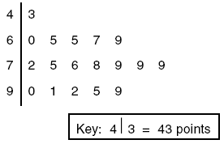

Find the median of these scores.

The lengths of the sides of two similar rectangular billboards are in the ratio 5:4. If 250 square feet of material is needed to cover the larger billboard, how much material, in square feet, is needed to cover the smaller billboard?

Solve for m: 0.6m + 3 = 2m + 0.2

In the accompanying diagram, line m is parallel to line p, line t is a transversal, ma = 3x + 12, and mb = 2x + 13. Find the value of x.

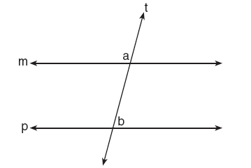

On the accompanying diagram of ABC, use a compass and a straightedge to construct a median from A to .

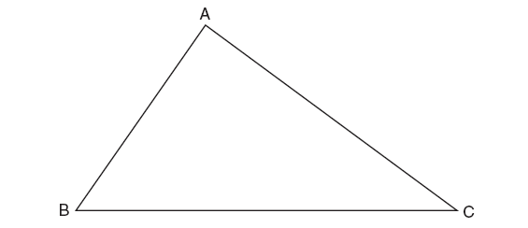

Part III

Answer all questions in this part. Each correct answer will receive 3 credits. Clearly indicate the necessary steps, including appropriate formula substitutions, diagrams, graphs, charts, etc. For all questions in this part, a correct numerical answer with no work shown will receive only 1 credit.

Seth has one less than twice the number of compact discs (CDs) that Jason has. Raoul has 53 more CDs than Jason has. If Seth gives Jason 25 CDs, Seth and Jason will have the same number of CDs. How many CDs did each of the three boys have to begin with?

Tina’s preschool has a set of cardboard building blocks, each of which measures 9 inches by 9 inches by 4 inches. How many of these blocks will Tina need to build a wall 4 inches thick, 3 feet high, and 12 feet long?

In a town election, candidates A and B were running for mayor. There were 30,500 people eligible to vote, and of them actually voted. Candidate B received of the votes cast. How many people voted for candidate B? What percent of the votes cast, to the nearest tenth of a percent, did candidate A receive?

A certain state is considering changing the arrangement of letters and numbers on its license plates. The two options the state is considering are:
Option 1: three letters followed by a four-digit number with repetition of both letters and digits allowed
Option 2: four letters followed by a three-digit number without repetition of either letters or digits
[Zero may be chosen as the first digit of the number in either option.]
Which option will enable the state to issue more license plates? How many more different license plates will that option yield?

To get from his high school to his home, Jamal travels 5.0 miles east and then 4.0 miles north. When Sheila goes to her home from the same high school, she travels 8.0 miles east and 2.0 miles south. What is the measure of the shortest distance, to the nearest tenth of a mile, between Jamal’s home and Sheila’s home? [The use of the accompanying grid is optional.]

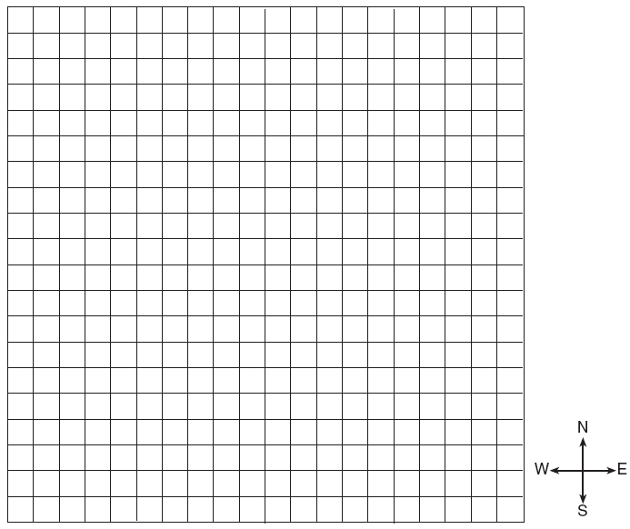

Part IV

Answer all questions in this part. Each correct answer will receive 4 credits. Clearly indicate the necessary steps, including appropriate formula substitutions, diagrams, graphs, charts, etc. For all questions in this part, a correct numerical answer with no work shown will receive only 1 credit.

Deborah built a box by cutting 3-inch squares from the corners of a rectangular sheet of cardboard, as shown in the accompanying diagram, and then folding the sides up. The volume of the box is 150 cubic inches, and the longer side of the box is 5 inches more than the shorter side. Find the number of inches in the shorter side of the original sheet of cardboard.

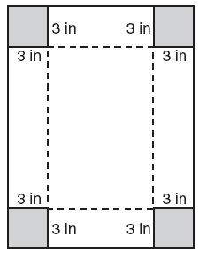

A triangular park is formed by the intersection of three streets, Bridge Street, Harbor Place, and College Avenue, as shown in the accompanying diagram. A walkway parallel to Harbor Place goes through the park. A time capsule has been buried in the park in a location that is equidistant from Bridge Street and College Avenue and 5 yards from the walkway. Indicate on the diagram with an X each possible location where the time capsule could be buried.

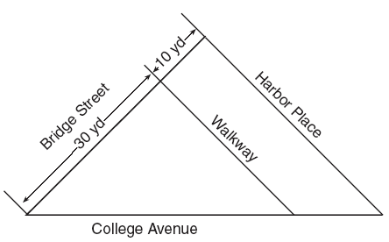

An architect is designing a museum entranceway in the shape of a parabolic arch represented by the equation, where and all dimensions are expressed in feet. On the accompanying set of axes, sketch a graph of the arch and determine its maximum height, in feet.

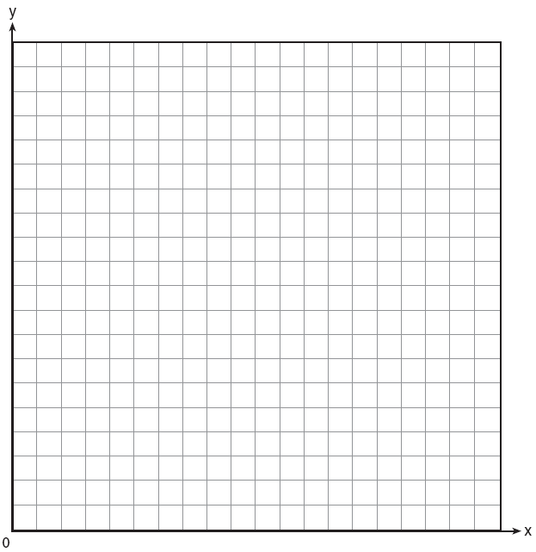

A straw is placed into a rectangular box that is 3 inches by 4 inches by 8 inches, as shown in the accompanying diagram. If the straw fits exactly into the box diagonally from the bottom left front corner to the top right back corner, how long is the straw, to the nearest tenth of an inch?

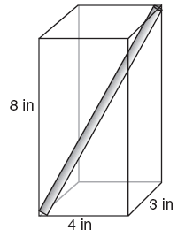

The senior class is sponsoring a dance. The cost of a student disk jockey is $40, and tickets sell for $2 each. Write a linear equation and, on the accompanying grid, graph the equation to represent the relationship between the number of tickets sold and the profit from the dance. Then find how many tickets must be sold to break even.



