Part I

Answer all questions in this part. Each correct answer will receive 2 credits. No partial credit will be allowed. For each question, write on the separate answer sheet the numeral preceding the word or expression that best completes the statement or answers the question.

Jamie is 5 years older than her sister Amy. If the sum of their ages is 19, how old is Jamie?
(1) 5 (3) 12
(2) 7 (4) 14

If the probability that it will rain on Thursday is , what is the probability that it will not rain on Thursday?
(1) 1 (3)
(2) 0 (4)

The accompanying diagram shows the results of a survey asking which sports the members of the Key Club watch on television.

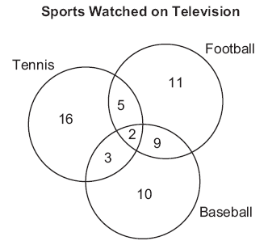

Which statement or statements are true?
I The most watched sport is tennis.
II The least watched sport is baseball.
III More Key Club members watch tennis than football.

(1) I, only (3) I and II, only
(2) II, only (4) II and III, only

During each marking period, there are five tests. If Vanita needs a 65 average to pass this marking period and her first four grades are 60, 72, 55, and 80, what is the lowest score she can earn on the last test to have a passing average?
(1) 58 (3) 80
(2) 65 (4) 100

What is the slope of the linear equation 5y – 10x = –15?
(1) 10 (3) –10
(2) 2 (4) –15

Which expression is a factor of ?
(1) n + 6 (3) n – 9
(2) (4) n + 9

If is divided by , the result is
(1) 1 (3)
(2) 0.01 (4)

Two triangles are similar. The lengths of the sides of the smaller triangle are 3, 5, and 6, and the length of the longest side of the larger triangle is 18. What is the perimeter of the larger triangle?
(1) 14 (3) 24
(2) 18 (4) 42

Which letter has point symmetry?
(1) A (3) H
(2) B (4) W

If two lines are parallel and the slope of one of the lines is m, what is the product of their slopes?
(1) 1 (3)
(2) 2m (4) 0

Which is an irrational number?
(1) 0 (3)
(2) (4)

If point P lies on line , which diagram represents the locus of points 3 centimeters from point P?

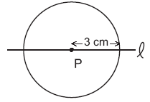  ( 1 ) | 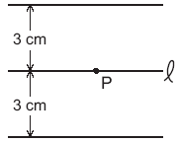  ( 3 )
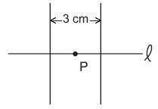  ( 2 ) | 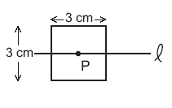  ( 4 )

What is the measure, in degrees, of each exterior angle of a regular hexagon?
(1) 45 (3) 120
(2) 60 (4) 135

What is the solution of the equation 3y – 5y + 10 = 36?
(1) –13 (3) 4.5
(2) 2 (4) 13

If the circumference of a circle is doubled, the diameter of the circle
(1) remains the same (3) is multiplied by 4
(2) increases by 2 (4) is doubled

In the accompanying diagram, ∆ABC is similar to but not congruent to ∆ A’B’C’.

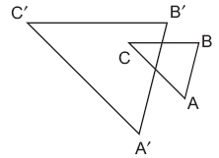

Which transformation is represented by ∆ A’B’C’?
(1) rotation (3) reflection
(2) translation (4) dilation

The expression 15 – 3[2 + 6(–3)] simplifies to
(1) –45 (3) 63
(2) –33 (4) 192

The expression $\sqrt{\text{90}}⋅\sqrt{\text{40}}−\sqrt{8}⋅\sqrt{\text{18}}$ simplifies to
(1) 22.9 (3) 864
(2) 48 (4) 3,456

If $x=2a−b^{2},$ then a equals
(1) (3)
(2) (4)

The accompanying diagram is an example of which type of graph?

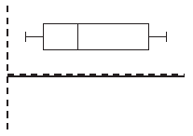

(1) bar graph (3) histogram
(2) stem-and-leaf plot (4) box-and-whisker plot

Part II

Answer all questions in this part. Each correct answer will receive 2 credits. Clearly indicate the necessary steps, including appropriate formula substitutions, diagrams, graphs, charts, etc. For all questions in this part, a correct numerical answer with no work shown will receive only 1 credit.

Given the true statement “John is not handsome” and the false statement “John is handsome or smart.” Determine the truth value for the statement “John is smart.”

Ninety percent of the ninth grade students at Richbartville High School take algebra. If 180 ninth grade students take algebra, how many ninth grade students do not take algebra?

If the instructions for cooking a turkey state “Roast turkey at 325° for 20 minutes per pound,” how many hours will it take to roast a 20-pound turkey at 325°?

An addition table for a subset of real numbers is shown below. Which number is the identity element? Explain your answer.

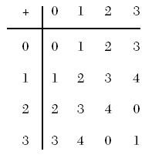

Write the equation for the line shown in the accompanying graph. Explain your answer.

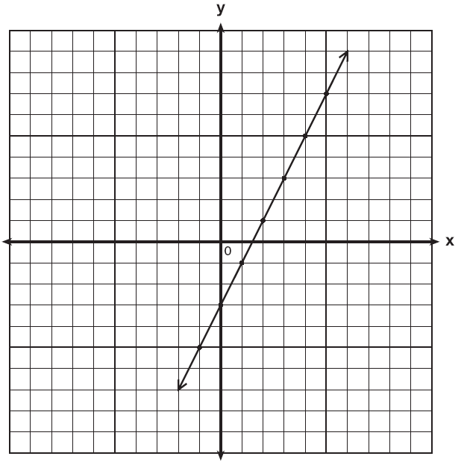

Part III

Answer all questions in this part. Each correct answer will receive 3 credits. Clearly indicate the necessary steps, including appropriate formula substitutions, diagrams, graphs, charts, etc. For all questions in this part, a correct numerical answer with no work shown will receive only 1 credit.

Two parallel roads, Elm Street and Oak Street, are crossed by a third, Walnut Street, as shown in the accompanying diagram. Find the number of degrees in the acute angle formed by the intersection of Walnut Street and Elm Street.

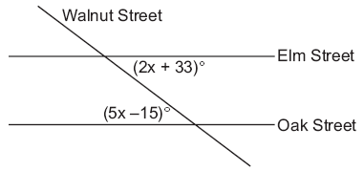

The plot of land illustrated in the accompanying diagram has a perimeter of 34 yards. Find the length, in yards, of each side of the figure. Could these measures actually represent the measures of the sides of a triangle? Explain your answer.

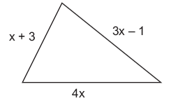

As shown in the accompanying diagram, radio station KMA is increasing its radio listening radius from 40 miles to 50 miles. How many additional square miles of listening area, to the nearest tenth, will the radio station gain?

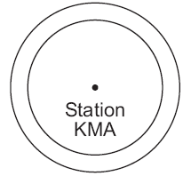

Solve for x:

In the accompanying diagram, triangle A is similar to triangle B. Find the value of n.

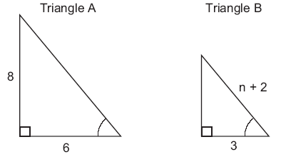

Part IV

Answer all questions in this part. Each correct answer will receive 4 credits. Clearly indicate the necessary steps, including appropriate formula substitutions, diagrams, graphs, charts, etc. For all questions in this part, a correct numerical answer with no work shown will receive only 1 credit.

As seen in the accompanying diagram, a person can travel from New York City to Buffalo by going north 170 miles to Albany and then west 280 miles to Buffalo.

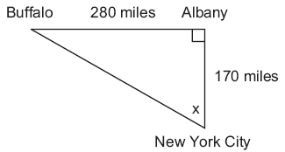

a If an engineer wants to design a highway to connect New York City directly to Buffalo, at what angle, x, would she need to build the highway? Find the angle to the nearest degree.
b To the nearest mile, how many miles would be saved by traveling directly from New York City to Buffalo rather than by traveling first to Albany and then to Buffalo?

At Ron’s Rental, a person can rent a big-screen television for $10 a month plus a one-time “wear-and-tear” fee of $100. At Josie’s Rental, the charge is $20 a month and an additional charge of $20 for delivery with no “wear-and-tear” fee.
a If c equals the cost, write one equation representing the cost of the rental for m months at Ron’s Rental and one equation representing the cost of the rental for m months at Josie’s Rental.
b On the accompanying grid, graph and label each equation.
c From your graph, determine in which month Josie’s cost will equal Ron’s cost.

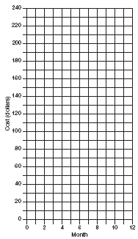

Mr. Perez owns a sneaker store. He bought 350 pairs of basketball sneakers and 150 pairs of soccer sneakers from the manufacturers for $62,500. He sold all the sneakers and made a 25% profit. If he sold the soccer sneakers for $130 per pair, how much did he charge for one pair of basketball sneakers?

Alexi’s wallet contains four $1 bills, three $5 bills, and one $10 bill. If Alexi randomly removes two bills without replacement, determine whether the probability that the bills will total $15 is greater than the probability that the bills will total $2.

A rocket is launched from the ground and follows a parabolic path represented by the equation . At the same time, a flare is launched from a height of 10 feet and follows a straight path represented by the equation y = –x + 10. Using the accompanying set of axes, graph the equations that represent the paths of the rocket and the flare, and find the coordinates of the point or points where the paths intersect.



