Part I

Answer all questions in this part. Each correct answer will receive 2 credits. No partial credit will be allowed. For each question, write on the separate answer sheet the numeral preceding the word or expression that best completes the statement or answers the question.

A car travels 110 miles in 2 hours. At the same rate of speed, how far will the car travel in h hours?
(1) 55h (3)
(2) 220h (4)

Which polynomial is the quotient of ?
(1) (3)
(2) (4)

If the length of a rectangular prism is doubled, its width is tripled, and its height remains the same, what is the volume of the new rectangular prism?
(1) double the original volume
(2) triple the original volume
(3) six times the original volume
(4) nine times the original volume

One root of the equation is
(1) (3) 3
(2) (4) –3

Which properties best describe the coordinate graph of two distinct parallel lines?
(1) same slopes and same intercepts
(2) same slopes and different intercepts
(3) different slopes and same intercepts
(4) different slopes and different intercepts

Which statement is not always true about a parallelogram?
(1) The diagonals are congruent.
(2) The opposite sides are congruent.
(3) The opposite angles are congruent.
(4) The opposite sides are parallel.

In isosceles triangle DOG, the measure of the vertex angle is three times the measure of one of the base angles. Which statement about DOG is true?
(1) DOG is a scalene triangle.
(2) DOG is an acute triangle.
(3) DOG is a right triangle.
(4) DOG is an obtuse triangle.

Which equation illustrates the distributive property for real numbers?
(1)
(2)
(3)
(4)

Factor completely:
(1) (3) 3(x + 3)(x – 3)
(2) (4) (3x + 3)(x – 9)

At a school costume party, seven girls wore masks and nine boys did not. If there were 15 boys at the party and 20 students did not wear masks, what was the total number of students at the party?
(1) 30 (3) 35
(2) 33 (4) 42

If one-half of a number is 8 less than two-thirds of the number, what is the number?
(1) 24 (3) 48
(2) 32 (4) 54

Which statement is logically equivalent to “If I eat, then I live”?
(1) If I live, then I eat.
(2) If I eat, then I do not live.
(3) I live if and only if I eat.
(4) If I do not live, then I do not eat.

If a is an odd number, b an even number, and c an odd number, which expression will always be equivalent to an odd number?
(1) a(bc) (3)
(2) (4)

If there are four teams in a league, how many games will have to be played so that each team plays every other team once?
(1) 6 (3) 3
(2) 8 (4) 16

A woman has a ladder that is 13 feet long. If she sets the base of the ladder on level ground 5 feet from the side of a house, how many feet above the ground will the top of the ladder be when it rests against the house?
(1) 8 (3) 11
(2) 9 (4) 12

A boy got 50% of the questions on a test correct. If he had 10 questions correct out of the first 12, and of the remaining questions correct, how many questions were on the test?
(1) 16 (3) 26
(2) 24 (4) 28

A hotel charges $20 for the use of its dining room and $2.50 a plate for each dinner. An association gives a dinner and charges $3 a plate but invites four nonpaying guests. If each person has one plate, how many paying persons must attend for the association to collect the exact amount needed to pay the hotel?
(1) 60 (3) 40
(2) 44 (4) 20

In the set of positive integers, what is the solution set of the inequality $2x−3<5?$
(1) {0,1,2,3} (3) {0,1,2,3,4}
(2) {1,2,3} (4) {1,2,3,4}
What is the total number of points of intersection in the graphs of the equations and y = 4?
(1) 1 (3) 3
(2) 2 (4) 0

Which is a rational number?
(1) (3)
(2) π (4)

Part II

Answer all questions in this part. Each correct answer will receive 2 credits. Clearly indicate the necessary steps, including appropriate formula substitutions, diagrams, graphs, charts, etc. For all questions in this part, a correct numerical answer with no work shown will receive only 1 credit.

A school district offers hockey and basketball. The result of a survey of 300 students showed:
120 students play hockey, only
90 students play basketball, only
30 students do not participate in either sport
Of those surveyed, how many students play both hockey and basketball?

In the accompanying diagram, parallel lines and are intersected by transversal at points X and Y, and mFYD = 123. Find mAXY.

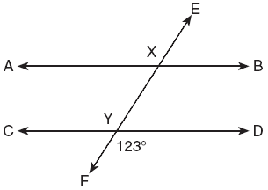

Ben had twice as many nickels as dimes. Altogether, Ben had $4.20. How many nickels and how many dimes did Ben have?

If a girl 1.2 meters tall casts a shadow 2 meters long, how many meters tall is a tree that casts a shadow 75 meters long at the same time?

There were seven students running in a race. How many different arrangements of first, second, and third place are possible?

Part III

Answer all questions in this part. Each correct answer will receive 3 credits. Clearly indicate the necessary steps, including appropriate formula substitutions, diagrams, graphs, charts, etc. For all questions in this part, a correct numerical answer with no work shown will receive only 1 credit.

In the accompanying diagram of parallelogram ABCD, mA = (2x + 10) and mB = 3x. Find the number of degrees in mB.

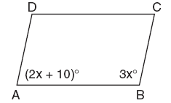

A factory packs CD cases into cartons for a music company. Each carton is designed to hold 1,152 CD cases. The Quality Control Unit in the factory expects an error of less than 5% over or under the desired packing number. What is the least number and the most number of CD cases that could be packed in a carton and still be acceptable to the Quality Control Unit?

Connor wants to compare Celsius and Fahrenheit temperatures by drawing a conversion graph. He knows that –40°C = –40°F and that 20°C = 68°F. On the accompanying grid, construct the conversion graph and, using the graph, determine the Celsius equivalent of 25°F.

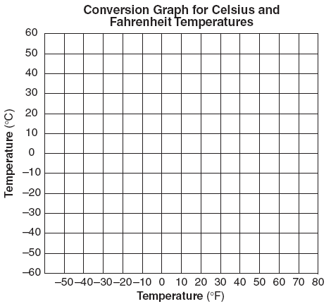

Virginia has a circular rug on her square living room floor, as represented in the accompanying diagram. If her entire living room floor measures 100 square feet, what is the area of the part of the floor covered by the rug?

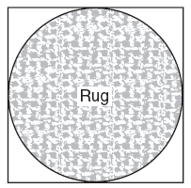

Mr. Yee has 10 boys and 15 girls in his mathematics class. If he chooses two students at random to work on the blackboard, what is the probability that both students chosen are girls?

Part IV

Answer all questions in this part. Each correct answer will receive 4 credits. Clearly indicate the necessary steps, including appropriate formula substitutions, diagrams, graphs, charts, etc. For all questions in this part, a correct numerical answer with no work shown will receive only 1 credit.

Find three consecutive odd integers such that the product of the first and the second exceeds the third by 8.

Keesha wants to tile the floor shown in the accompanying diagram. If each tile measures 1 foot by 1 foot and costs $2.99, what will be the total cost, including an 8% sales tax, for tiling the floor?

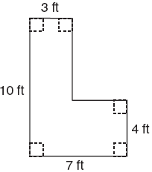

Ramón rented a sprayer and a generator. On his first job, he used each piece of equipment for 6 hours at a total cost of $90. On his second job, he used the sprayer for 4 hours and the generator for 8 hours at a total cost of $100. What was the hourly cost of each piece of equipment?

The plan of a parcel of land is represented by trapezoid ABCD in the accompanying diagram. If the area of ABE is 600 square feet, find the minimum number of feet of fence needed to completely enclose the entire parcel of land, ABCD.

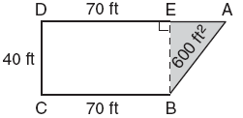

Triangle SUN has coordinates S(0,6), U(3,5), and N(3,0). On the accompanying grid, draw and label SUN. Then, graph and state the coordinates of S′U′N′, the image of SUN after a reflection in the y-axis.



