Part I

Answer all questions in this part. Each correct answer will receive 2 credits. No partial credit will be allowed. For each question, write on the separate answer sheet the numeral preceding the word or expression that best completes the statement or answers the question.

Which inequality is represented in the graph below?

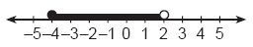

(1) –4 < x < 2 (3) –4 < x ≤ 2
(2) –4 ≤ x < 2 (4) –4 ≤ x ≤ 2

Which geometric figure has one and only one line of symmetry?

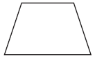  Isosceles trapezoid  ( 1 ) |   Square  ( 3 )
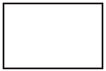  Rectangle  ( 2 ) | 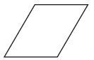  Rhombus  ( 4 )

Which number is rational?
(1) π (3)
(2) (4)

Two numbers are in the ratio 2:5. If 6 is subtracted from their sum, the result is 50. What is the larger number?
(1) 55 (3) 40
(2) 45 (4) 35

The quotient of $−\frac{\text{15}x^{8}}{5x^{2}}, x≠0,$ is
(1) (3)
(2) (4)

What is the inverse of the statement “If it is sunny, I will play baseball”?
(1) If I play baseball, then it is sunny.
(2) If it is not sunny, I will not play baseball.
(3) If I do not play baseball, then it is not sunny.
(4) I will play baseball if and only if it is sunny.

Which ordered pair is the solution of the following system of equations?
3x + 2y = 4
–2x + 2y = 24
(1) (2,–1) (3) (–4,8)
(2) (2,–5) (4) (–4,–8)

Which equation represents a circle whose center is (3,–2)?
(1)
(2)
(3)
(4)

The set of integers {3,4,5} is a Pythagorean triple. Another such set is
(1) {6,7,8} (3) {6,12,13}
(2) {6,8,12} (4) {8,15,17}

A truck travels 40 miles from point A to point B in exactly 1 hour. When the truck is halfway between point A and point B, a car starts from point A and travels at 50 miles per hour. How many miles has the car traveled when the truck reaches point B?
(1) 25 (3) 50
(2) 40 (4) 60

If and the sum of x and is 0, then
(1) x = a (3) x =
(2) x = –a (4) x = 1 – a

The accompanying figure shows the graph of the equation x = 5.

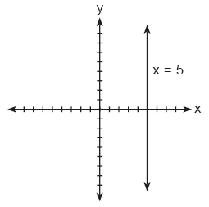

What is the slope of the line x = 5?
(1) 5 (3) 0
(2) –5 (4) undefined

Which transformation does not always produce an image that is congruent to the original figure?
(1) translation (3) rotation
(2) dilation (4) reflection

If rain is falling at the rate of 2 inches per hour, how many inches of rain will fall in x minutes?
(1) 2x (3)
(2) (4)

The expression is equivalent to
(1) (3)
(2) (4)

How many different five-digit numbers can be formed from the digits 1, 2, 3, 4, and 5 if each digit is used only once?
(1) 120 (3) 24
(2) 60 (4) 20

For five algebra examinations, Maria has an average of 88. What must she score on the sixth test to bring her average up to exactly 90?
(1) 92 (3) 98
(2) 94 (4) 100

The graphs of the equations and y + 3 = x are drawn on the same set of axes. At which point do the graphs intersect?
(1) (1,4) (3) (–2,1)
(2) (1,–2) (4) (–2,–5)

If is subtracted from , the difference is
(1) (3)
(2) (4)

What is the value of ?
(1) (3) 9
(2) (4) –9

Part II

Answer all questions in this part. Each correct answer will receive 2 credits. Clearly indicate the necessary steps, including appropriate formula substitutions, diagrams, graphs, charts, etc. For all questions in this part, a correct numerical answer with no work shown will receive only 1 credit.

The formula for changing Celsius (C) temperature to Fahrenheit (F) temperature is . Calculate, to the nearest degree, the Fahrenheit temperature when the Celsius temperature is –8.

Using only a ruler and compass, construct the bisector of angle BAC in the accompanying diagram.

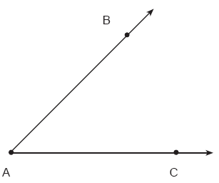

All seven-digit telephone numbers in a town begin with 245. How many telephone numbers may be assigned in the town if the last four digits do not begin or end in a zero?

The Rivera family bought a new tent for camping. Their old tent had equal sides of 10 feet and a floor width of 15 feet, as shown in the accompanying diagram.

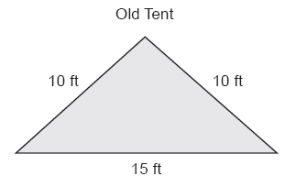

If the new tent is similar in shape to the old tent and has equal sides of 16 feet, how wide is the floor of the new tent?

The accompanying graph represents the yearly cost of playing 0 to 5 games of golf at the Shadybrook Golf Course. What is the total cost of joining the club and playing 10 games during the year?

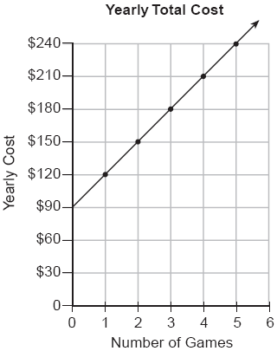

Part III

Answer all questions in this part. Each correct answer will receive 3 credits. Clearly indicate the necessary steps, including appropriate formula substitutions, diagrams, graphs, charts, etc. For all questions in this part, a correct numerical answer with no work shown will receive only 1 credit.

The accompanying Venn diagram shows the number of students who take various courses. All students in circle A take mathematics. All in circle B take science. All in circle C take technology. What percentage of the students take mathematics or technology?

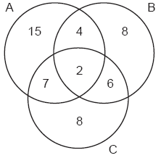

Hersch says if a triangle is an obtuse triangle, then it cannot also be an isosceles triangle. Using a diagram, show that Hersch is incorrect, and indicate the measures of all the angles and sides to justify your answer.

Tamika has a hard rubber ball whose circumference measures 13 inches. She wants to box it for a gift but can only find cube shaped boxes of sides 3 inches, 4 inches, 5 inches, or 6 inches. What is the smallest box that the ball will fit into with the top on?

The distance from Earth to the imaginary planet Med is miles. If a spaceship is capable of traveling 1,420 miles per hour, how many days will it take the spaceship to reach the planet Med? Round your answer to the nearest day.

A surveyor needs to determine the distance across the pond shown in the accompanying diagram. She determines that the distance from her position to point P on the south shore of the pond is 175 meters and the angle from her position to point X on the north shore is 32°. Determine the distance, PX, across the pond, rounded to the nearest meter.

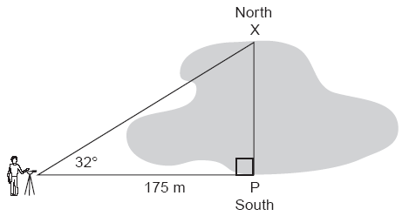

Part IV

Answer all questions in this part. Each correct answer will receive 4 credits. Clearly indicate the necessary steps, including appropriate formula substitutions, diagrams, graphs, charts, etc. For all questions in this part, a correct numerical answer with no work shown will receive only 1 credit.

The owner of a movie theater was counting the money from 1 day’s ticket sales. He knew that a total of 150 tickets were sold. Adult tickets cost $7.50 each and children’s tickets cost $4.75 each. If the total receipts for the day were $891.25, how many of each kind of ticket were sold?

A treasure map shows a treasure hidden in a park near a tree and a statue. The map indicates that the tree and the statue are 10 feet apart. The treasure is buried 7 feet from the base of the tree and also 5 feet from the base of the statue. How many places are possible locations for the treasure to be buried? Draw a diagram of the treasure map, and indicate with an X each possible location of the treasure.

The scores on a mathematics test were 70, 55, 61, 80, 85, 72, 65, 40, 74, 68, and 84. Complete the accompanying table, and use the table to construct a frequency histogram for these scores.

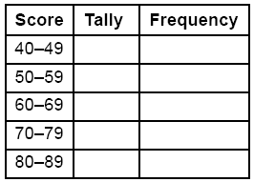



Paul orders a pizza. Chef Carl randomly chooses two different toppings to put on the pizza from the following: pepperoni, onion, sausage, mushrooms, and anchovies. If Paul will not eat pizza with mushrooms, determine the probability that Paul will not eat the pizza Chef Carl has made.

The area of the rectangular playground enclosure at South School is 500 square meters. The length of the playground is 5 meters longer than the width. Find the dimensions of the playground, in meters. [Only an algebraic solution will be accepted.]

