Part I

Answer all questions in this part. Each correct answer will receive 2 credits. No partial credit will be allowed. For each question, write on the separate answer sheet the numeral preceding the word or expression that best completes the statement or answers the question.

If 2(x + 3) = x + 10, then x equals
(1) 14 (3) 5
(2) 7 (4) 4

In the accompanying diagram, parallel lines and are intersected by transversal at points G and H, respectively, mAGH = x + 15, and mGHD = 2x.

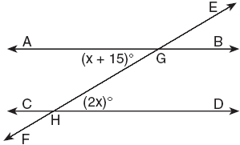

Which equation can be used to find the value of x?
(1) 2x = x + 15 (3) 2x + x + 15 = 90
(2) 2x + x + 15 = 180 (4) 2x(x + 15) = 0

On February 18, from 9 a.m. until 2 p.m., the temperature rose from –14°F to 36°F. What was the total increase in temperature during this time period?
(1) 50° (3) 32°
(2) 36° (4) 22°

Which statement about quadrilaterals is true?
(1) All quadrilaterals have four right angles.
(2) All quadrilaterals have equal sides.
(3) All quadrilaterals have four sides.
(4) All quadrilaterals are parallelograms.

In a school building, there are 10 doors that can be used to enter the building and 8 stairways to the second floor. How many different routes are there from outside the building to a class on the second floor?
(1) 1 (3) 18
(2) 10 (4) 80

What is the value of , if x = 4 and y = –3?
(1) –2 (3) 10
(2) 2 (4) 14

Given the true statements: “Jason goes shopping or he goes to the movies” and “Jason does not go to the movies.” Which statement must also be true?
(1) Jason stays home.
(2) Jason goes shopping.
(3) Jason does not go shopping.
(4) Jason does not go shopping and he does not go to the movies.

An equation of the line that has a slope of 3 and a y-intercept of –2 is
(1) x = 3y – 2 (3)
(2) y = 3x – 2 (4) y = –2x + 3

In the accompanying diagram, line is parallel to line .

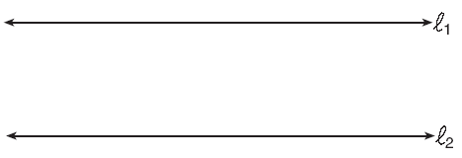

Which term describes the locus of all points that are equidistant from line and line ?
(1) line (3) point
(2) circle (4) rectangle

The accompanying diagram shows two similar triangles.

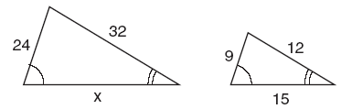

Which proportion could be used to solve for x?
(1) (3)
(2) (4)

Which graph is symmetric with respect to the y-axis?

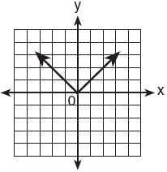  (1) | 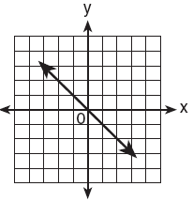  (3)
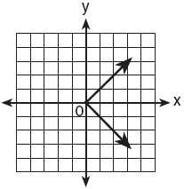  (2) | 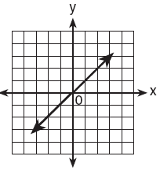  (4)

John left his home and walked 3 blocks to his school, as shown in the accompanying graph.

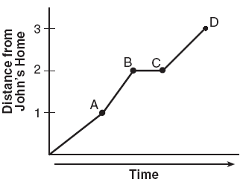

What is one possible interpretation of the section of the graph from point B to point C?
(1) John arrived at school and stayed throughout the day.
(2) John waited before crossing a busy street.
(3) John returned home to get his mathematics homework.
(4) John reached the top of a hill and began walking on level ground.

The expression $8^{−4}⋅8^{6}$ is equivalent to
(1) (3)
(2) (4)

What is a common factor of and ?
(1) x + 3 (3) x – 2
(2) x – 3 (4)

Which statement is the converse of “If the sum of two angles is 180°, then the angles are supplementary”?
(1) If two angles are supplementary, then their sum is 180°.
(2) If the sum of two angles is not 180°, then the angles are not supplementary.
(3) If two angles are not supplementary, then their sum is not 180°.
(4) If the sum of two angles is not 180°, then the angles are supplementary.

Which number is irrational?
(1) (3) 0.3333
(2) (4)

Triangle ABC represents a metal flag on pole AD, as shown in the accompanying diagram. On a windy day the triangle spins around the pole so fast that it looks like a three-dimensional shape.

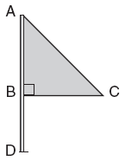

Which shape would the spinning flag create?
(1) sphere (3) right circular cylinder
(2) pyramid (4) cone

In the accompanying graph, if point P has coordinates (a,b), which point has coordinates (–b,a)?

(1) A (3) C
(2) B (4) D

What is the solution set of the equation ?
(1) {–2,6} (3) {}
(2) { } (4) {–6,2}

In the accompanying diagram of a construction, what does represent?

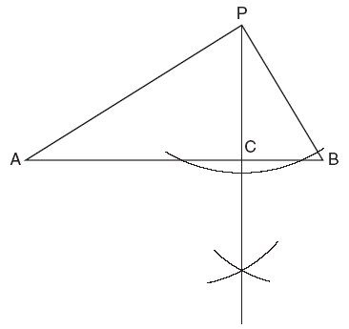

(1) an altitude drawn to
(2) a median drawn to
(3) the bisector of ∠APB
(4) the perpendicular bisector of

If 2ax – 5x = 2, then x is equivalent to
(1) (3)
(2) (4) 7 – 2a

If a > 0, then equals
(1) (3) 5a
(2) (4) 7a

What is the sum of and ?
(1) 1 (3)
(2) (4)

Five people have volunteered to work on an awards dinner at Madison High School. How many different committees of four can be formed from the five people?
(1) 1 (3) 10
(2) 5 (4) 20

The inequality is equivalent to
(1) (3) x < 6
(2) (4) x > 6

In the coordinate plane, the points (2,2) and (2,12) are the endpoints of a diameter of a circle. What is the length of the radius of the circle?
(1) 5 (3) 7
(2) 6 (4) 10

Which expression represents the number of yards in x feet?
(1) (3) 3x
(2) (4) 12x

Which equation illustrates the associative property of addition?
(1) x + y = y + x (3) (3 + x) + y = 3 + (x + y)
(2) 3(x + 2) = 3x + 6 (4) 3 + x = 0

If is subtracted from, the result is
(1) (3)
(2) (4)

The expression is equivalent to
(1) (3)
(2) (4)

Part II

Answer all questions in this part. Each correct answer will receive 2 credits. Clearly indicate the necessary steps, including appropriate formula substitutions, diagrams, graphs, charts, etc. For all questions in this part, a correct numerical answer with no work shown will receive only 1 credit.

Julio’s wages vary directly as the number of hours that he works. If his wages for 5 hours are $29.75, how much will he earn for 30 hours?

TOP Electronics is a small business with five employees. The mean (average) weekly salary for the five employees is $360. If the weekly salaries of four of the employees are $340, $340, $345, and $425, what is the salary of the fifth employee?

Bob and Latoya both drove to a baseball game at a college stadium. Bob lives 70 miles from the stadium and Latoya lives 60 miles from it, as shown in the accompanying diagram. Bob drove at a rate of 50 miles per hour, and Latoya drove at a rate of 40 miles per hour. If they both left home at the same time, who got to the stadium first?

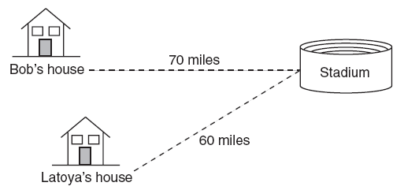

A car dealer has 22 vehicles on his lot. If 8 of the vehicles are vans and 6 of the vehicles are red, and 10 vehicles are neither vans nor red, how many red vans does he have on his lot?

In Jackson County, Wyoming, license plates are made with two letters (A through Z) followed by three digits (0 through 9). The plates are made according to the following restrictions:
• the first letter must be J or W, and the second letter can be any of the 26 letters in the alphabet
• no digit can be repeated
How many different license plates can be made with these restrictions?

Part III

Answer all questions in this part. Each correct answer will receive 3 credits. Clearly indicate the necessary steps, including appropriate formula substitutions, diagrams, graphs, charts, etc. For all questions in this part, a correct numerical answer with no work shown will receive only 1 credit.

Using only 32-cent and 20-cent stamps, Charlie put $3.36 postage on a package he sent to his sister. He used twice as many 32-cent stamps as 20-cent stamps. Determine how many of each type of stamp he used.

A wheel has a radius of 5 feet. What is the minimum number of complete revolutions that the wheel must make to roll at least 1,000 feet?

Part IV

Answer all questions in this part. Each correct answer will receive 4 credits. Clearly indicate the necessary steps, including appropriate formula substitutions, diagrams, graphs, charts, etc. For all questions in this part, a correct numerical answer with no work shown will receive only 1 credit.

In the accompanying diagram, the base of a 15-foot ladder rests on the ground 4 feet from a 6-foot fence.

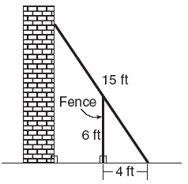

a If the ladder touches the top of the fence and the side of a building, what angle, to the nearest degree, does the ladder make with the ground?
b Using the angle found in part a, determine how far the top of the ladder reaches up the side of the building, to the nearest foot.

Tom throws a ball into the air. The ball travels on a parabolic path represented by the equation , where h is the height, in feet, and t is the time, in seconds.
a On the accompanying set of axes, graph the equation from t = 0 to t = 5 seconds, including all integral values of t from 0 to 5.
b What is the value of t at which h has its greatest value?

