Part I

Answer all questions in this part. Each correct answer will receive 2 credits. No partial credit will be allowed. For each question, write on the separate answer sheet the numeral preceding the word or expression that best completes the statement or answers the question.

The accompanying diagram shows a box-and-whisker plot of student test scores on last year’s Mathematics A midterm examination.

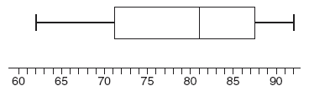

What is the median score?
(1) 62 (3) 81
(2) 71 (4) 92

Triangle A’B’C’ is the image of ABC under a dilation such that A’B’ = 3AB. Triangles ABC and A’B’C’ are
(1) congruent but not similar
(2) similar but not congruent
(3) both congruent and similar
(4) neither congruent nor similar

What is the inverse of the statement “If Mike did his homework, then he will pass this test”?
(1) If Mike passes this test, then he did his homework.
(2) If Mike does not pass this test, then he did not do his homework.
(3) If Mike does not pass this test, then he only did half his homework.
(4) If Mike did not do his homework, then he will not pass this test.

In which list are the numbers in order from least to greatest?
(1) (3)
(2) (4)

The accompanying diagram shows a transformation.

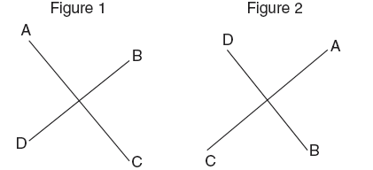

Which transformation performed on figure 1 resulted in figure 2?
(1) rotation (3) dilation
(2) reflection (4) translation

The product of and is
(1) (3)
(2) (4)

There are 12 people on a basketball team, and the coach needs to choose 5 to put into a game. How many different possible ways can the coach choose a team of 5 if each person has an equal chance of being selected?
(1) (3)
(2) (4)

Given the true statement: “If a person is eligible to vote, then that person is a citizen.” Which statement must also be true?
(1) Kayla is not a citizen; therefore, she is not eligible to vote.
(2) Juan is a citizen; therefore, he is eligible to vote.
(3) Marie is not eligible to vote; therefore, she is not a citizen.
(4) Morgan has never voted; therefore, he is not a citizen.

Line P and line C lie on a coordinate plane and have equal slopes. Neither line crosses the second or third quadrant. Lines P and C must
(1) form an angle of 45° (3) be horizontal
(2) be perpendicular (4) be vertical

The equation P = 2L + 2W is equivalent to
(1) L= (3)2L =
(2) L= (4)L = P – W

The sum of and is
(1) 15 (3) 6
(2) 18 (4)

Which graph represents the solution set for and ?

(1) | 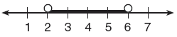
(2) | 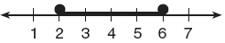
(3) | 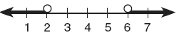
(4) | 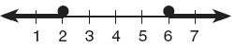

If the measure of an angle is represented by 2x, which expression represents the measure of its complement?
(1) 180 – 2x (3) 90 + 2x
(2) 90 – 2x (4) 88x

Which equation illustrates the multiplicative identity element?
(1) x + 0 = x (3) x • = 1
(2) x – x = 0 (4) x • 1 = x

The ages of five children in a family are 3, 3, 5, 8, and 18. Which statement is true for this group of data?
(1) mode > mean (3) median = mode
(2) mean > median (4) median > mean

In the accompanying diagram of right triangle ABC, AB = 8, BC = 15, AC = 17, and mABC = 90.

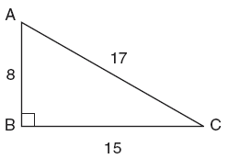

What is tan C?
(1) (3)
(2) (4)

The locus of points equidistant from two sides of an acute scalene triangle is
(1) an angle bisector (3) a median
(2) an altitude (4) the third side

What are the factors of ?
(1) (x – 4)(x + 6) (3) (x – 12)(x + 2)
(2) (x – 4)(x – 6) (4) (x + 12)(x – 2)

What is the value of in scientific notation?
(1) (3)
(2) (4)

In the accompanying figure, what is one pair of alternate interior angles?

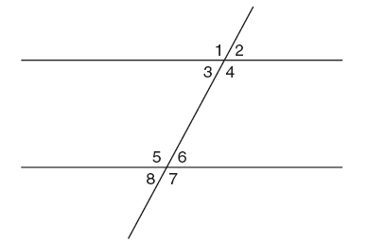

(1) ∠1 and 2 (3) ∠4 and∠6
(2) ∠4 and 5 (4) ∠6 and 8

Part II

Answer all questions in this part. Each correct answer will receive 2 credits. Clearly indicate the necessary steps, including appropriate formula substitutions, diagrams, graphs, charts, etc. For all questions in this part, a correct numerical answer with no work shown will receive only 1 credit.

If Laquisha can enter school by any one of three doors and the school has two staircases to the second floor, in how many different ways can Laquisha reach a room on the second floor? Justify your answer by drawing a tree diagram or listing a sample space.

The world population was 4.2 billion people in 1982. The population in 1999 reached 6 billion. Find the percent of change from 1982 to 1999.

Six members of a school’s varsity tennis team will march in a parade. How many different ways can the players be lined up if Angela, the team captain, is always at the front of the line?

A fish tank with a rectangular base has a volume of 3,360 cubic inches. The length and width of the tank are 14 inches and 12 inches, respectively. Find the height, in inches, of the tank.

Mr. Smith’s class voted on their favorite ice cream flavors, and the results are shown in the accompanying diagram. If there are 20 students in Mr. Smith’s class, how many students chose coffee ice cream as their favorite flavor?

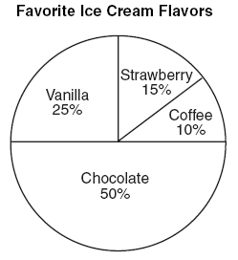

Part III

Answer all questions in this part. Each correct answer will receive 3 credits. Clearly indicate the necessary steps, including appropriate formula substitutions, diagrams, graphs, charts, etc. For all questions in this part, a correct numerical answer with no work shown will receive only 1 credit.

Three brothers have ages that are consecutive even integers. The product of the first and third boys’ ages is 20 more than twice the second boy’s age. Find the age of each of the three boys.

Arielle has a collection of grasshoppers and crickets. She has 561 insects in all. The number of grasshoppers is twice the number of crickets. Find the number of each type of insect that she has.

The graph of a quadratic equation is shown in the accompanying diagram. The scale on the axes is a unit scale. Write an equation of this graph in standard form.

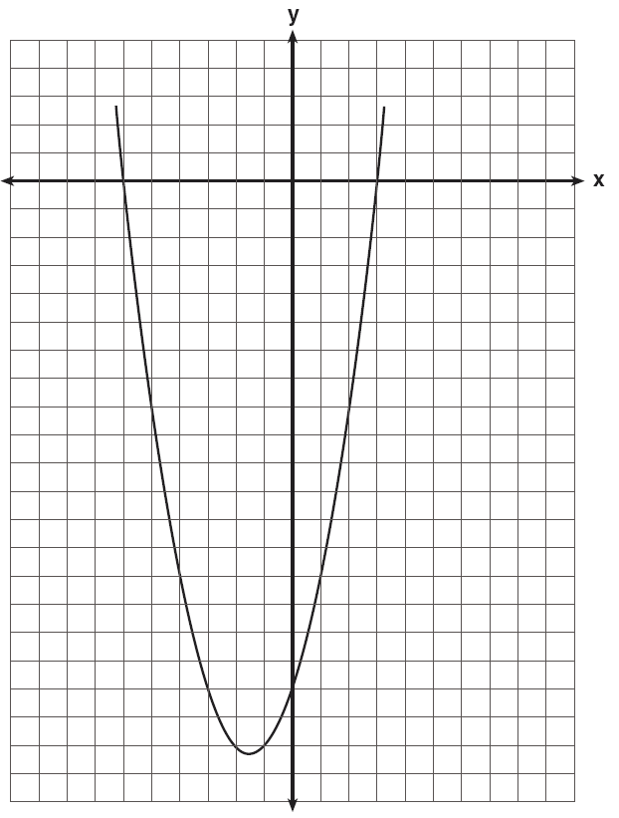

Currently, Tyrone has $60 and his sister has $135. Both get an allowance of $5 each week. Tyrone decides to save his entire allowance, but his sister spends all of hers each week plus an additional $10 each week. After how many weeks will they each have the same amount of money?
[The use of the grid is optional.]



A rectangular garden is going to be planted in a person’s rectangular backyard, as shown in the accompanying diagram. Some dimensions of the backyard and the width of the garden are given. Find the area of the garden to the nearest square foot.

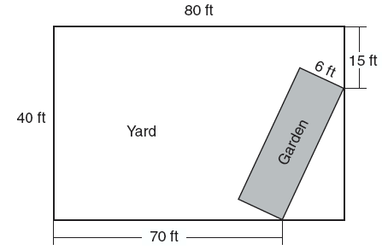

Part IV

Answer all questions in this part. Each correct answer will receive 4 credits. Clearly indicate the necessary steps, including appropriate formula substitutions, diagrams, graphs, charts, etc. For all questions in this part, a correct numerical answer with no work shown will receive only 1 credit.

At the Phoenix Surfboard Company, $306,000 in profits was made last year. This profit was shared by the four partners in the ratio 3:3:5:7. How much more money did the partner with the largest share make than one of the partners with the smallest share?

Alexandra purchases two doughnuts and three cookies at a doughnut shop and is charged $3.30. Briana purchases five doughnuts and two cookies at the same shop for $4.95. All the doughnuts have the same price and all the cookies have the same price. Find the cost of one doughnut and find the cost of one cookie.

On the accompanying grid, draw and label quadrilateral ABCD with points A(1,2), B(6,1), C(7,6), and D(3,7). On the same set of axes, plot and label quadrilateral , the reflection of quadrilateral ABCD in the y-axis. Determine the area, in square units, of quadrilateral .



Sarah’s mathematics grades for one marking period were 85, 72, 97, 81, 77, 93, 100, 75, 86, 70, 96, and 80.
a Complete the tally sheet and frequency table below, and construct and label a frequency histogram for Sarah’s grades using the accompanying grid.

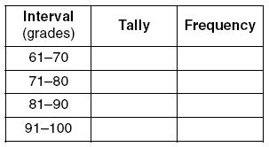



b Which interval contains the 75th percentile (upper quartile)?
On the accompanying set of axes, graph and label the following lines:
y = 5
x = –4
Calculate the area, in square units, of the triangle formed by the three points of intersection.

