Part I

Answer all questions in this part. Each correct answer will receive 2 credits. No partial credit will be allowed. For each question, write on the separate answer sheet the numeral preceding the word or expression that best completes the statement or answers the question.

Expressed in factored form, the binominal is equivalent to
(1) (2a – 3b)(2a – 3b) (3)(4a – 3b)(a + 3b)
(2) (2a + 3b)(2a – 3b) (4)(2a – 9b)(2a + b)

If the length of the legs of a right triangle are 5 and 7, what is the length of the hypotenuse?
(1) (3)
(2) (4)

What is the slope of the line whose equation is 2y = 5x + 4?
(1) 5 (3)
(2) 2 (4)

What is the value of x in the equation ?
(1) –16 (3) –4
(2) 16 (4) 4

The product of and is
(1) (3)
(2) (4)

The approximate number of seconds in a year is 32,000,000. When this number is written in scientific notation, the numerical value of the exponent is
(1) –7 (3) 7
(2) 6 (4) 8

Which expression must be added to 3x – 7 to equal 0?
(1) 0 (3) –3x – 7
(2) 3x + 7 (4) –3x + 7

What is the greatest possible number of points of intersection of a triangle and a circle?
(1) 6 (3) 3
(2) 2 (4) 4

A fair coin is tossed three times. What is the probability that the coin will land tails up on the second toss?
(1) (3)
(2) (4)

There are 357 seniors in Harris High School. The ratio of boys to girls is 7:10. How many boys are in the senior class?
(1) 210 (3) 117
(2) 147 (4) 107

If x and y are defined as indicated by the accompanying table, which equation correctly represents the relationship between x and y?

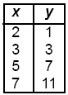

(1) y = x + 2 (3) y = 2x + 3
(2) y = 2x + 2 (4) y = 2x – 3

What is the area of a square whose perimeter is represented by 12x?
(1) (3)
(2) (4)

Which inequality is true if x =, y = 1.99 + 0.33, and z =?
(1) y < z < x (3) x < z < y
(2) y < x < z (4) x < y < z

Frank, George, and Hernando are a plumber, a cabinet maker, and an electrician, though not necessarily in that order. Each can do all work appropriate to his own field, but no work in other fields. Frank was not able to install a new electric line in his home. Hernando was not able to make cabinets. George is also a building contractor who hired one of the other people to do his electrical work. Which statement must be true?
(1) Hernando is an electrician.
(2) George is a cabinet maker.
(3) Frank is a plumber.
(4) Frank is an electrician.

What is the solution set of the equation ?
(1) {–2,–8} (3) {4,–4}
(2) {2,8} (4) {4,4}

In the accompanying diagram, is a straight line, and angle E in triangle BEC is a right angle.

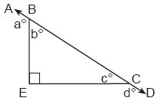

What does a° + d° equal?
(1) 135° (3) 180°
(2) 160° (4) 270°

Which set is closed under division?
(1) {1} (3) integers
(2) counting numbers (4) whole numbers

When Kimberly bought her new car, she found that there were 72 different ways her car could be equipped. Her choices included four choices of engine and three choices of transmission. If her only other choice was color, how many choices of color did she have?
(1) 6 (3) 60
(2) 12 (4) 65

Which is an irrational number?
(1) (3)
(2) 3.14 (4)

Which statement is logically equivalent to “If the team has a good pitcher, then the team has a good season”?
(1) If the team does not have a good season, then the team does not have a good pitcher.
(2) If the team does not have a good pitcher, then the team does not have a good season.
(3) If the team has a good season, then the team has a good pitcher.
(4) The team has a good pitcher and the team does not have a good season.

Part II

Answer all questions in this part. Each correct answer will receive 2 credits. Clearly indicate the necessary steps, including appropriate formula substitutions, diagrams, graphs, charts, etc. For all questions in this part, a correct numerical answer with no work shown will receive only 1 credit.

Seth is thinking of a number between 20 and 30. The number is prime and not more than 2 away from a perfect square. What is the number?

A 12-foot tree casts a 16-foot shadow. How many feet tall is a nearby tree that casts a 20-foot shadow at the same time?

Vertex angle A of isosceles triangle ABC measures 20° more than three times mB. Find mC.

Ashanti and Maria went to the store to buy snacks for their back-to-school party. They bought bags of chips, pretzels, and nachos. They bought three times as many bags of pretzels as bags of chips, and two fewer bags of nachos than bags of pretzels. If x represents the number of bags of chips they bought, express, in terms of x, how many bags of snacks they bought in all.

Construct a triangle with sides of lengths a, b, and c, as shown below. Be sure the longest side of your triangle lies on and that point P is one of the triangle’s vertices. [Show all arcs necessary for a valid construction.]

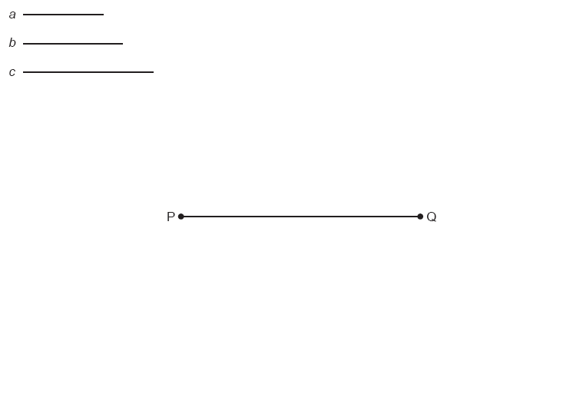

Part III

Answer all questions in this part. Each correct answer will receive 3 credits. Clearly indicate the necessary steps, including appropriate formula substitutions, diagrams, graphs, charts, etc. For all questions in this part, a correct numerical answer with no work shown will receive only 1 credit.

Jerry and Jean Jogger start at the same time from point A shown on the accompanying set of axes. Jerry jogs at a rate of 5 miles per hour traveling from point A to point R to point S and then to point C. Jean jogs directly from point A to point C on at the rate of 3 miles per hour. Which jogger reaches point C first? Explain or show your reasoning.

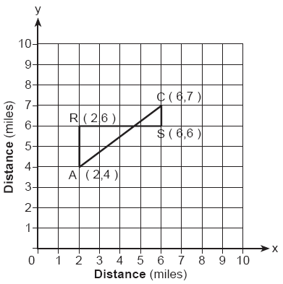

In the accompanying diagram, a rectangular container with the dimensions 10 inches by 15 inches by 20 inches is to be filled with water, using a cylindrical cup whose radius is 2 inches and whose height is 5 inches. What is the maximum number of full cups of water that can be placed into the container without the water overflowing the container?

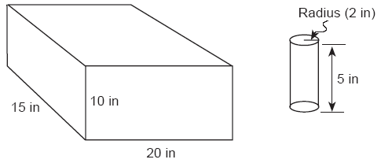

A total of 600 tickets were sold for a concert. Twice as many tickets were sold in advance than were sold at the door. If the tickets sold in advance cost $25 each and the tickets sold at the door cost $32 each, how much money was collected for the concert?

In the accompanying diagram, and intersect at E. If mAEC = 4x – 40 and mBED = x + 50, find the number of degrees in AEC.

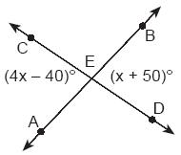

The students in Woodland High School’s meteorology class measured the noon temperature every schoolday for a week. Their readings for the first 4 days were Monday, 56°; Tuesday, 72°; Wednesday, 67°; and Thursday, 61°. If the mean (average) temperature for the 5 days was exactly 63°, what was the temperature on Friday?

Part IV

Answer all questions in this part. Each correct answer will receive 4 credits. Clearly indicate the necessary steps, including appropriate formula substitutions, diagrams, graphs, charts, etc. For all questions in this part, a correct numerical answer with no work shown will receive only 1 credit.

A square dartboard is represented in the accompanying diagram. The entire dartboard is the first quadrant from x = 0 to 6 and from y = 0 to 6. A triangular region on the dartboard is enclosed by the graphs of the equations y = 2, x = 6, and y = x. Find the probability that a dart that randomly hits the dartboard will land in the triangular region formed by the three lines.

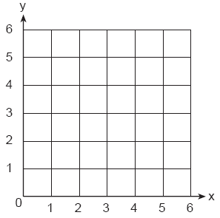

When Tony received his weekly allowance, he decided to purchase candy bars for all his friends. Tony bought three Milk Chocolate bars and four Creamy Nougat bars, which cost a total of $4.25 without tax. Then he realized this candy would not be enough for all his friends, so he returned to the store and bought an additional six Milk Chocolate bars and four Creamy Nougat bars, which cost a total of $6.50 without tax. How much did each type of candy bar cost?

Javon’s homework is to determine the dimensions of his rectangular backyard. He knows that the length is 10 feet more than the width, and the total area is 144 square feet. Write an equation that Javon could use to solve this problem. Then find the dimensions, in feet, of his backyard.

A company manufactures bicycles and skateboards. The company’s daily production of bicycles cannot exceed 10, and its daily production of skateboards must be less than or equal to 12. The combined number of bicycles and skateboards cannot be more than 16. If x is the number of bicycles and y is the number of skateboards, graph on the accompanying set of axes the region that contains the number of bicycles and skateboards the company can manufacture daily.



Draw and label a diagram of the path of an airplane climbing at an angle of 11° with the ground. Find, to the nearest foot, the ground distance the airplane has traveled when it has attained an altitude of 400 feet.

