Part I

Answer all questions in this part. Each correct answer will receive 2 credits. No partial credit will be allowed. For each question, write on the separate answer sheet the numeral preceding the word or expression that best completes the statement or answers the question.

There are 461 students and 20 teachers taking buses on a trip to a museum. Each bus can seat a maximum of 52. What is the least number of buses needed for the trip?
(1) 8 (3) 10
(2) 9 (4) 11

In right triangle ABC, mC = 3y – 10, mB = y + 40, and mA = 90. What type of right triangle is triangle ABC?
(1) scalene (3) equilateral
(2) isosceles (4) obtuse

If x > 0, the expression is equivalent to
(1) (3)
(2) 2x (4)

Three times as many robins as cardinals visited a bird feeder. If a total of 20 robins and cardinals visited the feeder, how many were robins?
(1) 5 (3) 15
(2) 10 (4) 20

One of the factors of is
(1) (x + 3) (3) (4x – 3)
(2) (2x + 3) (4) (x – 3)

At a school fair, the spinner represented in the accompanying diagram is spun twice.

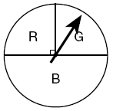

What is the probability that it will land in section G the first time and then in section B the second time?
(1) (3)
(2) (4)

If a and b are integers, which equation is always true?
(1) (3) a – b = b – a
(2) a + 2b = b + 2a (4) a + b = b + a

The sum of and is
(1) (3)
(2) (4)

If , the expression is equivalent to
(1) x + 2 (3) 3x
(2) 2 (4) 4

Helen is using a capital H in an art design. The H has
(1) only one line of symmetry
(2) only two points of symmetry
(3) two lines of symmetry and only one point of symmetry
(4) two lines of symmetry and two points of symmetry

The distance from Earth to the Sun is approximately 93 million miles. A scientist would write that number as
(1) (3)
(2) (4)

Given the statement: “If two sides of a triangle are congruent, then the angles opposite these sides are congruent.” Given the converse of the statement: “If two angles of a triangle are congruent, then the sides opposite these angles are congruent.”
What is true about this statement and its converse?
(1) Both the statement and its converse are true.
(2) Neither the statement nor its converse is true.
(3) The statement is true but its converse is false.
(4) The statement is false but its converse is true.

Which equation could represent the relationship between the x and y values shown in the accompanying table?

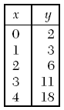

(1) y = x + 2 (3)
(2) (4)

A locker combination system uses three digits from 0 to 9. How many different three-digit combinations with no digit repeated are possible?
(1) 30 (3) 720
(2) 504 (4) 1,000

What is the slope of line in the accompanying diagram?

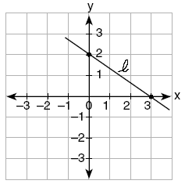

(1) (3)
(2) (4)

If bx – 2 = K, then x equals
(1) (3)
(2) (4)

In a molecule of water, there are two atoms of hydrogen and one atom of oxygen. How many atoms of hydrogen are in 28 molecules of water?
(1) 14 (3) 42
(2) 29 (4) 56

From January 3 to January 7, Buffalo recorded the following daily high temperatures: 5°, 7°, 6°, 5°, and 7°. Which statement about the temperatures is true?
(1) mean = median (3) median = mode
(2) mean = mode (4) mean < median

In which of the accompanying figures are segments XY and YZ perpendicular?

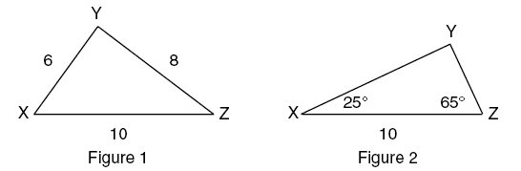

(1) figure 1, only
(2) figure 2, only
(3) both figure 1 and figure 2
(4) neither figure 1 nor figure 2

Let x and y be numbers such that 0 < x < y < 1, and let d = x – y. Which graph could represent the location of d on the number line?

(1) | 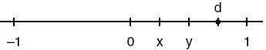
(2) | 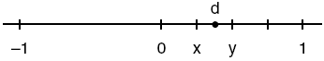
(3) | 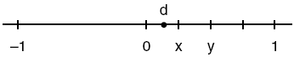
(4) | 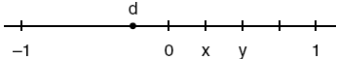
Part II

Answer all questions in this part. Each correct answer will receive 2 credits. Clearly indicate the necessary steps, including appropriate formula substitutions, diagrams, graphs, charts, etc. For all questions in this part, a correct numerical answer with no work shown will receive only 1 credit.

The accompanying graph shows Marie’s distance from home (A) to work (F) at various times during her drive.

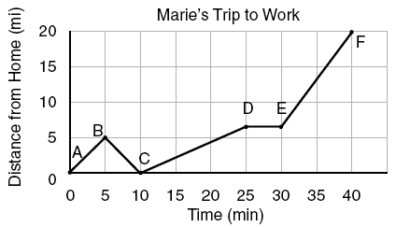

a Marie left her briefcase at home and had to return to get it. State which point represents when she turned back around to go home and explain how you arrived at that conclusion.
b Marie also had to wait at the railroad tracks for a train to pass. How long did she wait?

Sue bought a picnic table on sale for 50% off the original price. The store charged her 10% tax and her final cost was $22.00. What was the original price of the picnic table?

A cardboard box has length x – 2, width x + 1, and height 2x.
a Write an expression, in terms of x, to represent the volume of the box.
b If x = 8 centimeters, what is the number of cubic centimeters in the volume of the box?

The coordinates of the endpoints of are A(0,2) and B(4,6). Graph and state the coordinates of and , the images of A and B after is reflected in the x-axis.



Two trains leave the same station at the same time and travel in opposite directions. One train travels at 80 kilometers per hour and the other at 100 kilometers per hour. In how many hours will they be 900 kilometers apart?

Part III

Answer all questions in this part. Each correct answer will receive 3 credits. Clearly indicate the necessary steps, including appropriate formula substitutions, diagrams, graphs, charts, etc. For all questions in this part, a correct numerical answer with no work shown will receive only 1 credit.

Sal has a small bag of candy containing three green candies and two red candies. While waiting for the bus, he ate two candies out of the bag, one after another, without looking. What is the probability that both candies were the same color?

Steve has a treasure map, represented in the accompanying diagram, that shows two trees 8 feet apart and a straight fence connecting them. The map states that treasure is buried 3 feet from the fence and equidistant from the two trees.

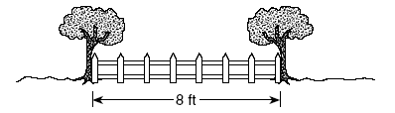

a Sketch a diagram to show all the places where the treasure could be buried. Clearly indicate in your diagram where the treasure could be buried.
b What is the distance between the treasure and one of the trees?

In the accompanying figure, two lines intersect, m3 = 6t + 30, and m2 = 8t – 60. Find the number of degrees in m4.

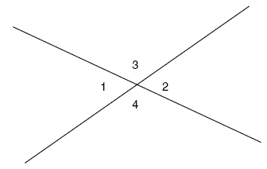

Mark says, “The number I see is odd.” Jan says, “That same number is prime.” The teacher says, “Mark is correct or Jan is correct.” Some integers would make the teacher’s statement true while other integers would make it false. Give and explain one example of when the teacher’s statement is true. Give and explain one example of when the teacher’s statement is false.

Juan has a cellular phone that costs $12.95 per month plus 25¢ per minute for each call. Tiffany has a cellular phone that costs $14.95 per month plus 15¢ per minute for each call. For what number of minutes do the two plans cost the same?

Part IV

Answer all questions in this part. Each correct answer will receive 4 credits. Clearly indicate the necessary steps, including appropriate formula substitutions, diagrams, graphs, charts, etc. For all questions in this part, a correct numerical answer with no work shown will receive only 1 credit.

Solve algebraically for x: $\frac{1}{x}=\frac{x+1}{6}$.

On a science quiz, 20 students received the following scores: 100, 95, 95, 90, 85, 85, 85, 80, 80, 80, 80, 75, 75, 75, 70, 70, 65, 65, 60, 55. Construct a statistical graph, such as a histogram or a stem-and-leaf plot, to display this data. [Be sure to title the graph and label all axes or parts used.]
If your type of plot requires a grid, show your work here.



If no grid is necessary, show your work here.

John uses the equation to represent the shape of a garden on graph paper.
a Graph on the accompanying grid.

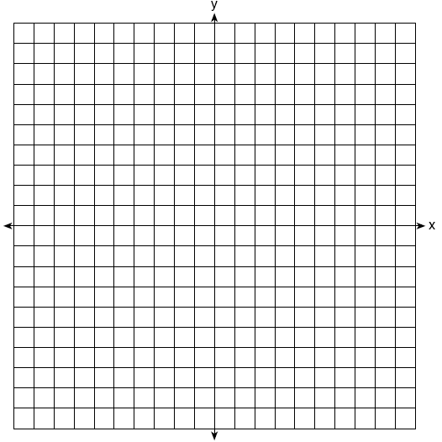

b What is the area of the garden to the nearest square unit?

There were 100 more balcony tickets than main-floor tickets sold for a concert. The balcony tickets sold for $4 and the main-floor tickets sold for $12. The total amount of sales for both types of tickets was $3,056.
a Write an equation or a system of equations that describes the given situation. Define the variables.
b Find the number of balcony tickets that were sold.

Find, to the nearest tenth of a foot, the height of the tree represented in the accompanying diagram.

