Part I

Answer all questions in this part. Each correct answer will receive 2 credits. No partial credit will be allowed. For each question, write on the separate answer sheet the numeral preceding the word or expression that best completes the statement or answers the question.

The expression is a number between
(1) 3 and 9 (3) 9 and 10
(2) 8 and 9 (4) 46 and 47

Which number has the greatest value?
(1) (3)
(2) (4) 1.5

Mary says, “The number I am thinking of is divisible by 2 or is divisible by 3.” Mary’s statement is false if the number she is thinking of is
(1) 6 (3) 11
(2) 8 (4) 15

Which expression is a factor of
(1) (x - 3) (3) (x + 15)
(2) (x + 3) (4) (x – 5)

What was the median high temperature in Middletown during the 7-day period shown in the table below?

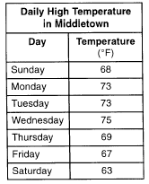

(1) 69 (3) 73
(2) 70 (4) 75

If the number represented by n-3 is an odd integer, which expression represents the next greater odd integer?
(1) n-5 (3) n-1
(2) n-2 (4) n+1

When the point (2,-5) is reflected in the x-axis, what are the coordinates of its image?
(1) (-5,2) (3) (2,5)
(2) (-2,5) (4) (5,2)

The expression is equivalent to
(1) (3)
(2) (4)

Twenty-five percent of 88 is the same as what percent of 22?
(1) (3) 50%
(2) 40% (4) 100%

A plot of land is in the shape of rhombus ABCD as shown below.

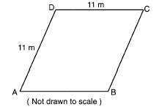

Which can not be the length of diagonal AC?
(1) 24 m (3) 11 m
(2) 18 m (4) 4 m

If , then x equals
(1) a (3)
(2) -a (4)

If the circumference of a circle is inches, what is the area, in square inches, of the circle?
(1) (3)
(2) (4)

How many different 4-letter arrangements can be formed using the letters of the word “JUMP,” if each letter is used only once?
(1) 24 (3) 12
(2) 16 (4) 4

Sterling silver is made of an alloy of silver and copper in the ratio of 37:3. If the mass of a sterling silver ingot is 600 grams, how much silver does it contain?
(1) 48.65 g (3) 450 g
(2) 200 g (4) 555 g

If , then equals
(1) -36 (3) 6
(2) -6 (4) 18

The expression is equivalent to
(1) (3)
(2) (4)

The party registration of the voters in Jonesville is shown in the table below.

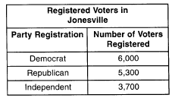

If one of the registered Jonesville voters is selected at random, what is the probability that the person selected is not a Democrat?
(1) 0.333 (3) 0.600
(2) 0.400 (4) 0.667

If the number of molecules in 1 mole of a substance is , then the number of molecules in 100 moles is
(1) (3)
(2) (4)

When is subtracted from , the result is
(1) (3)
(2) (4)

The distance between parallel lines and m is 12 units. Point A is on line . How many points are equidistant from lines and m and 8 units from point A.
(1) 1 (3) 3
(2) 2 (4) 4

Part II

Answer all questions in this part. Each correct answer will receive 2 credits. Clearly indicate the necessary steps, including appropriate formula substitutions, diagrams, graphs, charts, etc. For all questions in this part, a correct numerical answer with no work shown will receive only 1 credit.

The midpoint M of line segment AB has coordinates (-3,4). If point A is the origin, (0,0), what are the coordinates of point B? [The use of the accompanying grid is optional.]



Mary and Amy had a total of 20 yards of material from which to make costumes. Mary used three times more material to make her costume than Amy used, and 2 yards of material was not used. How many yards of materials did Amy use for her costumer?

A wall is supported by a brace 10 feet long, as shown in the diagram below. If one end of the brace is placed 6 feet from the base of the wall, how many feet up the wall does the brace reach?

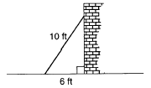

A straight line with slope 5 contains the points (1,2) and (3,K). Find the value of K. [The use of the accompanying grid is optional.]

Al says, “If ABCD is a parallelogram, then ABCD is a rectangle.” Sketch a quadrilateral ABCD that shows that Al’s statement is not always true. Your sketch must show the length of each side and the measure of each angle for the quadrilateral you draw.

Part III

Answer all questions in this part. Each correct answer will receive 3 credits. Clearly indicate the necessary steps, including appropriate formula substitutions, diagrams, graphs, charts, etc. For all questions in this part, a correct numerical answer with no work shown will receive only 1 credit.

Judy needs a mean (average) score of 86 on four tests to earn a midterm grade of B. If the mean of her scores for the first three tests was 83, what is the lowest score on a 100-point scale that she can receive on the fourth test to have a midterm grade of B?

A truck traveling at a constant rate of 45 miles per hour leaves Albany. One hour later a car traveling at a constant rate of 60 miles per hour also leaves Albany traveling in the same direction on the same highway. How long will it take for the car to catch up to the truck, if both vehicles continue in the same direction on the highway?

In the figure below, the large rectangle, ABCD, is divided into four smaller rectangles. The area of rectangle AEHG = 5x, the area of rectangle GHFB = , the area of rectangle HJCF = 6x, segment AG = 5, and segment AE = x.

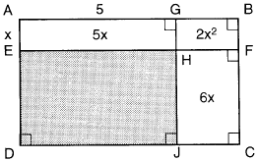

a Find the area of the shaded region.
b Write an expression for the area of the rectangle ABCD in terms of x.

a On the set of axes provided below, sketch a circle with a radius of 3 and center at (2,1) and also sketch the graph of the line 2x + y = 8.

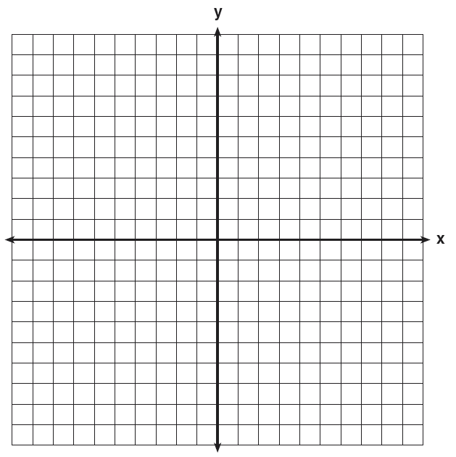

b What is the total number of points of intersection of the two graphs?

The volume of a rectangular pool is 1,080 cubic meters. Its length, width, and depth are in the ratio 10:4:1. Find the number of meters in each of the three dimensions of the pool.

Part IV

Answer all questions in this part. Each correct answer will receive 4 credits. Clearly indicate the necessary steps, including appropriate formula substitutions, diagrams, graphs, charts, etc. For all questions in this part, a correct numerical answer with no work shown will receive only 1 credit.

Amy tossed a ball in the air in such a way that the path of the ball was modeled by the equation . In the equation, y represents the height of the ball in feet and x is the time in seconds.
a Graph for on the grid provided below.

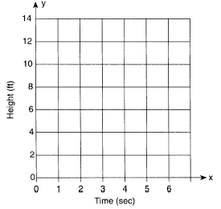

b At what time, x, is the ball at its highest point?

In the time trials for the 400-meter run at the state sectionals, the 15 runners recorded the times shown in the table below.

a Using the data from the frequency column, draw a frequency histogram on the grid provided below.

b What percent of runners completed the time trial between 52.0 and 53.9 seconds?

A group of 148 people is spending five days at a summer camp. The cook ordered 12 pounds of food for each adult and 9 pounds of food for each child. A total of 1,410 pounds of food was ordered.
a Write an equation or a system of equations that describes the above situation and define your variables.
b Using your work from part a, find:
(1) the total number of adults in the group
(2) the total number of children in the group

Three roses will be selected for a flower vase. The florist has 1 red rose, 1 white rose, 1 yellow rose, 1 orange rose and 1 pink rose from which to choose.
a How many different three rose selections can be formed from the 5 roses?
b What is the probability that 3 roses selected at random will contain 1 red rose, 1 white rose, and 1 pink rose?
c What is the probability that 3 roses selected at random will not contain an orange rose?

The Excel Cable Company has a monthly fee of $32.00 and an additional charge of $8.00 for each premium channel. The Best Cable Company has a monthly fee of $26.00 and an additional charge of $10.00 for each premium channel. The Horton family is deciding which of these two cable companies to subscribe to.
a For what number of premium channels will the total monthly subscription fee for the Excel and Best Cable companies be the same?
b The Horton family decides to subscribe to 2 premium channels for a period of one year.
(1) Which cable company should they subscribe to in order to spend less money?
(2) How much money will the Hortons save in one year by using the less expensive company?

