1 For 10 days, Romero kept a record of the number of hours he spent listening to music. The information is shown in the table below.

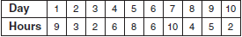

Which scatter plot shows Romero’s data graphically?
1) | 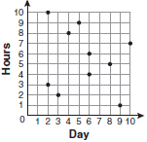 | 3) | 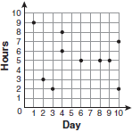
2) | 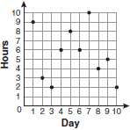 | 4) | 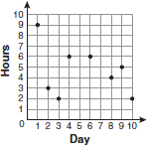

2 Throughout history, many people have contributed to the development of mathematics. These mathematicians include Pythagoras, Euclid, Hypatia, Euler, Einstein, Agnesi, Fibonacci, and Pascal. What is the probability that a mathematician’s name selected at random from those listed will start with either the letter E or the letter A?
1) |  | 3)
2) |  | 4)

3 Which expression represents 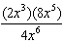 in simplest form?
1) |  | 3)
2) |  | 4)

4 Which interval notation represents the set of all numbers from 2 through 7, inclusive?
1) |  | 3)
2) |  | 4)

5 Which property is illustrated by the equation ?
1) | associative | 3) | distributive
2) | commutative | 4) | identity

6 The expression is equivalent to
1) |  | 3)
2) |  | 4)

7 Which situation describes a correlation that is not a causal relationship?
1) | The rooster crows, and the Sun rises.
2) | The more miles driven, the more gasoline needed
3) | The more powerful the microwave, the faster the food cooks.
4) | The faster the pace of a runner, the quicker the runner finishes.

8 The equations and represent the money collected from school concert ticket sales during two class periods. If x represents the cost for each adult ticket and y represents the cost for each student ticket, what is the cost for each adult ticket?
1) | $20 | 3) | $8
2) | $10 | 4) | $4

9 The data set 5, 6, 7, 8, 9, 9, 9, 10, 12, 14, 17, 17, 18, 19, 19 represents the number of hours spent on the Internet in a week by students in a mathematics class. Which box-and-whisker plot represents the data?
1) | 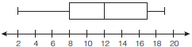 | 3) | 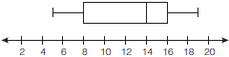
2) | 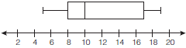 | 4) | 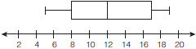

10 Given:
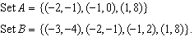
What is the intersection of sets A and B?
1) |  | 3)
2) |  | 4)

11 Tanya runs diagonally across a rectangular field that has a length of 40 yards and a width of 30 yards, as shown in the diagram below.

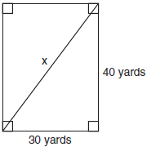

What is the length of the diagonal, in yards, that Tanya runs?
1) | 50 | 3) | 70
2) | 60 | 4) | 80

12 A cylindrical container has a diameter of 12 inches and a height of 15 inches, as illustrated in the diagram below.

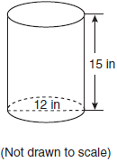

What is the volume of this container to the nearest tenth of a cubic inch?
1) | 6,785.8 | 3) | 2,160.0
2) | 4,241.2 | 4) | 1,696.5

13 What is an equation for the line that passes through the coordinates and ?
1) | 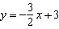 | 3) | 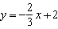
2) | 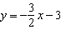 | 4) | 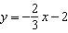

14 Which situation should be analyzed using bivariate data?
1) | Ms. Saleem keeps a list of the amount of time her daughter spends on her social studies homework.
2) | Mr. Benjamin tries to see if his students’ shoe sizes are directly related to their heights.
3) | Mr. DeStefan records his customers’ best video game scores during the summer.
4) | Mr. Chan keeps track of his daughter’s algebra grades for the quarter.

15 An electronics store sells DVD players and cordless telephones. The store makes a $75 profit on the sale of each DVD player (d) and a $30 profit on the sale of each cordless telephone (c). The store wants to make a profit of at least $255.00 from its sales of DVD players and cordless phones. Which inequality describes this situation?
1) |  | 3)
2) |  | 4)

16 What is the slope of the line containing the points and ?
1) |  | 3)
2) | 2 | 4)

17 Which type of graph is shown in the diagram below?

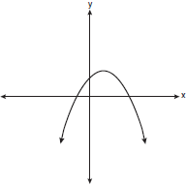
1) | absolute value | 3) | linear
2) | exponential | 4) | quadratic

18 The expression 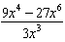 is equivalent to
1) |  | 3)
2) |  | 4)

19 Daniel’s Print Shop purchased a new printer for $35,000. Each year it depreciates (loses value) at a rate of 5%. What will its approximate value be at the end of the fourth year?
1) | $33,250.00 | 3) | $28,507.72
2) | $30,008.13 | 4) | $27,082.33

20 Which inequality is represented by the graph below?

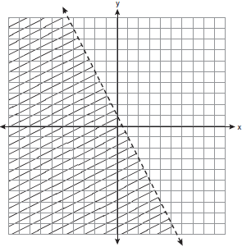
1) |  | 3) | 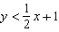
2) |  | 4) | 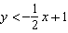

21 In triangle MCT, the measure of , , , and . Which ratio represents the sine of ?
1) |  | 3)
2) |  | 4)

22 The diagram below shows the graph of .

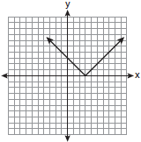

Which diagram shows the graph of ?
1) | 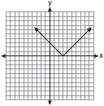 | 3) | 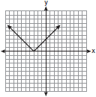
2) | 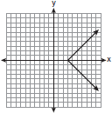 | 4) | 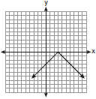

23 The groundskeeper is replacing the turf on a football field. His measurements of the field are 130 yards by 60 yards. The actual measurements are 120 yards by 54 yards. Which expression represents the relative error in the measurement?
1) | 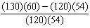 | 3) | 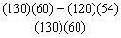
2) | 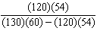 | 4) | 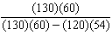

24 Which value of x is in the solution set of the inequality ?
1) |  | 3)
2) |  | 4) | 12

25 What is the quotient of and ?
1) |  | 3)
2) |  | 4)

26 The length of a rectangular window is 5 feet more than its width, w. The area of the window is 36 square feet. Which equation could be used to find the dimensions of the window?
1) |  | 3)
2) |  | 4)

27 What is the sum of and expressed in simplest form?
1) |  | 3)
2) |  | 4)

28 For which value of x is 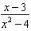 undefined?
1) |  | 3) | 3
2) | 0 | 4) | 4

29 Which verbal expression represents ?
1) | two times n minus six | 3) | two times the quantity n less than six
2) | two times six minus n | 4) | two times the quantity six less than n

30 Which graph represents a function?
1) | 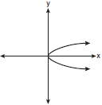 | 3) | 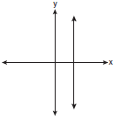
2) | 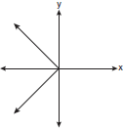 | 4) | 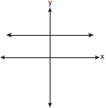

31 Express in simplest radical form.

32 Solve for g:

33 Serena’s garden is a rectangle joined with a semicircle, as shown in the diagram below. Line segment AB is the diameter of semicircle P. Serena wants to put a fence around her garden.

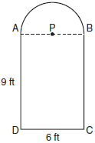

Calculate the length of fence Serena needs to the nearest tenth of a foot.

34 Hannah took a trip to visit her cousin. She drove 120 miles to reach her cousin’s house and the same distance back home. It took her 1.2 hours to get halfway to her cousin’s house. What was her average speed, in miles per hour, for the first 1.2 hours of the trip? Hannah’s average speed for the remainder of the trip to her cousin’s house was 40 miles per hour. How long, in hours, did it take her to drive the remaining distance? Traveling home along the same route, Hannah drove at an average rate of 55 miles per hour. After 2 hours her car broke down. How many miles was she from home?

35 A prom ticket at Smith High School is $120. Tom is going to save money for the ticket by walking his neighbor’s dog for $15 per week. If Tom already has saved $22, what is the minimum number of weeks Tom must walk the dog to earn enough to pay for the prom ticket?

36 Mr. Laub has three children: two girls (Sue and Karen) and one boy (David). After each meal, one child is chosen at random to wash dishes. If the same child can be chosen for both lunch and dinner, construct a tree diagram or list a sample space of all the possible outcomes of who will wash dishes after lunch and dinner on Saturday. Determine the probability that one boy and one girl will wash dishes after lunch and dinner on Saturday.

37 The values of 11 houses on Washington St. are shown in the table below.

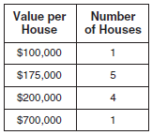

Find the mean value of these houses in dollars. Find the median value of these houses in dollars. State which measure of central tendency, the mean or the median, best represents the values of these 11 houses. Justify your answer.

38 Solve the following systems of equations graphically, on the set of axes below, and state the coordinates of the point(s) in the solution set.
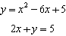

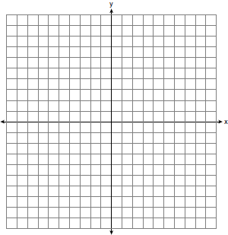

39 Solve for x: 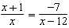
1 ANS: 2 PTS: 2 REF: fall0701ia STA: A.S.7
TOP: Scatter Plots

2 ANS: 3 PTS: 2 REF: fall0702ia STA: A.S.23
TOP: Theoretical Probability KEY: mutually exclusive events

3 ANS: 3
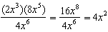

PTS: 2 REF: fall0703ia STA: A.A.12 TOP: Division of Powers

4 ANS: 4 PTS: 2 REF: fall0704ia STA: A.A.29
TOP: Set Theory

5 ANS: 3 PTS: 2 REF: fall0705ia STA: A.N.1
TOP: Identifying Properties

6 ANS: 3 PTS: 2 REF: fall0706ia STA: A.A.19
TOP: Factoring the Difference of Perfect Squares

7 ANS: 1
A rooster crows before sunrise, not because of the sun.

PTS: 2 REF: fall0707ia STA: A.S.14 TOP: Analysis of Data

8 ANS: 3
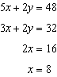

PTS: 2 REF: fall0708ia STA: A.A.7 TOP: Writing Linear Systems

9 ANS: 2
The median score, 10, is the vertical line in the center of the box.

PTS: 2 REF: fall0709ia STA: A.S.5 TOP: Box-and-Whisker Plots

10 ANS: 3 PTS: 2 REF: fall0710ia STA: A.A.31
TOP: Set Theory

11 ANS: 1
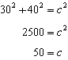. 30, 40, 50 is a multiple of 3, 4, 5.

PTS: 2 REF: fall0711ia STA: A.A.45 TOP: Pythagorean Theorem

12 ANS: 4

PTS: 2 REF: fall0712ia STA: A.G.2 TOP: Volume

13 ANS: 1
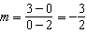. Using the given y-intercept to write the equation of the line .

PTS: 2 REF: fall0713ia STA: A.A.35 TOP: Writing Linear Equations

14 ANS: 2
The two values are shoe size and height.

PTS: 2 REF: fall0714ia STA: A.S.2 TOP: Analysis of Data

15 ANS: 4 PTS: 2 REF: fall0715ia STA: A.A.5
TOP: Modeling Inequalities

16 ANS: 3
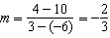

PTS: 2 REF: fall0716ia STA: A.A.33 TOP: Slope

17 ANS: 4 PTS: 2 REF: fall0717ia STA: A.G.4
TOP: Families of Functions

18 ANS: 2
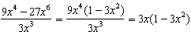

PTS: 2 REF: fall0718ia STA: A.A.14 TOP: Rational Expressions

19 ANS: 3

PTS: 2 REF: fall0719ia STA: A.A.9 TOP: Exponential Functions

20 ANS: 2
The slope of the inequality is .

PTS: 2 REF: fall0720ia STA: A.G.6 TOP: Linear Inequalities

21 ANS: 1
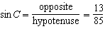

PTS: 2 REF: fall0721ia STA: A.A.42 TOP: Trigonometric Ratios

22 ANS: 4
The transformation is a reflection in the x-axis.

PTS: 2 REF: fall0722ia STA: A.G.5 TOP: Graphing Absolute Value Functions

23 ANS: 1 PTS: 2 REF: fall0723ia STA: A.M.3
TOP: Error

24 ANS: 1
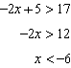

PTS: 2 REF: fall0724ia STA: A.A.21 TOP: Interpreting Solutions

25 ANS: 2 PTS: 2 REF: fall0725ia STA: A.N.4
TOP: Operations with Scientific Notation

26 ANS: 4
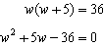

PTS: 2 REF: fall0726ia STA: A.A.5 TOP: Modeling Equations

27 ANS: 4
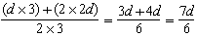

PTS: 2 REF: fall0727ia STA: A.A.17 TOP: Addition and Subtraction of Rationals

28 ANS: 1 PTS: 2 REF: fall0728ia STA: A.A.15
TOP: Undefined Rationals

29 ANS: 4 PTS: 2 REF: fall0729ia STA: A.A.2
TOP: Expressions

30 ANS: 4 PTS: 2 REF: fall0730ia STA: A.G.3
TOP: Defining Functions

31 ANS:
.

PTS: 2 REF: fall0731ia STA: A.N.2 TOP: Simplifying Radicals

32 ANS:
4. 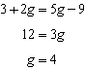 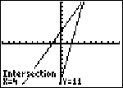

PTS: 2 REF: fall0732ia STA: A.A.22 TOP: Solving Equations

33 ANS:
33.4. Serena needs 24 feet of fencing to surround the rectangular portion of the garden. The length of the fencing needed for the semicircular portion of the garden is 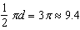 feet.

PTS: 2 REF: fall0733ia STA: A.G.1 TOP: Compositions of Polygons and Circles

34 ANS:
50, 1.5, 10. 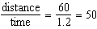. 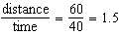. .

PTS: 3 REF: fall0734ia STA: A.M.1 TOP: Speed

35 ANS:
7. 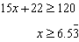

PTS: 3 REF: fall0735ia STA: A.A.6 TOP: Modeling Inequalities

36 ANS:
(S,S), (S,K), (S,D), (K,S), (K,K), (K,D), (D,S), (D,K), (D,D),

PTS: 3 REF: fall0736ia STA: A.S.19 TOP: Sample Space

37 ANS:
225000, 175000, the median better represents the value since it is closer to more values than the mean.

PTS: 4 REF: fall0737ia STA: A.S.4
TOP: Frequency Histograms, Bar Graphs and Tables

38 ANS:
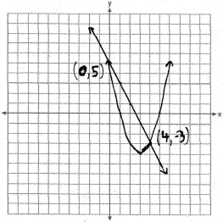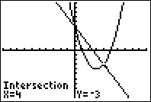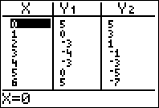

PTS: 4 REF: fall0738ia STA: A.G.9 TOP: Quadratic-Linear Systems

39 ANS:
. 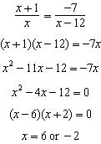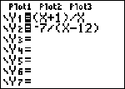 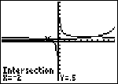

PTS: 4 REF: fall0739ia STA: A.A.26 TOP: Solving Rationals

