1 What is the product of and ?
1)
2)
3)
4)

2 The value of the expression is
1) | 26
2) | 14
3)
4)

3 When is factored, it is equivalent to . What is a value for b?
1) | 50
2) | 10
3) | 3
4) | 100

4 Which equation represents the line that passes through the points and ?
1)
2)
3) | 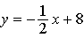
4) | 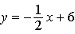

5 The graph below represents the parabolic path of a ball kicked by a young child. What are the vertex and the axis of symmetry for the parabola?

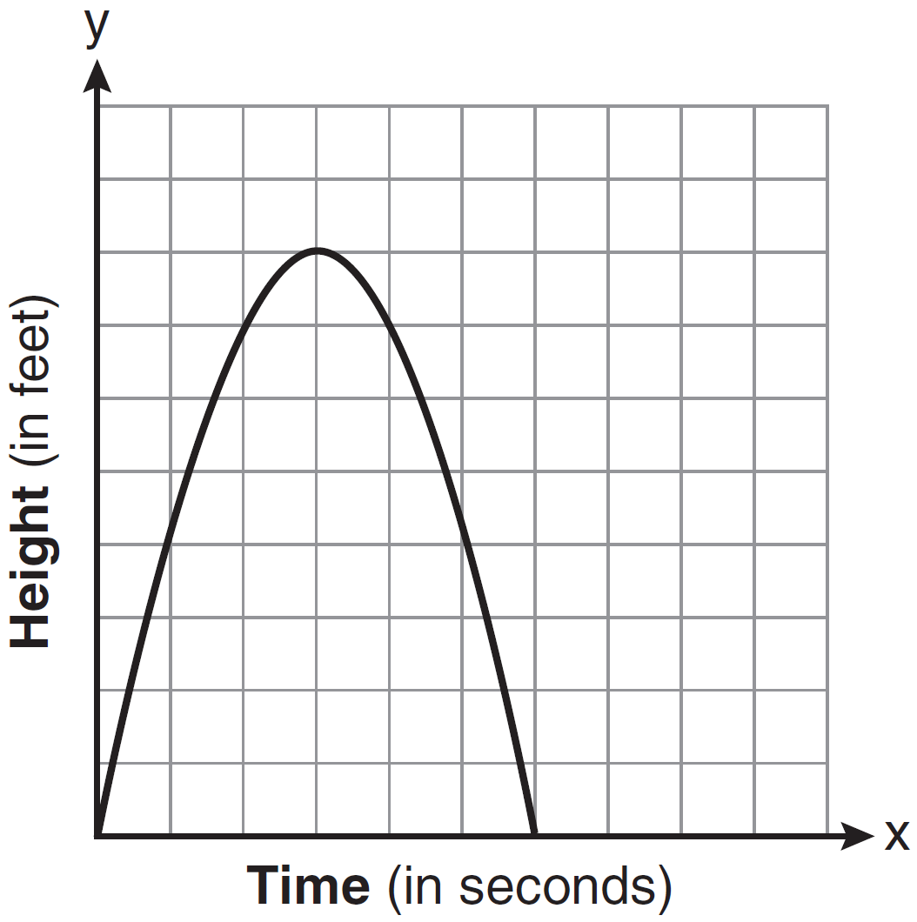
1) | vertex: ; axis of symmetry:
2) | vertex: ; axis of symmetry:
3) | vertex: ; axis of symmetry:
4) | vertex: ; axis of symmetry:

6 Which relationship can best be described as causal?
1) | The alarm goes off and the sun rises.
2) | The car is moving slowly and the driver is singing.
3) | The snow is falling and the stores run out of snow shovels.
4) | The birds are chirping and the rain is coming down.

7 In a class, which data can be classified as qualitative?
1) | age of students
2) | weight of students
3) | shoe size of students
4) | hair color of students

8 Given the following:
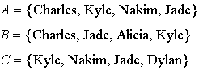
What is the intersection of sets A, B, and C?
1)
2)
3)
4)

9 The sum of 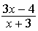 and 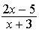 is
1) | 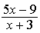
2) | 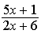
3) | 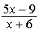
4) | 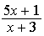

10 If Rosa's age is represented by R, which inequality represents the statement "Rosa is at most 29 years old"?
1)
2)
3)
4)

11 What is the slope of a line passing through points and ?
1)
2)
3)
4)

12 A positive correlation always exists on a scatter plot when
1) | y remains unchanged as x increases
2) | y changes randomly as x increases
3) | y decreases as x increases
4) | y increases as x increases

13 A sandwich consists of one type of meat, one type of condiment, and one type of cheese. The possible choices are listed below:
Meat: beef, chicken, turkey
Condiment: ketchup, mustard, mayonnaise
Cheese: American, cheddar, provolone, mozzarella
In the sample space of all the possible different sandwiches consisting of one type of meat, one type of condiment, and one type of cheese, how many sandwiches do not include provolone cheese?
1) | 27
2) | 9
3) | 3
4) | 36

14 The graph of the equation is shown below.

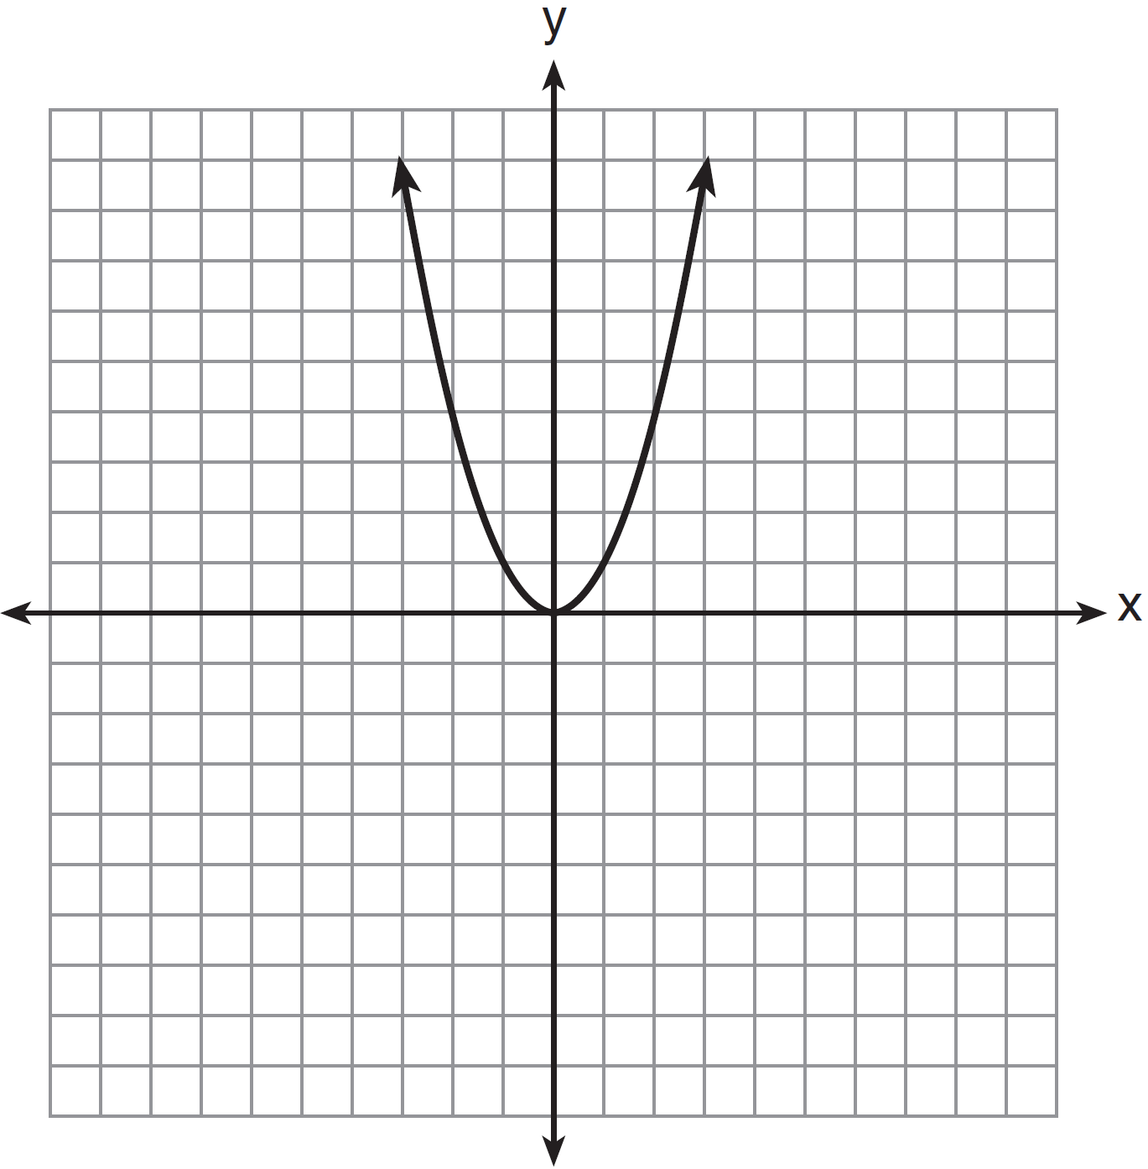

Which statement best describes the change in this graph when the coefficient of is multiplied by 4?
1) | The parabola becomes wider.
2) | The parabola becomes narrower.
3) | The parabola will shift up four units.
4) | The parabola will shift right four units.

15 A parking lot is 100 yards long. What is the length of of the parking lot, in feet?

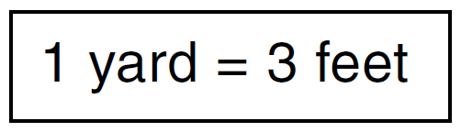
1) | 300
2) | 225
3) | 75
4) | 25

16 What is the solution of the equation 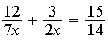?
1) | 1
2) | 5
3) | 3
4) | 14

17 The expression 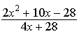 is undefined when x is
1) | 7, only
2) | , only
3) | 7 or
4) | or 2

18 In right triangle JKL in the diagram below, , , , and .

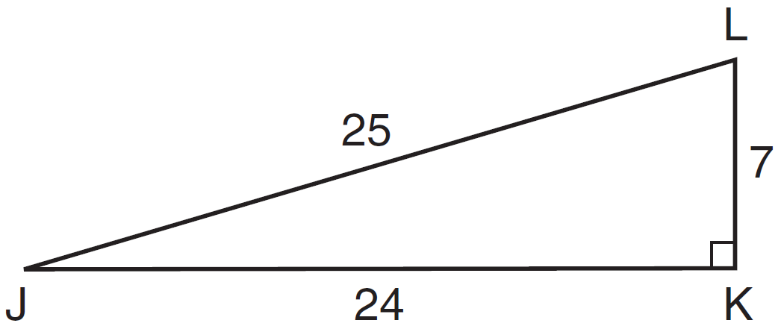

Which statement is not true?
1) | 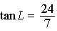
2) | 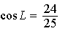
3) | 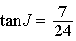
4) | 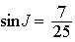

19 A teacher asked the class to solve the equation . Robert wrote as his first step. Which property did he use?
1) | associative property
2) | commutative property
3) | distributive property
4) | zero property of addition

20 If the roots of a quadratic equation are and 2, the equation is equivalent to
1)
2)
3)
4)

21 Kelsey scored the following points in her first six basketball games: 22, 14, 19, 22, 8, and 17. What is the relationship between the measures of central tendency of these data?
1) | mode > median > mean
2) | median > mode > mean
3) | mean > median > mode
4) | mode > mean > median

22 Sheba opened a retirement account with $36,500. Her account grew at a rate of 7% per year compounded annually. She made no deposits or withdrawals on the account. At the end of 20 years, what was the account worth, to the nearest dollar?
1) | $87,600
2) | $130,786
3) | $141,243
4) | $1,483,444,463

23 Which equation represents a vertical line?
1)
2)
3)
4)

24 Byron has 72 coins in his piggy bank. The piggy bank contains only dimes and quarters. If he has $14.70 in his piggy bank, which equation can be used to determine q, the number of quarters he has?
1)
2)
3)
4)

25 Which graph represents the equation ?
1) | 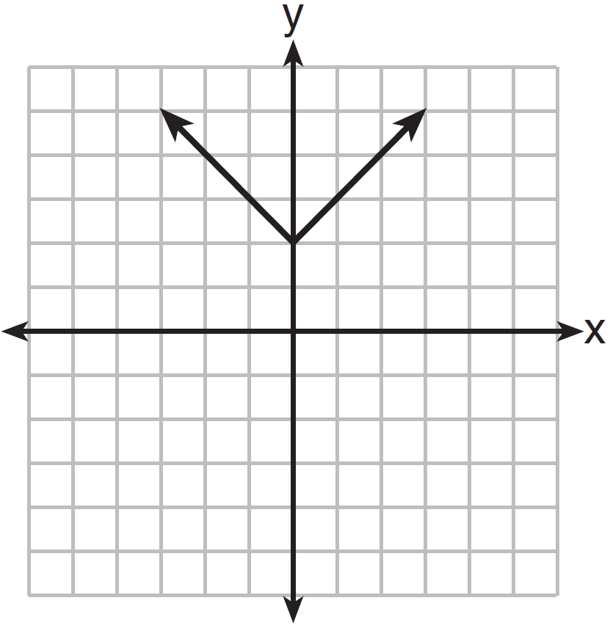
2) | 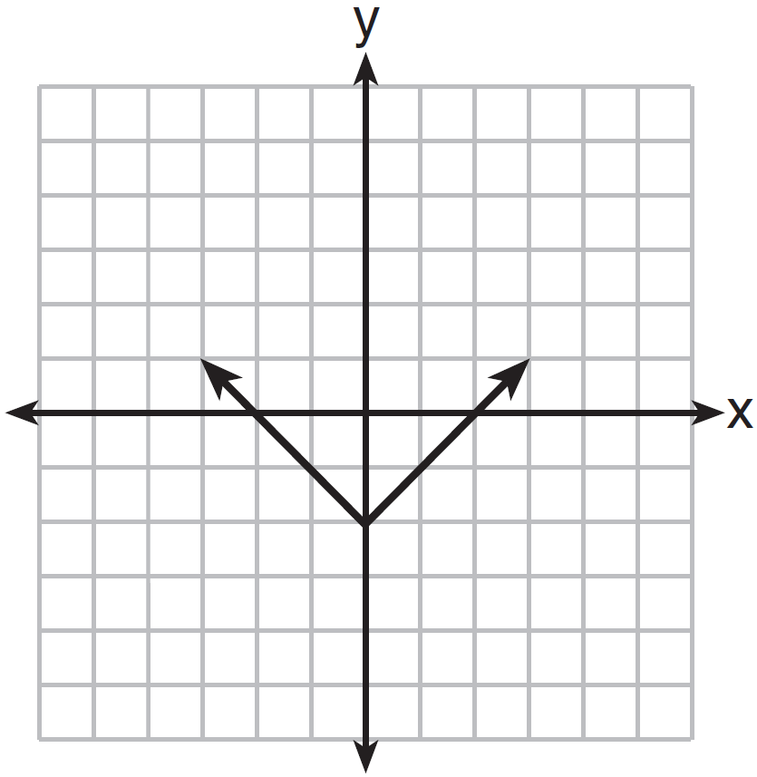
3) | 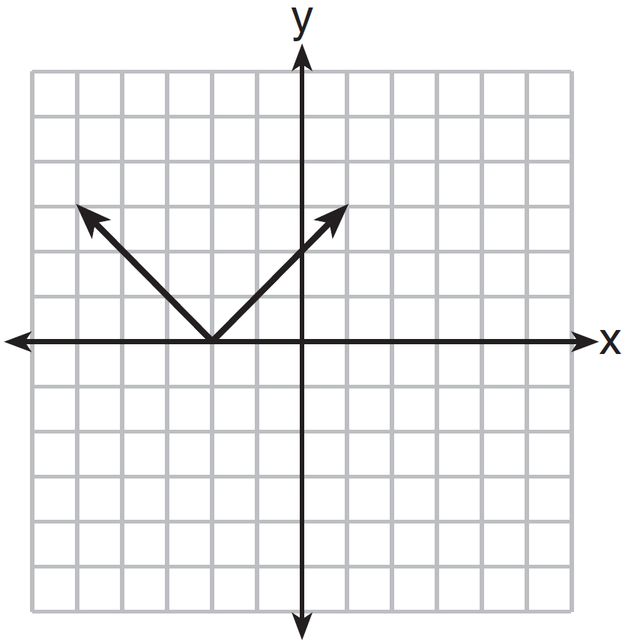
4) | 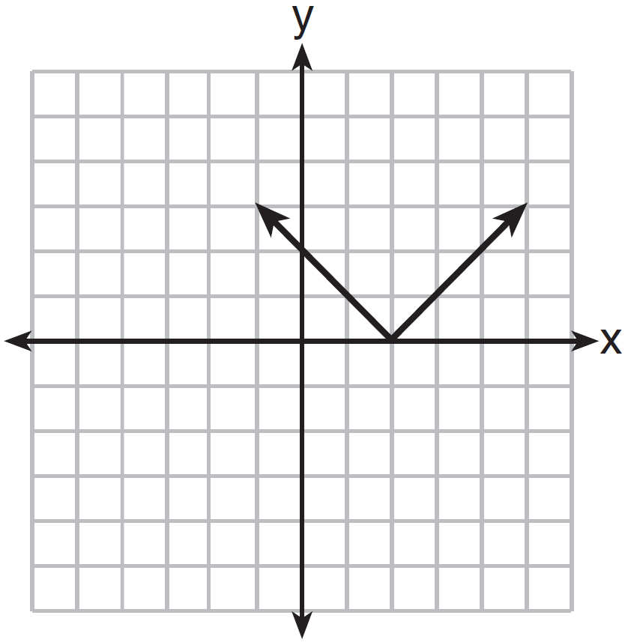

26 If , what is x expressed in terms of a and b?
1)
2) | 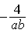
3) | 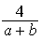
4) | 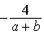

27 Which equation represents a line that is parallel to the line whose equation is ?
1) | 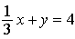
2) | 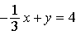
3)
4)

28 What is the result when is subtracted from ?
1)
2)
3)
4)

29 What is the solution of the equation 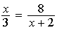?
1)
2)
3)
4)

30 Which set of integers is included in ?
1)
2)
3)
4)

31 Using his data on annual deer population in a forest, Noj found the following information:
25th percentile: 12
50th percentile: 15
75th percentile: 22
Minimum population: 8
Maximum population: 27
Using the number line below, construct a box-and-whisker plot to display these data.

32 The diagram below consists of a square with a side of 4 cm, a semicircle on the top, and an equilateral triangle on the bottom. Find the perimeter of the figure to the nearest tenth of a centimeter.

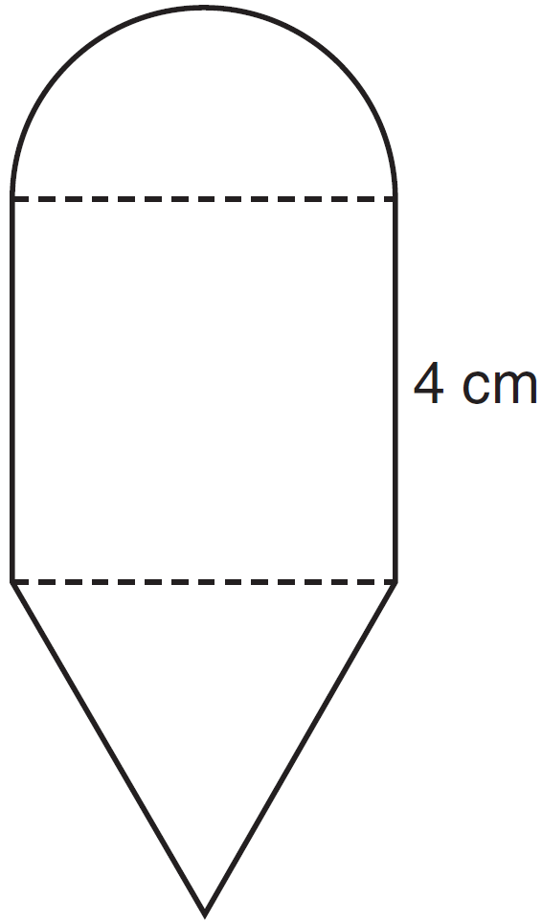

33 A thermos in the shape of a cylinder is filled to 1 inch from the top of the cylinder with coffee. The height of the cylinder is 12 inches and its radius is 2.5 inches. State, to the nearest hundredth of a cubic inch, the volume of coffee in the thermos.

34 The top of a lighthouse, T, is 215 feet above sea level, L, as shown in the diagram below. The angle of depression from the top of the lighthouse to a boat, B, at sea is 26°. Determine, to the nearest foot, the horizontal distance, x, from the boat to the base of the lighthouse.

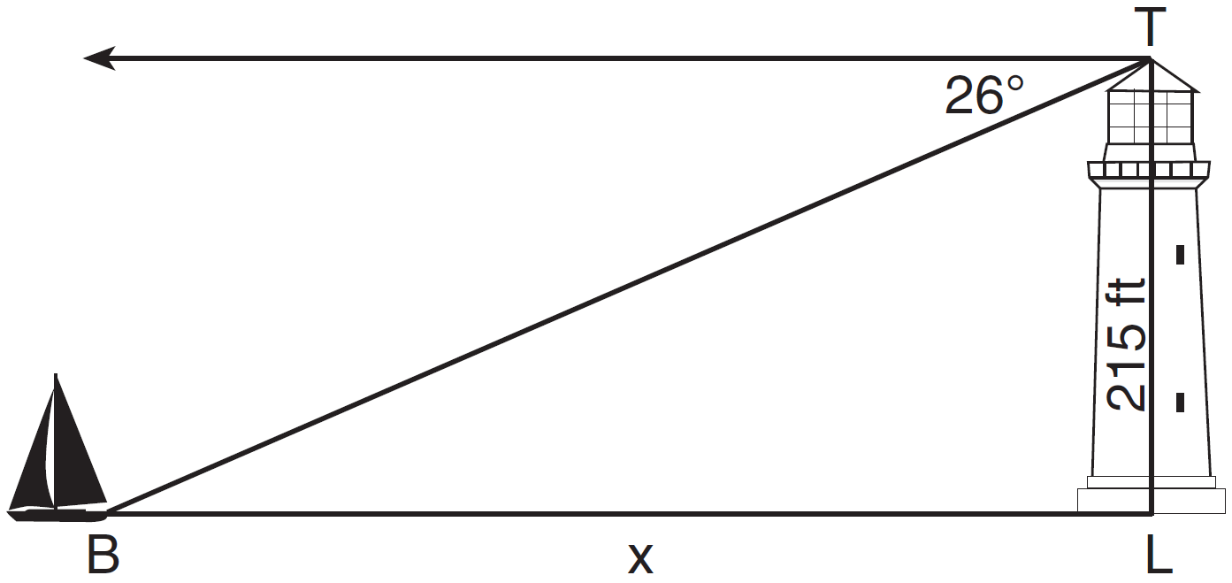

35 There are six apples, five oranges, and one pear in John's basket. His friend takes three pieces of fruit at random without replacement. Determine the probability that all three fruits taken are apples.

36 Express 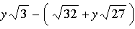 in simplest radical form.

37 On the set of axes below, solve the following system of inequalities graphically.
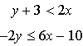
State the coordinates of a point in the solution set.

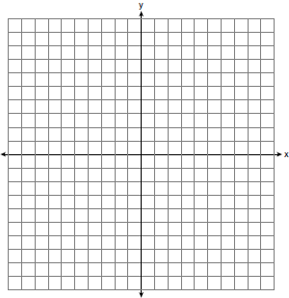

38 The actual side of a square tile is 4 inches. The manufacturers allow a relative error of 0.025 in the area of a tile. Two machines are used to cut the tiles. Machine A produces a square tile with a length of 3.97 inches. Machine B produces a square tile with a length of 4.12 inches. Determine which machine produces a tile whose area falls within the allowed relative error.

39 Solve the following system of equations algebraically: 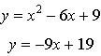

1 ANS: 4 PTS: 2 REF: 081401ia STA: A.A.12
TOP: Multiplication of Powers

2 ANS: 2 PTS: 2 REF: 081402ia STA: A.N.6
TOP: Evaluating Expressions

3 ANS: 2 PTS: 2 REF: 081403ia STA: A.A.19
TOP: Factoring the Difference of Perfect Squares

4 ANS: 2
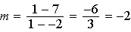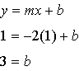

PTS: 2 REF: 081404ia STA: A.A.35 TOP: Writing Linear Equations

5 ANS: 1 PTS: 2 REF: 081405ia STA: A.G.10
TOP: Identifying the Vertex of a Quadratic Given Graph

6 ANS: 3 PTS: 2 REF: 081406ia STA: A.S.13
TOP: Analysis of Data

7 ANS: 4
The other situations are quantitative.

PTS: 2 REF: 081407ia STA: A.S.1 TOP: Analysis of Data

8 ANS: 4 PTS: 2 REF: 081408ia STA: A.A.31
TOP: Set Theory

9 ANS: 1 PTS: 2 REF: 081409ia STA: A.A.17
TOP: Addition and Subtraction of Rationals

10 ANS: 3 PTS: 2 REF: 081410ia STA: A.A.4
TOP: Modeling Inequalities

11 ANS: 2
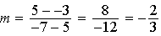

PTS: 2 REF: 081411ia STA: A.A.33 TOP: Slope

12 ANS: 4 PTS: 2 REF: 081412ia STA: A.S.12
TOP: Scatter Plots

13 ANS: 1

PTS: 2 REF: 081413ia STA: A.S.19 TOP: Sample Space

14 ANS: 2 PTS: 2 REF: 081414ia STA: A.G.5
TOP: Graphing Quadratic Functions

15 ANS: 2
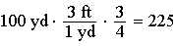

PTS: 2 REF: 081415ia STA: A.M.2 TOP: Conversions
KEY: dimensional analysis

16 ANS: 3
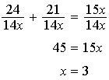

PTS: 2 REF: 081416ia STA: A.A.26 TOP: Solving Rationals

17 ANS: 2
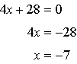

PTS: 2 REF: 081417ia STA: A.A.15 TOP: Undefined Rationals

18 ANS: 2 PTS: 2 REF: 081418ia STA: A.A.42
TOP: Trigonometric Ratios

19 ANS: 3 PTS: 2 REF: 081419ia STA: A.N.1
TOP: Identifying Properties

20 ANS: 1 PTS: 2 REF: 081420ia STA: A.A.28
TOP: Roots of Quadratics

21 ANS: 1
The mean is 17, the median is 18 and the mode is 22.

PTS: 2 REF: 081421ia STA: A.S.4 TOP: Central Tendency

22 ANS: 3

PTS: 2 REF: 081422ia STA: A.A.9 TOP: Exponential Functions

23 ANS: 4 PTS: 2 REF: 081423ia STA: A.A.36
TOP: Parallel and Perpendicular Lines

24 ANS: 3 PTS: 2 REF: 081424ia STA: A.A.5
TOP: Modeling Equations

25 ANS: 4 PTS: 2 REF: 081425ia STA: A.G.4
TOP: Graphing Absolute Value Functions

26 ANS: 3
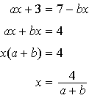

PTS: 2 REF: 081426ia STA: A.A.23 TOP: Transforming Formulas

27 ANS: 3
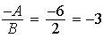

PTS: 2 REF: 081427ia STA: A.A.38 TOP: Parallel and Perpendicular Lines

28 ANS: 4 PTS: 2 REF: 081428ia STA: A.A.13
TOP: Addition and Subtraction of Polynomials KEY: subtraction

29 ANS: 2
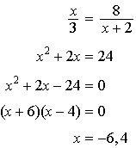

PTS: 2 REF: 081429ia STA: A.A.26 TOP: Solving Rationals

30 ANS: 1 PTS: 2 REF: 081430ia STA: A.A.29
TOP: Set Theory

31 ANS:
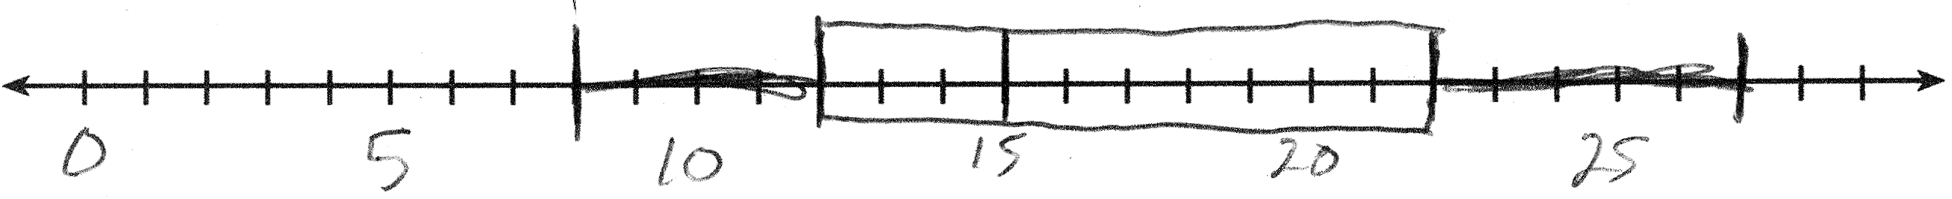

PTS: 2 REF: 081431ia STA: A.S.5 TOP: Box-and-Whisker Plots

32 ANS:

PTS: 2 REF: 081432ia STA: A.G.1 TOP: Compositions of Polygons and Circles
KEY: perimeter

33 ANS:

PTS: 2 REF: 081433ia STA: A.G.2 TOP: Volume

34 ANS:
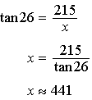

PTS: 3 REF: 081434ia STA: A.A.44 TOP: Using Trigonometry to Find a Side

35 ANS:
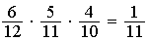

PTS: 3 REF: 081435ia STA: A.S.23 TOP: Theoretical Probability
KEY: dependent events

36 ANS:

PTS: 3 REF: 081436ia STA: A.N.3 TOP: Operations with Radicals
KEY: subtraction

37 ANS:
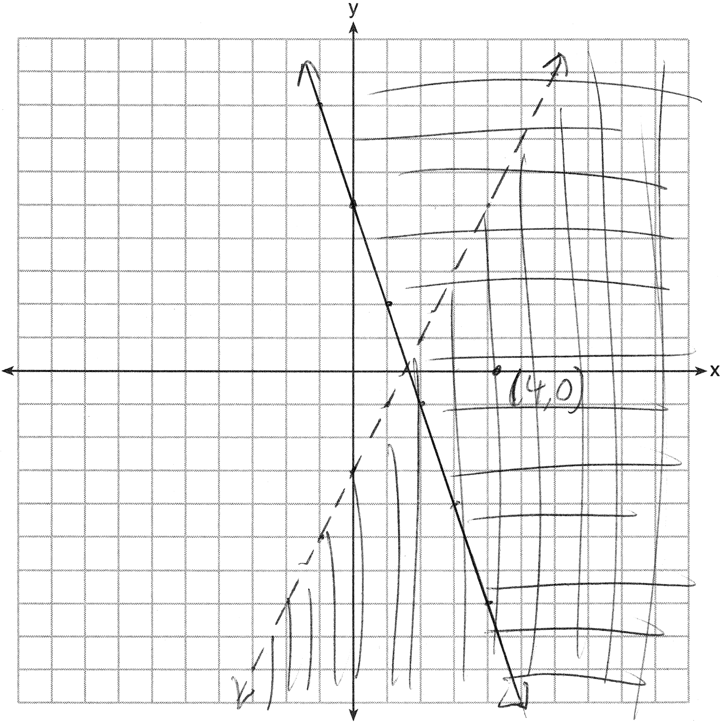

PTS: 4 REF: 081437ia STA: A.G.7 TOP: Systems of Linear Inequalities

38 ANS:
Machine A. 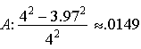 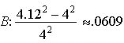

PTS: 4 REF: 081438ia STA: A.M.3 TOP: Error
KEY: area

39 ANS:
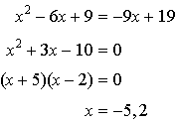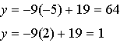

PTS: 4 REF: 081439ia STA: A.A.11 TOP: Quadratic-Linear Systems

