1 Which situation describes a negative correlation?
1) | the amount of gas left in a car's tank and the amount of gas used from it
2) | the number of gallons of gas purchased and the amount paid for the gas
3) | the size of a car's gas tank and the number of gallons it holds
4) | the number of miles driven and the amount of gas used

2 The sum of and is
1)
2)
3)
4)

3 Which event is certain to happen?
1) | Everyone walking into a room will have red hair.
2) | All babies born in June will be males.
3) | The Yankees baseball team will win the World Series.
4) | The Sun will rise in the east.

4 Noj is 5 years older than Jacob. The product of their ages is 84. How old is Noj?
1) | 6
2) | 7
3) | 12
4) | 14

5 Marie currently has a collection of 58 stamps. If she buys s stamps each week for w weeks, which expression represents the total number of stamps she will have?
1)
2)
3)
4)

6 Given:
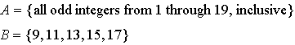
What is the complement of set B within set A?
1)
2)
3)
4)

7 Which equation represents a line that is parallel to the line whose equation is ?
1)
2) | 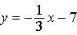
3) | 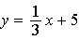
4)

8 Which graph does not represent the graph of a function?
1) | 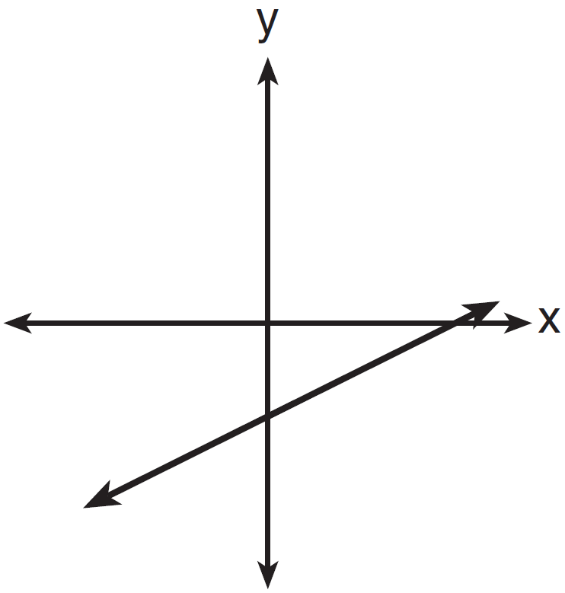
2) | 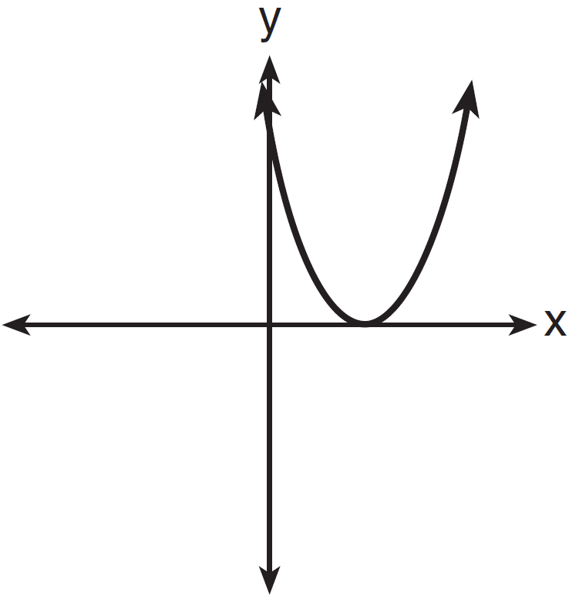
3) | 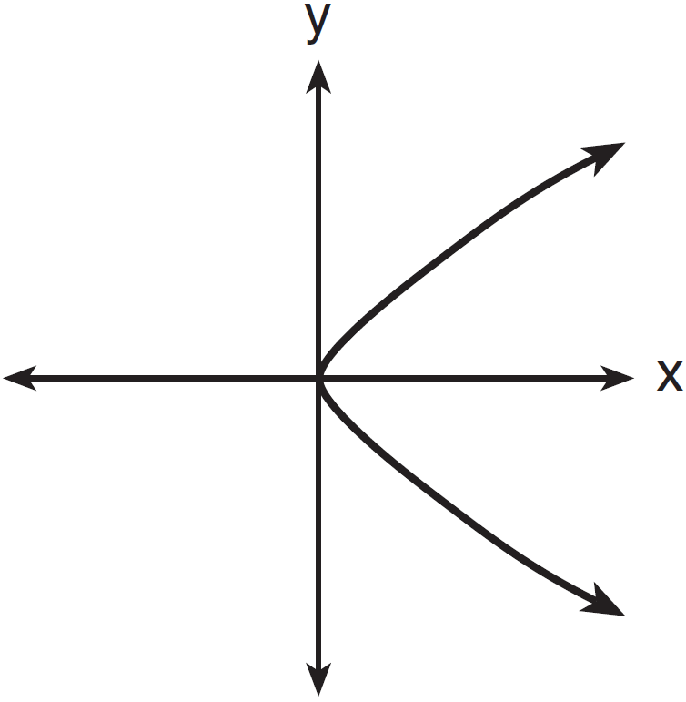
4) | 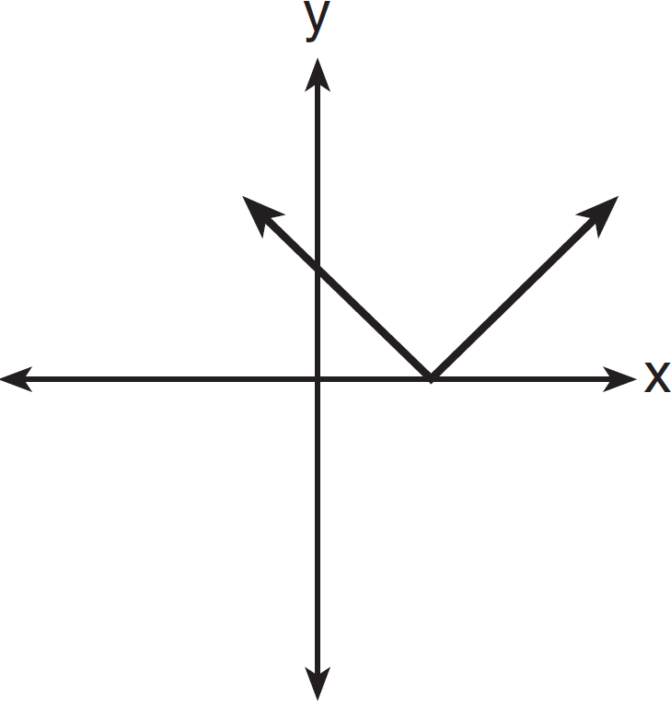

9 Which value of x is in the solution set of ?
1)
2)
3) | 0
4) | 3

10 What is the slope of the line that passes through the points and ?
1)
2)
3) | 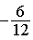
4) | 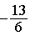

11 The product of 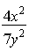 and 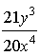, expressed in simplest form, is
1)
2) | 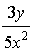
3) | 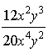
4) | 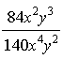

12 The box-and-whisker plot below represents a set of grades in a college statistics class.

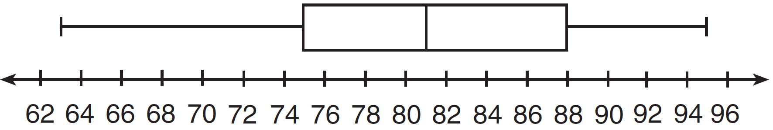

Which interval contains exactly 50% of the grades?
1) | 63-88
2) | 63-95
3) | 75-81
4) | 75-88

13 An art studio has a list of information posted with each sculpture that is for sale. Each entry in the list could be classified as quantitative except for the
1) | cost
2) | height
3) | artist
4) | weight

14 Which graph represents the inequality ?
1) | 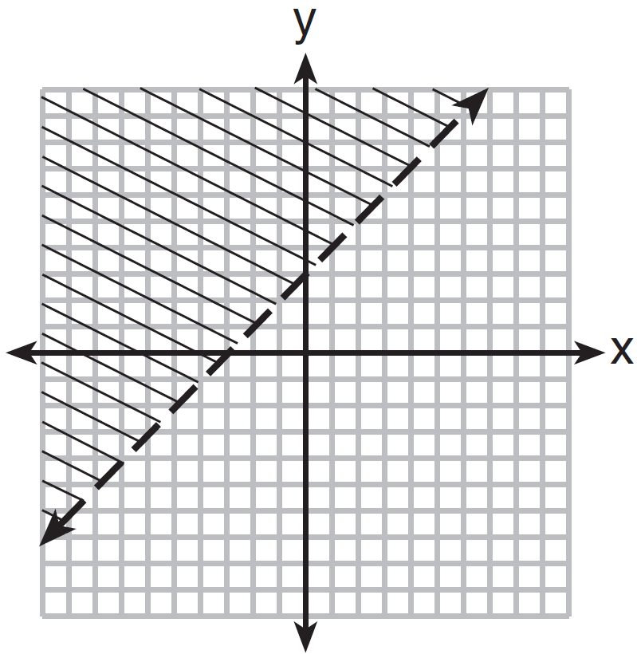
2) | 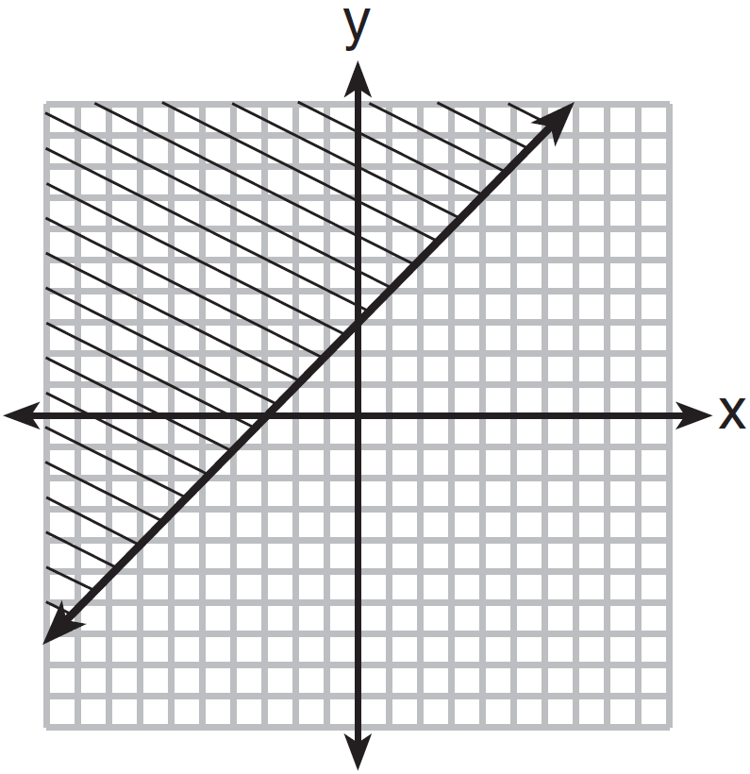
3) | 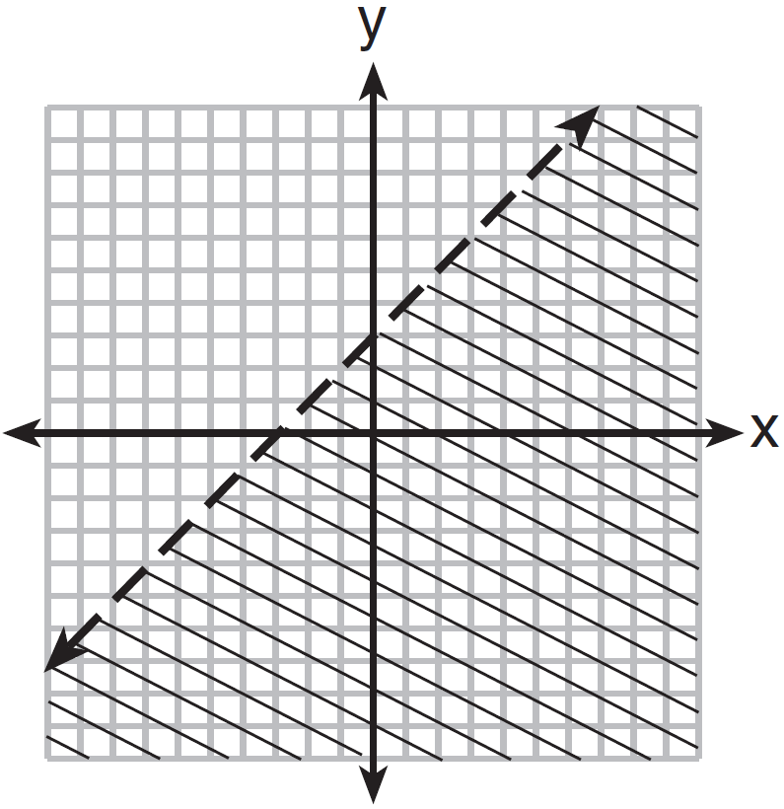
4) | 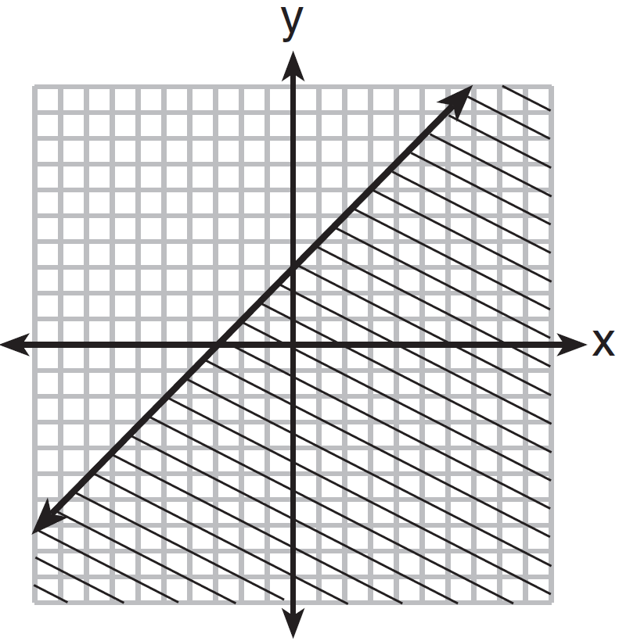

15 Using the substitution method, Ken solves the following system of equations algebraically.
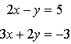
Which equivalent equation could Ken use?
1)
2)
3) | 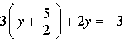
4) | 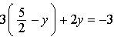

16 A value of x that makes the expression 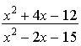 undefined is
1)
2)
3) | 3
4) | 5

17 The statement is true when x is equal to
1)
2)
3) | 17
4) | 21

18 Which equation is true?
1) | 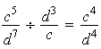
2)
3) | 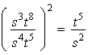
4)

19 The equation illustrates which property?
1) | commutative
2) | associative
3) | distributive
4) | multiplicative inverse

20 Monique has three sons who play football, two sons who play baseball, and one son who plays both sports. If all of her sons play baseball or football, how many sons does she have?
1) | 5
2) | 6
3) | 3
4) | 4

21 Written in set-builder notation, is
1)
2)
3)
4)

22 Which is the equation of a parabola that has the same vertex as the parabola represented by , but is wider?
1)
2)
3)
4) | 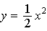

23 In right triangle ABC, , , and . What is the length of ?
1) | 6
2) | 20
3)
4)

24 A cube, with faces numbered 1 to 6, is rolled, and a penny is tossed at the same time. How many elements in the sample space consist of an even number and a tail?
1) | 12
2) | 2
3) | 3
4) | 4

25 If the volume of a cube is 8 cubic centimeters, what is its surface area, in square centimeters?
1) | 32
2) | 24
3) | 12
4) | 4

26 A designer created a garden, as shown in the diagram below. The garden consists of four quarter-circles of equal size inside a square. The designer put a fence around both the inside and the outside of the garden.

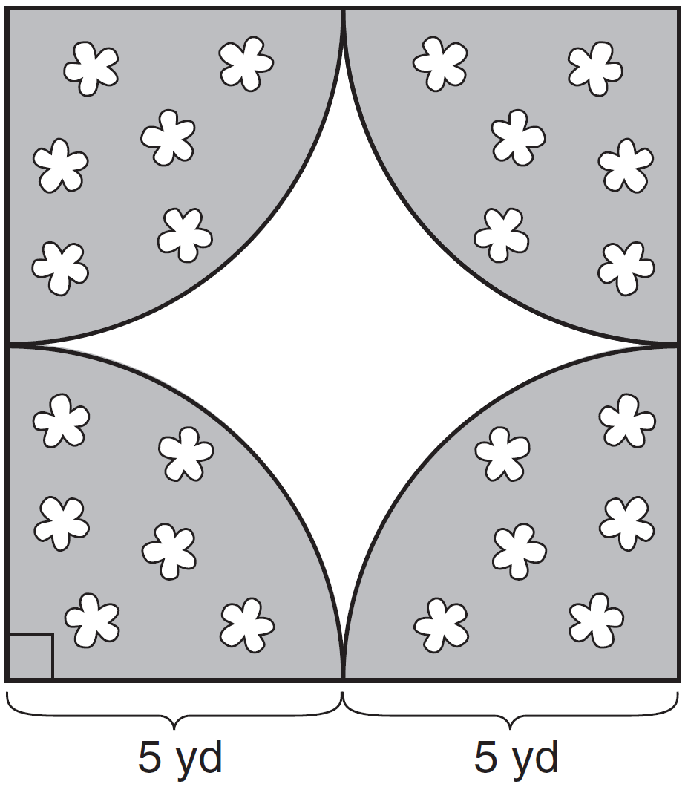

Which expression represents the amount of fencing, in yards, that the designer used for the fence?
1)
2)
3)
4)

27 Mr. Taylor raised all his students’ scores on a recent test by five points. How were the mean and the range of the scores affected?
1) | The mean increased by five and the range increased by five.
2) | The mean increased by five and the range remained the same.
3) | The mean remained the same and the range increased by five.
4) | The mean remained the same and the range remained the same.

28 Which fraction is equivalent to 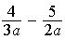?
1)
2) | 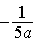
3) | 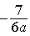
4) | 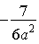

29 Which ratio represents the cosine of angle A in the right triangle below?

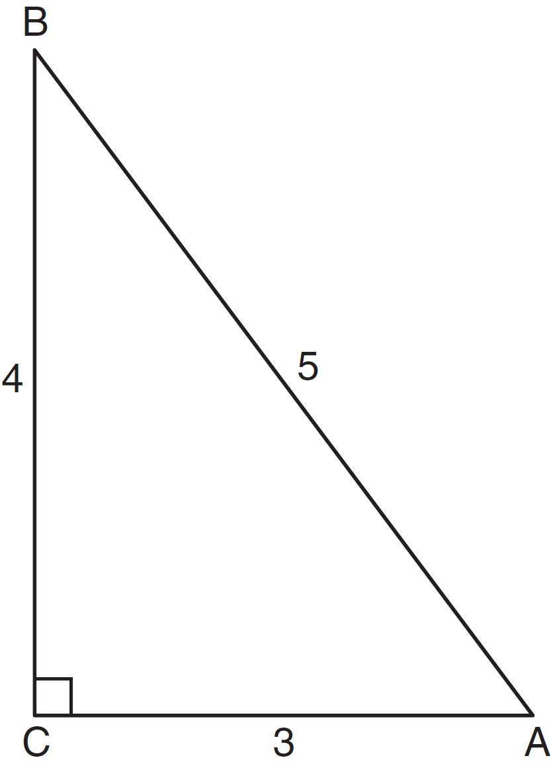
1)
2)
3)
4)

30 If , then w, in terms of x and y, is equal to
1)
2) | 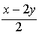
3)
4) | 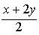

31 A jogger ran at a rate of 5.4 miles per hour. Find the jogger's exact rate, in feet per minute.

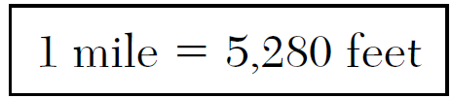

32 Express in simplest radical form.

33 Adrianne invested $2000 in an account at a 3.5% interest rate compounded annually. She made no deposits or withdrawals on the account for 4 years. Determine, to the nearest dollar, the balance in the account after the 4 years.

34 Miller's Department Store is having a sale with a 25% discount on mattresses. If the sales tax rate is 8%, how much change will Frank receive from $800 if he purchases a mattress regularly priced at $895 during this sale?

35 The difference between two numbers is 28. The larger number is 8 less than twice the smaller number. Find both numbers. [Only an algebraic solution can receive full credit.]

36 Janis measures the dimensions of the floor in her rectangular classroom for a rug. Her measurements are 10.50 feet by 12.25 feet. The actual measurements of the floor are 10.75 feet by 12.50 feet. Determine the relative error in calculating the area, to the nearest thousandth.

37 On the set of axes below, graph the following system of equations. Using the graph, determine and state all solutions of the system of equations.
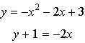

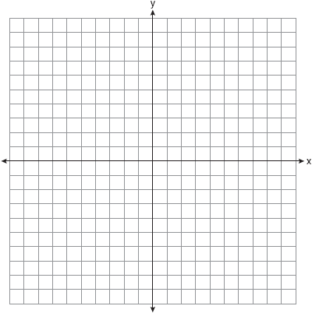

38 Express 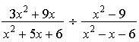 in simplest form.

39 A bottle contains 12 red marbles and 8 blue marbles. A marble is chosen at random and not replaced. Then, a second marble is chosen at random. Determine the probability that the two marbles are not the same color. Determine the probability that at least one of the marbles is red.

1 ANS: 1 PTS: 2 REF: 081301ia STA: A.S.12
TOP: Scatter Plots

2 ANS: 1 PTS: 2 REF: 081302ia STA: A.A.13
TOP: Addition and Subtraction of Polynomials KEY: addition

3 ANS: 4 PTS: 2 REF: 081303ia STA: A.S.22
TOP: Theoretical Probability

4 ANS: 3
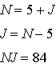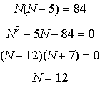

PTS: 2 REF: 081304ia STA: A.A.8 TOP: Writing Quadratics

5 ANS: 2 PTS: 2 REF: 081305ia STA: A.A.1
TOP: Expressions

6 ANS: 4

PTS: 2 REF: 081306ia STA: A.A.30 TOP: Set Theory

7 ANS: 1

PTS: 2 REF: 081307ia STA: A.A.38 TOP: Parallel and Perpendicular Lines

8 ANS: 3 PTS: 2 REF: 081308ia STA: A.G.3
TOP: Defining Functions KEY: graphs

9 ANS: 1
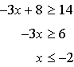

PTS: 2 REF: 081309ia STA: A.A.21 TOP: Interpreting Solutions

10 ANS: 2
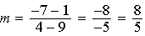

PTS: 2 REF: 081310ia STA: A.A.33 TOP: Slope

11 ANS: 2 PTS: 2 REF: 081311ia STA: A.A.12
TOP: Division of Powers

12 ANS: 4 PTS: 2 REF: 081312ia STA: A.S.6
TOP: Box-and-Whisker Plots

13 ANS: 3
The other situations are quantitative.

PTS: 2 REF: 081313ia STA: A.S.1 TOP: Analysis of Data

14 ANS: 2 PTS: 2 REF: 081314ia STA: A.G.6
TOP: Linear Inequalities

15 ANS: 1 PTS: 2 REF: 081315ia STA: A.A.10
TOP: Solving Linear Systems

16 ANS: 4
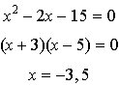

PTS: 2 REF: 081316ia STA: A.A.15 TOP: Undefined Rationals

17 ANS: 3 PTS: 2 REF: 081317ia STA: A.A.21
TOP: Interpreting Solutions

18 ANS: 2 PTS: 2 REF: 081318ia STA: A.A.12
TOP: Powers of Powers

19 ANS: 1 PTS: 2 REF: 081319ia STA: A.N.1
TOP: Identifying Properties

20 ANS: 4

PTS: 2 REF: 081320ia STA: A.A.6 TOP: Venn Diagrams

21 ANS: 4 PTS: 2 REF: 081321ia STA: A.A.29
TOP: Set Theory

22 ANS: 4 PTS: 2 REF: 081322ia STA: A.G.5
TOP: Graphing Quadratic Functions

23 ANS: 3
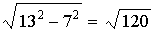

PTS: 2 REF: 081323ia STA: A.A.45 TOP: Pythagorean Theorem

24 ANS: 3

PTS: 2 REF: 081324ia STA: A.S.19 TOP: Sample Space

25 ANS: 2
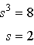.

PTS: 2 REF: 081325ia STA: A.G.2 TOP: Surface Area

26 ANS: 1

PTS: 2 REF: 081326ia STA: A.G.1 TOP: Compositions of Polygons and Circles
KEY: perimeter

27 ANS: 2 PTS: 2 REF: 081327ia STA: A.S.16
TOP: Central Tendency

28 ANS: 3
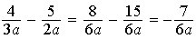

PTS: 2 REF: 081328ia STA: A.A.17 TOP: Addition and Subtraction of Rationals

29 ANS: 1
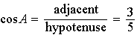

PTS: 2 REF: 081329ia STA: A.A.42 TOP: Trigonometric Ratios

30 ANS: 2
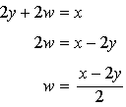

PTS: 2 REF: 081330ia STA: A.A.23 TOP: Transforming Formulas

31 ANS:
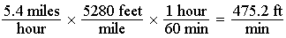

PTS: 2 REF: 081331ia STA: A.M.2 TOP: Conversions
KEY: dimensional analysis

32 ANS:

PTS: 2 REF: 081332ia STA: A.N.2 TOP: Simplifying Radicals

33 ANS:

PTS: 2 REF: 081333ia STA: A.A.9 TOP: Exponential Functions

34 ANS:

PTS: 3 REF: 081334ia STA: A.N.5 TOP: Percents

35 ANS:
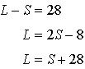. 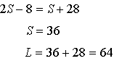

PTS: 3 REF: 081335ia STA: A.A.7 TOP: Writing Linear Systems

36 ANS:
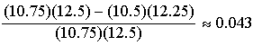
PTS: 3 REF: 081336ia STA: A.M.3 TOP: Error
KEY: area

37 ANS:
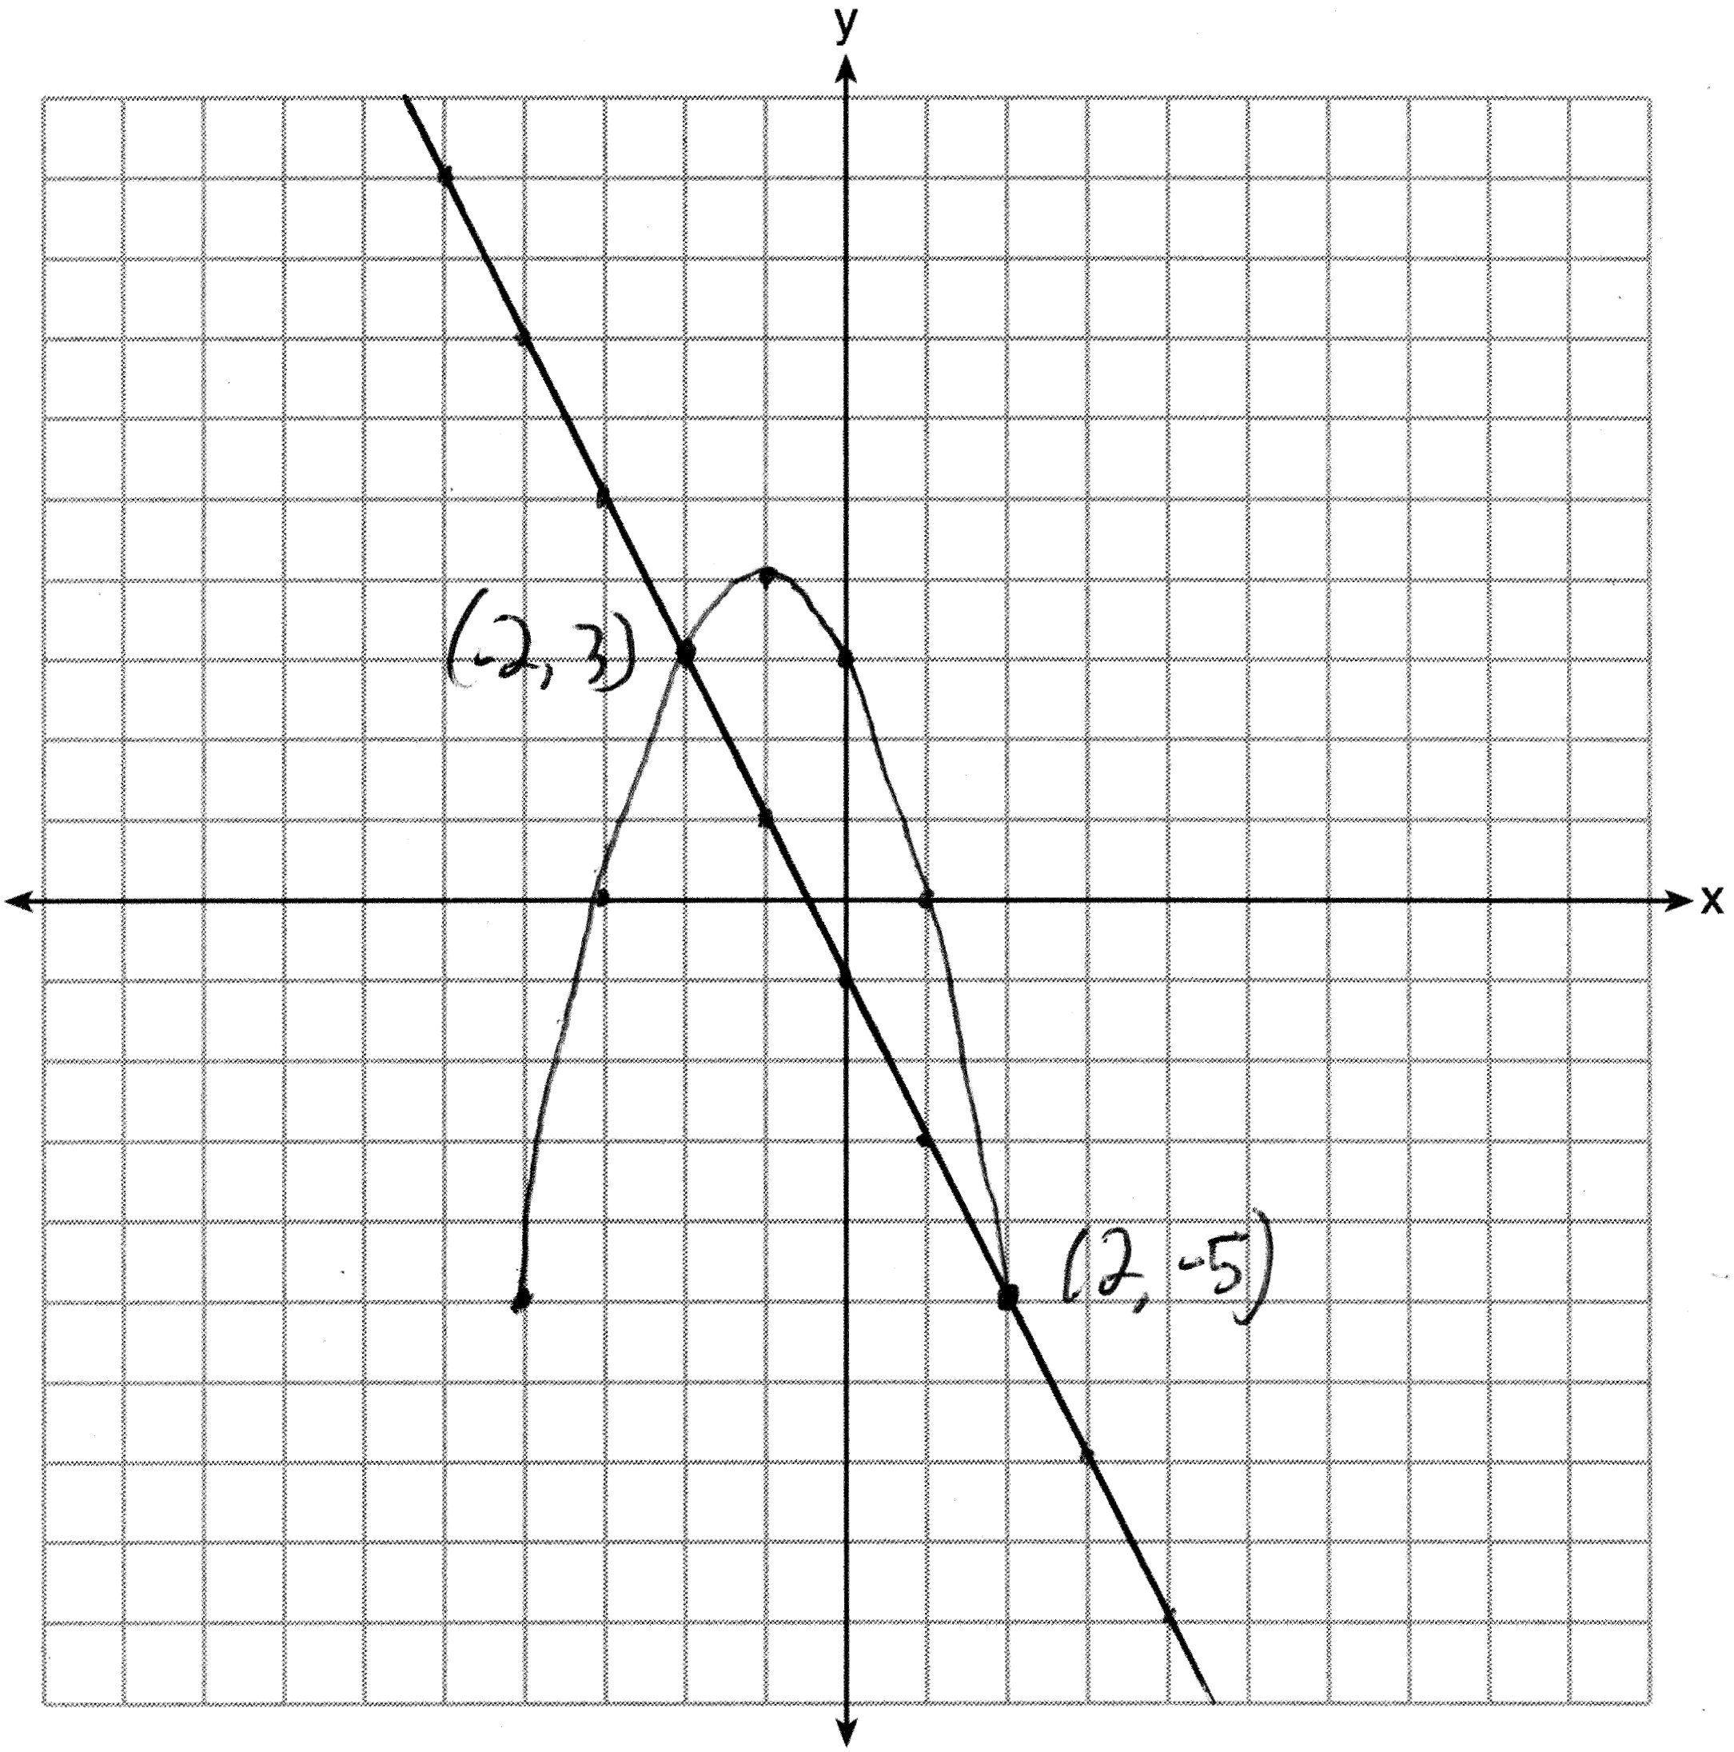
PTS: 4 REF: 081337ia STA: A.G.9 TOP: Quadratic-Linear Systems

38 ANS:
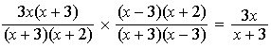
PTS: 4 REF: 081338ia STA: A.A.18 TOP: Multiplication and Division of Rationals
KEY: division

39 ANS:
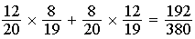. 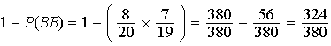
PTS: 4 REF: 081339ia STA: A.S.23 TOP: Theoretical Probability
KEY: dependent events

