1 A system of equations is graphed on the set of axes below.

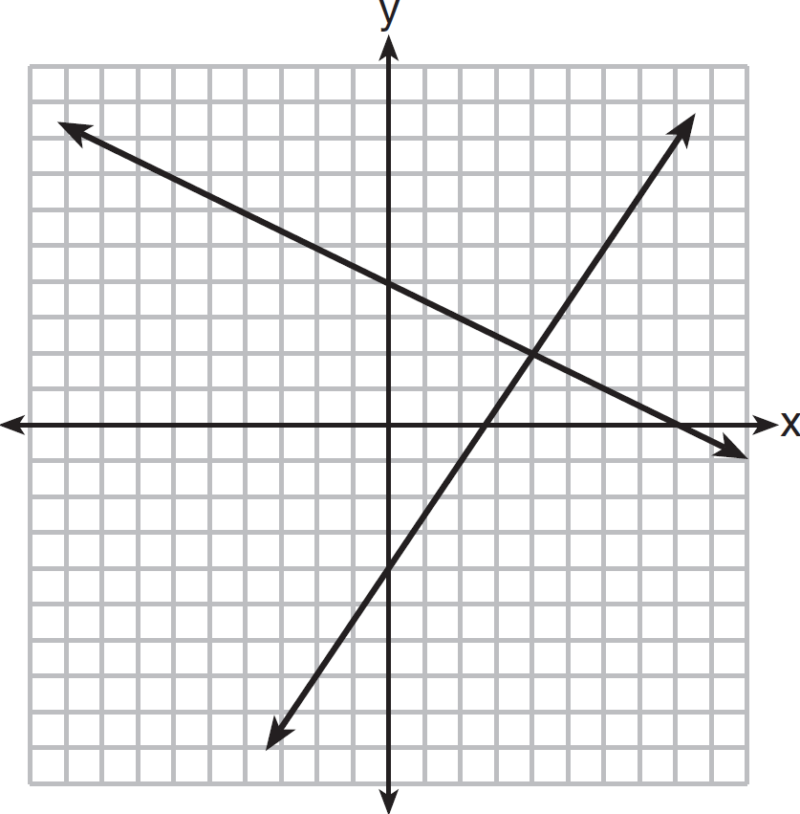

The solution of this system is
1)
2)
3)
4)

2 A cell phone can receive 120 messages per minute. At this rate, how many messages can the phone receive in 150 seconds?
1) | 48
2) | 75
3) | 300
4) | 18,000

3 The value of y in the equation is
1) | 500
2)
3) | 5,000
4)

4 The scatter plot shown below represents a relationship between x and y.

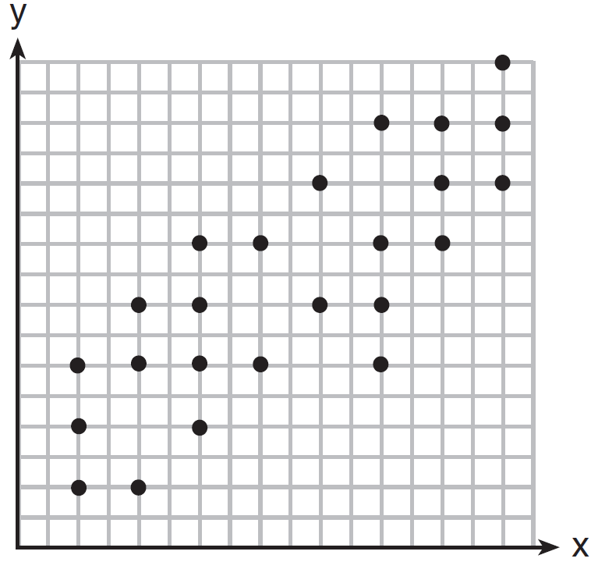
This type of relationship is
1) | a positive correlation
2) | a negative correlation
3) | a zero correlation
4) | not able to be determined

5 The sum of and is
1)
2)
3)
4)

6 Jason’s part-time job pays him $155 a week. If he has already saved $375, what is the minimum number of weeks he needs to work in order to have enough money to buy a dirt bike for $900?
1) | 8
2) | 9
3) | 3
4) | 4

7 The expression is equivalent to
1)
2)
3)
4)

8 The scatter plot below shows the profit, by month, for a new company for the first year of operation. Kate drew a line of best fit, as shown in the diagram.

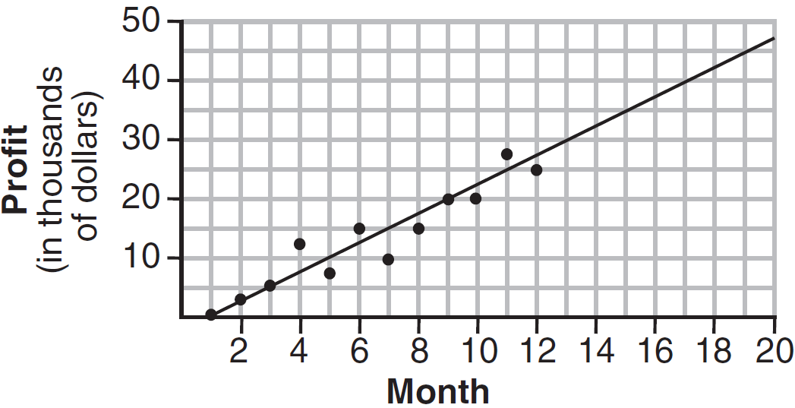

Using this line, what is the best estimate for profit in the 18th month?
1) | $35,000
2) | $37,750
3) | $42,500
4) | $45,000

9 Which statement illustrates the additive identity property?
1)
2)
3)
4)

10 Peter walked 8,900 feet from home to school.

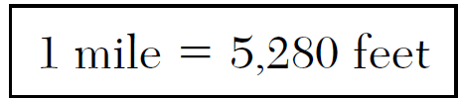
How far, to the nearest tenth of a mile, did he walk?
1) | 0.5
2) | 0.6
3) | 1.6
4) | 1.7

11 Is the equation a model of exponential growth or exponential decay, and what is the rate (percent) of change per time period?
1) | exponential growth and 12%
2) | exponential growth and 88%
3) | exponential decay and 12%
4) | exponential decay and 88%

12 The length of a rectangle is 15 and its width is w. The perimeter of the rectangle is, at most, 50. Which inequality can be used to find the longest possible width?
1)
2)
3)
4)

13 Craig sees an advertisement for a car in a newspaper. Which information would not be classified as quantitative?
1) | the cost of the car
2) | the car’s mileage
3) | the model of the car
4) | the weight of the car

14 What are the coordinates of the vertex and the equation of the axis of symmetry of the parabola shown in the graph below?

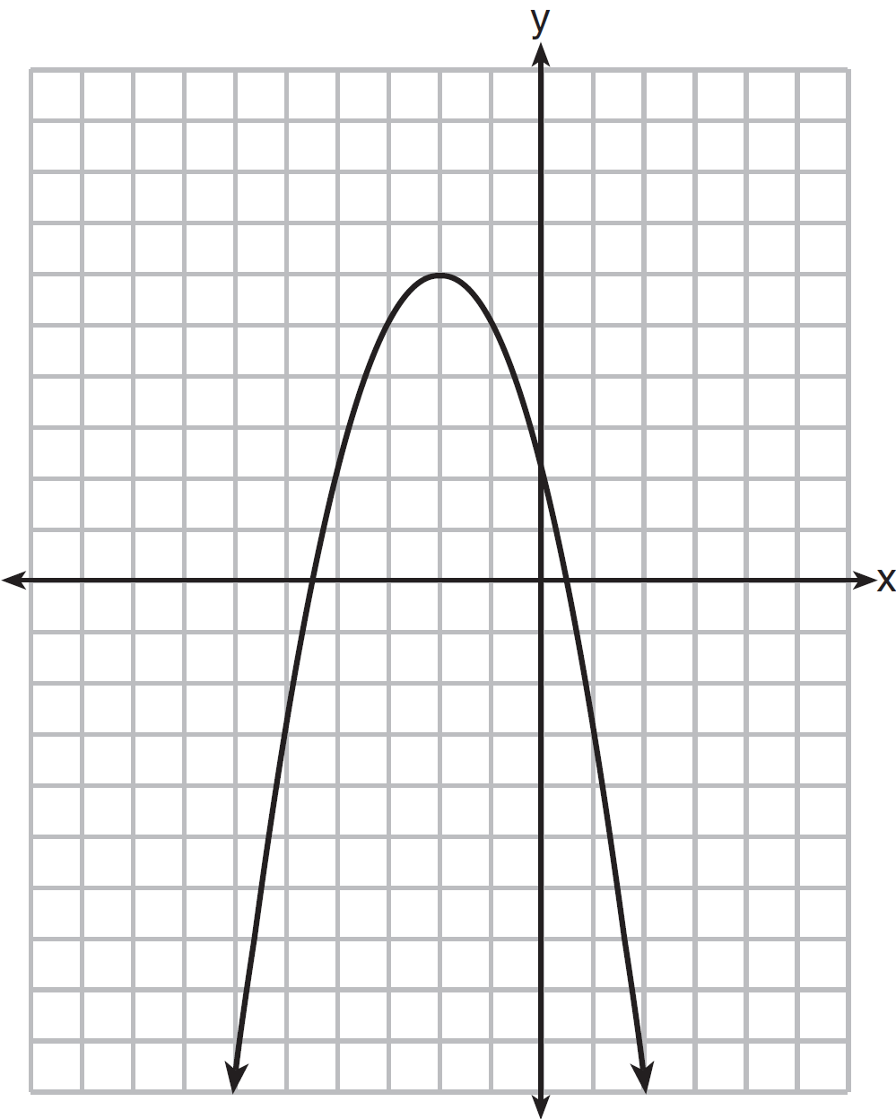
1) | and
2) | and
3) | and
4) | and

15 A correct translation of “six less than twice the value of x” is
1)
2)
3)
4)

16 The rectangular prism shown below has a length of 3.0 cm, a width of 2.2 cm, and a height of 7.5 cm.

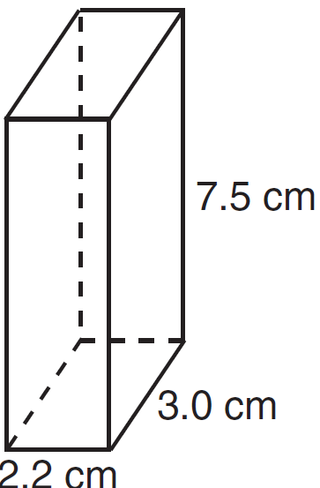

What is the surface area, in square centimeters?
1) | 45.6
2) | 49.5
3) | 78.0
4) | 91.2

17 Which set of coordinates is a solution of the equation ?
1)
2)
3)
4)

18 The graph of a parabola is represented by the equation where a is a positive integer. If a is multiplied by 2, the new parabola will become
1) | narrower and open downward
2) | narrower and open upward
3) | wider and open downward
4) | wider and open upward

19 Which equation represents a line that has a slope of and passes through the point ?
1)
2)
3)
4)

20 What is the value of 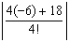?
1)
2)
3) | 12
4)

21 Given: 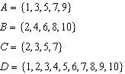
What statement is false?
1)
2)
3)
4)

22 Which expression is equivalent to 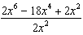?
1)
2)
3) | `
4)

23 In a given linear equation, the value of the independent variable decreases at a constant rate while the value of the dependent variable increases at a constant rate. The slope of this line is
1) | positive
2) | negative
3) | zero
4) | undefined

24 The volume of a cylindrical can in cubic inches. If the height of the can is 2 inches, what is its radius, in inches?
1) | 8
2) | 2
3) | 16
4) | 4

25 The expression 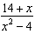 is undefined when x is
1) | , only
2) | 2, only
3) | or 2
4) | , , or 2

26 What is the solution of 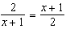?
1) | and
2) | and 3
3) | 1 and
4) | 1 and 3

27 The total score in a football game was 72 points. The winning team scored 12 points more than the losing team. How many points did the winning team score?
1) | 30
2) | 42
3) | 54
4) | 60

28 What is the perimeter of the figure shown below, which consists of an isosceles trapezoid and a semicircle?

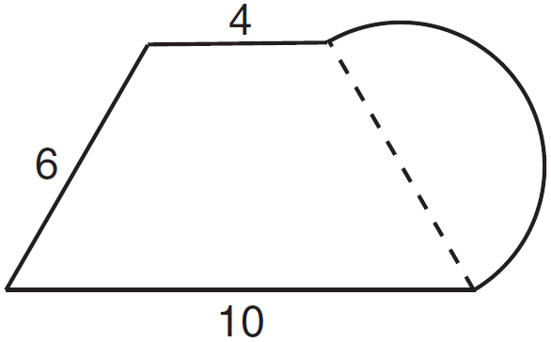
1)
2)
3)
4)

29 The probability it will rain tomorrow is . The probability that our team will win tomorrow’s basketball game is . Which expression represents the probability that it will rain and that our team will not win the game?
1) | 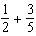
2) | 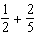
3) | 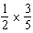
4) | 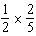

30 The formula for the volume of a pyramid is 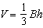. What is h expressed in terms of B and V?
1) | 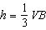
2) | 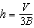
3) | 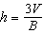
4)

31 State the value of the expression 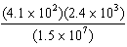 in scientific notation.

32 Express the product of 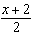 and 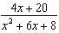 in simplest form.

33 On the set of axes below, graph over the interval .

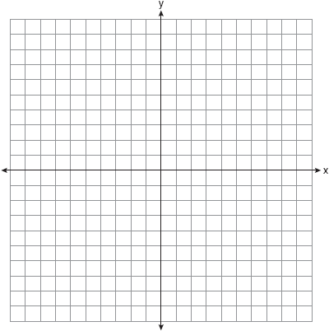

34 The following cumulative frequency histogram shows the distances swimmers completed in a recent swim test.

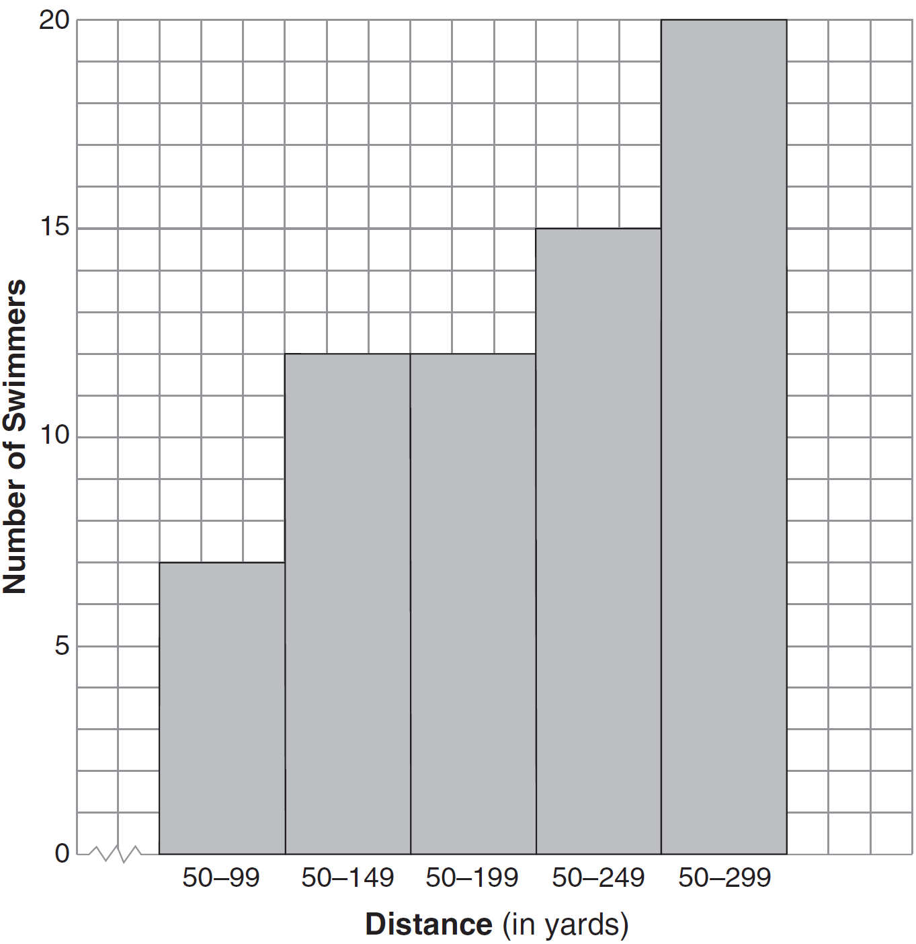

Based on the cumulative frequency histogram, determine the number of swimmers who swam between 200 and 249 yards. Determine the number of swimmers who swam between 150 and 199 yards. Determine the number of swimmers who took the swim test.

35 Ashley measured the dimensions of a rectangular prism to be 6 cm by 10 cm by 1.5 cm. The actual dimensions are 5.9 cm by 10.3 cm by 1.7 cm. Determine the relative error, to the nearest thousandth, in calculating the volume of the prism.

36 Solve the following system of equations algebraically for all values of x and y.
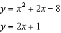

37 A company is running a contest and offering a first, second, and third prize. First prize is a choice of a car or $15,000 cash. Second prize is a choice of a motorbike, a trip to New York City, or $2,000 cash. Third prize is a choice of a television or $500 cash. If each prize is equally likely to be selected, list the sample space or draw a tree diagram of all possible different outcomes of first, second, and third prizes. Determine the number of ways that all three prizes selected could be cash. Determine the number of ways that none of the three prizes selected could be cash.

38 In right triangle ABC shown below, inches, inches, and . Find the number of degrees in the measure of angle BAC, to the nearest degree.

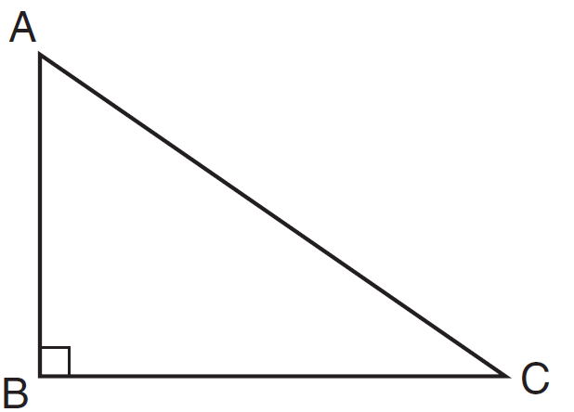

Find the length of to the nearest inch.

39 On the set of axes below, graph the following system of inequalities.
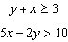
State the coordinates of one point that satisfies , but does not satisfy .

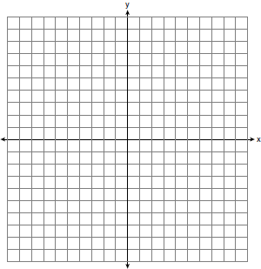

1 ANS: 3 PTS: 2 REF: 081201ia STA: A.G.7
TOP: Solving Linear Systems

2 ANS: 3
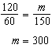

PTS: 2 REF: 081202ia STA: A.M.1 TOP: Using Rate

3 ANS: 3
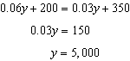

PTS: 2 REF: 081203ia STA: A.A.25 TOP: Solving Equations with Decimals

4 ANS: 1 PTS: 2 REF: 081204ia STA: A.S.12
TOP: Scatter Plots

5 ANS: 2 PTS: 2 REF: 081205ia STA: A.A.13
TOP: Addition and Subtraction of Polynomials KEY: addition

6 ANS: 4
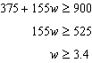

PTS: 2 REF: 081206ia STA: A.A.6 TOP: Modeling Inequalities

7 ANS: 3 PTS: 2 REF: 081207ia STA: A.A.19
TOP: Factoring the Difference of Perfect Squares

8 ANS: 3 PTS: 2 REF: 081208ia STA: A.S.17
TOP: Scatter Plots

9 ANS: 1 PTS: 2 REF: 081209ia STA: A.N.1
TOP: Properties of Reals

10 ANS: 4
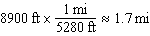

PTS: 2 REF: 081210ia STA: A.M.2 TOP: Conversions
KEY: dimensional analysis

11 ANS: 3 PTS: 2 REF: 081211ia STA: A.A.9
TOP: Exponential Functions

12 ANS: 2 PTS: 2 REF: 081212ia STA: A.A.5
TOP: Modeling Inequalities

13 ANS: 3
The other situations are qualitative.

PTS: 2 REF: 081213ia STA: A.S.1 TOP: Analysis of Data

14 ANS: 4 PTS: 2 REF: 081214ia STA: A.G.10
TOP: Identifying the Vertex of a Quadratic Given Graph

15 ANS: 2 PTS: 2 REF: 081215ia STA: A.A.1
TOP: Expressions

16 ANS: 4

PTS: 2 REF: 081216ia STA: A.G.2 TOP: Surface Area

17 ANS: 4

PTS: 2 REF: 081217ia STA: A.A.39 TOP: Identifying Points on a Line

18 ANS: 2 PTS: 2 REF: 081218ia STA: A.G.5
TOP: Graphing Quadratic Functions

19 ANS: 3
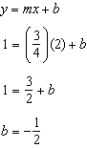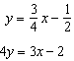

PTS: 2 REF: 081219ia STA: A.A.34 TOP: Writing Linear Equations

20 ANS: 1
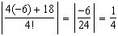

PTS: 2 REF: 081220ia STA: A.N.6 TOP: Evaluating Expressions

21 ANS: 3

PTS: 2 REF: 081221ia STA: A.A.31 TOP: Set Theory

22 ANS: 4
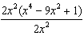

PTS: 2 REF: 081222ia STA: A.A.16 TOP: Rational Expressions
KEY: a > 0

23 ANS: 2 PTS: 2 REF: 081223ia STA: A.A.32
TOP: Slope

24 ANS: 4
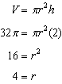

PTS: 2 REF: 081224ia STA: A.G.2 TOP: Volume

25 ANS: 3
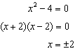

PTS: 2 REF: 081225ia STA: A.A.15 TOP: Undefined Rationals

26 ANS: 3
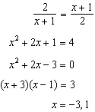

PTS: 2 REF: 081226ia STA: A.A.26 TOP: Solving Rationals

27 ANS: 2
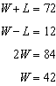

PTS: 2 REF: 081227ia STA: A.A.7 TOP: Writing Linear Systems

28 ANS: 1
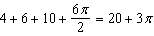

PTS: 2 REF: 081228ia STA: A.G.1 TOP: Compositions of Polygons and Circles
KEY: perimeter

29 ANS: 4 PTS: 2 REF: 081229ia STA: A.S.23
TOP: Theoretical Probability KEY: independent events

30 ANS: 3 PTS: 2 REF: 081230ia STA: A.A.23
TOP: Transforming Formulas

31 ANS:

PTS: 2 REF: 081231ia STA: A.N.4 TOP: Operations with Scientific Notation

32 ANS:
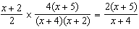

PTS: 2 REF: 081232ia STA: A.A.18 TOP: Multiplication and Division of Rationals
KEY: multiplication

33 ANS:
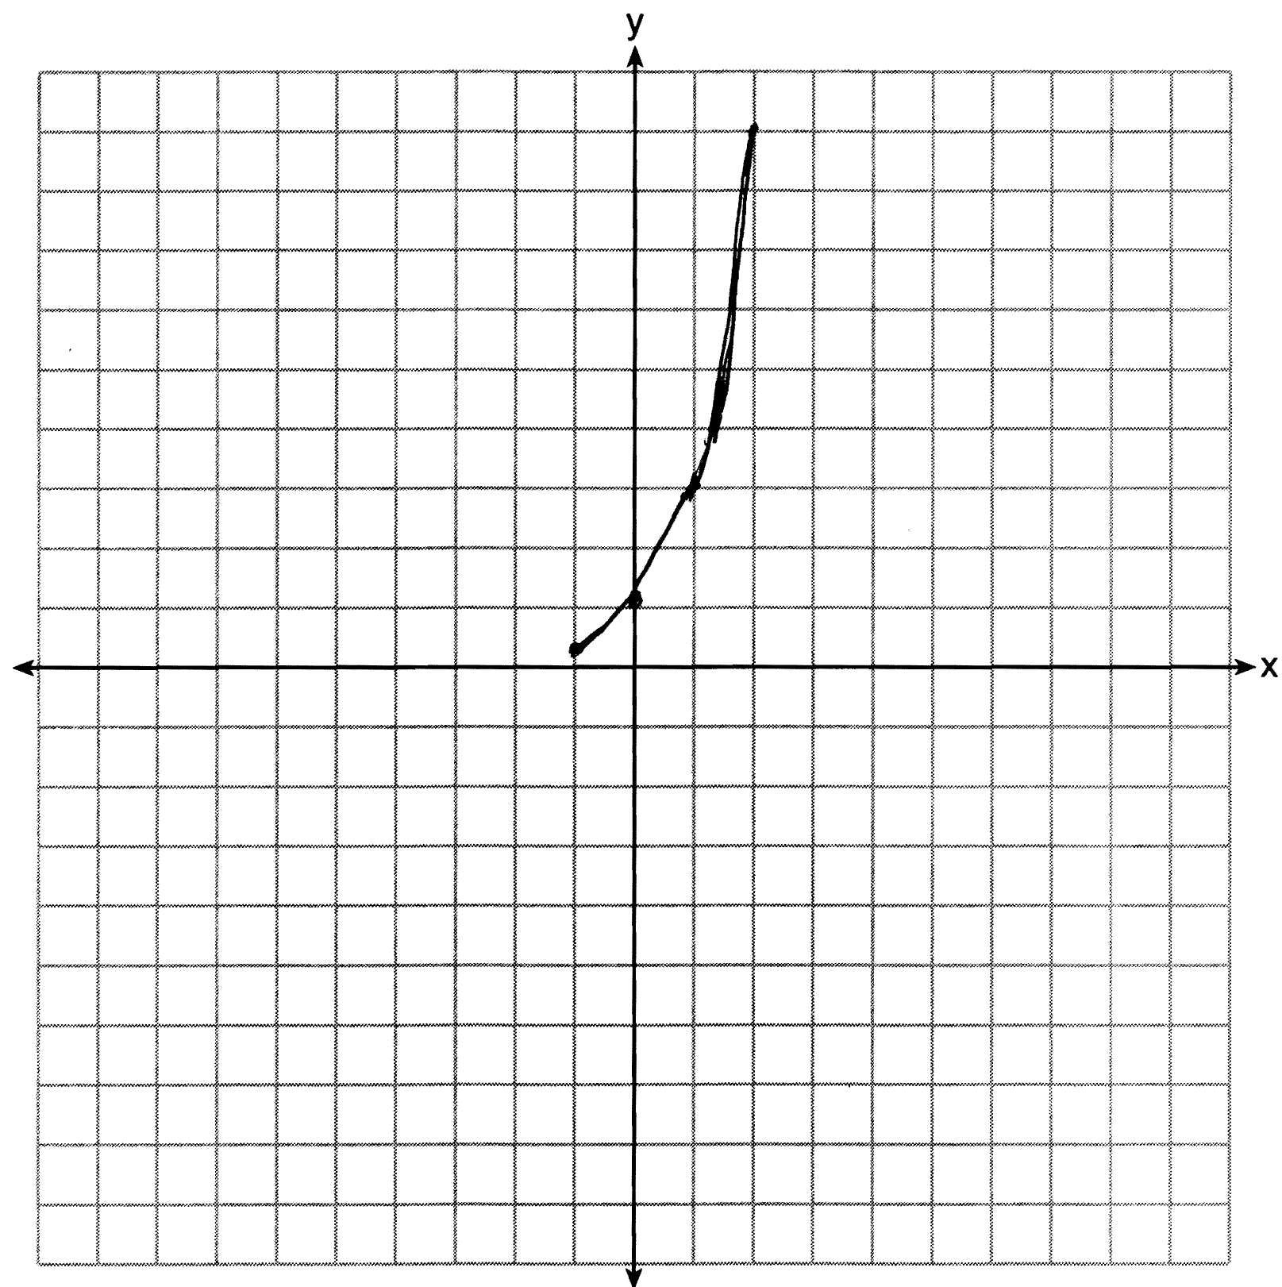

PTS: 2 REF: 081233ia STA: A.G.4 TOP: Graphing Exponential Functions

34 ANS:
3, 0, 20. .

PTS: 3 REF: 081234ia STA: A.S.9 TOP: Frequency Histograms, Bar Graphs and Tables

35 ANS:
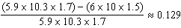

PTS: 3 REF: 081235ia STA: A.M.3 TOP: Error
KEY: volume and surface area

36 ANS:
. 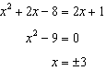. 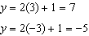

PTS: 3 REF: 081236ia STA: A.A.11 TOP: Quadratic-Linear Systems

37 ANS:
(C,B,T), (C,B,5), (C,N,T), (C,N,5), (C,2,T), (C,2,5), (F,B,T), (F,B,5), (F,N,T), (F,N,5), (F,2,T), (F,2,5). 1, 2.

PTS: 4 REF: 081237ia STA: A.S.19 TOP: Sample Space

38 ANS:
54, 23. 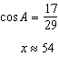.

PTS: 4 REF: 081238ia STA: A.A.43 TOP: Using Trigonometry to Find an Angle

39 ANS:
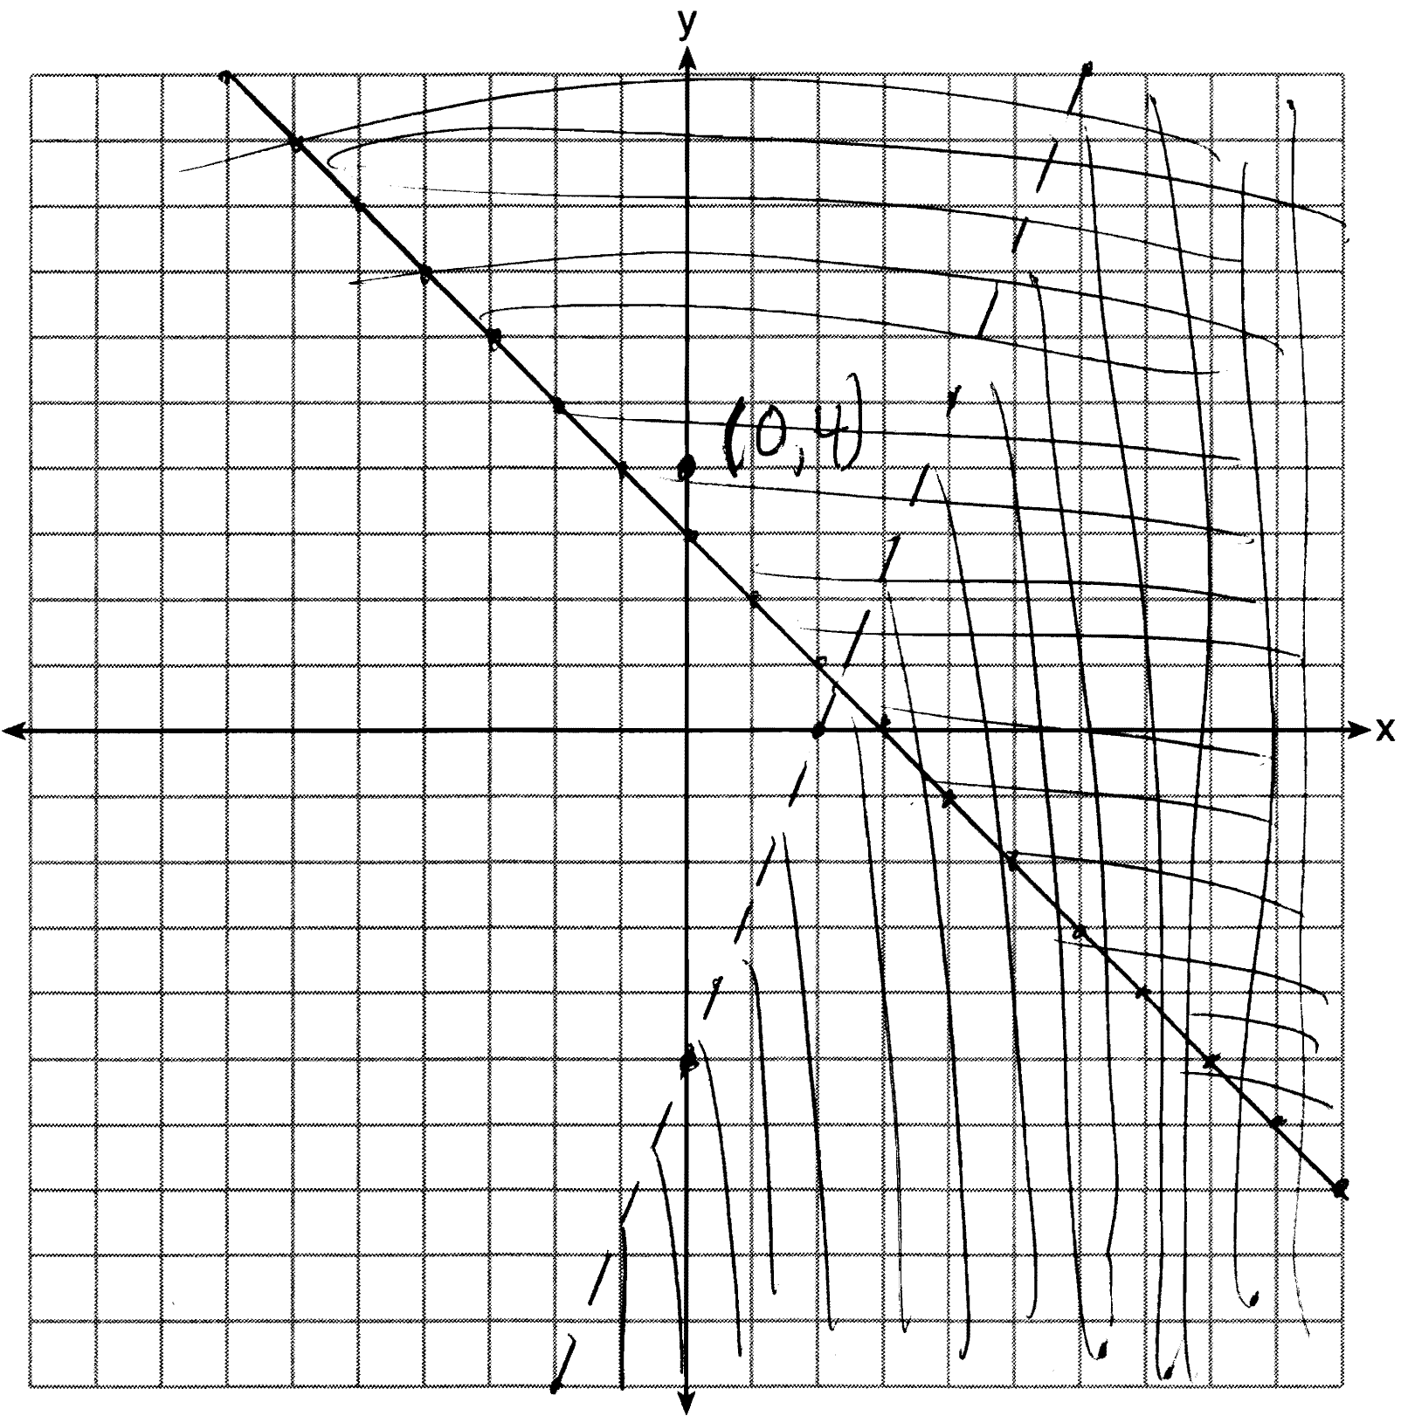

PTS: 4 REF: 081239ia STA: A.G.7 TOP: Systems of Linear Inequalities

