1 The school store did a study comparing the cost of a sweatshirt with the number of sweatshirts sold. The price was changed several times and the numbers of sweatshirts sold were recorded. The data are shown in the table below.

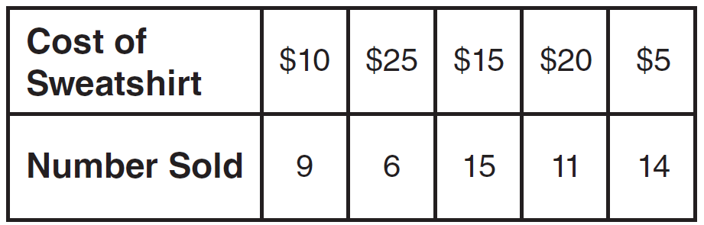

Which scatter plot represents the data?
1) | 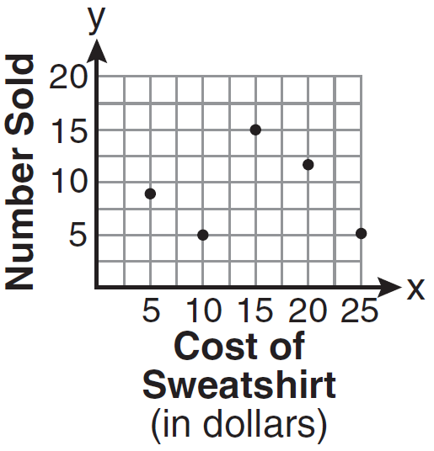
2) | 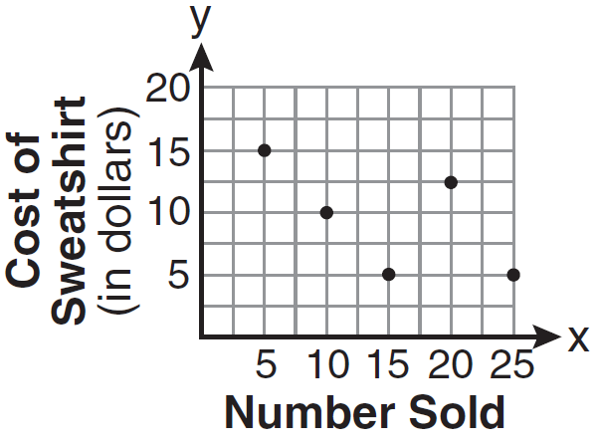
3) | 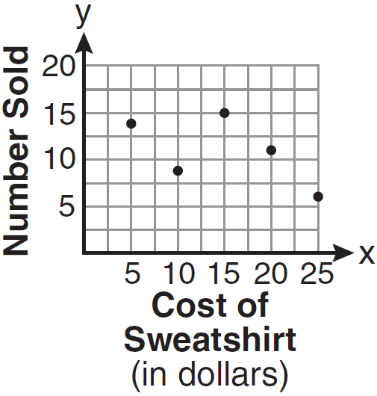
4) | 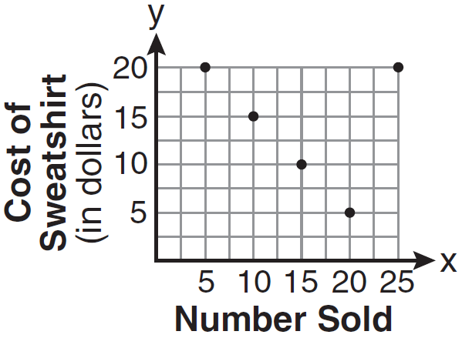

2 What is the solution of ?
1)
2)
3)
4)

3 Which set represents the intersection of sets A, B, and C shown in the diagram below?

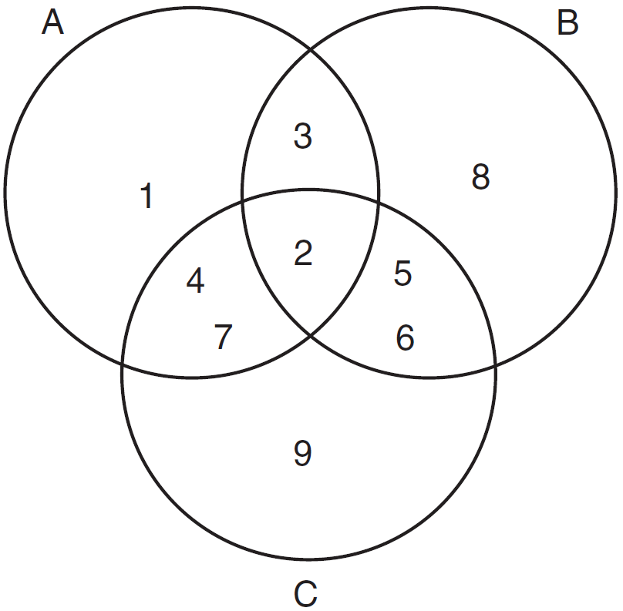
1)
2)
3)
4)

4 The end of a dog's leash is attached to the top of a 5-foot-tall fence post, as shown in the diagram below. The dog is 7 feet away from the base of the fence post.

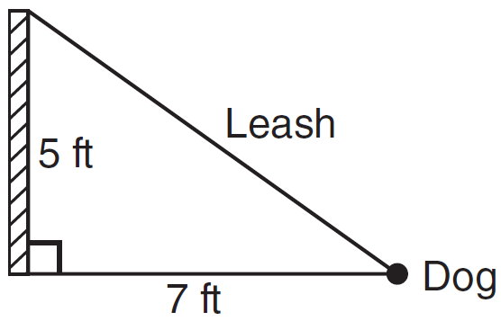

How long is the leash, to the nearest tenth of a foot?
1) | 4.9
2) | 8.6
3) | 9.0
4) | 12.0

.
5 What is the slope of the line passing through the points A and B, as shown on the graph below?

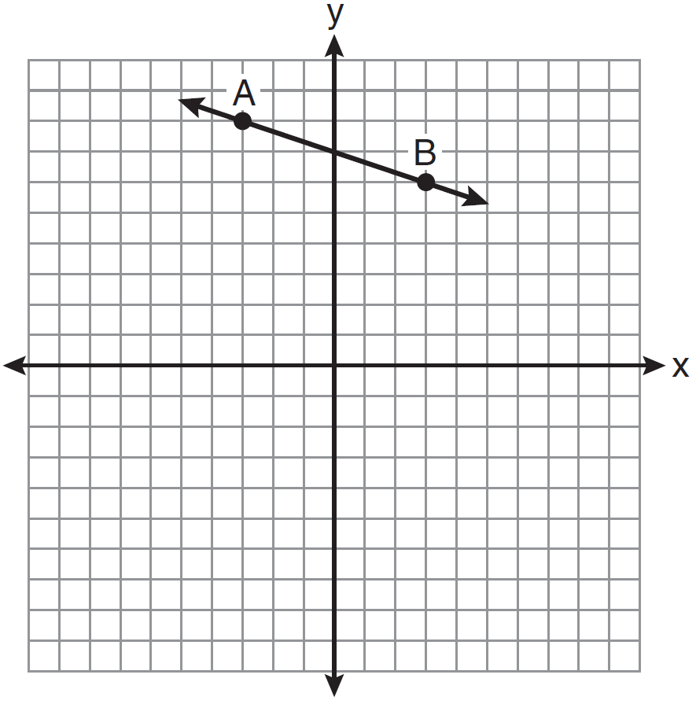
1)
2)
3) | 3
4)

6 The quotient of and expressed in scientific notation is
1) | 4,000
2) | 40,000
3)
4)

7 In a recent town election, 1,860 people voted for either candidate A or candidate B for the position of supervisor. If candidate A received 55% of the votes, how many votes did candidate B receive?
1) | 186
2) | 837
3) | 1,023
4) | 1,805

8 Which expression is equivalent to ?
1)
2)
3)
4)

9 Given: 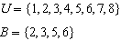
Set B is a subset of set U. What is the complement of set B?
1)
2)
3)
4)

10 Which graph can be used to find the solution of the following system of equations?
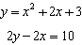
1) | 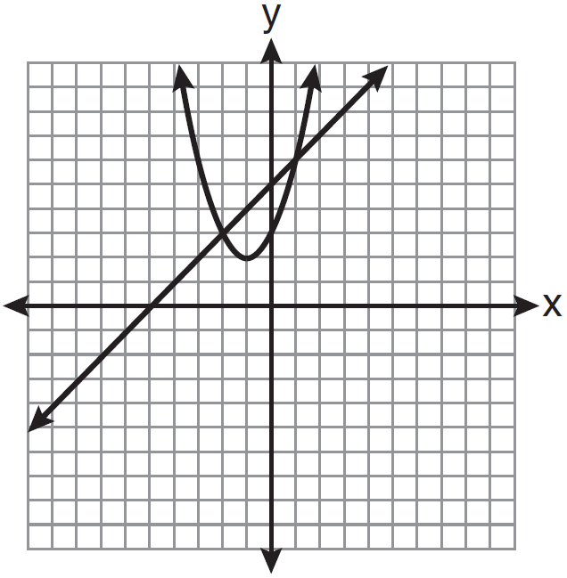
2) | 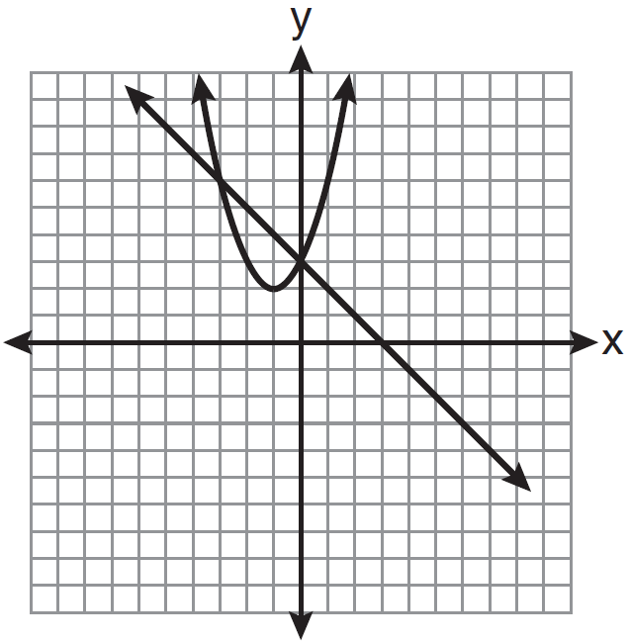
3) | 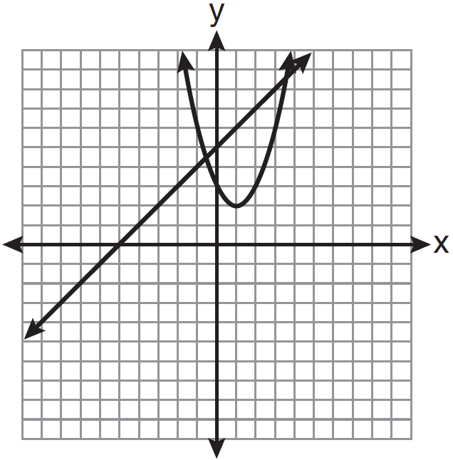
4) | 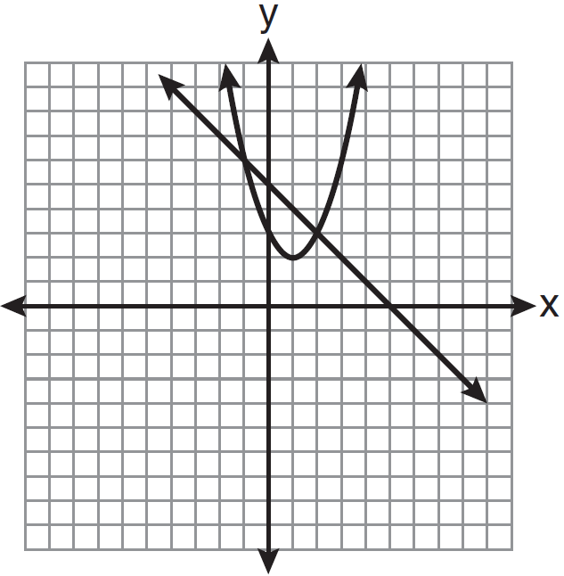

11 The width of a rectangle is 3 less than twice the length, x. If the area of the rectangle is 43 square feet, which equation can be used to find the length, in feet?
1)
2)
3)
4)

12 Which value of x is the solution of 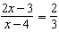?
1)
2)
3)
4) | 4

13 What is the perimeter of a regular pentagon with a side whose length is ?
1)
2)
3)
4)

14 Which equation represents a line parallel to the y-axis?
1)
2)
3)
4)

15 The diagram below shows the graph of .

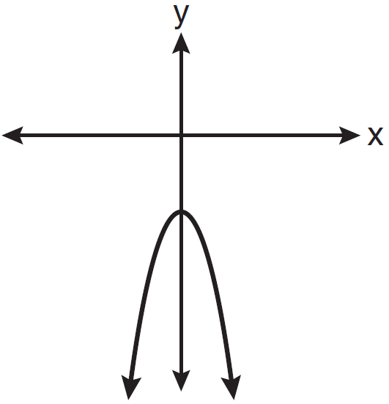

Which diagram shows the graph of ?
1) | 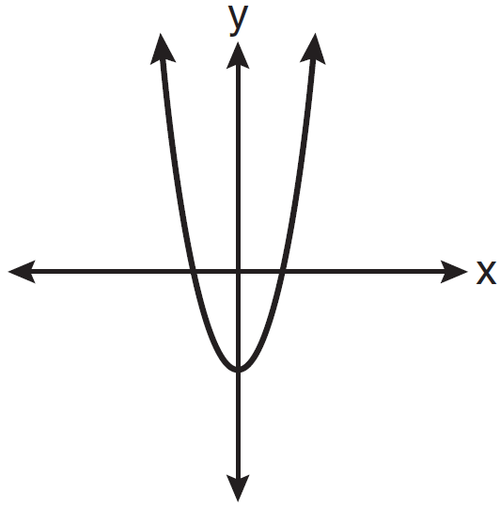
2) | 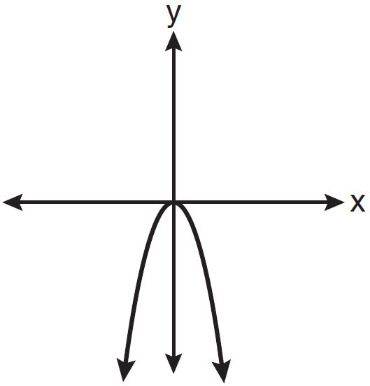
3) | 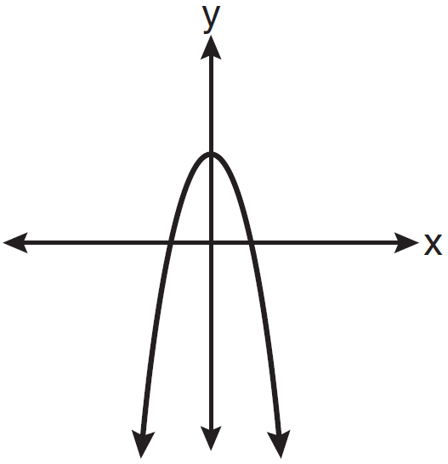
4) | 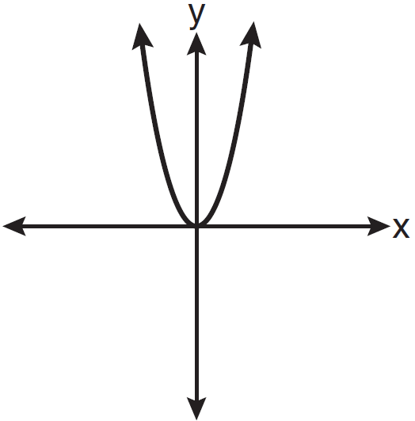

16 Which point lies on the line whose equation is ?
1)
2)
3)
4)

17 Which phrase best describes the relationship between the number of miles driven and the amount of gasoline used?
1) | causal, but not correlated
2) | correlated, but not causal
3) | both correlated and causal
4) | neither correlated nor causal

18 The height, y, of a ball tossed into the air can be represented by the equation , where x is the elapsed time. What is the equation of the axis of symmetry of this parabola?
1)
2)
3)
4)

19 In the diagram below, MATH is a rectangle, , , and .

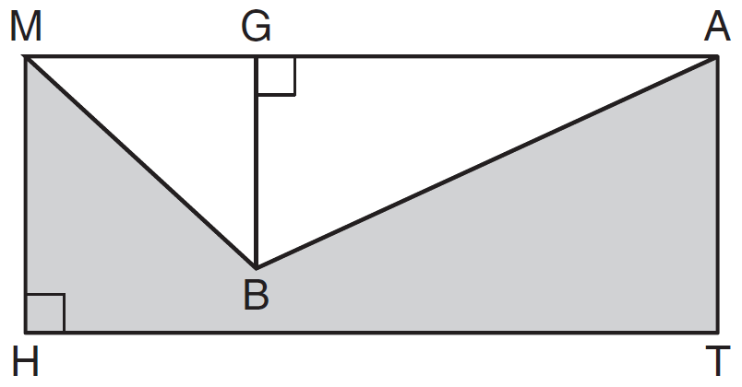

What is the area of polygon MBATH?
1) | 34.5
2) | 55.5
3) | 90.0
4) | 124.5

20 This year, John played in 10 baseball games. In these games he had hit the ball 2, 3, 0, 1, 3, 2, 4, 0, 2, and 3 times. In the first 10 games he plays next year, John wants to increase his average (mean) hits per game by 0.5. What is the total number of hits John needs over the first 10 games next year to achieve his goal?
1) | 5
2) | 2
3) | 20
4) | 25

21 What is the value of the y-coordinate of the solution to the system of equations and ?
1)
2) | 2
3) | 3
4)

22 Which set-builder notation describes ?
1)
2)
3)
4)

23 Corinne calculated the area of a paper plate to be 50.27 square inches. If the actual area of the plate is 55.42 square inches, what is the relative error in calculating the area, to the nearest thousandth?
1) | 0.092
2) | 0.093
3) | 0.102
4) | 0.103

24 The probability that it will snow on Sunday is . The probability that it will snow on both Sunday and Monday is . What is the probability that it will snow on Monday, if it snowed on Sunday?
1)
2) | 2
3)
4)

25 Which graph represents an exponential equation?
1) | 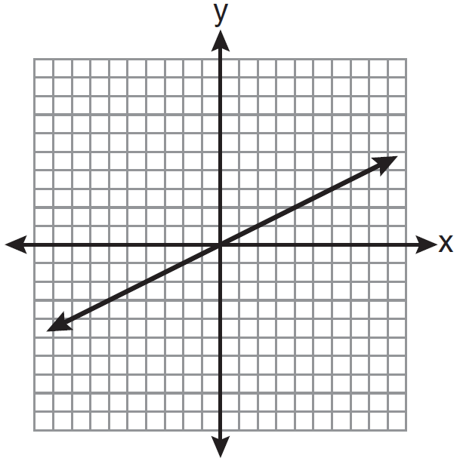
2) | 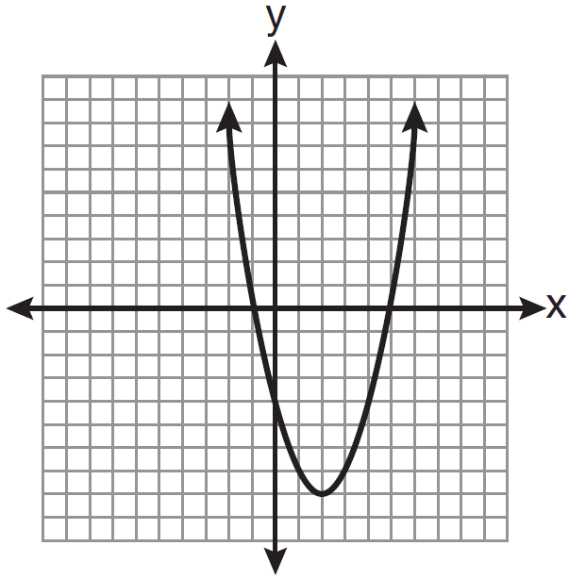
3) | 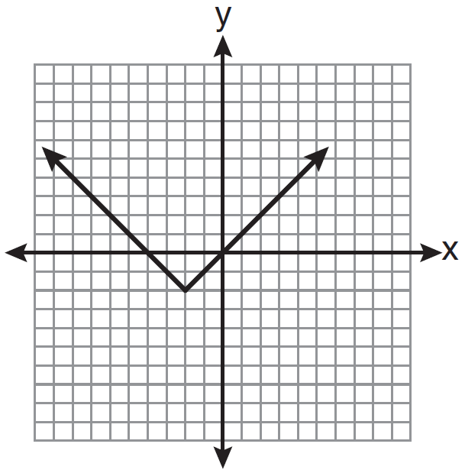
4) | 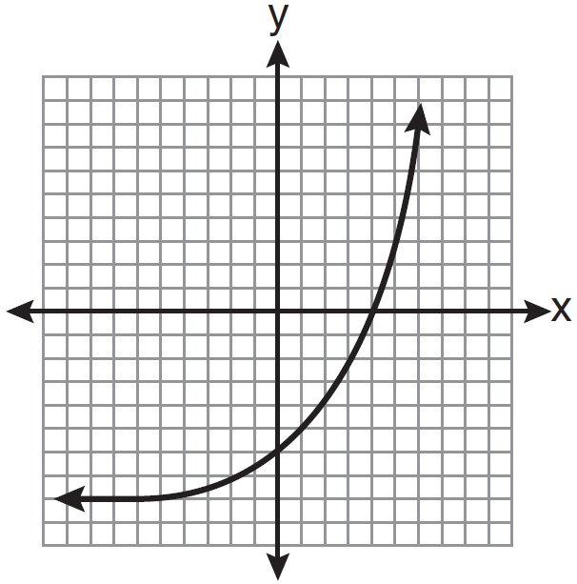

26 Right triangle ABC has legs of 8 and 15 and a hypotenuse of 17, as shown in the diagram below.

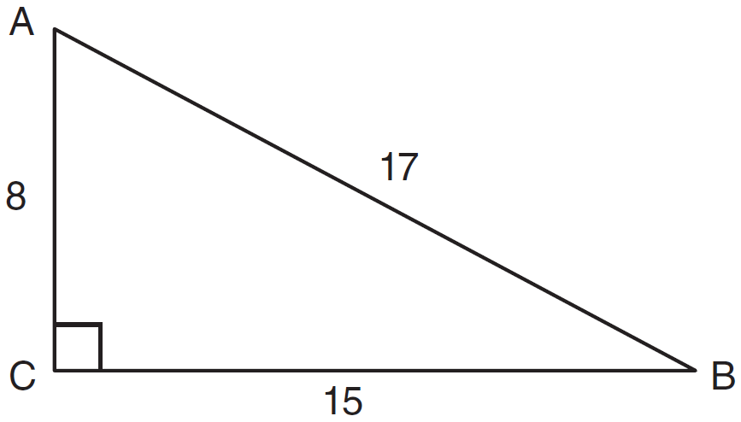

The value of the tangent of is
1) | 0.4706
2) | 0.5333
3) | 0.8824
4) | 1.8750

27 What is 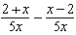 expressed in simplest form?
1) | 0
2)
3)
4) | 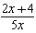

28 How many different four-letter arrangements are possible with the letters if each letter may be used only once?
1) | 15
2) | 24
3) | 360
4) | 720

29 What is an equation of the line that passes through the points and ?
1) | 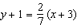
2) | 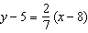
3) | 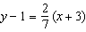
4) | 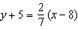

30 An example of an algebraic expression is
1)
2)
3)
4)

31 Express in simplest form: 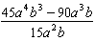

32 Joseph typed a 1,200-word essay in 25 minutes. At this rate, determine how many words he can type in 45 minutes.

33 Express in simplest radical form.

34 The number of songs fifteen students have on their MP3 players is:
120,124, 132, 145,200,255,260,292,
308,314,342,407,421,435,452
State the values of the minimum, 1st quartile, median, 3rd quartile, and maximum. Using these values, construct a box-and-whisker plot using an appropriate scale on the line below.

35 Find the volume, in cubic centimeters, and the surface area, in square centimeters, of the rectangular prism shown below.

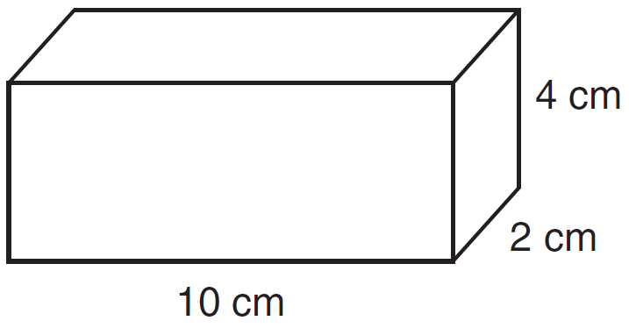

36 Find the roots of the equation algebraically.

37 On the set of axes below, solve the following system of inequalities graphically.
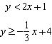
State the coordinates of a point in the solution set.

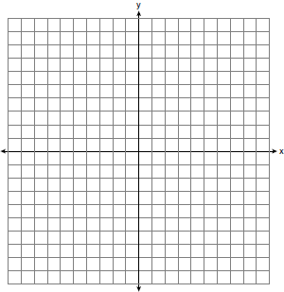

38 Each of the hats shown below has colored marbles placed inside. Hat A contains five green marbles and four red marbles. Hat B contains six blue marbles and five red marbles. Hat C contains five green marbles and five blue marbles.

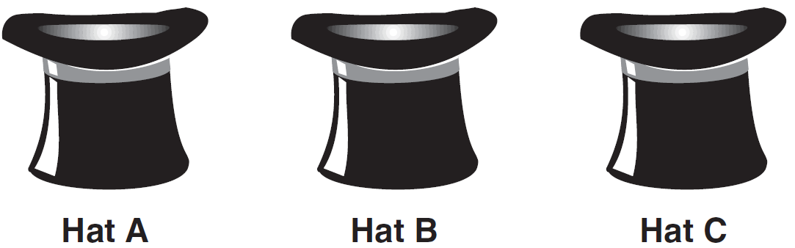

If a student were to randomly pick one marble from each of these three hats, determine from which hat the student would most likely pick a green marble. Justify your answer. Determine the fewest number of marbles, if any, and the color of these marbles that could be added to each hat so that the probability of picking a green marble will be one-half in each of the three hats.

39 A hot-air balloon is tied to the ground with two taut (straight) ropes, as shown in the diagram below. One rope is directly under the balloon and makes a right angle with the ground. The other rope forms an angle of 50º with the ground.

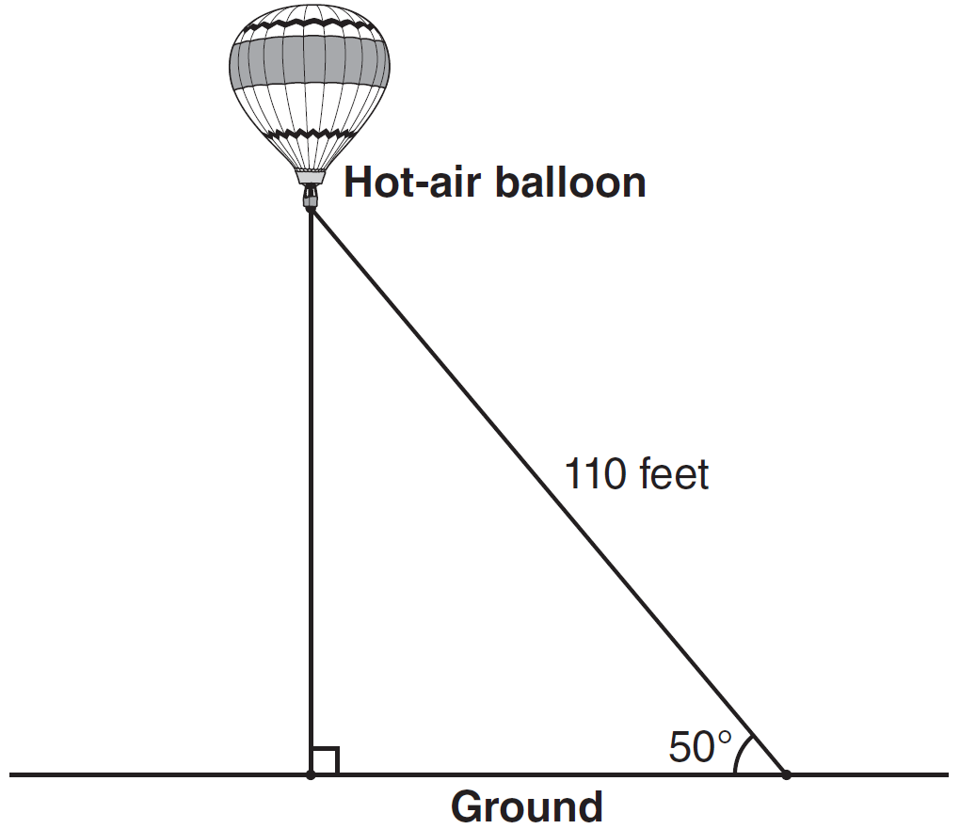

Determine the height, to the nearest foot, of the balloon directly above the ground. Determine the distance, to the nearest foot, on the ground between the two ropes.
1 ANS: 3 PTS: 2 REF: 081001ia STA: A.S.7
TOP: Scatter Plots

2 ANS: 1
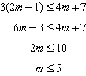

PTS: 2 REF: 081002ia STA: A.A.24 TOP: Solving Inequalities

3 ANS: 2 PTS: 2 REF: 081003ia STA: A.A.31
TOP: Set Theory

4 ANS: 2

PTS: 2 REF: 081004ia STA: A.A.45 TOP: Pythagorean Theorem

5 ANS: 2
and . 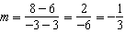

PTS: 2 REF: 081005ia STA: A.A.33 TOP: Slope

6 ANS: 4
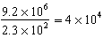

PTS: 2 REF: 081006ia STA: A.N.4 TOP: Operations with Scientific Notation

7 ANS: 2
Candidate B received 45%.

PTS: 2 REF: 081007ia STA: A.N.5 TOP: Percents

8 ANS: 3 PTS: 2 REF: 081008ia STA: A.A.19
TOP: Factoring the Difference of Perfect Squares

9 ANS: 3 PTS: 2 REF: 081009ia STA: A.A.30
TOP: Set Theory

10 ANS: 1
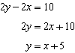 axis of symmetry: 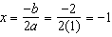

PTS: 2 REF: 081010ia STA: A.G.9 TOP: Quadratic-Linear Systems

11 ANS: 4 PTS: 2 REF: 081011ia STA: A.A.5
TOP: Modeling Equations

12 ANS: 2
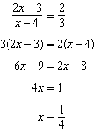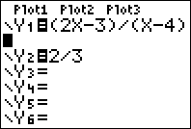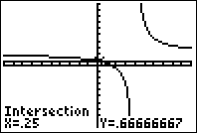

PTS: 2 REF: 081012ia STA: A.A.26 TOP: Solving Rationals

13 ANS: 4

PTS: 2 REF: 081013ia STA: A.A.1 TOP: Expressions

14 ANS: 2 PTS: 2 REF: 081014ia STA: A.A.36
TOP: Parallel and Perpendicular Lines

15 ANS: 1 PTS: 2 REF: 081015ia STA: A.G.5
TOP: Graphing Quadratic Functions

16 ANS: 4
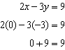

PTS: 2 REF: 081016ia STA: A.A.39 TOP: Identifying Points on a Line

17 ANS: 3 PTS: 2 REF: 081017ia STA: A.S.14
TOP: Analysis of Data

18 ANS: 3
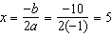.

PTS: 2 REF: 081018ia STA: A.A.41
TOP: Identifying the Vertex of a Quadratic Given Equation

19 ANS: 2
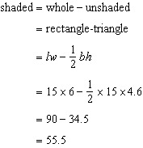

PTS: 2 REF: 081019ia STA: A.G.1 TOP: Compositions of Polygons and Circles

20 ANS: 4
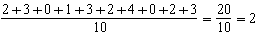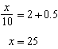

PTS: 2 REF: 081020ia STA: A.S.16 TOP: Average Known with Missing Data

21 ANS: 2
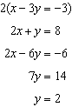

PTS: 2 REF: 081021ia STA: A.A.10 TOP: Solving Linear Systems

22 ANS: 4 PTS: 2 REF: 081022ia STA: A.A.29
TOP: Set Theory

23 ANS: 2
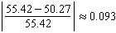

PTS: 2 REF: 081023ia STA: A.M.3 TOP: Error

24 ANS: 3
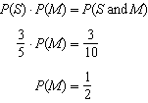

PTS: 2 REF: 081024ia STA: A.S.23 TOP: Theoretical Probability
KEY: independent events

25 ANS: 4 PTS: 2 REF: 081025ia STA: A.G.4
TOP: Families of Functions

26 ANS: 2
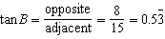

PTS: 2 REF: 081026ia STA: A.A.42 TOP: Trigonometric Ratios

27 ANS: 3
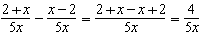

PTS: 2 REF: 081027ia STA: A.A.17 TOP: Addition and Subtraction of Rationals

28 ANS: 3

PTS: 2 REF: 081028ia STA: A.N.8 TOP: Permutations

29 ANS: 2
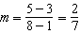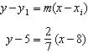

PTS: 2 REF: 081029ia STA: A.A.35 TOP: Writing Linear Equations

30 ANS: 1 PTS: 2 REF: 081030ia STA: A.A.3
TOP: Expressions

31 ANS:
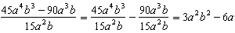

PTS: 2 REF: 081031ia STA: A.A.14 TOP: Rational Expressions

32 ANS:
2,160 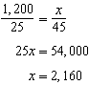

PTS: 2 REF: 081032ia STA: A.M.1 TOP: Using Rate

33 ANS:

PTS: 2 REF: 081033ia STA: A.N.2 TOP: Simplifying Radicals

34 ANS:
minimum is 120, 1st quartile is 145, median is 292, 3rd quartile is 407, and maximum is 452
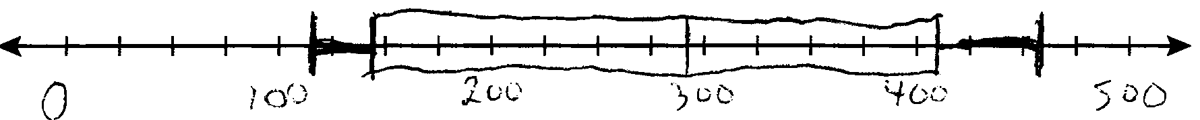

PTS: 3 REF: 081034ia STA: A.S.5 TOP: Box-and-Whisker Plots

35 ANS:
80, 136

PTS: 3 REF: 081035ia STA: A.G.2 TOP: Surface Area

36 ANS:
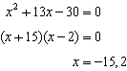

PTS: 3 REF: 081036ia STA: A.A.28 TOP: Roots of Quadratics

37 ANS:
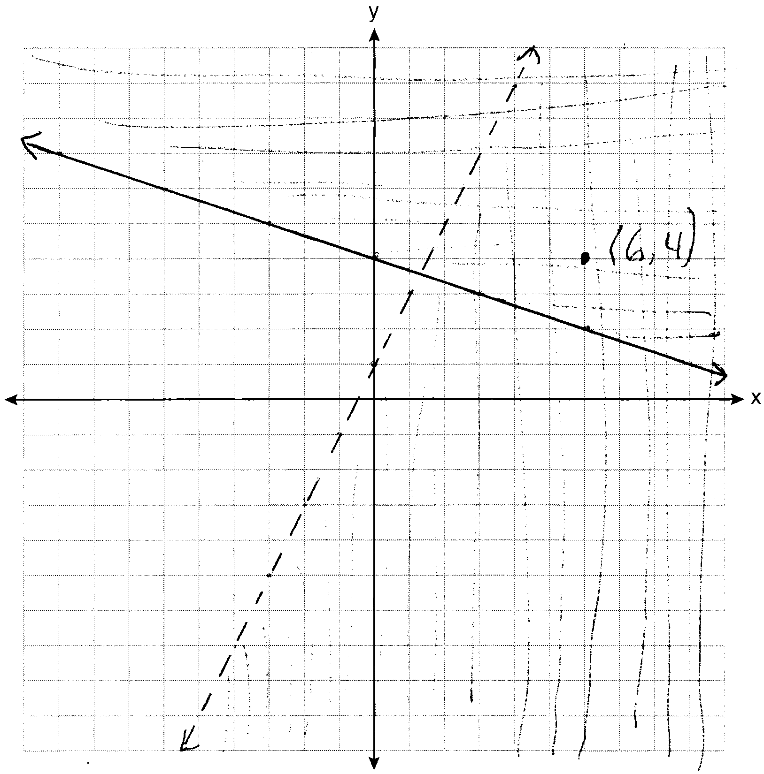

PTS: 4 REF: 081037ia STA: A.G.7 TOP: Systems of Linear Inequalities

38 ANS:
Hat A, add 1 not green to Hat A, add 11 green to Hat B, and add none to Hat C.

PTS: 4 REF: 081038ia STA: A.S.22 TOP: Theoretical Probability

39 ANS:
84, 71 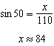 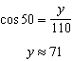

PTS: 4 REF: 081039ia STA: A.A.44 TOP: Using Trigonometry to Find a Side

