1 If h represents a number, which equation is a correct translation of "Sixty more than 9 times a number is 375"?
1) |  | 3)
2) |  | 4)

2 Which expression is equivalent to ?
1) |  | 3)
2) |  | 4)

3 Which expression represents in simplest form?
1) |  | 3)
2) |  | 4)

4 An online music club has a one-time registration fee of $13.95 and charges $0.49 to buy each song. If Emma has $50.00 to join the club and buy songs, what is the maximum number of songs she can buy?
1) | 73 | 3) | 130
2) | 74 | 4) | 131

5 The local ice cream stand offers three flavors of soft-serve ice cream: vanilla, chocolate, and strawberry; two types of cone: sugar and wafer; and three toppings: sprinkles, nuts, and cookie crumbs. If Dawn does not order vanilla ice cream, how many different choices can she make that have one flavor of ice cream, one type of cone, and one topping?
1) | 7 | 3) | 12
2) | 8 | 4) | 18

6 Nancy’s rectangular garden is represented in the diagram below.

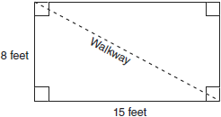

If a diagonal walkway crosses her garden, what is its length, in feet?
1) | 17 | 3)
2) | 22 | 4)

7 The spinner below is divided into eight equal regions and is spun once. What is the probability of not getting red?

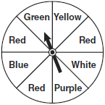
1) |  | 3)
2) |  | 4)

8 Which relationship can best be described as causal?
1) | height and intelligence | 3) | number of correct answers on a test and test score
2) | shoe size and running speed | 4) | number of students in a class and number of students with brown hair

9 Solve for x: 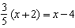
1) | 8 | 3) | 15
2) | 13 | 4) | 23

10 Erica is conducting a survey about the proposed increase in the sports budget in the Hometown School District. Which survey method would likely contain the most bias?
1) | Erica asks every third person entering the Hometown Grocery Store. | 3) | Erica asks every fifth student entering Hometown High School on Monday morning.
2) | Erica asks every third person leaving the Hometown Shopping Mall this weekend. | 4) | Erica asks every fifth person leaving Saturday’s Hometown High School football game.

11 Which equation represents a line parallel to the x-axis?
1) |  | 3)
2) |  | 4)

12 Given:
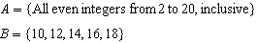
What is the complement of set B within the universe of set A?
1) |  | 3)
2) |  | 4)

13 Which value of x is in the solution set of the inequality ?
1) | 0 | 3) | 3
2) | 2 | 4) | 5

14 A tree casts a 25-foot shadow on a sunny day, as shown in the diagram below.

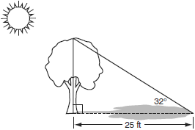

If the angle of elevation from the tip of the shadow to the top of the tree is 32°, what is the height of the tree to the nearest tenth of a foot?
1) | 13.2 | 3) | 21.2
2) | 15.6 | 4) | 40.0

15 What is the slope of the line that passes through the points and ?
1) |  | 3)
2) | 0 | 4) | undefined

16 The equation is graphed on the set of axes below.

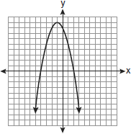

Based on this graph, what are the roots of the equation ?
1) | 8 and 0 | 3) | 9 and
2) | 2 and | 4) | 4 and

17 What is the sum of and expressed in simplest form?
1) |  | 3)
2) |  | 4)

18 Which value of x makes the expression 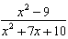 undefined?
1) |  | 3) | 3
2) | 2 | 4)

19 Which relation is not a function?
1) |  | 3)
2) |  | 4)

20 What is the value of the y-coordinate of the solution to the system of equations and ?
1) | 1 | 3) | 3
2) |  | 4) | 4

21 The solution to the equation is
1) | 0, only | 3) | 0 and 6
2) | 6, only | 4)

22 When is written in simplest radical form, the result is . What is the value of k?
1) | 20 | 3) | 7
2) | 10 | 4) | 4

23 What is the value of the expression when ?
1) |  | 3) | 13
2) |  | 4) | 37

24 A playground in a local community consists of a rectangle and two semicircles, as shown in the diagram below.

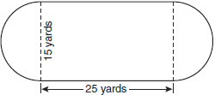

Which expression represents the amount of fencing, in yards, that would be needed to completely enclose the playground?
1) |  | 3)
2) |  | 4)

25 Which equation is represented by the graph below?

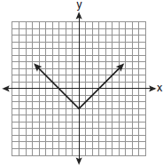
1) |  | 3)
2) |  | 4)

26 Carrie bought new carpet for her living room. She calculated the area of the living room to be 174.2 square feet. The actual area was 149.6 square feet. What is the relative error of the area to the nearest ten-thousandth?
1) | 0.1412 | 3) | 1.8588
2) | 0.1644 | 4) | 2.1644

27 What is an equation of the line that passes through the point and has a slope of 2?
1) |  | 3)
2) |  | 4)

28 The ages of three brothers are consecutive even integers. Three times the age of the youngest brother exceeds the oldest brother's age by 48 years. What is the age of the youngest brother?
1) | 14 | 3) | 22
2) | 18 | 4) | 26

29 Cassandra bought an antique dresser for $500. If the value of her dresser increases 6% annually, what will be the value of Cassandra's dresser at the end of 3 years to the nearest dollar?
1) | $415 | 3) | $596
2) | $590 | 4) | $770

30 The number of hours spent on math homework each week and the final exam grades for twelve students in Mr. Dylan's algebra class are plotted below.

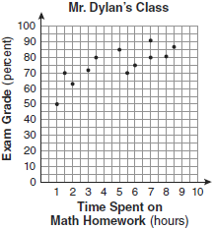

Based on a line of best fit, which exam grade is the best prediction for a student who spends about 4 hours on math homework each week?
1) | 62 | 3) | 82
2) | 72 | 4) | 92

31 Chad complained to his friend that he had five equations to solve for homework. Are all of the homework problems equations? Justify your answer.

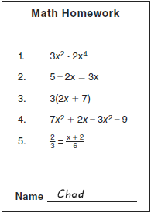

32 The diagram below represents Joe's two fish tanks.

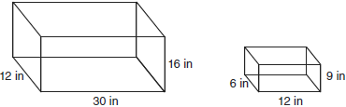

Joe's larger tank is completely filled with water. He takes water from it to completely fill the small tank. Determine how many cubic inches of water will remain in the larger tank.

33 Clayton has three fair coins. Find the probability that he gets two tails and one head when he flips the three coins.

34 Find algebraically the equation of the axis of symmetry and the coordinates of the vertex of the parabola whose equation is .

35 At the end of week one, a stock had increased in value from $5.75 a share to $7.50 a share. Find the percent of increase at the end of week one to the nearest tenth of a percent. At the end of week two, the same stock had decreased in value from $7.50 to $5.75. Is the percent of decrease at the end of week two the same as the percent of increase at the end of week one? Justify your answer.

36 The chart below compares two runners.

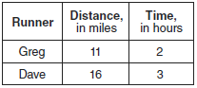

Based on the information in this chart, state which runner has the faster rate. Justify your answer.

37 Express in simplest form: 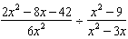

38 On the grid below, solve the system of equations graphically for x and y.
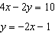



39 The test scores from Mrs. Gray’s math class are shown below.

72, 73, 66, 71, 82, 85, 95, 85, 86, 89, 91, 92

Construct a box-and-whisker plot to display these data.

1 ANS: 2 PTS: 2 REF: 080901ia STA: A.A.4
TOP: Modeling Equations

2 ANS: 1 PTS: 2 REF: 080902ia STA: A.A.19
TOP: Factoring the Difference of Perfect Squares

3 ANS: 4 PTS: 2 REF: 080903ia STA: A.A.12
TOP: Multiplication of Powers

4 ANS: 1
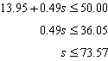

PTS: 2 REF: 080904ia STA: A.A.6 TOP: Modeling Inequalities

5 ANS: 3

PTS: 2 REF: 080905ia STA: A.N.7 TOP: Conditional Probability

6 ANS: 1
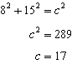

PTS: 2 REF: 080906ia STA: A.A.45 TOP: Pythagorean Theorem

7 ANS: 3 PTS: 2 REF: 080907ia STA: A.S.20
TOP: Theoretical Probability

8 ANS: 3
The number of correct answers on a test causes the test score.

PTS: 2 REF: 080908ia STA: A.S.13 TOP: Analysis of Data

9 ANS: 2
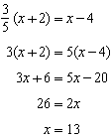

PTS: 2 REF: 080909ia STA: A.A.25
TOP: Solving Equations with Fractional Expressions

10 ANS: 4
Surveying persons leaving a football game about a sports budget contains the most bias.

PTS: 2 REF: 080910ia STA: A.S.3 TOP: Analysis of Data

11 ANS: 1 PTS: 2 REF: 080911ia STA: A.A.36
TOP: Parallel and Perpendicular Lines

12 ANS: 4

PTS: 2 REF: 080912ia STA: A.A.30 TOP: Set Theory

13 ANS: 4
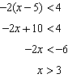

PTS: 2 REF: 080913ia STA: A.A.21 TOP: Interpreting Solutions

14 ANS: 2
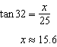

PTS: 2 REF: 080914ia STA: A.A.44 TOP: Using Trigonometry to Find a Side

15 ANS: 1
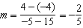

PTS: 2 REF: 080915ia STA: A.A.33 TOP: Slope

16 ANS: 2 PTS: 2 REF: 080916ia STA: A.G.8
TOP: Solving Quadratics by Graphing

17 ANS: 2
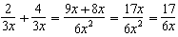

PTS: 2 REF: 080917ia STA: A.A.17 TOP: Addition and Subtraction of Rationals

18 ANS: 1
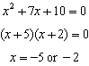

PTS: 2 REF: 080918ia STA: A.A.15 TOP: Undefined Rationals

19 ANS: 3
An element of the domain, 1, is paired with two different elements of the range, 3 and 7.

PTS: 2 REF: 080919ia STA: A.G.3 TOP: Defining Functions

20 ANS: 1
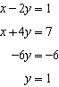

PTS: 2 REF: 080920ia STA: A.A.10 TOP: Solving Linear Systems

21 ANS: 3
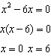

PTS: 2 REF: 080921ia STA: A.A.27 TOP: Solving Quadratics by Factoring

22 ANS: 2

PTS: 2 REF: 080922ia STA: A.N.2 TOP: Simplifying Radicals

23 ANS: 3

PTS: 2 REF: 080923ia STA: A.N.6 TOP: Evaluating Expressions

24 ANS: 1 PTS: 2 REF: 080924ia STA: A.G.1
TOP: Compositions of Polygons and Circles

25 ANS: 3 PTS: 2 REF: 080925ia STA: A.G.4
TOP: Identifying the Equation of a Graph

26 ANS: 2
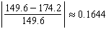

PTS: 2 REF: 080926ia STA: A.M.3 TOP: Error

27 ANS: 4
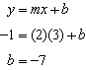

PTS: 2 REF: 080927ia STA: A.A.34 TOP: Writing Linear Equations

28 ANS: 4
Let x = youngest brother and x + 4 = oldest brother. 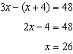.

PTS: 2 REF: 080928ia STA: A.A.6 TOP: Modeling Equations

29 ANS: 3

PTS: 2 REF: 080929ia STA: A.A.9 TOP: Exponential Functions

30 ANS: 2 PTS: 2 REF: 080930ia STA: A.S.17
TOP: Scatter Plots

31 ANS:
Not all of the homework problems are equations. The first problem is an expression.

PTS: 2 REF: 080931ia STA: A.A.3 TOP: Expressions

32 ANS:
5,112.

PTS: 2 REF: 080932ia STA: A.G.2 TOP: Volume

33 ANS:
. (H,H,H), (H,H,T), (H,T,H), (H,T,T), (T,H,H), (T,H,T), (T,T,H), (T,T,T)

PTS: 2 REF: 080933ia STA: A.S.19 TOP: Sample Space

34 ANS:
. 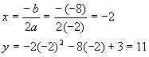

PTS: 3 REF: 080934ia STA: A.A.41
TOP: Identifying the Vertex of a Quadratic Given Equation

35 ANS:
30.4%; no, 23.3%. 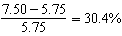. 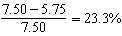
PTS: 3 REF: 080935ia STA: A.N.5 TOP: Percents

36 ANS:
Greg’s rate of 5.5 is faster than Dave’s rate of 5.3. 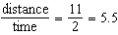. 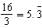
PTS: 3 REF: 080936ia STA: A.M.1 TOP: Speed

37 ANS:
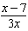.
PTS: 4 REF: 080937ia STA: A.A.18 TOP: Multiplication and Division of Rationals

38 ANS:
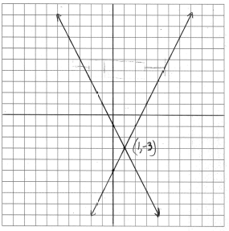
PTS: 4 REF: 080938ia STA: A.G.7 TOP: Solving Linear Systems

39 ANS:
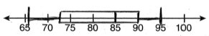
PTS: 4 REF: 080939ia STA: A.S.5 TOP: Box-and-Whisker Plots

