1 Which value of p is the solution of ?
1) |  | 3) | 3
2) |  | 4) | 7

2 The statement is an example of the use of which property of real numbers?
1) | associative | 3) | additive inverse
2) | additive identity | 4) | distributive

3 Mrs. Smith wrote "Eight less than three times a number is greater than fifteen" on the board. If x represents the number, which inequality is a correct translation of this statement?
1) |  | 3)
2) |  | 4)

4 Which statement is true about the data set 3, 4, 5, 6, 7, 7, 10?
1) | mean = mode | 3) | mean = median
2) | mean > mode | 4) | mean < median

5 Which value of x is in the solution set of the inequality ?
1) |  | 3) | 3
2) | 2 | 4)

6 Factored completely, the expression is equivalent to
1) |  | 3)
2) |  | 4)

7 The gas tank in a car holds a total of 16 gallons of gas. The car travels 75 miles on 4 gallons of gas. If the gas tank is full at the beginning of a trip, which graph represents the rate of change in the amount of gas in the tank?
1) | 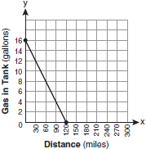 | 3) | 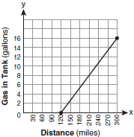
2) | 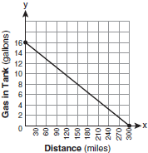 | 4) | 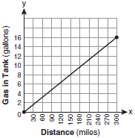

8 If , then x equals
1) |  | 3) | 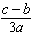
2) |  | 4) | 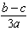

9 The length of the hypotenuse of a right triangle is 34 inches and the length of one of its legs is 16 inches. What is the length, in inches, of the other leg of this right triangle?
1) | 16 | 3) | 25
2) | 18 | 4) | 30

10 Which equation represents a line parallel to the x-axis?
1) |  | 3) | 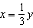
2) |  | 4)

11 Sam and Odel have been selling frozen pizzas for a class fundraiser. Sam has sold half as many pizzas as Odel. Together they have sold a total of 126 pizzas. How many pizzas did Sam sell?
1) | 21 | 3) | 63
2) | 42 | 4) | 84

12 Which ordered pair is in the solution set of the system of equations and ?
1) |  | 3)
2) |  | 4)

13 A swim team member performs a dive from a 14-foot-high springboard. The parabola below shows the path of her dive.

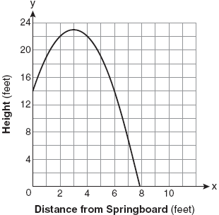

Which equation represents the axis of symmetry?
1) |  | 3)
2) |  | 4)

14 Nicole’s aerobics class exercises to fast-paced music. If the rate of the music is 120 beats per minute, how many beats would there be in a class that is 0.75 hour long?
1) | 90 | 3) | 5,400
2) | 160 | 4) | 7,200

15 Luis is going to paint a basketball court on his driveway, as shown in the diagram below. This basketball court consists of a rectangle and a semicircle.

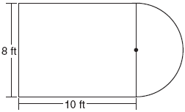

Which expression represents the area of this basketball court, in square feet?
1) | 80 | 3) | 80 + 16π
2) | 80 + 8π | 4) | 80 + 64π

16 John is going to line up his four golf trophies on a shelf in his bedroom. How many different possible arrangements can he make?
1) | 24 | 3) | 10
2) | 16 | 4) | 4

17 A rectangle has an area of 24 square units. The width is 5 units less than the length. What is the length, in units, of the rectangle?
1) | 6 | 3) | 3
2) | 8 | 4) | 19

18 What is the value of the third quartile shown on the box-and-whisker plot below?

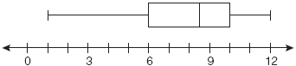
1) | 6 | 3) | 10
2) | 8.5 | 4) | 12

19 When is subtracted from , the difference is
1) |  | 3)
2) |  | 4)

20 Which value of x is the solution of 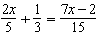?
1) |  | 3) | 3
2) |  | 4) | 7

21 Which expression represents 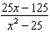 in simplest form?
1) |  | 3) | 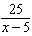
2) |  | 4) | 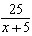

22 Which equation most closely represents the line of best fit for the scatter plot below?

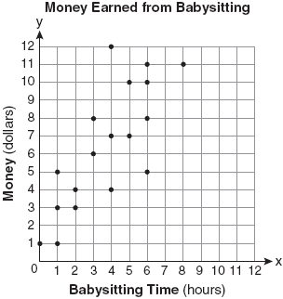
1) |  | 3) | 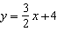
2) | 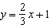 | 4) | 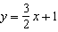

23 In a linear equation, the independent variable increases at a constant rate while the dependent variable decreases at a constant rate. The slope of this line is
1) | zero | 3) | positive
2) | negative | 4) | undefined

24 Which equation could be used to find the measure of one acute angle in the right triangle shown below?

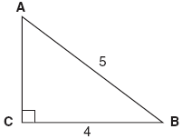
1) | 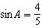 | 3) | 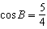
2) | 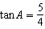 | 4) | 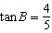

25 Which ordered pair is in the solution set of the following system of inequalities?
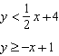
1) |  | 3)
2) |  | 4)

26 What is the product of 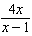 and 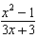 expressed in simplest form?
1) |  | 3) | 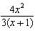
2) |  | 4) | 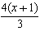

27 Which expression is equivalent to ?
1) |  | 3)
2) |  | 4)

28 Ryan estimates the measurement of the volume of a popcorn container to be 282 cubic inches. The actual volume of the popcorn container is 289 cubic inches. What is the relative error of Ryan's measurement to the nearest thousandth?
1) | 0.024 | 3) | 0.096
2) | 0.025 | 4) | 1.025

29 In the diagram of shown below, and .

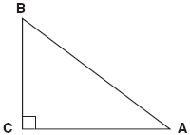

To the nearest tenth of a degree, what is the measure of the largest acute angle in the triangle?
1) | 32.0 | 3) | 51.3
2) | 38.7 | 4) | 90.0

30 The faces of a cube are numbered from 1 to 6. If the cube is tossed once, what is the probability that a prime number or a number divisible by 2 is obtained?
1) |  | 3)
2) |  | 4)

31 In a game of ice hockey, the hockey puck took 0.8 second to travel 89 feet to the goal line. Determine the average speed of the puck in feet per second.

32 Brianna is using the two spinners shown below to play her new board game. She spins the arrow on each spinner once. Brianna uses the first spinner to determine how many spaces to move. She uses the second spinner to determine whether her move from the first spinner will be forward or backward.

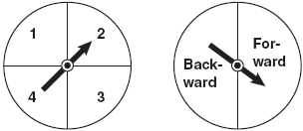

Find the probability that Brianna will move fewer than four spaces and backward.

33 Twelve players make up a high school basketball team. The team jerseys are numbered 1 through 12. The players wearing the jerseys numbered 3, 6, 7, 8, and 11 are the only players who start a game. Using set notation, list the complement of this subset.

34 Express the product of in simplest radical form.

35 On the set of axes below, draw the graph of over the interval . Will this graph ever intersect the x-axis? Justify your answer.

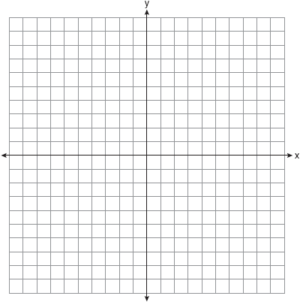

36 Write an equation that represents the line that passes through the points and .

37 The cost of 3 markers and 2 pencils is $1.80. The cost of 4 markers and 6 pencils is $2.90. What is the cost of each item? Include appropriate units in your answer.

38 Twenty students were surveyed about the number of days they played outside in one week. The results of this survey are shown below.

{6,5,4,3,0,7,1,5,4,4,3,2,2,3,2,4,3,4,0,7}

Complete the frequency table below for these data.

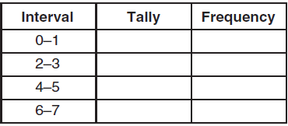

Complete the cumulative frequency table below using these data.

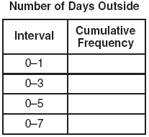

On the grid below, create a cumulative frequency histogram based on the table you made.



39 On the set of axes below, solve the following system of equations graphically and state the coordinates of all points in the solution set.
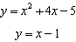

1 ANS: 4
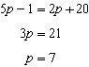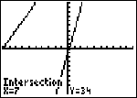

PTS: 2 REF: 080801ia STA: A.A.22 TOP: Solving Equations

2 ANS: 2 PTS: 2 REF: 080802ia STA: A.N.1
TOP: Identifying Properties

3 ANS: 1 PTS: 2 REF: 080803ia STA: A.A.4
TOP: Modeling Inequalities

4 ANS: 3
mean = 6, median = 6 and mode = 7

PTS: 2 REF: 080804ia STA: A.S.4 TOP: Central Tendency

5 ANS: 4
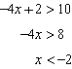

PTS: 2 REF: 080805ia STA: A.A.21 TOP: Interpreting Solutions

6 ANS: 2

PTS: 2 REF: 080806ia STA: A.A.20 TOP: Factoring Polynomials

7 ANS: 2
If the car can travel 75 miles on 4 gallons, it can travel 300 miles on 16 gallons. 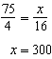.

PTS: 2 REF: 080807ia STA: A.G.4 TOP: Graphing Linear Functions

8 ANS: 3
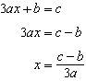

PTS: 2 REF: 080808ia STA: A.A.23 TOP: Transforming Formulas

9 ANS: 4
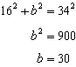

PTS: 2 REF: 080809ia STA: A.A.45 TOP: Pythagorean Theorem

10 ANS: 2 PTS: 2 REF: 080810ia STA: A.A.36
TOP: Parallel and Perpendicular Lines

11 ANS: 2
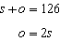. 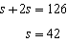

PTS: 2 REF: 080811ia STA: A.A.7 TOP: Writing Linear Systems

12 ANS: 2
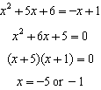. 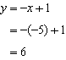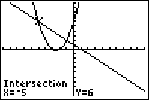

PTS: 2 REF: 080812ia STA: A.A.11 TOP: Quadratic-Linear Systems

13 ANS: 1 PTS: 2 REF: 080813ia STA: A.G.10
TOP: Identifying the Vertex of a Quadratic Given Graph

14 ANS: 3
0.75 hours = 45 minutes. 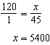

PTS: 2 REF: 080814ia STA: A.M.1 TOP: Using Rate

15 ANS: 2 PTS: 2 REF: 080815ia STA: A.G.1
TOP: Compositions of Polygons and Circles

16 ANS: 1

PTS: 2 REF: 080816ia STA: A.N.8 TOP: Permutations

17 ANS: 2
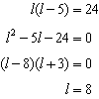

PTS: 2 REF: 080817ia STA: A.A.8 TOP: Geometric Applications of Quadratics

18 ANS: 3
The value of the third quartile is the last vertical line of the box.

PTS: 2 REF: 080818ia STA: A.S.6 TOP: Box-and-Whisker Plots

19 ANS: 3 PTS: 2 REF: 080819ia STA: A.A.13
TOP: Addition and Subtraction of Polynomials KEY: subtraction

20 ANS: 4
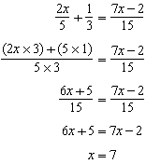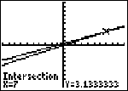

PTS: 2 REF: 080820ia STA: A.A.25
TOP: Solving Equations with Fractional Expressions

21 ANS: 4
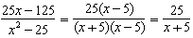

PTS: 2 REF: 080821ia STA: A.A.16 TOP: Rational Expressions
KEY: a > 0

22 ANS: 4
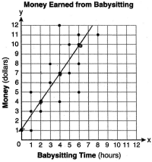

PTS: 2 REF: 080822ia STA: A.S.8 TOP: Scatter Plots

23 ANS: 2 PTS: 2 REF: 080823ia STA: A.A.32
TOP: Slope

24 ANS: 1 PTS: 2 REF: 080824ia STA: A.A.43
TOP: Using Trigonometry to Find an Angle

25 ANS: 4 PTS: 2 REF: 080825ia STA: A.A.40
TOP: Systems of Linear Inequalities

26 ANS: 1
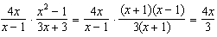

PTS: 2 REF: 080826ia STA: A.A.18 TOP: Multiplication and Division of Rationals

27 ANS: 4 PTS: 2 REF: 080827ia STA: A.A.12
TOP: Powers of Powers

28 ANS: 1
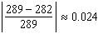

PTS: 2 REF: 080828ia STA: A.M.3 TOP: Error

29 ANS: 3
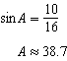 . A 90º angle is not acute.

PTS: 2 REF: 080829ia STA: A.A.43 TOP: Using Trigonometry to Find an Angle

30 ANS: 2
The events are not mutually exclusive: P(prime) = , P(even) = , P(prime AND even) =
P(prime OR even) = 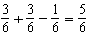

PTS: 2 REF: 080830ia STA: A.S.23 TOP: Theoretical Probability
KEY: not mutually exclusive events

31 ANS:
111.25. 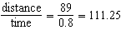

PTS: 2 REF: 080831ia STA: A.M.1 TOP: Speed

32 ANS:
. 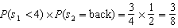

PTS: 2 REF: 080832ia STA: A.S.23 TOP: Theoretical Probability
KEY: independent events

33 ANS:
{1,2,4,5,9,10,12}

PTS: 2 REF: 080833ia STA: A.A.30 TOP: Set Theory

34 ANS:
.

PTS: 3 REF: 080834ia STA: A.N.3 TOP: Operations with Radicals
KEY: multiplication

35 ANS:
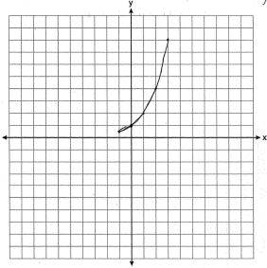. The graph will never intersect the x-axis as for all values of x.

PTS: 3 REF: 080835ia STA: A.G.4 TOP: Graphing Exponential Functions

36 ANS:
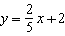. 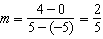. 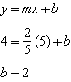.

PTS: 3 REF: 080836ia STA: A.A.35 TOP: Writing Linear Equations

37 ANS:
m = 50¢, p = 15¢. 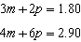. 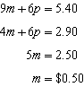. 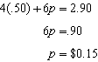

PTS: 4 REF: 080837ia STA: A.A.7 TOP: Writing Linear Systems

38 ANS:
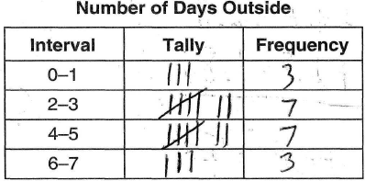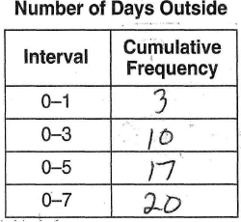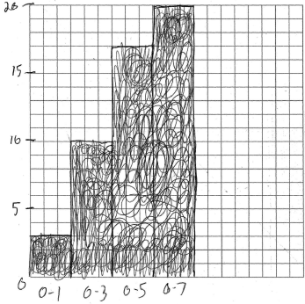

PTS: 4 REF: 080838ia STA: A.S.5
TOP: Frequency Histograms, Bar Graphs and Tables

39 ANS:
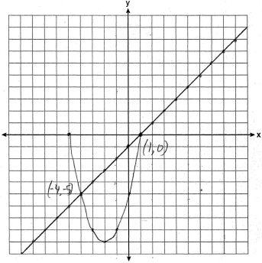. 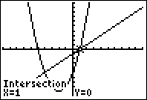

PTS: 4 REF: 080839ia STA: A.G.9 TOP: Quadratic-Linear Systems

