1 A line of best fit has been drawn on the scatter plot below.

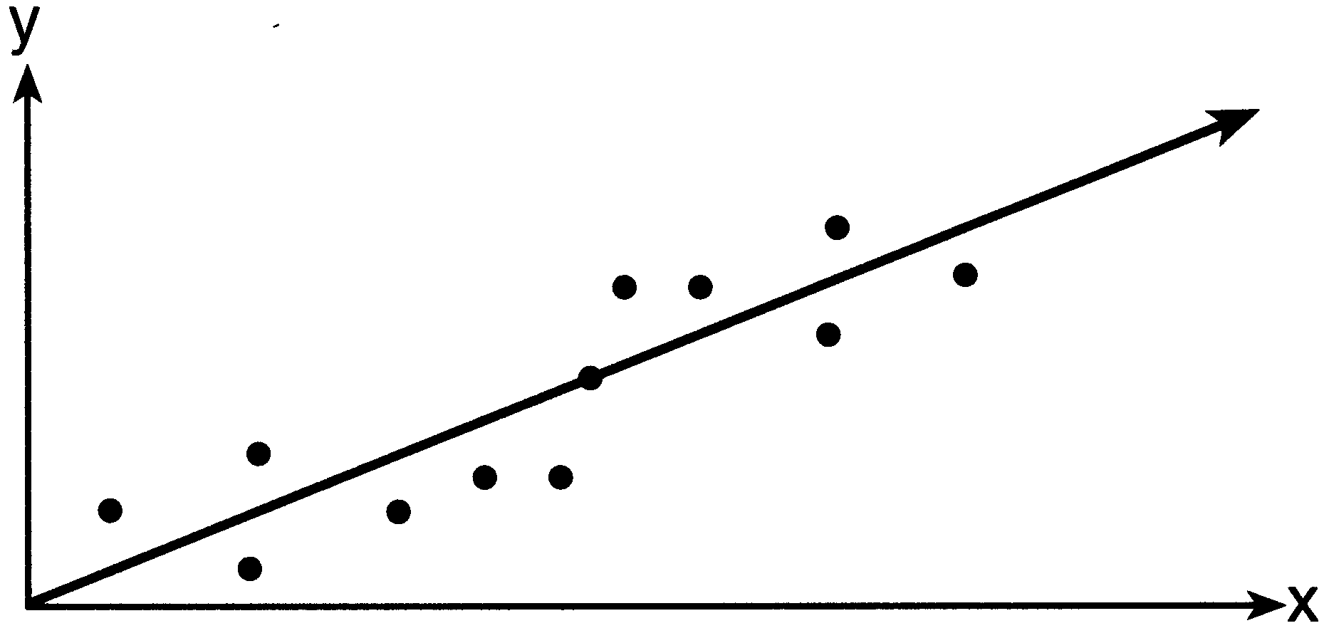

The relationship between these variables can be described as having
1) | a negative correlation
2) | no correlation
3) | a positive correlation
4) | zero correlation

2 The amount of money spent at a parking meter varies directly with the amount of time spent parked in the parking space. Noah spent $1.50 to park 90 minutes. How many minutes can he park for $4.00?
1) | 667
2) | 360
3) | 240
4) | 135

3 An athlete has one blue jersey and one orange jersey, as well as 3 different colors of pants. He also has 2 different colors of helmets. How many distinct uniforms consisting of one helmet, one jersey, and one pair of pants does the athlete have?
1) | 5
2) | 6
3) | 7
4) | 12

4 Given: 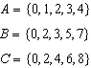
What is the intersection of sets A, B, and C?
1)
2)
3)
4)

5 The equation is graphed on the set of axes below.

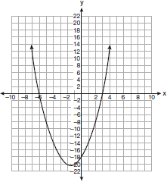

Based on this graph, what are the roots of the equation ?
1) | and 6
2) | 0 and
3) | 3 and
4) | 3 and

6 What is an equation of the line that passes through and ?
1) | 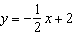
2) | 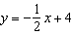
3)
4)

7 If each member of the data set is multiplied by 2, which changes will take place in the mean, median, and mode of the data?
1) | The mean, median, and mode will be multiplied by 2.
2) | The median will remain the same; the mean and mode will be multiplied by 2.
3) | The mode will remain the same; the mean and median will be multiplied by 2.
4) | The mean will remain the same; the median and mode will be multiplied by 2.

8 Which characteristic of a cat is qualitative?
1) | age
2) | color
3) | length
4) | weight

9 What is the value of A in the following system of equations?
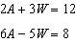
1) | 1
2) | 2
3) | 3
4) | 9

10 A cell phone company is conducting a survey to determine the cell phone features that its customers use. Which survey is least biased?
1) | The company conducts the survey on teenagers.
2) | The company conducts the survey on all age groups.
3) | The company conducts the survey on retired females.
4) | The company conducts the survey on middle-aged males.

11 Which pair of linear equations represents parallel lines?
1) | 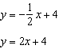
2) | 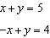
3) | 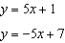
4) | 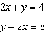

12 Which set of points does not represent a function?
1)
2)
3)
4)

13 A system of inequalities is graphed on the set of axes below.

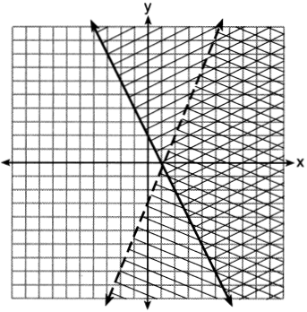

The coordinates of a point in the solution of this system of inequalities are
1)
2)
3)
4) | (3,1)

14 The axis of symmetry and the vertex of are
1)
2)
3)
4)

15 What is the slope of the line whose equation is ?
1)
2)
3)
4)

16 The students in Ms. Glenn's math class earned the grades shown below.
Which box-and-whisker plot represents these data?
1) | 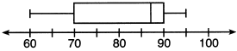
2) | 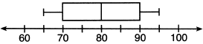
3) | 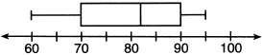
4) | 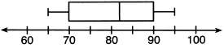

17 When translated into symbols, "three less than half of a number" is
1) | 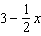
2) | 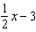
3) | 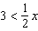
4) | 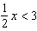

18 An example of an algebraic expression is
1)
2)
3)
4)

19 Which equation could be used to find the measure of one acute angle in the right triangle shown below?

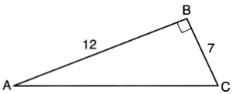
1) | 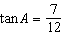
2) | 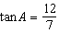
3) | 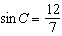
4) | 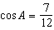

20 Which interval notation describes the set ?
1)
2)
3)
4)

21 Robert invests $800 in an account at 1.8% interest compounded annually. He will make no deposits or withdrawals on this account for 3 years. Which formula could be used to find the balance, A, in the account after the 3 years?
1)
2)
3)
4)

22 Which value of x is a solution of ?
1)
2)
3) | 3
4) | 0

23 Given 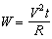, which expression can be used to represent t in terms of W, R, and V?
1)
2)
3) | 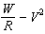
4)

24 The longest side of a right triangle is 25. If one of the other sides is 5, which measure is the length of the missing side?
1)
2)
3) | 30
4) | 60

25 Which statement is correct?
1)
2) | 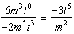
3)
4) | 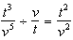

26 What value of x would make the expression 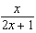 undefined?
1) | 0
2)
3)
4)

27 Written in factored form, the binomial is equivalent to
1)
2)
3)
4)

28 A spinner is divided into three equal regions, as shown in the diagram below. Ray spun the spinner six times and recorded his results: red, blue, blue, green, red, red.

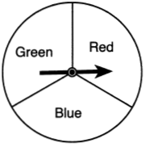

Which statement is true about the outcomes of blue in Ray's experiment?
1) | The empirical probability was less than the theoretical probability.
2) | The empirical probability was greater than the theoretical probability.
3) | The empirical and theoretical probabilities were equal.
4) | The empirical and theoretical probabilities were unrelated.

29 Liem is 6 feet 2 inches, Eli is 5 feet 9 inches, Faith is 6 feet, and Simon is 5 feet 4 inches. In yards, what is the total of their heights?
1)
2)
3) | 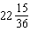
4)

30 The sum of and is
1)
2)
3)
4)

31 Jim calculated the area of a triangle to be 51.75 cm². The actual area of the triangle is 53.24 cm². Find the relative error in Jim's calculation of the area to the nearest thousandth.

32 A 12 foot ladder is placed against a wall. The ladder makes an angle of 73° with the floor. Determine, to the nearest tenth of a foot, how high up the wall the ladder will reach.

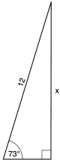

33 On the set of axes below, draw the graph of the function . Include the interval .

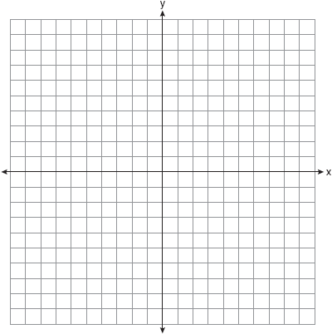

34 Ryan bought three bags of mixed tulip bulbs at a local garden store. The first bag contained 7 yellow bulbs, 8 red bulbs, and 5 white bulbs. The second bag contained 3 yellow bulbs, 11 red bulbs, and 6 white bulbs. The third bag contained 13 yellow bulbs, 2 red bulbs, and 5 white bulbs. Ryan combined the contents of these three bags into a single container. He randomly selected one bulb, planted it, and then randomly selected another and planted that one. Determine if it is more likely that Ryan planted a red bulb and then another red bulb, or planted a yellow bulb and then a white bulb. Justify your answer.

35 A particular jewelry box is in the shape of a rectangular prism. The box is advertised as having an interior length of 20.3 centimeters, an interior width of 12. 7 centimeters, and an interior height of 10.2 centimeters. However, when a customer measures the interior of the box, she finds that the interior height is actually 6.3 centimeters. Upon further examination, she discovers that the bottom of the interior of the box lifts up to reveal a hidden compartment. Find the volume of this hidden compartment to the nearest cubic centimeter.

36 Solve algebraically for all values of x that satisfy the equation: 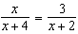

37 On the set of axes below, solve the following system of equations graphically for all values of x and y. State the coordinates of all solutions.
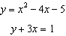

38 Express in simplest form: 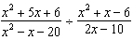

39 The length of a rectangle is and the width is . Express the perimeter of the rectangle in simplest radical form. Express the area of the rectangle in simplest radical form.
1 ANS: 3 PTS: 2 REF: 061601ia STA: A.S.12
TOP: Scatter Plots KEY: describe

2 ANS: 3
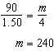

PTS: 2 REF: 061602ia STA: A.N.5 TOP: Direct Variation

3 ANS: 4

PTS: 2 REF: 061603ia STA: A.N.7 TOP: Multiplication Counting Principle

4 ANS: 2 PTS: 2 REF: 061604ia STA: A.A.31
TOP: Set Theory KEY: intersection

5 ANS: 3 PTS: 2 REF: 061605ia STA: A.G.8
TOP: Graphing Quadratic Functions

6 ANS: 1
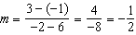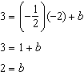

PTS: 2 REF: 061606ia STA: A.A.35 TOP: Writing Linear Equations
KEY: slope-intercept form

7 ANS: 1 PTS: 2 REF: 061607ia STA: A.S.16
TOP: Central Tendency and Dispersion KEY: compute

8 ANS: 2 PTS: 2 REF: 061608ia STA: A.S.1
TOP: Analysis of Data KEY: qualitative or quantitative

9 ANS: 3
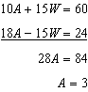

PTS: 2 REF: 061609ia STA: A.A.10 TOP: Solving Linear Systems

10 ANS: 2
To determine customer use, survey the widest range of customers.
PTS: 2 REF: 061610ia STA: A.S.3 TOP: Analysis of Data
KEY: bias

11 ANS: 4
The slope of both is .
PTS: 2 REF: 061611ia STA: A.A.38 TOP: Parallel and Perpendicular Lines
KEY: identify parallel lines

12 ANS: 3 PTS: 2 REF: 061612ia STA: A.G.3
TOP: Defining Functions KEY: ordered pairs

13 ANS: 4 PTS: 2 REF: 061613ia STA: A.G.6
TOP: Graphing Systems of Linear Inequalities KEY: solution set

14 ANS: 1
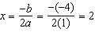
PTS: 2 REF: 061614ia STA: A.A.41 TOP: Graphing Quadratic Functions
KEY: no context

15 ANS: 1
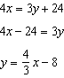
PTS: 2 REF: 061615ia STA: A.A.37 TOP: Slope
KEY: equation

16 ANS: 4 PTS: 2 REF: 061616ia STA: A.S.5
TOP: Box Plots KEY: represent

17 ANS: 2 PTS: 2 REF: 061617ia STA: A.A.1
TOP: Modeling Expressions

18 ANS: 4 PTS: 2 REF: 061618ia STA: A.A.3
TOP: Expressions

19 ANS: 1
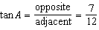
PTS: 2 REF: 061619ia STA: A.A.42 TOP: Using Trigonometry to Find an Angle

20 ANS: 2 PTS: 2 REF: 061620ia STA: A.A.29
TOP: Set Theory KEY: interval notation

21 ANS: 4 PTS: 2 REF: 061621ia STA: A.A.9
TOP: Modeling Exponential Functions KEY: AI

22 ANS: 1
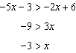
PTS: 2 REF: 061622ia STA: A.A.21 TOP: Interpreting Solutions

23 ANS: 1 PTS: 2 REF: 061623ia STA: A.A.23
TOP: Transforming Formulas

24 ANS: 2
PTS: 2 REF: 061624ia STA: A.A.45 TOP: Pythagorean Theorem
KEY: without graphics

25 ANS: 2 PTS: 2 REF: 061625ia STA: A.A.12
TOP: Powers of Powers

26 ANS: 2 PTS: 2 REF: 061626ia STA: A.A.15
TOP: Undefined Rationals

27 ANS: 1 PTS: 2 REF: 061627ia STA: A.A.19
TOP: Factoring the Difference of Perfect Squares KEY: multivariable AI

28 ANS: 3
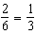
PTS: 2 REF: 061628ia STA: A.S.21 TOP: Experimental Probability

29 ANS: 1
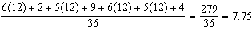
PTS: 2 REF: 061629ia STA: A.M.2 TOP: Conversions
KEY: dimensional analysis

30 ANS: 3
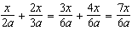
PTS: 2 REF: 061630ia STA: A.A.17 TOP: Addition and Subtraction of Rationals

31 ANS:
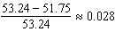
PTS: 2 REF: 061631ia STA: A.M.3 TOP: Error
KEY: area

32 ANS:
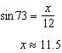
PTS: 2 REF: 061632ia STA: A.A.44 TOP: Using Trigonometry to Find a Side

33 ANS:
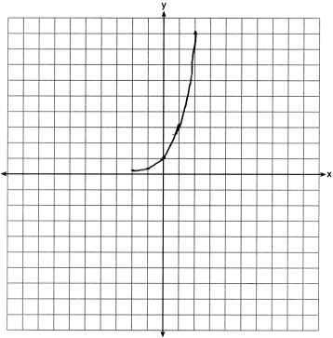
PTS: 2 REF: 061633ia STA: A.G.4 TOP: Graphing Exponential Functions

34 ANS:
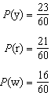 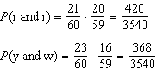 is greater.
PTS: 3 REF: 061634ia STA: A.S.22 TOP: Theoretical Probability

35 ANS:
PTS: 3 REF: 061635ia STA: A.G.2 TOP: Volume
KEY: prisms

36 ANS:
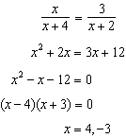
PTS: 3 REF: 061636ia STA: A.A.26 TOP: Solving Rationals
KEY: rational solutions

37 ANS:
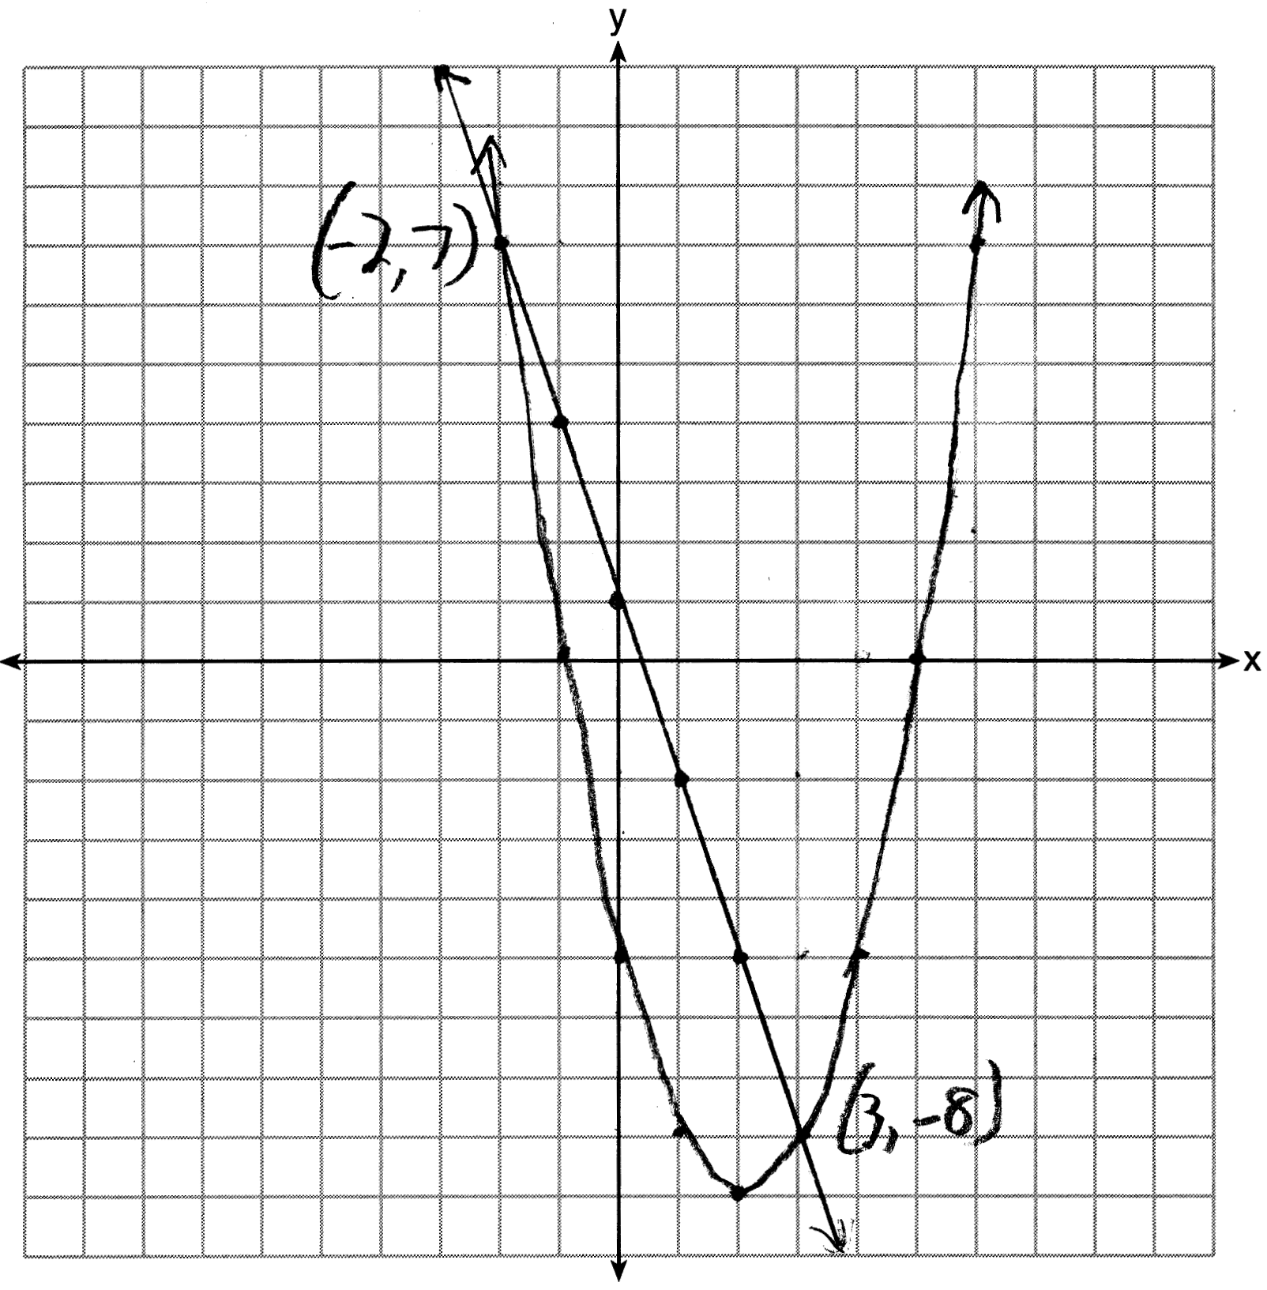. 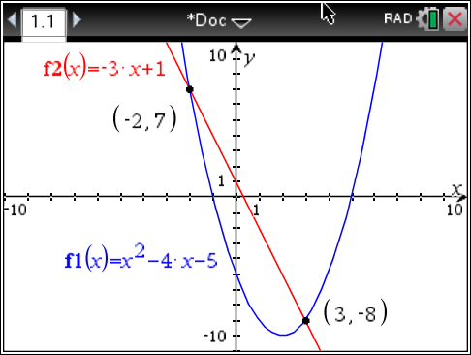
PTS: 4 REF: 061637ia STA: A.G.9 TOP: Quadratic-Linear Systems
KEY: graphically

38 ANS:
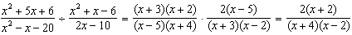
PTS: 4 REF: 061638ia STA: A.A.18 TOP: Multiplication and Division of Rationals
KEY: division

39 ANS:
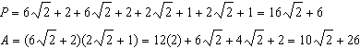
PTS: 4 REF: 061639ia STA: A.N.3 TOP: Operations with Radicals
KEY: mixed

