1 If and , then the intersection of these two sets is
1)
2)
3)
4)

2 There are 4 students running for Student Government President. A survey was taken asking 100 students which candidate they would vote for in the election. The results are shown in the table below:

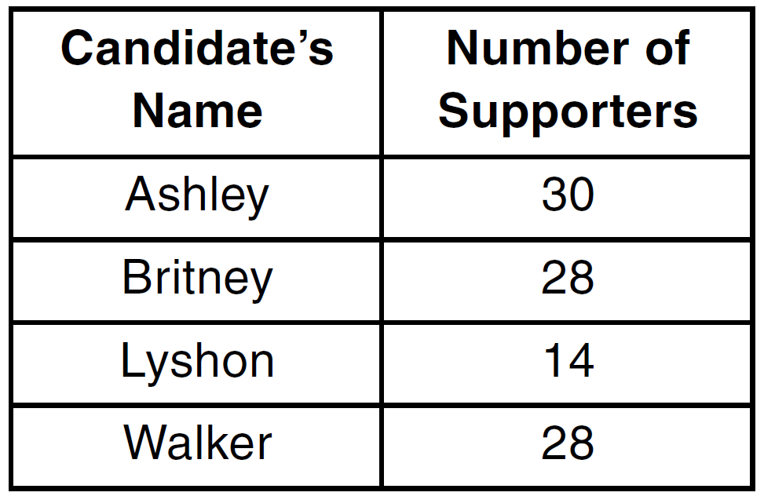

Based on the table, what is the probability that a student chosen at random will vote for Lyshon?
1)
2)
3)
4)

3 The graph of is shown below.

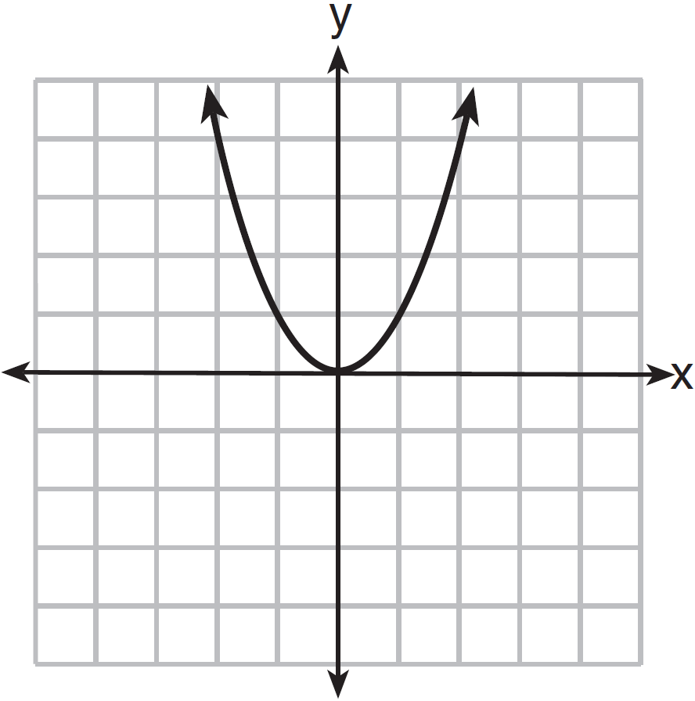

Which graph represents ?
1) | 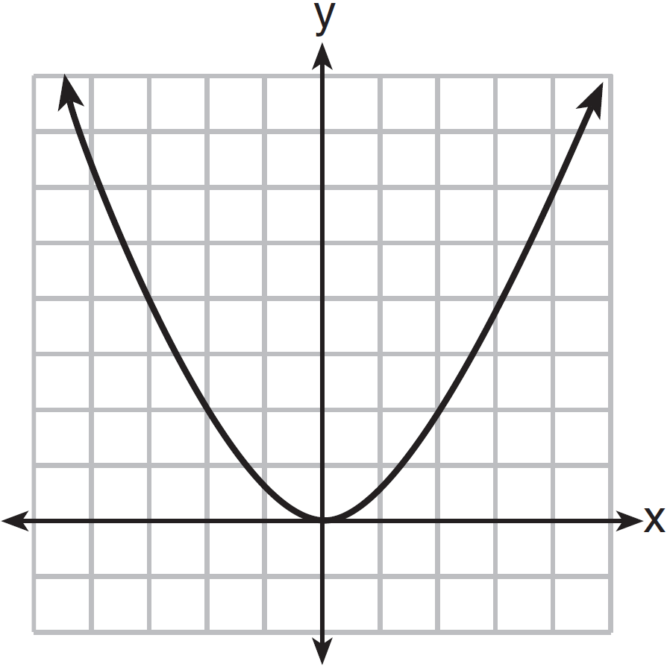
2) | 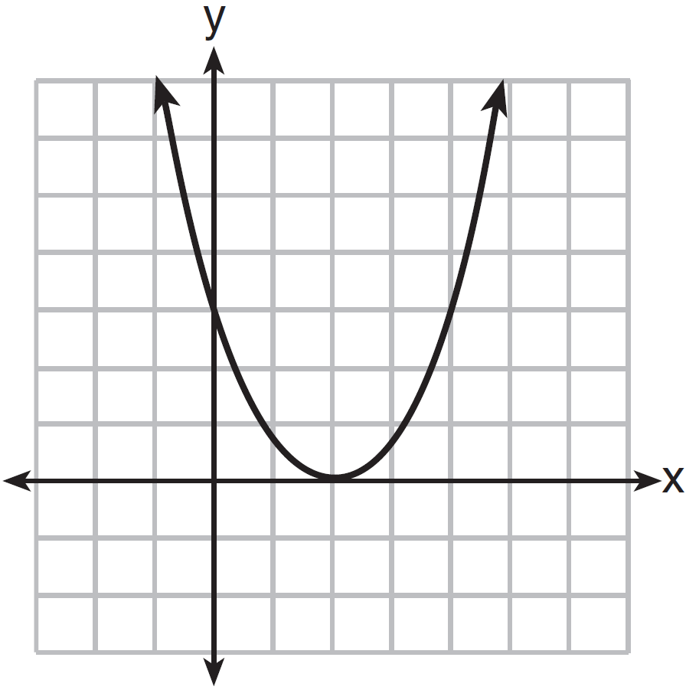
3) | 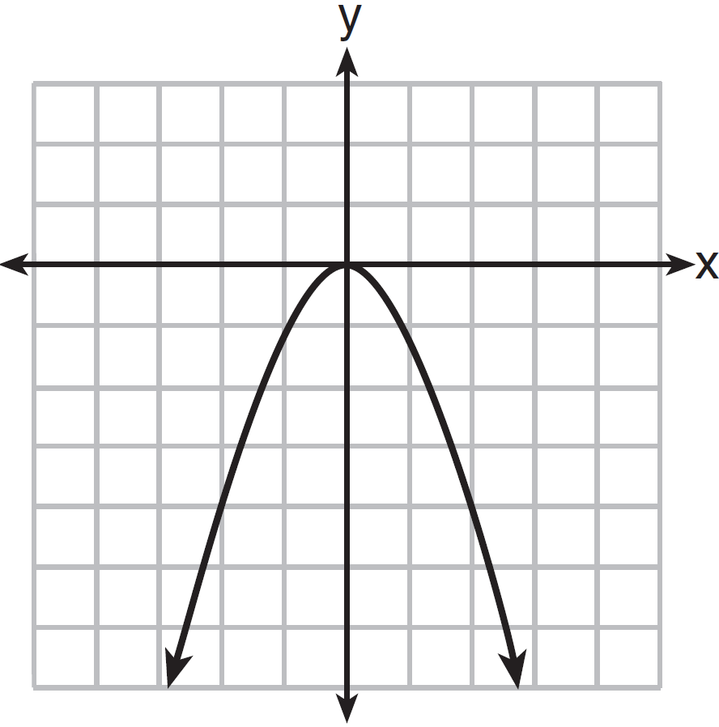
4) | 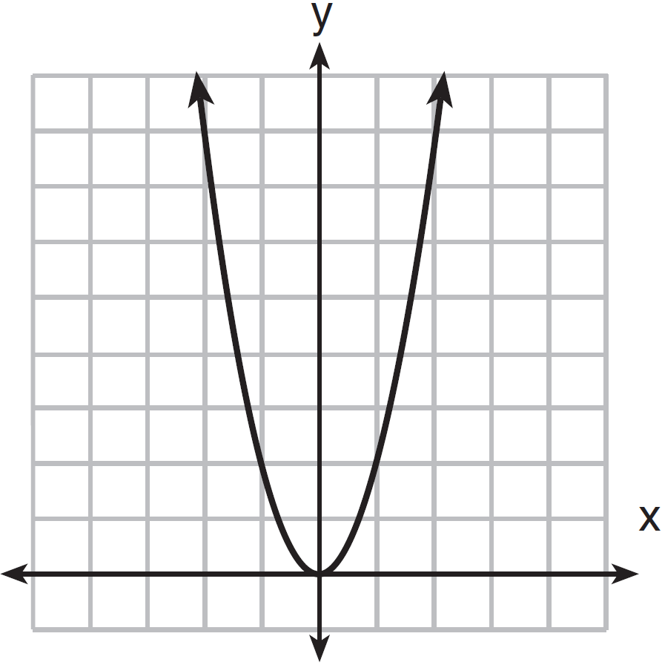

4 The local deli charges a fee for delivery. On Monday, they delivered two dozen bagels to an office at a total cost of $8. On Tuesday, three dozen bagels were delivered at a total cost of $11. Which system of equations could be used to find the cost of a dozen bagels, b, if the delivery fee is f?
1) | 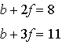
2) | 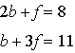
3) | 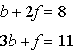
4) | 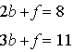

5 Which inequality is shown in the graph below?

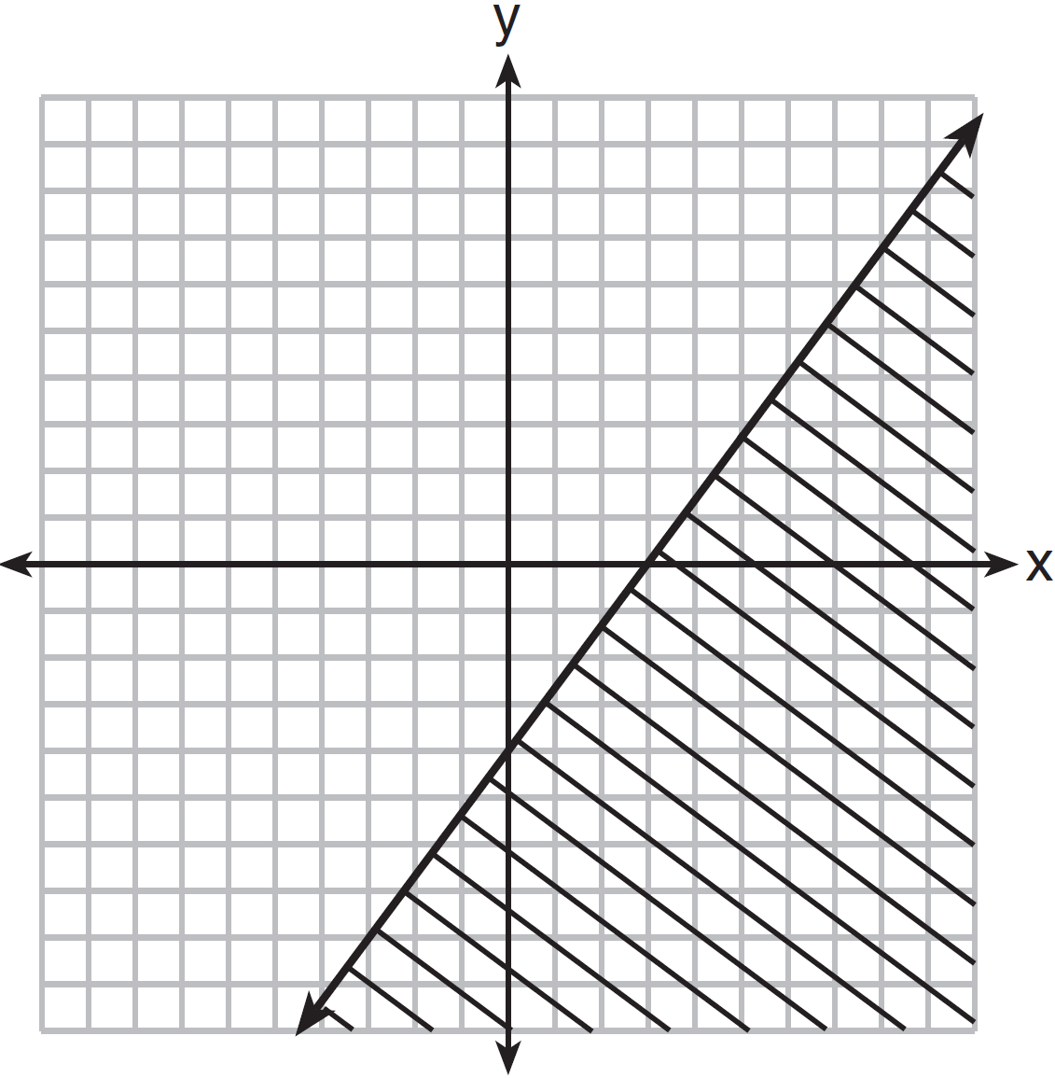
1) | 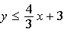
2) | 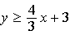
3) | 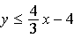
4) | 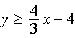

6 Which expression is equivalent to ?
1)
2)
3)
4)

7 Which value of x is the solution of 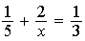?
1) | 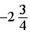
2)
3)
4) | 15

8 The product of a number and 3, increased by 5, is 7 less than twice the number. Which equation can be used to find this number, n?
1)
2)
3)
4)

9 Which linear equation represents a line that has a slope of ?
1)
2)
3)
4)

10 Which situation is an example of bivariate data?
1) | shoe sizes of a tennis team
2) | goals scored in soccer games
3) | Calories consumed in one day
4) | hours studying compared to test scores

11 What is the solution of the following system of equations? 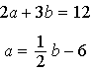
1) | and
2) | and
3) | and
4) | and

12 Which statement is true about the data shown in the scatter plot below?

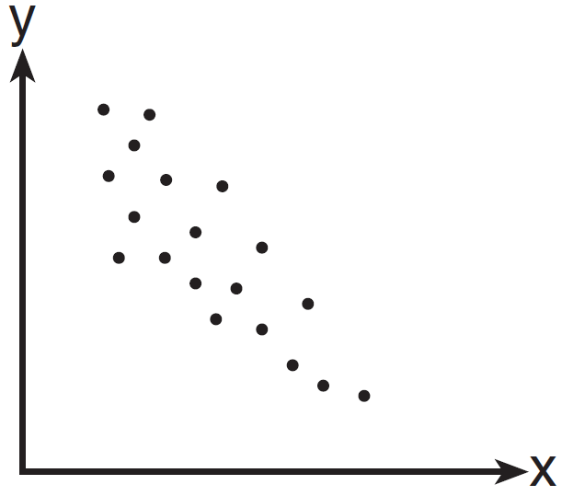
1) | There is no correlation between the two sets of data.
2) | There is a positive correlation between the two sets of data.
3) | There is a negative correlation between the two sets of data.
4) | The correlation between the data is both positive and negative.

13 The graph of the equation is a line
1) | parallel to the x-axis
2) | parallel to the y-axis
3) | passing through the origin
4) | passing through the point

14 The base of a closed right circular cylinder has a diameter of 5 cm. If the height of the cylinder is 8 cm, what is the surface area of the cylinder, to the nearest square centimeter?
1) | 157
2) | 165
3) | 408
4) | 628

15 Which equation represents the line that passes through the points and ?
1)
2)
3)
4)

16 As shown in the diagram below, a building casts a 72-foot shadow on the ground when the angle of elevation of the Sun is 40°.

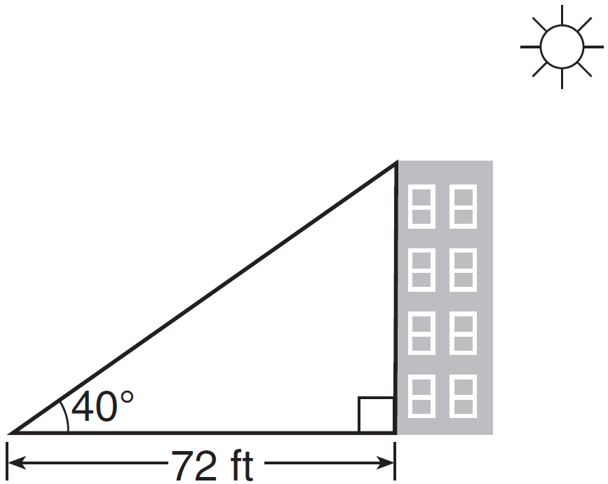

How tall is the building, to the nearest foot?
1) | 46
2) | 60
3) | 86
4) | 94

17 Which value of x is a solution of the inequality ?
1) | 13
2) | 14
3) | 15
4) | 16

18 The square of a positive number is 24 more than 5 times the number. What is the value of the number?
1) | 6
2) | 8
3) | 3
4) | 4

19 Owino gets paid $280 per week plus 5% commission on all sales for selling electronic equipment. If he sells n dollars worth of electronic equipment in one week, which algebraic expression represents the amount of money he will earn that week?
1)
2)
3)
4)

20 Which value of x makes the expression 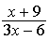 undefined?
1)
2) | 2
3)
4) | 0

21 A total of 1680 ounces of pet food have to be packed in 5-pound bags. How many 5-pound bags of pet food can be packed?

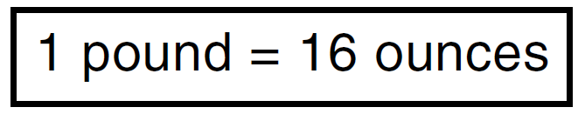
1) | 21
2) | 28
3) | 105
4) | 336

22 For a class of students, which data set could be classified as qualitative?
1) | political opinions
2) | heights
3) | weights
4) | ages

23 In right triangle EFD, , , and . What is the measure of angle E, to the nearest degree?
1) | 61
2) | 57
3) | 33
4) | 29

24 If , what is x expressed in terms of y and z?
1)
2) | 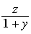
3) | 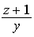
4) | 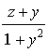

25 Mrs. Porter recorded her students' grades in the frequency table below.

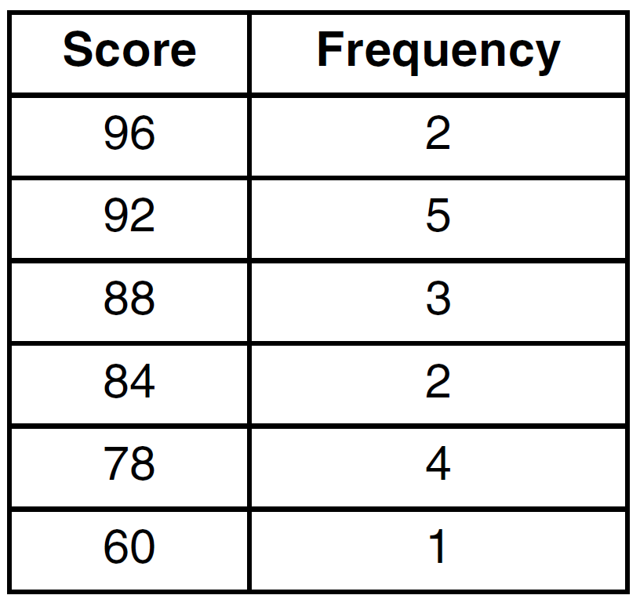

Which statement is true for the data?
1) | mean > median > mode
2) | mean > mode > median
3) | mode > median > mean
4) | median > mean > mode

26 The equation illustrates the use of which property?
1) | distributive property
2) | associative property of addition
3) | associative property of multiplication
4) | commutative property of multiplication

27 If , what is the value of n?
1) | 6
2) | 5
3) | 3
4) | 7

28 Which value is equivalent to the product of and ?
1)
2)
3)
4)

29 The set of integers in can be written as
1)
2)
3)
4)

30 A rectangular tank measures 5 feet long, 4 feet wide, and 3 feet high. Water is poured into the tank to a depth of feet. How many cubic feet of water are in the tank?
1) | 60
2) | 50
3) | 15.5
4) | 11.5

31 Jen traveled a distance of 170 miles in 2 hours and 45 minutes. Express her speed, in miles per hour, to the nearest tenth.

32 As shown below, polygon ABCGFED consists of two squares, ABCD and CGFE, and an equilateral triangle CED. The length of is cm. Determine the perimeter of polygon ABCGFED in radical form.

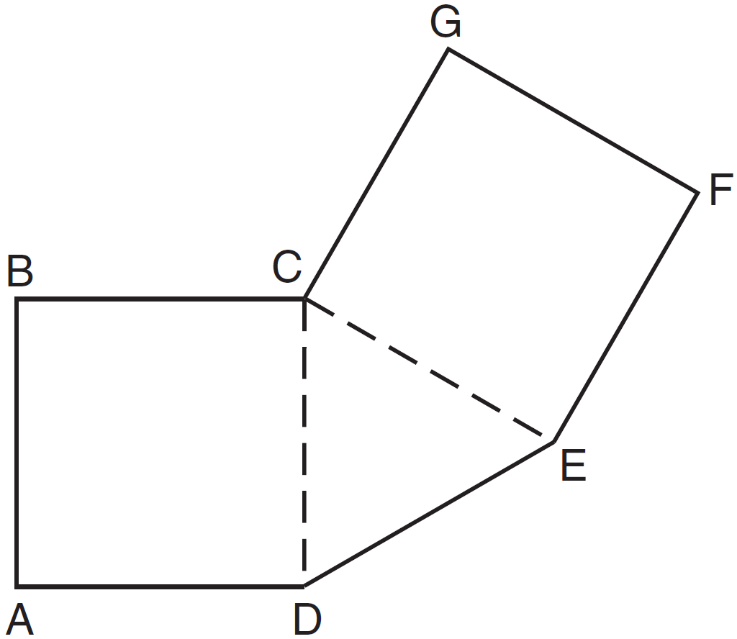

33 Write a quadratic equation in standard form that has roots of and 2.

34 Find algebraically the equation of the axis of symmetry and the vertex of the parabola represented by the equation .

35 Linda measures her rectangular bedroom window for a new shade. The measurements she made are 36 inches by 42 inches. The actual measurements of the window are 36.5 inches and 42.5 inches. Determine the relative error in calculating the area. Express your answer as a decimal to the nearest thousandth.

36 The following set of data represents the heights, in inches, of the 20 students in Ms. Fitzgerald's freshman class:
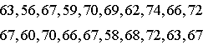
Complete the frequency table below.

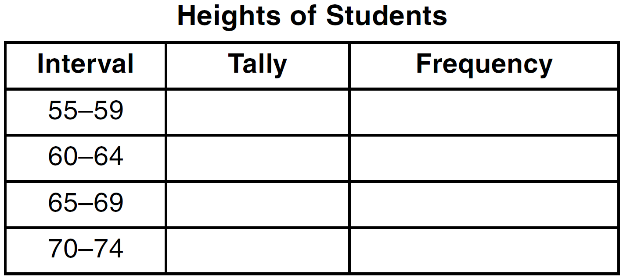

On the grid below, draw and label a frequency histogram for these data.



37 On the set of axes below, graph . State the roots of .

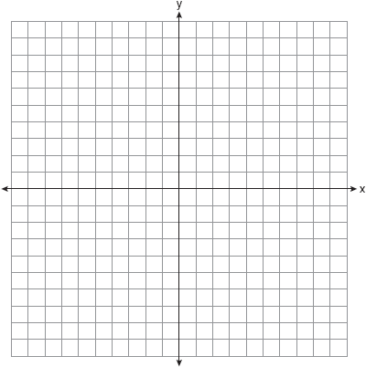

38 The length of a rectangle is represented by , and the width is represented by . Express the perimeter of the rectangle as a trinomial. Express the area of the rectangle as a trinomial.

39 Tony makes a phone call at a pay phone. The charge is 25 cents for the first four minutes, and 10 cents for each additional minute. Tony has $2.10 in change in his pocket. Write an inequality that can be used to find m, the maximum number of minutes that Tony can talk on the phone. Solve this inequality algebraically to find the maximum number of whole minutes he can talk on the phone.
1 ANS: 3 PTS: 2 REF: 061501ia STA: A.A.31
TOP: Set Theory

2 ANS: 3
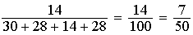

PTS: 2 REF: 061502ia STA: A.S.21 TOP: Experimental Probability

3 ANS: 4 PTS: 2 REF: 061503ia STA: A.G.5
TOP: Graphing Quadratic Functions

4 ANS: 4 PTS: 2 REF: 061504ia STA: A.A.7
TOP: Writing Linear Systems

5 ANS: 3 PTS: 2 REF: 061505ia STA: A.G.6
TOP: Linear Inequalities

6 ANS: 3 PTS: 2 REF: 061506ia STA: A.A.19
TOP: Factoring the Difference of Perfect Squares

7 ANS: 4
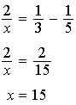

PTS: 2 REF: 061507ia STA: A.A.26 TOP: Solving Rationals

8 ANS: 1 PTS: 2 REF: 061508ia STA: A.A.4
TOP: Modeling Equations

9 ANS: 4 PTS: 2 REF: 061509ia STA: A.A.37
TOP: Slope

10 ANS: 4 PTS: 2 REF: 061510ia STA: A.S.2
TOP: Analysis of Data

11 ANS: 3
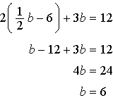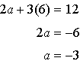

PTS: 2 REF: 061511ia STA: A.A.10 TOP: Solving Linear Systems

12 ANS: 3 PTS: 2 REF: 061512ia STA: A.S.12
TOP: Scatter Plots

13 ANS: 1 PTS: 2 REF: 061513ia STA: A.A.36
TOP: Parallel and Perpendicular Lines

14 ANS: 2

PTS: 2 REF: 061514ia STA: A.G.2 TOP: Surface Area

15 ANS: 1
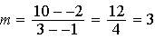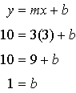

PTS: 2 REF: 061515ia STA: A.A.35 TOP: Writing Linear Equations

16 ANS: 2
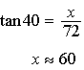

PTS: 2 REF: 061516ia STA: A.A.44 TOP: Using Trigonometry to Find a Side

17 ANS: 1
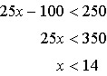

PTS: 2 REF: 061517ia STA: A.A.21 TOP: Interpreting Solutions

18 ANS: 2
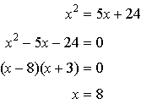

PTS: 2 REF: 061518ia STA: A.A.8 TOP: Writing Quadratics

19 ANS: 3 PTS: 2 REF: 061519ia STA: A.A.1
TOP: Expressions

20 ANS: 2 PTS: 2 REF: 061520ia STA: A.A.15
TOP: Undefined Rationals

21 ANS: 1
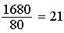

PTS: 2 REF: 061521ia STA: A.M.2 TOP: Conversions
KEY: dimensional analysis

22 ANS: 1
The other situations are quantitative.

PTS: 2 REF: 061522ia STA: A.S.1 TOP: Analysis of Data

23 ANS: 2
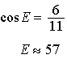

PTS: 2 REF: 061523ia STA: A.A.43 TOP: Using Trigonometry to Find an Angle

24 ANS: 4
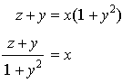

PTS: 2 REF: 061524ia STA: A.A.23 TOP: Transforming Formulas

25 ANS: 3
The mean is 86, the median is 88 and the mode is 92.

PTS: 2 REF: 061525ia STA: A.S.4 TOP: Central Tendency

26 ANS: 1 PTS: 2 REF: 061526ia STA: A.N.1
TOP: Identifying Properties

27 ANS: 2
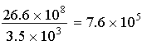

PTS: 2 REF: 061527ia STA: A.N.4 TOP: Operations with Scientific Notation

28 ANS: 1
PTS: 2 REF: 061528ia STA: A.N.3 TOP: Operations with Radicals
KEY: multiplication

29 ANS: 3 PTS: 2 REF: 061529ia STA: A.A.29
TOP: Set Theory

30 ANS: 2
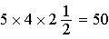
PTS: 2 REF: 061530ia STA: A.G.2 TOP: Volume

31 ANS:
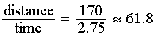
PTS: 2 REF: 061531ia STA: A.M.1 TOP: Speed

32 ANS:
PTS: 2 REF: 061532ia STA: A.G.1 TOP: Compositions of Polygons and Circles
KEY: perimeter

33 ANS:
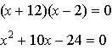
PTS: 2 REF: 061533ia STA: A.A.28 TOP: Roots of Quadratics

34 ANS:
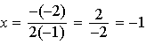
PTS: 3 REF: 061534ia STA: A.A.41
TOP: Identifying the Vertex of a Quadratic Given Equation

35 ANS:
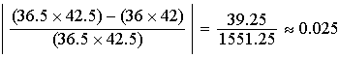
PTS: 3 REF: 061535ia STA: A.M.3 TOP: Error
KEY: area

36 ANS:
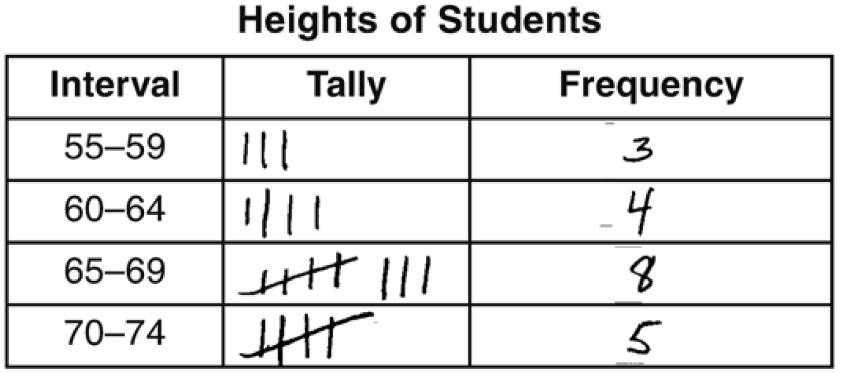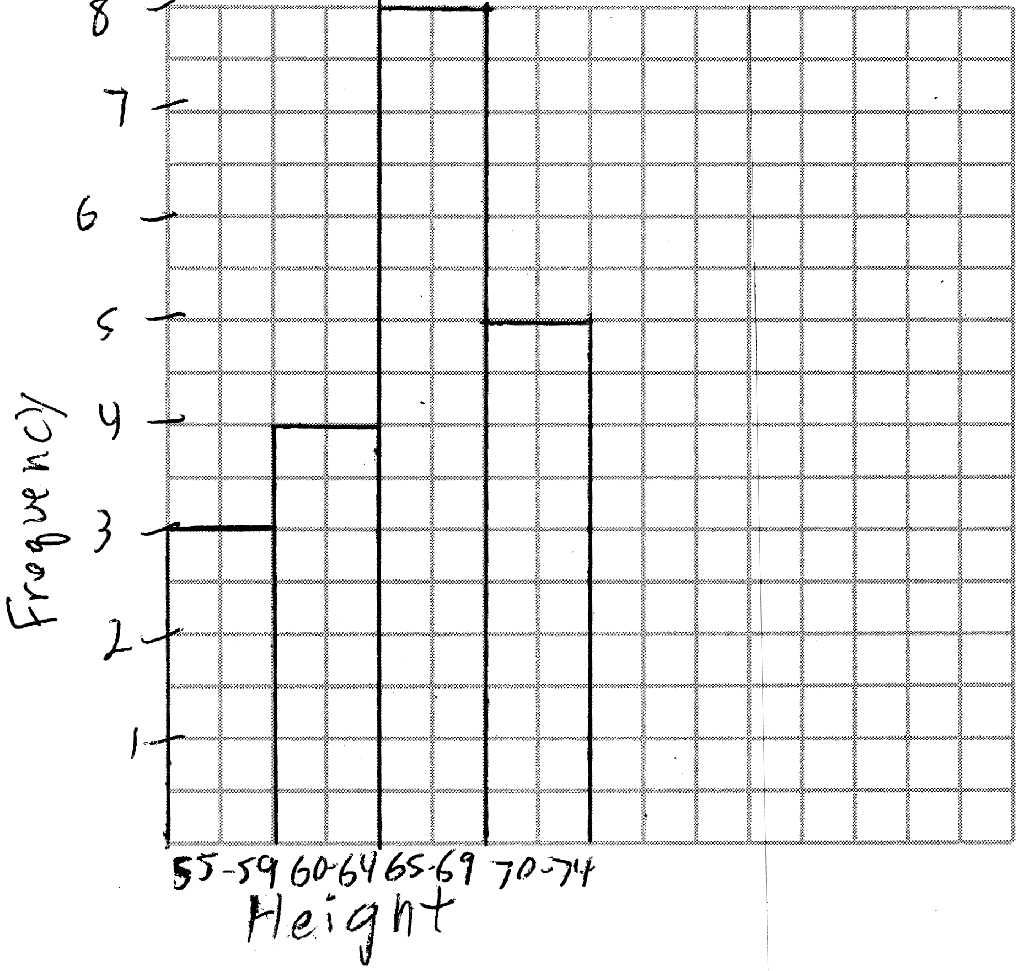
PTS: 3 REF: 061536ia STA: A.S.5
TOP: Frequency Histograms, Bar Graphs and Tables KEY: frequency histograms

37 ANS:
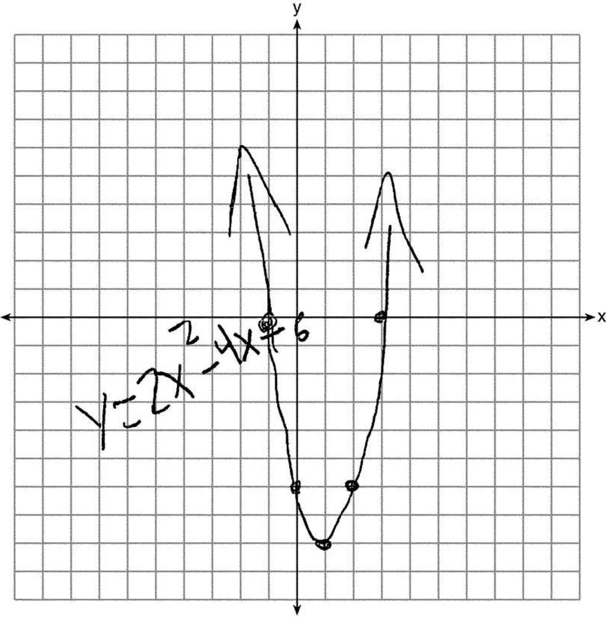3 and .
PTS: 4 REF: 061537ia STA: A.G.8 TOP: Solving Quadratics by Graphing

38 ANS:
PTS: 4 REF: 061538ia STA: A.A.13 TOP: Multiplication of Polynomials

39 ANS:
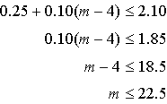 22 minutes
PTS: 4 REF: 061539ia STA: A.A.6 TOP: Modeling Inequalities

