1 The product of and is
1)
2)
3)
4)

2 Which set of data is qualitative?
1) | laps swum in a race
2) | number of swimmers on the team
3) | swimmers’ favorite swimsuit colors
4) | temperature in Fahrenheit of the water in a pool

3 It takes a snail 500 hours to travel 15 miles. At this rate, how many hours will it take the snail to travel 6 miles?
1) | 0.18
2) | 5.56
3) | 150
4) | 200

4 The equation is graphed on the set of axes below.

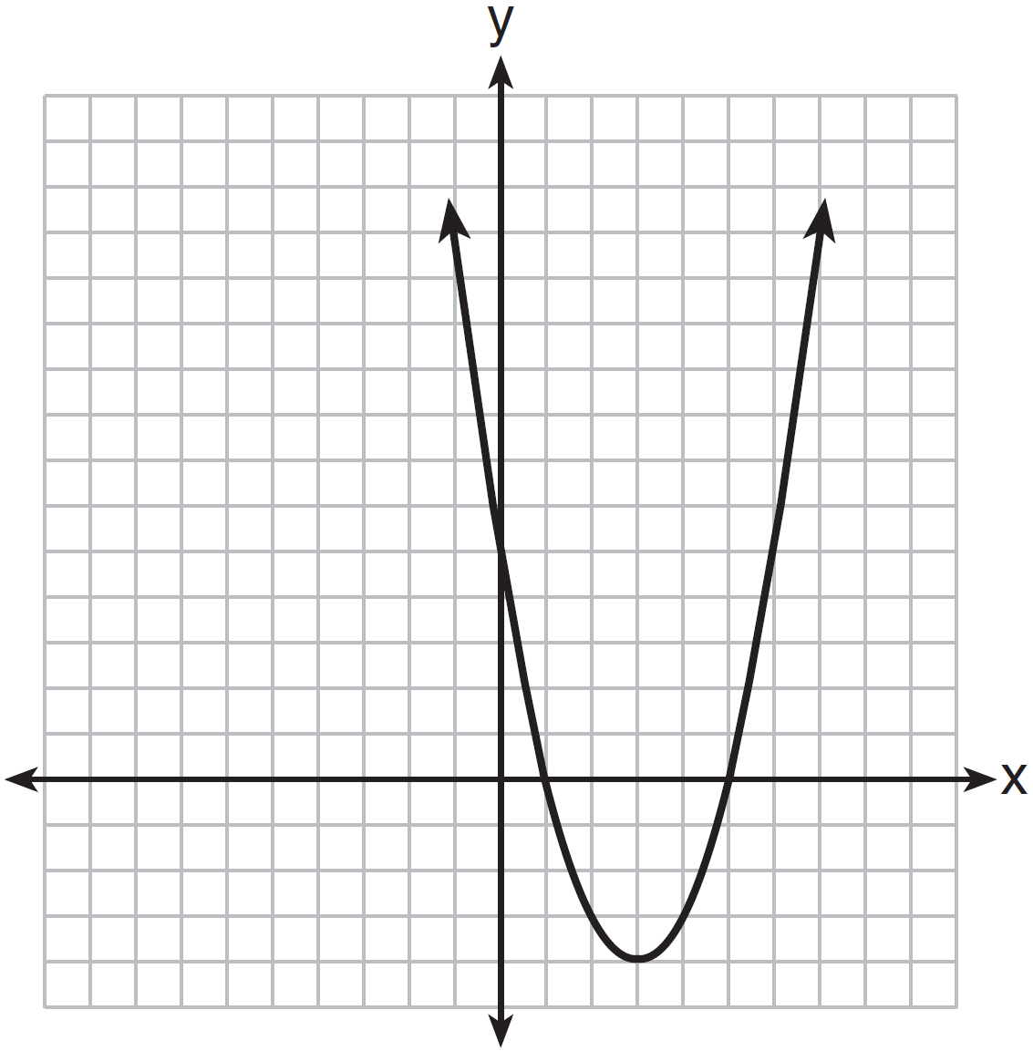

Based on the graph, what are the roots of the equation ?
1) | 0 and 5
2) | 1 and 0
3) | 1 and 5
4) | 3 and

5 When solving for the value of x in the equation , Aaron wrote the following lines on the board.
[line 1]
[line 2]
[line 3]
[line 4]
[line 5]
Which property was used incorrectly when going from line 2 to line 3?
1) | distributive
2) | commutative
3) | associative
4) | multiplicative inverse

6 What is the solution of ?
1)
2)
3)
4)

7 A local government is planning to increase the fee for use of a campsite. If a survey were taken, which group would be most biased in their opposition to the increase?
1) | teachers
2) | soccer players
3) | postal workers
4) | campers

8 An example of an algebraic equation is
1)
2)
3)
4)

9 What is the value of x in the solution of the system of equations and ?
1) | 8
2) | 2
3) | 3
4) | 4

10 What is the slope of a line that passes through the points and ?
1)
2)
3)
4)

11 Which notation is equivalent to the inequality ?
1)
2)
3)
4)

12 What is the value of the expression when ?
1)
2)
3) | 21
4) | 45

13 Which relation is a function?
1)
2)
3)
4)

14 When is subtracted from , the result is
1)
2)
3)
4)

15 The lengths of the sides of a right triangle can be
1)
2)
3)
4)

16 Which equation represents a line that is parallel to the y-axis?
1)
2)
3)
4)

17 In right triangle ABC shown below, , , and .

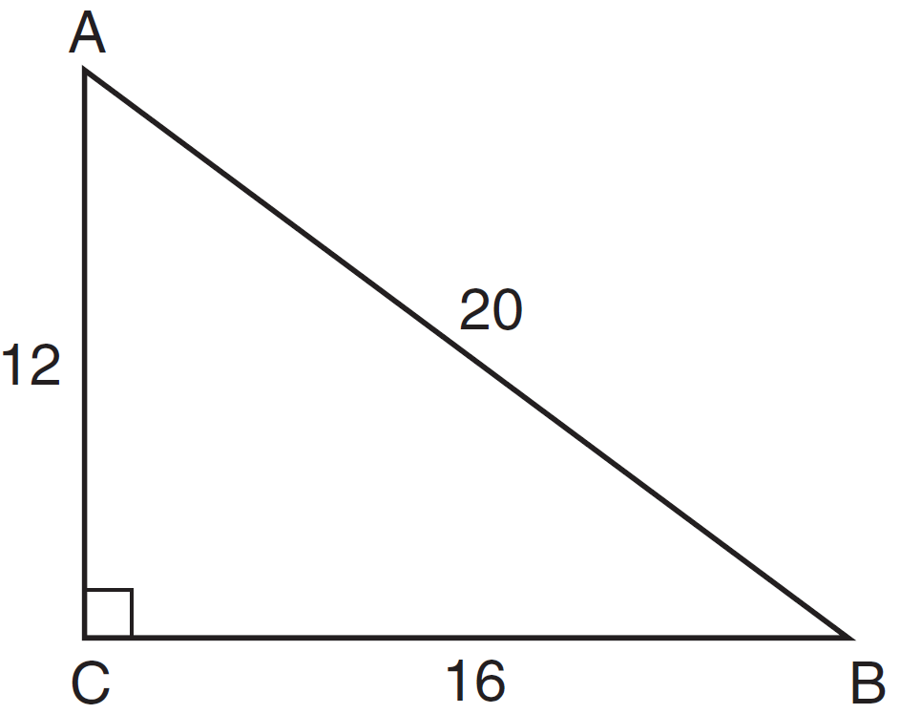

Which equation is not correct?
1) | 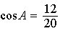
2) | 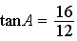
3) | 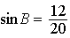
4) | 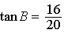

18 Three times the sum of a number and four is equal to five times the number, decreased by two. If x represents the number, which equation is a correct translation of the statement?
1)
2)
3)
4)

19 What is the equation of the line that passes through the point and has a slope of ?
1) | 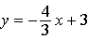
2) | 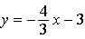
3) | 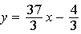
4) | 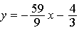

20 Which parabola has an axis of symmetry of ?
1) | 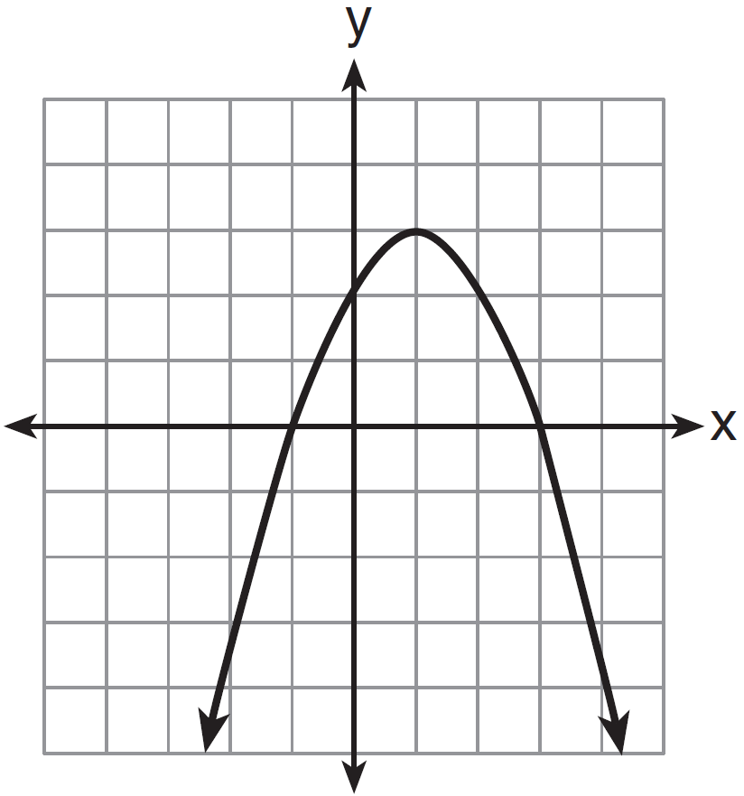
2) | 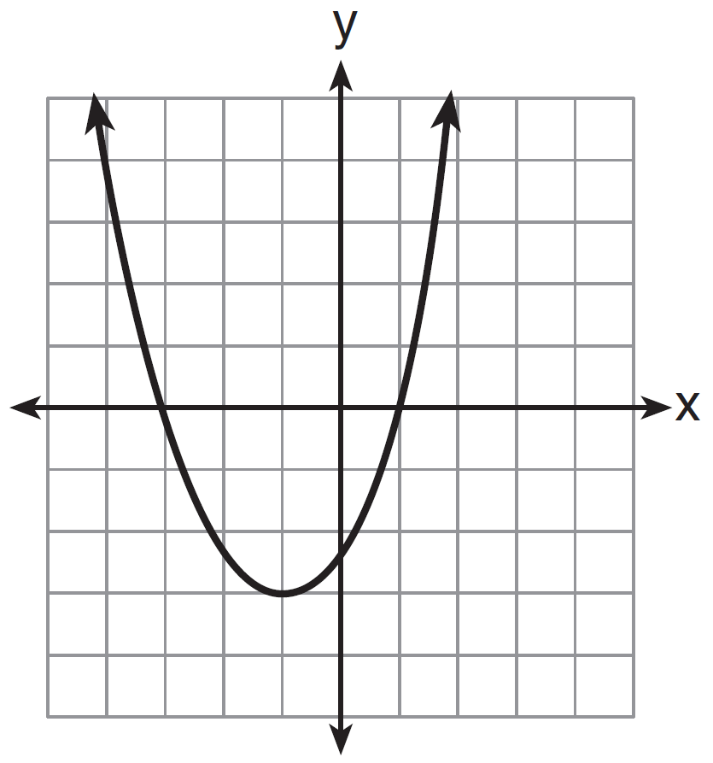
3) | 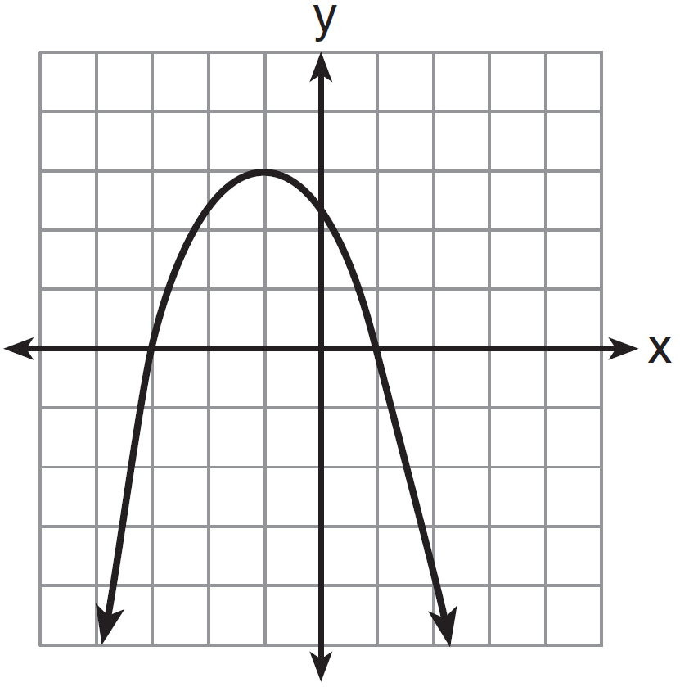
4) | 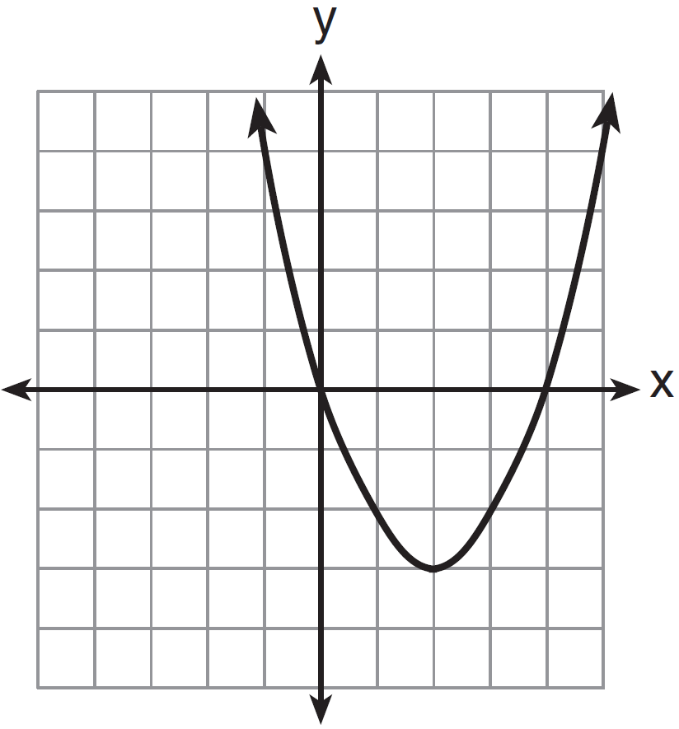

21 When factored completely, the expression is equivalent to
1)
2)
3)
4)

22 The equation models the United States population, P, in millions since 1900. If t represents the number of years after 1900, then what is the estimated population in 2025 to the nearest tenth of a million?
1) | 217.8
2) | 219.0
3) | 343.9
4) | 356.9

23 Which graph represents an absolute value equation?
1) | 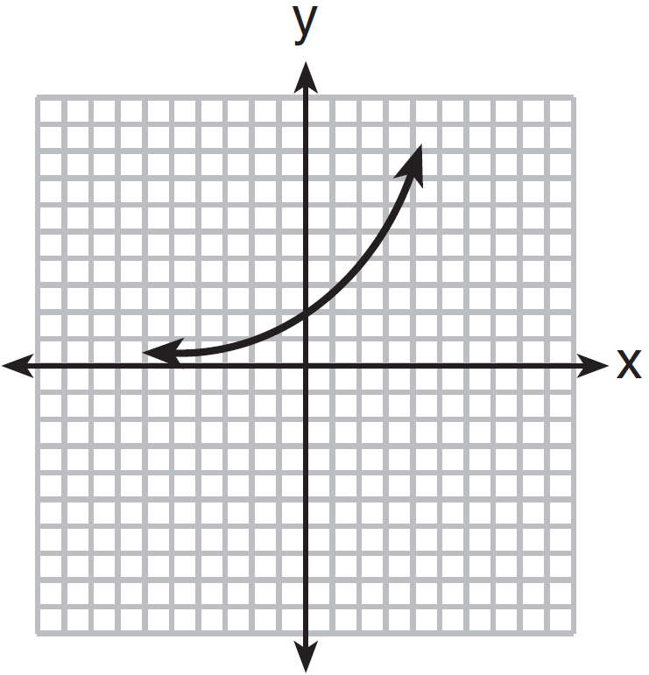
2) | 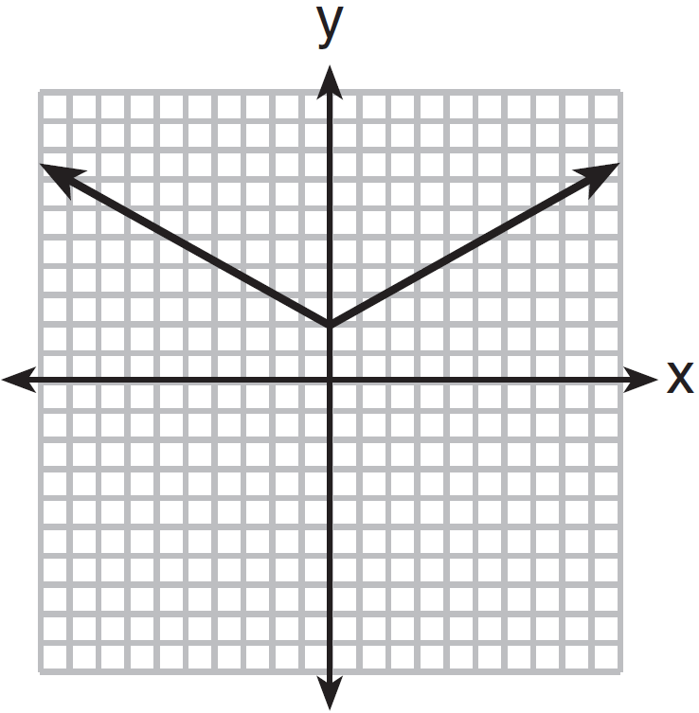
3) | 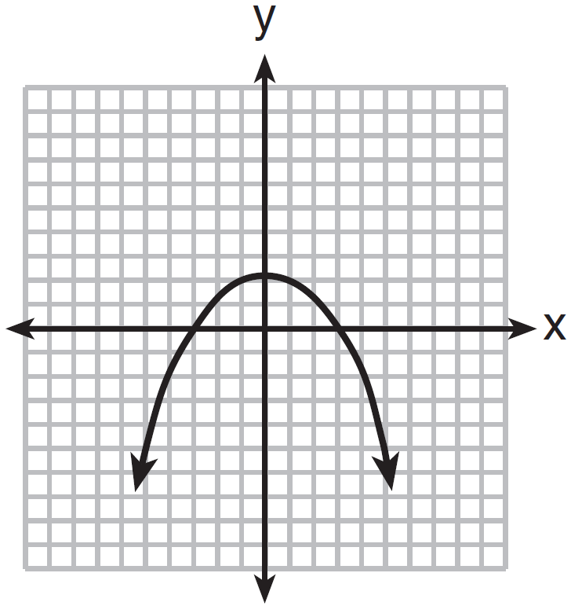
4) | 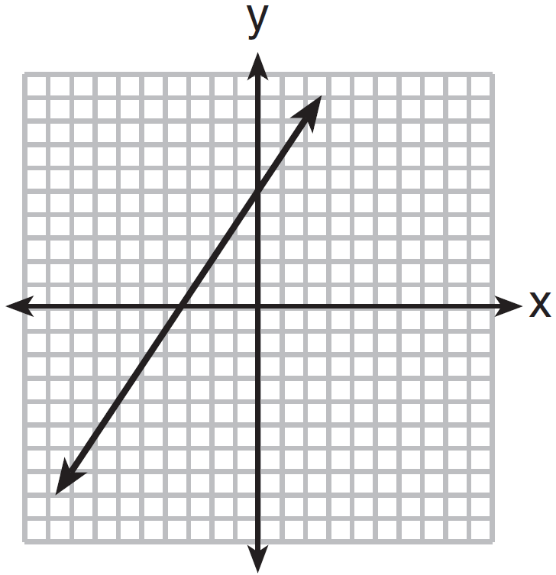

24 The expression 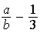 is equivalent to
1) | 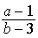
2) | 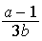
3) | 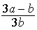
4) | 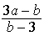

25 Which value of x is the solution of the equation ?
1) | 1
2) | 2
3) | 6
4) | 0

26 Given: 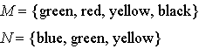
Which set represents ?
1)
2)
3)
4)

27 Which situation describes a correlation that is not a causal relationship?
1) | the number of miles walked and the total Calories burned
2) | the population of a country and the census taken every ten years
3) | the number of hours a TV is on and the amount of electricity used
4) | the speed of a car and the number of hours it takes to travel a given distance

28 A school offers three classes of math and two classes of science, all of which meet at different times. What is the total number of ways a student can take a math class and a science class?
1) | 5
2) | 6
3) | 8
4) | 9

29 The expression 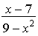 is undefined when x is
1) | 3 and 7
2) | 3 and
3) | 3, only
4) | 9

30 What is the product of and expressed in scientific notation?
1)
2)
3)
4)

31 A patio consisting of two semicircles and a square is shown in the diagram below. The length of each side of the square region is represented by . Write an expression for the area of the entire patio, in terms of x and .

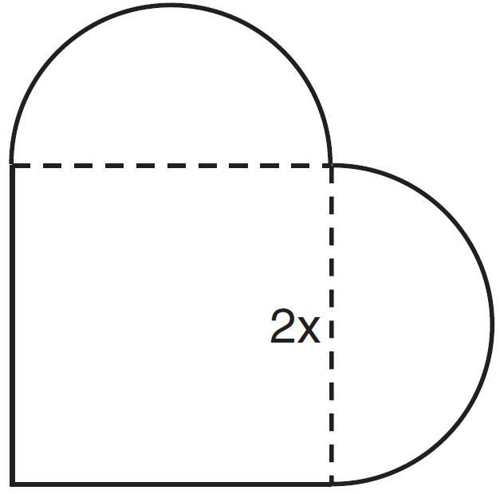

32 Clayton is performing some probability experiments consisting of flipping three fair coins. What is the probability that when Clayton flips the three coins, he gets two tails and one head?

33 Ross is installing edging around his pool, which consists of a rectangle and a semicircle, as shown in the diagram below.

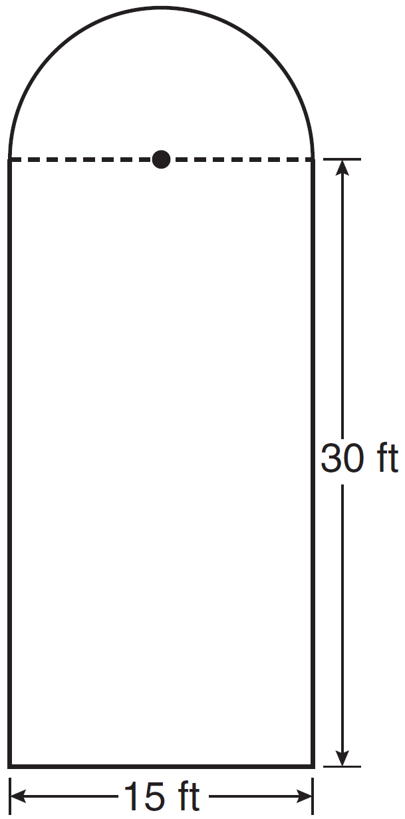

Determine the length of edging, to the nearest tenth of a foot, that Ross will need to go completely around the pool.

34 Solve the following system of equations algebraically for all values of x and y.
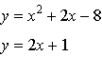

35 A storage container in the form of a rectangular prism is measured to be 12 inches by 8 inches by 4 inches. Its actual measurements are 11.75 inches by 7.75 inches by 4 inches. Find the relative error in calculating the volume of the container, to the nearest thousandth.

36 Perform the indicated operations and express the answer in simplest radical form.
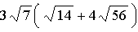

37 During its first week of business, a market sold a total of 108 apples and oranges. The second week, five times the number of apples and three times the number of oranges were sold. A total of 452 apples and oranges were sold during the second week. Determine how many apples and how many oranges were sold the first week. [Only an algebraic solution can receive full credit.]

38 On the set of axes below, solve the following system of inequalities graphically. Label the solution set S.
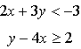

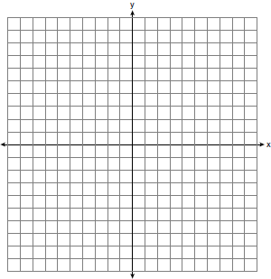

39 During the last 15 years of his baseball career, Andrew hit the following number of home runs each season.
State and label the values of the minimum, 1st quartile, median, 3rd quartile, and maximum. Using the line below, construct a box-and-whisker plot for this set of data.

1 ANS: 3 PTS: 2 REF: 061401ia STA: A.A.12
TOP: Multiplication of Powers

2 ANS: 3
The other situations are quantitative.

PTS: 2 REF: 061402ia STA: A.S.1 TOP: Analysis of Data

3 ANS: 4
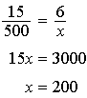

PTS: 2 REF: 061403ia STA: A.M.1 TOP: Speed

4 ANS: 3 PTS: 2 REF: 061404ia STA: A.G.8
TOP: Solving Quadratics by Graphing

5 ANS: 1 PTS: 2 REF: 061405ia STA: A.N.1
TOP: Identifying Properties

6 ANS: 1
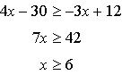

PTS: 2 REF: 061406ia STA: A.A.24 TOP: Solving Inequalities

7 ANS: 4 PTS: 2 REF: 061407ia STA: A.S.3
TOP: Analysis of Data

8 ANS: 3 PTS: 2 REF: 061408ia STA: A.A.3
TOP: Expressions

9 ANS: 2
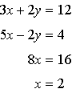

PTS: 2 REF: 061409ia STA: A.A.10 TOP: Solving Linear Systems

10 ANS: 2
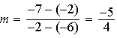

PTS: 2 REF: 061410ia STA: A.A.33 TOP: Slope

11 ANS: 2 PTS: 2 REF: 061411ia STA: A.A.29
TOP: Set Theory

12 ANS: 3

PTS: 2 REF: 061412ia STA: A.N.6 TOP: Evaluating Expressions

13 ANS: 1 PTS: 2 REF: 061413ia STA: A.G.3
TOP: Defining Functions KEY: ordered pairs

14 ANS: 2 PTS: 2 REF: 061414ia STA: A.A.13
TOP: Addition and Subtraction of Polynomials KEY: subtraction

15 ANS: 1 PTS: 2 REF: 061415ia STA: A.A.45
TOP: Pythagorean Theorem

16 ANS: 1 PTS: 2 REF: 061416ia STA: A.A.36
TOP: Parallel and Perpendicular Lines

17 ANS: 4 PTS: 2 REF: 061417ia STA: A.A.42
TOP: Trigonometric Ratios

18 ANS: 1 PTS: 2 REF: 061418ia STA: A.A.4
TOP: Modeling Equations

19 ANS: 2
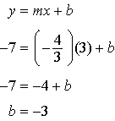

PTS: 2 REF: 061419ia STA: A.A.34 TOP: Writing Linear Equations

20 ANS: 1 PTS: 2 REF: 061420ia STA: A.G.10
TOP: Identifying the Vertex of a Quadratic Given Graph

21 ANS: 4

PTS: 2 REF: 061421ia STA: A.A.20 TOP: Factoring Polynomials

22 ANS: 4

PTS: 2 REF: 061422ia STA: A.A.8 TOP: Quadratic Functions

23 ANS: 2 PTS: 2 REF: 061423is STA: A.G.4
TOP: Families of Functions

24 ANS: 3 PTS: 2 REF: 061424ia STA: A.A.17
TOP: Addition and Subtraction of Rationals

25 ANS: 2
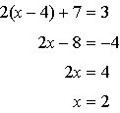

PTS: 2 REF: 061425ia STA: A.A.22 TOP: Solving Equations

26 ANS: 4 PTS: 2 REF: 061426ia STA: A.A.31
TOP: Set Theory

27 ANS: 2 PTS: 2 REF: 061427ia STA: A.S.14
TOP: Analysis of Data

28 ANS: 2 PTS: 2 REF: 061428ia STA: A.N.7
TOP: Conditional Probability

29 ANS: 2 PTS: 2 REF: 061429ia STA: A.A.15
TOP: Undefined Rationals

30 ANS: 3 PTS: 2 REF: 061430ia STA: A.N.4
TOP: Operations with Scientific Notation

31 ANS:

PTS: 2 REF: 061431ia STA: A.G.1 TOP: Compositions of Polygons and Circles
KEY: area

32 ANS:
. (H,H,H), (H,H,T), (H,T,H), (H,T,T), (T,H,H), (T,H,T), (T,T,H), (T,T,T)

PTS: 2 REF: 061432ia STA: A.S.19 TOP: Sample Space

33 ANS:
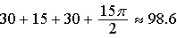

PTS: 2 REF: 061433ia STA: A.G.1 TOP: Compositions of Polygons and Circles
KEY: perimeter

34 ANS:
. 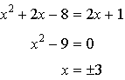. 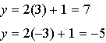

PTS: 3 REF: 061434ia STA: A.A.11 TOP: Quadratic-Linear Systems

35 ANS:
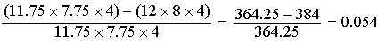

PTS: 3 REF: 061435ia STA: A.M.3 TOP: Error
KEY: volume and surface area

36 ANS:

PTS: 3 REF: 061436ia STA: A.N.3 TOP: Operations with Radicals
KEY: mixed

37 ANS:
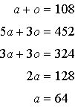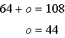

PTS: 4 REF: 061437ia STA: A.A.7 TOP: Writing Linear Systems

38 ANS:
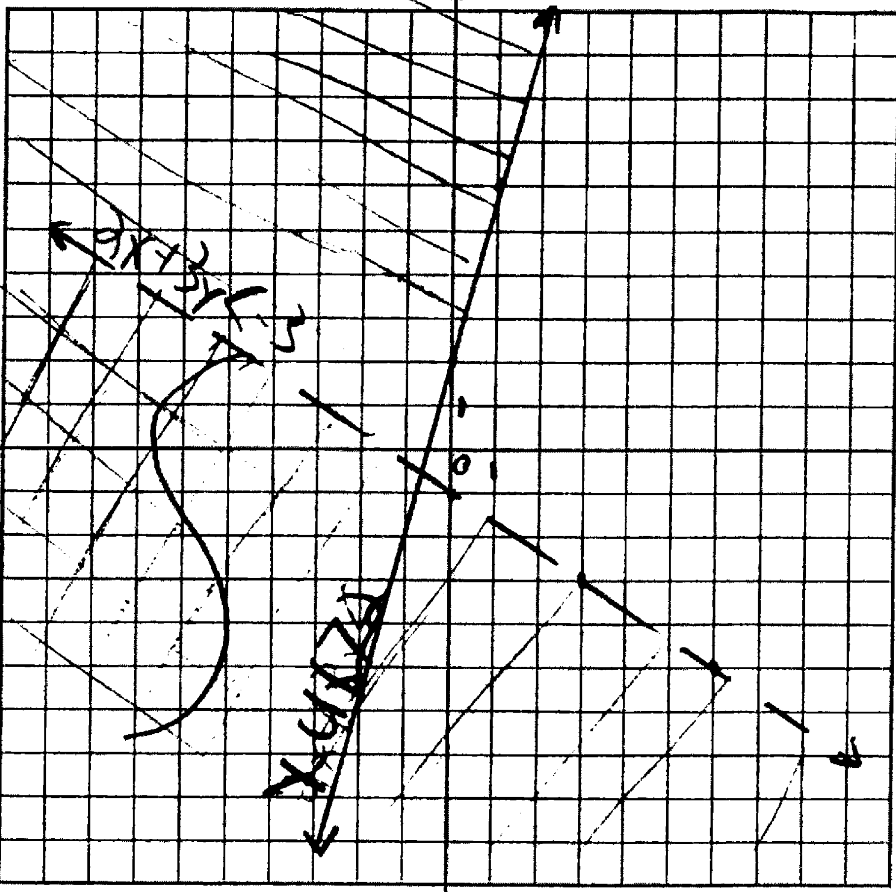

PTS: 4 REF: 061438ia STA: A.G.7 TOP: Systems of Linear Inequalities

39 ANS:
Min: 8, Q1: 20, Med: 32, Q3: 36, Max: 40

PTS: 4 REF: 061439ia STA: A.S.5 TOP: Box-and-Whisker Plots

