1 In a baseball game, the ball traveled 350.7 feet in 4.2 seconds. What was the average speed of the ball, in feet per second?
1) | 83.5
2) | 177.5
3) | 354.9
4) | 1,472.9

2 A survey is being conducted to determine if a cable company should add another sports channel to their schedule. Which random survey would be the least biased?
1) | surveying 30 men at a gym
2) | surveying 45 people at a mall
3) | surveying 50 fans at a football game
4) | surveying 20 members of a high school soccer team

3 The quotient of 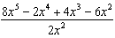 is
1)
2) | `
3)
4)

4 Marcy determined that her father's age is four less than three times her age. If x represents Marcy's age, which expression represents her father's age?
1)
2)
3)
4)

5 A set of data is graphed on the scatter plot below.

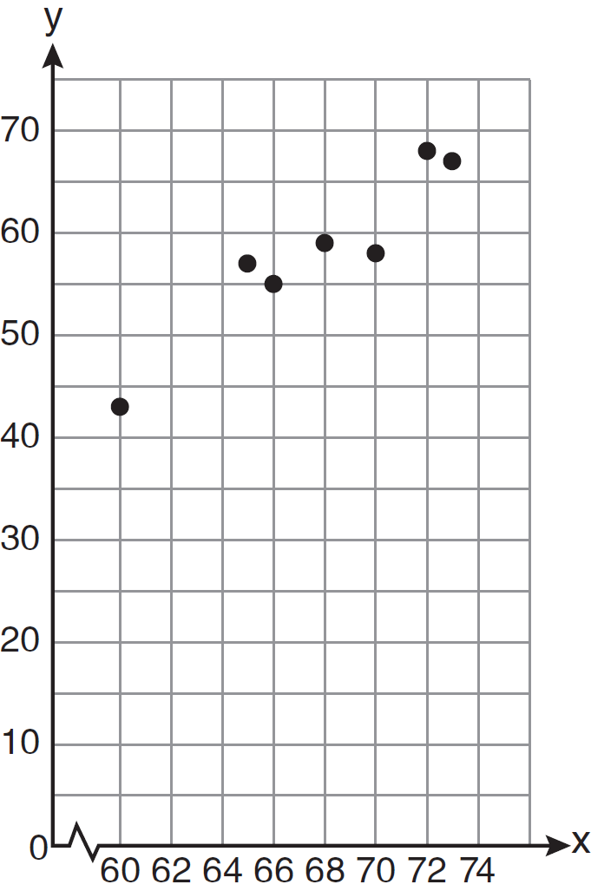
This scatter plot shows
1) | no correlation
2) | positive correlation
3) | negative correlation
4) | undefined correlation

6 Which situation is an example of bivariate data?
1) | the number of pizzas Tanya eats during her years in high school
2) | the number of times Ezra puts air,in his bicycle tires during the summer
3) | the number of home runs Elias hits per game and the number of hours he practices baseball
4) | the number of hours Nellie studies for her mathematics tests during the first half of the school year

7 Brianna's score on a national math assessment exceeded the scores of 95,000 of the 125,000 students who took the assessment. What was her percentile rank?
1) | 6
2) | 24
3) | 31
4) | 76

8 If , , and , then is
1)
2)
3)
4)

9 Which graph represents a function?
1) | 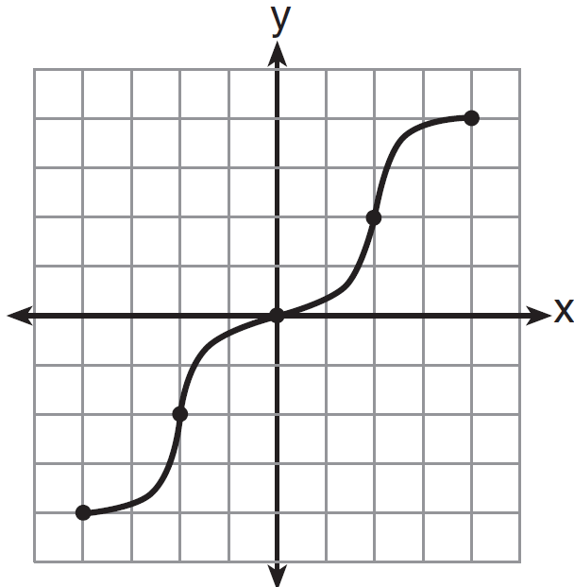
2) | 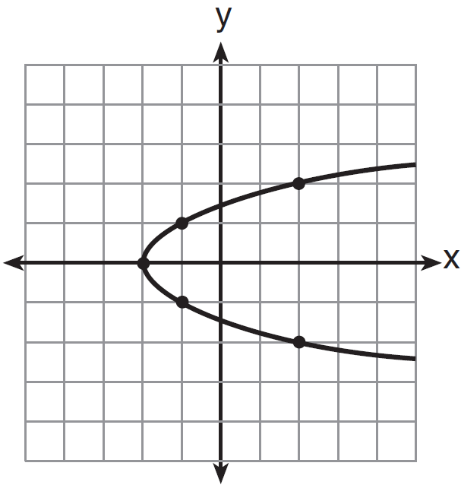
3) | 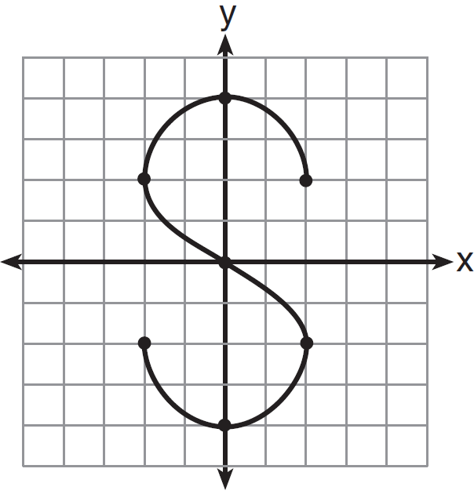
4) | 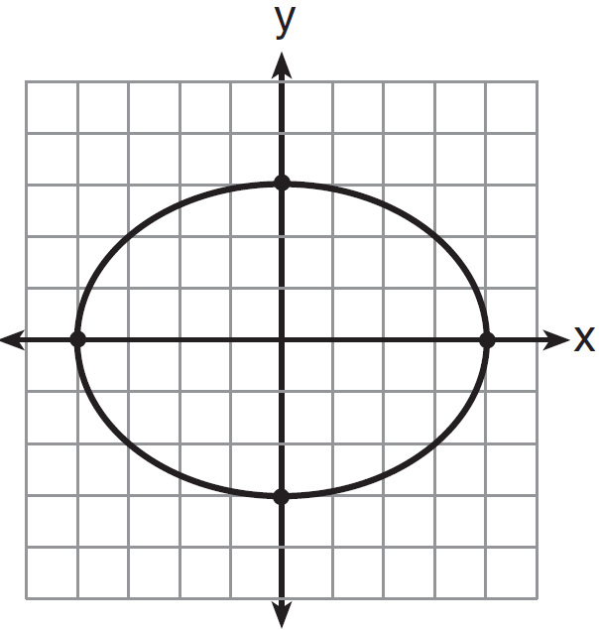

10 What is the product of and ?
1)
2)
3)
4)

11 If five times a number is less than 55, what is the greatest possible integer value of the number?
1) | 12
2) | 11
3) | 10
4) | 9

12 The line represented by the equation has a slope of
1)
2) | 2
3) | 3
4)

13 What is the solution set of the system of equations and ?
1)
2)
3)
4)

14 What is the vertex of the parabola represented by the equation ?
1)
2)
3)
4)

15 If , the value of m in terms of a, k, and x can be expressed as
1) | 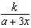
2) | 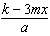
3) | 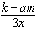
4) | 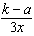

16 Which expression represents 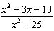 in simplest form?
1)
2) | 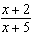
3) | 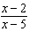
4) | 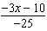

17 Which interval notation describes the set ?
1)
2)
3)
4) | (1,10)

18 The bull's-eye of a dartboard has a radius of 2 inches and the entire board has a radius of 9 inches, as shown in the diagram below.

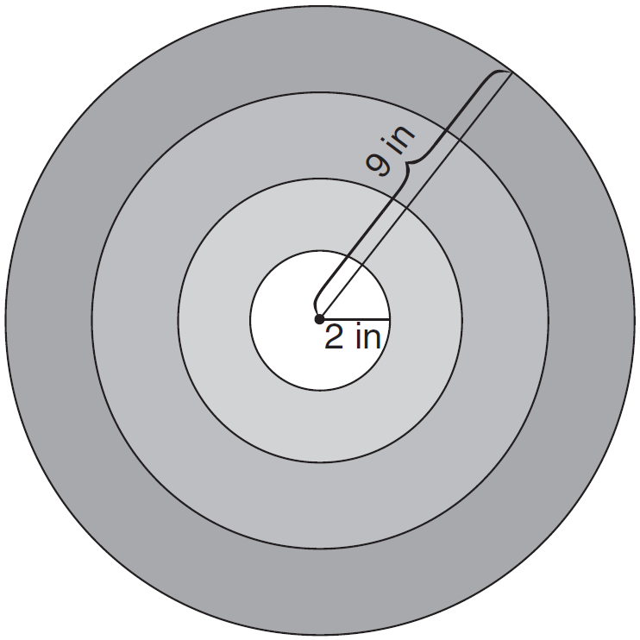

If a dart is thrown and hits the board, what is the probability that the dart will land in the bull's-eye?
1)
2)
3)
4)

19 What is one-third of ?
1)
2)
3)
4)

20 The expression 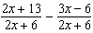 is equivalent to
1) | 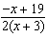
2) | 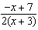
3) | 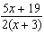
4) | 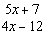

21 Which equation is represented by the graph below?

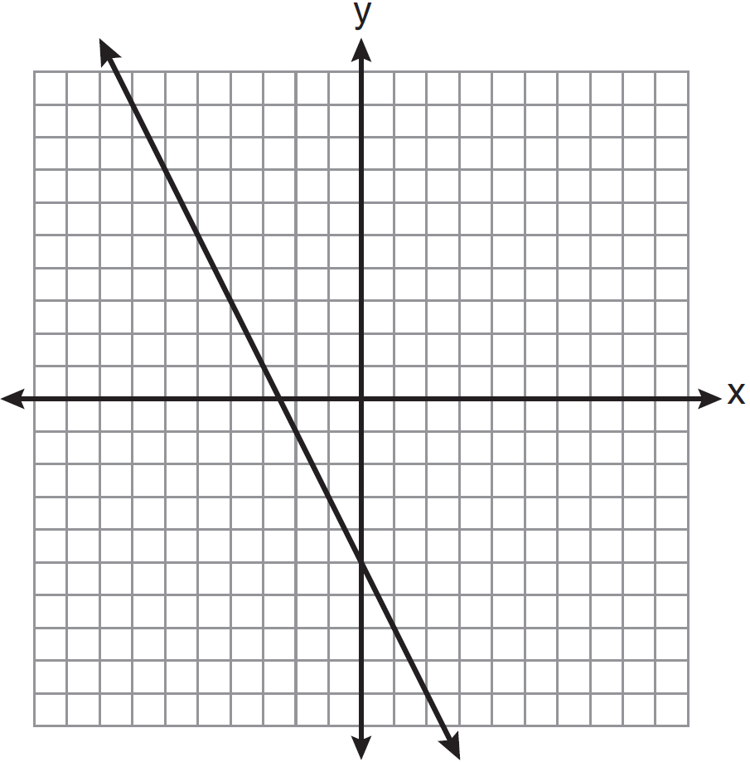
1)
2)
3)
4)

22 Which coordinates represent a point in the solution set of the system of inequalities shown below?
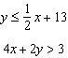
1)
2)
3)
4)

23 The length of one side of a square is 13 feet. What is the length, to the nearest foot, of a diagonal of the square?
1) | 13
2) | 18
3) | 19
4) | 26

24 In , . If and , which statement is not true?
1) | 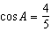
2) | 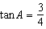
3) | 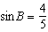
4) | 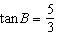

25 If n is an odd integer, which equation can be used to find three consecutive odd integers whose sum is ?
1)
2)
3)
4)

26 When is subtracted from , the result is
1)
2)
3)
4)

27 Factored completely, the expression is equivalent to
1)
2)
3)
4)

28 Elizabeth is baking chocolate chip cookies. A single batch uses teaspoon of vanilla. If Elizabeth is mixing the ingredients for five batches at the same time, how many tablespoons of vanilla will she use?

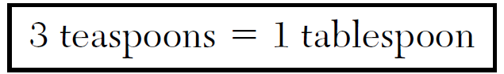
1)
2)
3)
4)

29 A car depreciates (loses value) at a rate of 4.5% annually. Greg purchased a car for $12,500. Which equation can be used to determine the value of the car, V, after 5 years?
1)
2)
3)
4)

30 The cumulative frequency table below shows the length of time that 30 students spent text messaging on a weekend.

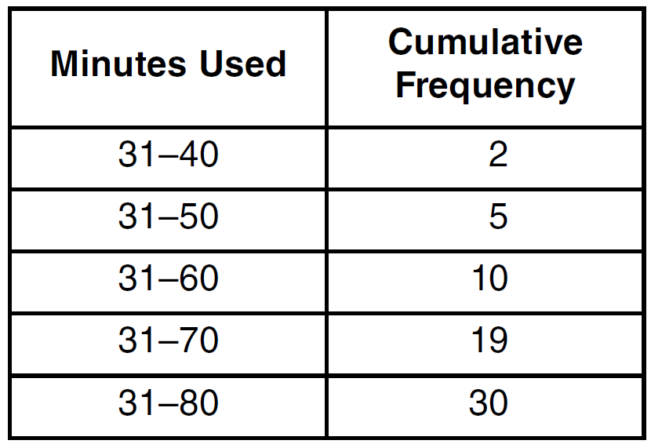

Which 10-minute interval contains the first quartile?
1)
2)
3)
4)

31 Solve the following system of equations algebraically for y:
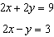

32 Three storage bins contain colored blocks. Bin 1 contains 15 red and 14 blue blocks. Bin 2 contains 16 white and 15 blue blocks. Bin 3 contains 15 red and 15 white blocks. All of the blocks from the three bins are placed into one box. If one block is randomly selected from the box, which color block would most likely be picked? Justify your answer.

33 Students calculated the area of a playing field to be 8,100 square feet. The actual area of the field is 7,678.5 square feet. Find the relative error in the area, to the nearest thousandth.

34 On the set of axes below, graph the equation . Using the graph, determine and state the roots of the equation .

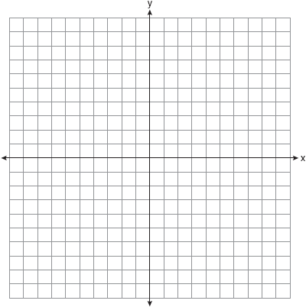

35 A 28-foot ladder is leaning against a house. The bottom of the ladder is 6 feet from the base of the house. Find the measure of the angle formed by the ladder and the ground, to the nearest degree.

36 Express 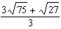 in simplest radical form.

37 Mike buys his ice cream packed in a rectangular prism-shaped carton, while Carol buys hers in a cylindrical-shaped carton. The dimensions of the prism are 5 inches by 3.5 inches by 7 inches. The cylinder has a diameter of 5 inches and a height of 7 inches. Which container holds more ice cream? Justify your answer. Determine, to the nearest tenth of a cubic inch, how much more ice cream the larger container holds.

38 Solve algebraically for x:

39 A large company must chose between two types of passwords to log on to a computer. The first type is a four-letter password using any of the 26 letters of the alphabet, without repetition of letters. The second type is a six-digit password using the digits 0 through 9, with repetition of digits allowed. Determine the number of possible four-letter passwords. Determine the number of possible six-digit passwords. The company has 500,000 employees and needs a different password for each employee. State which type of password the company should choose. Explain your answer.
1 ANS: 1
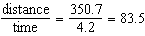

PTS: 2 REF: 061201ia STA: A.M.1 TOP: Speed

2 ANS: 2
People at a gym or football game and members of a soccer team are more biased towards sports.

PTS: 2 REF: 061202ia STA: A.S.3 TOP: Analysis of Data

3 ANS: 4 PTS: 2 REF: 061203ia STA: A.A.14
TOP: Division of Polynomials

4 ANS: 1 PTS: 2 REF: 061204ia STA: A.A.1
TOP: Expressions

5 ANS: 2 PTS: 2 REF: 061205ia STA: A.S.12
TOP: Scatter Plots

6 ANS: 3 PTS: 2 REF: 061206ia STA: A.S.2
TOP: Analysis of Data

7 ANS: 4
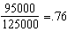

PTS: 2 REF: 061207ia STA: A.S.11 TOP: Quartiles and Percentiles

8 ANS: 3 PTS: 2 REF: 061208ia STA: A.A.31
TOP: Set Theory

9 ANS: 1 PTS: 2 REF: 061209ia STA: A.G.3
TOP: Defining Functions

10 ANS: 3

PTS: 2 REF: 061210ia STA: A.A.13 TOP: Multiplication of Polynomials

11 ANS: 3
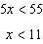

PTS: 2 REF: 061211ia STA: A.A.6 TOP: Modeling Inequalities

12 ANS: 4
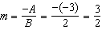

PTS: 2 REF: 061212ia STA: A.A.37 TOP: Slope

13 ANS: 2
. 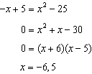. 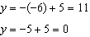. 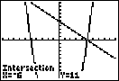

PTS: 2 REF: 061213ia STA: A.A.11 TOP: Quadratic-Linear Systems

14 ANS: 3
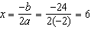.

PTS: 2 REF: 061214ia STA: A.A.41
TOP: Identifying the Vertex of a Quadratic Given Equation

15 ANS: 1
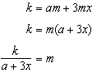

PTS: 2 REF: 061215ia STA: A.A.23 TOP: Transforming Formulas

16 ANS: 2
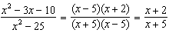

PTS: 2 REF: 061216ia STA: A.A.16 TOP: Rational Expressions
KEY: a > 0

17 ANS: 3 PTS: 2 REF: 061217ia STA: A.A.29
TOP: Set Theory

18 ANS: 3 PTS: 2 REF: 061218ia STA: A.S.20
TOP: Geometric Probability

19 ANS: 3
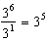

PTS: 2 REF: 061219ia STA: A.A.12 TOP: Division of Powers

20 ANS: 1 PTS: 2 REF: 061220ia STA: A.A.17
TOP: Addition and Subtraction of Rationals

21 ANS: 4 PTS: 2 REF: 061221ia STA: A.G.4
TOP: Identifying the Equation of a Graph

22 ANS: 4 PTS: 2 REF: 061222ia STA: A.A.40
TOP: Systems of Linear Inequalities

23 ANS: 2
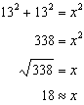

PTS: 2 REF: 061223ia STA: A.A.45 TOP: Pythagorean Theorem

24 ANS: 4
If , then is the hypotenuse, and the triangle is a 3-4-5 triangle.

PTS: 2 REF: 061224ia STA: A.A.42 TOP: Trigonometric Ratios

25 ANS: 3 PTS: 2 REF: 061225ia STA: A.A.5
TOP: Modeling Equations

26 ANS: 4 PTS: 2 REF: 061226ia STA: A.A.13
TOP: Addition and Subtraction of Polynomials KEY: subtraction

27 ANS: 4

PTS: 2 REF: 061227ia STA: A.A.20 TOP: Factoring Polynomials

28 ANS: 1
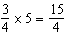 teaspoons 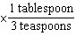=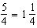 tablespoon

PTS: 2 REF: 061228ia STA: A.M.2 TOP: Conversions

29 ANS: 2 PTS: 2 REF: 061229ia STA: A.A.9
TOP: Exponential Functions

30 ANS: 3 PTS: 2 REF: 061230ia STA: A.S.9
TOP: Frequency Histograms, Bar Graphs and Tables

31 ANS:
2. Subtracting the equations: 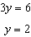

PTS: 2 REF: 061231ia STA: A.A.10 TOP: Solving Linear Systems

32 ANS:
White. There are 31 white blocks, 30 red blocks and 29 blue blocks.

PTS: 2 REF: 061232ia STA: A.S.22 TOP: Theoretical Probability

33 ANS:
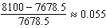

PTS: 2 REF: 061233ia STA: A.M.3 TOP: Error
KEY: area

34 ANS:
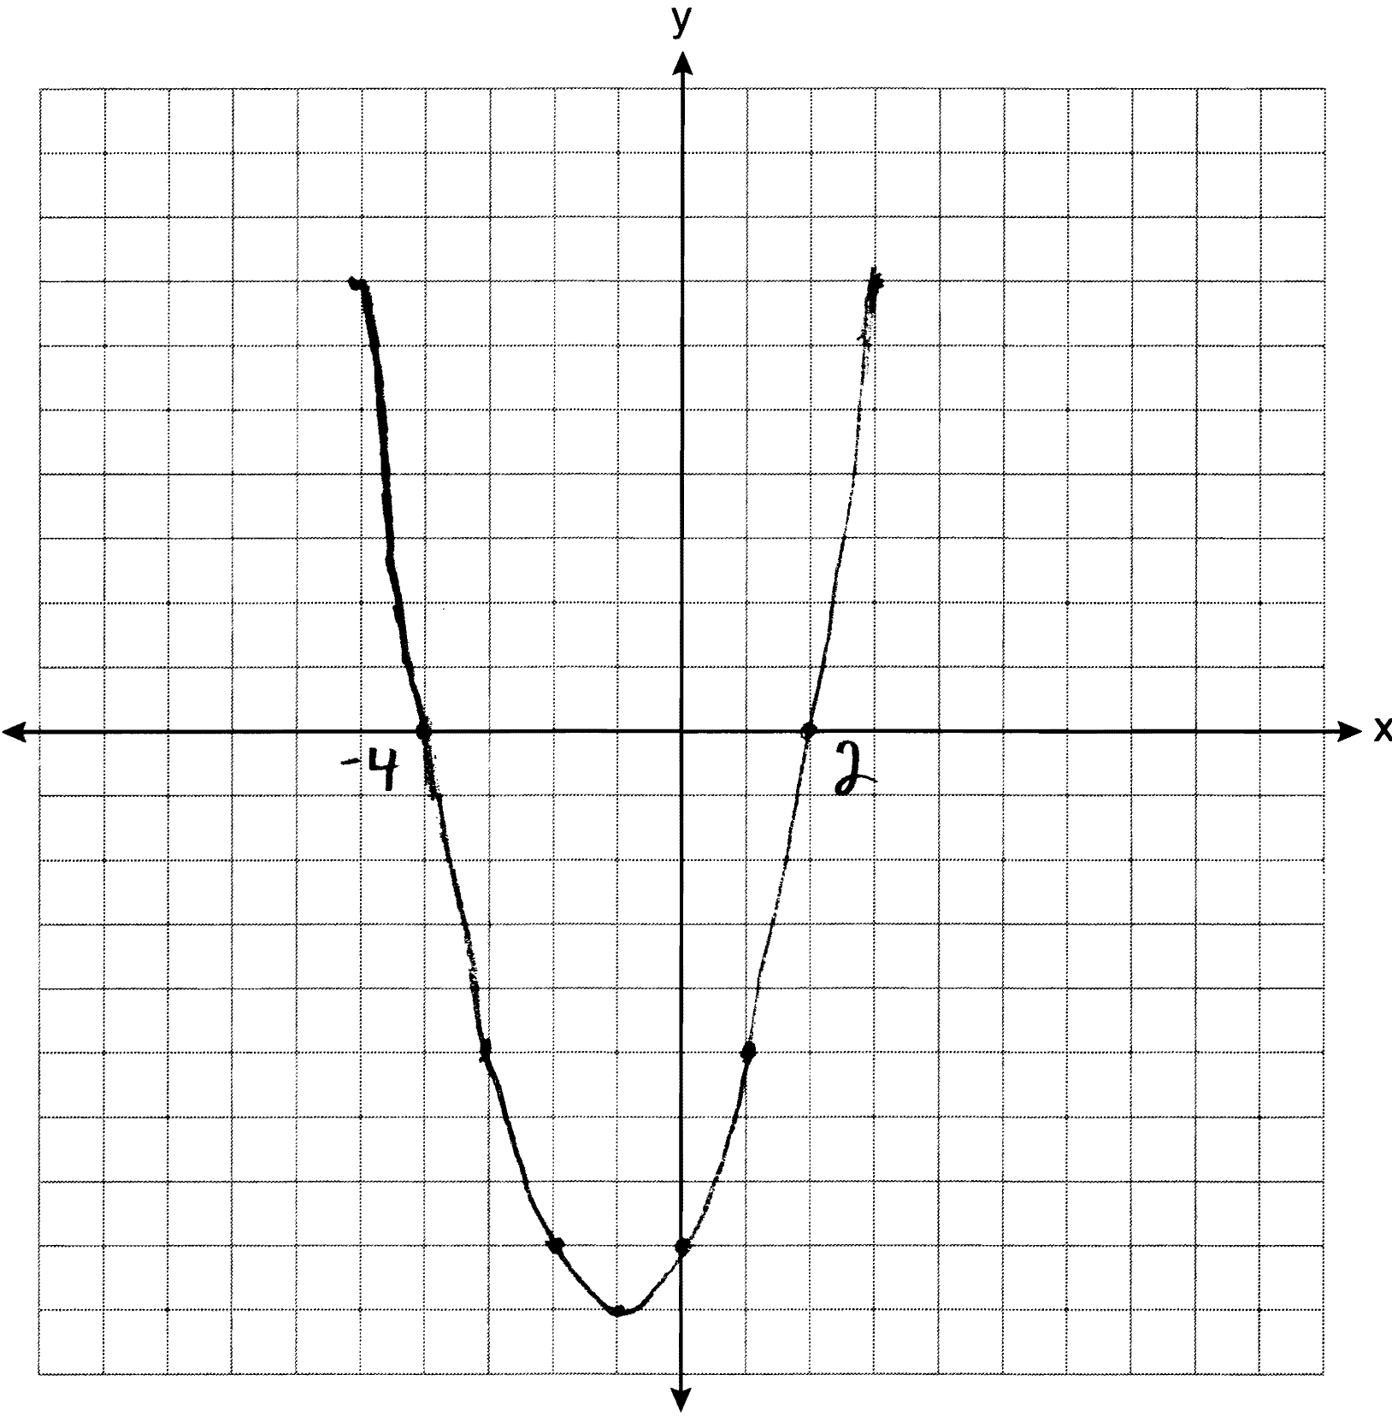

PTS: 3 REF: 061234ia STA: A.G.8 TOP: Solving Quadratics by Graphing

35 ANS:
78. 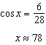

PTS: 3 REF: 061235ia STA: A.A.43 TOP: Using Trigonometry to Find an Angle

36 ANS:

PTS: 3 REF: 061236ia STA: A.N.3 TOP: Operations with Radicals

37 ANS:
Carol’s, by 14.9. . .

PTS: 4 REF: 061237ia STA: A.G.2 TOP: Volume

38 ANS:
4. 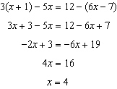

PTS: 4 REF: 061238ia STA: A.A.22 TOP: Solving Equations

39 ANS:
. Use the numeric password since there are over 500,000 employees

PTS: 4 REF: 061239ia STA: A.N.8 TOP: Permutations

