1 It takes Tammy 45 minutes to ride her bike 5 miles. At this rate, how long will it take her to ride 8 miles?
1) | 0.89 hour | 3) | 48 minutes
2) | 1.125 hours | 4) | 72 minutes

2 What are the roots of the equation ?
1) | 1 and 7 | 3) | and
2) | and 7 | 4) | 1 and 6

3 Which expression represents 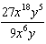 in simplest form?
1) |  | 3)
2) |  | 4)

4 Marie currently has a collection of 58 stamps. If she buys s stamps each week for w weeks, which expression represents the total number of stamps she will have?
1) |  | 3)
2) |  | 4)

5 Which data set describes a situation that could be classified as qualitative?
1) | the ages of the students in Ms. Marshall’s Spanish class | 3) | the favorite ice cream flavor of each of Mr. Hayden’s students
2) | the test scores of the students in Ms. Fitzgerald’s class | 4) | the heights of the players on the East High School basketball team

6 The sign shown below is posted in front of a roller coaster ride at the Wadsworth County Fairgrounds.

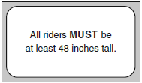

If h represents the height of a rider in inches, what is a correct translation of the statement on this sign?
1) |  | 3)
2) |  | 4)

7 Which value of x is the solution of the equation 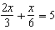?
1) | 6 | 3) | 15
2) | 10 | 4) | 30

8 Students in Ms. Nazzeer's mathematics class tossed a six-sided number cube whose faces are numbered 1 to 6. The results are recorded in the table below.

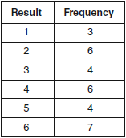

Based on these data, what is the empirical probability of tossing a 4?
1) |  | 3)
2) |  | 4)

9 What is the value of x, in inches, in the right triangle below?

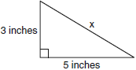
1) |  | 3)
2) | 8 | 4) | 4

10 What is expressed in simplest radical form?
1) |  | 3)
2) |  | 4)

11 If the speed of sound is 344 meters per second, what is the approximate speed of sound, in meters per hour?

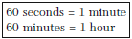
1) | 20,640 | 3) | 123,840
2) | 41,280 | 4) | 1,238,400

12 The sum of two numbers is 47, and their difference is 15. What is the larger number?
1) | 16 | 3) | 32
2) | 31 | 4) | 36

13 If , the value of a in terms of b and r can be expressed as
1) | 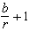 | 3) | 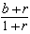
2) | 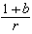 | 4) | 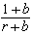

14 Which value of x is in the solution set of 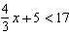?
1) | 8 | 3) | 12
2) | 9 | 4) | 16

15 The box-and-whisker plot below represents students' scores on a recent English test.

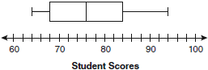

What is the value of the upper quartile?
1) | 68 | 3) | 84
2) | 76 | 4) | 94

16 Which value of n makes the expression 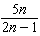 undefined?
1) | 1 | 3)
2) | 0 | 4)

17 At Genesee High School, the sophomore class has 60 more students than the freshman class. The junior class has 50 fewer students than twice the students in the freshman class. The senior class is three times as large as the freshman class. If there are a total of 1,424 students at Genesee High School, how many students are in the freshman class?
1) | 202 | 3) | 235
2) | 205 | 4) | 236

18 What are the vertex and axis of symmetry of the parabola ?
1) | vertex: ; axis of symmetry: | 3) | vertex: ; axis of symmetry:
2) | vertex: ; axis of symmetry: | 4) | vertex: ; axis of symmetry:

19 Which statement is true about the relation shown on the graph below?

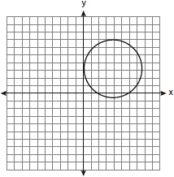
1) | It is a function because there exists one x-coordinate for each y-coordinate. | 3) | It is not a function because there are multiple y-values for a given x-value.
2) | It is a function because there exists one y-coordinate for each x-coordinate. | 4) | It is not a function because there are multiple x-values for a given y-value.

20 Which graph represents the solution of ?
1) | 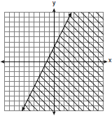 | 3) | 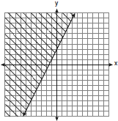
2) | 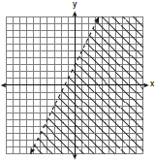 | 4) | 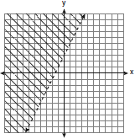

21 Which expression represents 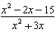 in simplest form?
1) |  | 3) | 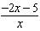
2) | 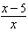 | 4) | 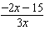

22 What is an equation of the line that passes through the point and has a slope of ?
1) |  | 3)
2) |  | 4)

23 When is subtracted from , the result is
1) |  | 3)
2) |  | 4)

24 The equation is graphed on the set of axes below.

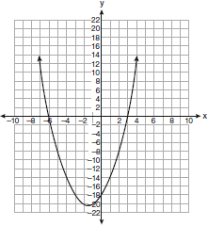

Based on this graph, what are the roots of the equation ?
1) | and 6 | 3) | 3 and
2) | 0 and | 4) | 3 and

25 What is the value of the y-coordinate of the solution to the system of equations and ?
1) | 6 | 3) | 3
2) | 2 | 4) | 5

26 What is the additive inverse of the expression ?
1) |  | 3)
2) |  | 4)

27 What is the product of 12 and expressed in scientific notation?
1) |  | 3)
2) |  | 4)

28 To calculate the volume of a small wooden cube, Ezra measured an edge of the cube as 2 cm. The actual length of the edge of Ezra’s cube is 2.1 cm. What is the relative error in his volume calculation to the nearest hundredth?
1) | 0.13 | 3) | 0.15
2) | 0.14 | 4) | 0.16

29 What is 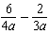 expressed in simplest form?
1) |  | 3)
2) |  | 4)

30 The set is equivalent to
1) |  | 3)
2) |  | 4)

31 Determine how many three-letter arrangements are possible with the letters A, N, G, L, and E if no letter may be repeated.

32 Factor completely:

33 Some books are laid on a desk. Two are English, three are mathematics, one is French, and four are social studies. Theresa selects an English book and Isabelle then selects a social studies book. Both girls take their selections to the library to read. If Truman then selects a book at random, what is the probability that he selects an English book?

34 In the diagram below, the circumference of circle O is 16π inches. The length of is three-quarters of the length of diameter and inches. Calculate the area, in square inches, of trapezoid ABCD.

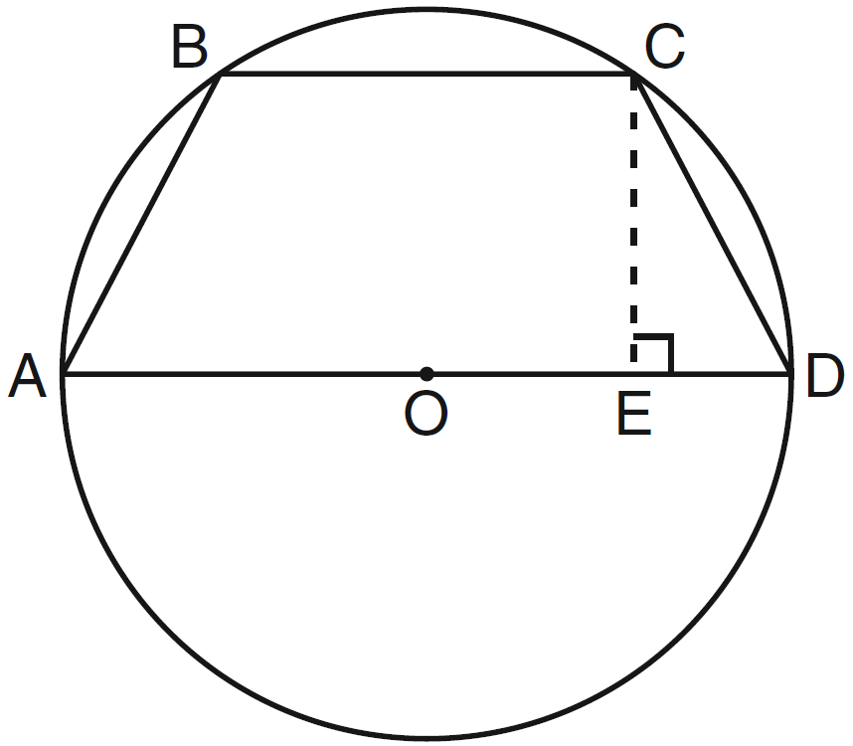

35 A bank is advertising that new customers can open a savings account with a 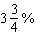 interest rate compounded annually. Robert invests $5,000 in an account at this rate. If he makes no additional deposits or withdrawals on his account, find the amount of money he will have, to the nearest cent, after three years.

36 The table below shows the number of prom tickets sold over a ten-day period.

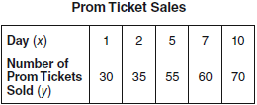

Plot these data points on the coordinate grid below. Use a consistent and appropriate scale. Draw a reasonable line of best fit and write its equation.

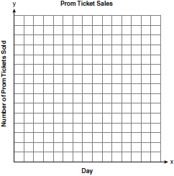

37 A stake is to be driven into the ground away from the base of a 50-foot pole, as shown in the diagram below. A wire from the stake on the ground to the top of the pole is to be installed at an angle of elevation of 52°.

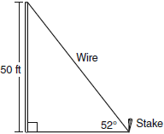

How far away from the base of the pole should the stake be driven in, to the nearest foot? What will be the length of the wire from the stake to the top of the pole, to the nearest foot?

38 The Fahrenheit temperature readings on 30 April mornings in Stormville, New York, are shown below.

41°, 58°, 61°, 54°, 49°, 46°, 52°, 58°, 67°, 43°, 47°, 60°, 52°, 58°, 48°,
44°, 59°, 66°, 62°, 55°, 44°, 49°, 62°, 61°, 59°, 54°, 57°, 58°, 63°, 60°

Using the data, complete the frequency table below.

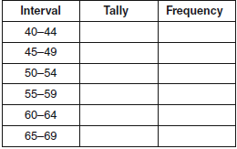

On the grid below, construct and label a frequency histogram based on the table.



39 On the set of axes below, solve the following system of equations graphically for all values of x and y.
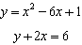

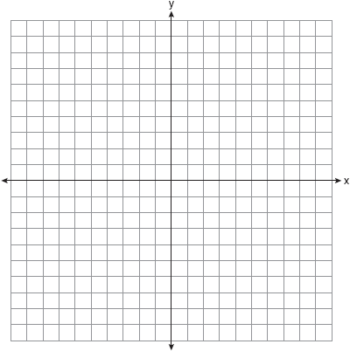
1 ANS: 4
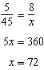

PTS: 2 REF: 060901ia STA: A.M.1 TOP: Speed

2 ANS: 4
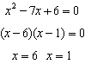

PTS: 2 REF: 060902ia STA: A.A.28 TOP: Roots of Quadratics

3 ANS: 1 PTS: 2 REF: 060903ia STA: A.A.12
TOP: Division of Powers

4 ANS: 2 PTS: 2 REF: 060904ia STA: A.A.1
TOP: Expressions

5 ANS: 3
The other situations are quantitative.

PTS: 2 REF: 060905ia STA: A.S.1 TOP: Analysis of Data

6 ANS: 4 PTS: 2 REF: 060906ia STA: A.A.4
TOP: Modeling Inequalities

7 ANS: 1
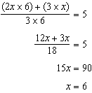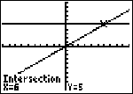

PTS: 2 REF: 060907ia STA: A.A.25
TOP: Solving Equations with Fractional Expressions

8 ANS: 2 PTS: 2 REF: 060908ia STA: A.S.21
TOP: Empirical Probability

9 ANS: 3
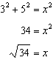

PTS: 2 REF: 060909ia STA: A.A.45 TOP: Pythagorean Theorem

10 ANS: 2

PTS: 2 REF: 060910ia STA: A.N.2 TOP: Simplifying Radicals

11 ANS: 4
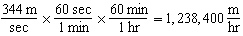

PTS: 2 REF: 060911ia STA: A.M.2 TOP: Conversions

12 ANS: 2
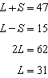

PTS: 2 REF: 060912ia STA: A.A.7 TOP: Writing Linear Systems

13 ANS: 3
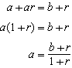

PTS: 2 REF: 060913ia STA: A.A.23 TOP: Transforming Formulas

14 ANS: 1
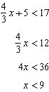

PTS: 2 REF: 060914ia STA: A.A.21 TOP: Interpreting Solutions

15 ANS: 3
The value of the upper quartile is the last vertical line of the box.

PTS: 2 REF: 060915ia STA: A.S.6 TOP: Box-and-Whisker Plots

16 ANS: 4 PTS: 2 REF: 060916ia STA: A.A.15
TOP: Undefined Rationals

17 ANS: 1
. 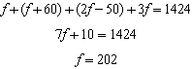

PTS: 2 REF: 060917ia STA: A.A.7 TOP: Writing Linear Systems

18 ANS: 1
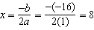.

PTS: 2 REF: 060918ia STA: A.A.41
TOP: Identifying the Vertex of a Quadratic Given Equation

19 ANS: 3 PTS: 2 REF: 060919ia STA: A.G.3
TOP: Defining Functions

20 ANS: 1 PTS: 2 REF: 060920ia STA: A.G.6
TOP: Linear Inequalities

21 ANS: 2
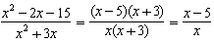

PTS: 2 REF: 060921ia STA: A.A.16 TOP: Rational Expressions
KEY: a > 0

22 ANS: 1
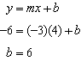

PTS: 2 REF: 060922ia STA: A.A.34 TOP: Writing Linear Equations

23 ANS: 2 PTS: 2 REF: 060923ia STA: A.A.13
TOP: Addition and Subtraction of Polynomials KEY: subtraction

24 ANS: 3 PTS: 2 REF: 060924ia STA: A.G.8
TOP: Solving Quadratics by Graphing

25 ANS: 2
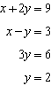

PTS: 2 REF: 060925ia STA: A.A.10 TOP: Solving Linear Systems

26 ANS: 3 PTS: 2 REF: 060926ia STA: A.N.1
TOP: Properties of Reals

27 ANS: 4 PTS: 2 REF: 060927ia STA: A.N.4
TOP: Operations with Scientific Notation

28 ANS: 2
The volume of the cube using Ezra’s measurements is 8 (2³). The actual volume is 9.261 (2.1³). The relative error is 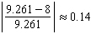.

PTS: 2 REF: 060928ia STA: A.M.3 TOP: Error

29 ANS: 2
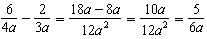

PTS: 2 REF: 060929ia STA: A.A.17 TOP: Addition and Subtraction of Rationals

30 ANS: 4 PTS: 2 REF: 060930ia STA: A.A.29
TOP: Set Theory

31 ANS:
60.

PTS: 2 REF: 060931ia STA: A.N.8 TOP: Permutations

32 ANS:
.

PTS: 2 REF: 060932ia STA: A.A.19
TOP: Factoring the Difference of Perfect Squares

33 ANS:
. After the English and social studies books are taken, 8 books are left and 1 is an English book.

PTS: 2 REF: 060933ia STA: A.S.18 TOP: Conditional Probability

34 ANS:
56. If the circumference of circle O is 16ð inches, the diameter, , is 16 inches and the length of is 12 inches 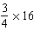. The area of trapezoid ABCD is 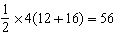.

PTS: 3 REF: 060934ia STA: A.G.1 TOP: Compositions of Polygons and Circles

35 ANS:
5,583.86.

PTS: 3 REF: 060935ia STA: A.A.9 TOP: Exponential Functions

36 ANS:
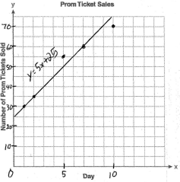

PTS: 3 REF: 060936ia STA: A.S.8 TOP: Scatter Plots

37 ANS:
39, 63. 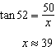. 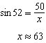

PTS: 4 REF: 060937ia STA: A.A.44 TOP: Using Trigonometry to Find a Side

38 ANS:
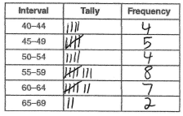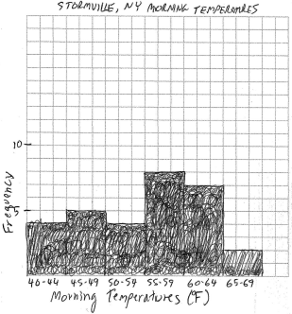

PTS: 4 REF: 060938ia STA: A.S.5
TOP: Frequency Histograms, Bar Graphs and Tables

39 ANS:
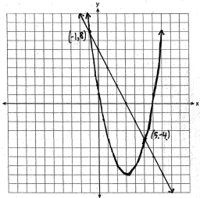

PTS: 4 REF: 060939ia STA: A.G.9 TOP: Quadratic-Linear Systems

