1 Which graph represents a linear function?
1) | 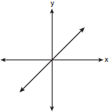 | 3) | 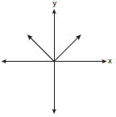
2) | 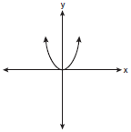 | 4) | 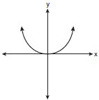

2 A spinner is divided into eight equal regions as shown in the diagram below.

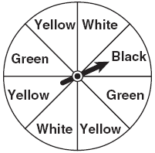

Which event is most likely to occur in one spin?
1) | The arrow will land in a green or white area.
2) | The arrow will land in a green or black area.
3) | The arrow will land in a yellow or black area.
4) | The arrow will land in a yellow or green area.

3 A school wants to add a coed soccer program. To determine student interest in the program, a survey will be taken. In order to get an unbiased sample, which group should the school survey?
1) | every third student entering the building
2) | every member of the varsity football team
3) | every member in Ms. Zimmer’s drama classes
4) | every student having a second-period French class

4 Factored, the expression is equivalent to
1) |  | 3)
2) |  | 4)

5 There is a negative correlation between the number of hours a student watches television and his or her social studies test score. Which scatter plot below displays this correlation?
1) | 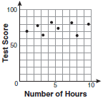 | 3) | 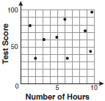
2) | 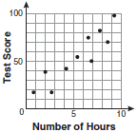 | 4) | 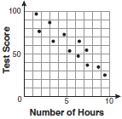

6 Jack bought 3 slices of cheese pizza and 4 slices of mushroom pizza for a total cost of $12.50. Grace bought 3 slices of cheese pizza and 2 slices of mushroom pizza for a total cost of $8.50. What is the cost of one slice of mushroom pizza?
1) | $1.50 | 3) | $3.00
2) | $2.00 | 4) | $3.50

7 What is the product of and ?
1) |  | 3)
2) |  | 4)

8 The bowling team at Lincoln High School must choose a president, vice president, and secretary. If the team has 10 members, which expression could be used to determine the number of ways the officers could be chosen?
1) |  | 3)
2) |  | 4)

9 Lenny made a cube in technology class. Each edge measured 1.5 cm. What is the volume of the cube in cubic centimeters?
1) | 2.25 | 3) | 9.0
2) | 3.375 | 4) | 13.5

10 Which ordered pair is a solution to the system of equations and ?
1) |  | 3)
2) |  | 4)

11 What are the vertex and the axis of symmetry of the parabola shown in the diagram below?

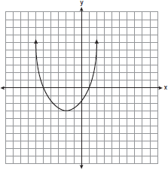
1) | The vertex is , and the axis of symmetry is .
2) | The vertex is , and the axis of symmetry is .
3) | The vertex is , and the axis of symmetry is .
4) | The vertex is , and the axis of symmetry is .

12 Pam is playing with red and black marbles. The number of red marbles she has is three more than twice the number of black marbles she has. She has 42 marbles in all. How many red marbles does Pam have?
1) | 13 | 3) | 29
2) | 15 | 4) | 33

13 What is half of ?
1) |  | 3)
2) |  | 4)

14 Which equation represents a line that is parallel to the line ?
1) |  | 3) | 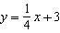
2) | 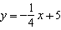 | 4)

15 What is the product of 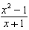 and 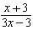 expressed in simplest form?
1) | x | 3)
2) |  | 4) | 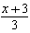

16 The center pole of a tent is 8 feet long, and a side of the tent is 12 feet long as shown in the diagram below.

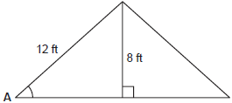

If a right angle is formed where the center pole meets the ground, what is the measure of angle A to the nearest degree?
1) | 34 | 3) | 48
2) | 42 | 4) | 56

17 Which value of x makes the expression 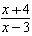 undefined?
1) |  | 3) | 3
2) |  | 4) | 0

18 Consider the set of integers greater than -2 and less than 6. A subset of this set is the positive factors of 5. What is the complement of this subset?
1) |  | 3)
2) |  | 4)

19 Which data set describes a situation that could be classified as qualitative?
1) | the elevations of the five highest mountains in the world
2) | the ages of presidents at the time of their inauguration
3) | the opinions of students regarding school lunches
4) | the shoe sizes of players on the basketball team

20 What is the slope of the line that passes through the points and ?
1) |  | 3)
2) | 2 | 4)

21 Students in a ninth grade class measured their heights, h, in centimeters. The height of the shortest student was 155 cm, and the height of the tallest student was 190 cm. Which inequality represents the range of heights?
1) |  | 3)
2) |  | 4)

22 The table below shows a cumulative frequency distribution of runners' ages.

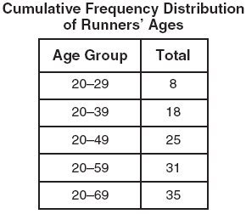

According to the table, how many runners are in their forties?
1) | 25 | 3) | 7
2) | 10 | 4) | 6

23 Mr. Turner bought x boxes of pencils. Each box holds 25 pencils. He left 3 boxes of pencils at home and took the rest to school. Which expression represents the total number of pencils he took to school?
1) |  | 3)
2) |  | 4)

24 Which expression represents 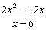 in simplest form?
1) | 0 | 3)
2) |  | 4)

25 Don placed a ladder against the side of his house as shown in the diagram below.

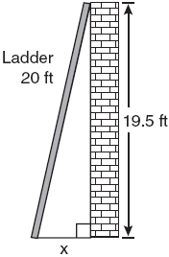

Which equation could be used to find the distance, x, from the foot of the ladder to the base of the house?
1) |  | 3)
2) |  | 4)

26 Which value of x is a solution of 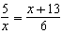?
1) |  | 3)
2) |  | 4)

27 Mrs. Ayer is painting the outside of her son’s toy box, including the top and bottom. The toy box measures 3 feet long, 1.5 feet wide, and 2 feet high. What is the total surface area she will paint?
1) |  | 3)
2) |  | 4)

28 What is 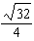 expressed in simplest radical form?
1) |  | 3)
2) |  | 4)

29 Consider the graph of the equation , when . If a is multiplied by 3, what is true of the graph of the resulting parabola?
1) | The vertex is 3 units above the vertex of the original parabola.
2) | The new parabola is 3 units to the right of the original parabola.
3) | The new parabola is wider than the original parabola.
4) | The new parabola is narrower than the original parabola.

30 Kathy plans to purchase a car that depreciates (loses value) at a rate of 14% per year. The initial cost of the car is $21,000. Which equation represents the value, v, of the car after 3 years?
1) |  | 3)
2) |  | 4)

31 Tom drove 290 miles from his college to home and used 23.2 gallons of gasoline. His sister, Ann, drove 225 miles from her college to home and used 15 gallons of gasoline. Whose vehicle had better gas mileage? Justify your answer.

32 A designer created the logo shown below. The logo consists of a square and four quarter-circles of equal size.

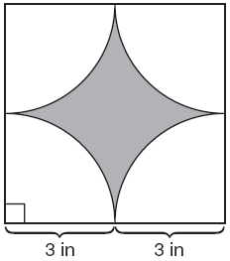

Express, in terms of π, the exact area, in square inches, of the shaded region.

33 Maureen tracks the range of outdoor temperatures over three days. She records the following information.

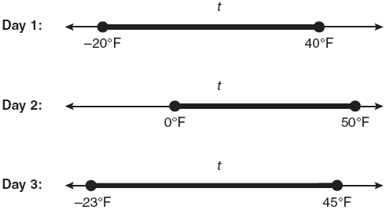

Express the intersection of the three sets as an inequality in terms of temperature, t.

34 Peter begins his kindergarten year able to spell 10 words. He is going to learn to spell 2 new words every day. Write an inequality that can be used to determine how many days, d, it takes Peter to be able to spell at least 75 words. Use this inequality to determine the minimum number of whole days it will take for him to be able to spell at least 75 words.

35 The Hudson Record Store is having a going-out-of-business sale. CDs normally sell for $18.00. During the first week of the sale, all CDs will sell for $15.00. Written as a fraction, what is the rate of discount? What is this rate expressed as a percent? Round your answer to the nearest hundredth of a percent. During the second week of the sale, the same CDs will be on sale for 25% off the original price. What is the price of a CD during the second week of the sale?

36 Graph the equation on the accompanying set of axes. Using the graph, determine the roots of the equation .

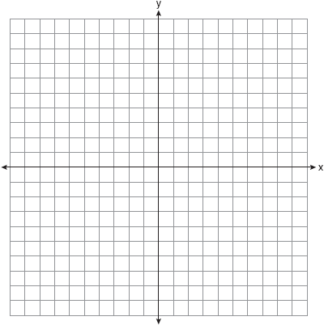

37 A contractor needs 54 square feet of brick to construct a rectangular walkway. The length of the walkway is 15 feet more than the width. Write an equation that could be used to determine the dimensions of the walkway. Solve this equation to find the length and width, in feet, of the walkway.

38 Sophie measured a piece of paper to be 21.7 cm by 28.5 cm. The piece of paper is actually 21.6 cm by 28.4 cm. Determine the number of square centimeters in the area of the piece of paper using Sophie’s measurements. Determine the number of square centimeters in the actual area of the piece of paper. Determine the relative error in calculating the area. Express your answer as a decimal to the nearest thousandth. Sophie does not think there is a significant amount of error. Do you agree or disagree? Justify your answer.

39 The prices of seven race cars sold last week are listed in the table below.

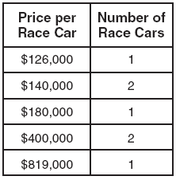

What is the mean value of these race cars, in dollars? What is the median value of these race cars, in dollars? State which of these measures of central tendency best represents the value of the seven race cars. Justify your answer.
1 ANS: 1 PTS: 2 REF: 060801ia STA: A.G.4
TOP: Families of Functions

2 ANS: 4
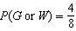, 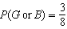, 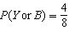, 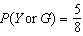

PTS: 2 REF: 060802ia STA: A.S.22 TOP: Theoretical Probability

3 ANS: 1
To determine student interest, survey the widest range of students.

PTS: 2 REF: 060803ia STA: A.S.3 TOP: Analysis of Data

4 ANS: 1 PTS: 2 REF: 060804ia STA: A.A.19
TOP: Factoring the Difference of Perfect Squares

5 ANS: 4 PTS: 2 REF: 060805ia STA: A.S.12
TOP: Scatter Plots

6 ANS: 2
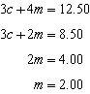

PTS: 2 REF: 060806ia STA: A.A.7 TOP: Writing Linear Systems

7 ANS: 1 PTS: 2 REF: 060807ia STA: A.A.13
TOP: Multiplication of Polynomials

8 ANS: 3 PTS: 2 REF: 060808ia STA: A.N.8
TOP: Permutations

9 ANS: 2

PTS: 2 REF: 060809ia STA: A.G.2 TOP: Volume

10 ANS: 4
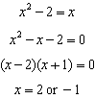Since , the solutions are and . 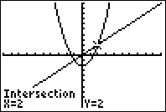

PTS: 2 REF: 060810ia STA: A.A.11 TOP: Quadratic-Linear Systems

11 ANS: 1 PTS: 2 REF: 060811ia STA: A.G.10
TOP: Identifying the Vertex of a Quadratic Given Graph

12 ANS: 3
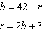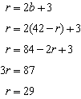

PTS: 2 REF: 060812ia STA: A.A.7 TOP: Writing Linear Systems

13 ANS: 4
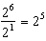

PTS: 2 REF: 060813ia STA: A.A.12 TOP: Division of Powers

14 ANS: 1
The slope of both is .

PTS: 2 REF: 060814ia STA: A.A.38 TOP: Parallel and Perpendicular Lines

15 ANS: 4
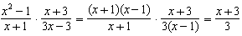

PTS: 2 REF: 060815ia STA: A.A.18 TOP: Multiplication and Division of Rationals

16 ANS: 2
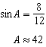

PTS: 2 REF: 060816ia STA: A.A.43 TOP: Using Trigonometry to Find an Angle

17 ANS: 3 PTS: 2 REF: 060817ia STA: A.A.15
TOP: Undefined Rationals

18 ANS: 2
The set of integers greater than -2 and less than 6 is . The subset of this set that is the positive factors of 5 is . The complement of this subset is .

PTS: 2 REF: 060818ia STA: A.A.30 TOP: Set Theory

19 ANS: 3
The other situations are quantitative.

PTS: 2 REF: 060819ia STA: A.S.1 TOP: Analysis of Data

20 ANS: 3
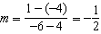

PTS: 2 REF: 060820ia STA: A.A.33 TOP: Slope

21 ANS: 2 PTS: 2 REF: 060821ia STA: A.A.5
TOP: Modeling Inequalities

22 ANS: 3

PTS: 2 REF: 060822ia STA: A.S.9
TOP: Frequency Histograms, Bar Graphs and Tables

23 ANS: 4

PTS: 2 REF: 060823ia STA: A.A.1 TOP: Expressions

24 ANS: 2
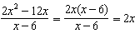

PTS: 2 REF: 060824ia STA: A.A.14 TOP: Rational Expressions

25 ANS: 3 PTS: 2 REF: 060825ia STA: A.A.45
TOP: Pythagorean Theorem

26 ANS: 4
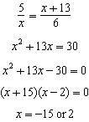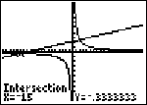

PTS: 2 REF: 060826ia STA: A.A.26 TOP: Solving Rationals

27 ANS: 4

PTS: 2 REF: 060827ia STA: A.G.2 TOP: Surface Area

28 ANS: 1
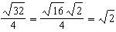

PTS: 2 REF: 060828ia STA: A.N.2 TOP: Simplifying Radicals

29 ANS: 4 PTS: 2 REF: 060829ia STA: A.G.5
TOP: Graphing Quadratic Functions

30 ANS: 2 PTS: 2 REF: 060830ia STA: A.A.9
TOP: Exponential Functions

31 ANS:
Ann’s. 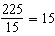 mpg is greater than 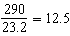 mpg

PTS: 2 REF: 060831ia STA: A.M.1 TOP: Using Rate

32 ANS:
. 15.6. Area of square–area of 4 quarter circles.

PTS: 2 REF: 060832ia STA: A.G.1 TOP: Compositions of Polygons and Circles

33 ANS:

PTS: 2 REF: 060833ia STA: A.A.31 TOP: Set Theory

34 ANS:
, 33. 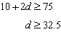

PTS: 3 REF: 060834ia STA: A.A.6 TOP: Modeling Inequalities

35 ANS:
, 16.67%, $13.50. 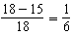.

PTS: 3 REF: 060835ia STA: A.N.5 TOP: Percents

36 ANS:
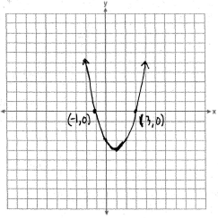
PTS: 3 REF: 060836ia STA: A.G.8 TOP: Solving Quadratics by Graphing

37 ANS:
, 3, 18. 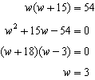
PTS: 4 REF: 060837ia STA: A.A.8 TOP: Geometric Applications of Quadratics

38 ANS:
618.45, 613.44, 0.008. . . 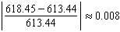. An error of less than 1% would seem to be insignificant.
PTS: 4 REF: 060838ia STA: A.M.3 TOP: Error

39 ANS:
315,000, 180,000, the median better represents value since it is closer to more prices than the mean.
PTS: 4 REF: 060839ia STA: A.S.4
TOP: Frequency Histograms, Bar Graphs and Tables

