1 If and , the intersection of sets A and B is
1)
2)
3)
4)

2 What is the value of n in the equation ?
1) | 8
2) | 2
3) | 20
4) | 44

3 The expression 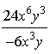 is equivalent to
1)
2)
3)
4)

4 Which situation is represented by bivariate data?
1) | A student lists her algebra quiz grades for one month.
2) | A wrestler records his weight before each match.
3) | A musician writes down how many minutes she practices her instrument each day.
4) | An ice cream vendor tracks the daily high temperature and how many ice cream bars he sells each day.

5 A cylinder has a circular base with a radius of 3 units and a height of 7 units. What is the volume of the cylinder in cubic units?
1)
2)
3)
4)

6 The graph of is shown below.

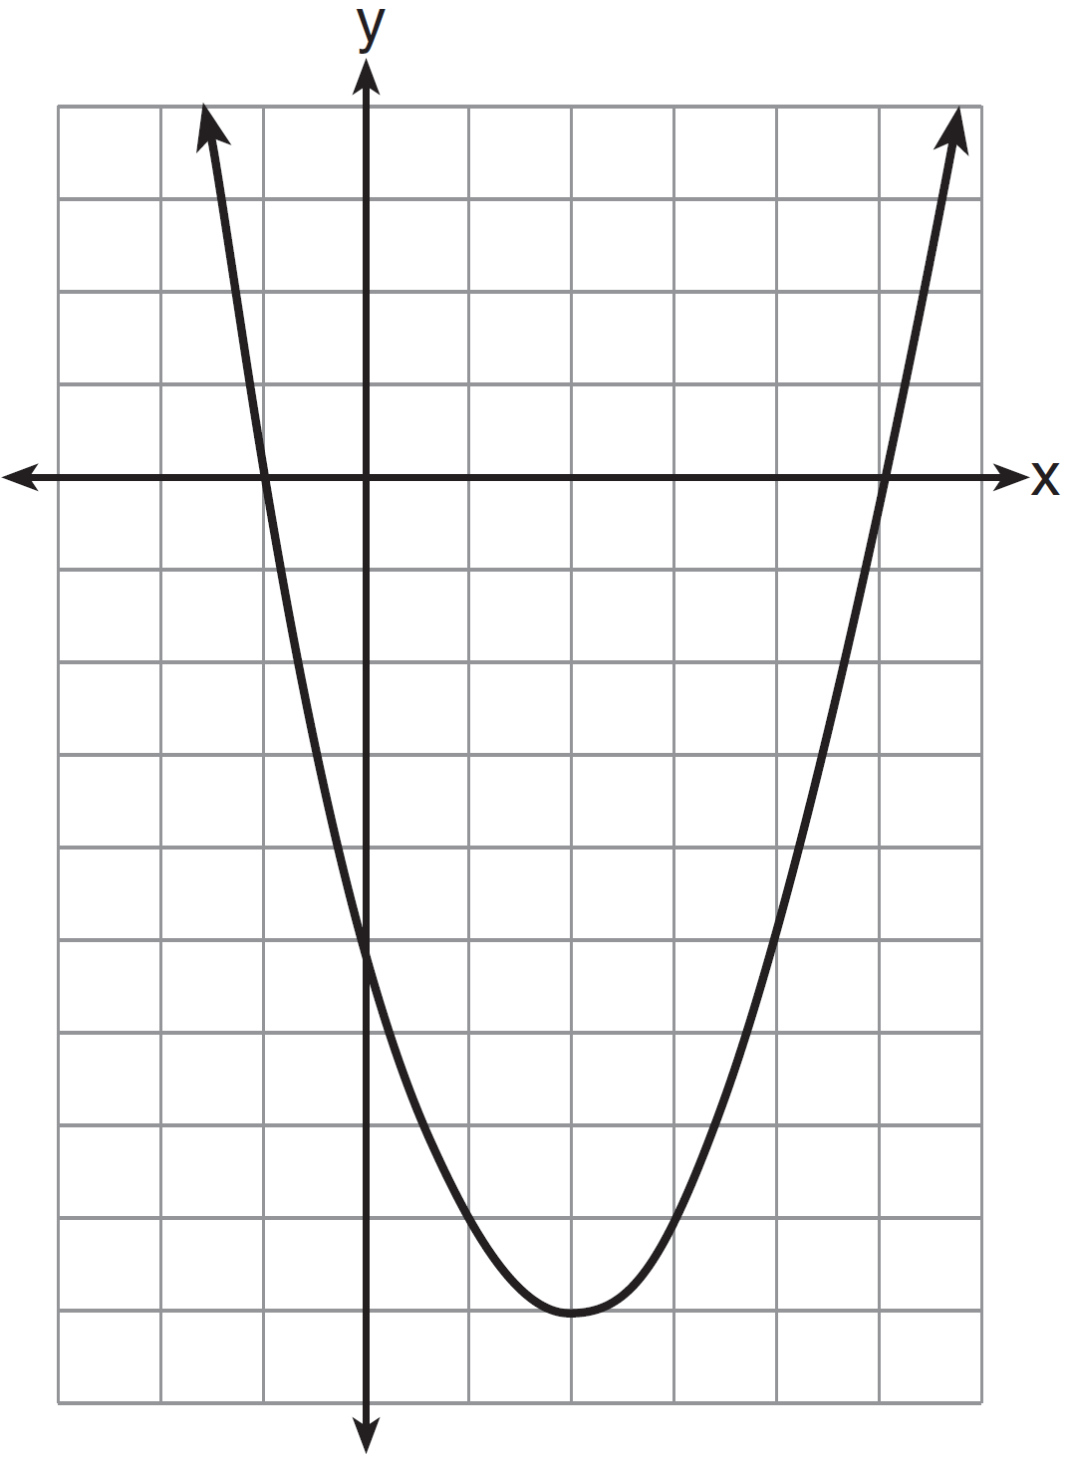

Based on this graph, what are the roots of the equation ?
1) | 1 and
2) | and 5
3) | 2 and
4) | and and 5

7 Jose wants to ride his bike a total of 50 miles this weekend. If he rides m miles on Saturday, which expression represents the number of miles he must ride on Sunday?
1)
2)
3)
4)

8 Four students are playing a math game at home. One of the math game questions asked them to write an algebraic equation.
Brandon wrote:
William wrote:
Alice wrote:
Kayla wrote:
Which student wrote an algebraic equation?
1) | Brandon
2) | William
3) | Alice
4) | Kayla

9 A student spent 15 minutes painting a 2-foot by 3-foot bulletin board. To the nearest tenth of a minute, how long did it take the student to paint 1 square foot?
1) | 0.4
2) | 1.5
3) | 2.5
4) | 3.5

10 What is an equation of the line that passes through the points and ?
1) | 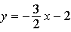
2) | 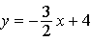
3) | 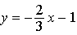
4) | 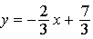

11 What is 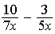 expressed in simplest form?
1)
2)
3) | 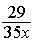
4) | 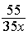

12 In the box-and-whisker plot below, what is the 2nd quartile?

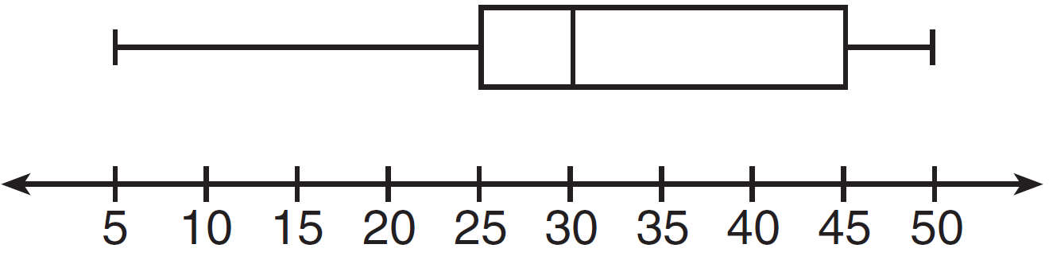
1) | 25
2) | 30
3) | 45
4) | 50

13 The length of a rectangle is three feet less than twice its width. If x represents the width of the rectangle, in feet, which inequality represents the area of the rectangle that is at most 30 square feet?
1)
2)
3)
4)

14 Which set is a function?
1)
2)
3)
4)

15 The weights of 40 students were recorded. If the 75th percentile of their weights was 140 pounds, what is the total number of students who weighed more than 140 pounds?
1) | 10
2) | 20
3) | 30
4) | 4

16 What is the slope of the line represented by the equation ?
1)
2)
3)
4)

17 What is expressed in simplest radical form?
1)
2)
3)
4)

18 In below, the measure of , , , and .

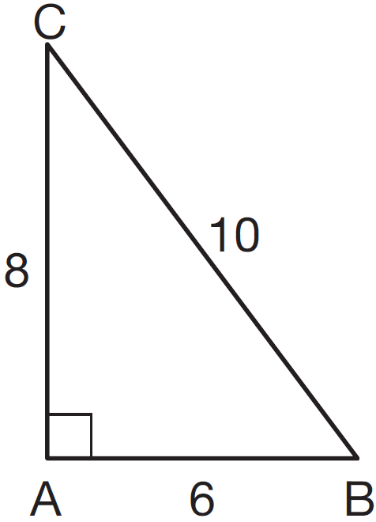

Which ratio represents the sine of ?
1)
2)
3)
4)

19 The equations and represent the money collected from selling gift baskets in a school fundraising event. If x represents the cost for each snack gift basket and y represents the cost for each chocolate gift basket, what is the cost for each chocolate gift basket?
1) | $20
2) | $25
3) | $30
4) | $54

20 Which equation represents the axis of symmetry of the graph of the equation ?
1)
2)
3)
4)

21 For which value of x is the expression 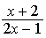 undefined?
1) | 0
2)
3)
4)

22 Last year, Nick rode his bicycle a total of 8000 miles. To the nearest yard, Nick rode an average of how many yards per day?

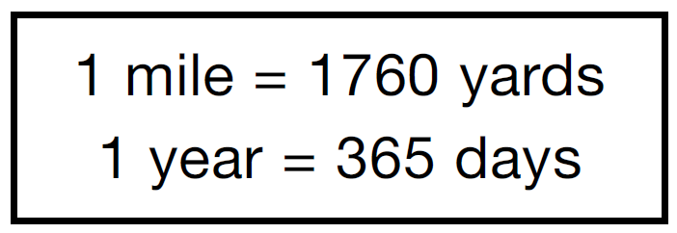
1) | 22
2) | 236
3) | 1659
4) | 38,575

23 The set of integers is not closed for
1) | division
2) | multiplication
3) | addition
4) | subtraction

24 A model rocket is launched into the air from ground level. The height, in feet, is modeled by , where x is the number of elapsed seconds. What is the total number of seconds the model rocket will be in the air?
1) | 1
2) | 2
3) | 0
4) | 16

25 The diagram below shows the path a bird flies from the top of a 9.5-foot-tall sunflower to a point on the ground 5 feet from the base of the sunflower.

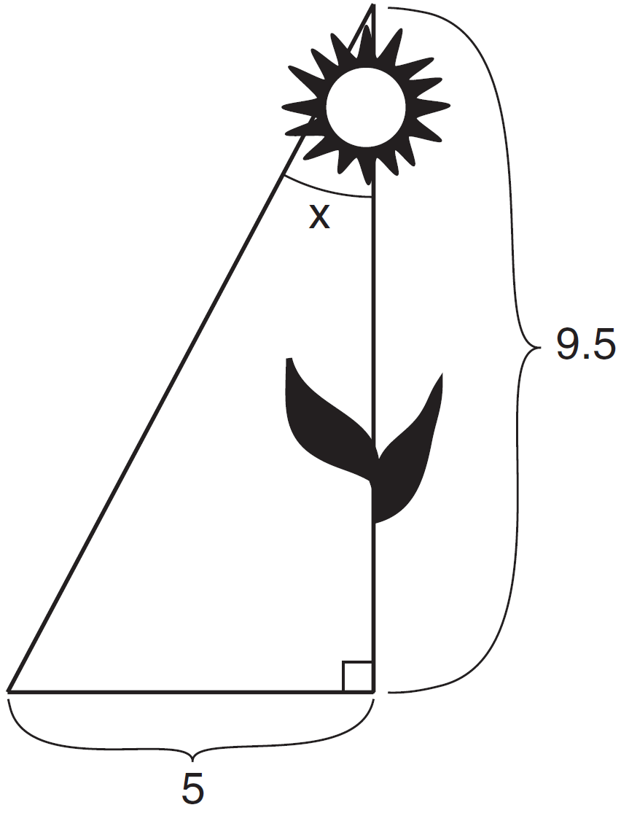

To the nearest tenth of a degree, what is the measure of angle x?
1) | 27.8
2) | 31.8
3) | 58.2
4) | 62.2

26 Which set of numbers represents the lengths of the sides of a right triangle?
1)
2)
3)
4) | {14, 16, 18

27 How many different seven-letter arrangements of the letters in the word HEXAGON can be made if each letter is used only once?
1) | 28
2) | 49
3) | 720
4) | 5040

28 Three students each rolled a wooden cube with faces painted red, white, and blue. The color of the top face is recorded each time the cube is rolled. The table below shows the results.

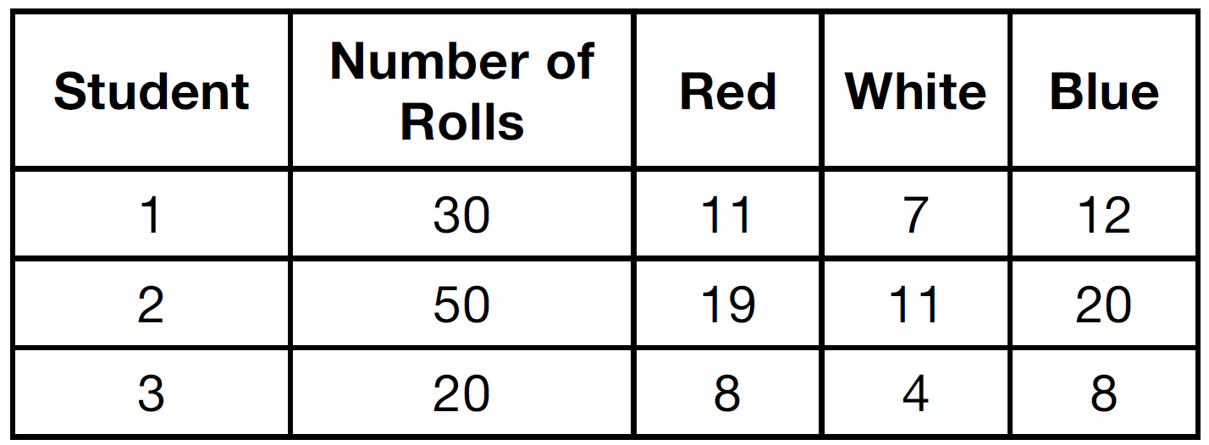

If a fourth student rolled the cube 75 times, based on these experimental data, approximately how many times can the cube be expected to land with blue on top?
1) | 25
2) | 30
3) | 35
4) | 40

29 Dominick graphs the equation where a is a positive integer. If Gina multiplies a by , the new graph will become
1) | narrower and open downward
2) | narrower and open upward
3) | wider and open downward
4) | wider and open upward

30 Mr. Suppe recorded the height, in inches, of each student in his class. The results are recorded in the table below.

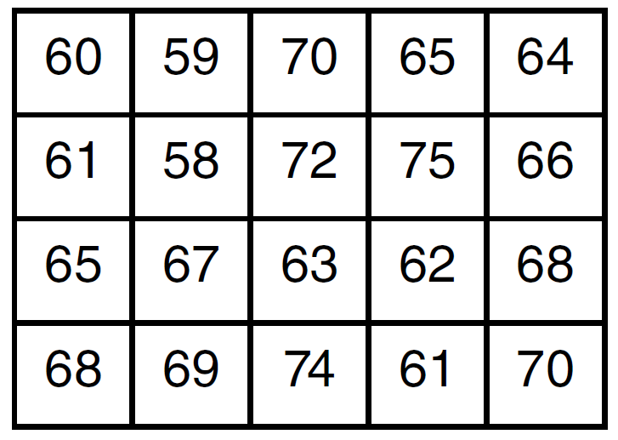

Which cumulative frequency histogram represents the data?
1) | 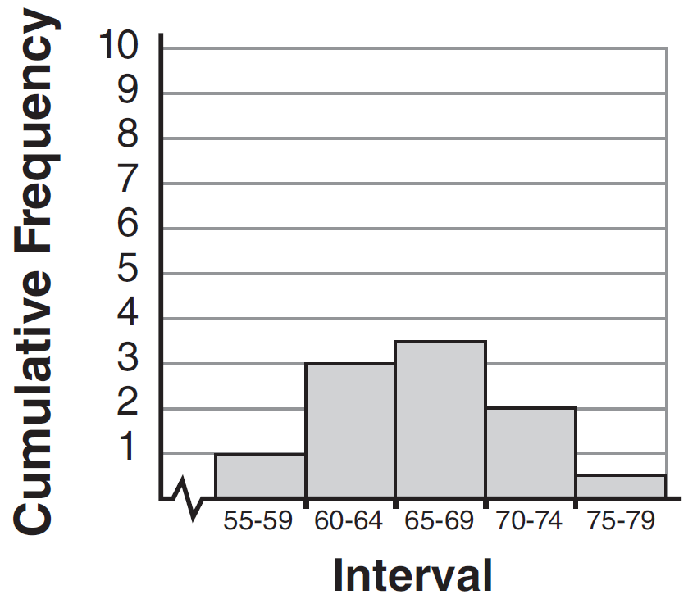
2) | 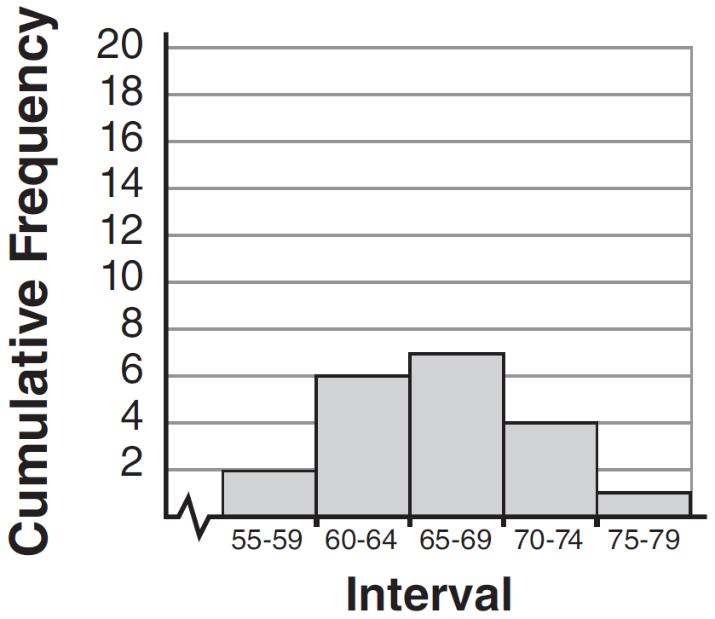
3) | 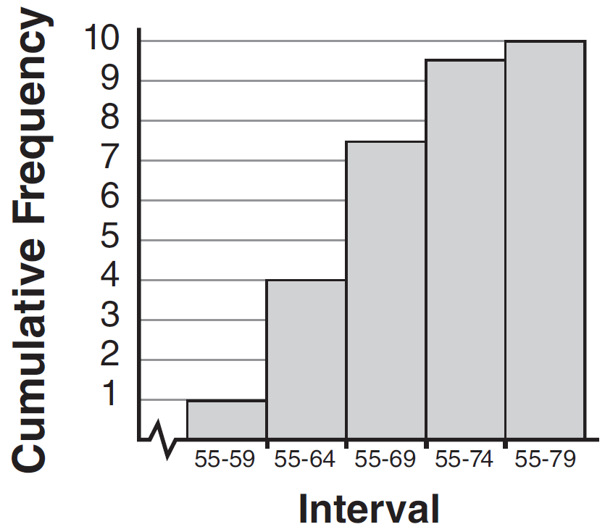
4) | 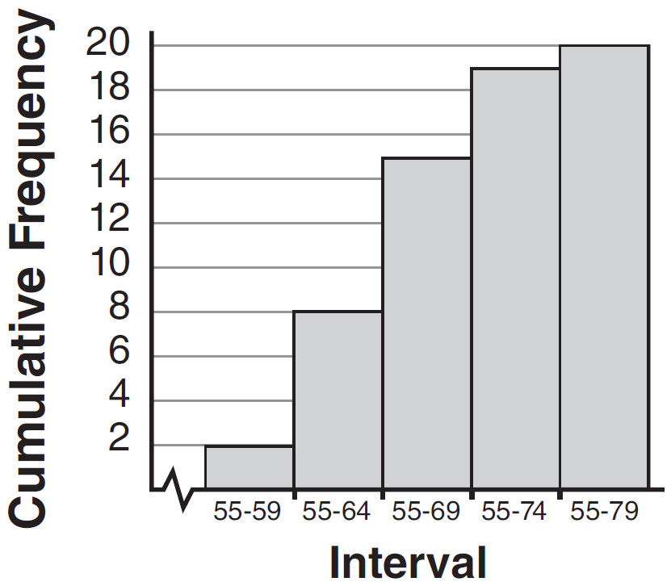

31 As shown in the diagram below, a ladder 12 feet long leans against a wall and makes an angle of 72° with the ground.

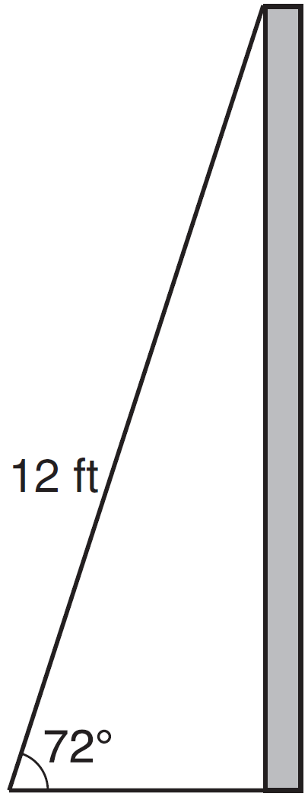

Find, to the nearest tenth of a foot, the distance from the wall to the base of the ladder.

32 Carla bought a dress at a sale for 20% off the original price. The sale price of the dress was $28.80. Find the original price of the dress, in dollars.

33 The probability that a student owns a dog is . The probability that the same student owns a dog and a cat is . Determine the probability that the student owns a cat.

34 A DVD costs twice as much as a music CD. Jack buys 2 DVDs and 2 CDs and spends $45. Determine how much one CD costs, in dollars. [Only an algebraic solution can receive full credit.]

35 Noj has the following test scores:
His teacher will allow him to retake the test on which he scored lowest. Noj wants an average of at least 82. Determine the least number of additional points Noj must score on the retest.

36 Graph and on the axes below.

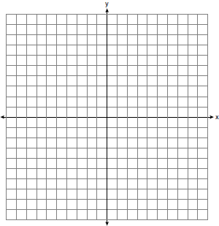

State the coordinates of a point in the solution set.

37 The Rock Solid Concrete Company has been asked to pave a rectangular area surrounding a circular fountain with a diameter of 8 feet, as shown in the diagram.

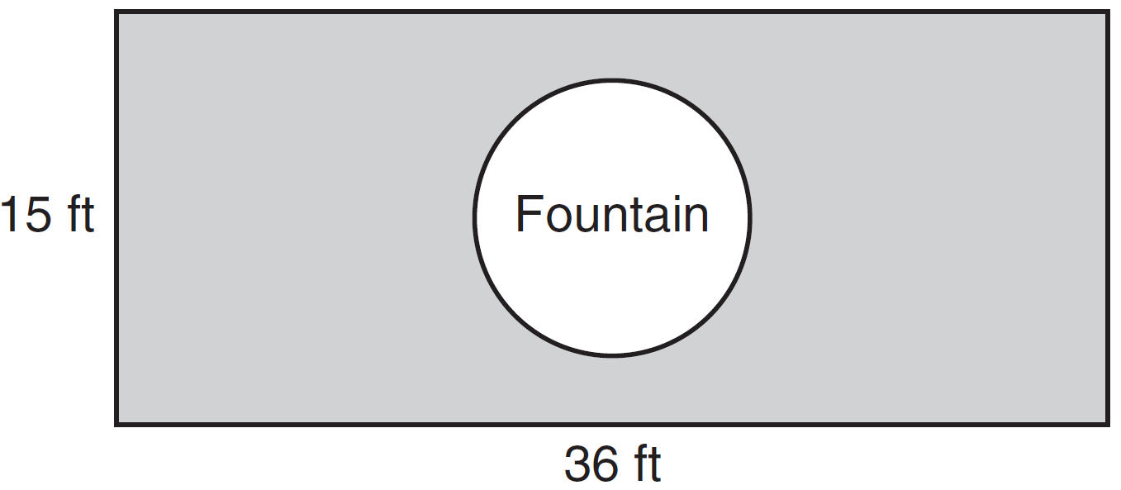

Find the area, to the nearest square foot, that must be paved. Find the cost, in dollars, of paving the area if the Rock Solid Concrete Company charges $8.95 per square foot.

38 Solve the following system of equations algebraically: 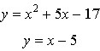

39 Perform the indicated operations and express the result in simplest form:
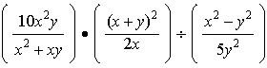
1 ANS: 2 REF: 011501ia STA: A.A.31 TOP: Set Theory

2 ANS: 3
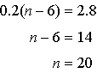

REF: 011502ia STA: A.A.25 TOP: Solving Equations with Decimals

3 ANS: 4 REF: 011503ia STA: A.A.12 TOP: Division of Powers

4 ANS: 4 REF: 011504ia STA: A.S.2 TOP: Analysis of Data

5 ANS: 3

REF: 011505ia STA: A.G.2 TOP: Volume

6 ANS: 2 REF: 011506ia STA: A.G.8 TOP: Solving Quadratics by Graphing

7 ANS: 3 REF: 011507ia STA: A.A.1 TOP: Expressions

8 ANS: 4 REF: 011508ia STA: A.A.3 TOP: Expressions

9 ANS: 3
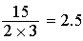

REF: 011509ia STA: A.M.1 TOP: Using Rate

10 ANS: 2
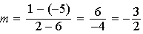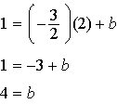

REF: 011510ia STA: A.A.35 TOP: Writing Linear Equations

11 ANS: 3
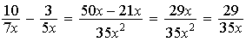

REF: 011511ia STA: A.A.17 TOP: Addition and Subtraction of Rationals

12 ANS: 2 REF: 011512ia STA: A.S.6 TOP: Box-and-Whisker Plots

13 ANS: 1 REF: 011513ia STA: A.A.5 TOP: Modeling Inequalities

14 ANS: 2 REF: 011514ia STA: A.G.3 TOP: Defining Functions
KEY: ordered pairs

15 ANS: 1

REF: 011515ia STA: A.S.11 TOP: Quartiles and Percentiles

16 ANS: 4
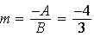

REF: 011516ia STA: A.A.37 TOP: Slope

17 ANS: 1

REF: 011517ia STA: A.N.3 TOP: Operations with Radicals
KEY: addition

18 ANS: 4
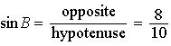

REF: 011518ia STA: A.A.42 TOP: Trigonometric Ratios

19 ANS: 3
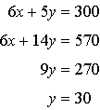

REF: 011519ia STA: A.A.10 TOP: Solving Linear Systems

20 ANS: 1
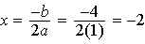

REF: 011520ia STA: A.A.41 TOP: Identifying the Vertex of a Quadratic Given Equation

21 ANS: 4 REF: 011521ia STA: A.A.15 TOP: Undefined Rationals

22 ANS: 4
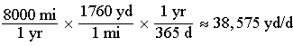

REF: 011522ia STA: A.M.2 TOP: Conversions KEY: dimensional analysis

23 ANS: 1 REF: 011523ia STA: A.N.1 TOP: Properties of Integers

24 ANS: 2
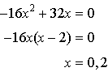

REF: 011524ia STA: A.A.8 TOP: Quadratic Functions

25 ANS: 1
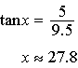

REF: 011525ia STA: A.A.43 TOP: Using Trigonometry to Find an Angle

26 ANS: 1

REF: 011526ia STA: A.A.45 TOP: Pythagorean Theorem

27 ANS: 4

REF: 011527ia STA: A.N.8 TOP: Permutations

28 ANS: 2
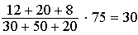

REF: 011528ia STA: A.S.21 TOP: Empirical Probability

29 ANS: 1 REF: 011529ia STA: A.G.5 TOP: Graphing Absolute Value Functions

30 ANS: 4 REF: 011530ia STA: A.S.5
TOP: Frequency Histograms, Bar Graphs and Tables

31 ANS:
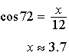

REF: 011531ia STA: A.A.44 TOP: Using Trigonometry to Find a Side

32 ANS:
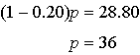

REF: 011532ia STA: A.N.5 TOP: Percents

33 ANS:
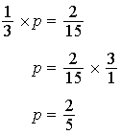

REF: 011533ia STA: A.S.23 TOP: Theoretical Probability
KEY: independent events

34 ANS:
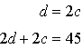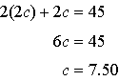

REF: 011534ia STA: A.A.7 TOP: Writing Linear Systems

35 ANS:
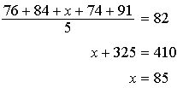

REF: 011535ia STA: A.S.16 TOP: Average Known with Missing Data

36 ANS:
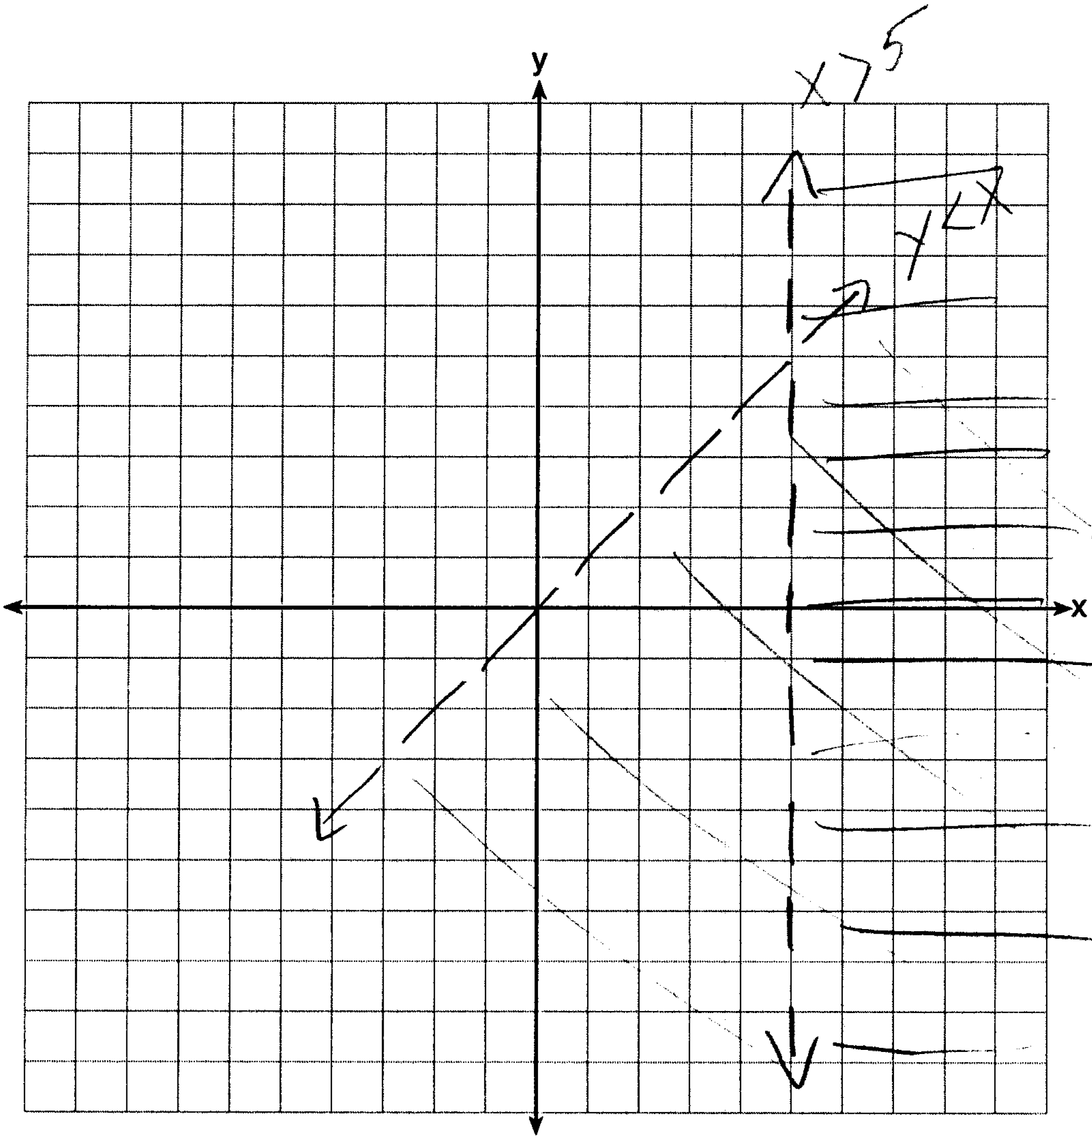

REF: 011536ia STA: A.G.7 TOP: Systems of Linear Inequalities

37 ANS:
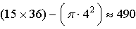

REF: 011537ia STA: A.G.1 TOP: Compositions of Polygons and Circles
KEY: area

38 ANS:
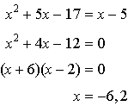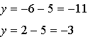

REF: 011538ia STA: A.A.11 TOP: Quadratic-Linear Systems

39 ANS:
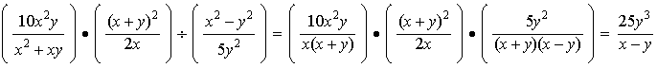

REF: 011539ia STA: A.A.18 TOP: Multiplication and Division of Rationals
KEY: division

