1 An example of an equation is
1)
2)
3)
4)

2 The greatest common factor of is?
1)
2)
3)
4)

3 Jeremy is hosting a Halloween party for 80 children. He will give each child at least one candy bar. If each bag of candy contains 18 candy bars, which inequality can be used to determine how many bags, c, Jeremy will need to buy?
1)
2)
3) | 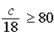
4) | 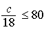

4 Which statement regarding biased sampling is false?
1) | Online sampling is biased because only the people who happen to visit the web site will take the survey.
2) | A radio call-in survey is biased because only people who feel strongly about the topic will respond.
3) | A survey handed to every third person leaving a library is biased because everyone leaving the library was not asked to participate.
4) | Asking for experts to take a survey is biased because they may have particular knowledge of the topic.

5 Which relation is not a function?
1)
2)
3)
4)

6 What is an equation of the line that passes through the point and has a slope of 3?
1)
2)
3)
4)

7 A figure consists of a square and a semicircle, as shown in the diagram below.

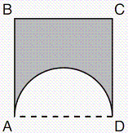

If the length of a side of the square is 6, what is the area of the shaded region?
1)
2)
3)
4)

8 The box-and-whisker plot shown below represents the number of magazine subscriptions sold by members of a club.

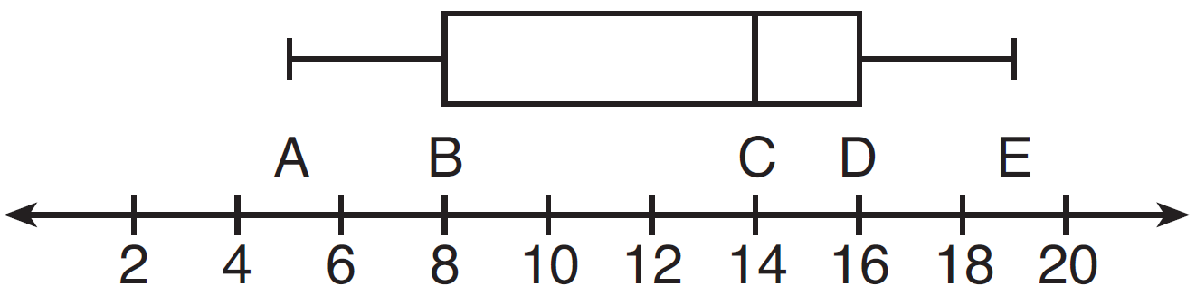

Which statistical measures do points B, D, and E represent, respectively?
1) | minimum, median, maximum
2) | first quartile, median, third quartile
3) | first quartile, third quartile, maximum
4) | median, third quartile, maximum

9 What is the slope of a line represented by the equation ?
1) | 1
2)
3)
4)

10 What is the solution of the system of equations below?
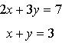
1)
2)
3)
4)

11 The graph below illustrates the number of acres used for farming in Smalltown, New York, over several years.

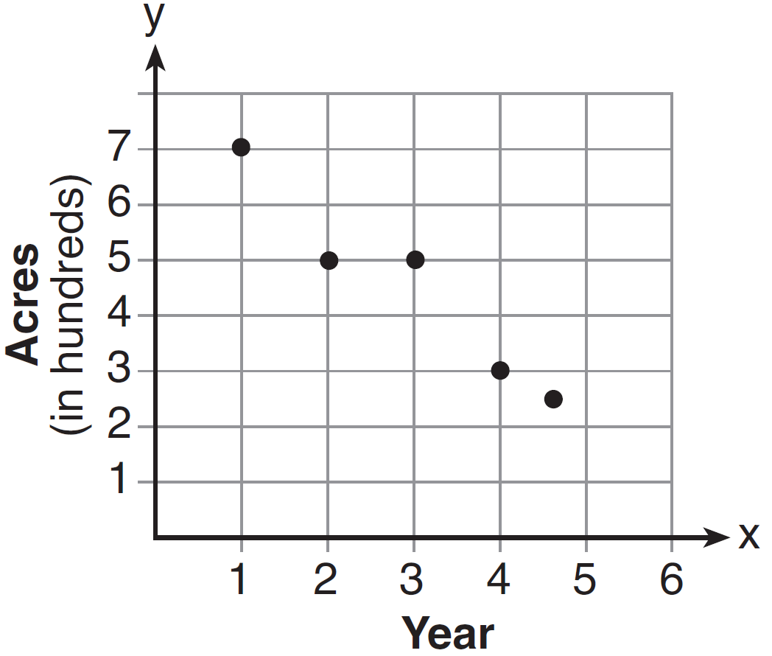

Using a line of best fit, approximately how many acres will be used for farming in the 5th year?
1) | 0
2) | 200
3) | 300
4) | 400

12 When is divided by , the quotient is
1)
2)
3)
4)

13 The width of a rectangle is 4 less than half the length. If represents the length, which equation could be used to find the width, w?
1) | 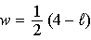
2) | 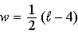
3) | 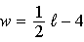
4) | 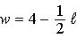

14 Which data can be classified as quantitative?
1) | favorite stores at which you shop
2) | U.S. Representatives and their home states
3) | sales tax rate in each New York county
4) | opinion of a freshman on the color of Paul's shirt

15 Two cubes with sides numbered 1 through 6 were rolled 20 times. Their sums are recorded in the table below.

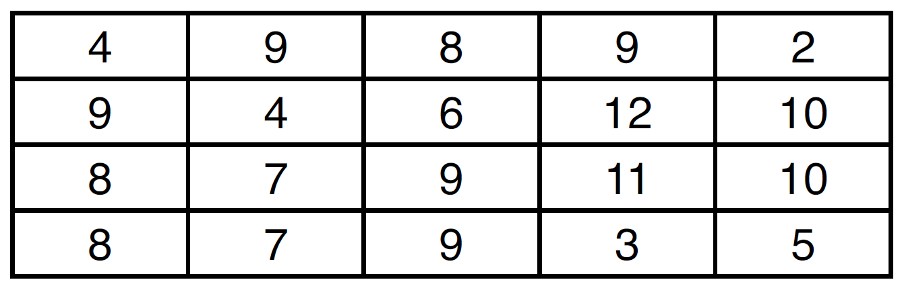

What is the empirical probability of rolling a sum of 9?
1)
2)
3)
4)

16 What is the vertex of the graph of the equation ?
1)
2)
3)
4)

17 The length and width of a rectangle are 48 inches and 40 inches. To the nearest inch, what is the length of its diagonal?
1) | 27
2) | 62
3) | 88
4) | 90

18 Which graph represents the solution set of ?
1) | 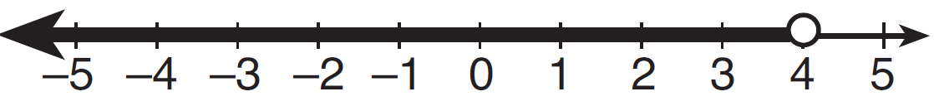
2) | 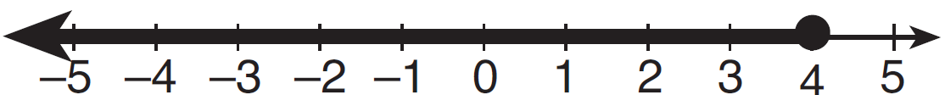
3) | 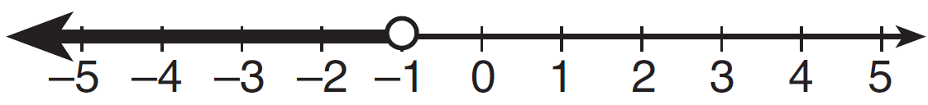
4) | 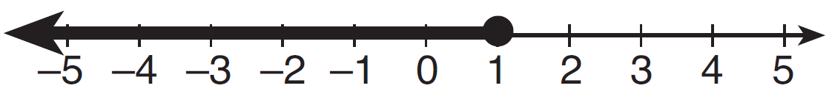

19 Jonathan drove to the airport to pick up his friend. A rainstorm forced him to drive at an average speed of 45 mph, reaching the airport in 3 hours. He drove back home at an average speed of 55 mph. How long, to the nearest tenth of an hour, did the trip home take him?
1) | 2.0 hours
2) | 2.5 hours
3) | 2.8 hours
4) | 3.7 hours

20 The expression 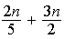 is equivalent to
1)
2) | 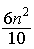
3) | 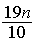
4)

21 When , the value of is
1) | 24
2) | 25
3) | 26
4) | 28

22 Which graph represents the solution of ?
1) | 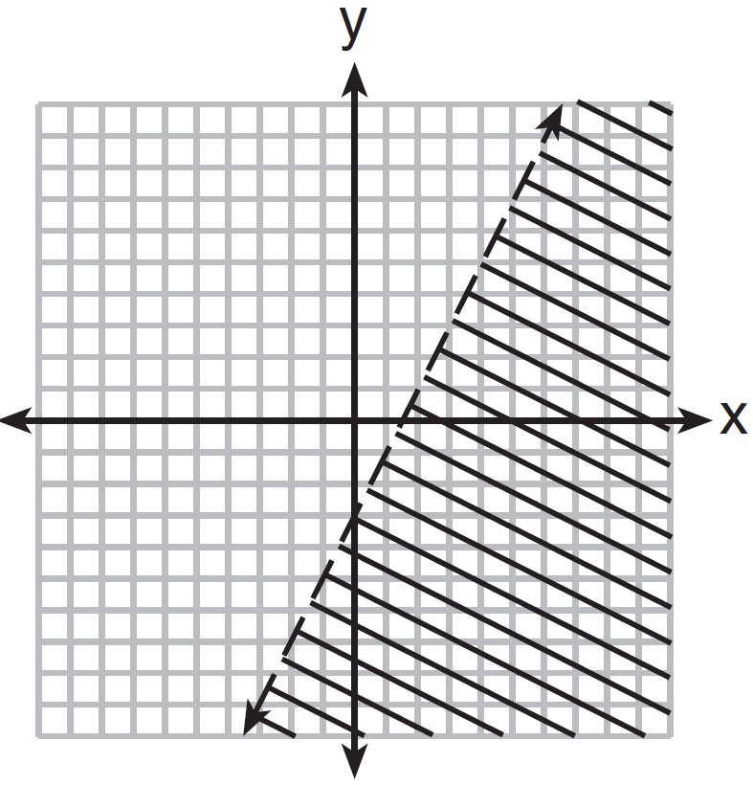
2) | 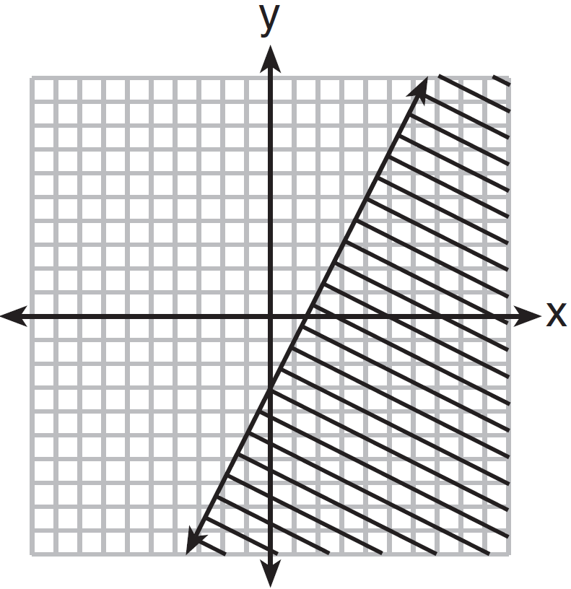
3) | 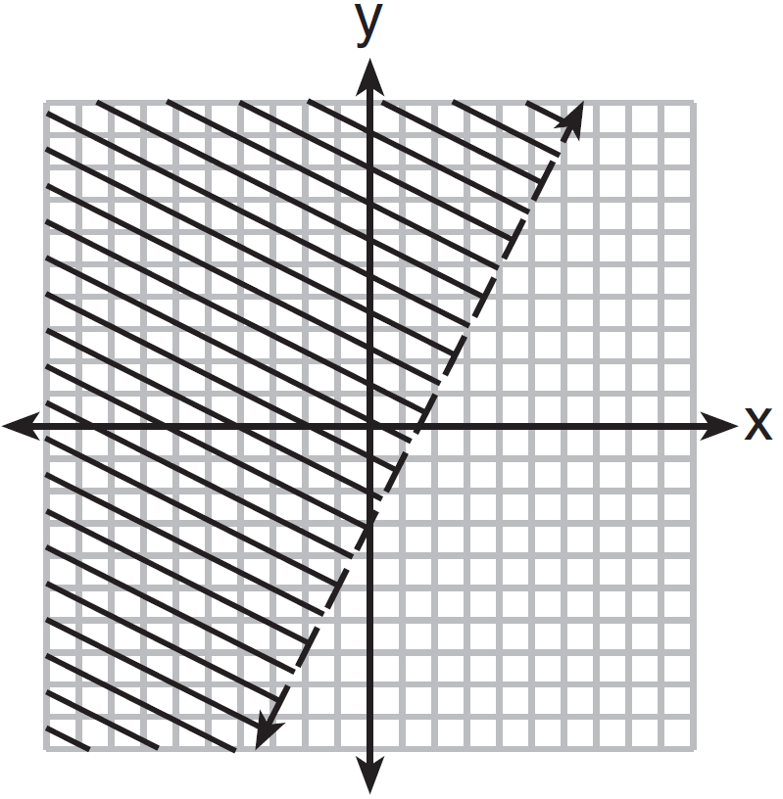
4) | 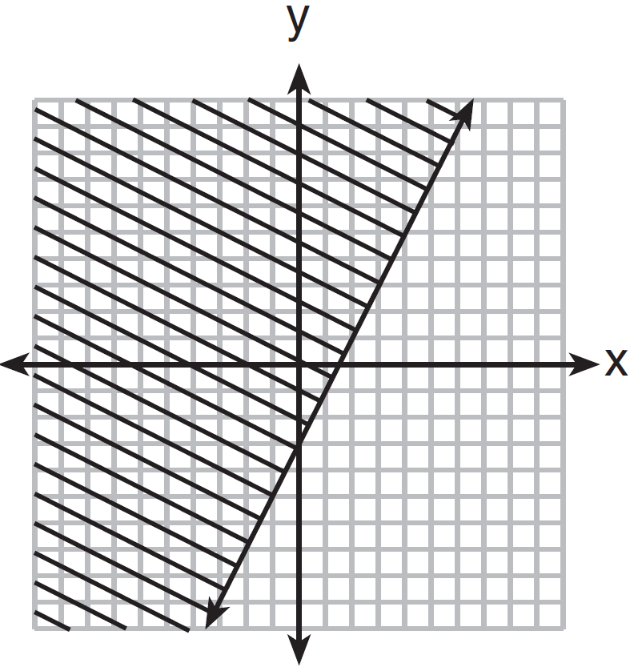

23 Which graph represents the exponential decay of a radioactive element?
1) | 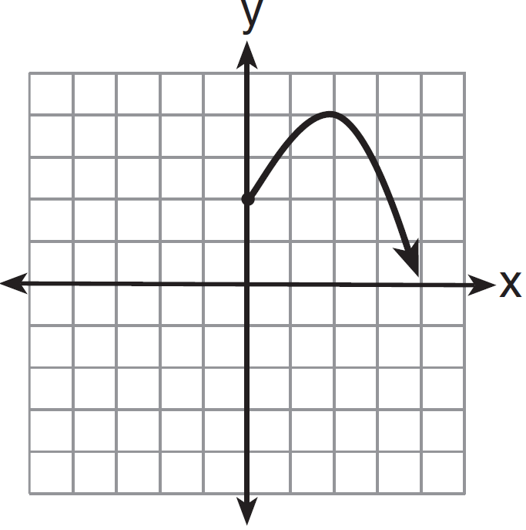
2) | 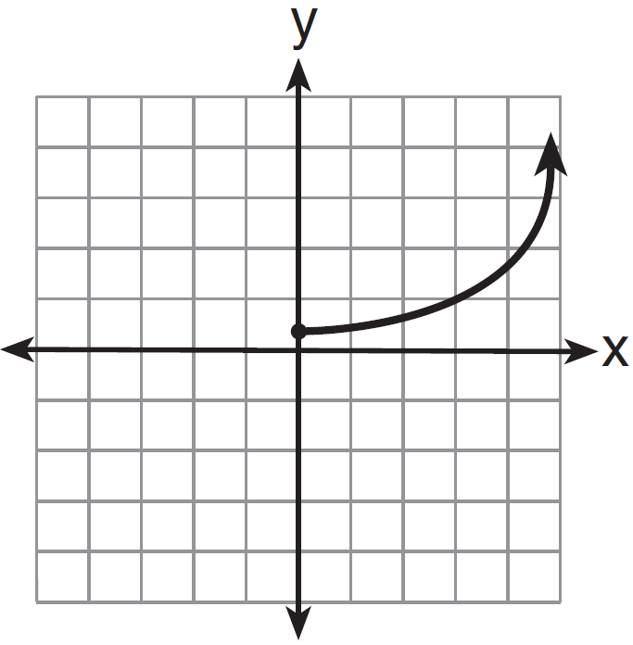
3) | 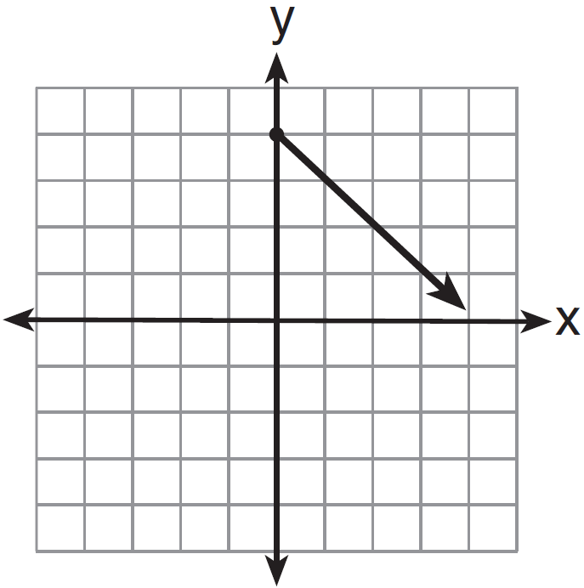
4) | 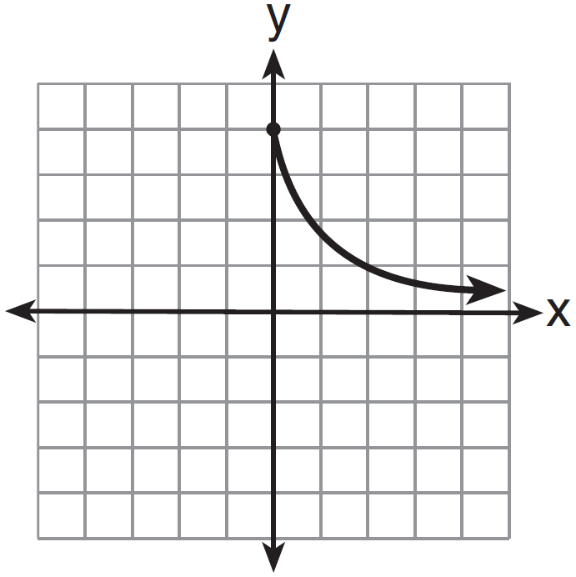

24 Which fraction represents 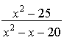 expressed in simplest form?
1)
2) | 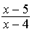
3) | 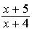
4) | 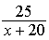

25 If , what is x in terms of a and b?
1) | 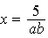
2) | 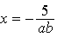
3)
4)

26 Given: 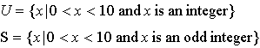
The complement of set S within the universal set U is
1)
2)
3)
4)

27 The roots of the equation are
1) | and 2
2) | and 2
3) | 0 and
4) | 0 and 4

28 Which equation illustrates the multiplicative inverse property?
1)
2)
3) | 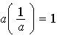
4)

29 What is the result when is subtracted from ?
1)
2)
3)
4)

30 Julie has three children whose ages are consecutive odd integers. If x represents the youngest child’s age, which expression represents the sum of her children’s ages?
1)
2)
3)
4)

31 Express 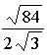 in simplest radical form.

32 The cumulative frequency table below shows the number of minutes 31 students spent text messaging on a weekend.

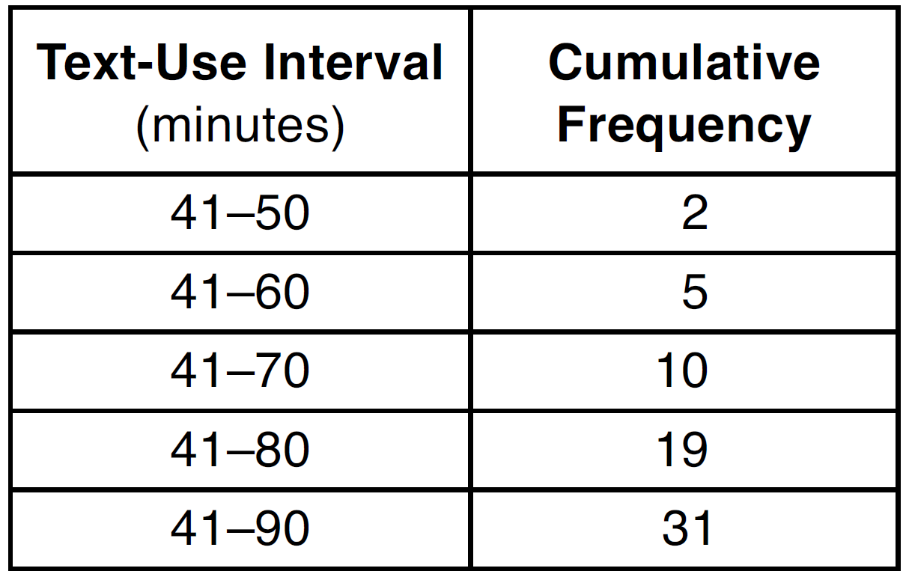

Determine which 10-minute interval contains the median. Justify your choice.

33 Kirsten invested $1000 in an account at an annual interest rate of 3%. She made no deposits or withdrawals on the account for 5 years. The interest was compounded annually. Find the balance in the account, to the nearest cent, at the end of 5 years.

34 Graph and label the functions and on the set of axes below.

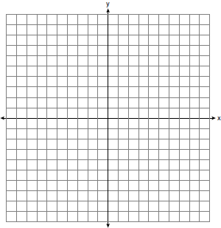

Explain how increasing the coefficient of x affects the graph of .

35 Terry estimated the length of the edge of a cube to be 5 cm. The actual length of the side is 5.2 cm. Find the relative error of the surface area of the cube, to the nearest thousandth.

36 From the top of an apartment building, the angle of depression to a car parked on the street below is 38 degrees, as shown in the diagram below. The car is parked 80 feet from the base of the building. Find the height of the building, to the nearest tenth of a foot.

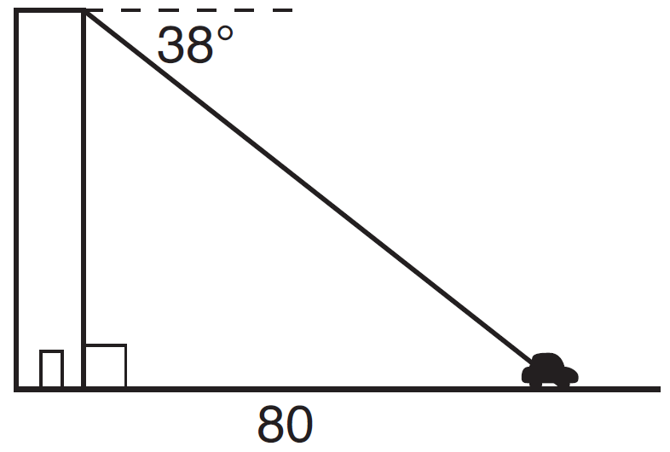

37 On the set of axes below, solve the following system of equations graphically for all values of x and y. State the coordinates of all solutions.
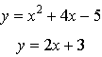

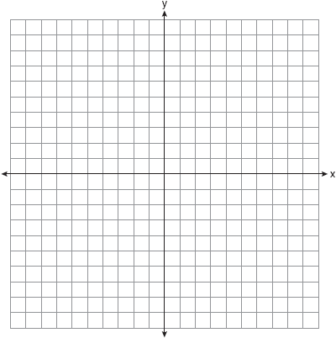

38 Solve algebraically for all values of x: 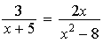

39 Doug has four baseball caps: one tan, one blue, one red, and one green. He also has three jackets: one blue, one red, and one white. Draw a tree diagram or list a sample space to show all possible outfits consisting of one baseball cap and one jacket. Find the number of Doug’s outfits that consist of a cap and a jacket that are different colors. On Spirit Day, Doug wants to wear either green or white, his school’s colors. Find the number of his outfits from which he can choose.
1 ANS: 4 REF: 011401ia STA: A.A.3 TOP: Expressions

2 ANS: 3

REF: 011402ia STA: A.A.20 TOP: Factoring Polynomials

3 ANS: 1 REF: 011403ia STA: A.A.5 TOP: Modeling Inequalities

4 ANS: 3 REF: 011404ia STA: A.S.3 TOP: Analysis of Data

5 ANS: 4
An element of the domain, 1, is paired with two different elements of the range, 1 and .

REF: 011405ia STA: A.G.3 TOP: Defining Functions
KEY: ordered pairs

6 ANS: 1
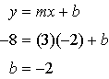

REF: 011406ia STA: A.A.34 TOP: Writing Linear Equations

7 ANS: 2
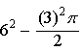

REF: 011407ia STA: A.G.1 TOP: Compositions of Polygons and Circles
KEY: area

8 ANS: 3 REF: 011408ia STA: A.S.6 TOP: Box-and-Whisker Plots

9 ANS: 2
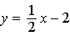

REF: 011409ia STA: A.A.37 TOP: Slope

10 ANS: 2
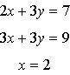

REF: 011410ia STA: A.A.10 TOP: Solving Linear Systems

11 ANS: 2 REF: 011411ia STA: A.S.17 TOP: Scatter Plots

12 ANS: 4 REF: 011412ia STA: A.A.14 TOP: Division of Polynomials

13 ANS: 3 REF: 011413ia STA: A.A.4 TOP: Modeling Equations

14 ANS: 3
The other situations are qualitative.

REF: 011414ia STA: A.S.1 TOP: Analysis of Data

15 ANS: 2 REF: 011415ia STA: A.S.21 TOP: Experimental Probability

16 ANS: 1
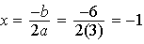.

REF: 011416ia STA: A.A.41 TOP: Identifying the Vertex of a Quadratic Given Equation

17 ANS: 2

REF: 011417ia STA: A.A.45 TOP: Pythagorean Theorem

18 ANS: 1 REF: 011418ia STA: A.A.24 TOP: Solving Inequalities

19 ANS: 2
miles. 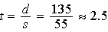 hours

REF: 011419ia STA: A.M.1 TOP: Speed

20 ANS: 3
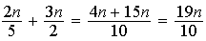

REF: 011420ia STA: A.A.17 TOP: Addition and Subtraction of Rationals

21 ANS: 3

REF: 011421ia STA: A.N.6 TOP: Evaluating Expressions

22 ANS: 3

REF: 011422ia STA: A.G.6 TOP: Linear Inequalities

23 ANS: 4 REF: 011423ia STA: A.G.4 TOP: Graphing Exponential Functions

24 ANS: 3
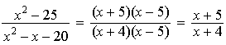

REF: 011424ia STA: A.A.16 TOP: Rational Expressions
KEY: a > 0

25 ANS: 1
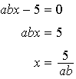

REF: 011425ia STA: A.A.23 TOP: Transforming Formulas

26 ANS: 4 REF: 011426ia STA: A.A.30 TOP: Set Theory

27 ANS: 4
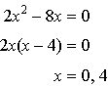

REF: 011427ia STA: A.A.28 TOP: Roots of Quadratics

28 ANS: 3 REF: 011428ia STA: A.N.1 TOP: Properties of Reals

29 ANS: 4 REF: 011429ia STA: A.A.13 TOP: Addition and Subtraction of Polynomials
KEY: subtraction

30 ANS: 4

REF: 011430ia STA: A.A.1 TOP: Expressions

31 ANS:
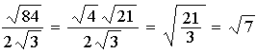

REF: 011431ia STA: A.N.3 TOP: Operations with Radicals
KEY: division

32 ANS:
If there are 31 students. the 16th student’s time represents the median. The 16th time is in the 41-80 interval on the cumulative frequency table and the 71-80 interval on the related frequency table.

REF: 011432ia STA: A.S.9 TOP: Frequency Histograms, Bar Graphs and Tables

33 ANS:

REF: 011433ia STA: A.A.9 TOP: Exponential Functions

34 ANS:
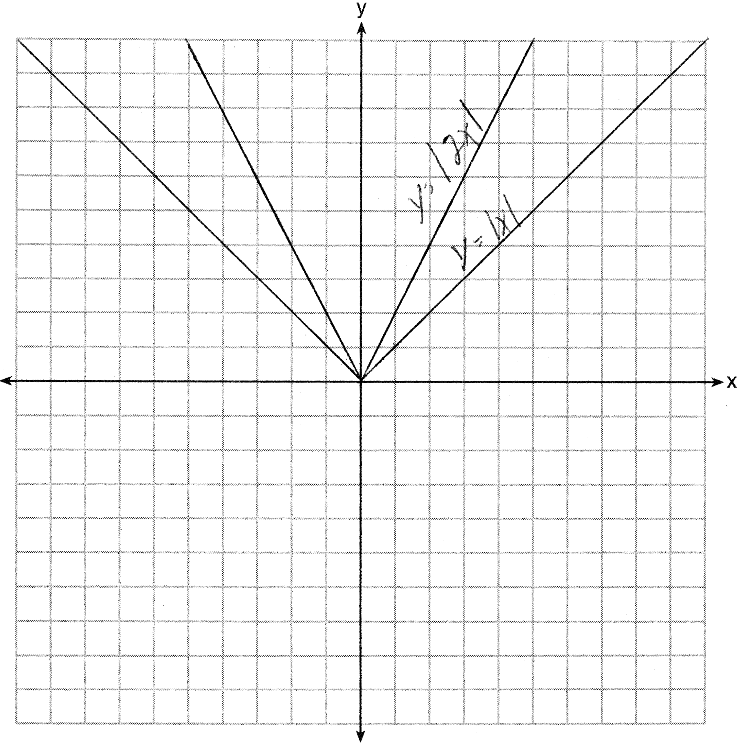. Graph becomes narrower as the coefficient increases.

REF: 011434ia STA: A.G.5 TOP: Graphing Absolute Value Functions

35 ANS:
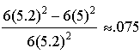

REF: 011435ia STA: A.M.3 TOP: Error KEY: volume and surface area

36 ANS:
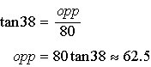

REF: 011436ia STA: A.A.44 TOP: Using Trigonometry to Find a Side

37 ANS:
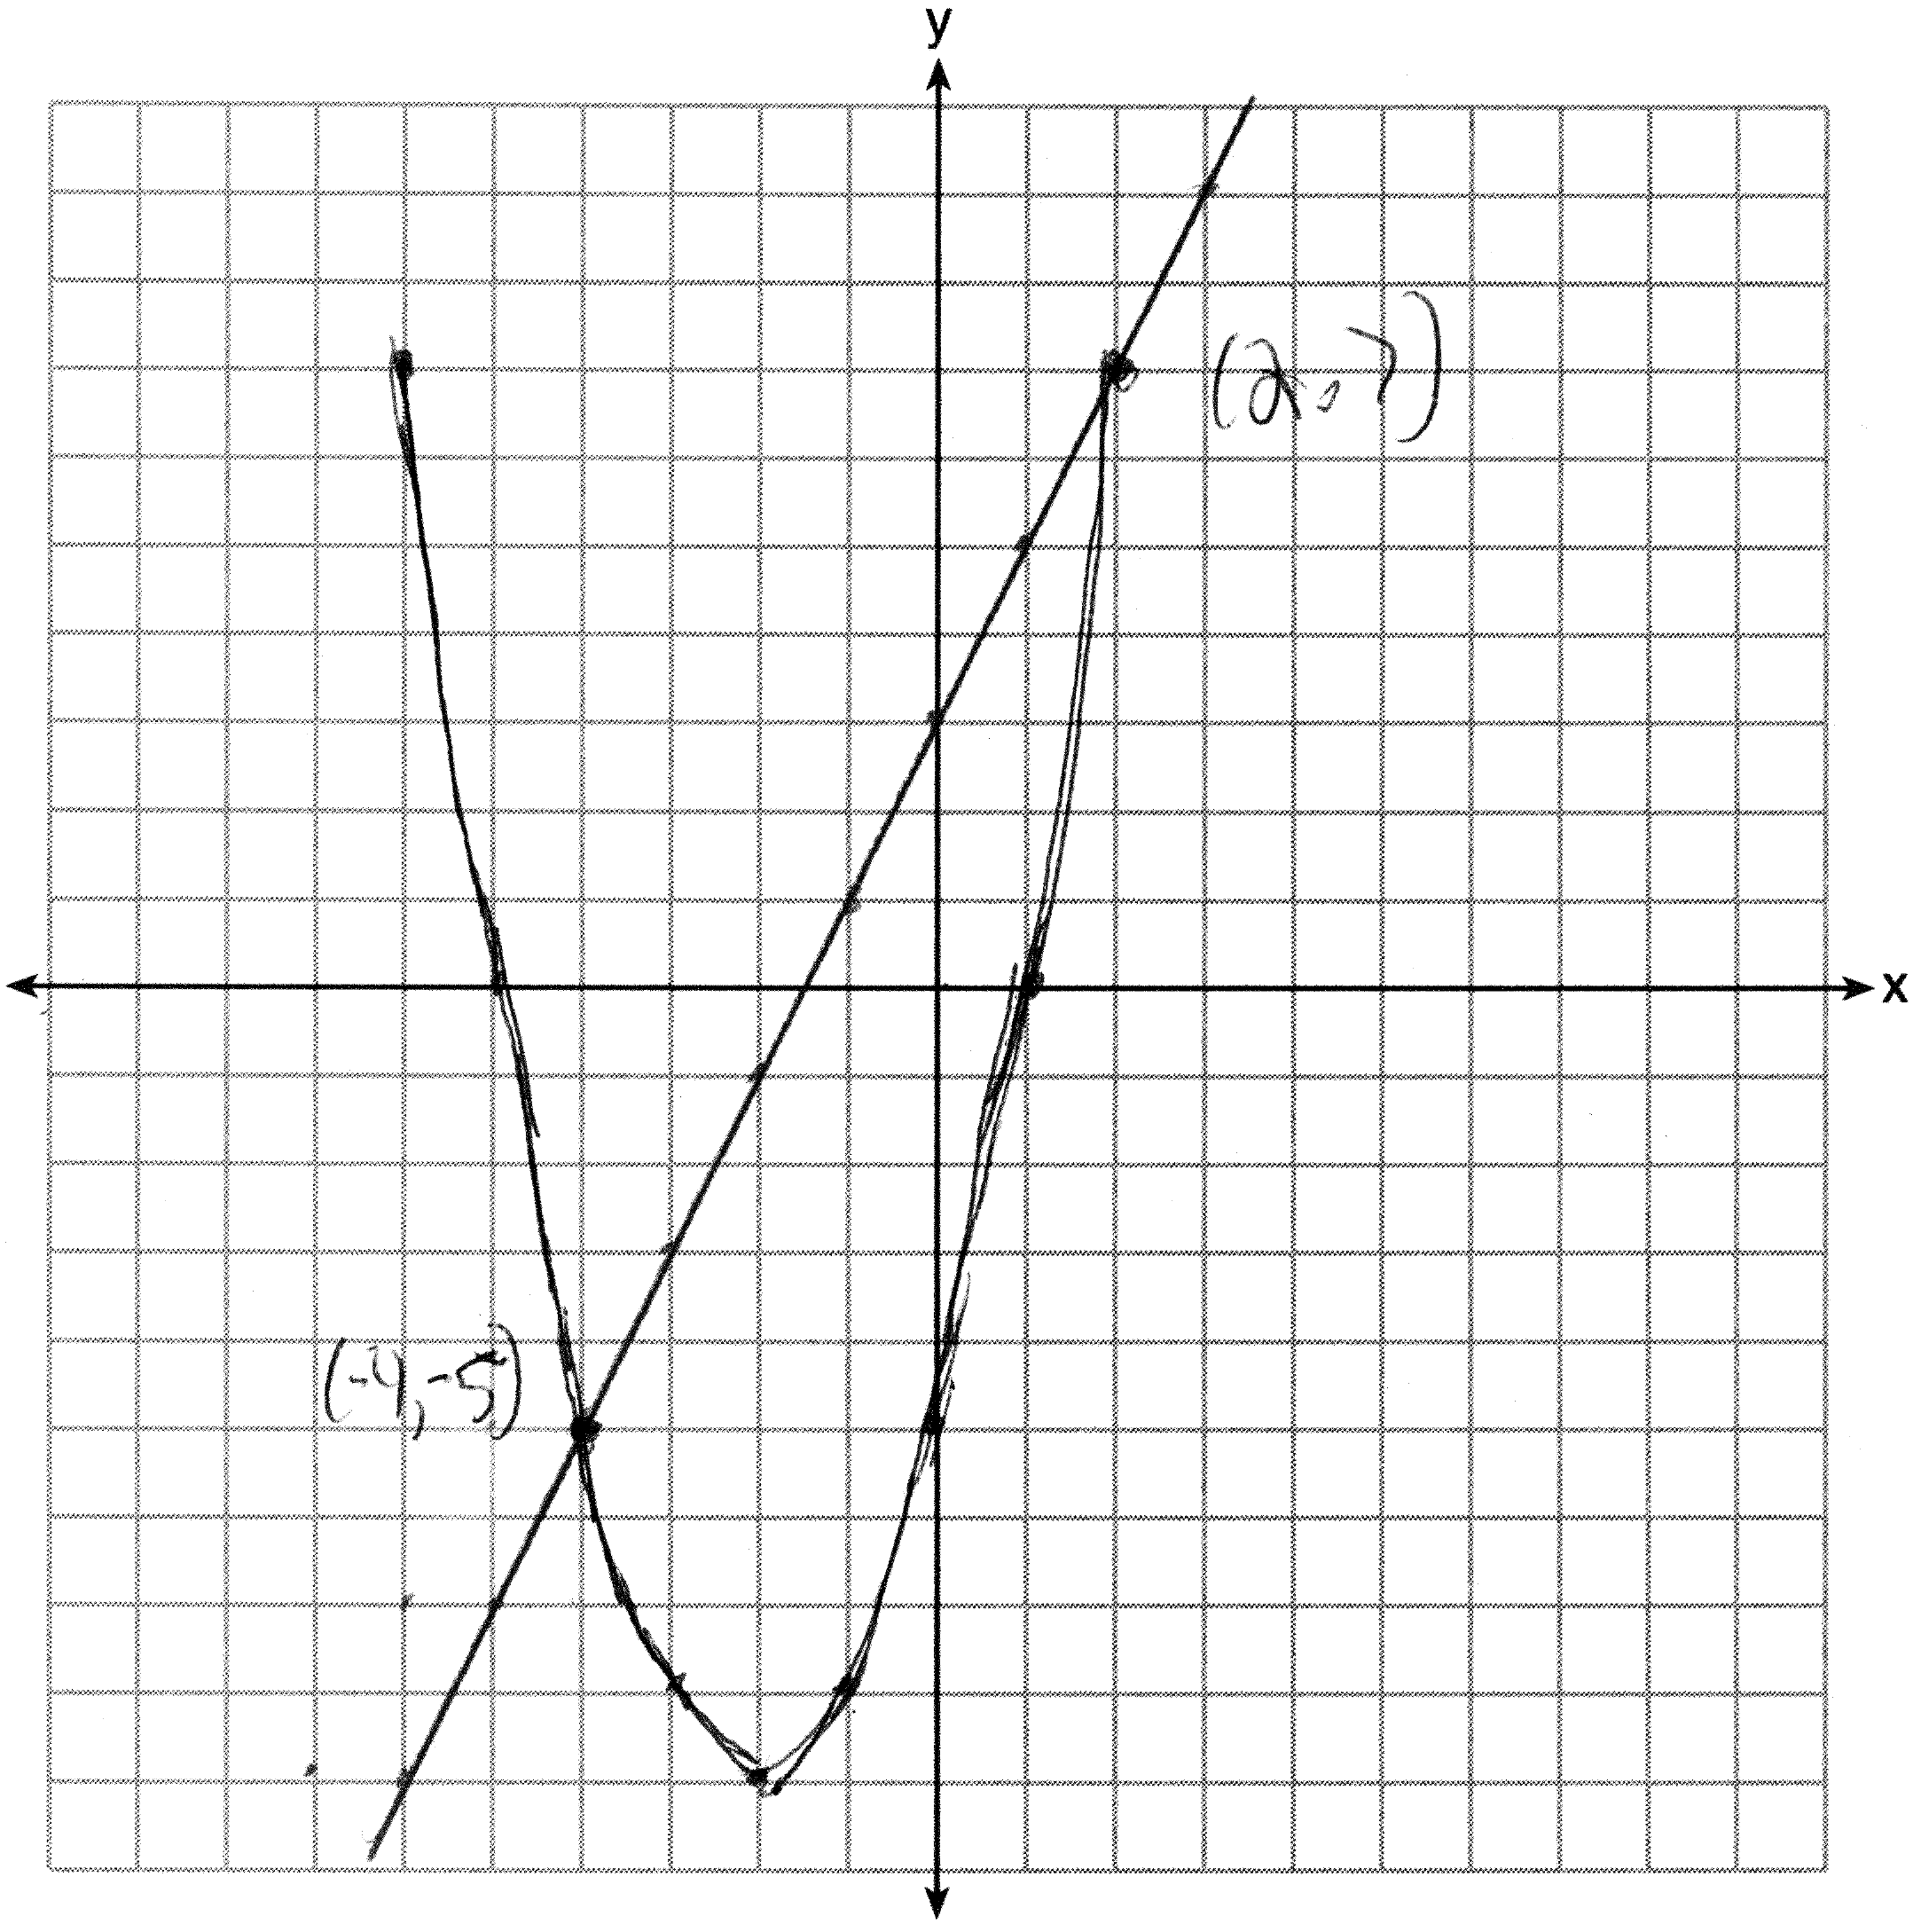

REF: 011437ia STA: A.G.9 TOP: Quadratic-Linear Systems

38 ANS:
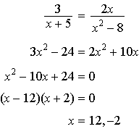

REF: 011438ia STA: A.A.26 TOP: Solving Rationals

39 ANS:
cap-jacket: TT, TR, TW, BB, BR, BW, RB, RR, RW, GB, GR, GW, 10, 6.

REF: 011439ia STA: A.S.19 TOP: Sample Space

