1 The number of hours spent on math homework during one week and the math exam grades for eleven students in Ms. Smith’s algebra class are plotted below.

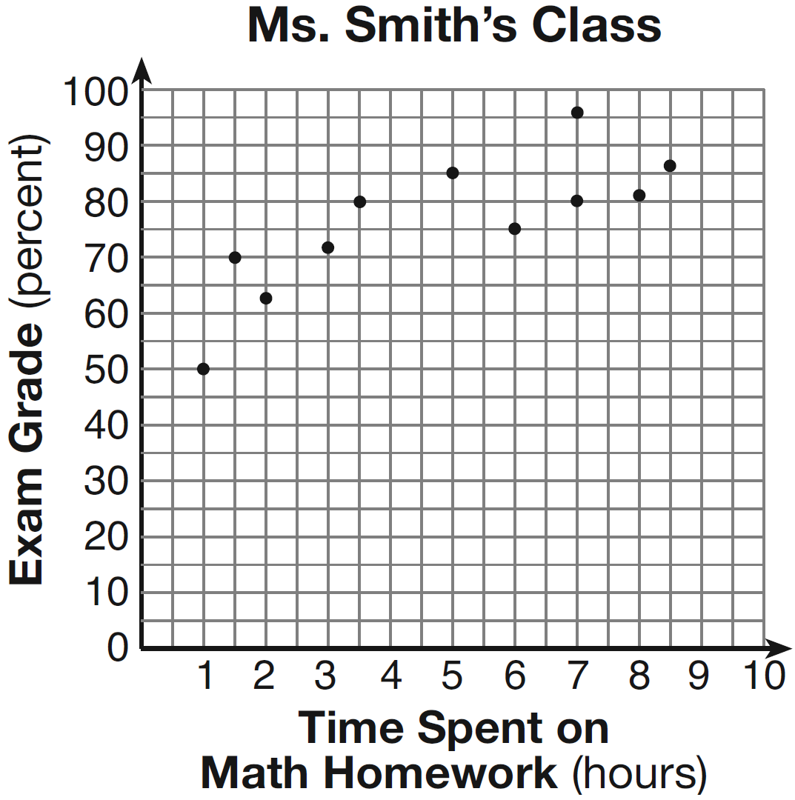
Based on the plotted data, what is the correlation between the time spent on homework and the exam grade?
1) | positive
2) | negative
3) | no correlation
4) | cannot be determined

2 A car uses one gallon of gasoline for every 20 miles it travels. If a gallon of gasoline costs $3.98, how much will the gas cost, to the nearest dollar, to travel 180 miles?
1) | 9
2) | 36
3) | 45
4) | 80

3 If Angelina’s weekly allowance is d dollars, which expression represents her allowance, in dollars, for x weeks?
1)
2)
3)
4)

4 What is the solution of the system of equations shown in the graph below?

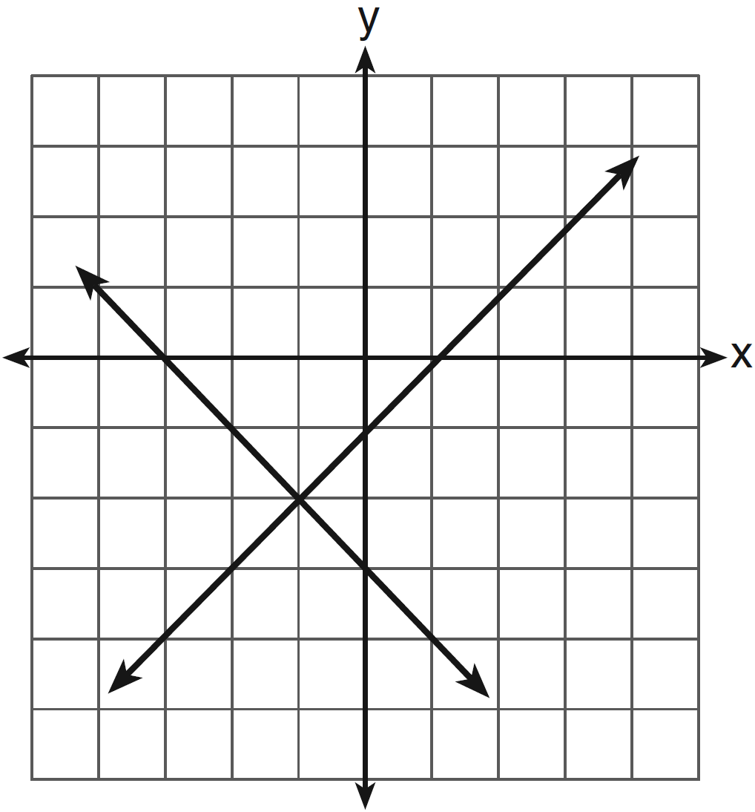
1) | and
2) | and
3)
4)

5 The solution of the equation is
1) | 1
2) | 2
3)
4)

6 The expression is equivalent to
1)
2)
3)
4)

7 In right triangle shown below, what is the value of ?

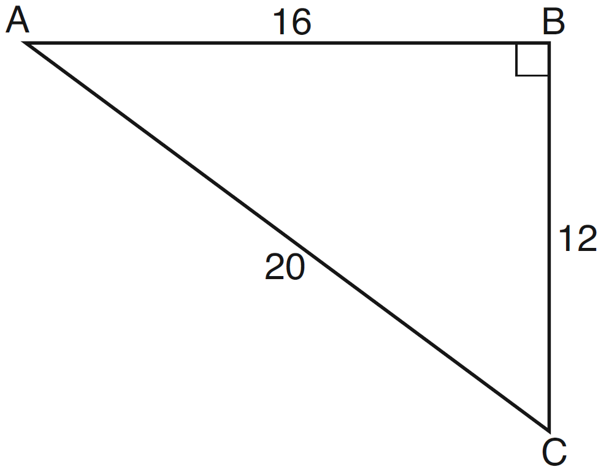
1)
2)
3)
4)

8 A bag contains five green gumdrops and six red gumdrops. If Kim pulls a green gumdrop out of the bag and eats it, what is the probability that the next gumdrop she pulls out will be red?
1)
2)
3)
4)

9 Which graph represents a function?
1) | 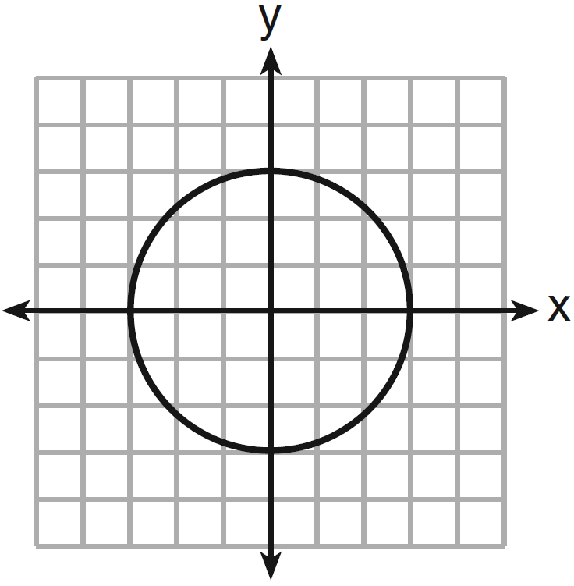
2) | 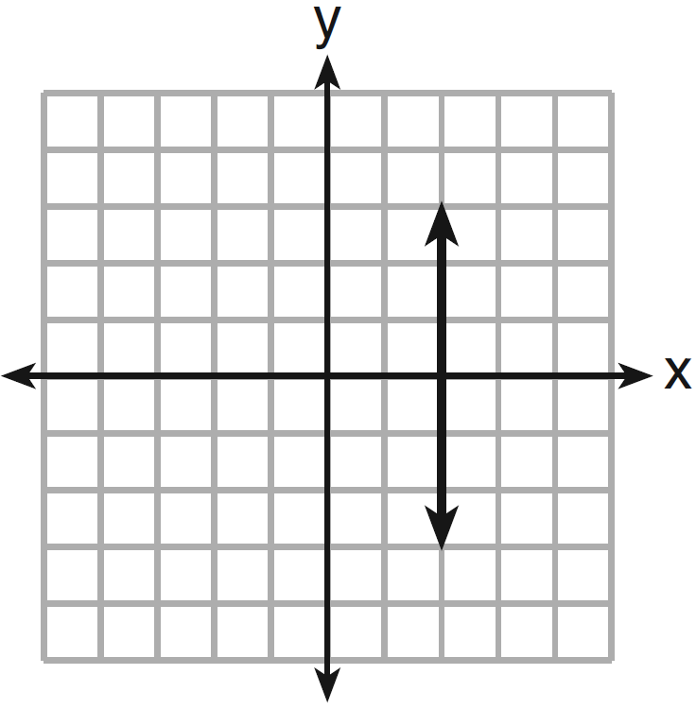
3) | 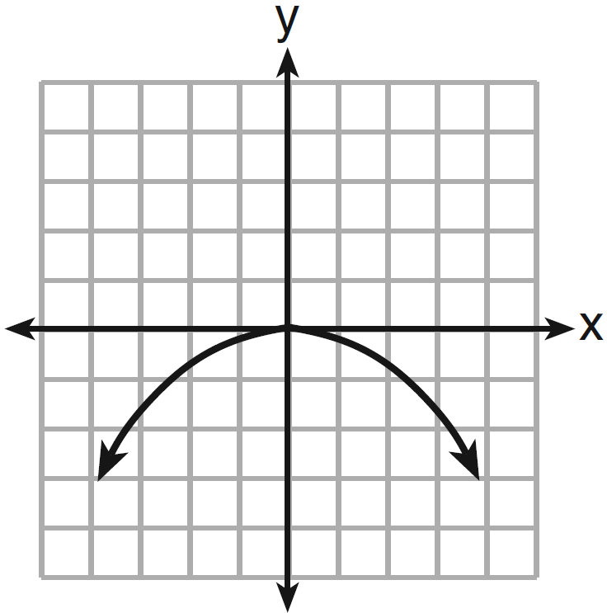
4) | 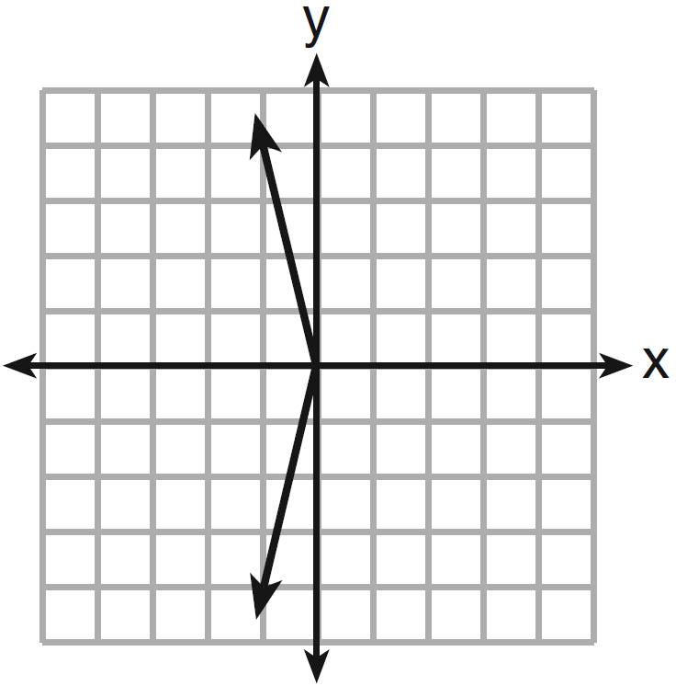

10 The current population of a town is 10,000. If the population, P, increases by 20% each year, which equation could be used to find the population after t years?
1)
2)
3)
4)

11 Which verbal expression is represented by ?
1) | twice the sum of a number and four
2) | the sum of two times a number and four
3) | two times the difference of a number and four
4) | twice the product of a number and four

12 How many cubes with 5-inch sides will completely fill a cube that is 10 inches on a side?
1) | 50
2) | 25
3) | 8
4) | 4

13 A school newspaper will survey students about the quality of the school’s lunch program. Which method will create the least biased results?
1) | Twenty-five vegetarians are randomly surveyed.
2) | Twenty-five students are randomly chosen from each grade level.
3) | Students who dislike the school’s lunch program are chosen to complete the survey.
4) | A booth is set up in the cafeteria for the students to voluntarily complete the survey.

14 The vertex of the parabola lies in Quadrant
1) | I
2) | II
3) | III
4) | IV

15 In the figure below, ABCD is a square and semicircle O has a radius of 6.

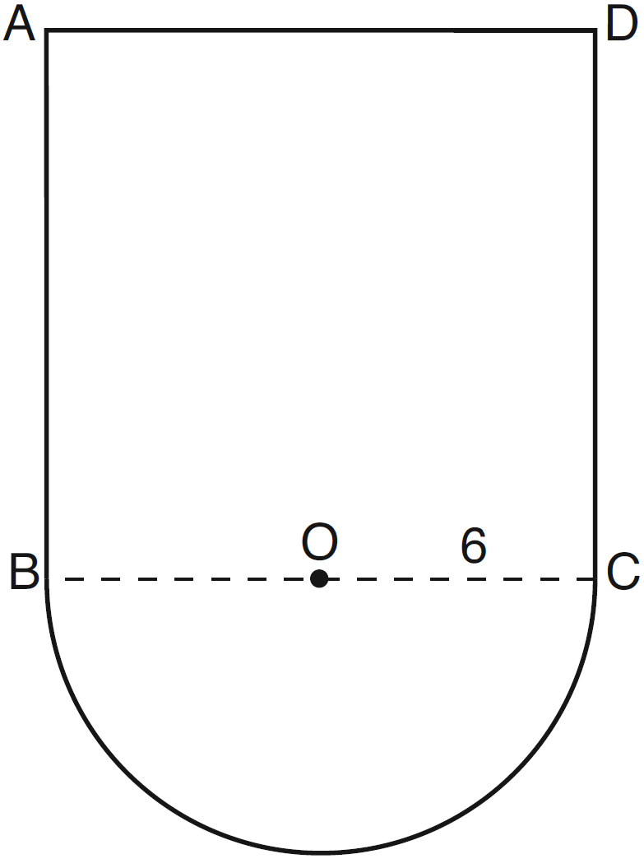

What is the area of the figure?
1)
2)
3)
4)

16 What is divided by ?
1)
2)
3)
4)

17 Which expression can be used to change 75 kilometers per hour to meters per minute?
1) | 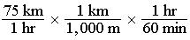
2) | 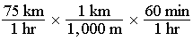
3) | 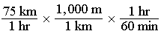
4) | 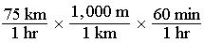

18 The inequality can be written as
1)
2)
3)
4)

19 The expression 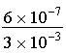 is equivalent to
1)
2)
3)
4)

20 The roots of the equation are
1) | and
2) | and 8
3) | 6 and
4) | 6 and 8

21 If , what is the value of ?
1)
2)
3) | 7
4) | 16

22 Which equation represents a line that is parallel to the line whose equation is ?
1) | 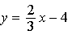
2) | 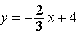
3) | 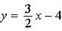
4) | 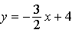

23 Which ordered pair is in the solution set of the system of inequalities and ?
1)
2)
3)
4)

24 Which equation represents the line that passes through the point and is parallel to the x-axis?
1)
2)
3)
4)

25 A cube with faces numbered 1 through 6 is rolled 75 times, and the results are given in the table below.

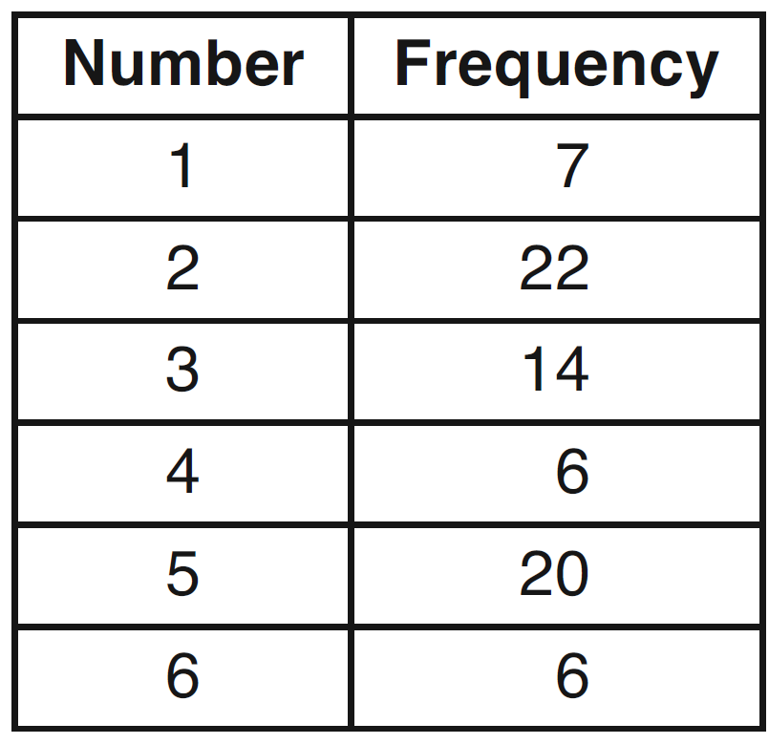

Based on these results, which statement is true?
1)
2)
3)
4)

26 Given:
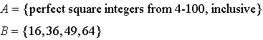
The complement of set B in the universal set A is
1)
2)
3)
4)

27 The expression 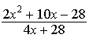 is equivalent to
1) | 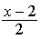
2)
3) | 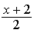
4) | 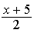

28 Which value of x is the solution of the equation 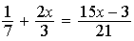?
1) | 6
2) | 0
3)
4)

29 Which statement is true about the data set 4, 5, 6, 6, 7, 9, 12?
1) | mean = mode
2) | mode = median
3) | mean < median
4) | mode > mean

30 How is the graph of affected when the coefficient of is changed to a smaller positive number?
1) | The graph becomes wider, and the y-intercept changes.
2) | The graph becomes wider, and the y-intercept stays the same.
3) | The graph becomes narrower, and the y-intercept changes.
4) | The graph becomes narrower, and the y-intercept stays the same.

31 Express in simplest radical form.

32 Factor completely:

33 On the set of axes below, graph . Include the interval .

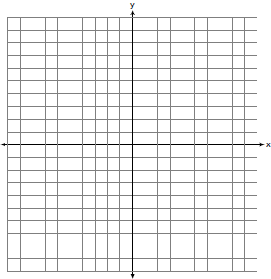

34 In a game, a player must spin each spinner shown in the diagram below once.

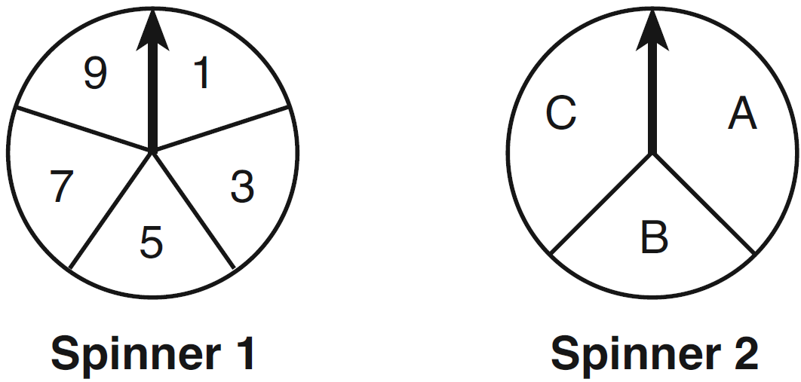

Draw a tree diagram or list a sample space showing all possible outcomes. Determine the number of outcomes that consist of a prime number and a letter in the word “CAT.”

35 The cost of three notebooks and four pencils is $8.50. The cost of five notebooks and eight pencils is $14.50. Determine the cost of one notebook and the cost of one pencil. [Only an algebraic solution can receive full credit.]

36 Wendy measures the floor in her rectangular bedroom for new carpeting. Her measurements are 24 feet by 14 feet. The actual measurements are 24.2 feet by 14.1 feet. Determine the relative error in calculating the area of her bedroom. Express your answer as a decimal to the nearest thousandth.

37 Using the line provided, construct a box-and-whisker plot for the 12 scores below.
26, 32, 19, 65, 57, 16, 28, 42, 40, 21, 38, 10

Determine the number of scores that lie above the 75th percentile.

38 A metal pipe is used to hold up a 9-foot fence, as shown in the diagram below. The pipe makes an angle of 48° with the ground.

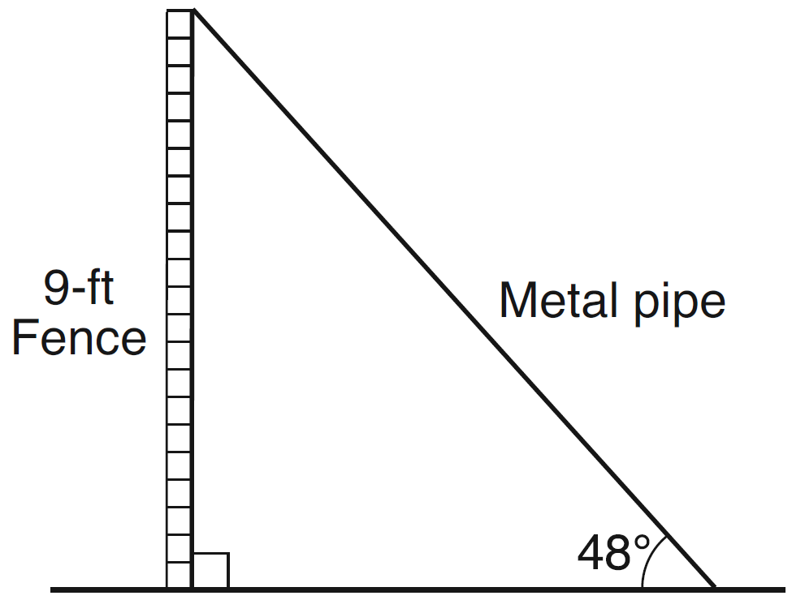

Determine, to the nearest foot, how far the bottom of the pipe is from the base of the fence. Determine, to the nearest foot, the length of the metal pipe.

39 On the set of axes below, graph the following system of equations.
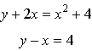
Using the graph, determine and state the coordinates of all points in the solution set for the system of equations.

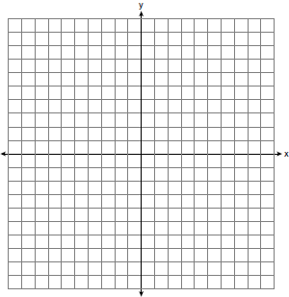

1 ANS: 1 REF: 011301ia STA: A.S.12 TOP: Scatter Plots

2 ANS: 2
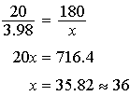

REF: 011302ia STA: A.M.1 TOP: Using Rate

3 ANS: 1 REF: 011303ia STA: A.A.1 TOP: Expressions

4 ANS: 3 REF: 011304ia STA: A.G.7 TOP: Solving Linear Systems

5 ANS: 4
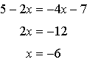

REF: 011305ia STA: A.A.22 TOP: Solving Equations

6 ANS: 1 REF: 011306ia STA: A.A.19
TOP: Factoring the Difference of Perfect Squares

7 ANS: 2
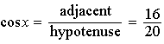

REF: 011307ia STA: A.A.42 TOP: Trigonometric Ratios

8 ANS: 4 REF: 011308ia STA: A.S.18 TOP: Conditional Probability

9 ANS: 3 REF: 011309ia STA: A.G.3 TOP: Defining Functions

10 ANS: 3 REF: 011310ia STA: A.A.9 TOP: Exponential Functions

11 ANS: 1 REF: 011311ia STA: A.A.2 TOP: Expressions

12 ANS: 3
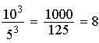

REF: 011312ia STA: A.G.2 TOP: Volume

13 ANS: 2
To determine student opinion, survey the widest range of students.

REF: 011313ia STA: A.S.3 TOP: Analysis of Data

14 ANS: 3
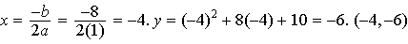

REF: 011314ia STA: A.A.41 TOP: Identifying the Vertex of a Quadratic Given Equation

15 ANS: 3 REF: 011315ia STA: A.G.1 TOP: Compositions of Polygons and Circles
KEY: area

16 ANS: 2 REF: 011316ia STA: A.A.14 TOP: Division of Polynomials

17 ANS: 3 REF: 011317ia STA: A.M.2 TOP: Conversions
KEY: dimensional analysis

18 ANS: 4 REF: 011318ia STA: A.A.29 TOP: Set Theory

19 ANS: 3 REF: 011319ia STA: A.N.4 TOP: Operations with Scientific Notation

20 ANS: 4
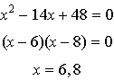

REF: 011320ia STA: A.A.28 TOP: Roots of Quadratics

21 ANS: 2

REF: 011321ia STA: A.N.6 TOP: Evaluating Expressions

22 ANS: 1
Using 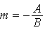, the slope of is .

REF: 011322ia STA: A.A.38 TOP: Parallel and Perpendicular Lines

23 ANS: 2
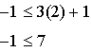. 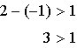

REF: 011323ia STA: A.A.40 TOP: Systems of Linear Inequalities

24 ANS: 3 REF: 011324ia STA: A.A.36 TOP: Parallel and Perpendicular Lines

25 ANS: 4
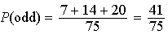. 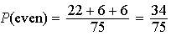. 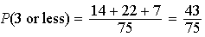. 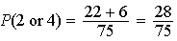

REF: 011325ia STA: A.S.22 TOP: Theoretical Probability

26 ANS: 2

REF: 011326ia STA: A.A.30 TOP: Set Theory

27 ANS: 1
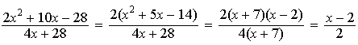

REF: 011327ia STA: A.A.16 TOP: Rational Expressions
KEY: a > 0

28 ANS: 1
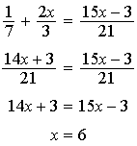

REF: 011328ia STA: A.A.25 TOP: Solving Equations with Fractional Expressions

29 ANS: 2
mean = 7, median = 6 and mode = 6

REF: 011329ia STA: A.S.4 TOP: Central Tendency

30 ANS: 2 REF: 011330ia STA: A.G.5 TOP: Graphing Quadratic Functions

31 ANS:

REF: 011331ia STA: A.N.2 TOP: Simplifying Radicals

32 ANS:
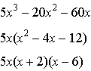

REF: 011332ia STA: A.A.20 TOP: Factoring Polynomials

33 ANS:
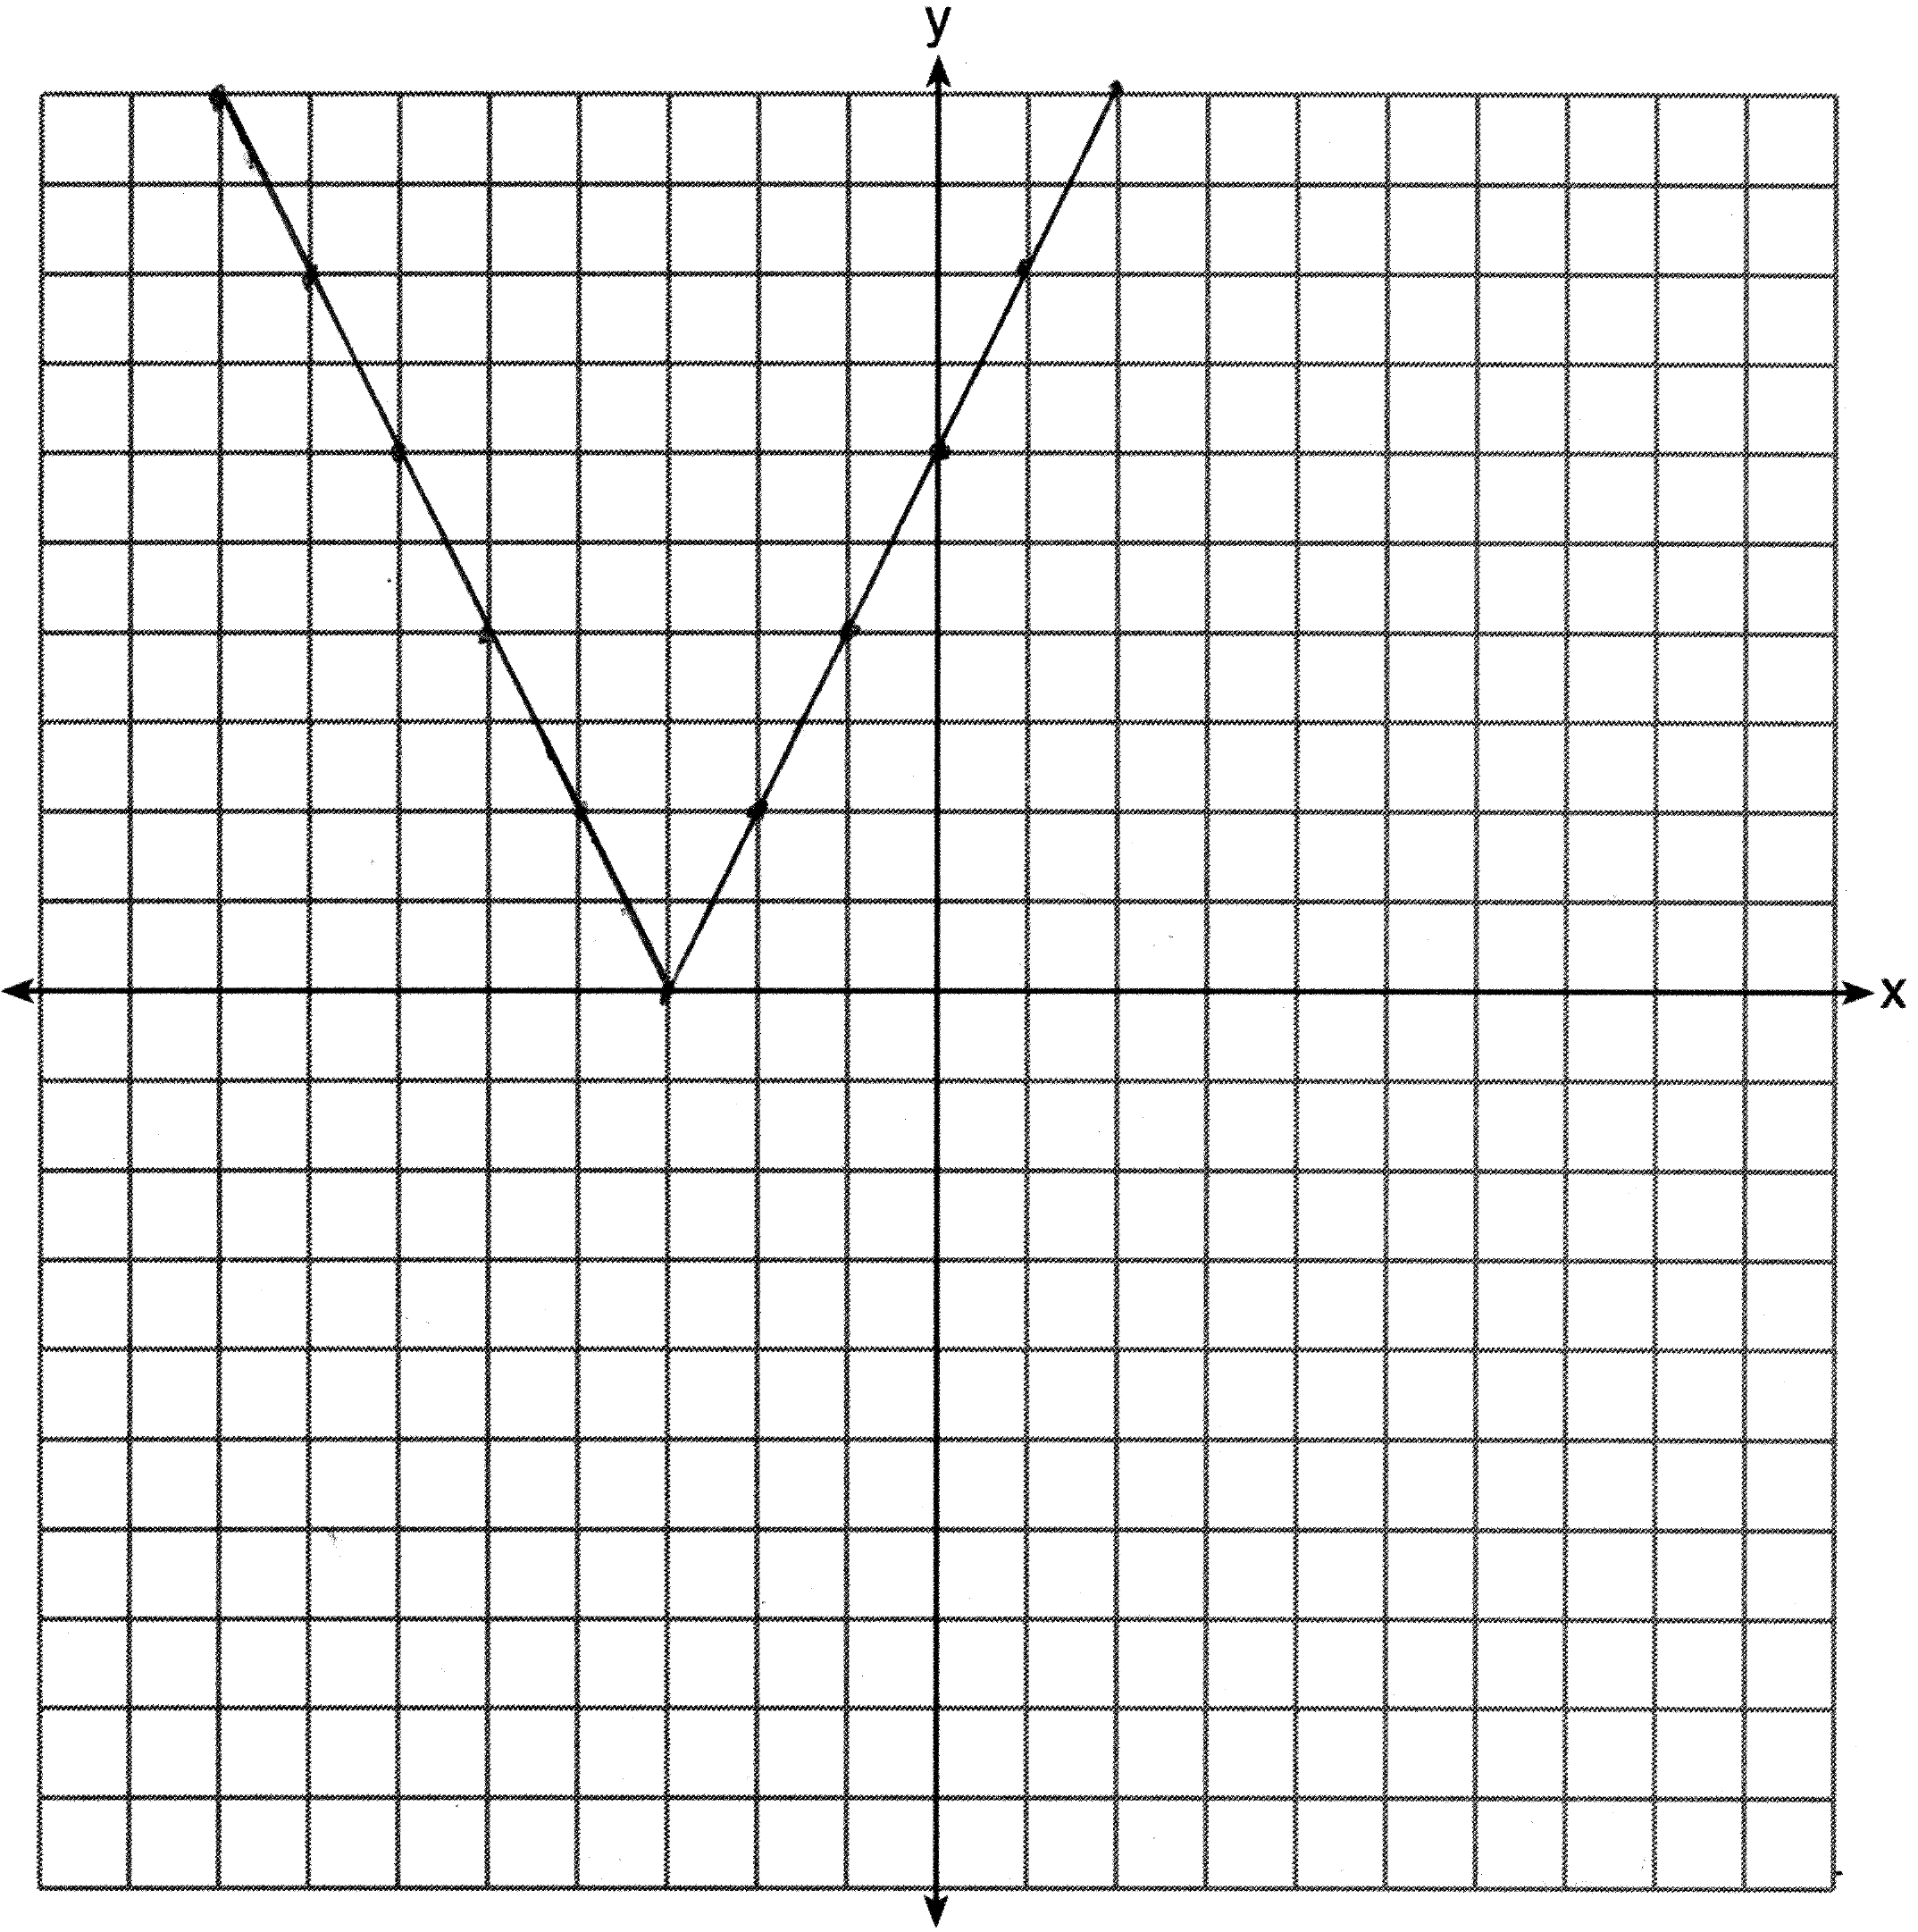

REF: 011333ia STA: A.G.4 TOP: Graphing Absolute Value Functions

34 ANS:
(1,A), (1,B), (1,C), (3,A), (3,B), (3,C), (5,A), (5,B), (5,C), (7,A), (7,B), (7,C), (9,A), (9,B), (9,C). 6

REF: 011334ia STA: A.S.19 TOP: Sample Space

35 ANS:
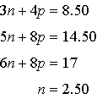. 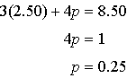

REF: 011335ia STA: A.A.7 TOP: Writing Linear Systems

36 ANS:
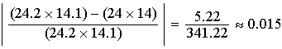

REF: 011336ia STA: A.M.3 TOP: Error KEY: area

37 ANS:
. Three scores are above 41.

REF: 011337ia STA: A.S.5 TOP: Box-and-Whisker Plots

38 ANS:
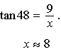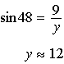

REF: 011338ia STA: A.A.44 TOP: Using Trigonometry to Find a Side

39 ANS:
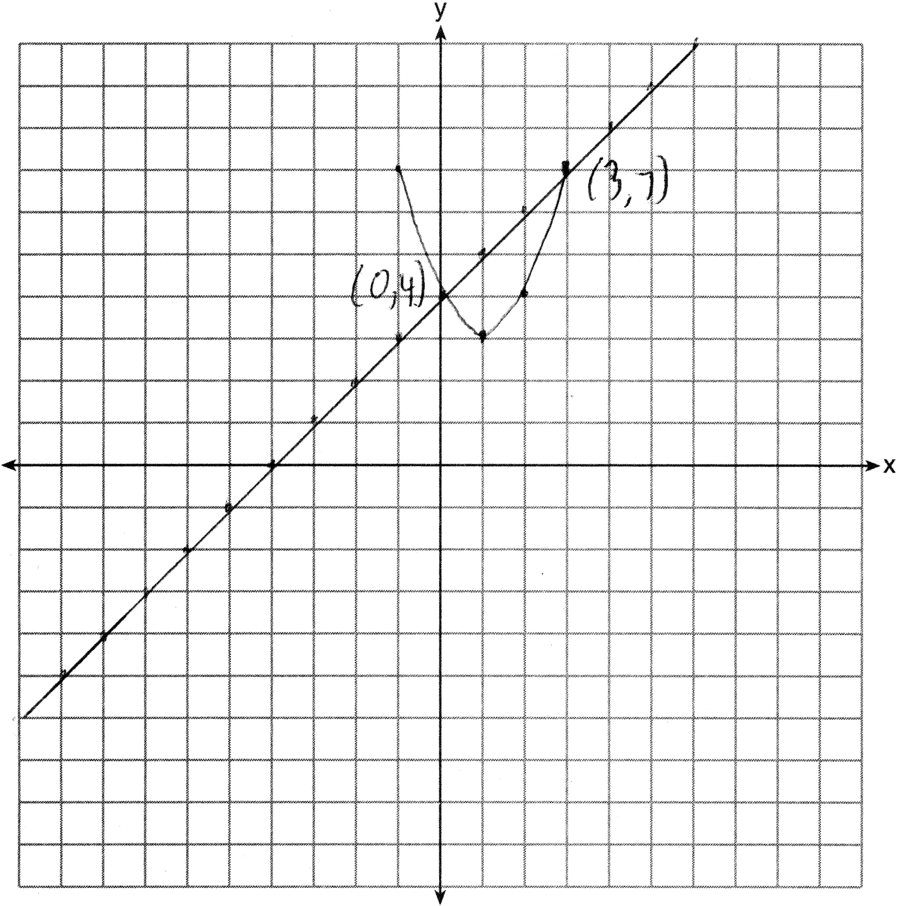

REF: 011339ia STA: A.G.9 TOP: Quadratic-Linear Systems

