1 Which expression is equivalent to ?
1)
2)
3)
4)

2 Mr. Smith invested $2,500 in a savings account that earns 3% interest compounded annually. He made no additional deposits or withdrawals. Which expression can be used to determine the number of dollars in this account at the end of 4 years?
1)
2)
3)
4)

3 What is expressed in simplest radical form?
1)
2)
3)
4)

4 Which graph does not represent a function?
1) | 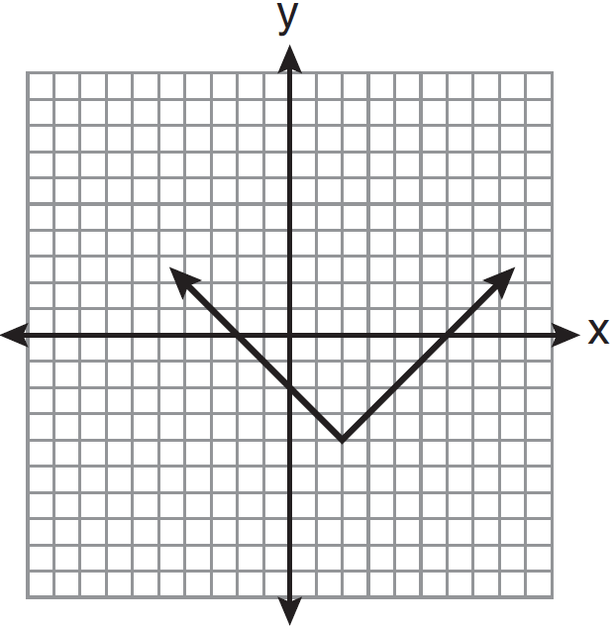
2) | 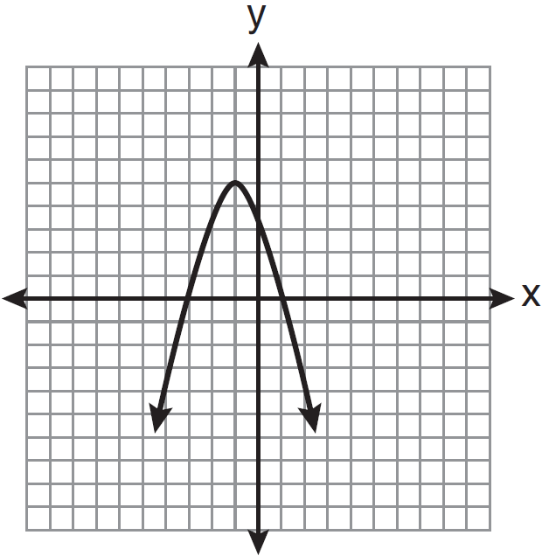
3) | 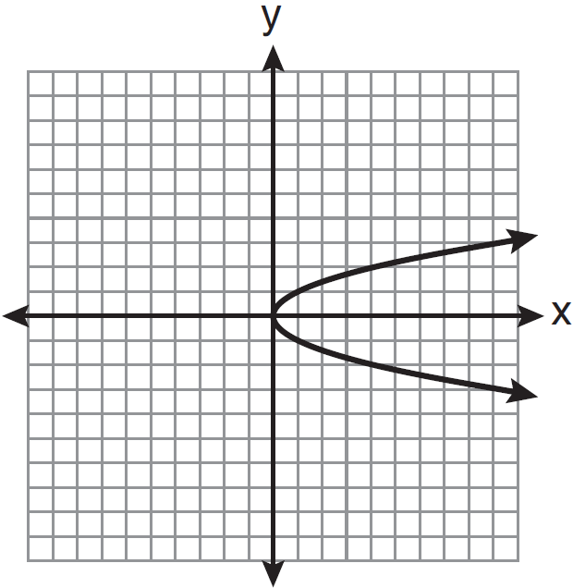
4) | 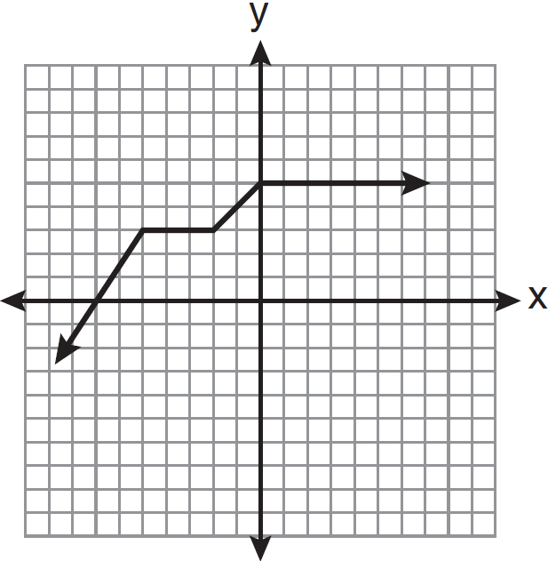

5 Timmy bought a skateboard and two helmets for a total of d dollars. If each helmet cost h dollars, the cost of the skateboard could be represented by
1)
2)
3)
4) | 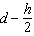

6 The graph of is shown below.

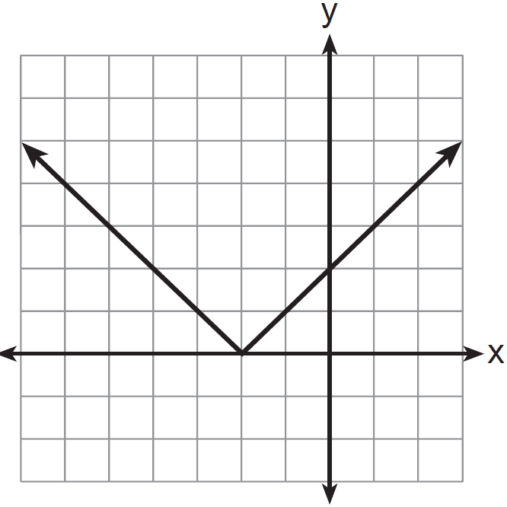

Which graph represents ?
1) | 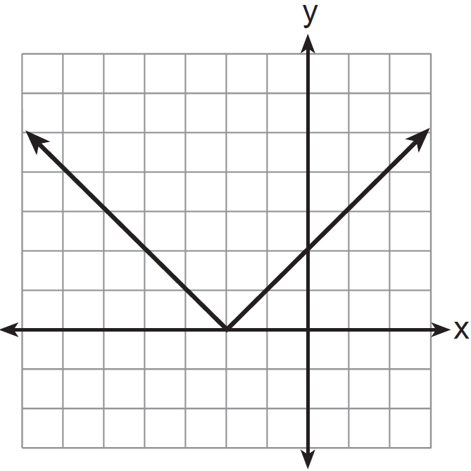
2) | 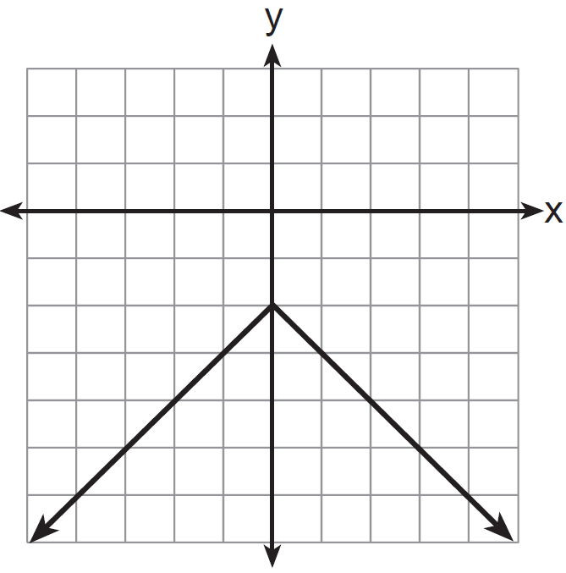
3) | 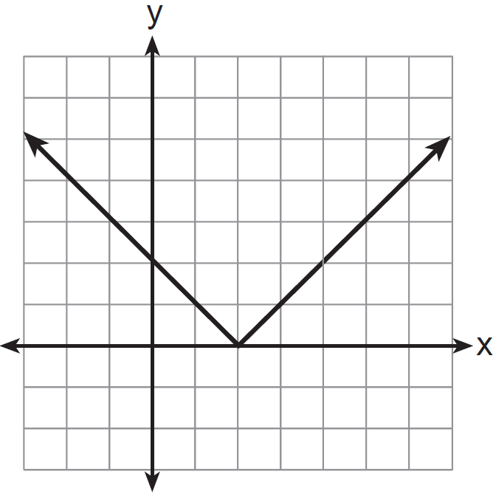
4) | 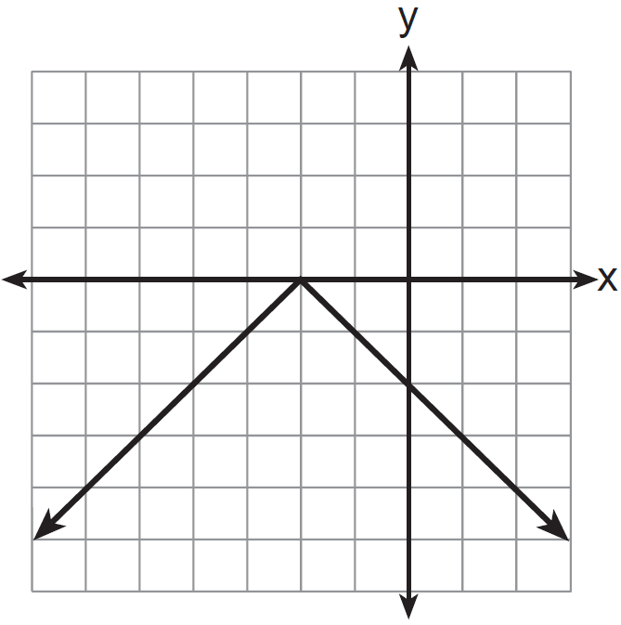

7 Two equations were graphed on the set of axes below.

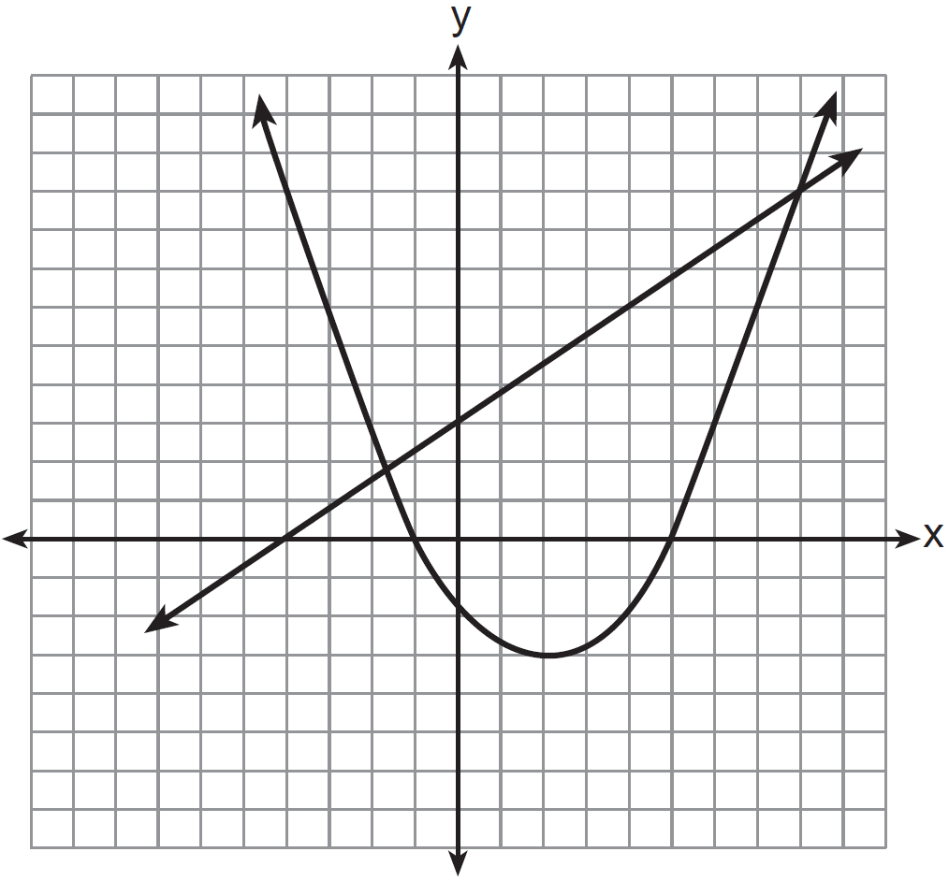

Which point is a solution of the system of equations shown on the graph?
1)
2)
3)
4)

8 Byron is 3 years older than Doug. The product of their ages is 40. How old is Doug?
1) | 10
2) | 8
3) | 5
4) | 4

9 The actual dimensions of a rectangle are 2.6 cm by 6.9 cm. Andy measures the sides as 2.5 cm by 6.8 cm. In calculating the area, what is the relative error, to the nearest thousandth?
1) | 0.055
2) | 0.052
3) | 0.022
4) | 0.021

10 Which graph represents the inequality ?
1) | 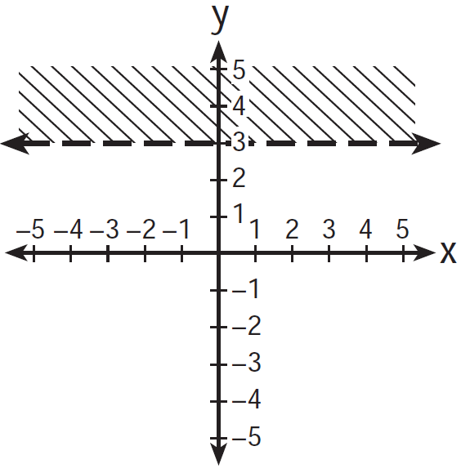
2) | 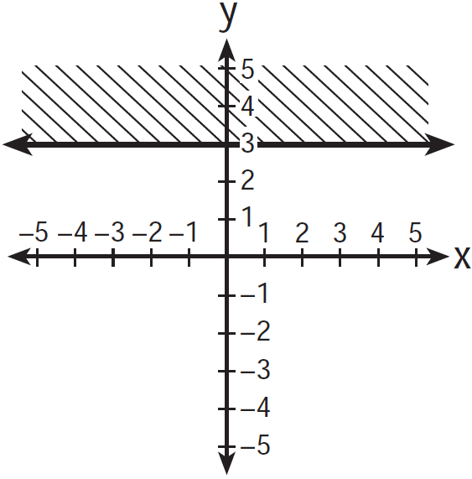
3) | 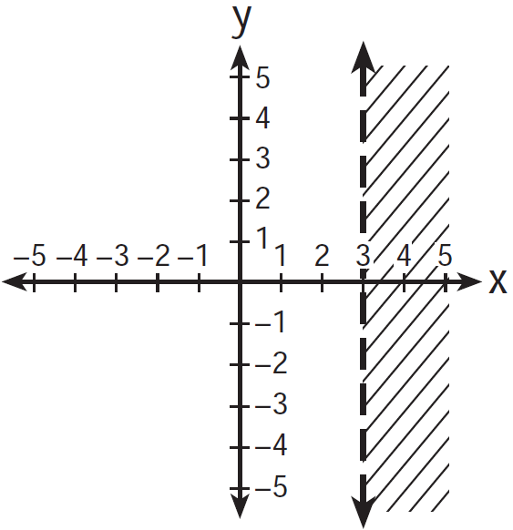
4) | 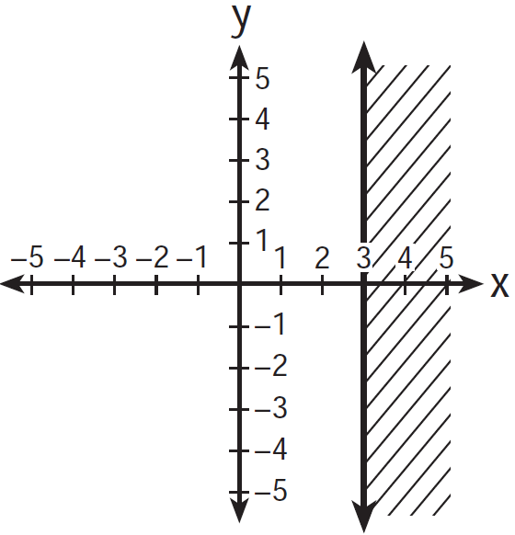

11 Which set of data can be classified as quantitative?
1) | first names of students in a chess club
2) | ages of students in a government class
3) | hair colors of students in a debate club
4) | favorite sports of students in a gym class

12 Three fair coins are tossed. What is the probability that two heads and one tail appear?
1)
2)
3)
4)

13 What is the sum of and ?
1)
2)
3)
4)

14 For which values of x is the fraction 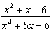 undefined?
1) | 1 and
2) | 2 and
3) | 3 and
4) | 6 and

15 What is the slope of the line that passes through the points and ?
1)
2)
3)
4)

16 The expression 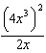 is equivalent to
1)
2)
3)
4)

17 In the diagram below, circle O is inscribed in square ABCD. The square has an area of 36.

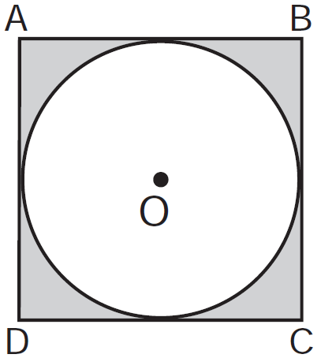

What is the area of the circle?
1) | 9π
2) | 6π
3) | 3π
4) | 36π

18 Which point lies on the graph represented by the equation ?
1)
2)
3)
4)

19 The equation of the axis of symmetry of the graph of is
1) | 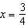
2) | 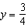
3) | 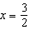
4) | 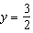

20 The box-and-whisker plot below represents the ages of 12 people.

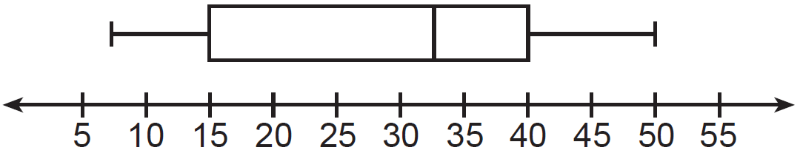

What percentage of these people are age 15 or older?
1) | 25
2) | 35
3) | 75
4) | 85

21 Campsite A and campsite B are located directly opposite each other on the shores of Lake Omega, as shown in the diagram below. The two campsites form a right triangle with Sam’s position, S. The distance from campsite B to Sam’s position is 1,300 yards, and campsite A is 1,700 yards from his position.

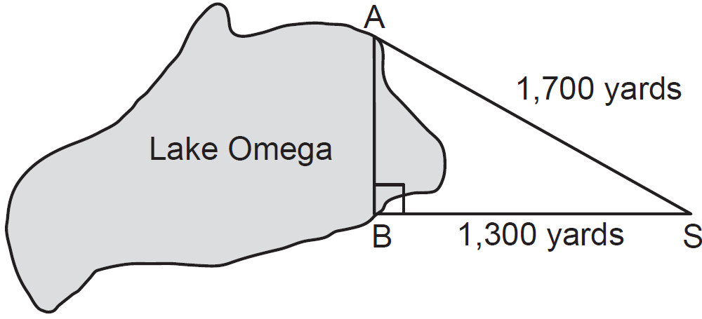

What is the distance from campsite A to campsite B, to the nearest yard?
1) | 1,095
2) | 1,096
3) | 2,140
4) | 2,141

22 Which set builder notation describes ?
1)
2)
3)
4)

23 The roots of the equation are
1) | 0 and 9
2) | 0 and
3) | 0 and 3
4) | 0 and

24 Which equation is an example of the use of the associative property of addition?
1)
2)
3)
4)

25 Given: 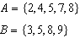
What is ?
1)
2)
3)
4)

26 The diagram below shows right triangle LMP.

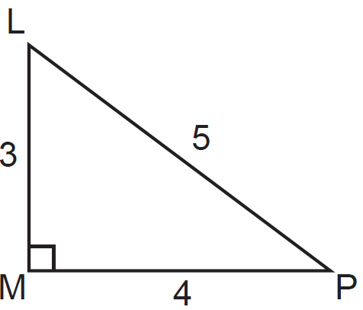

Which ratio represents the tangent of ?
1)
2)
3)
4)

27 Mr. Stanton asked his students to write an algebraic expression on a piece of paper. He chose four students to go to the board and write their expression.
Robert wrote:
Meredith wrote:
Steven wrote:
Cynthia wrote:
Which student wrote an algebraic expression?
1) | Robert
2) | Meredith
3) | Steven
4) | Cynthia

28 If 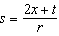, then x equals
1) | 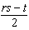
2) | 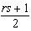
3)
4)

29 A scatter plot was constructed on the graph below and a line of best fit was drawn.

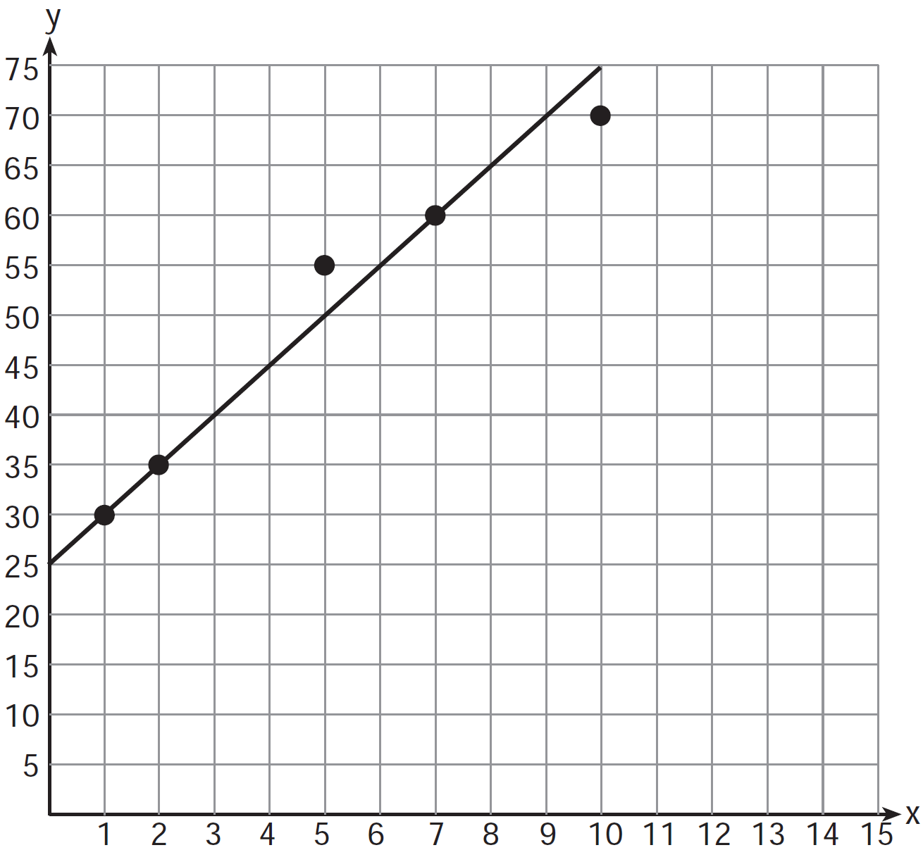

What is the equation of this line of best fit?
1)
2)
3)
4)

30 What is the sum of 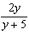 and 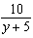 expressed in simplest form?
1) | 1
2) | 2
3) | 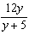
4) | 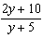

31 The length and width of the base of a rectangular prism are 5.5 cm and 3 cm. The height of the prism is 6.75 cm. Find the exact value of the surface area of the prism, in square centimeters.

32 Casey purchased a pack of assorted flower seeds and planted them in her garden. When the first 25 flowers bloomed, 11 were white, 5 were red, 3 were blue, and the rest were yellow. Find the empirical probability that a flower that blooms will be yellow.

33 Express in simplest form: 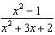

34 Solve algebraically for x: 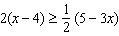

35 On the set of axes below, solve the following system of equations graphically. State the coordinates of the solution.
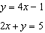

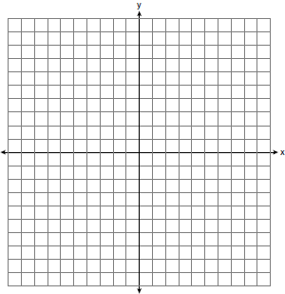

36 A turtle and a rabbit are in a race to see who is first to reach a point 100 feet away. The turtle travels at a constant speed of 20 feet per minute for the entire 100 feet. The rabbit travels at a constant speed of 40 feet per minute for the first 50 feet, stops for 3 minutes, and then continues at a constant speed of 40 feet per minute for the last 50 feet. Determine which animal won the race and by how much time.

37 The sum of three consecutive odd integers is 18 less than five times the middle number. Find the three integers. [Only an algebraic solution can receive full credit.]

38 A sandwich consists of one type of bread, one type of meat, and one type of cheese. The possible choices are listed below.
Bread: white, rye
Meat: ham, turkey, beef
Cheese: American, Swiss
Draw a tree diagram or list a sample space of all the possible different sandwiches consisting of one type of bread, one type of meat, and one type of cheese. Determine the number of sandwiches that will not include turkey. Determine the number of sandwiches that will include rye bread and Swiss cheese.

39 Shana wants to buy a new bicycle that has a retail price of $259.99. She knows that it will be on sale next week for 30% off the retail price. If the tax rate is 7%, find the total amount, to the nearest cent, that she will save by waiting until next week.

1 ANS: 2 REF: 011201ia STA: A.A.19
TOP: Factoring the Difference of Perfect Squares

2 ANS: 1 REF: 011202ia STA: A.A.9 TOP: Exponential Functions

3 ANS: 3

REF: 011203ia STA: A.N.2 TOP: Simplifying Radicals

4 ANS: 3 REF: 011204ia STA: A.G.3 TOP: Defining Functions

5 ANS: 3 REF: 011205ia STA: A.A.1 TOP: Expressions

6 ANS: 4
The transformation is a reflection in the x-axis.

REF: 011206ia STA: A.G.5 TOP: Graphing Absolute Value Functions

7 ANS: 1 REF: 011207ia STA: A.G.9 TOP: Quadratic-Linear Systems

8 ANS: 3
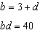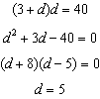

REF: 011208ia STA: A.A.8 TOP: Writing Quadratics

9 ANS: 2
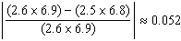

REF: 011209ia STA: A.M.3 TOP: Error KEY: area

10 ANS: 1 REF: 011210ia STA: A.G.6 TOP: Linear Inequalities

11 ANS: 2
The other sets of data are qualitative.

REF: 011211ia STA: A.S.1 TOP: Analysis of Data

12 ANS: 2 REF: 011212ia STA: A.S.23 TOP: Theoretical Probability
KEY: independent events

13 ANS: 1 REF: 011213ia STA: A.A.13 TOP: Addition and Subtraction of Polynomials
KEY: addition

14 ANS: 1
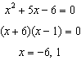

REF: 011214ia STA: A.A.15 TOP: Undefined Rationals

15 ANS: 4
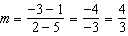

REF: 011215ia STA: A.A.33 TOP: Slope

16 ANS: 4
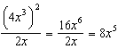

REF: 011216ia STA: A.A.12 TOP: Powers of Powers

17 ANS: 1
If the area of the square is 36, a side is 6, the diameter of the circle is 6, and its radius is 3.

REF: 011217ia STA: A.G.1 TOP: Compositions of Polygons and Circles
KEY: area

18 ANS: 4
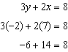

REF: 011218ia STA: A.A.39 TOP: Identifying Points on a Line

19 ANS: 1
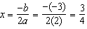.

REF: 011219ia STA: A.A.41 TOP: Identifying the Vertex of a Quadratic Given Equation

20 ANS: 3 REF: 011220ia STA: A.S.6 TOP: Box-and-Whisker Plots

21 ANS: 1

REF: 011221ia STA: A.A.45 TOP: Pythagorean Theorem

22 ANS: 4 REF: 011222ia STA: A.A.29 TOP: Set Theory

23 ANS: 1
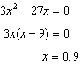

REF: 011223ia STA: A.A.28 TOP: Roots of Quadratics

24 ANS: 3 REF: 011224ia STA: A.N.1 TOP: Properties of Reals

25 ANS: 4 REF: 011225ia STA: A.A.31 TOP: Set Theory

26 ANS: 3
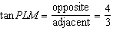

REF: 011226ia STA: A.A.42 TOP: Trigonometric Ratios

27 ANS: 2 REF: 011227ia STA: A.A.3 TOP: Expressions

28 ANS: 1
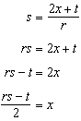

REF: 011228ia STA: A.A.23 TOP: Transforming Formulas

29 ANS: 4 REF: 011229ia STA: A.S.8 TOP: Scatter Plots

30 ANS: 2
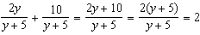

REF: 011230ia STA: A.A.17 TOP: Addition and Subtraction of Rationals

31 ANS:
147.75

REF: 011231ia STA: A.G.2 TOP: Surface Area

32 ANS:
. 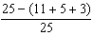

REF: 011232ia STA: A.S.21 TOP: Experimental Probability

33 ANS:
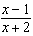. 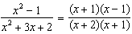

REF: 011233ia STA: A.A.16 TOP: Rational Expressions
KEY: a > 0

34 ANS:
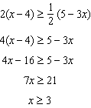

REF: 011234ia STA: A.A.24 TOP: Solving Inequalities

35 ANS:
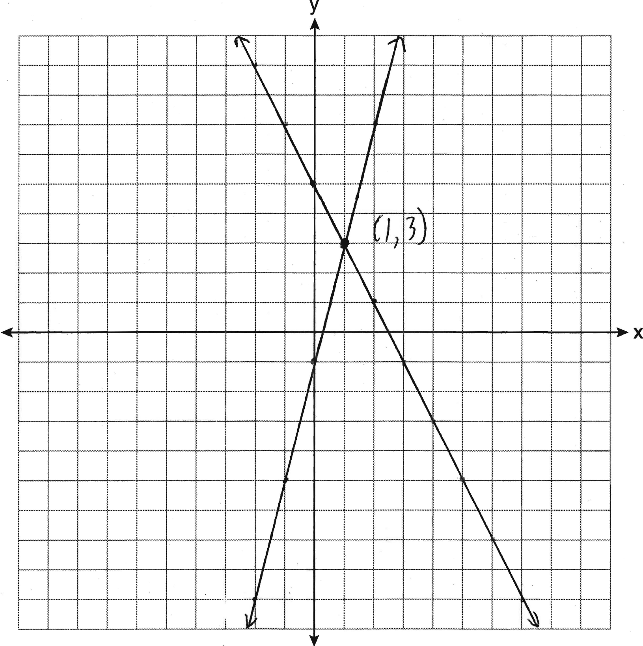

REF: 011235ia STA: A.G.7 TOP: Solving Linear Systems

36 ANS:
The turtle won by .5 minutes. Turtle: 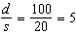. Rabbit: 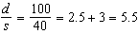

REF: 011236ia STA: A.M.1 TOP: Speed

37 ANS:
7, 9, 11. 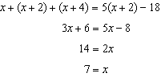

REF: 011237ia STA: A.A.6 TOP: Modeling Equations

38 ANS:
(W,H,A), (W,H,S), (W,T,A), (W,T,S), (W,B,A), (W,B,S), (R,H,A), (R,H,S), (R,T,A), (R,T,S), (R,B,A), (R,B,S). 8, 3

REF: 011238ia STA: A.S.19 TOP: Sample Space

39 ANS:

REF: 011239ia STA: A.N.5 TOP: Percents

