1 Given: 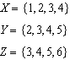
What is the intersection of sets X, Y, and Z?
1)
2)
3)
4)

2 Which graph could be used to find the solution of the system of equations and ?
1) | 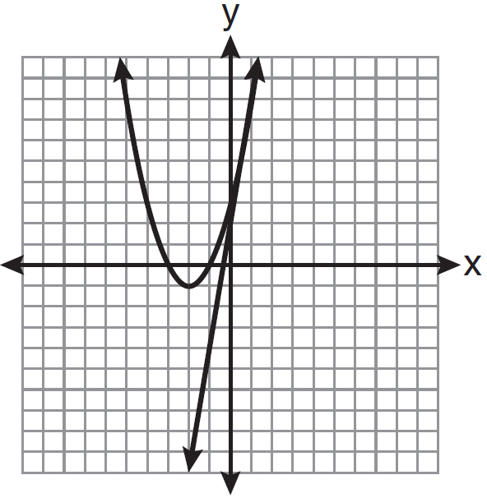
2) | 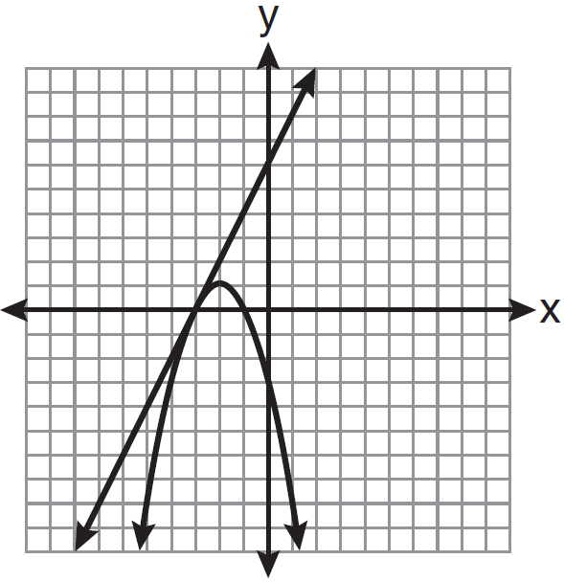
3) | 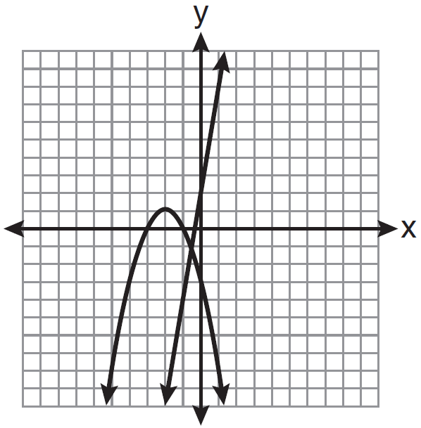
4) | 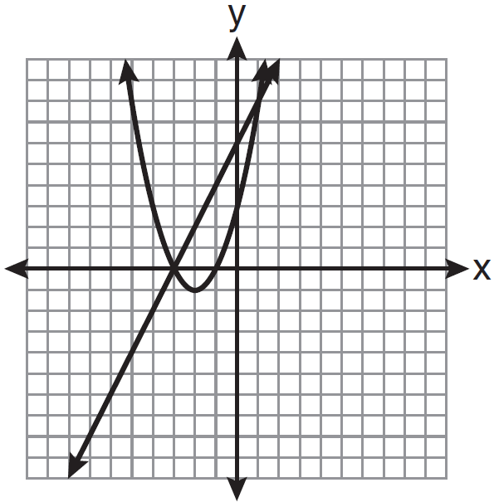

3 What is the relationship between the independent and dependent variables in the scatter plot shown below?

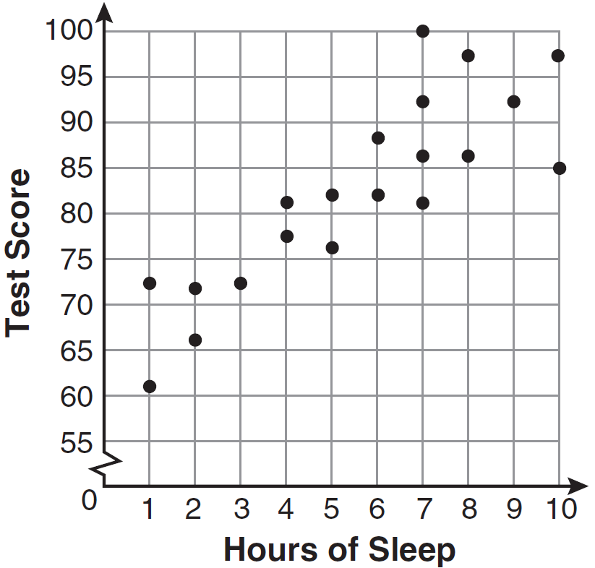
1) | undefined correlation
2) | negative correlation
3) | positive correlation
4) | no correlation

4 Tim ate four more cookies than Alice. Bob ate twice as many cookies as Tim. If x represents the number of cookies Alice ate, which expression represents the number of cookies Bob ate?
1)
2)
3)
4)

5 Which relation is a function?
1) | 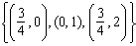
2) | 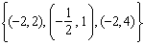
3)
4)

6 What is the value of x in the equation ?
1)
2) | 2
3)
4)

7 The rectangle shown below has a diagonal of 18.4 cm and a width of 7 cm.

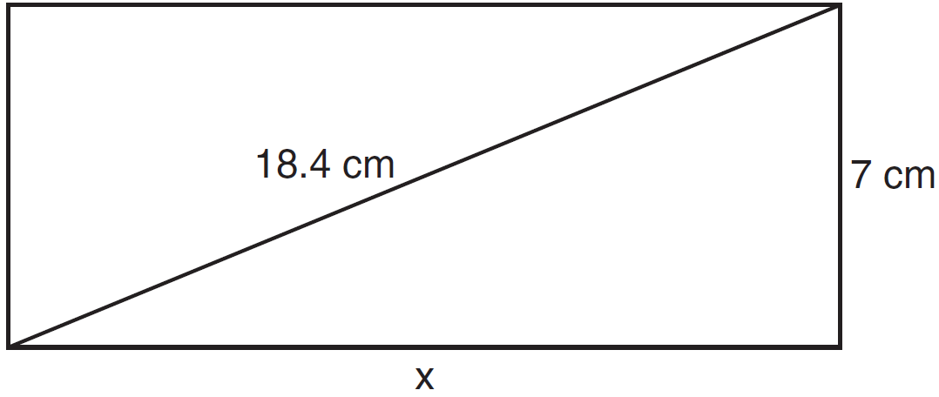

To the nearest centimeter, what is the length, x, of the rectangle?
1) | 11
2) | 17
3) | 20
4) | 25

8 When is factored completely, the result is
1)
2)
3)
4)

9 Which ratio represents in the right triangle shown below?

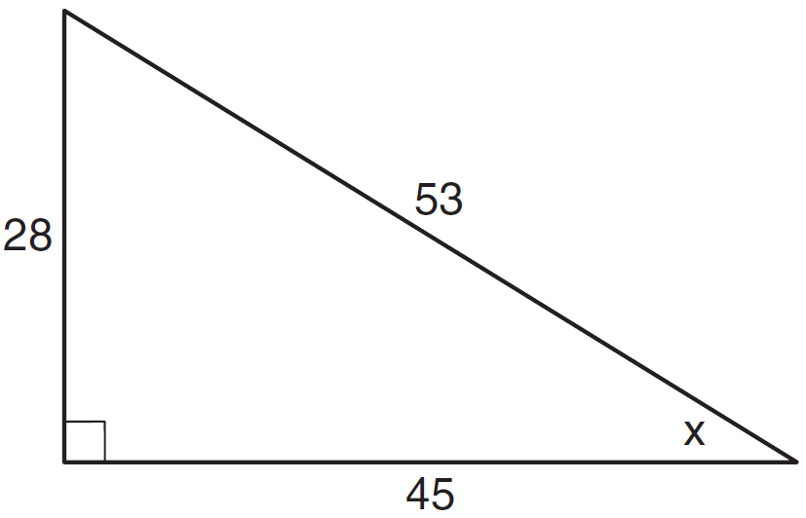
1)
2)
3)
4)

10 What is the value of the expression when and ?
1) | 64
2) | 49
3) | -49
4) | -64

11 A student correctly graphed the parabola shown below to solve a given quadratic equation.

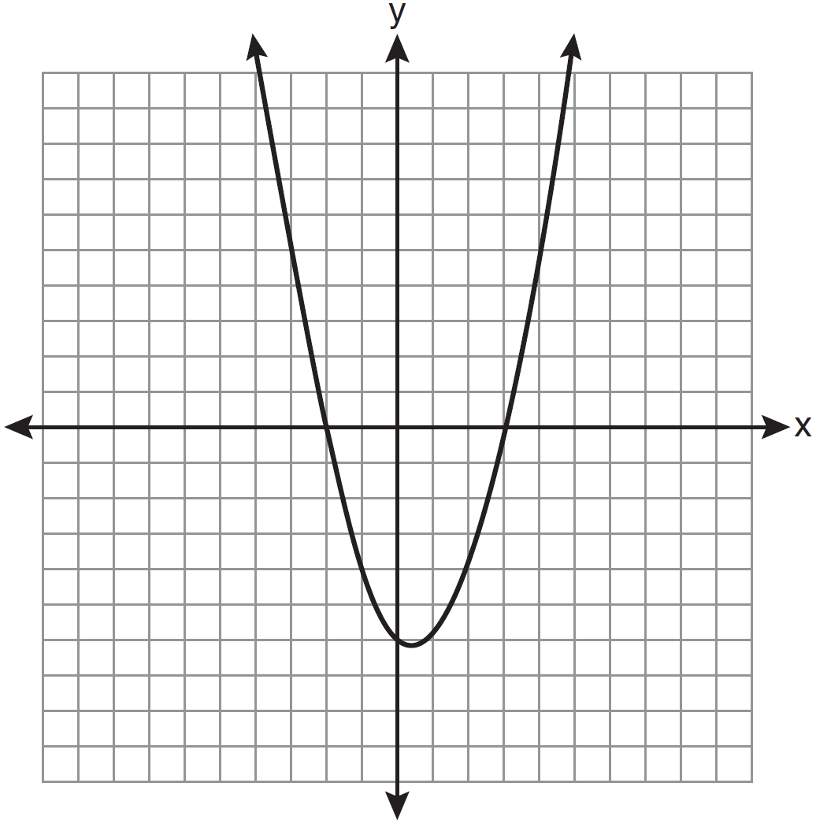

What are the roots of the quadratic equation associated with this graph?
1) | and 3
2) | and 0
3) | and 2
4) | and 3

12 Which value of x is the solution of the equation 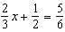?
1)
2) | 2
3)
4)

13 What is the range of the data represented in the box-and-whisker plot shown below?

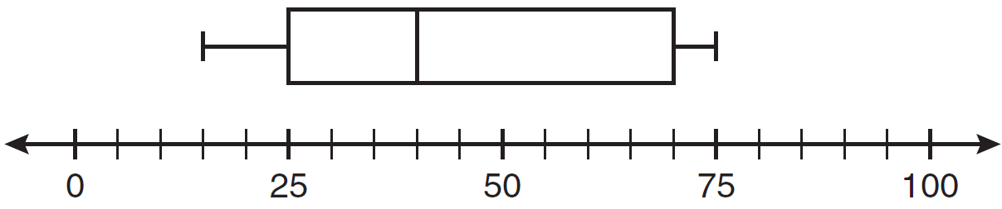
1) | 40
2) | 45
3) | 60
4) | 100

14 Which equation illustrates the associative property?
1)
2)
3)
4)

15 Josh and Mae work at a concession stand. They each earn $8 per hour. Josh worked three hours more than Mae. If Josh and Mae earned a total of $120, how many hours did Josh work?
1) | 6
2) | 9
3) | 12
4) | 15

16 Which data set describes a situation that could be classified as quantitative?
1) | the phone numbers in a telephone book
2) | the addresses for students at Hopkins High School
3) | the zip codes of residents in the city of Buffalo, New York
4) | the time it takes each of Mr. Harper’s students to complete a test

17 Which is the graph of ?
1) | 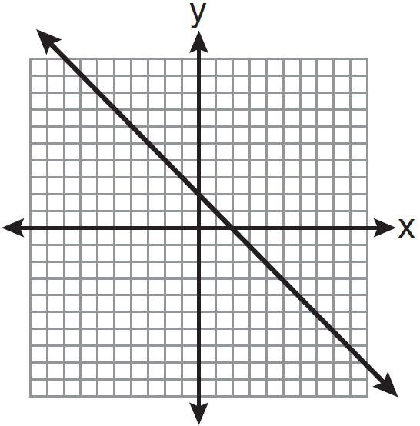
2) | 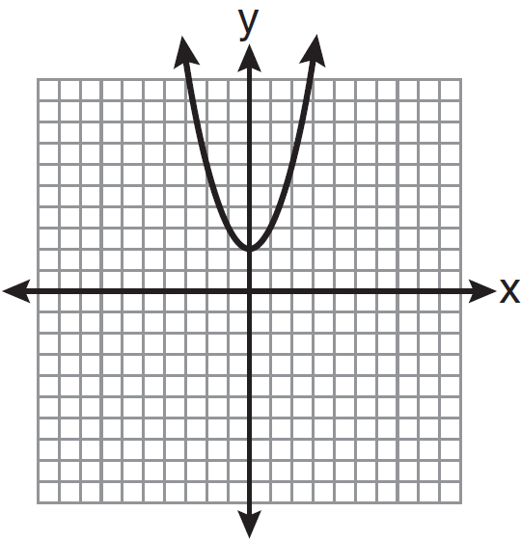
3) | 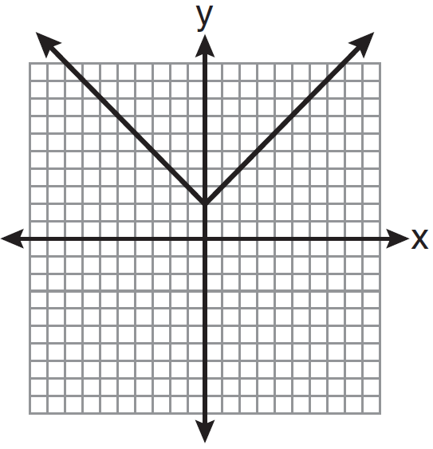
4) | 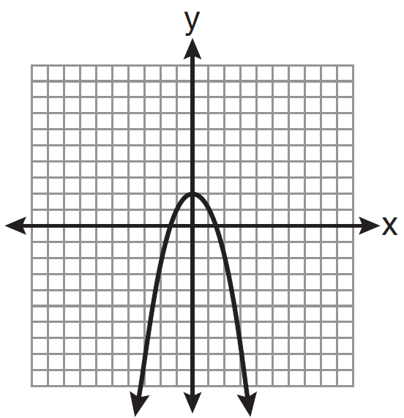

18 Sam’s grades on eleven chemistry tests were 90, 85, 76, 63, 94, 89, 81, 76, 78, 69, and 97. Which statement is true about the measures of central tendency?
1) | mean > mode
2) | mean < median
3) | mode > median
4) | median = mean

19 Which interval notation represents the set of all real numbers greater than 2 and less than or equal to 20?
1)
2)
3)
4)

20 What is the sum of and ?
1)
2)
3)
4)

21 What is expressed in simplest radical form?
1)
2)
3)
4)

22 What is the slope of the line whose equation is ?
1)
2)
3)
4)

23 The figure shown below is composed of two rectangles and a quarter circle.

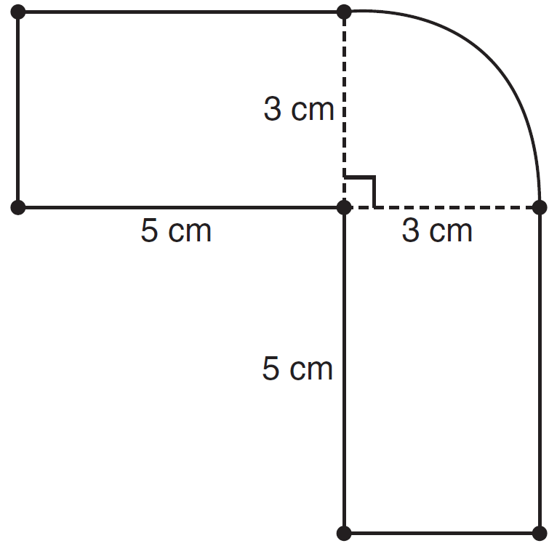

What is the area of this figure, to the nearest square centimeter?
1) | 33
2) | 37
3) | 44
4) | 58

24 The expression 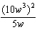 is equivalent to
1)
2)
3)
4)

25 If 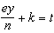, what is y in terms of e, n, k, and t?
1) | 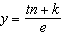
2) | 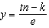
3) | 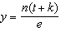
4) | 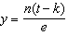

26 What is the result when is subtracted from ?
1)
2)
3)
4)

27 What is an equation of the axis of symmetry of the parabola represented by ?
1)
2)
3)
4)

28 Which equation has roots of and 5?
1)
2)
3)
4)

29 A spinner that is equally divided into eight numbered sectors is spun 20 times. The table below shows the number of times the arrow landed in each numbered sector.

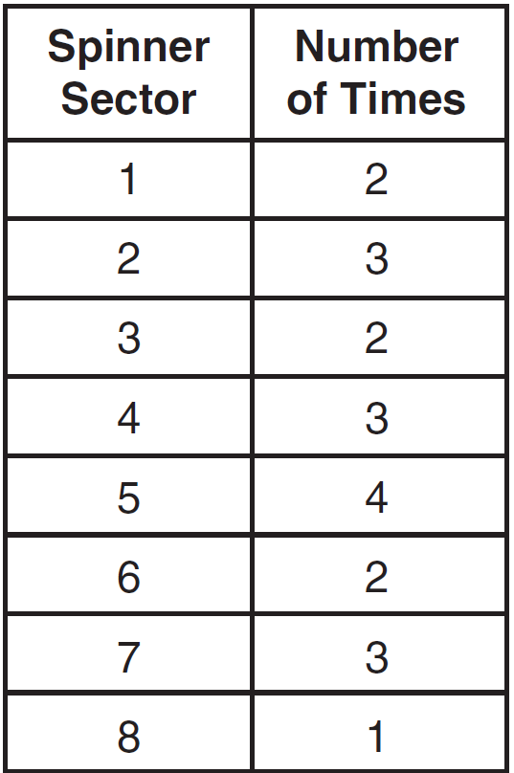

Based on the table, what is the empirical probability that the spinner will land on a prime number on the next spin?
1)
2)
3)
4)

30 Which expression represents 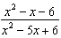 in simplest form?
1) | 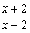
2) | 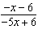
3)
4)

31 Roberta needs ribbon for a craft project. The ribbon sells for $3.75 per yard. Find the cost, in dollars, for 48 inches of the ribbon.

32 The square dart board shown below has a side that measures 40 inches. The shaded portion in the center is a square whose side is 15 inches. A dart thrown at the board is equally likely to land on any point on the dartboard.

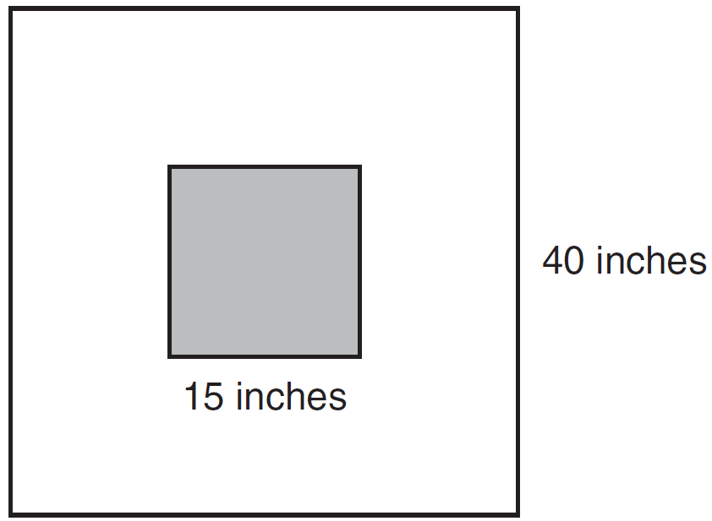

Find the probability that a dart hitting the board will not land in the shaded area.

33 As shown in the diagram below, a ladder 5 feet long leans against a wall and makes an angle of 65° with the ground. Find, to the nearest tenth of a foot, the distance from the wall to the base of the ladder.

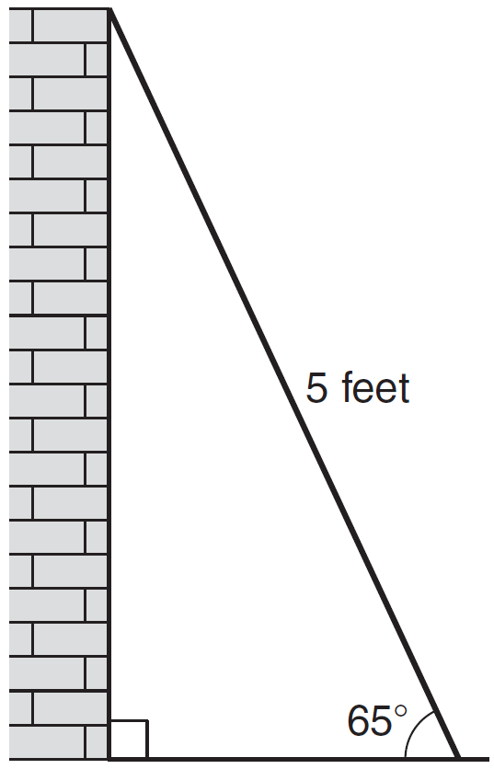

34 A line having a slope of passes through the point . Write the equation of this line in slope-intercept form.

35 The test scores for 18 students in Ms. Mosher’s class are listed below:
86, 81, 79, 71, 58, 87, 52, 71, 87,
87, 93, 64, 94, 81, 76, 98, 94, 68
Complete the frequency table below.

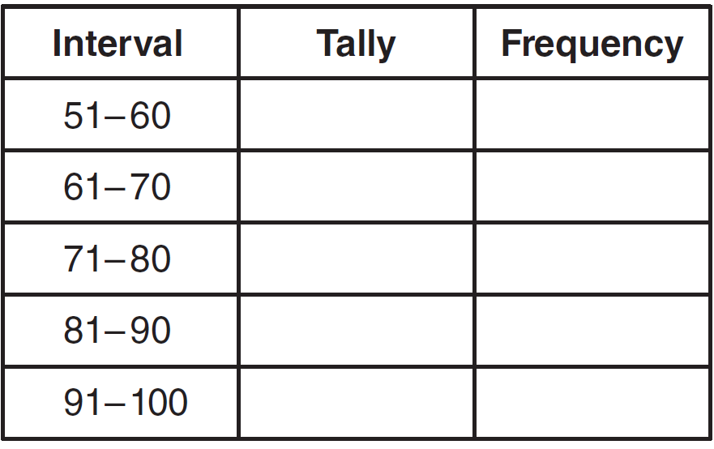

Draw and label a frequency histogram on the grid below.



36 Solve algebraically for x: 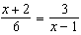

37 An oil company distributes oil in a metal can shaped like a cylinder that has an actual radius of 5.1 cm and a height of 15.1 cm. A worker incorrectly measured the radius as 5 cm and the height as 15 cm. Determine the relative error in calculating the surface area, to the nearest thousandth.

38 The Booster Club raised $30,000 for a sports fund. No more money will be placed into the fund. Each year the fund will decrease by 5%. Determine the amount of money, to the nearest cent, that will be left in the sports fund after 4 years.

39 Graph the following systems of inequalities on the set of axes shown below and label the solution set S:
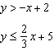

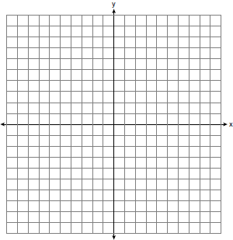

1 ANS: 1 REF: 011101ia STA: A.A.31 TOP: Set Theory

2 ANS: 4 REF: 011102ia STA: A.G.9 TOP: Quadratic-Linear Systems

3 ANS: 3 REF: 011103ia STA: A.S.12 TOP: Scatter Plots

4 ANS: 3 REF: 011104ia STA: A.A.1 TOP: Expressions

5 ANS: 4
In (4), each element in the domain corresponds to a unique element in the range.

REF: 011105ia STA: A.G.3 TOP: Defining Functions

6 ANS: 1
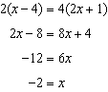

REF: 011106ia STA: A.A.22 TOP: Solving Equations

7 ANS: 2

REF: 011107ia STA: A.A.45 TOP: Pythagorean Theorem

8 ANS: 2

REF: 011108ia STA: A.A.19 TOP: Factoring the Difference of Perfect Squares

9 ANS: 1
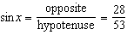

REF: 011109ia STA: A.A.42 TOP: Trigonometric Ratios

10 ANS: 2 REF: 011110ia STA: A.N.6 TOP: Evaluating Expressions

11 ANS: 4 REF: 011111ia STA: A.G.8 TOP: Solving Quadratics by Graphing

12 ANS: 1
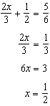

REF: 011112ia STA: A.A.25 TOP: Solving Equations with Fractional Expressions

13 ANS: 3

REF: 011113ia STA: A.S.6 TOP: Box-and-Whisker Plots

14 ANS: 4 REF: 011114ia STA: A.N.1 TOP: Properties of Reals

15 ANS: 2
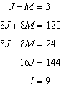

REF: 011115ia STA: A.A.7 TOP: Writing Linear Systems

16 ANS: 4 REF: 011116ia STA: A.S.1 TOP: Analysis of Data

17 ANS: 3 REF: 011117ia STA: A.G.4 TOP: Graphing Absolute Value Functions

18 ANS: 1
mean = 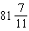, median = 81 and mode = 76

REF: 011118ia STA: A.S.4 TOP: Central Tendency

19 ANS: 2 REF: 011119ia STA: A.A.29 TOP: Set Theory

20 ANS: 2
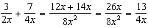

REF: 011120ia STA: A.A.17 TOP: Addition and Subtraction of Rationals

21 ANS: 3

REF: 011121ia STA: A.N.3 TOP: Operations with Radicals
KEY: addition

22 ANS: 2
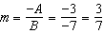

REF: 011122ia STA: A.A.37 TOP: Slope

23 ANS: 2
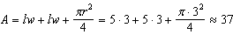

REF: 011123ia STA: A.G.1 TOP: Compositions of Polygons and Circles
KEY: area

24 ANS: 3
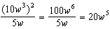

REF: 011124ia STA: A.A.12 TOP: Powers of Powers

25 ANS: 4
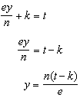

REF: 011125ia STA: A.A.23 TOP: Transforming Formulas

26 ANS: 1 REF: 011126ia STA: A.A.13 TOP: Addition and Subtraction of Polynomials
KEY: subtraction

27 ANS: 1
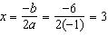.

REF: 011127ia STA: A.A.41 TOP: Identifying the Vertex of a Quadratic Given Equation

28 ANS: 2
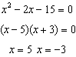

REF: 011128ia STA: A.A.28 TOP: Roots of Quadratics

29 ANS: 3
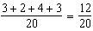

REF: 011129ia STA: A.S.21 TOP: Experimental Probability

30 ANS: 1
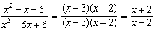

REF: 011130ia STA: A.A.16 TOP: Rational Expressions
KEY: a > 0

31 ANS:
5. 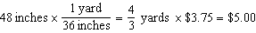

REF: 011131ia STA: A.M.2 TOP: Conversions

32 ANS:
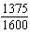. 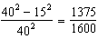

REF: 011132ia STA: A.S.20 TOP: Theoretical Probability

33 ANS:
2.1. 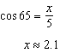

REF: 011133ia STA: A.A.44 TOP: Using Trigonometry to Find a Side

34 ANS:
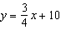. 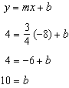

REF: 011134ia STA: A.A.34 TOP: Writing Linear Equations

35 ANS:
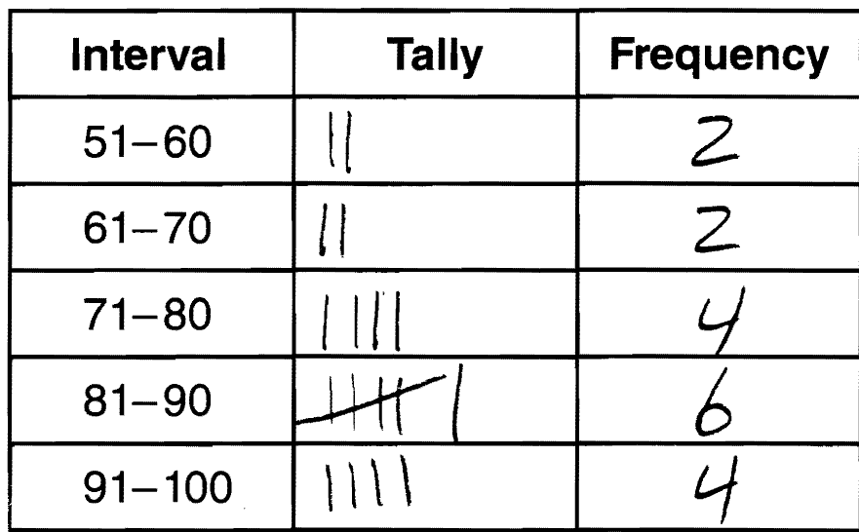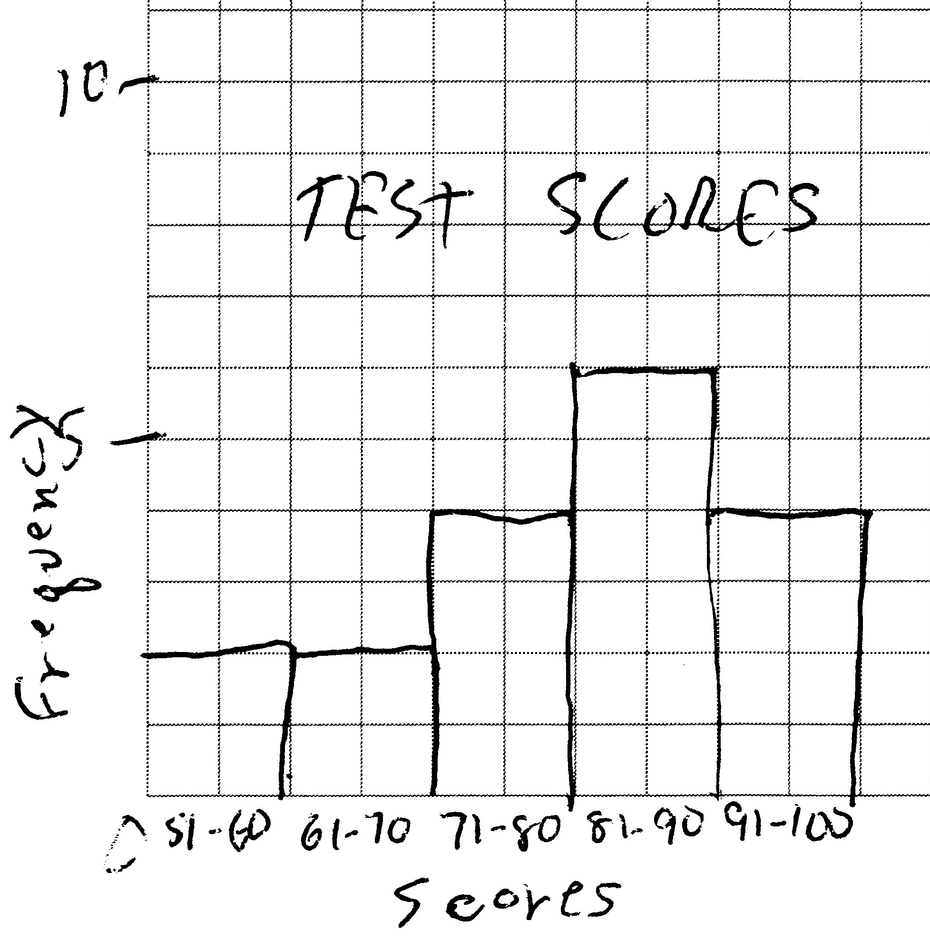

REF: 011135ia STA: A.S.5 TOP: Frequency Histograms, Bar Graphs and Tables

36 ANS:
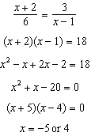

REF: 011136ia STA: A.A.26 TOP: Solving Rationals

37 ANS:
0.029. 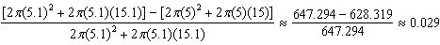

REF: 011137ia STA: A.M.3 TOP: Error KEY: volume and surface area

38 ANS:
24,435.19.

REF: 011138ia STA: A.A.9 TOP: Exponential Functions

39 ANS:
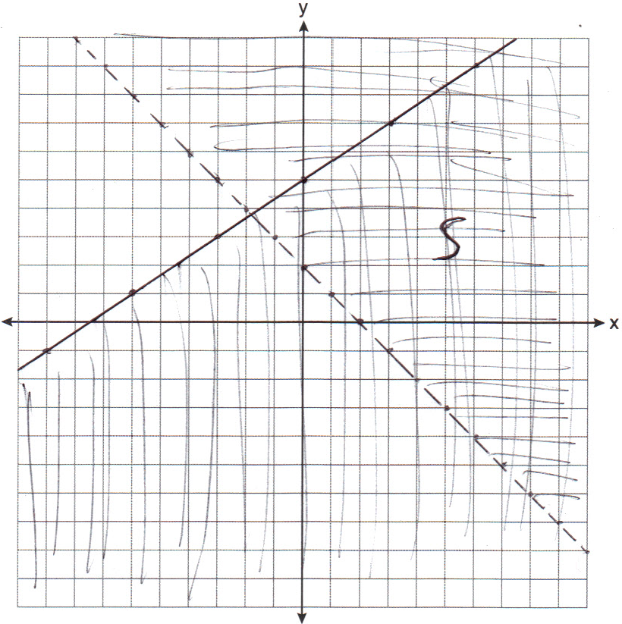

REF: 011139ia STA: A.G.7 TOP: Systems of Linear Inequalities

