1 The box-and-whisker plot below represents the math test scores of 20 students.

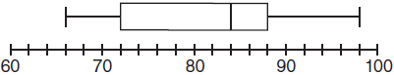

What percentage of the test scores are less than 72?
1) | 25
2) | 50
3) | 75
4) | 100

2 A bag contains eight green marbles, five white marbles, and two red marbles. What is the probability of drawing a red marble from the bag?
1)
2)
3)
4)

3 Julia went to the movies and bought one jumbo popcorn and two chocolate chip cookies for $5.00. Marvin went to the same movie and bought one jumbo popcorn and four chocolate chip cookies for $6.00. How much does one chocolate chip cookie cost?
1) | $0.50
2) | $0.75
3) | $1.00
4) | $2.00

4 Given:
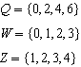
What is the intersection of sets Q, W, and Z?
1)
2)
3)
4)

5 Roger is having a picnic for 78 guests. He plans to serve each guest at least one hot dog. If each package, p, contains eight hot dogs, which inequality could be used to determine how many packages of hot dogs Roger will need to buy?
1)
2)
3)
4)

6 In a science fiction novel, the main character found a mysterious rock that decreased in size each day. The table below shows the part of the rock that remained at noon on successive days.

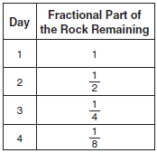

Which fractional part of the rock will remain at noon on day 7?
1)
2)
3)
4)

7 In the diagram below, what is the slope of the line passing through points A and B?

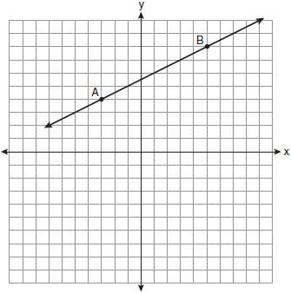
1)
2) | 2
3)
4)

8 Which equation shows a correct trigonometric ratio for angle A in the right triangle below?

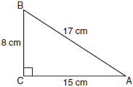
1) | 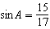
2) | 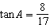
3) | 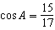
4) | 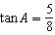

9 Debbie solved the linear equation as follows:

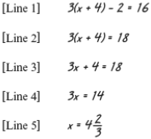

She made an error between lines
1) | 1 and 2
2) | 2 and 3
3) | 3 and 4
4) | 4 and 5

10 The value of the expression when and is
1)
2) | 10
3)
4) | 4

11 Which expression represents 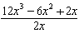 in simplest form?
1)
2)
3)
4)

12 Which ordered pair is a solution of the system of equations shown in the graph below?

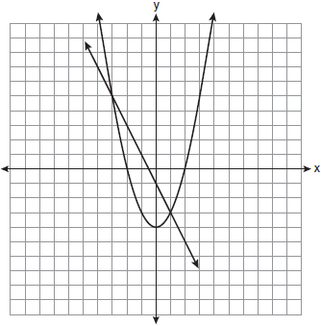
1)
2)
3)
4)

13 Which equation represents the line that passes through the points and ?
1) | 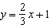
2) | 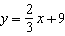
3) | 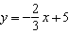
4) | 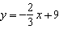

14 Which data table represents univariate data?
1) | 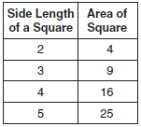
2) | 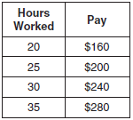
3) | 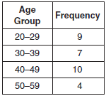
4) | 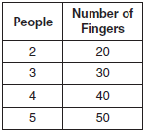

15 What is the equation of the axis of symmetry of the parabola shown in the diagram below?

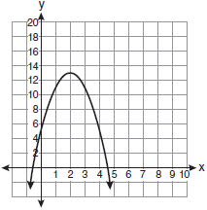
1)
2)
3)
4)

16 The members of the senior class are planning a dance. They use the equation to determine the total receipts. What is n expressed in terms of r and p ?
1)
2)
3) | 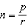
4) | 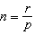

17 The graph of the equation is shown in the diagram below.

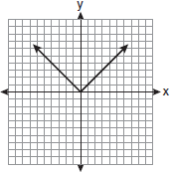

Which diagram could represent a graph of the equation when ?
1) | 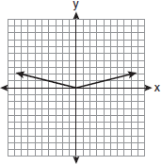
2) | 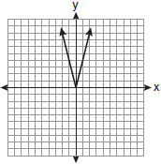
3) | 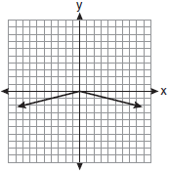
4) | 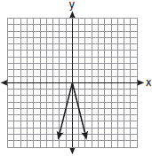

18 Which relation represents a function?
1)
2)
3)
4)

19 Which scatter plot shows the relationship between x and y if x represents a student score on a test and y represents the number of incorrect answers a student received on the same test?
1) | 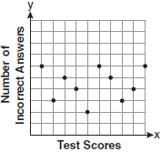
2) | 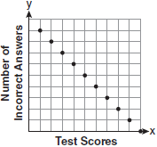
3) | 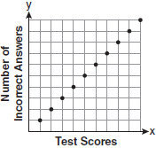
4) | 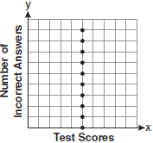

20 Which expression is equivalent to ?
1)
2)
3)
4)

21 Which point is on the line ?
1)
2)
3)
4)

22 If Ann correctly factors an expression that is the difference of two perfect squares, her factors could be
1)
2)
3)
4)

23 Which ordered pair is in the solution set of the following system of linear inequalities?
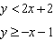
1)
2)
3)
4)

24 The expression written in simplest radical form is
1)
2)
3)
4)

25 What is the sum of 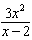 and 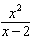?
1) | 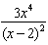
2) | 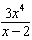
3) | 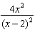
4) | 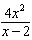

26 Which equation represents a line parallel to the graph of ?
1) | 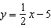
2) | 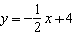
3)
4)

27 An example of an algebraic expression is
1) | 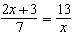
2)
3)
4)

28 What is the solution set of 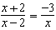?
1)
2)
3)
4)

29 How many square inches of wrapping paper are needed to entirely cover a box that is 2 inches by 3 inches by 4 inches?
1) | 18
2) | 24
3) | 26
4) | 52

30 Which situation describes a correlation that is not a causal relationship?
1) | the length of the edge of a cube and the volume of the cube
2) | the distance traveled and the time spent driving
3) | the age of a child and the number of siblings the child has
4) | the number of classes taught in a school and the number of teachers employed

31 Angela wants to purchase carpeting for her living room. The dimensions of her living room are 12 feet by 12 feet. If carpeting is sold by the square yard, determine how many square yards of carpeting she must purchase.

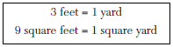

32 In right triangle ABC, , , , and . Find, to the nearest degree, the measure of .

33 Jon is buying tickets for himself for two concerts. For the jazz concert, 4 tickets are available in the front row, and 32 tickets are available in the other rows. For the orchestra concert, 3 tickets are available in the front row, and 23 tickets are available in the other rows. Jon is randomly assigned one ticket for each concert. Determine the concert for which he is more likely to get a front-row ticket. Justify your answer.

34 Find the roots of the equation algebraically.

35 Ms. Mosher recorded the math test scores of six students in the table below.

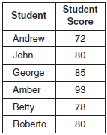

Determine the mean of the student scores, to the nearest tenth. Determine the median of the student scores. Describe the effect on the mean and the median if Ms. Mosher adds 5 bonus points to each of the six students’ scores.

36 Using his ruler, Howell measured the sides of a rectangular prism to be 5 cm by 8 cm by 4 cm. The actual measurements are 5.3 cm by 8.2 cm by 4.1 cm. Find Howell’s relative error in calculating the volume of the prism, to the nearest thousandth.

37 A password consists of three digits, 0 through 9, followed by three letters from an alphabet having 26 letters. If repetition of digits is allowed, but repetition of letters is not allowed, determine the number of different passwords that can be made. If repetition is not allowed for digits or letters, determine how many fewer different passwords can be made.

38 Graph the solution set for the inequality on the set of axes below. Determine if the point is in the solution set. Justify your answer.

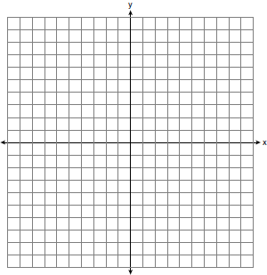

39 Find three consecutive positive even integers such that the product of the second and third integers is twenty more than ten times the first integer. [Only an algebraic solution can receive full credit.]
1 ANS: 1 PTS: 2 REF: 011001ia STA: A.S.6
TOP: Box-and-Whisker Plots

2 ANS: 2 PTS: 2 REF: 011002ia STA: A.S.20
TOP: Theoretical Probability

3 ANS: 1
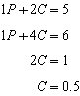

PTS: 2 REF: 011003ia STA: A.A.7 TOP: Writing Linear Systems

4 ANS: 1 PTS: 2 REF: 011004ia STA: A.A.31
TOP: Set Theory

5 ANS: 2 PTS: 2 REF: 011005ia STA: A.A.5
TOP: Modeling Inequalities

6 ANS: 2

PTS: 2 REF: 011006ia STA: A.A.9 TOP: Exponential Functions

7 ANS: 4
and . 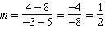

PTS: 2 REF: 011007ia STA: A.A.33 TOP: Slope

8 ANS: 3
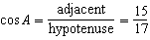

PTS: 2 REF: 011008ia STA: A.A.42 TOP: Trigonometric Ratios

9 ANS: 2
Debbie failed to distribute the 3 properly.

PTS: 2 REF: 011009ia STA: A.A.22 TOP: Solving Equations

10 ANS: 1

PTS: 2 REF: 011010ia STA: A.N.6 TOP: Evaluating Expressions

11 ANS: 3
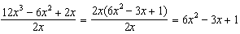

PTS: 2 REF: 011011ia STA: A.A.14 TOP: Rational Expressions

12 ANS: 2 PTS: 2 REF: 011012ia STA: A.G.9
TOP: Quadratic-Linear Systems

13 ANS: 3
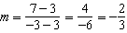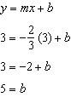

PTS: 2 REF: 011013ia STA: A.A.35 TOP: Writing Linear Equations

14 ANS: 3
Frequency is not a variable.

PTS: 2 REF: 011014ia STA: A.S.2 TOP: Analysis of Data

15 ANS: 2 PTS: 2 REF: 011015ia STA: A.G.10
TOP: Identifying the Vertex of a Quadratic Given Graph

16 ANS: 4 PTS: 2 REF: 011016ia STA: A.A.23
TOP: Transforming Formulas

17 ANS: 3 PTS: 2 REF: 011017ia STA: A.G.5
TOP: Graphing Absolute Value Functions

18 ANS: 4
In (4), each element in the domain corresponds to a unique element in the range.

PTS: 2 REF: 011018ia STA: A.G.3 TOP: Defining Functions

19 ANS: 2 PTS: 2 REF: 011019ia STA: A.S.12
TOP: Scatter Plots

20 ANS: 4 PTS: 2 REF: 011020ia STA: A.A.12
TOP: Multiplication of Powers

21 ANS: 1
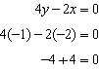

PTS: 2 REF: 011021ia STA: A.A.39 TOP: Identifying Points on a Line

22 ANS: 2 PTS: 2 REF: 011022ia STA: A.A.19
TOP: Factoring the Difference of Perfect Squares

23 ANS: 2 PTS: 2 REF: 011023ia STA: A.A.40
TOP: Systems of Linear Inequalities

24 ANS: 4

PTS: 2 REF: 011024ia STA: A.N.3 TOP: Operations with Radicals
KEY: addition

25 ANS: 4 PTS: 2 REF: 011025ia STA: A.A.17
TOP: Addition and Subtraction of Rationals

26 ANS: 1
The slope of is 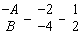

PTS: 2 REF: 011026ia STA: A.A.38 TOP: Parallel and Perpendicular Lines

27 ANS: 2 PTS: 2 REF: 011027ia STA: A.A.3
TOP: Expressions

28 ANS: 4
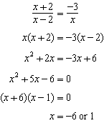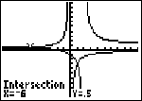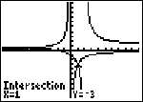

PTS: 2 REF: 011028ia STA: A.A.26 TOP: Solving Rationals

29 ANS: 4

PTS: 2 REF: 011029ia STA: A.G.2 TOP: Surface Area

30 ANS: 3
The age of a child does not cause the number of siblings he has, or vice versa.

PTS: 2 REF: 011030ia STA: A.S.14 TOP: Analysis of Data

31 ANS:
16. 12 feet equals 4 yards. .

PTS: 2 REF: 011031ia STA: A.M.2 TOP: Conversions

32 ANS:
53. 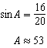

PTS: 2 REF: 011032ia STA: A.A.43 TOP: Using Trigonometry to Find an Angle

33 ANS:
orchestra: 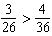

PTS: 2 REF: 011033ia STA: A.S.22 TOP: Theoretical Probability

34 ANS:
. 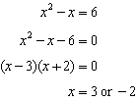

PTS: 3 REF: 011034ia STA: A.A.28 TOP: Roots of Quadratics

35 ANS:
81.3, 80, both increase

PTS: 3 REF: 011035ia STA: A.S.16 TOP: Central Tendency

36 ANS:
0.102. 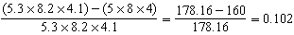

PTS: 3 REF: 011036ia STA: A.M.3 TOP: Error

37 ANS:
15,600,000, 4,368,000. . . .

PTS: 4 REF: 011037ia STA: A.N.8 TOP: Permutations

38 ANS:
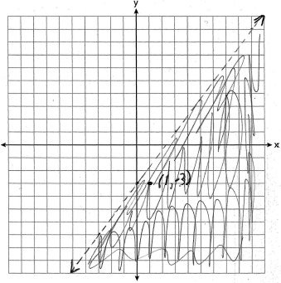 is in the solution set. 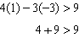

PTS: 4 REF: 011038ia STA: A.G.6 TOP: Linear Inequalities

39 ANS:
6, 8, 10. Three consecutive even integers are x, and . 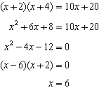
PTS: 4 REF: 011039ia STA: A.A.8 TOP: Writing Quadratics

