1 On a certain day in Toronto, Canada, the temperature was 15° Celsius (C). Using the formula 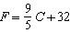, Peter converts this temperature to degrees Fahrenheit (F). Which temperature represents 15°C in degrees Fahrenheit?
1) |  | 3) | 59
2) | 35 | 4) | 85

2 What is the speed, in meters per second, of a paper airplane that flies 24 meters in 6 seconds?
1) | 144 | 3) | 18
2) | 30 | 4) | 4

3 The faces of a cube are numbered from 1 to 6. If the cube is rolled once, which outcome is least likely to occur?
1) | rolling an odd number | 3) | rolling a number less than 6
2) | rolling an even number | 4) | rolling a number greater than 4

4 Tamara has a cell phone plan that charges $0.07 per minute plus a monthly fee of $19.00. She budgets $29.50 per month for total cell phone expenses without taxes. What is the maximum number of minutes Tamara could use her phone each month in order to stay within her budget?
1) | 150 | 3) | 421
2) | 271 | 4) | 692

5 Antwaan leaves a cup of hot chocolate on the counter in his kitchen. Which graph is the best representation of the change in temperature of his hot chocolate over time?
1) | 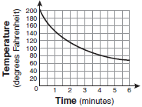 | 3) | 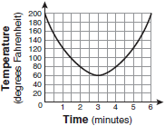
2) | 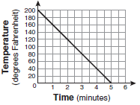 | 4) | 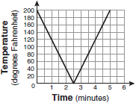

6 What is the solution of 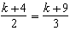?
1) | 1 | 3) | 6
2) | 5 | 4) | 14

7 Alex earned scores of 60, 74, 82, 87, 87, and 94 on his first six algebra tests. What is the relationship between the measures of central tendency of these scores?
1) | median < mode < mean | 3) | mode < median < mean
2) | mean < mode < median | 4) | mean < median < mode

8 The New York Volleyball Association invited 64 teams to compete in a tournament. After each round, half of the teams were eliminated. Which equation represents the number of teams, t, that remained in the tournament after r rounds?
1) |  | 3)
2) |  | 4)

9 The expression is equivalent to
1) |  | 3)
2) |  | 4)

10 What is an equation of the line that passes through the points and ?
1) |  | 3)
2) |  | 4)

11 If the formula for the perimeter of a rectangle is , then w can be expressed as
1) | 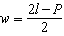 | 3) | 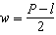
2) | 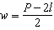 | 4) | 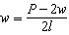

12 In the right triangle shown in the diagram below, what is the value of x to the nearest whole number?

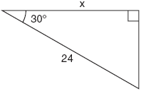
1) | 12 | 3) | 21
2) | 14 | 4) | 28

13 What is the slope of the line that passes through the points and ?
1) |  | 3)
2) |  | 4)

14 What are the roots of the equation ?
1) | 1 and 21 | 3) | 3 and 7
2) |  | 4)

15 Rhonda has $1.35 in nickels and dimes in her pocket. If she has six more dimes than nickels, which equation can be used to determine x, the number of nickels she has?
1) |  | 3)
2) |  | 4)

16 Which equation represents the axis of symmetry of the graph of the parabola below?

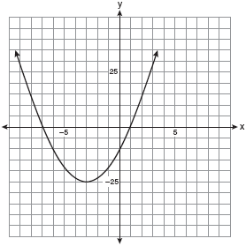
1) |  | 3)
2) |  | 4)

17 The set is equivalent to
1) |  | 3)
2) |  | 4)

18 What is the value of x in the equation 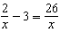?
1) |  | 3)
2) |  | 4) | 8

19 The diagram below shows right triangle UPC.

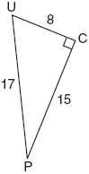

Which ratio represents the sine of ?
1) |  | 3)
2) |  | 4)

20 What is expressed in simplest radical form?
1) |  | 3)
2) |  | 4)

21 What is 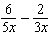 in simplest form?
1) | 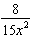 | 3)
2) |  | 4)

22 Which ordered pair is a solution of the system of equations and ?
1) |  | 3)
2) |  | 4)

23 A survey is being conducted to determine which types of television programs people watch. Which survey and location combination would likely contain the most bias?
1) | surveying 10 people who work in a sporting goods store | 3) | randomly surveying 50 people during the day in a mall
2) | surveying the first 25 people who enter a grocery store | 4) | randomly surveying 75 people during the day in a clothing store

24 The length of a rectangular room is 7 less than three times the width, w, of the room. Which expression represents the area of the room?
1) |  | 3)
2) |  | 4)

25 The function 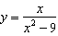 is undefined when the value of x is
1) | 0 or 3 | 3) | 3, only
2) |  | 4)

26 Which equation represents a line that is parallel to the line ?
1) |  | 3)
2) |  | 4)

27 What is the product of and written in scientific notation?
1) |  | 3)
2) |  | 4)

28 Keisha is playing a game using a wheel divided into eight equal sectors, as shown in the diagram below. Each time the spinner lands on orange, she will win a prize.

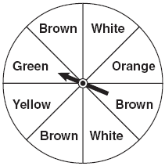

If Keisha spins this wheel twice, what is the probability she will win a prize on both spins?
1) |  | 3)
2) |  | 4)

29 A movie theater recorded the number of tickets sold daily for a popular movie during the month of June. The box-and-whisker plot shown below represents the data for the number of tickets sold, in hundreds.

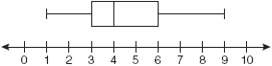

Which conclusion can be made using this plot?
1) | The second quartile is 600. | 3) | The range of the attendance is 300 to 600.
2) | The mean of the attendance is 400. | 4) | Twenty-five percent of the attendance is between 300 and 400.

30 Which graph represents a function?
1) | 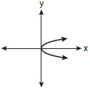 | 3) | 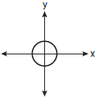
2) | 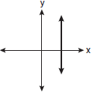 | 4) | 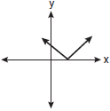

31 A window is made up of a single piece of glass in the shape of a semicircle and a rectangle, as shown in the diagram below. Tess is decorating for a party and wants to put a string of lights all the way around the outside edge of the window.

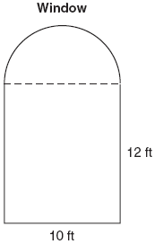

To the nearest foot, what is the length of the string of lights that Tess will need to decorate the window?

32 Simplify: 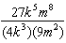

33 The table below represents the number of hours a student worked and the amount of money the student earned.

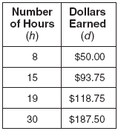

Write an equation that represents the number of dollars, d, earned in terms of the number of hours, h, worked. Using this equation, determine the number of dollars the student would earn for working 40 hours.

34 Sarah measures her rectangular bedroom window for a new shade. Her measurements are 36 inches by 42 inches. The actual measurements of the window are 36.5 inches and 42.5 inches. Using the measurements that Sarah took, determine the number of square inches in the area of the window. Determine the number of square inches in the actual area of the window. Determine the relative error in calculating the area. Express your answer as a decimal to the nearest thousandth.

35 Perform the indicated operation and simplify: 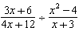

36 A soup can is in the shape of a cylinder. The can has a volume of and a diameter of 6 cm. Express the height of the can in terms of π. Determine the maximum number of soup cans that can be stacked on their base between two shelves if the distance between the shelves is exactly 36 cm. Explain your answer.

37 Solve the following system of equations algebraically:
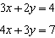
[Only an algebraic solution can receive full credit.]

38 On the set of axes below, graph the following system of inequalities and state the coordinates of a point in the solution set.
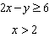

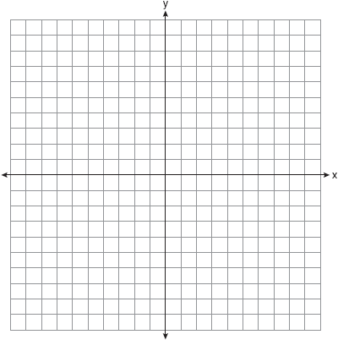

39 A restaurant sells kids' meals consisting of one main course, one side dish, and one drink, as shown in the table below.

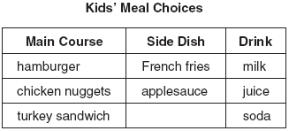

Draw a tree diagram or list the sample space showing all possible kids' meals. How many different kids' meals can a person order? Jose does not drink juice. Determine the number of different kids' meals that do not include juice. Jose's sister will eat only chicken nuggets for her main course. Determine the number of different kids' meals that include chicken nuggets.
1 ANS: 3
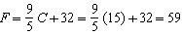

PTS: 2 REF: 010901ia STA: A.M.2 TOP: Conversions

2 ANS: 4
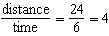

PTS: 2 REF: 010902ia STA: A.M.1 TOP: Speed

3 ANS: 4
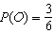, 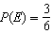, 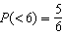, 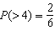

PTS: 2 REF: 010903ia STA: A.S.22 TOP: Theoretical Probability

4 ANS: 1
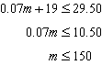

PTS: 2 REF: 010904ia STA: A.A.6 TOP: Modeling Inequalities

5 ANS: 1 PTS: 2 REF: 010905ia STA: A.G.4
TOP: Families of Functions

6 ANS: 3
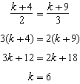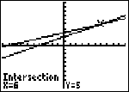

PTS: 2 REF: 010906ia STA: A.A.26 TOP: Solving Rationals

7 ANS: 4
The mean is , the median is 84.5 and the mode is 87.

PTS: 2 REF: 010907ia STA: A.S.4 TOP: Central Tendency

8 ANS: 4 PTS: 2 REF: 010908ia STA: A.A.9
TOP: Exponential Functions

9 ANS: 2 PTS: 2 REF: 010909ia STA: A.A.19
TOP: Factoring the Difference of Perfect Squares

10 ANS: 3 PTS: 2 REF: 010910ia STA: A.A.35
TOP: Writing Linear Equations

11 ANS: 2
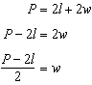

PTS: 2 REF: 010911ia STA: A.A.23 TOP: Transforming Formulas

12 ANS: 3
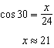

PTS: 2 REF: 010912ia STA: A.A.44 TOP: Using Trigonometry to Find a Side

13 ANS: 2
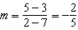

PTS: 2 REF: 010913ia STA: A.A.33 TOP: Slope

14 ANS: 3
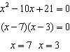

PTS: 2 REF: 010914ia STA: A.A.28 TOP: Roots of Quadratics

15 ANS: 2 PTS: 2 REF: 010915ia STA: A.A.5
TOP: Modeling Equations

16 ANS: 2 PTS: 2 REF: 010916ia STA: A.G.10
TOP: Identifying the Vertex of a Quadratic Given Graph

17 ANS: 3 PTS: 2 REF: 010917ia STA: A.A.29
TOP: Set Theory

18 ANS: 1
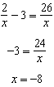

PTS: 2 REF: 010918ia STA: A.A.25 TOP: Solving Rationals

19 ANS: 2
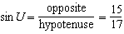

PTS: 2 REF: 010919ia STA: A.A.42 TOP: Trigonometric Ratios

20 ANS: 3

PTS: 2 REF: 010920ia STA: A.N.2 TOP: Simplifying Radicals

21 ANS: 2
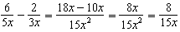

PTS: 2 REF: 010921ia STA: A.A.17 TOP: Addition and Subtraction of Rationals

22 ANS: 2
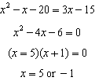. 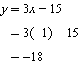. 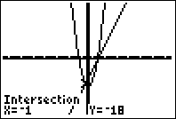

PTS: 2 REF: 010922ia STA: A.A.11 TOP: Quadratic-Linear Systems

23 ANS: 1
Everyone eats, can shop in malls and wear clothes. People who work in a sporting goods store probably watch more sports television than most.

PTS: 2 REF: 010923ia STA: A.S.3 TOP: Analysis of Data

24 ANS: 4

PTS: 2 REF: 010924ia STA: A.A.1 TOP: Expressions

25 ANS: 2 PTS: 2 REF: 010925ia STA: A.A.15
TOP: Undefined Rationals

26 ANS: 1
The slope of is . Using 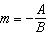, the slope of is 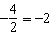.

PTS: 2 REF: 010926ia STA: A.A.38 TOP: Parallel and Perpendicular Lines

27 ANS: 4 PTS: 2 REF: 010927ia STA: A.N.4
TOP: Operations with Scientific Notation

28 ANS: 1
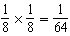

PTS: 2 REF: 010928ia STA: A.S.23 TOP: Theoretical Probability
KEY: independent events

29 ANS: 4 PTS: 2 REF: 010929ia STA: A.S.6
TOP: Box-and-Whisker Plots

30 ANS: 4 PTS: 2 REF: 010930ia STA: A.G.3
TOP: Defining Functions

31 ANS:
50. 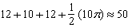

PTS: 2 REF: 010931ia STA: A.G.1 TOP: Compositions of Polygons and Circles

32 ANS:
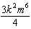

PTS: 2 REF: 010932ia STA: A.A.12 TOP: Division of Powers

33 ANS:
, 250.

PTS: 2 REF: 010933ia STA: A.N.5 TOP: Direct Variation

34 ANS:
1,512, 1,551.25, 0.025. . . 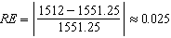.

PTS: 3 REF: 010934ia STA: A.M.3 TOP: Error

35 ANS:
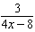. 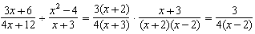

PTS: 3 REF: 010935ia STA: A.A.18 TOP: Multiplication and Division of Rationals

36 ANS:
, 2. 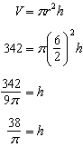. 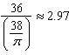. Three cans will not fit. The maximum number is 2.

PTS: 3 REF: 010936ia STA: A.G.2 TOP: Volume

37 ANS:
. 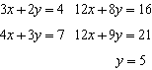. 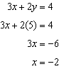

PTS: 4 REF: 010937ia STA: A.A.10 TOP: Solving Linear Systems

38 ANS:
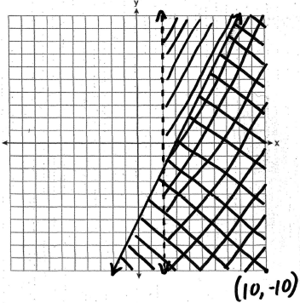

PTS: 4 REF: 010938ia STA: A.G.7 TOP: Systems of Linear Inequalities

39 ANS:
(H,F,M), (H,F,J), (H,F,S), (H,A,M), (H,A,J), (H,A,S), (C,F,M), (C,F,J), (C,F,S), (C,A,M), (C,A,J), (C,A,S), (T,F,M), (T,F,J), (T,F,S), (T,A,M), (T,A,J), (T,A,S). There are 18 different kids’ meals, 12 do not include juice and 6 include chicken nuggets.

PTS: 4 REF: 010939ia STA: A.S.19 TOP: Sample Space

