1 Triangles ABC and DEF are graphed on the set of axes below.

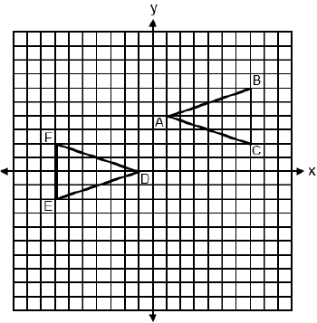

Which sequence of rigid motions maps onto ?
1) | A reflection over . | 3) | A translation 2 units left followed by a reflection over the x-axis.
2) | A point reflection through . | 4) | A translation 4 units down followed by a reflection over the y-axis.

2 In right triangle ABC below, , , and .

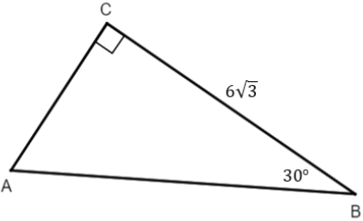

The length of is
1) |  | 3) | 12
2) | 9 | 4)

3 In non-right triangle ABC shown below, , , and .

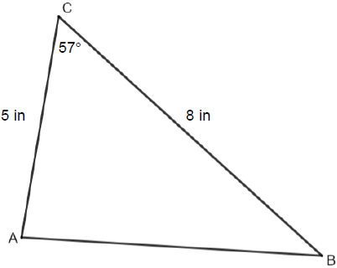

What is the area of , to the nearest tenth of a square inch?
1) | 10.9 | 3) | 21.8
2) | 16.8 | 4) | 33.5

4 Circle P with center at and passing through is graphed on the set of axes below.

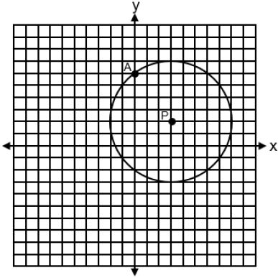
An equation of circle P is
1) |  | 3)
2) |  | 4)

5 A triangle with vertices at , , and , is graphed on the set of axes below. A horizontal stretch of scale factor 2 with respect to , is represented by . Graph the image of this triangle, after the horizontal stretch on the same set of axes.

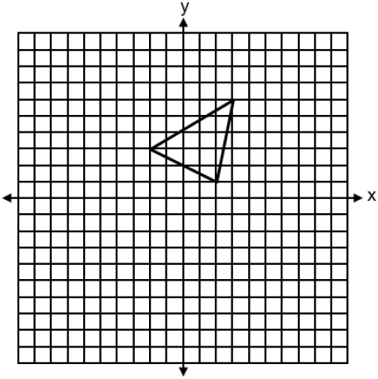

6 Triangle XYZ is shown below. Using a compass and straightedge, construct the circumcenter of .
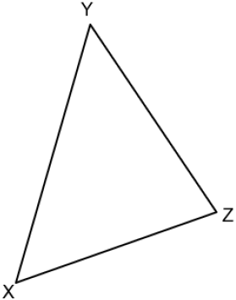

7 In the diagram below, .

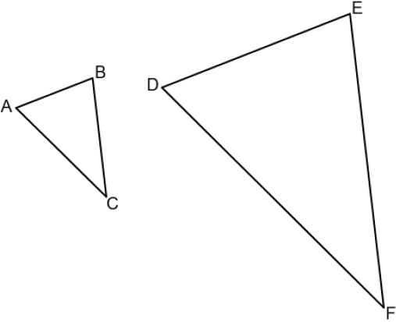

If , , , and , determine and state the length of .

8 Hexagon ABCDEF with coordinates at , , , , , and is graphed on the set of axes below.

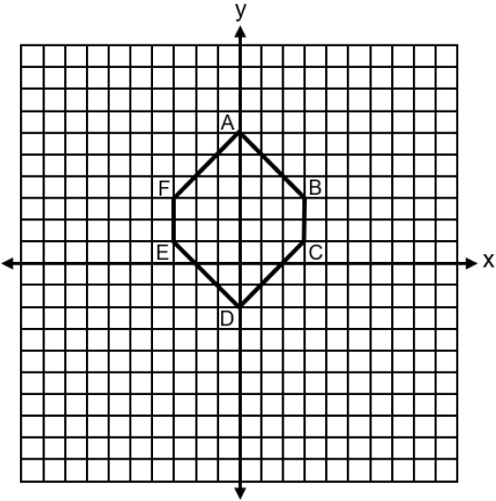

Determine and state the perimeter of ABCDEF in simplest radical form.
1 ANS: 2 PTS: 2 REF: spr2401geo NAT: G.CO.A.2
TOP: Identifying Transformations

2 ANS: 3
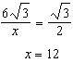

PTS: 2 REF: spr2402geo NAT: G.SRT.C.8 TOP: 30-60-90 Triangles

3 ANS: 2
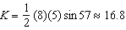

PTS: 2 REF: spr2403geo NAT: G.SRT.D.9 TOP: Using Trigonometry to Find Area
KEY: basic

4 ANS: 4 PTS: 2 REF: spr2404geo NAT: G.GPE.A.1
TOP: Equations of Circles KEY: write equation, given graph

5 ANS:
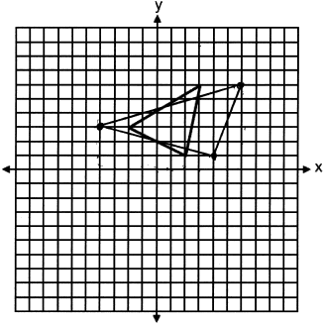

PTS: 2 REF: spr2405geo NAT: G.CO.A.2
TOP: Analytical Representations of Transformations KEY: graphics

6 ANS:
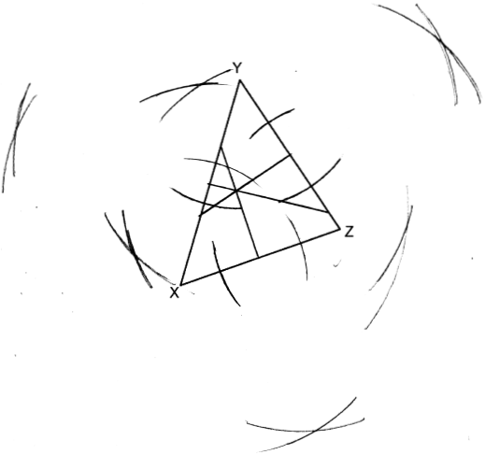

PTS: 2 REF: spr2406geo NAT: G.CO.D.12 TOP: Constructions
KEY: line bisector

7 ANS:
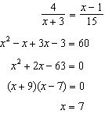

PTS: 4 REF: spr2407geo NAT: G.SRT.B.5 TOP: Similarity
KEY: basic

8 ANS:

PTS: 2 REF: spr2408geo NAT: G.GPE.B.7 TOP: Polygons in the Coordinate Plane

