1 What are the coordinates of the point on the directed line segment from to that partitions the segment into a ratio of 3 to 2?
1) |  | 3) | 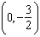
2) |  | 4)

2 A regular pentagon is shown in the diagram below.

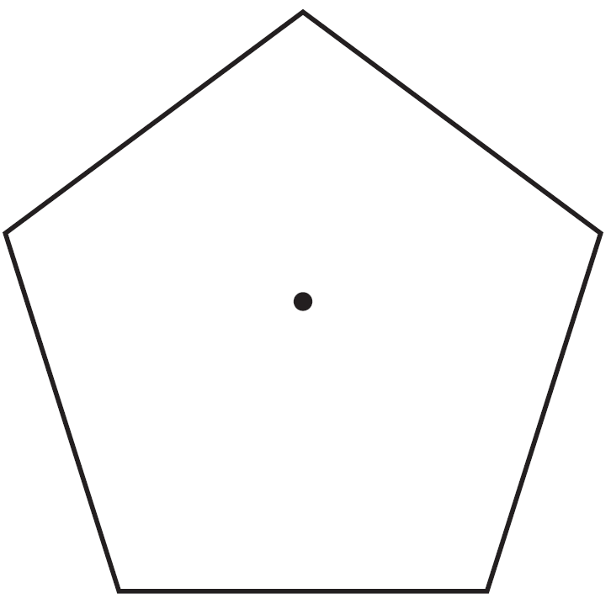

If the pentagon is rotated clockwise around its center, the minimum number of degrees it must be rotated to carry the pentagon onto itself is
1) | 54º | 3) | 108º
2) | 72º | 4) | 360º

3 The equation of line h is . Line m is the image of line h after a dilation of scale factor 4 with respect to the origin. What is the equation of the line m?
1) |  | 3)
2) |  | 4)

4 As shown in the diagram below, circle A has a radius of 3 and circle B has a radius of 5.

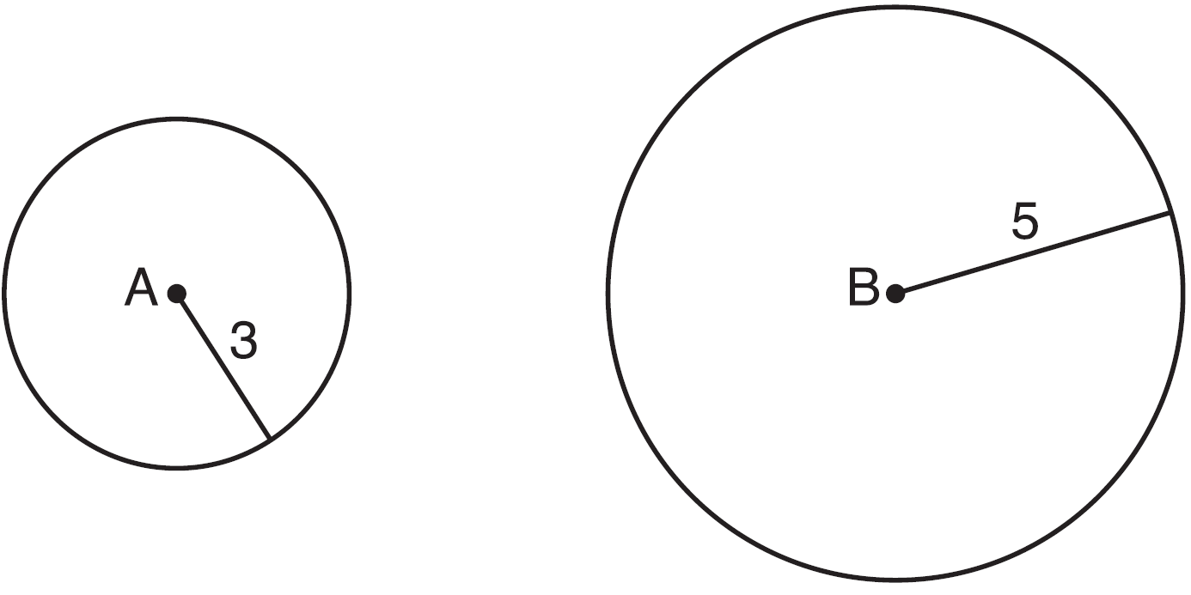

Use transformations to explain why circles A and B are similar.

5 Two stacks of 23 quarters each are shown below. One stack forms a cylinder but the other stack does not form a cylinder.

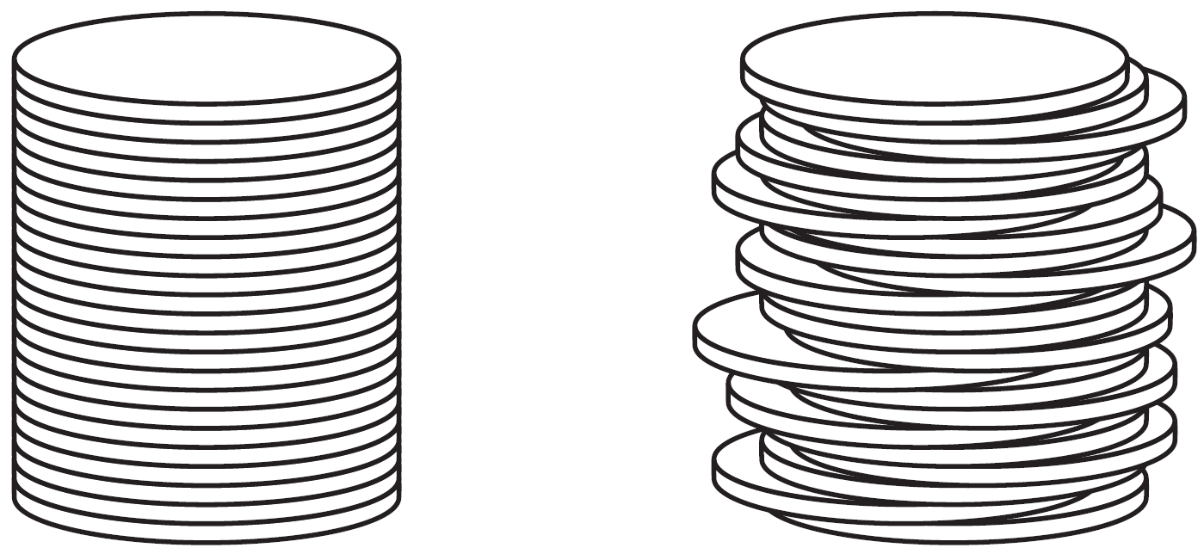

Use Cavelieri’s principle to explain why the volumes of these two stacks of quarters are equal.

6 In the diagram below, triangles XYZ and UVZ are drawn such that and .

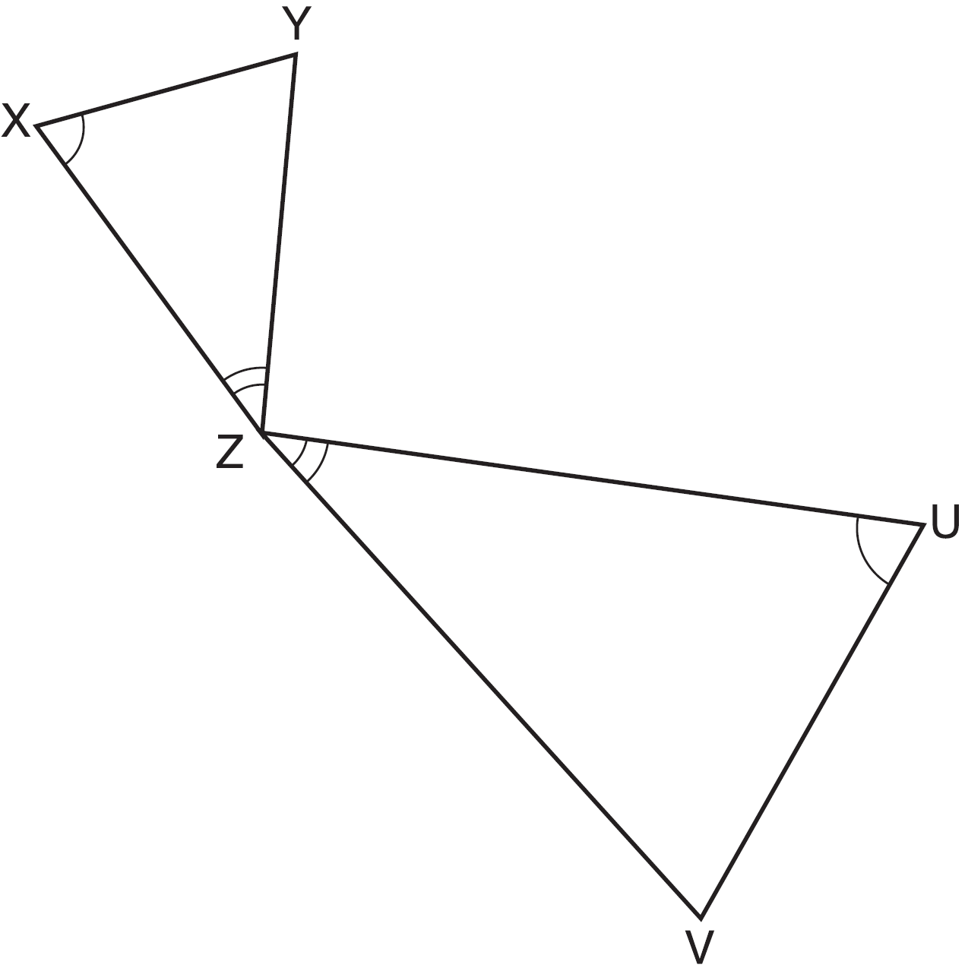

Describe a sequence of similarity transformations that shows is similar to .

7 Explain why for x such that .

8 In the diagram of and below, , , and .
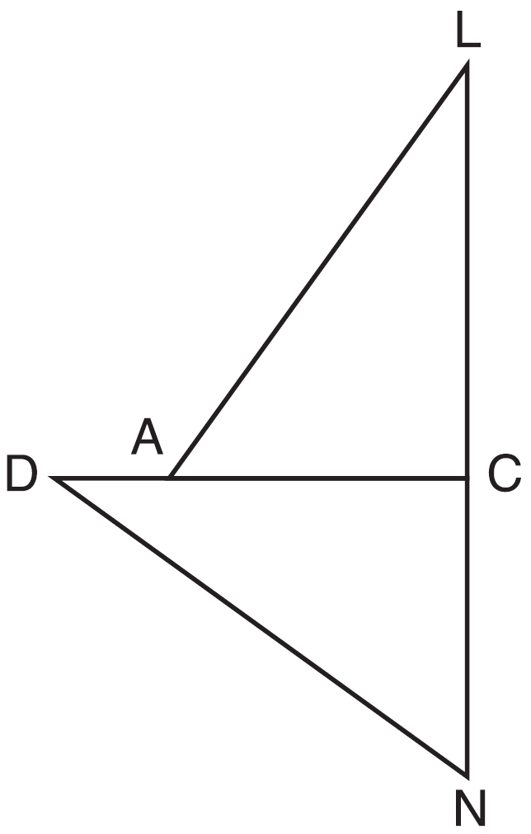

a) Prove that .
b) Describe a sequence of rigid motions that will map onto .

9 As shown below, a canoe is approaching a lighthouse on the coastline of a lake. The front of the canoe is 1.5 feet above the water and an observer in the lighthouse is 112 feet above the water.
At 5:00, the observer in the lighthouse measured the angle of depression to the front of the canoe to be 6°. Five minutes later, the observer measured and saw the angle of depression to the front of the canoe had increased by 49°. Determine and state, to the nearest foot per minute, the average speed at which the canoe traveled toward the lighthouse.

10 In the diagram below of circle O, diameter and radii and are drawn. The length of is 12 and the measure of is 20 degrees.
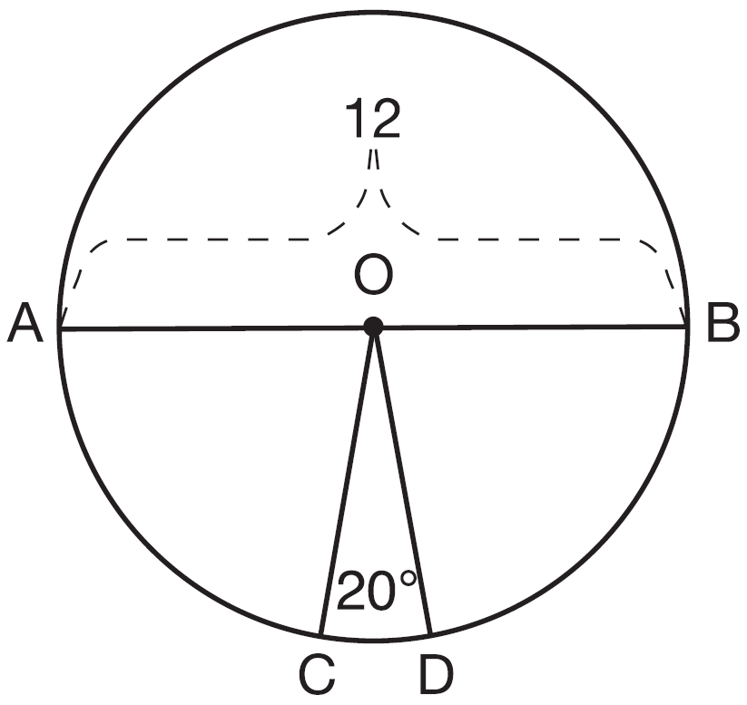
If , find the area of sector BOD in terms of .

11 Given: , , and bisects
Prove that is a right angle.

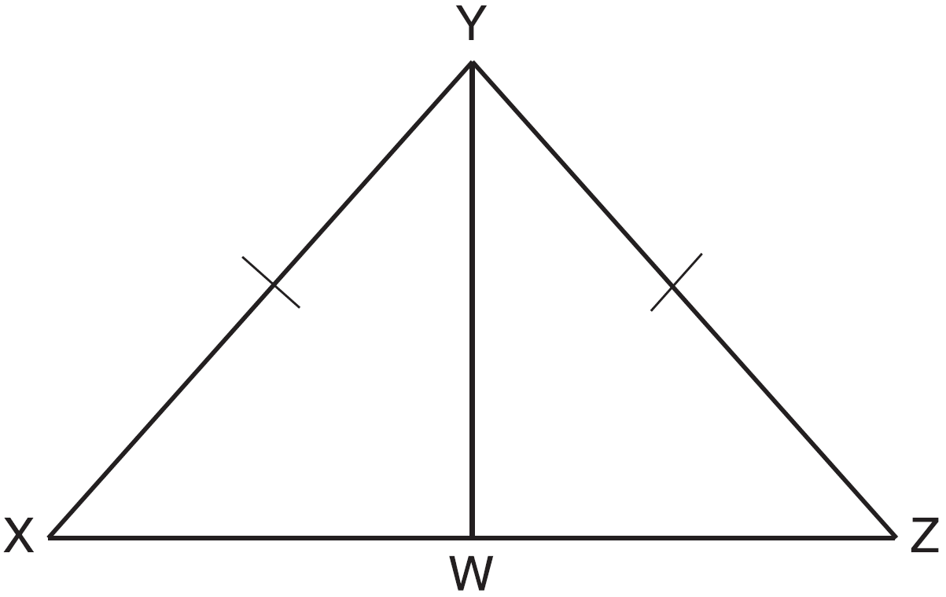

12 Trees that are cut down and stripped of their branches for timber are approximately cylindrical. A timber company specializes in a certain type of tree that has a typical diameter of 50 cm and a typical height of about 10 meters. The density of the wood is 380 kilograms per cubic meter, and the wood can be sold by mass at a rate of $4.75 per kilogram. Determine and state the minimum number of whole trees that must be sold to raise at least $50,000.

13 In the diagram below, secant and tangent are drawn from external point A to circle O.

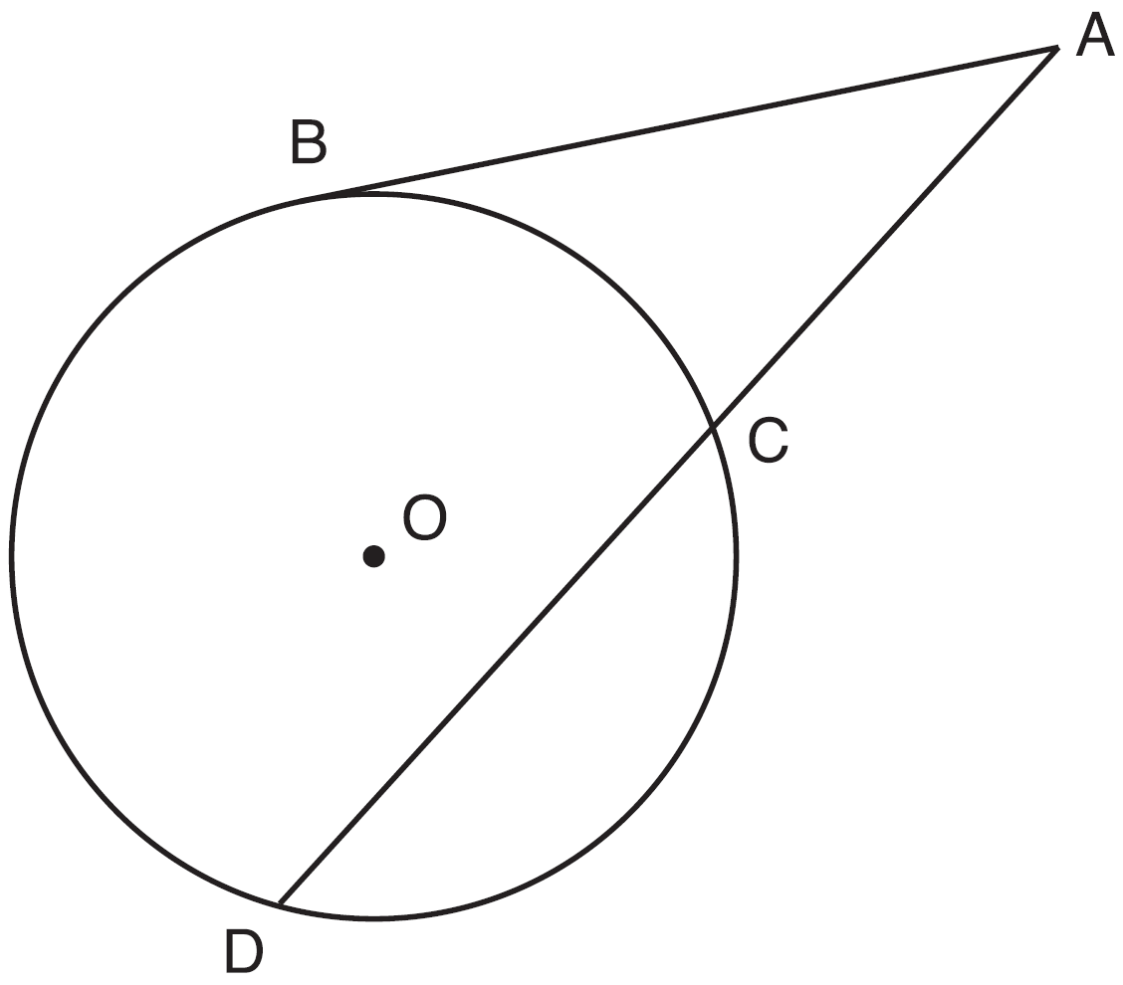

Prove the theorem: If a secant and a tangent are drawn to a circle from an external point, the product of the lengths of the secant segment and its external segment equals the length of the tangent segment squared.

14 Given: D is the image of A after a reflection over .
is the perpendicular bisector of
and are drawn
Prove:

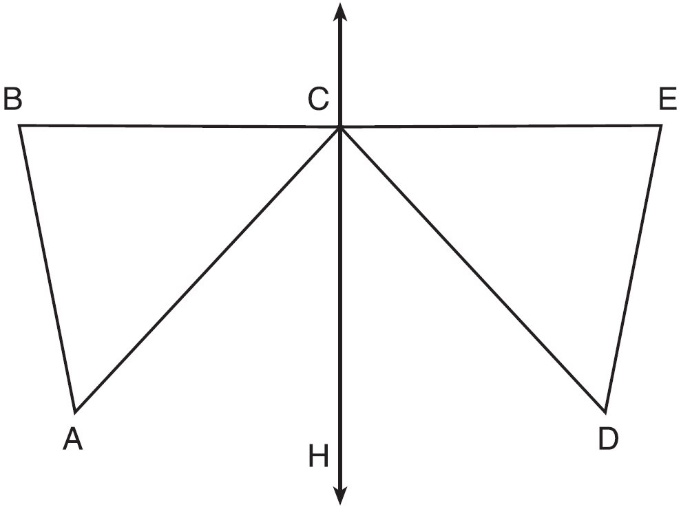

15 A man who is 5 feet 9 inches tall casts a shadow of 8 feet 6 inches. Assuming that the man is standing perpendicular to the ground, what is the angle of elevation from the end of the shadow to the top of the man’s head, to the nearest tenth of a degree?
1) | 34.1 | 3) | 42.6
2) | 34.5 | 4) | 55.9

16 The image of after a rotation of 90º clockwise about the origin is , as shown below.

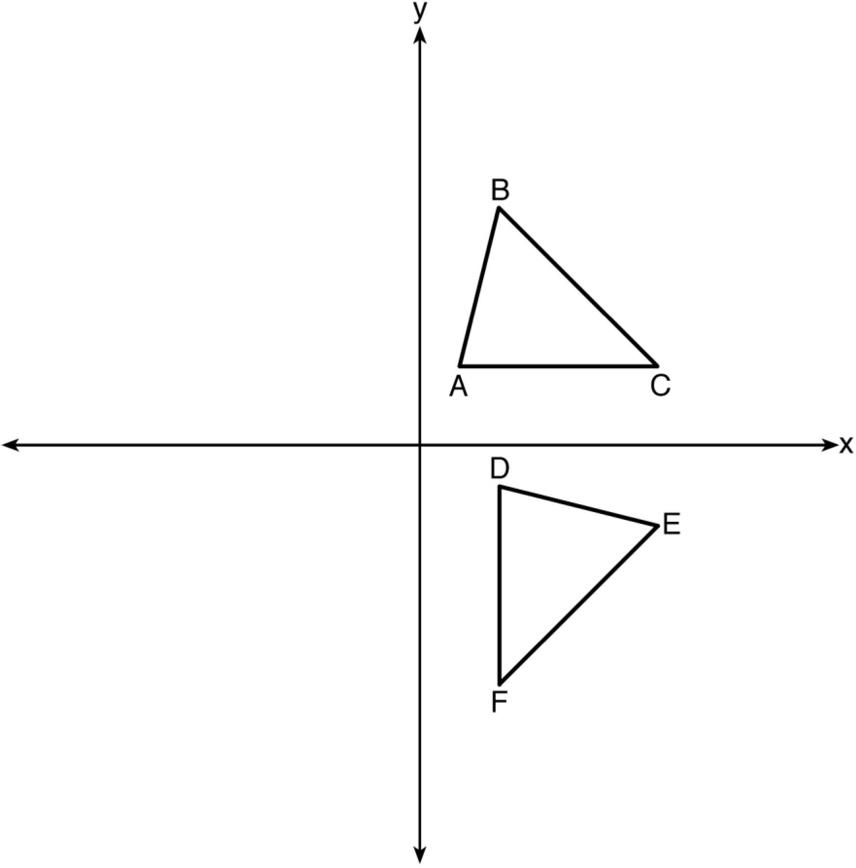

Which statement is true?
1) |  | 3)
2) |  | 4)

17 The line is dilated by a scale factor of and centered at the origin. Which equation represents the image of the line after the dilation?
1) |  | 3)
2) |  | 4)

18 In the diagram below, the circle shown has radius 10. Angle B intercepts an arc with a length of .
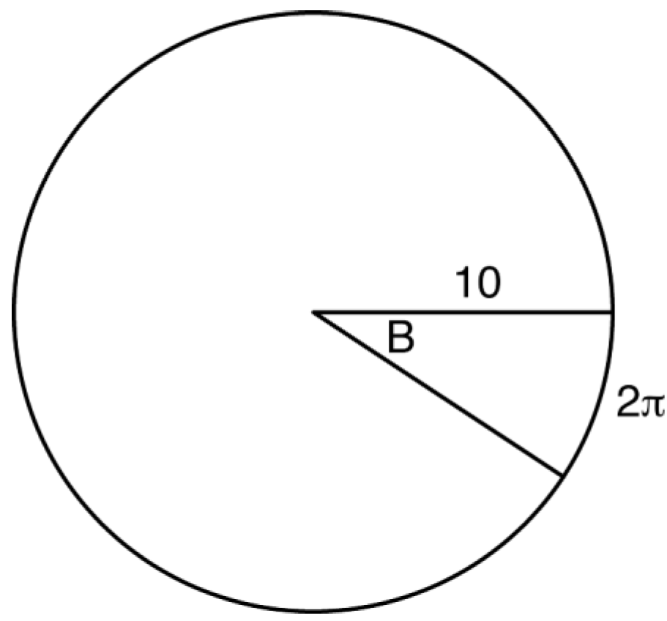

What is the measure of angle B, in radians?
1) |  | 3)
2) |  | 4)

19 In isosceles , line segment NO bisects vertex , as shown below. If , find the length of and explain your answer.
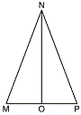

20 A contractor needs to purchase 500 bricks. The dimensions of each brick are 5.1 cm by 10.2 cm by 20.3 cm, and the density of each brick is . The maximum capacity of the contractor’s trailer is 900 kg. Can the trailer hold the weight of 500 bricks? Justify your answer.

21 In right triangle ABC with the right angle at C, and . Determine and state the value of x. Explain your answer.

22 Given right triangles ABC and DEF where and are right angles, and . Describe a precise sequence of rigid motions which would show .

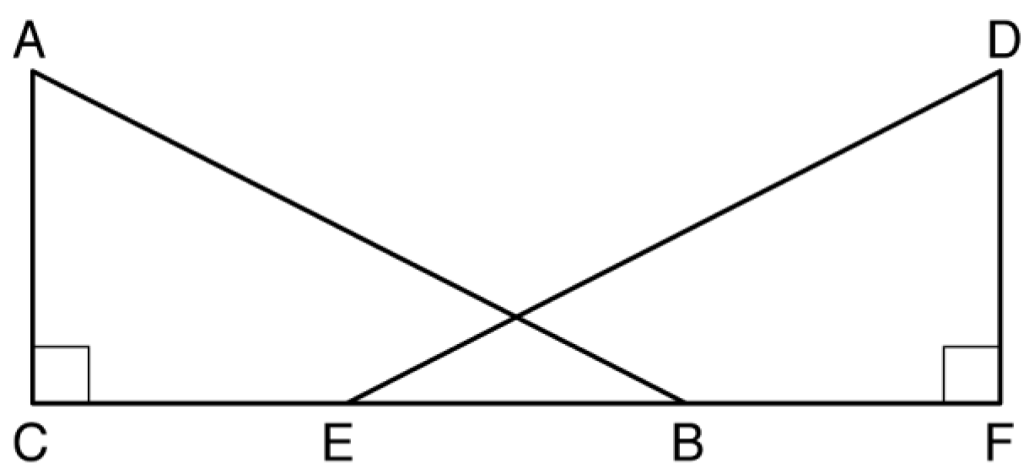

23 Using a compass and straightedge, construct an altitude of triangle ABC below. [Leave all construction marks.]

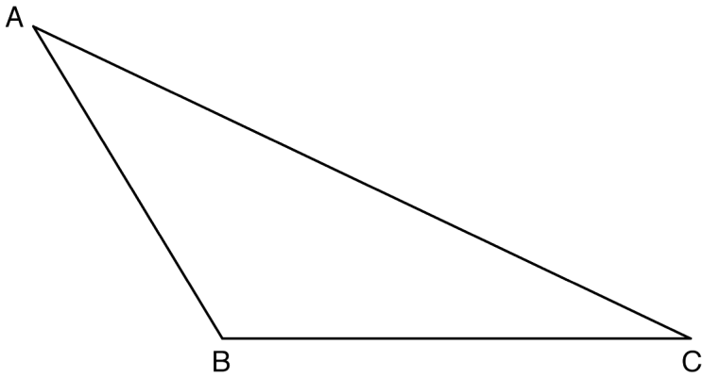

24 Prove the sum of the exterior angles of a triangle is 360°.

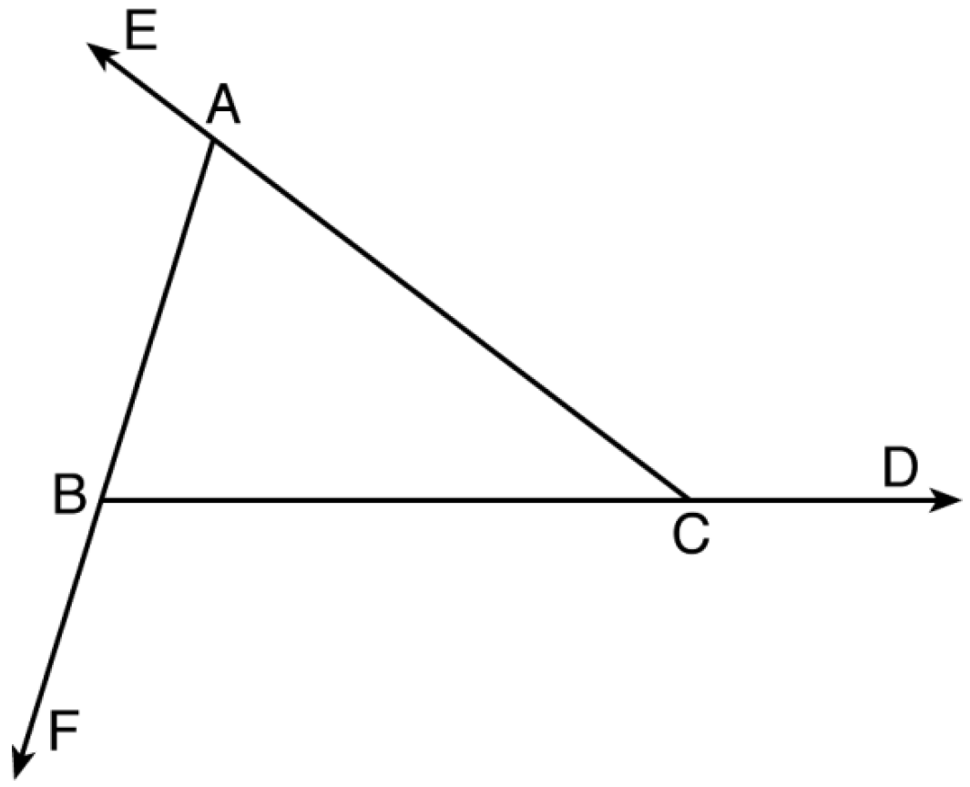

25 In rhombus MATH, the coordinates of the endpoints of the diagonal are and . Write an equation of the line that contains diagonal . [Use of the set of axes below is optional.] Using the given information, explain how you know that your line contains diagonal .
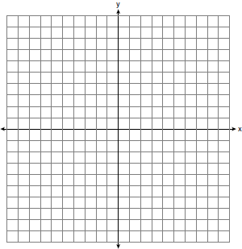
26 Using a straightedge and compass, construct a square inscribed in circle O below. [Leave all construction marks.]

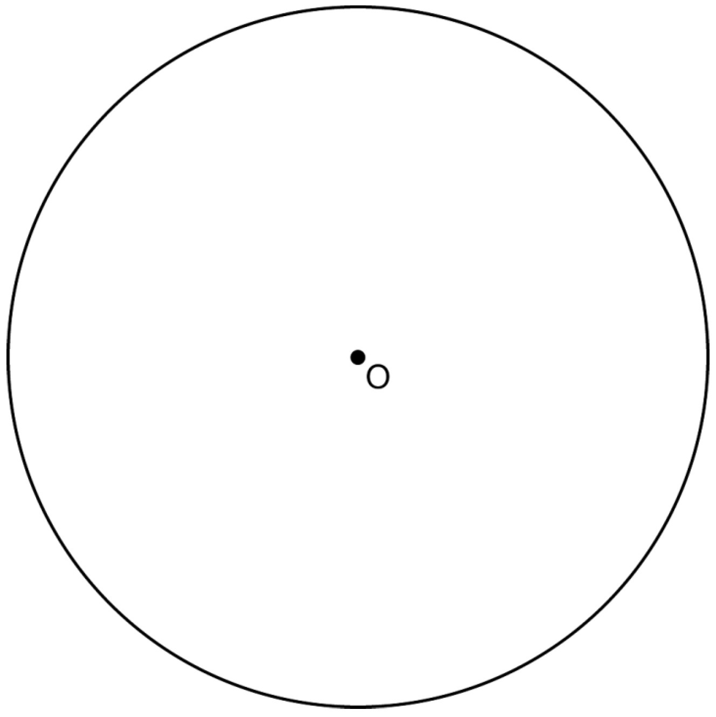

Determine the measure of the arc intercepted by two adjacent sides of the constructed square. Explain your reasoning.

27 The map below shows the three tallest mountain peaks in New York State: Mount Marcy, Algonquin Peak, and Mount Haystack. Mount Haystack, the shortest peak, is 4960 feet tall. Surveyors have determined the horizontal distance between Mount Haystack and Mount Marcy is 6336 feet and the horizontal distance between Mount Marcy and Algonquin Peak is 20,493 feet.

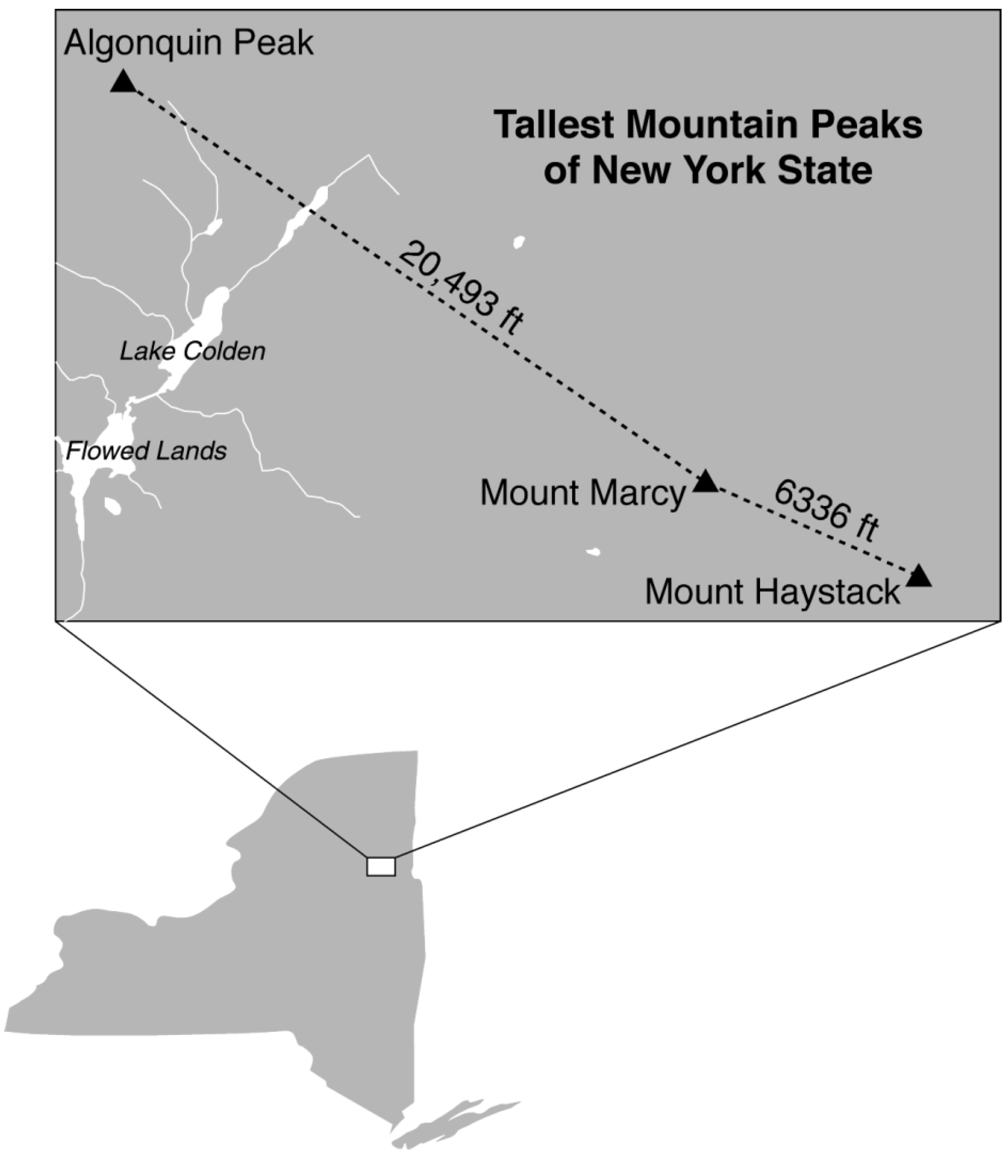

The angle of depression from the peak of Mount Marcy to the peak of Mount Haystack is 3.47 degrees. The angle of elevation from the peak of Algonquin Peak to the peak of Mount Marcy is 0.64 degrees. What are the heights, to the nearest foot, of Mount Marcy and Algonquin Peak? Justify your answer.
1 ANS: 4
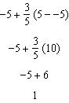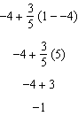

PTS: 2 REF: spr1401geo NAT: G.GPE.B.6 TOP: Directed Line Segments

2 ANS: 2
Segments drawn from the center of the regular pentagon bisect each angle of the pentagon, and create five isosceles triangles as shown in the diagram below. Since each exterior angle equals the angles formed by the segments drawn from the center of the regular pentagon, the minimum degrees necessary to carry a regular polygon onto itself are equal to the measure of an exterior angle of the regular polygon.
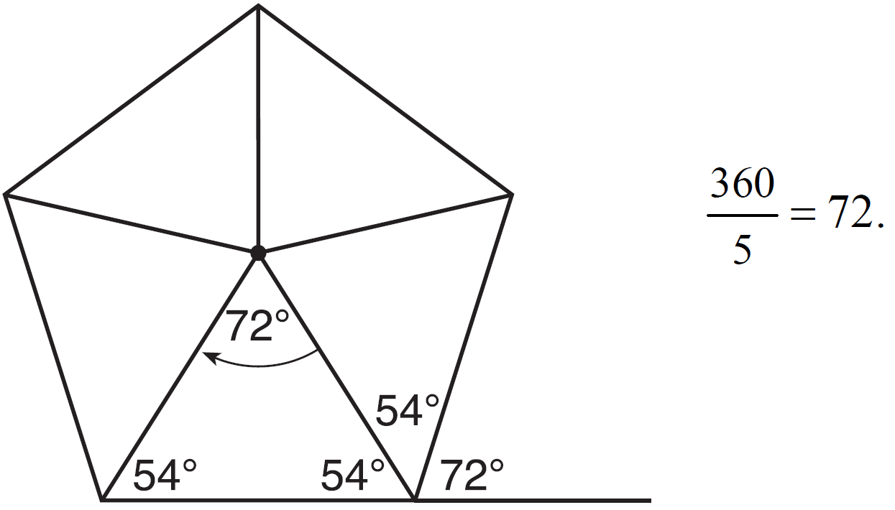

PTS: 2 REF: spr1402geo NAT: G.CO.A.3 TOP: Mapping a Polygon onto Itself

3 ANS: 2
The given line h, , does not pass through the center of dilation, the origin, because the y-intercept is at . The slope of the dilated line, m, will remain the same as the slope of line h, -. All points on line h, such as , the y-intercept, are dilated by a scale factor of 4; therefore, the y-intercept of the dilated line is because the center of dilation is the origin, resulting in the dilated line represented by the equation .

PTS: 2 REF: spr1403geo NAT: G.SRT.A.1 TOP: Line Dilations

4 ANS:
Circle A can be mapped onto circle B by first translating circle A along vector such that A maps onto B, and then dilating circle A, centered at A, by a scale factor of . Since there exists a sequence of transformations that maps circle A onto circle B, circle A is similar to circle B.

PTS: 2 REF: spr1404geo NAT: G.C.A.1 TOP: Similarity Proofs

5 ANS:
Each quarter in both stacks has the same base area. Therefore, each corresponding cross-section of the stacks will have the same area. Since the two stacks of quarters have the same height of 23 quarters, the two volumes must be the same.

PTS: 2 REF: spr1405geo NAT: G.GMD.A.1 TOP: Volume

6 ANS:
Triangle is the image of after a rotation about point Z such that coincides with . Since rotations preserve angle measure, coincides with , and corresponding angles X and Y, after the rotation, remain congruent, so . Then, dilate by a scale factor of with its center at point Z. Since dilations preserve parallelism, maps onto . Therefore, .

PTS: 2 REF: spr1406geo NAT: G.SRT.A.2 TOP: Compositions of Transformations
KEY: grids

7 ANS:
The acute angles in a right triangle are always complementary. The sine of any acute angle is equal to the cosine of its complement.

PTS: 2 REF: spr1407geo NAT: G.SRT.C.7 TOP: Cofunctions

8 ANS:
, , and (Given). and are right angles (Definition of perpendicular lines). and are right triangles (Definition of a right triangle). (HL).
will map onto after rotating counterclockwise 90º about point C such that point L maps onto point D.

PTS: 4 REF: spr1408geo NAT: G.CO.B.8 TOP: Triangle Congruency

9 ANS:
x represents the distance between the lighthouse and the canoe at 5:00; y represents the distance between the lighthouse and the canoe at 5:05. 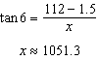 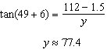 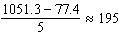

PTS: 4 REF: spr1409geo NAT: G.SRT.C.8 TOP: Using Trigonometry to Find a Side
KEY: advanced

10 ANS:
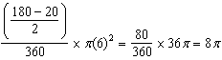

PTS: 4 REF: spr1410geo NAT: G.C.B.5 TOP: Sectors

11 ANS:
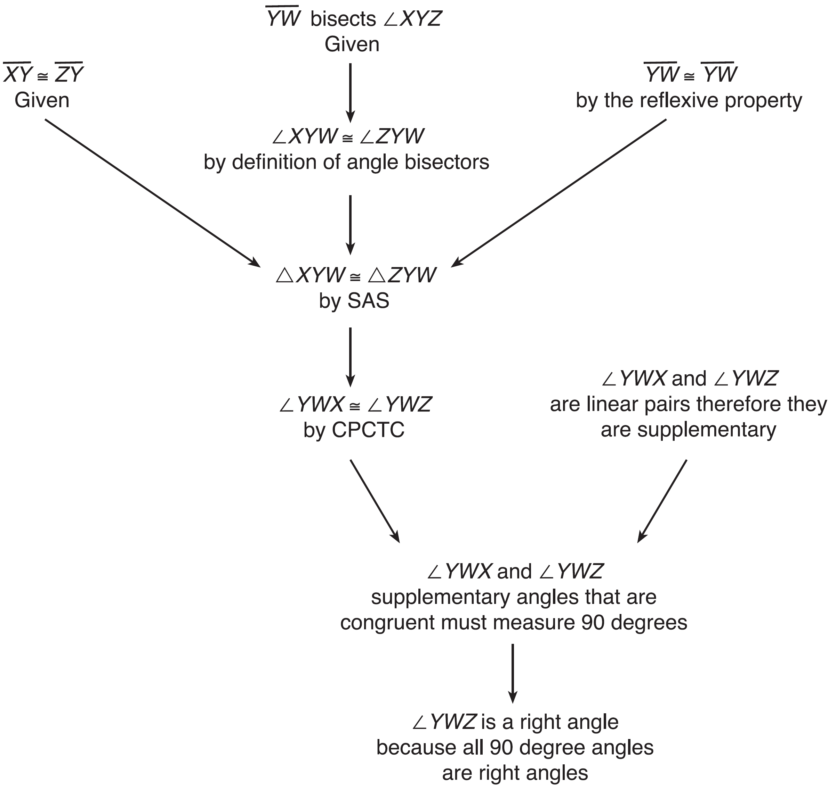 , , and bisects (Given). is isosceles (Definition of isosceles triangle). is an altitude of (The angle bisector of the vertex of an isosceles triangle is also the altitude of that triangle). (Definition of altitude). is a right angle (Definition of perpendicular lines).

PTS: 4 REF: spr1411geo NAT: G.CO.C.10 TOP: Triangle Proofs

12 ANS:
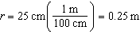 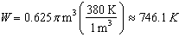 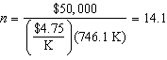 15 trees

PTS: 4 REF: spr1412geo NAT: G.MG.A.2 TOP: Density

13 ANS:
Circle O, secant , tangent (Given). Chords and are drawn (Auxiliary lines). , (Reflexive property).  (The measure of an inscribed angle is half the measure of the intercepted arc). 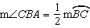 (The measure of an angle formed by a tangent and a chord is half the measure of the intercepted arc). (Angles equal to half of the same arc are congruent). (AA). 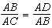 (Corresponding sides of similar triangles are proportional). (In a proportion, the product of the means equals the product of the extremes).

PTS: 6 REF: spr1413geo NAT: G.SRT.B.5 TOP: Circle Proofs

14 ANS:
It is given that point D is the image of point A after a reflection in line CH. It is given that is the perpendicular bisector of at point C. Since a bisector divides a segment into two congruent segments at its midpoint, . Point E is the image of point B after a reflection over the line CH, since points B and E are equidistant from point C and it is given that is perpendicular to . Point C is on , and therefore, point C maps to itself after the reflection over . Since all three vertices of triangle ABC map to all three vertices of triangle DEC under the same line reflection, then because a line reflection is a rigid motion and triangles are congruent when one can be mapped onto the other using a sequence of rigid motions.

PTS: 6 REF: spr1414geo NAT: G.CO.B.7 TOP: Triangle Congruency

15 ANS: 1
The man’s height, 69 inches, is opposite to the angle of elevation, and the shadow length, 102 inches, is adjacent to the angle of elevation. Therefore, tangent must be used to find the angle of elevation. 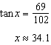

PTS: 2 REF: fall1401geo NAT: G.SRT.C.8 TOP: Using Trigonometry to Find an Angle

16 ANS: 4
The measures of the angles of a triangle remain the same after all rotations because rotations are rigid motions which preserve angle measure.

PTS: 2 REF: fall1402geo NAT: G.CO.B.6 TOP: Properties of Transformations
KEY: graphics

17 ANS: 2
The line does not pass through the center of dilation, so the dilated line will be distinct from . Since a dilation preserves parallelism, the line and its image will be parallel, with slopes of 2. To obtain the y-intercept of the dilated line, the scale factor of the dilation, , can be applied to the y-intercept, . Therefore, 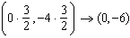. So the equation of the dilated line is .

PTS: 2 REF: fall1403geo NAT: G.SRT.A.1 TOP: Line Dilations

18 ANS: 3
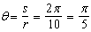

PTS: 2 REF: fall1404geo NAT: G.C.B.5 TOP: Arc Length
KEY: angle

19 ANS:
is congruent to by SAS. Since , then by CPCTC. So must divide in half, and .

PTS: 2 REF: fall1405geo NAT: G.SRT.B.5 TOP: Isosceles Triangle Theorem

20 ANS:
No, the weight of the bricks is greater than 900 kg. . 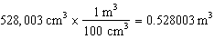. 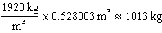.

PTS: 2 REF: fall1406geo NAT: G.MG.A.2 TOP: Density

21 ANS:
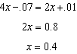 is the ratio of the opposite side and the hypotenuse while is the ratio of the adjacent side and the hypotenuse. The side opposite angle A is the same side as the side adjacent to angle B. Therefore, .

PTS: 2 REF: fall1407geo NAT: G.SRT.C.7 TOP: Cofunctions

22 ANS:
Translate along such that point C maps onto point F, resulting in image . Then reflect over such that maps onto .
or
Reflect over the perpendicular bisector of such that maps onto .

PTS: 2 REF: fall1408geo NAT: G.CO.B.7 TOP: Triangle Congruency

23 ANS:
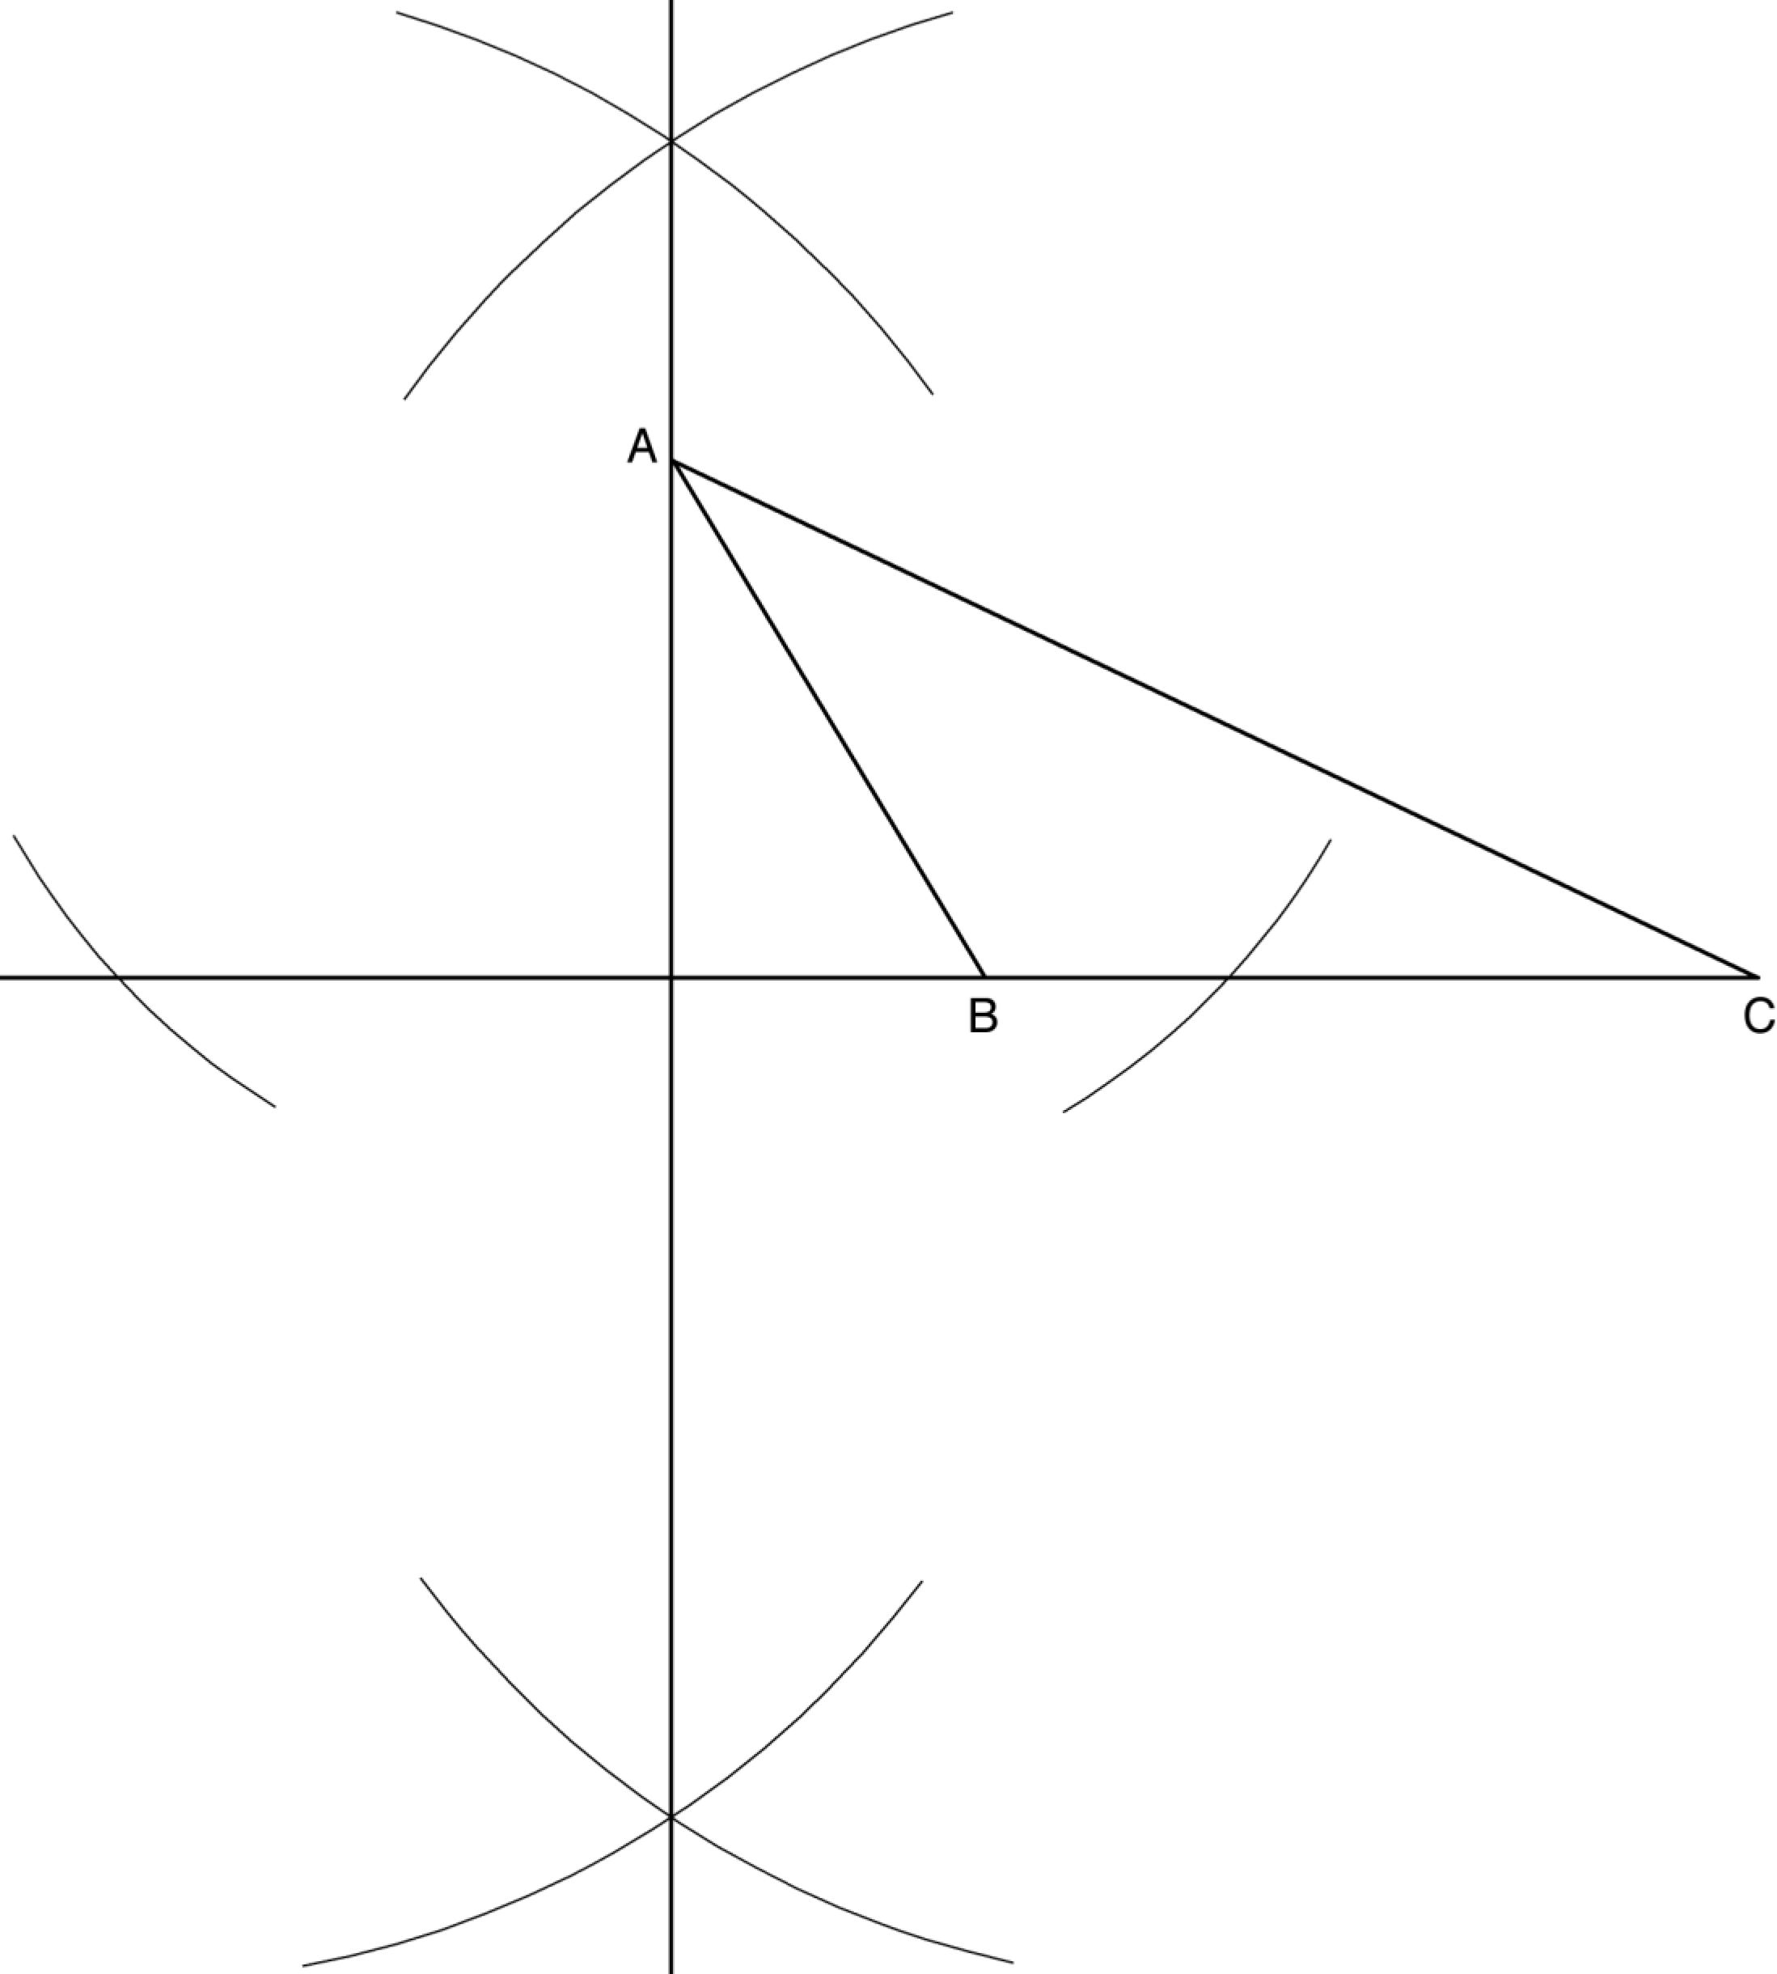

PTS: 2 REF: fall1409geo NAT: G.CO.D.12 TOP: Constructions
KEY: parallel and perpendicular lines

24 ANS:
As the sum of the measures of the angles of a triangle is 180°, . Each interior angle of the triangle and its exterior angle form a linear pair. Linear pairs are supplementary, so , , and . By addition, the sum of these linear pairs is 540°. When the angle measures of the triangle are subtracted from this sum, the result is 360°, the sum of the exterior angles of the triangle.

PTS: 4 REF: fall1410geo NAT: G.CO.C.10 TOP: Triangle Proofs

25 ANS:
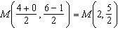 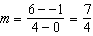 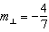 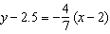 The diagonals, and , of rhombus MATH are perpendicular bisectors of each other.

PTS: 4 REF: fall1411geo NAT: G.GPE.B.4 TOP: Quadrilaterals in the Coordinate Plane
KEY: grids

26 ANS:
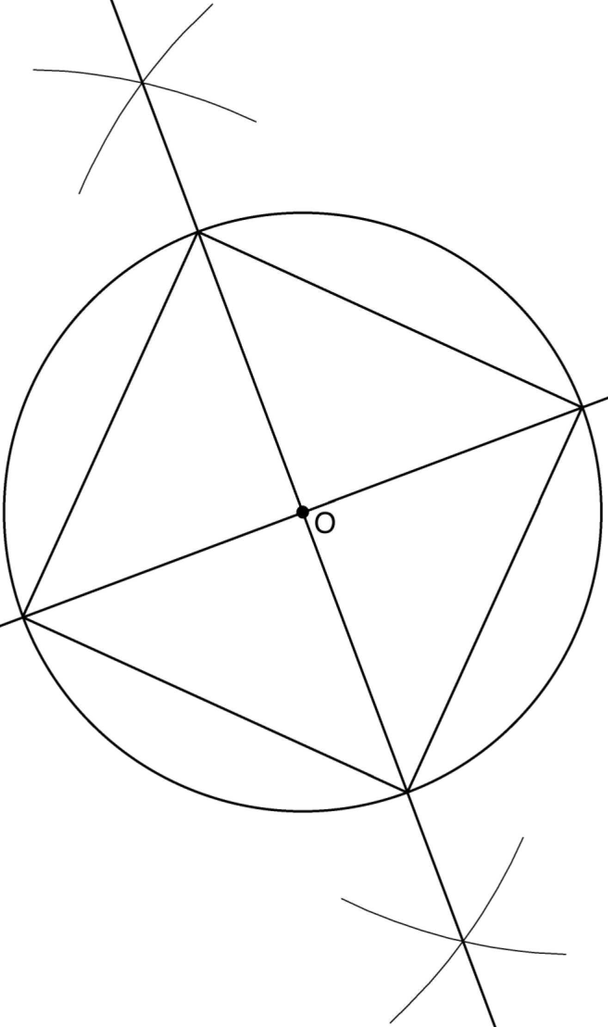 Since the square is inscribed, each vertex of the square is on the circle and the diagonals of the square are diameters of the circle. Therefore, each angle of the square is an inscribed angle in the circle that intercepts the circle at the endpoints of the diameters. Each angle of the square, which is an inscribed angle, measures 90 degrees. Therefore, the measure of the arc intercepted by two adjacent sides of the square is 180 degrees because it is twice the measure of its inscribed angle.

PTS: 4 REF: fall1412geo NAT: G.CO.D.13 TOP: Constructions

27 ANS:
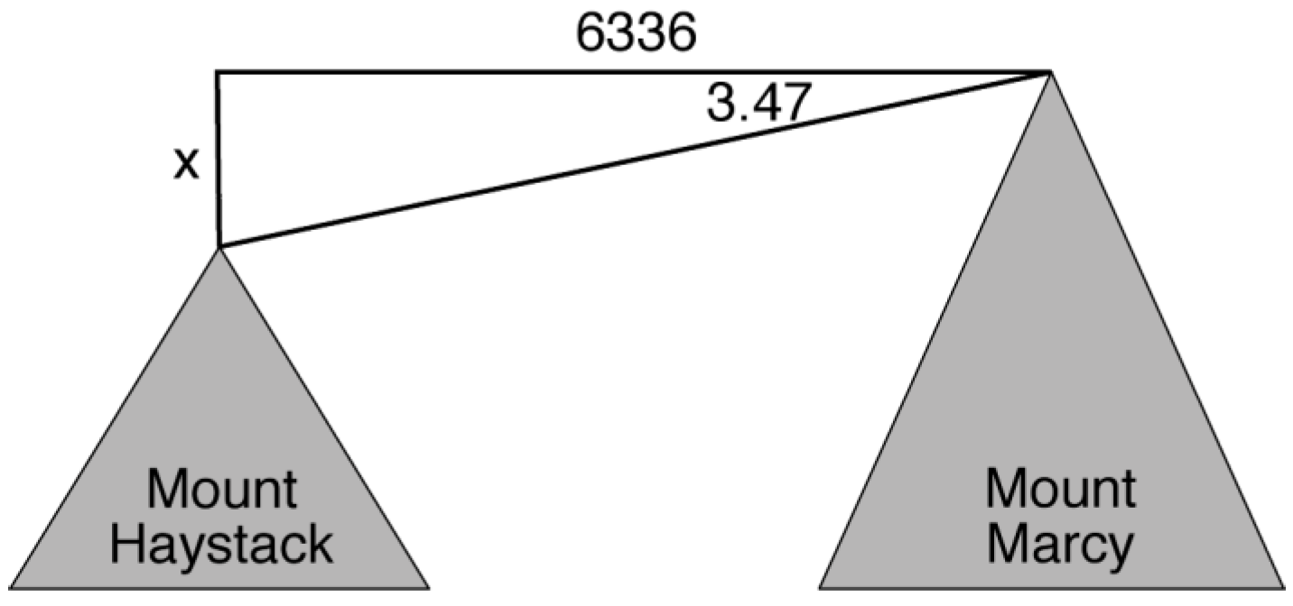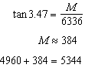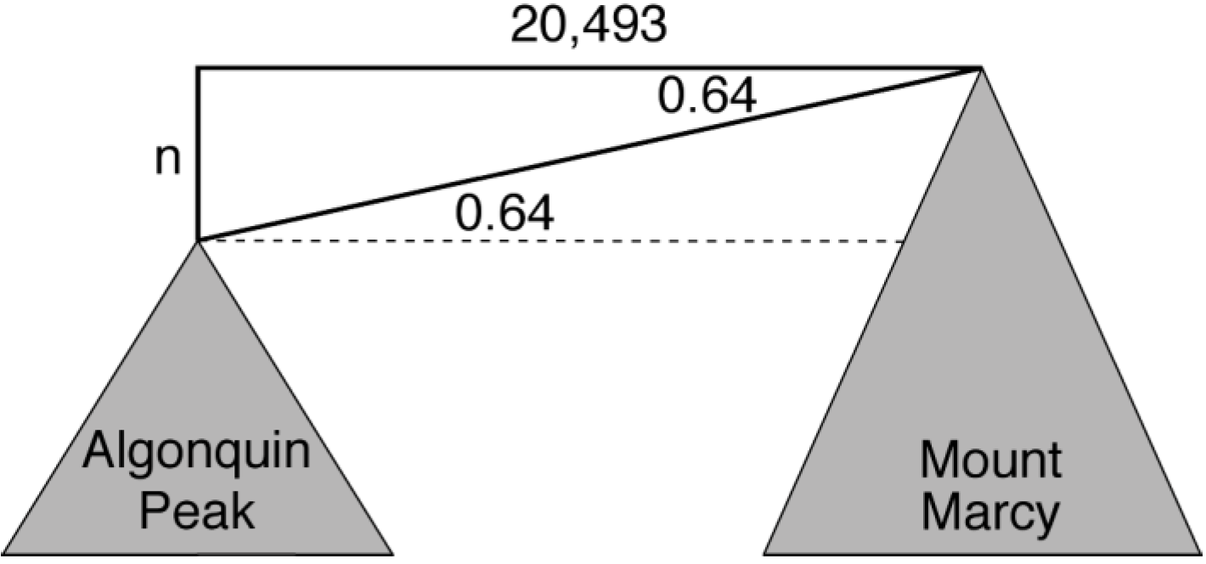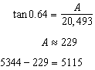

PTS: 6 REF: fall1413geo NAT: G.SRT.C.8 TOP: Using Trigonometry to Find a Side
KEY: advanced

