1 In right triangle LMN below, , , and .

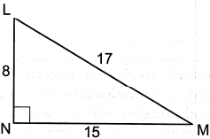

If triangle LMN is translated such that it maps onto triangle XYZ, which statement is always true?
1) |  | 3)
2) |  | 4)

2 Directed line segment KC has endpoints and . Point E divides such that is . What are the coordinates of point E?
1) |  | 3)
2) |  | 4)

3 In right triangle DAN, . Which statement must always be true?
1) |  | 3)
2) |  | 4)

4 In the diagram below of parallelogram RSTV, diagonals and intersect at E.

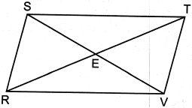

Which statement is always true?
1) |  | 3)
2) |  | 4)

5 In below, .
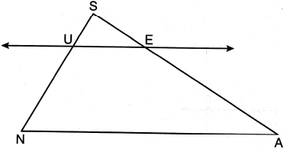

If , , and , what is the length of , to the nearest tenth?
1) | 2.5 | 3) | 4.9
2) | 3.5 | 4) | 17.9

6 Many roofs are slanted to prevent the buildup of snow. As modeled below, the length of a roof is 5.5 meters and it rises to a height of 2.5 meters.

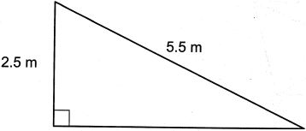

The angle of elevation of the roof, to the nearest degree, is
1) | 24º | 3) | 27º
2) | 25º | 4) | 28º

7 In the diagram below, , and and are drawn such that .

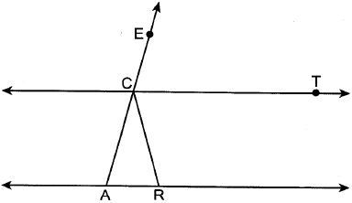

If , what is ?
1) | 30º | 3) | 75º
2) | 60º | 4) | 105º

8 In the diagram below, has medians , , and that intersect at point P.

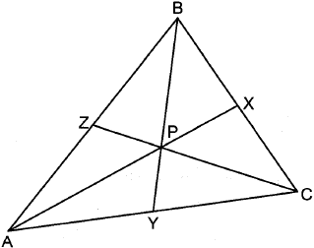

If , , and , what is the perimeter of ?
1) | 57 | 3) | 70
2) | 65 | 4) | 73

9 In right triangle ABC below, , , and .
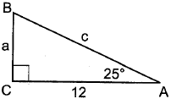
Which equation is correct for ?
1) | 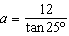 | 3) | 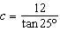
2) |  | 4)

10 Triangle HUS is shown below.
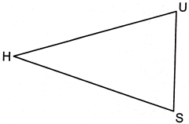
If point G is located on and is drawn, which additional information is sufficient to prove by SAS?
1) | bisects | 3) | bisects
2) | is an altitude | 4) | is the perpendicular bisector of

11 The area of the base of a cone is square inches. The volume of the cone is cubic inches. What is the height of the cone in inches?
1) | 12 | 3) | 3
2) | 8 | 4) | 4

12 On the set of axes below, , , , , and are drawn.

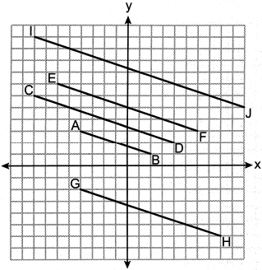

Which segment is the image of after a dilation with a scale factor of 2 centered at ?
1) |  | 3)
2) |  | 4)

13 Trapezoid ABCD is graphed on the set of axes below.

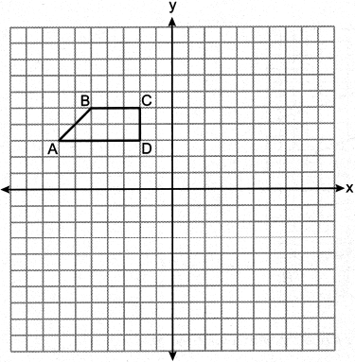

Which transformation would map point A onto ?
1) | reflection over | 3) | rotation of 180° about
2) | reflection over the y-axis | 4) | rotation of 90° counterclockwise about

14 A storage building is modeled below by a hemisphere on top of a cylinder. The diameter of both the cylinder and hemisphere is 12 feet. The total height of the storage building is 30 feet.

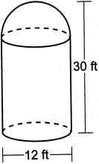

To the nearest cubic foot, what is the volume of the storage building?
1) | 942 | 3) | 3167
2) | 2488 | 4) | 3845

15 Which regular polygon will carry onto itself after a 135° rotation about its center?
1) | triangle | 3) | hexagon
2) | pentagon | 4) | octagon

16 What is the length of the radius of the circle whose equation is ?
1) |  | 3) | 5
2) |  | 4) | 10

17 The line represented by the equation is dilated by a scale factor of 2 centered at the origin. Which equation represents its image?
1) |  | 3)
2) |  | 4)

18 Line segment RH has endpoints and . Which equation represents a line perpendicular to that passes through the point ?
1) | 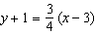 | 3) | 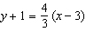
2) | 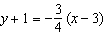 | 4) | 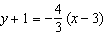

19 In right triangle SNO below, altitude is drawn to hypotenuse .

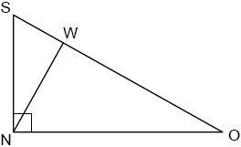

Which statement is not always true?
1) | 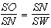 | 3) | 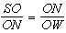
2) | 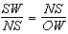 | 4) | 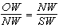

20 A rectangle has a width of 3 and a length of 4. The rectangle is dilated by a scale factor of 1.8. What is the area of its image, to the nearest tenth?
1) | 3.7 | 3) | 21.6
2) | 6.7 | 4) | 38.9

21 In the diagram below of circle P, diameter and chord intersect at Q, , and .

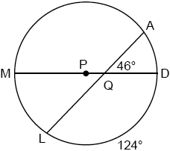

What is ?
1) | 36º | 3) | 51º
2) | 46º | 4) | 92º

22 The right prism with a triangular base shown below is cut by a plane perpendicular to its bases.

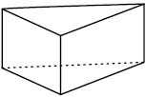

The two-dimensional shape of the cross section is always a
1) | triangle | 3) | pentagon
2) | rhombus | 4) | rectangle

23 A rectangular fish tank measures 24 inches long, 12 inches wide, and 16 inches high, as modeled in the diagram below.

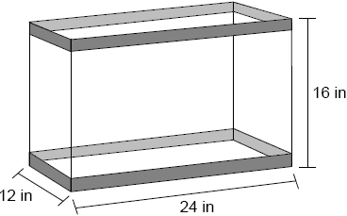

If the empty tank weighs 25 pounds and the fish tank is filled with water to a height of 14 inches, what is the approximate weight of the tank and water? [27.7 in.³=1 pound of water]
1) | 146 | 3) | 171
2) | 166 | 4) | 191

24 A circle has a radius of 4.5. What is the measure of the central angle that intercepts an arc whose length is 6.2, to the nearest degree?
1) | 35º | 3) | 64º
2) | 42º | 4) | 79º

25 In the diagram below, .

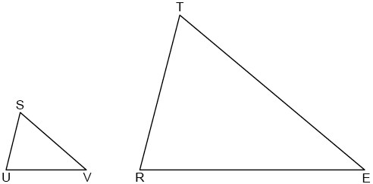

If , , , and , determine and state the length of .

26 Using a compass and straightedge, construct the line of reflection that maps onto its image, . [Leave all construction marks.]

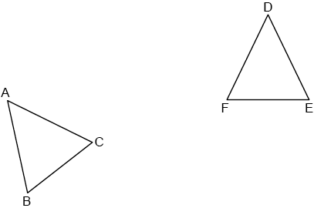

27 Triangle MAX has vertices with coordinates , , and . Determine and state the area of . [The use of the set of axes below is optional.]

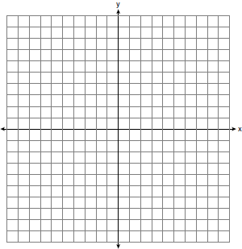

28 A person observes a kite at an angle of elevation of 32° from a line of sight that begins 4 feet above the ground, as modeled in the diagram below. At the moment of observation, the kite is 70 feet above the ground.

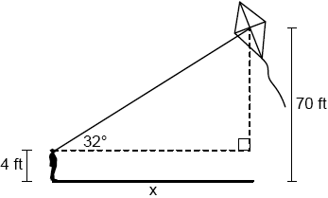

Determine and state the horizontal distance, x, between the person and the point on the ground directly below the kite, to the nearest foot.

29 In below, N and E are the midpoints of and , respectively, is drawn.

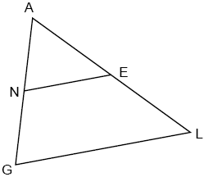

If and , determine and state the value of x.

30 In the diagram below, is the image of after a reflection over .

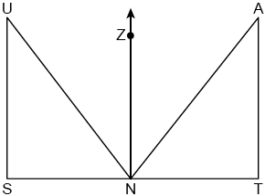

Use the properties of rigid motions to explain why .

31 A pyramid with a square base is made of solid glass. The pyramid has a base with a side length of 5.7 cm and a height of 7 cm. The density of the glass is 2.4 grams per cubic centimeter. Determine and state, to the nearest gram, the mass of the pyramid.

32 A drone is used to measure the size of a brush fire on the ground. Segment AB represents the width of the fire, as shown below. The drone calculates the distance to point B to be 1076 feet at an angle of depression of 25°. At the same point, the drone calculates the distance to point A to be 774 feet at an angle of depression of 36°.

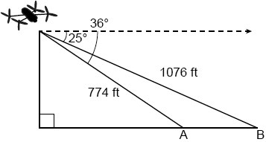

Determine and state the width of the fire, , to the nearest foot.

33 Quadrilateral ABCD has vertices with coordinates , , , and . Joe defines an isosceles trapezoid as a trapezoid with congruent diagonals. Use Joe's definition to prove ABCD is an isosceles trapezoid. [The use of the set of axes below is optional.]

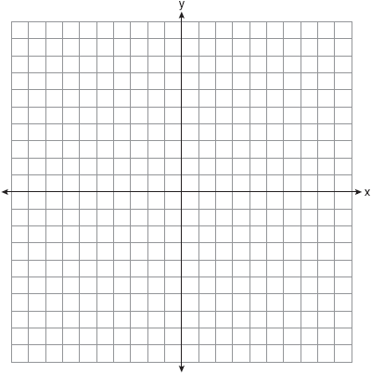

34 Ali made six solid spherical decorations out of modeling clay. Each decoration has a radius of 2.5 inches. The weight of clay is 68 pounds per cubic foot. Determine and state, to the nearest pound, the total weight of the six decorations.

35 In quadrilateral HOPE below, , , , and and are perpendicular to diagonal at points G and J, respectively.

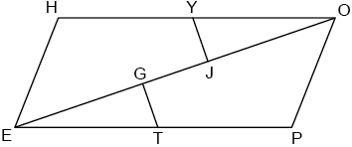

Prove that .
1 ANS: 3
The measures of the angles of a triangle remain the same after a translation because translations are rigid motions which preserve angle measure.

PTS: 2 REF: 082401geo NAT: G.CO.B.6 TOP: Properties of Transformations

2 ANS: 1
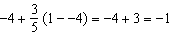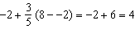

PTS: 2 REF: 082402geo NAT: G.GPE.B.6 TOP: Directed Line Segments

3 ANS: 2
Sine and cosine are cofunctions.

PTS: 2 REF: 082403geo NAT: G.SRT.C.7 TOP: Cofunctions

4 ANS: 4 PTS: 2 REF: 082404geo NAT: G.CO.C.11
TOP: Parallelograms

5 ANS: 3
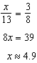

PTS: 2 REF: 082405geo NAT: G.SRT.B.5 TOP: Side Splitter Theorem

6 ANS: 3
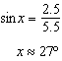

PTS: 2 REF: 082406geo NAT: G.SRT.C.8 TOP: Using Trigonometry to Find an Angle

7 ANS: 1

PTS: 2 REF: 082407geo NAT: G.CO.C.9 TOP: Lines and Angles

8 ANS: 2
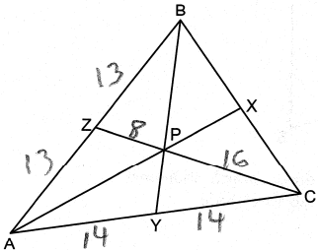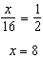

PTS: 2 REF: 082408geo NAT: G.CO.C.10
TOP: Centroid, Orthocenter, Incenter and Circumcenter

9 ANS: 2
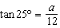

PTS: 2 REF: 082409geo NAT: G.SRT.C.8 TOP: Using Trigonometry to Find a Side

10 ANS: 4 PTS: 2 REF: 082410geo NAT: G.SRT.B.5
TOP: Triangle Congruency

11 ANS: 1
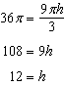

PTS: 2 REF: 082411geo NAT: G.GMD.A.3 TOP: Volume
KEY: cones

12 ANS: 2

PTS: 2 REF: 082412geo NAT: G.SRT.A.1 TOP: Line Dilations

13 ANS: 1 PTS: 2 REF: 082413geo NAT: G.CO.A.2
TOP: Identifying Transformations

14 ANS: 3
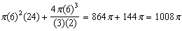

PTS: 2 REF: 082414geo NAT: G.GMD.A.3 TOP: Volume
KEY: compositions

15 ANS: 4
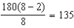

PTS: 2 REF: 082415geo NAT: G.CO.A.3 TOP: Mapping a Polygon onto Itself

16 ANS: 2
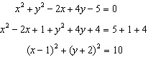

PTS: 2 REF: 082416geo NAT: G.GPE.A.1 TOP: Equations of Circles
KEY: completing the square

17 ANS: 2 PTS: 2 REF: 082417geo NAT: G.SRT.A.1
TOP: Line Dilations

18 ANS: 1
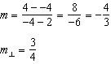

PTS: 2 REF: 082418geo NAT: G.GPE.B.5 TOP: Parallel and Perpendicular Lines
KEY: write equation of perpendicular line

19 ANS: 2 PTS: 2 REF: 082419geo NAT: G.SRT.B.5
TOP: Similarity KEY: altitude

20 ANS: 4

PTS: 2 REF: 082420geo NAT: G.SRT.A.2 TOP: Dilations

21 ANS: 1
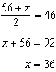

PTS: 2 REF: 082421geo NAT: G.C.A.2 TOP: Chords, Secants and Tangents
KEY: intersecting chords, angle

22 ANS: 4 PTS: 2 REF: 082422geo NAT: G.GMD.B.4
TOP: Cross-Sections of Three-Dimensional Objects

23 ANS: 3
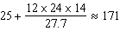

PTS: 2 REF: 082423geo NAT: G.MG.A.2 TOP: Density

24 ANS: 4
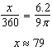

PTS: 2 REF: 082424geo NAT: G.C.B.5 TOP: Arc Length

25 ANS:
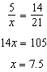

PTS: 2 REF: 082425geo NAT: G.SRT.B.5 TOP: Similarity
KEY: basic

26 ANS:
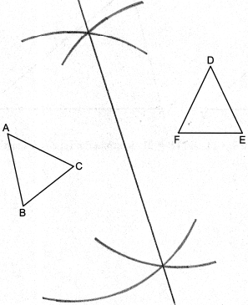

PTS: 2 REF: 082426geo NAT: G.CO.D.12 TOP: Constructions
KEY: line bisector

27 ANS:
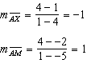 is an altitude. 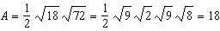

PTS: 2 REF: 082427geo NAT: G.GPE.B.7 TOP: Polygons in the Coordinate Plane

28 ANS:
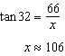

PTS: 2 REF: 082428geo NAT: G.SRT.C.8 TOP: Using Trigonometry to Find a Side

29 ANS:
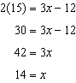

PTS: 2 REF: 082429geo NAT: G.CO.C.10 TOP: Midsegments

30 ANS:
Reflections preserve distance, so the corresponding sides are congruent.

PTS: 2 REF: 082430geo NAT: G.CO.B.6 TOP: Properties of Transformations

31 ANS:
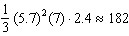

PTS: 2 REF: 082431geo NAT: G.MG.A.2 TOP: Density

32 ANS:
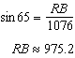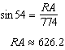

PTS: 4 REF: 082432geo NAT: G.SRT.C.8 TOP: Using Trigonometry to Find a Side

33 ANS:
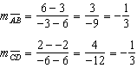 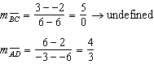 ABCD is a trapezoid because it has only one pair of parallel sides. 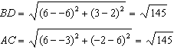 ABCD is isosceles because ABCD’s diagonals are congruent.

PTS: 4 REF: 082433geo NAT: G.GPE.B.4 TOP: Quadrilaterals in the Coordinate Plane

34 ANS:
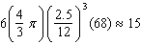

PTS: 4 REF: 082434geo NAT: G.MG.A.2 TOP: Density

35 ANS:
Quad HOPE, , , , and (Given); HOPE is a parallelogram (Both pairs of opposite sides are parallel); (Opposite sides of a parallelogram are parallel); (Parallel lines cut by a transversal form congruent alternate interior angles); (Reflexive); (Subtraction); and are right angles (Perpendicular lines form right angles); (All right angles are congruent); (ASA); (CPCTC).

PTS: 6 REF: 082435geo NAT: G.SRT.B.5 TOP: Quadrilateral Proofs

