1 In the diagram below, is reflected over line to create .

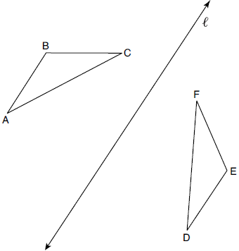

If and , what is ?
1) | 40° | 3) | 85°
2) | 45° | 4) | 95°

2 The diagram below shows triangle ABC with point X on side and point Y on side .

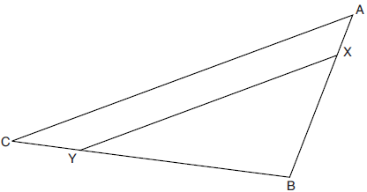

Which information is sufficient to prove that ?
1) | is a right angle. | 3) | is isosceles.
2) | is parallel to . | 4)

3 Quadrilateral MATH is congruent to quadrilateral WXYZ. Which statement is always true?
1) |  | 3) | Quadrilateral WXYZ can be mapped onto quadrilateral MATH using a sequence of rigid motions.
2) |  | 4) | Quadrilateral MATH and quadrilateral WXYZ are the same shape, but not necessarily the same size.

4 A quadrilateral has diagonals that are perpendicular but not congruent. This quadrilateral could be
1) | a square | 3) | a rectangle
2) | a rhombus | 4) | an isosceles trapezoid

5 Which regular polygon has a minimum rotation of 36° about its center that carries the polygon onto itself?
1) | pentagon | 3) | nonagon
2) | octagon | 4) | decagon

6 On the set of axes below, is the image of after a dilation centered at point P.
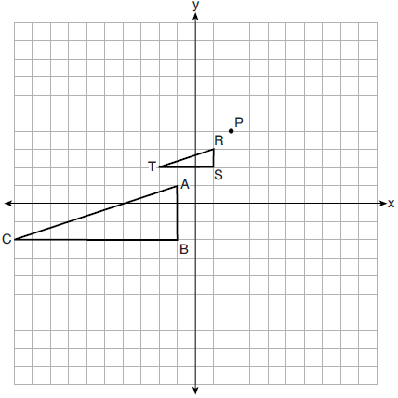

The scale factor of the dilation that maps onto is
1) |  | 3) | 3
2) | 2 | 4)

7 In the diagram of below, , , and .
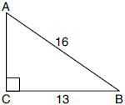

What is the measure of , to the nearest degree?
1) | 36° | 3) | 51°
2) | 39° | 4) | 54°

8 The Pyramid of Memphis, in Tennessee, stands 107 yards tall and has a square base whose side is 197 yards long.

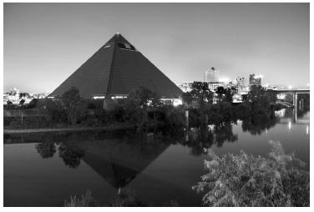

What is the volume of the Pyramid of Memphis, to the nearest cubic yard?
1) | 751,818 | 3) | 2,076,212
2) | 1,384,188 | 4) | 4,152,563

9 A square is graphed on the set of axes below, with vertices at , , , and .

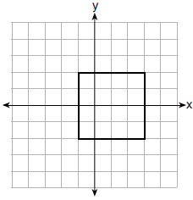

Which transformation would not carry the square onto itself?
1) | reflection over the y-axis | 3) | rotation of 180 degrees around point
2) | reflection over the x-axis | 4) | reflection over the line

10 If scalene triangle XYZ is similar to triangle QRS and , which equation is always true?
1) |  | 3)
2) |  | 4)

11 A plane intersects a cylinder perpendicular to its bases.

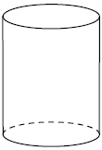

This cross section can be described as a
1) | rectangle | 3) | triangle
2) | parabola | 4) | circle

12 An equation of line p is 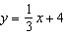. An equation of line q is 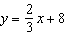. Which statement about lines p and q is true?
1) | A dilation of centered at the origin will map line q onto line p. | 3) | Line q is not the image of line p after a dilation because the lines are not parallel.
2) | A dilation of 2 centered at the origin will map line p onto line q. | 4) | Line q is not the image of line p after a dilation because the lines do not pass through the origin.

13 The coordinates of the endpoints of are and . If point M is on , what are the coordinates of M such that SM:MC is 1:2?
1) |  | 3)
2) |  | 4) | 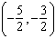

14 On the set of axes below, rectangle WIND has vertices with coordinates , , , and .

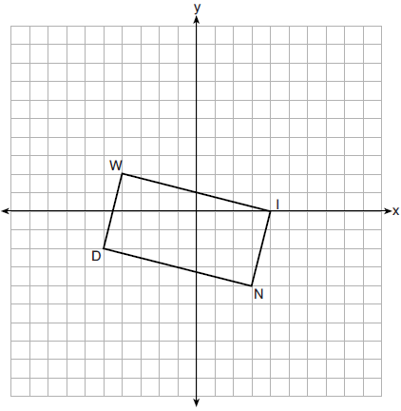

What is the area of rectangle WIND?
1) | 17 | 3) | 32
2) | 31 | 4) | 34

15 In parallelogram ABCD shown below, bisects .

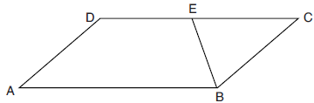

If , then is
1) | 40° | 3) | 110°
2) | 70° | 4) | 140°

16 In right triangles ABC and RST, hypotenuse and hypotenuse . If , then 1:16 is the ratio of the corresponding
1) | legs | 3) | volumes
2) | areas | 4) | perimeters

17 Parallelogram ABCD with diagonal is drawn below. Line segment EF is drawn such that it bisects at M.

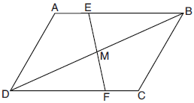

Which triangle congruence method would prove that ?
1) | ASA, only | 3) | both ASA and AAS
2) | AAS, only | 4) | neither ASA nor AAS

18 In the diagram below of circle O, chords and intersect at E, and chords and are drawn.

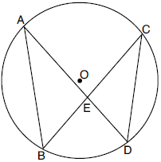

Which statement must always be true?
1) |  | 3)
2) |  | 4)

19 What are the coordinates of the center and the length of the radius of the circle whose equation is ?
1) | center and radius 7.5 | 3) | center and radius 4.5
2) | center and radius 7.5 | 4) | center and radius 4.5

20 In the diagram below, ABCD is a rectangle, and diagonal is drawn. Line , a vertical line of symmetry, and line m, a horizontal line of symmetry, intersect at point E.

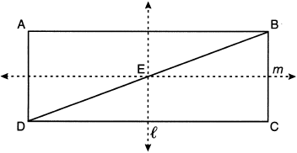

Which sequence of transformations will map onto ?
1) | a reflection over line followed by a 180° rotation about point E | 3) | a 180° rotation about point B
2) | a reflection over line followed by a reflection over line m | 4) | a reflection over

21 The diagram below models a countertop designed for a kitchen. The countertop is made of solid oak and is 3 inches thick.

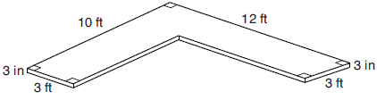

If oak weighs approximately 44 pounds per cubic foot, the approximate weight, in pounds, of the countertop is
1) | 630 | 3) | 750
2) | 730 | 4) | 870

22 In the diagram below of , intersects and at points T and V respectively, and .

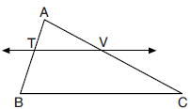

If , , , and , what is the perimeter of quadrilateral TBCV?
1) | 38.5 | 3) | 40.5
2) | 39.5 | 4) | 44.9

23 A circle centered at the origin passes through .

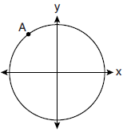

What is the equation of the line tangent to the circle at A?
1) | 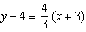 | 3) | 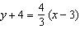
2) | 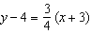 | 4) | 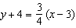

24 In the diagram below, quadrilateral ABCD is inscribed in circle O, , , and .

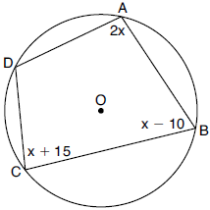

What is ?
1) | 55° | 3) | 110°
2) | 70° | 4) | 135°

25 On the set of axes below, .
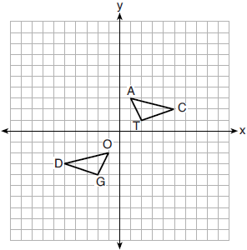
Describe a sequence of transformations that maps onto .

26 In right triangle MTH shown below, , , and .
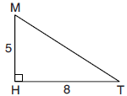
Determine and state, to the nearest tenth, the volume of the three-dimensional solid formed by rotating continuously around .

27 Using a compass and straightedge, dilate triangle ABC by a scale factor of 2 centered at C. [Leave all construction marks.]

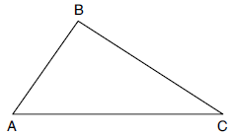

28 A rock-climbing wall at a local park has a right triangular section that slants toward the climber, as shown in the picture below. The height of the wall is 5 meters and the slanted section begins 1.2 meters up the wall at an angle of 14 degrees.

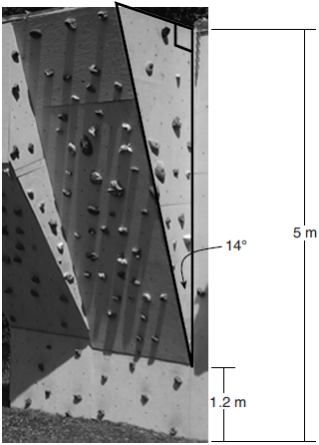

Determine and state, to the nearest hundredth, the number of meters in the length of the section of the wall that is slanted (hypotenuse).

29 In the diagram below of right triangle BAL, altitude is drawn to hypotenuse . The length of is 6.

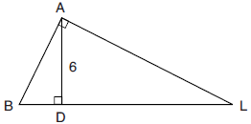

If the length of is four times the length of , determine and state the length of .

30 Trapezoid ABCD, where , is shown below. Diagonals and intersect at E, and .

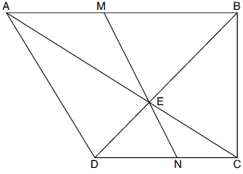

If , , and , determine and state .

31 In the diagram below of circle O, the measure of inscribed angle ABC is 36° and the length of is 4 inches.

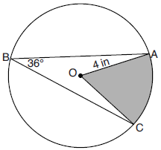

Determine and state, to the nearest tenth of a square inch, the area of the shaded sector.

32 As modeled in the diagram below, a building has a height of 50 meters. The angle of depression from the top of the building to the top of the tree, T, is 13.3°. The angle of depression from the top of the building to the bottom of the tree, B, is 22.2°.

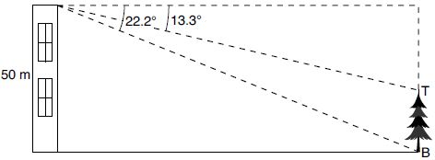

Determine and state, to the nearest meter, the height of the tree.

33 The coordinates of the vertices of quadrilateral HYPE are , , , and . Prove HYPE is a rectangle. [The use of the set of axes below is optional.]

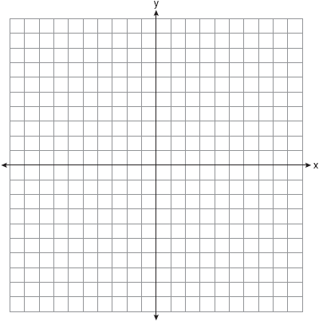

34 A packing box for baseballs is the shape of a rectangular prism with dimensions of . Each baseball has a diameter of 2.94 inches.

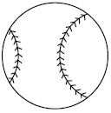

Determine and state the maximum number of baseballs that can be packed in the box if they are stacked in layers and each layer contains an equal number of baseballs. The weight of a baseball is approximately 0.025 pound per cubic inch. Determine and state, to the nearest pound, the total weight of all the baseballs in the fully packed box.

35 Given: Quadrilateral ABCD, and intersect at H, , , and .

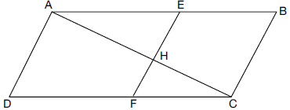

Prove:
1 ANS: 2

PTS: 2 REF: 082201geo NAT: G.CO.B.6 TOP: Properties of Transformations
KEY: graphics

2 ANS: 2
If (2) is true, and .

PTS: 2 REF: 082202geo NAT: G.SRT.B.5 TOP: Side Splitter Theorem

3 ANS: 3 PTS: 2 REF: 082203geo NAT: G.CO.B.6
TOP: Properties of Transformations KEY: basic

4 ANS: 2 PTS: 2 REF: 082204geo NAT: G.CO.C.11
TOP: Special Quadrilaterals

5 ANS: 4
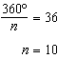

PTS: 2 REF: 082205geo NAT: G.CO.A.3 TOP: Mapping a Polygon onto Itself

6 ANS: 1
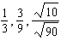

PTS: 2 REF: 082206geo NAT: G.SRT.A.2 TOP: Dilations

7 ANS: 4
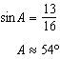

PTS: 2 REF: 082207geo NAT: G.SRT.C.8 TOP: Using Trigonometry to Find an Angle

8 ANS: 2
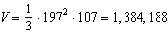

PTS: 2 REF: 082208geo NAT: G.GMD.A.3 TOP: Volume
KEY: pyramids

9 ANS: 1 PTS: 2 REF: 082209geo NAT: G.CO.A.3
TOP: Mapping a Polygon onto Itself

10 ANS: 4 PTS: 2 REF: 082210geo NAT: G.SRT.C.7
TOP: Cofunctions

11 ANS: 1 PTS: 2 REF: 082211geo NAT: G.GMD.B.4
TOP: Cross-Sections of Three-Dimensional Objects

12 ANS: 3 PTS: 2 REF: 082212geo NAT: G.SRT.A.1
TOP: Line Dilations

13 ANS: 1
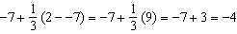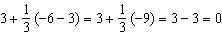

PTS: 2 REF: 082213geo NAT: G.GPE.B.6 TOP: Directed Line Segments

14 ANS: 4
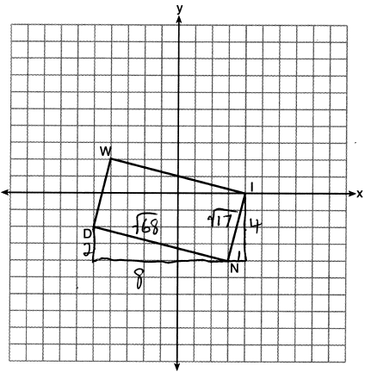

PTS: 2 REF: 082214geo NAT: G.GPE.B.7 TOP: Polygons in the Coordinate Plane

15 ANS: 3
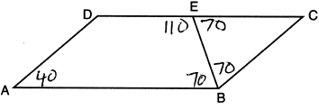

PTS: 2 REF: 082215geo NAT: G.CO.C.11 TOP: Interior and Exterior Angles of Polygons

16 ANS: 2
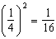

PTS: 2 REF: 082216geo NAT: G.SRT.B.5 TOP: Similarity
KEY: perimeter and area

17 ANS: 3
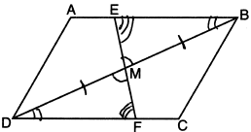

PTS: 2 REF: 082217geo NAT: G.SRT.B.5 TOP: Triangle Proofs
KEY: statements

18 ANS: 4
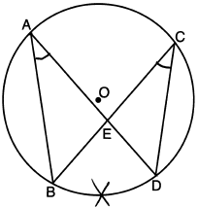

PTS: 2 REF: 082218geo NAT: G.C.A.2 TOP: Chords, Secants and Tangents
KEY: inscribed

19 ANS: 1
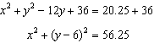

PTS: 2 REF: 082219geo NAT: G.GPE.A.1 TOP: Equations of Circles
KEY: completing the square

20 ANS: 2 PTS: 2 REF: 082220geo NAT: G.CO.A.5
TOP: Compositions of Transformations KEY: identify

21 ANS: 1
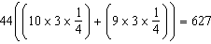

PTS: 2 REF: 082221geo NAT: G.GMD.A.3 TOP: Volume
KEY: compositions

22 ANS: 4
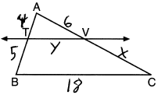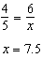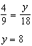

PTS: 2 REF: 082222geo NAT: G.SRT.B.5 TOP: Side Splitter Theorem

23 ANS: 2
slope of 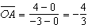 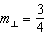

PTS: 2 REF: 082223geo NAT: G.C.A.2 TOP: Chords, Secants and Tangents
KEY: radius drawn to tangent

24 ANS: 4
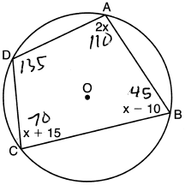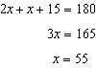

PTS: 2 REF: 082224geo NAT: G.C.A.3 TOP: Inscribed Quadrilaterals

25 ANS:

PTS: 2 REF: 082225geo NAT: G.CO.A.5 TOP: Compositions of Transformations
KEY: identify

26 ANS:
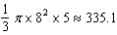

PTS: 2 REF: 082226geo NAT: G.GMD.B.4 TOP: Rotations of Two-Dimensional Objects

27 ANS:
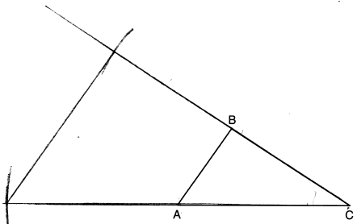

PTS: 2 REF: 082227geo NAT: G.CO.D.12 TOP: Constructions
KEY: congruent and similar figures

28 ANS:
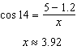

PTS: 2 REF: 082228geo NAT: G.SRT.C.8 TOP: Using Trigonometry to Find a Side

29 ANS:
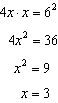

PTS: 2 REF: 082229geo NAT: G.SRT.B.5 TOP: Similarity
KEY: leg

30 ANS:
47.5° 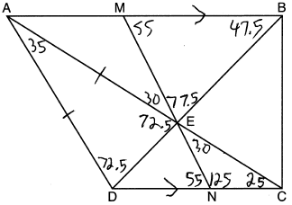

PTS: 2 REF: 082230geo NAT: G.CO.C.11 TOP: Interior and Exterior Angles of Polygons

31 ANS:
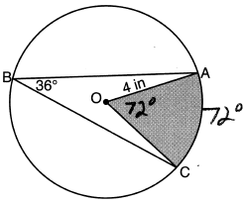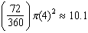

PTS: 2 REF: 082231geo NAT: G.C.B.5 TOP: Sectors

32 ANS:
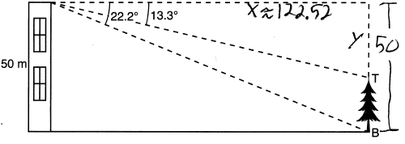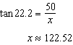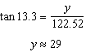

PTS: 4 REF: 082232geo NAT: G.SRT.C.8 TOP: Using Trigonometry to Find a Side
KEY: advanced

33 ANS:
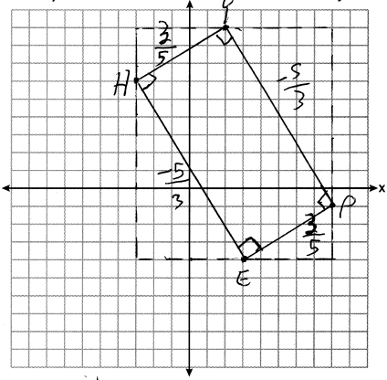 1) Quadrilateral HYPE with , , , and (Given); 2) Slope of and is , slope of and is (Slope determined graphically); 3) , , , (The slopes of perpendicular lines are opposite reciprocals); 4) , , , are right angles (Perpendicular lines form right angles); 5) HYPE is a rectangle (A rectangle has four right angles).

PTS: 4 REF: 082233geo NAT: G.GPE.B.4 TOP: Quadrilaterals in the Coordinate Plane
KEY: grids

34 ANS:
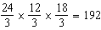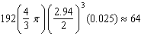

PTS: 4 REF: 082234geo NAT: G.MG.A.2 TOP: Density

35 ANS:
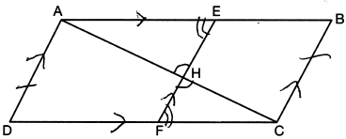 1) Quadrilateral ABCD, and intersect at H, , , and (Given); 2) (Vertical angles are congruent); 3) (Transitive property of parallel lines); 4) ABCD is a parallelogram (Quadrilateral with a pair of sides both parallel and congruent); 5) (Opposite sides of a parallelogram); 6) (Alternate interior angles formed by parallel lines and a transversal); 7) (AA); 8) 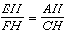 (Corresponding sides of similar triangles are proportional); 8) (Product of means equals product of extremes).

PTS: 6 REF: 082235geo NAT: G.SRT.B.5 TOP: Quadrilateral Proofs

