1 On the set of axes below, is dilated by a scale factor of centered at point P.

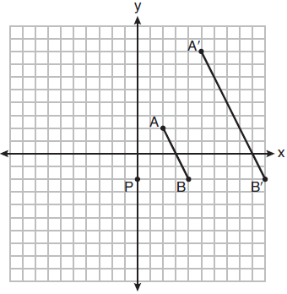

Which statement is always true?
1)
2)
3)
4) | 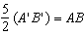

2 The coordinates of the vertices of parallelogram CDEH are , , , and . What are the coordinates of P, the point of intersection of diagonals and ?
1)
2)
3)
4)

3 The coordinates of the endpoints of are and . Point R is on such that QR:RS is in the ratio of 1:2. What are the coordinates of point R?
1)
2)
3)
4)

4 If the altitudes of a triangle meet at one of the triangle’s vertices, then the triangle is
1) | a right triangle
2) | an acute triangle
3) | an obtuse triangle
4) | an equilateral triangle

5 In the diagram below of , is a median to , and .
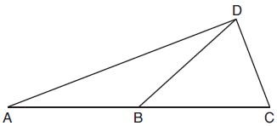
If , what is ?
1) | 32º
2) | 52º
3) | 58º
4) | 64º

6 What are the coordinates of the center and the length of the radius of the circle whose equation is ?
1) | center and radius 64
2) | center and radius 64
3) | center and radius 8
4) | center and radius 8

7 In the diagram below of parallelogram ABCD, , bisects , bisects , and and intersect at E.
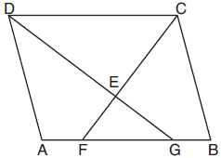
If , then the measure of is
1) | 142.5°
2) | 127.5°
3) | 52.5°
4) | 37.5°

8 What is an equation of a line that is perpendicular to the line whose equation is ?
1) | 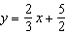
2) | 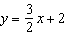
3) | 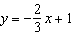
4) | 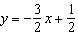

9 Triangles ABC and RST are graphed on the set of axes below.
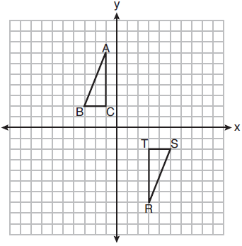
Which sequence of rigid motions will prove ?
1) | a line reflection over
2) | a rotation of 180° centered at
3) | a line reflection over the x-axis followed by a translation of 6 units right
4) | a line reflection over the x-axis followed by a line reflection over

10 If the line represented by 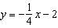 is dilated by a scale factor of 4 centered at the origin, which statement about the image is true?
1) | The slope is and the y-intercept is .
2) | The slope is and the y-intercept is .
3) | The slope is and the y-intercept is .
4) | The slope is and the y-intercept is .

11 Square MATH has a side length of 7 inches. Which three-dimensional object will be formed by continuously rotating square MATH around side ?
1) | a right cone with a base diameter of 7 inches
2) | a right cylinder with a diameter of 7 inches
3) | a right cone with a base radius of 7 inches
4) | a right cylinder with a radius of 7 inches

12 Circle O with a radius of 9 is drawn below. The measure of central angle AOC is 120°.
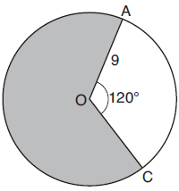

What is the area of the shaded sector of circle O?
1)
2)
3)
4)

13 In quadrilateral QRST, diagonals and intersect at M. Which statement would always prove quadrilateral QRST is a parallelogram?
1) | and are supplementary.
2) | and
3) | and
4) | and

14 A standard-size golf ball has a diameter of 1.680 inches. The material used to make the golf ball weighs 0.6523 ounce per cubic inch. What is the weight, to the nearest hundredth of an ounce, of one golf ball?
1) | 1.10
2) | 1.62
3) | 2.48
4) | 3.81

15 Chelsea is sitting 8 feet from the foot of a tree. From where she is sitting, the angle of elevation of her line of sight to the top of the tree is 36°. If her line of sight starts 1.5 feet above ground, how tall is the tree, to the nearest foot?
1) | 8
2) | 7
3) | 6
4) | 4

16 In the diagram below of right triangle ABC, altitude intersects hypotenuse at D.
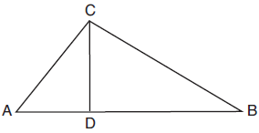
Which equation is always true?
1) | 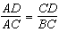
2) | 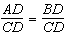
3) | 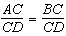
4) | 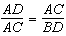

17 A countertop for a kitchen is modeled with the dimensions shown below. An 18-inch by 21-inch rectangle will be removed for the installation of the sink.
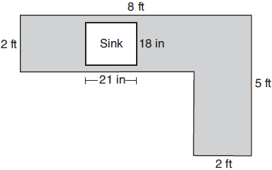
What is the area of the top of the installed countertop, to the nearest square foot?
1) | 26
2) | 23
3) | 22
4) | 19

18 In the diagram below, connects points B and C on the congruent sides of isosceles triangle ADE, such that is isosceles with vertex angle A.

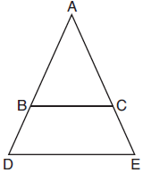

If , , and , what is the length of ?
1) | 6
2) | 7
3) | 8
4) | 9

19 In below, angle C is a right angle.
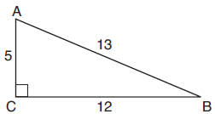

Which statement must be true?
1)
2)
3)
4)

20 In right triangle RST, altitude is drawn to hypotenuse . If and , what is the length of ?
1)
2) | 15
3)
4) | 27

21 What is the volume, in cubic centimeters, of a right square pyramid with base edges that are 64 cm long and a slant height of 40 cm?
1) | 8192.0
2)
3) | 32,768.0
4)

22 In the diagram below, chords and of circle O intersect at T.
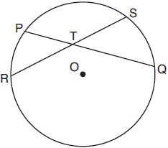
Which relationship must always be true?
1)
2)
3)
4)

23 A rhombus is graphed on the set of axes below.
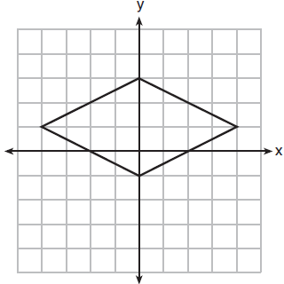
Which transformation would carry the rhombus onto itself?
1) | 180° rotation counterclockwise about the origin
2) | reflection over the line 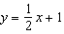
3) | reflection over the line
4) | reflection over the line

24 A 15-foot ladder leans against a wall and makes an angle of 65° with the ground. What is the horizontal distance from the wall to the base of the ladder, to the nearest tenth of a foot?
1) | 6.3
2) | 7.0
3) | 12.9
4) | 13.6

25 In parallelogram ABCD shown below, and .

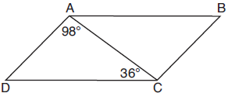

What is the measure of angle B? Explain why.

26 An airplane took off at a constant angle of elevation. After the plane traveled for 25 miles, it reached an altitude of 5 miles, as modeled below.

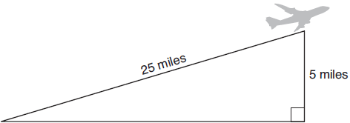

To the nearest tenth of a degree, what was the angle of elevation?

27 On the set of axes below, .

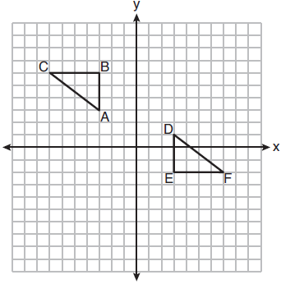

Describe a sequence of rigid motions that maps onto .

28 The vertices of have coordinates , , and . Determine and state the area of . [The use of the set of axes below is optional.]

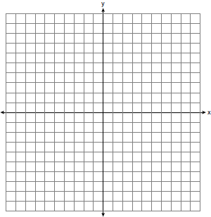

29 Using the construction below, state the degree measure of . Explain why.

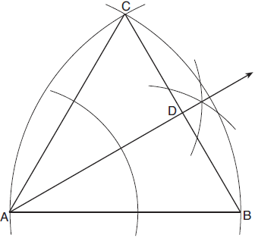

30 In the diagram below of circle K, secant and tangent are drawn from external point P.

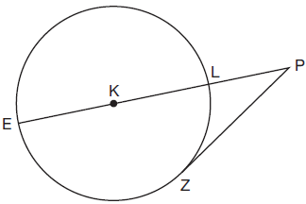

If , determine and state the degree measure of angle P.

31 A large water basin is in the shape of a right cylinder. The inside of the basin has a diameter of feet and a height of 3 feet. Determine and state, to the nearest cubic foot, the number of cubic feet of water that it will take to fill the basin to a level of foot from the top.

32 Triangle ABC is shown below. Using a compass and straightedge, construct the dilation of centered at B with a scale factor of 2. [Leave all construction marks.]

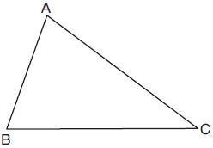

Is the image of similar to the original triangle? Explain why.

33 In the diagram below, .

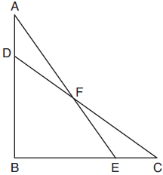

Prove:

34 A cargo trailer, pictured below, can be modeled by a rectangular prism and a triangular prism. Inside the trailer, the rectangular prism measures 6 feet wide and 10 feet long. The walls that form the triangular prism each measure 4 feet wide inside the trailer. The diagram below is of the floor, showing the inside measurements of the trailer.

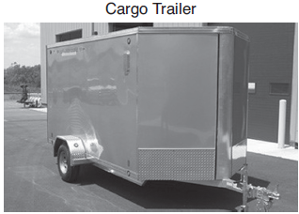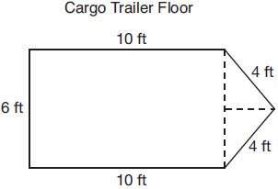

If the inside height of the trailer is 6.5 feet, what is the total volume of the inside of the trailer, to the nearest cubic foot?

35 The coordinates of the vertices of are , , and . Prove that is isosceles. State the coordinates of point D such that quadrilateral ABCD is a square. Prove that your quadrilateral ABCD is a square. [The use of the set of axes below is optional.]

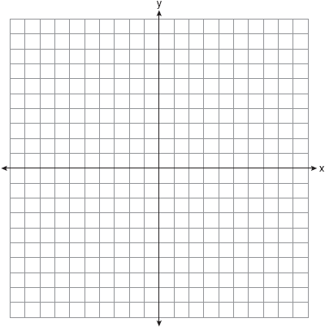
1 ANS: 2 PTS: 2 REF: 081901geo NAT: G.SRT.A.1
TOP: Line Dilations

2 ANS: 3
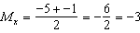 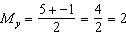.

PTS: 2 REF: 081902geo NAT: G.GPE.B.4 TOP: Quadrilaterals in the Coordinate Plane
KEY: general

3 ANS: 3
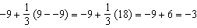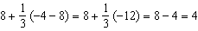

PTS: 2 REF: 081903geo NAT: G.GPE.B.6 TOP: Directed Line Segments

4 ANS: 1 PTS: 2 REF: 081904geo NAT: G.CO.C.10
TOP: Centroid, Orthocenter, Incenter and Circumcenter

5 ANS: 3
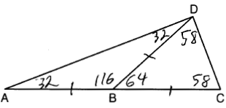

PTS: 2 REF: 081905geo NAT: G.CO.C.10 TOP: Exterior Angle Theorem

6 ANS: 4
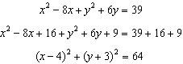

PTS: 2 REF: 081906geo NAT: G.GPE.A.1 TOP: Equations of Circles
KEY: completing the square

7 ANS: 2
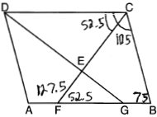

PTS: 2 REF: 081907geo NAT: G.CO.C.11 TOP: Interior and Exterior Angles of Polygons

8 ANS: 1
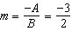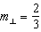

PTS: 2 REF: 081908geo NAT: G.GPE.B.5 TOP: Parallel and Perpendicular Lines
KEY: identify perpendicular lines

9 ANS: 2 PTS: 2 REF: 081909geo NAT: G.CO.A.5
TOP: Compositions of Transformations KEY: identify

10 ANS: 1
A dilation by a scale factor of 4 centered at the origin preserves parallelism and .

PTS: 2 REF: 081910geo NAT: G.SRT.A.1 TOP: Line Dilations

11 ANS: 4 PTS: 2 REF: 081911geo NAT: G.GMD.B.4
TOP: Rotations of Two-Dimensional Objects

12 ANS: 4
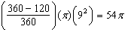

PTS: 2 REF: 081912geo NAT: G.C.B.5 TOP: Sectors

13 ANS: 3 PTS: 2 REF: 081913geo NAT: G.CO.C.11
TOP: Special Quadrilaterals

14 ANS: 2
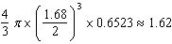

PTS: 2 REF: 081914geo NAT: G.MG.A.2 TOP: Density

15 ANS: 2
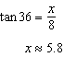

PTS: 2 REF: 081915geo NAT: G.SRT.C.8 TOP: Using Trigonometry to Find a Side

16 ANS: 1 PTS: 2 REF: 081916geo NAT: G.SRT.B.5
TOP: Similarity KEY: leg

17 ANS: 4
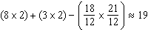

PTS: 2 REF: 081917geo NAT: G.MG.A.3 TOP: Compositions of Polygons and Circles
KEY: area

18 ANS: 3
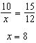

PTS: 2 REF: 081918geo NAT: G.SRT.B.5 TOP: Similarity
KEY: basic

19 ANS: 1 PTS: 2 REF: 081919geo NAT: G.SRT.C.7
TOP: Cofunctions

20 ANS: 2
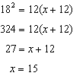

PTS: 2 REF: 081920geo NAT: G.SRT.B.5 TOP: Similarity
KEY: leg

21 ANS: 3
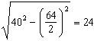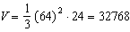

PTS: 2 REF: 081921geo NAT: G.GMD.A.3 TOP: Volume
KEY: pyramids

22 ANS: 4 PTS: 2 REF: 081922geo NAT: G.C.A.2
TOP: Chords, Secants and Tangents KEY: intersecting chords, length

23 ANS: 4 PTS: 2 REF: 081923geo NAT: G.CO.A.3
TOP: Mapping a Polygon onto Itself

24 ANS: 1
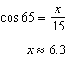

PTS: 2 REF: 081924geo NAT: G.SRT.C.8 TOP: Using Trigonometry to Find a Side

25 ANS:
because the angles of a triangle equal 180°. because opposite angles of a parallelogram are congruent.

PTS: 2 REF: 081925geo NAT: G.CO.C.11 TOP: Interior and Exterior Angles of Polygons

26 ANS:
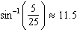

PTS: 2 REF: 081926geo NAT: G.SRT.C.8 TOP: Using Trigonometry to Find an Angle

27 ANS:

PTS: 2 REF: 081927geo NAT: G.CO.A.5 TOP: Compositions of Transformations
KEY: identify

28 ANS:
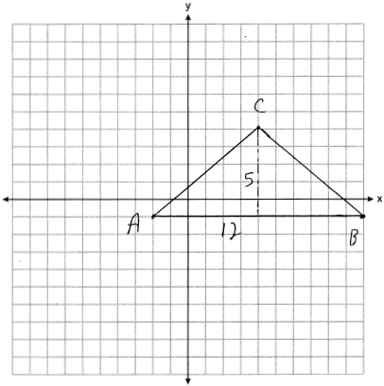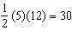

PTS: 2 REF: 081928geo NAT: G.GPE.B.7 TOP: Polygons in the Coordinate Plane

29 ANS:
30° is an equilateral triangle, so . Since is an angle bisector, .

PTS: 2 REF: 081929geo NAT: G.CO.D.12 TOP: Constructions
KEY: equilateral triangles

30 ANS:
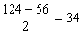

PTS: 2 REF: 081930geo NAT: G.C.A.2 TOP: Chords, Secants and Tangents
KEY: secant and tangent drawn from common point, angle

31 ANS:
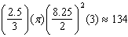

PTS: 2 REF: 081931geo NAT: G.GMD.A.3 TOP: Volume
KEY: cylinders

32 ANS:
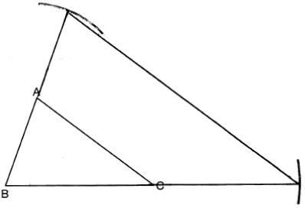Yes, because a dilation preserves angle measure.

PTS: 4 REF: 081932geo NAT: G.CO.D.12 TOP: Constructions
KEY: congruent and similar figures

33 ANS:
(given); (CPCTC); (vertical angles are congruent); , (CPCTC); (segment subtraction); (AAS)

PTS: 4 REF: 081933geo NAT: G.SRT.B.5 TOP: Triangle Proofs
KEY: proof

34 ANS:
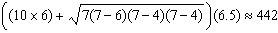

PTS: 4 REF: 081934geo NAT: G.GMD.A.3 TOP: Volume
KEY: compositions

35 ANS:
, (because , is isosceles). . , , 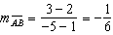, 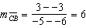 (ABCD is a square because all four sides are congruent, consecutive sides are perpendicular since slopes are opposite reciprocals and so is a right angle). 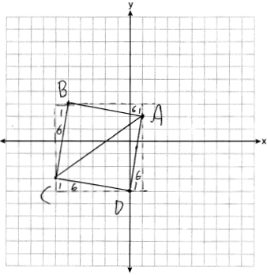

PTS: 6 REF: 081935geo NAT: G.GPE.B.4 TOP: Quadrilaterals in the Coordinate Plane
KEY: grids

