1 In the diagram below, , and and are drawn.

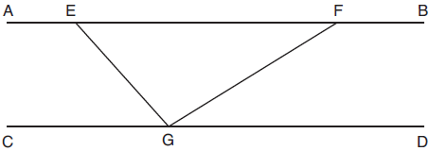

If and , what is ?
1) | 11º
2) | 43º
3) | 75º
4) | 105º

2 If is mapped onto after a line reflection and is mapped onto after a translation, the relationship between and is that they are always
1) | congruent and similar
2) | congruent but not similar
3) | similar but not congruent
4) | neither similar nor congruent

3 An isosceles right triangle whose legs measure 6 is continuously rotated about one of its legs to form a three-dimensional object. The three-dimensional object is a
1) | cylinder with a diameter of 6
2) | cylinder with a diameter of 12
3) | cone with a diameter of 6
4) | cone with a diameter of 12

4 In regular hexagon ABCDEF shown below, , , and all intersect at G.

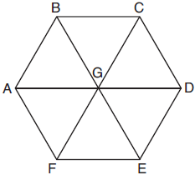

When is reflected over and then rotated 180° about point G, is mapped onto
1)
2)
3)
4)

5 A right cylinder is cut perpendicular to its base. The shape of the cross section is a
1) | circle
2) | cylinder
3) | rectangle
4) | triangular prism

6 Yolanda is making a springboard to use for gymnastics. She has 8-inch-tall springs and wants to form a 16.5° angle with the base, as modeled in the diagram below.

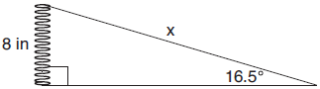

To the nearest tenth of an inch, what will be the length of the springboard, x?
1) | 2.3
2) | 8.3
3) | 27.0
4) | 28.2

7 In the diagram below of right triangle ABC, altitude is drawn to hypotenuse .

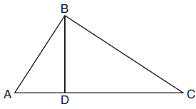

If , , and , what is the length of ?
1) | 5
2) | 2
3) | 8
4) | 11

8 Rhombus STAR has vertices , , , and . What is the perimeter of rhombus STAR?
1)
2)
3)
4)

9 In the diagram below of and , angles H and N are right angles, and .

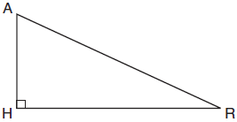

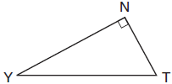

If and , what is the measure of angle Y, to the nearest degree?
1) | 23°
2) | 25°
3) | 65°
4) | 67°

10 In the diagram below, , , , and are drawn such that .

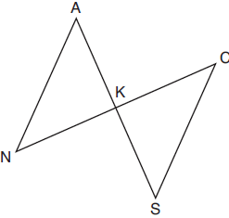

Which additional statement is sufficient to prove by AAS?
1) | and bisect each other.
2) | K is the midpoint of .
3)
4)

11 Which equation represents a line that is perpendicular to the line represented by 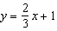?
1)
2)
3) | 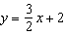
4) | 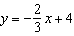

12 In the diagram of below, points D and E are on sides and respectively, such that .

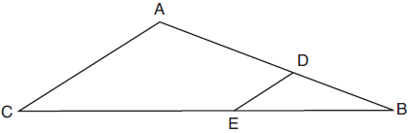

If EB is 3 more than DB, , and , what is the length of ?
1) | 6
2) | 8
3) | 9
4) | 12

13 Quadrilateral MATH has both pairs of opposite sides congruent and parallel. Which statement about quadrilateral MATH is always true?
1)
2)
3)
4)

14 In the figure shown below, quadrilateral TAEO is circumscribed around circle D. The midpoint of is R, and .

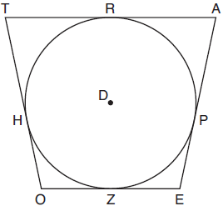

If and , what is the perimeter of quadrilateral TAEO?
1) | 56
2) | 64
3) | 72
4) | 76

15 The coordinates of the endpoints of directed line segment ABC are and . If , the coordinates of B are
1)
2)
3)
4)

16 In triangle ABC, points D and E are on sides and , respectively, such that , and .

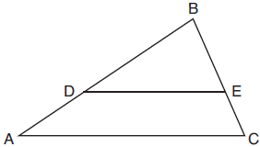

If and , what is the length of , to the nearest tenth?
1) | 3.8
2) | 5.6
3) | 5.9
4) | 15.7

17 In the diagram below, rectangle ABCD has vertices whose coordinates are , , , and .

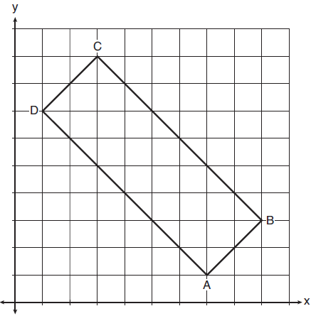

Which transformation will not carry the rectangle onto itself?
1) | a reflection over the line
2) | a reflection over the line
3) | a rotation of 180° about the point
4) | a rotation of 180° about the point

18 A circle with a diameter of 10 cm and a central angle of 30° is drawn below.

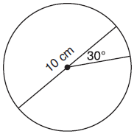

What is the area, to the nearest tenth of a square centimeter, of the sector formed by the 30° angle?
1) | 5.2
2) | 6.5
3) | 13.1
4) | 26.2

19 A child's tent can be modeled as a pyramid with a square base whose sides measure 60 inches and whose height measures 84 inches. What is the volume of the tent, to the nearest cubic foot?
1) | 35
2) | 58
3) | 82
4) | 175

20 In the accompanying diagram of right triangle ABC, altitude is drawn to hypotenuse .
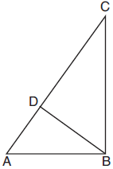
Which statement must always be true?
1) | 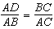
2) | 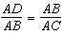
3) | 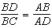
4) | 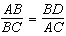

21 An equation of circle O is . The statement that best describes circle O is the
1) | center is and is tangent to the x-axis
2) | center is and is tangent to the y-axis
3) | center is and is tangent to the x-axis
4) | center is and is tangent to the y-axis

22 In , is the perpendicular bisector of . Based upon this information, which statements below can be proven?
I. is a median.
II. bisects .
III. is isosceles.
1) | I and II, only
2) | I and III, only
3) | II and III, only
4) | I, II, and III

23 Triangle RJM has an area of 6 and a perimeter of 12. If the triangle is dilated by a scale factor of 3 centered at the origin, what are the area and perimeter of its image, triangle R'J'M'?
1) | area of 9 and perimeter of 15
2) | area of 18 and perimeter of 36
3) | area of 54 and perimeter of 36
4) | area of 54 and perimeter of 108

24 If , what is the value of x?
1) | 7
2) | 15
3) | 21
4) | 30

25 In the circle below, is a chord. Using a compass and straightedge, construct a diameter of the circle. [Leave all construction marks.]

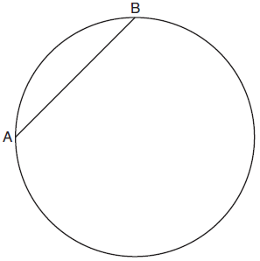

26 In parallelogram ABCD shown below, the bisectors of and meet at E, a point on .

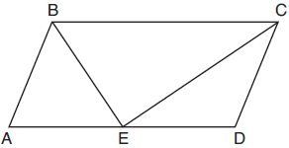

If , determine and state .

27 In circle A below, chord and diameter intersect at F.

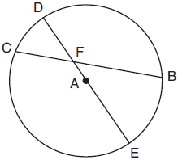

If and , what is ?

28 Trapezoids ABCD and A"B"C"D" are graphed on the set of axes below.

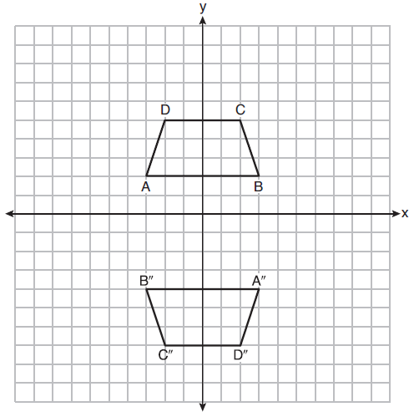

Describe a sequence of transformations that maps trapezoid ABCD onto trapezoid A"B"C"D".

29 In the model below, a support wire for a telephone pole is attached to the pole and anchored to a stake in the ground 15 feet from the base of the telephone pole. Jamal places a 6-foot wooden pole under the support wire parallel to the telephone pole, such that one end of the pole is on the ground and the top of the pole is touching the support wire. He measures the distance between the bottom of the pole and the stake in the ground.

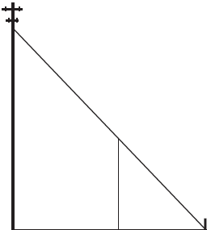

Jamal says he can approximate how high the support wire attaches to the telephone pole by using similar triangles. Explain why the triangles are similar.

30 Aliyah says that when the line is dilated by a scale factor of 2 centered at the point , the equation of the dilated line is 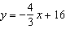. Is Aliyah correct? Explain why. [The use of the set of axes below is optional.]

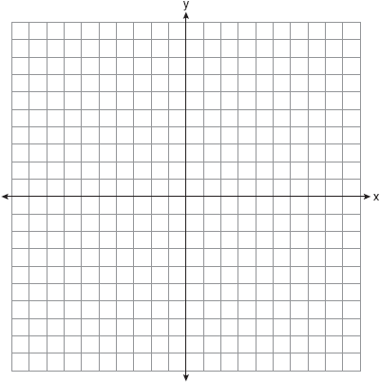

31 Ian needs to replace two concrete sections in his sidewalk, as modeled below. Each section is 36 inches by 36 inches and 4 inches deep. He can mix his own concrete for $3.25 per cubic foot.

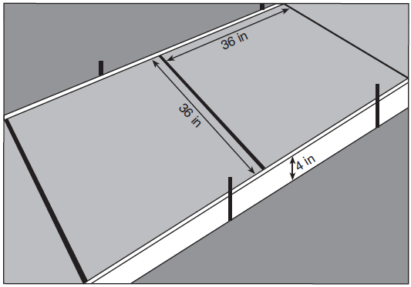

How much money will it cost Ian to replace the two concrete sections?

32 Given: , , with , and
Prove: is the perpendicular bisector of

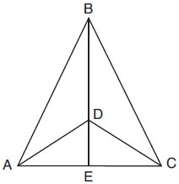

Fill in the missing statement and reasons below.

Statements | Reasons
1 , , with , and | 1 Given
2 | 2
3 and are supplementary. and are supplementary. | 3 Linear pairs of angles are supplementary.
4 | 4 Supplements of congruent angles are congruent.
5 | 5 ASA
6 , | 6
7 is the perpendicular bisector of . | 7

33 A homeowner is building three steps leading to a deck, as modeled by the diagram below. All three step rises, , , and , are congruent, and all three step runs, , , and , are congruent. Each step rise is perpendicular to the step run it joins. The measure of and .

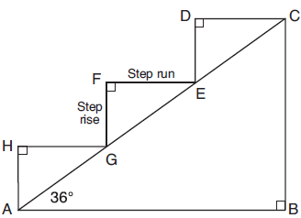

If each step run is parallel to and has a length of 10 inches, determine and state the length of each step rise, to the nearest tenth of an inch. Determine and state the length of , to the nearest inch.

34 A bakery sells hollow chocolate spheres. The larger diameter of each sphere is 4 cm. The thickness of the chocolate of each sphere is 0.5 cm. Determine and state, to the nearest tenth of a cubic centimeter, the amount of chocolate in each hollow sphere. The bakery packages 8 of them into a box. If the density of the chocolate is 1.308 g/cm³, determine and state, to the nearest gram, the total mass of the chocolate in the box.

35 The vertices of quadrilateral MATH have coordinates , , , and . Prove that quadrilateral MATH is a parallelogram. Prove that quadrilateral MATH is a rectangle. [The use of the set of axes below is optional.]

1 ANS: 4 PTS: 2 REF: 081801geo NAT: G.CO.C.9
TOP: Lines and Angles

2 ANS: 1
Distance and angle measure are preserved after a reflection and translation.

PTS: 2 REF: 081802geo NAT: G.CO.B.6 TOP: Properties of Transformations
KEY: basic

3 ANS: 4 PTS: 2 REF: 081803geo NAT: G.GMD.B.4
TOP: Rotations of Two-Dimensional Objects

4 ANS: 1 PTS: 2 REF: 081804geo NAT: G.SRT.A.2
TOP: Compositions of Transformations KEY: grids

5 ANS: 3 PTS: 2 REF: 081805geo NAT: G.GMD.B.4
TOP: Cross-Sections of Three-Dimensional Objects

6 ANS: 4
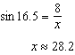

PTS: 2 REF: 081806ai NAT: G.SRT.C.8 TOP: Using Trigonometry to Find a Side

7 ANS: 3
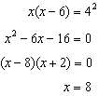

PTS: 2 REF: 081807geo NAT: G.SRT.B.5 TOP: Similarity
KEY: altitude

8 ANS: 4

PTS: 2 REF: 081808geo NAT: G.GPE.B.7 TOP: Polygons in the Coordinate Plane

9 ANS: 1
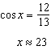

PTS: 2 REF: 081809ai NAT: G.SRT.C.8 TOP: Using Trigonometry to Find an Angle

10 ANS: 4 PTS: 2 REF: 081810geo NAT: G.SRT.B.5
TOP: Triangle Proofs KEY: statements

11 ANS: 1
The slope of is , which is the opposite reciprocal of .

PTS: 2 REF: 081811geo NAT: G.GPE.B.5 TOP: Parallel and Perpendicular Lines
KEY: identify perpendicular lines

12 ANS: 2
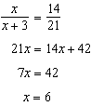

PTS: 2 REF: 081812geo NAT: G.SRT.B.5 TOP: Side Splitter Theorem

13 ANS: 4 PTS: 2 REF: 081813geo NAT: G.CO.C.11
TOP: Parallelograms

14 ANS: 2
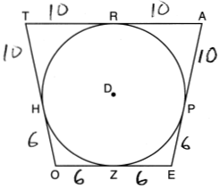

PTS: 2 REF: 081814geo NAT: G.C.A.2 TOP: Chords, Secants and Tangents
KEY: tangents drawn from common point, length

15 ANS: 1
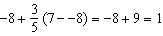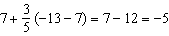

PTS: 2 REF: 081815geo NAT: G.GPE.B.6 TOP: Directed Line Segments

16 ANS: 3
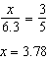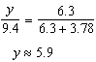

PTS: 2 REF: 081816geo NAT: G.SRT.B.5 TOP: Side Splitter Theorem

17 ANS: 3 PTS: 2 REF: 081817geo NAT: G.CO.A.3
TOP: Mapping a Polygon onto Itself

18 ANS: 2
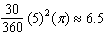

PTS: 2 REF: 081818geo NAT: G.C.B.5 TOP: Sectors

19 ANS: 2
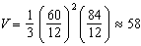

PTS: 2 REF: 081819geo NAT: G.GMD.A.3 TOP: Volume
KEY: pyramids

20 ANS: 2
since is a 6-8-10 triangle. 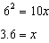

PTS: 2 REF: 081820geo NAT: G.SRT.B.5 TOP: Similarity
KEY: leg

21 ANS: 4
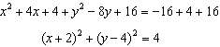

PTS: 2 REF: 081821geo NAT: G.GPE.A.1 TOP: Equations of Circles
KEY: completing the square

22 ANS: 4 PTS: 2 REF: 081822geo NAT: G.CO.C.10
TOP: Medians, Altitudes and Bisectors

23 ANS: 3

PTS: 2 REF: 081823geo NAT: G.SRT.A.2 TOP: Dilations

24 ANS: 2
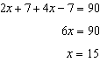

PTS: 2 REF: 081824geo NAT: G.SRT.C.7 TOP: Cofunctions

25 ANS:
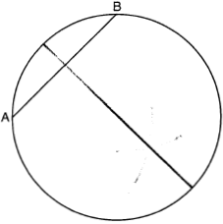

PTS: 2 REF: 081825geo NAT: G.CO.D.12 TOP: Constructions
KEY: parallel and perpendicular lines

26 ANS:
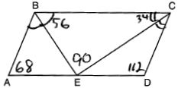

PTS: 2 REF: 081826geo NAT: G.CO.C.11 TOP: Parallelograms

27 ANS:
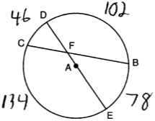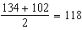

PTS: 2 REF: 081827geo NAT: G.C.A.2 TOP: Chords, Secants and Tangents
KEY: intersecting chords, angle

28 ANS:
rotation 180º about the origin, translation 2 units down; rotation 180º about B, translation 6 units down and 6 units left; or reflection over x-axis, translation 2 units down, reflection over y-axis

PTS: 2 REF: 081828geo NAT: G.CO.A.5 TOP: Compositions of Transformations
KEY: identify

29 ANS:
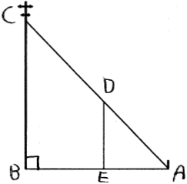 by AA. because they are the same . because they are both right s.

PTS: 2 REF: 081829geo NAT: G.SRT.B.5 TOP: Similarity
KEY: basic

30 ANS:
No, The line passes through the center of dilation, so the dilated line is not distinct. 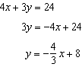

PTS: 2 REF: 081830geo NAT: G.SRT.A.1 TOP: Line Dilations

31 ANS:
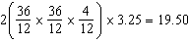

PTS: 2 REF: 081831geo NAT: G.GMD.A.3 TOP: Volume
KEY: prisms

32 ANS:
2 Reflexive; 4 ; 6 CPCTC; 7 If points B and D are equidistant from the endpoints of , then B and D are on the perpendicular bisector of .

PTS: 4 REF: 081832geo NAT: G.SRT.B.5 TOP: Triangle Proofs
KEY: proof

33 ANS:
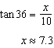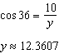

PTS: 4 REF: 081833geo NAT: G.SRT.C.8 TOP: Using Trigonometry to Find a Side

34 ANS:
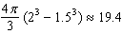

PTS: 4 REF: 081834geo NAT: G.MG.A.2 TOP: Density

35 ANS:
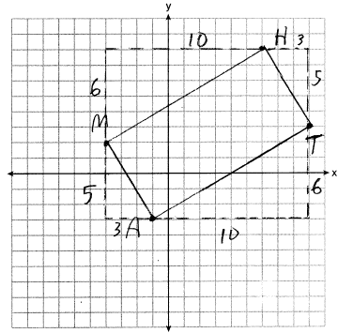 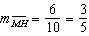, 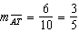, 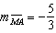, 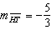; and . MATH is a parallelogram since both sides of opposite sides are parallel. , 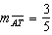. Since the slopes are negative reciprocals, and is a right angle. MATH is a rectangle because it is a parallelogram with a right angle.

PTS: 6 REF: 081835geo NAT: G.GPE.B.4 TOP: Quadrilaterals in the Coordinate Plane
KEY: grids

