1 A two-dimensional cross section is taken of a three-dimensional object. If this cross section is a triangle, what can not be the three-dimensional object?
1) | cone | 3) | pyramid
2) | cylinder | 4) | rectangular prism

2 The image of is . Under which transformation will he triangles not be congruent?
1) | a reflection through the origin | 3) | a dilation with a scale factor of 1 centered at
2) | a reflection over the line | 4) | a dilation with a scale factor of centered at the origin

3 The vertices of square RSTV have coordinates , , , and . What is the perimeter of RSTV?
1) |  | 3)
2) |  | 4)

4 In the diagram below of circle O, chord is parallel to diameter and .

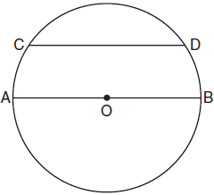

What is ?
1) | 25 | 3) | 65
2) | 50 | 4) | 115

5 In the diagram below, intersects at C, and .
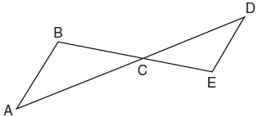

If cm, cm, cm, and cm, what is the length of , to the nearest hundredth of a centimeter?
1) | 2.70 | 3) | 5.28
2) | 3.34 | 4) | 8.25

6 As shown in the graph below, the quadrilateral is a rectangle.
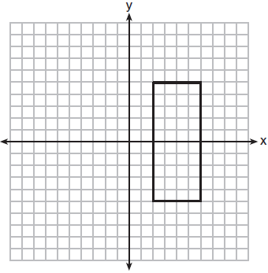

Which transformation would not map the rectangle onto itself?
1) | a reflection over the x-axis | 3) | a rotation of 180° about the origin
2) | a reflection over the line | 4) | a rotation of 180° about the point

7 In the diagram below, triangle ACD has points B and E on sides and , respectively, such that , , , and
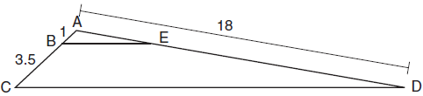

What is the length of , to the nearest tenth?
1) | 14.0 | 3) | 3.3
2) | 5.1 | 4) | 4.0

8 In the diagram below of parallelogram ROCK, is 70° and is 65°.
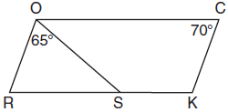

What is ?
1) | 45º | 3) | 115º
2) | 110º | 4) | 135º

9 In the diagram below, , , , , and .

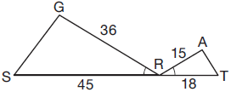

Which triangle similarity statement is correct?
1) | by AA. | 3) | by SSS.
2) | by SAS. | 4) | is not similar to .

10 The line represented by the equation is transformed by a dilation centered at the origin. Which linear equation could represent its image?
1) |  | 3)
2) |  | 4)

11 Given with and side extended to D, as shown below.
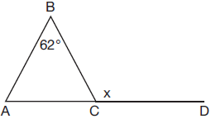
Which value of x makes ?
1) | 59º | 3) | 118º
2) | 62º | 4) | 121º

12 In the diagram shown below, is tangent to circle T at A, and secant is drawn where point B is on circle T.

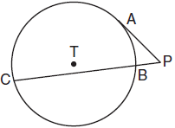

If and , what is the length of ?
1) |  | 3) | 3
2) |  | 4) | 9

13 A rectangle whose length and width are 10 and 6, respectively, is shown below. The rectangle is continuously rotated around a straight line to form an object whose volume is .

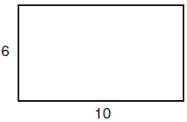

Which line could the rectangle be rotated around?
1) | a long side | 3) | the vertical line of symmetry
2) | a short side | 4) | the horizontal line of symmetry

14 If ABCD is a parallelogram, which statement would prove that ABCD is a rhombus?
1) |  | 3)
2) |  | 4)

15 To build a handicapped-access ramp, the building code states that for every 1 inch of vertical rise in height, the ramp must extend out 12 inches horizontally, as shown in the diagram below.

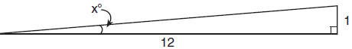

What is the angle of inclination, x, of this ramp, to the nearest hundredth of a degree?
1) | 4.76 | 3) | 85.22
2) | 4.78 | 4) | 85.24

16 In the diagram below of , D, E, and F are the midpoints of , , and , respectively.

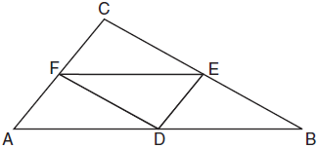

What is the ratio of the area of to the area of ?
1) | 1:1 | 3) | 1:3
2) | 1:2 | 4) | 1:4

17 The coordinates of the endpoints of are and . Point P is on . What are the coordinates of point P, such that is 3:5?
1) |  | 3)
2) |  | 4)

18 Kirstie is testing values that would make triangle KLM a right triangle when is an altitude, and , as shown below.
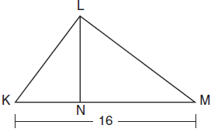

Which lengths would make triangle KLM a right triangle?
1) | and | 3) | and
2) | and | 4) | and

19 In right triangle ABC, , , and . What is the length of , to the nearest tenth of a centimeter?
1) | 3.3 | 3) | 5.3
2) | 3.9 | 4) | 11.7

20 The 2010 U.S. Census populations and population densities are shown in the table below.

State | Population Density 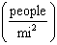 | Population in  2010
Florida | 350.6 | 18,801,310
Illinois | 231.1 | 12,830,632
New York | 411.2 | 19,378,102
Pennsylvania | 283.9 | 12,702,379

Based on the table above, which list has the states' areas, in square miles, in order from largest to smallest?
1) | Illinois, Florida, New York, Pennsylvania | 3) | New York, Florida, Pennsylvania, Illinois
2) | New York, Florida, Illinois, Pennsylvania | 4) | Pennsylvania, New York, Florida, Illinois

21 In a right triangle, . What is the value of x?
1) | 10 | 3) | 20
2) | 15 | 4) | 25

22 A regular decagon is rotated n degrees about its center, carrying the decagon onto itself. The value of n could be
1) | 10° | 3) | 225°
2) | 150° | 4) | 252°

23 In a circle with a diameter of 32, the area of a sector is 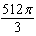. The measure of the angle of the sector, in radians, is
1) |  | 3)
2) |  | 4)

24 What is an equation of the perpendicular bisector of the line segment shown in the diagram below?
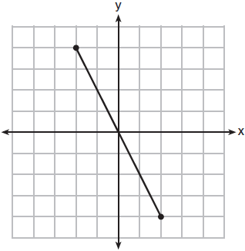
1) |  | 3)
2) |  | 4)

25 Sue believes that the two cylinders shown in the diagram below have equal volumes.
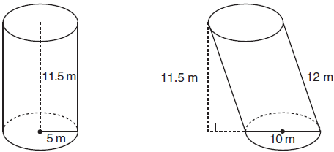

Is Sue correct? Explain why.

26 In the diagram of rhombus PQRS below, the diagonals and intersect at point T, , and . Determine and state the perimeter of PQRS.

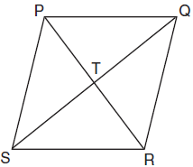

27 Quadrilateral MATH and its image M"A"T"H" are graphed on the set of axes below.

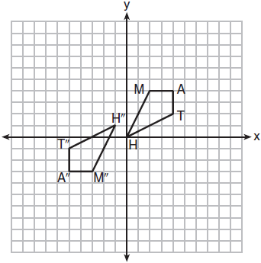

Describe a sequence of transformations that maps quadrilateral MATH onto quadrilateral M"A"T"H".

28 Using a compass and straightedge, construct a regular hexagon inscribed in circle O. [Leave all construction marks.]

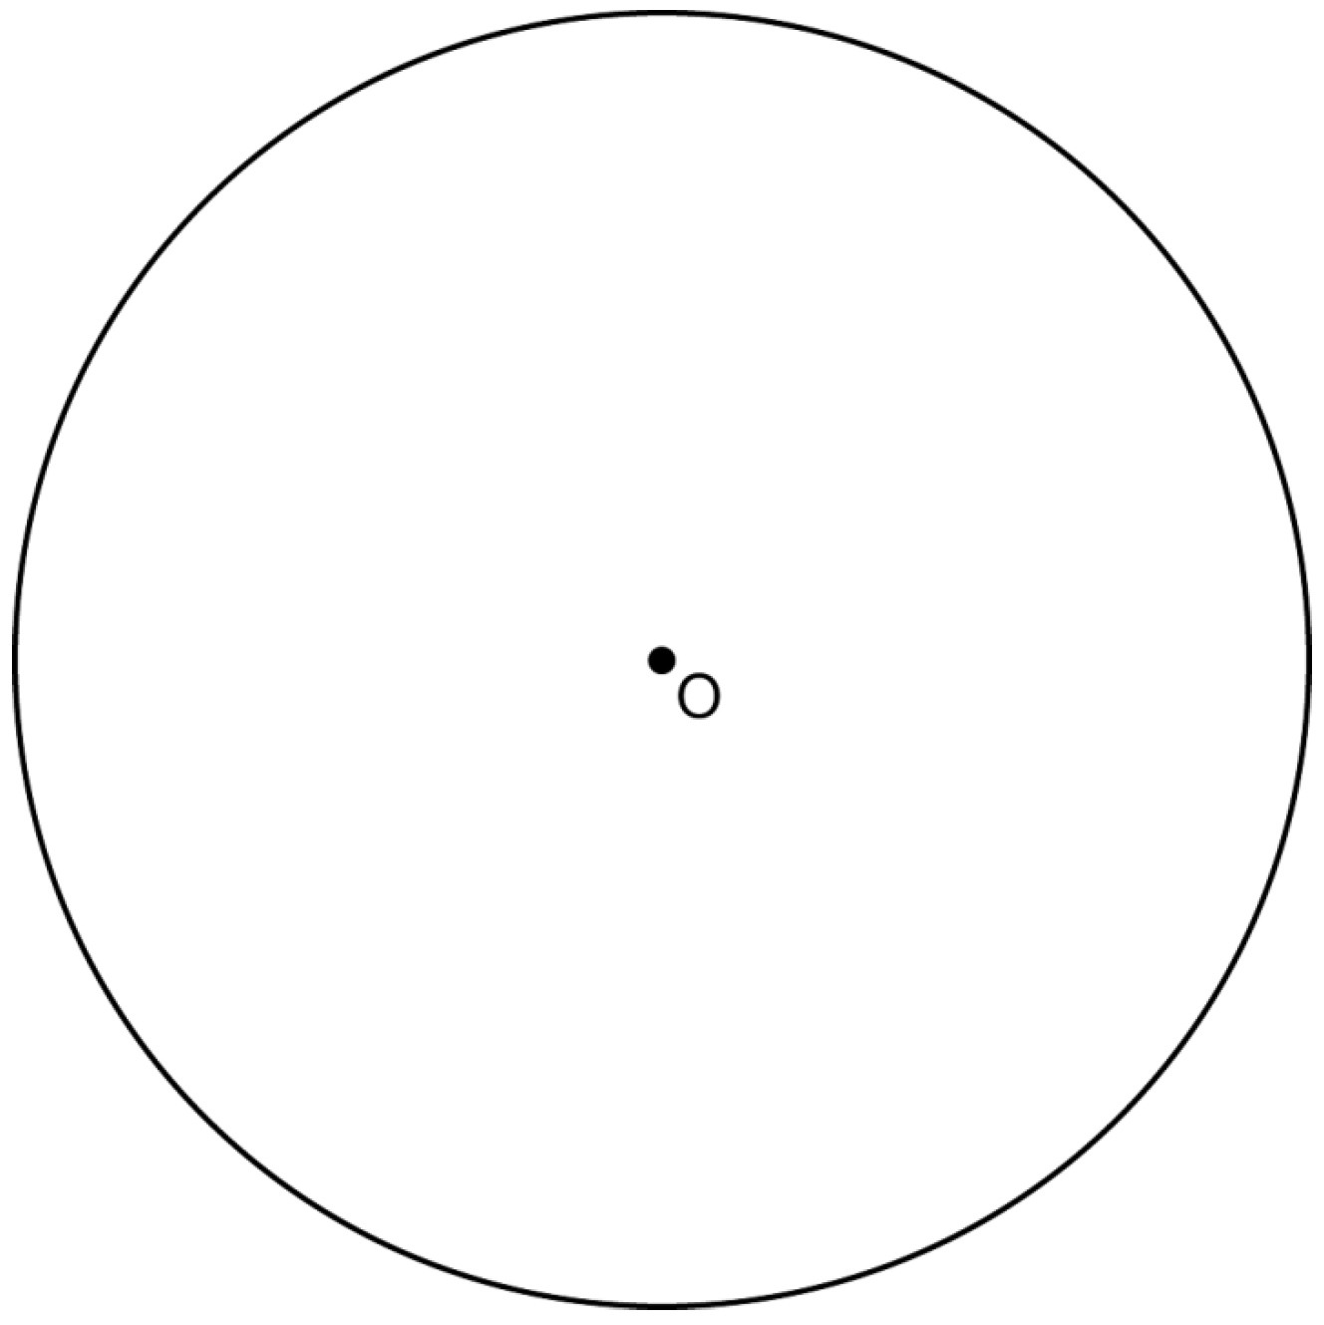

29 The coordinates of the endpoints of are and . Determine the length of , the image of , after a dilation of centered at the origin. [The use of the set of axes below is optional.]

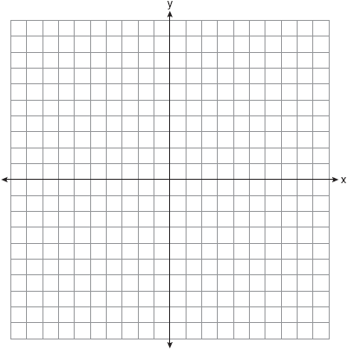

30 In the diagram below of and , a sequence of rigid motions maps onto ,
onto , and onto .

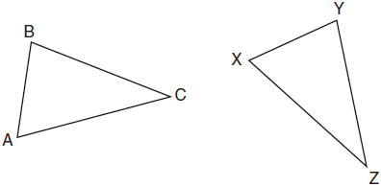

Determine and state whether . Explain why.

31 Determine and state the coordinates of the center and the length of the radius of a circle whose equation is .

32 Triangle PQR has vertices , , and , and points A and B are midpoints of and , respectively. Use coordinate geometry to prove that is parallel to and is half the length of . [The use of the set of axes below is optional.]

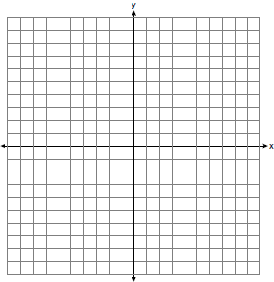

33 In the diagram below of circle O, tangent is drawn to diameter . Chord is parallel to secant , and chord is drawn.

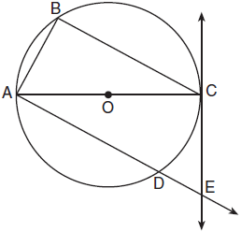

Prove: 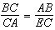

34 Keira has a square poster that she is framing and placing on her wall. The poster has a diagonal 58 cm long and fits exactly inside the frame. The width of the frame around the picture is 4 cm.

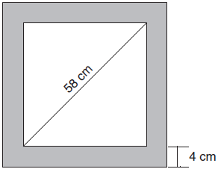

Determine and state the total area of the poster and frame to the nearest tenth of a square centimeter.

35 Isosceles trapezoid ABCD has bases and with nonparallel legs and . Segments AE, BE, CE, and DE are drawn in trapezoid ABCD such that , , and .

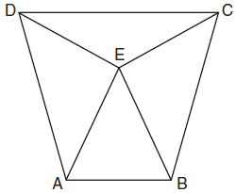

Prove and prove is an isosceles triangle.

36 A rectangular in-ground pool is modeled by the prism below. The inside of the pool is 16 feet wide and 35 feet long. The pool has a shallow end and a deep end, with a sloped floor connecting the two ends. Without water, the shallow end is 9 feet long and 4.5 feet deep, and the deep end of the pool is 12.5 feet long.

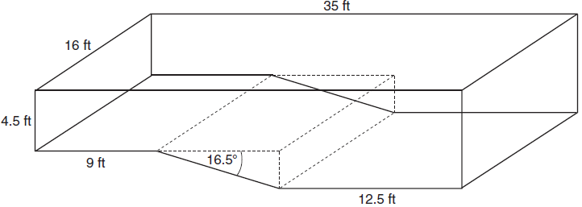

If the sloped floor has an angle of depression of 16.5 degrees, what is the depth of the pool at the deep end, to the nearest tenth of a foot? Find the volume of the inside of the pool to the nearest cubic foot. A garden hose is used to fill the pool. Water comes out of the hose at a rate of 10 .5 gallons per minute. How much time, to the nearest hour, will it take to fill the pool 6 inches from the top? [1 ft³=7.48 gallons]
1 ANS: 2 PTS: 2 REF: 081701geo NAT: G.GMD.B.4
TOP: Cross-Sections of Three-Dimensional Objects

2 ANS: 4 PTS: 2 REF: 081702geo NAT: G.CO.A.2
TOP: Identifying Transformations KEY: basic

3 ANS: 3

PTS: 2 REF: 081703geo NAT: G.GPE.B.7 TOP: Polygons in the Coordinate Plane

4 ANS: 1
Parallel chords intercept congruent arcs. 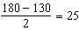

PTS: 2 REF: 081704geo NAT: G.C.A.2 TOP: Chords, Secants and Tangents
KEY: parallel lines

5 ANS: 4
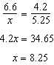

PTS: 2 REF: 081705geo NAT: G.SRT.B.5 TOP: Similarity
KEY: basic

6 ANS: 3
The x-axis and line are lines of symmetry and is a point of symmetry.

PTS: 2 REF: 081706geo NAT: G.CO.A.3 TOP: Mapping a Polygon onto Itself

7 ANS: 4
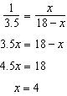

PTS: 2 REF: 081707geo NAT: G.SRT.B.5 TOP: Side Splitter Theorem

8 ANS: 4
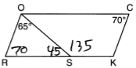

PTS: 2 REF: 081708geo NAT: G.CO.C.11 TOP: Interior and Exterior Angles of Polygons

9 ANS: 4
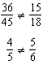

PTS: 2 REF: 081709geo NAT: G.SRT.A.3 TOP: Similarity Proofs

10 ANS: 1
Since a dilation preserves parallelism, the line and its image are parallel, with slopes of .

PTS: 2 REF: 081710geo NAT: G.SRT.A.1 TOP: Line Dilations

11 ANS: 4
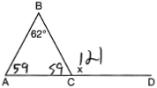

PTS: 2 REF: 081711geo NAT: G.CO.C.10 TOP: Exterior Angle Theorem

12 ANS: 2
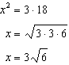

PTS: 2 REF: 081712geo NAT: G.C.A.2 TOP: Chords, Secants and Tangents
KEY: secant and tangent drawn from common point, length

13 ANS: 3
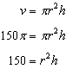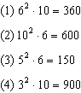

PTS: 2 REF: 081713geo NAT: G.GMD.B.4 TOP: Rotations of Two-Dimensional Objects

14 ANS: 3
In (1) and (2), ABCD could be a rectangle with non-congruent sides. (4) is not possible

PTS: 2 REF: 081714geo NAT: G.CO.C.11 TOP: Special Quadrilaterals

15 ANS: 1
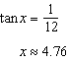

PTS: 2 REF: 081715geo NAT: G.SRT.C.8 TOP: Using Trigonometry to Find an Angle

16 ANS: 4 PTS: 2 REF: 081716geo NAT: G.CO.C.10
TOP: Midsegments

17 ANS: 1
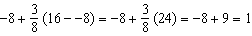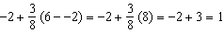

PTS: 2 REF: 081717geo NAT: G.GPE.B.6 TOP: Directed Line Segments

18 ANS: 2
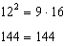

PTS: 2 REF: 081718geo NAT: G.SRT.B.5 TOP: Similarity
KEY: leg

19 ANS: 1
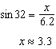

PTS: 2 REF: 081719geo NAT: G.SRT.C.8 TOP: Using Trigonometry to Find a Side

20 ANS: 1
Illinois: 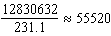 Florida: 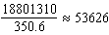 New York: 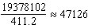 Pennsylvania: 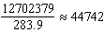

PTS: 2 REF: 081720geo NAT: G.MG.A.2 TOP: Density

21 ANS: 4
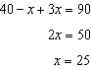

PTS: 2 REF: 081721geo NAT: G.SRT.C.7 TOP: Cofunctions

22 ANS: 4
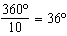 252º is a multiple of 36º

PTS: 2 REF: 081722geo NAT: G.CO.A.3 TOP: Mapping a Polygon onto Itself

23 ANS: 2
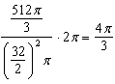

PTS: 2 REF: 081723geo NAT: G.C.B.5 TOP: Sectors

24 ANS: 4
The segment’s midpoint is the origin and slope is . The slope of a perpendicular line is . 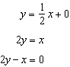

PTS: 2 REF: 081724geo NAT: G.GPE.B.5 TOP: Parallel and Perpendicular Lines
KEY: perpendicular bisector

25 ANS:
Yes. The bases of the cylinders have the same area and the cylinders have the same height.

PTS: 2 REF: 081725geo NAT: G.GMD.A.1 TOP: Volume

26 ANS:
The four small triangles are 8-15-17 triangles.

PTS: 2 REF: 081726geo NAT: G.CO.C.11 TOP: Special Quadrilaterals

27 ANS:
about 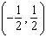

PTS: 2 REF: 081727geo NAT: G.CO.A.5 TOP: Compositions of Transformations
KEY: identify

28 ANS:
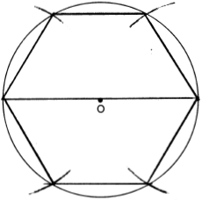

PTS: 2 REF: 081728geo NAT: G.CO.D.13 TOP: Constructions

29 ANS:
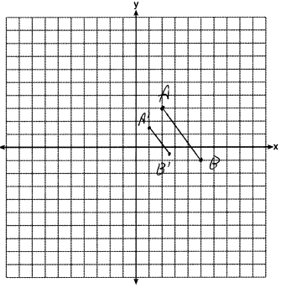

PTS: 2 REF: 081729geo NAT: G.SRT.A.2 TOP: Dilations

30 ANS:
Yes. , , after a sequence of rigid motions which preserve distance and angle measure, so by ASA. by CPCTC.

PTS: 2 REF: 081730geo NAT: G.CO.B.7 TOP: Triangle Congruency

31 ANS:
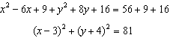

PTS: 2 REF: 081731geo NAT: G.GPE.A.1 TOP: Equations of Circles
KEY: completing the square

32 ANS:
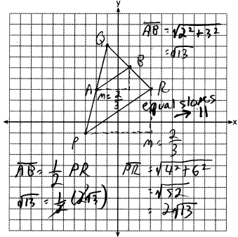

PTS: 4 REF: 081732geo NAT: G.GPE.B.4 TOP: Triangles in the Coordinate Plane

33 ANS:
Circle O, tangent to diameter , chord secant , and chord (given); is a right angle (an angle inscribed in a semi-circle is a right angle); (a radius drawn to a point of tangency is perpendicular to the tangent); is a right angle (perpendicular lines form right angles); (all right angles are congruent); (the transversal of parallel lines creates congruent alternate interior angles); (AA); (Corresponding sides of similar triangles are in proportion).

PTS: 4 REF: 081733geo NAT: G.SRT.B.5 TOP: Circle Proofs

34 ANS:
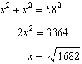

PTS: 4 REF: 081734geo NAT: G.MG.A.3 TOP: Area of Polygons

35 ANS:
Isosceles trapezoid ABCD, , , and (given); (congruent legs of isosceles trapezoid); and are right angles (perpendicular lines form right angles); (all right angles are congruent); (base angles of an isosceles trapezoid are congruent); 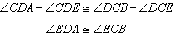 (subtraction postulate); (AAS); (CPCTC); is an isosceles triangle (an isosceles triangle has two congruent sides).

PTS: 6 REF: 081735geo NAT: G.SRT.B.5 TOP: Quadrilateral Proofs

36 ANS:
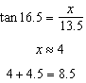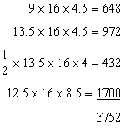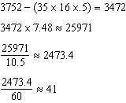

PTS: 6 REF: 081736geo NAT: G.GMD.A.3 TOP: Volume
KEY: compositions

