1 In the diagram below, lines , m, n, and p intersect line r.

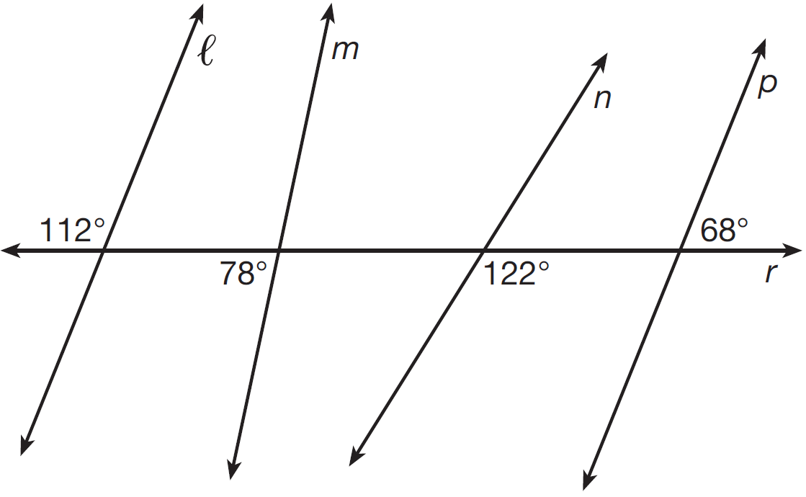

Which statement is true?
1) |  | 3)
2) |  | 4)

2 Which transformation would not always produce an image that would be congruent to the original figure?
1) | translation | 3) | rotation
2) | dilation | 4) | reflection

3 If an equilateral triangle is continuously rotated around one of its medians, which 3-dimensional object is generated?
1) | cone | 3) | prism
2) | pyramid | 4) | sphere

4 In the diagram below, , , and .

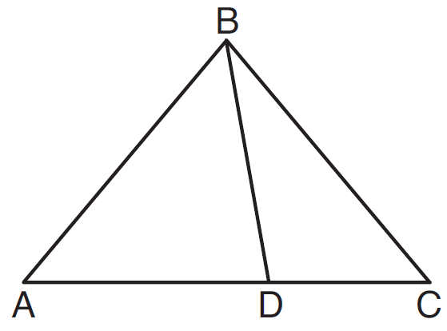

Which statement is true?
1) | is obtuse. | 3)
2) | is isosceles. | 4) | is scalene.

5 Which point shown in the graph below is the image of point P after a counterclockwise rotation of 90° about the origin?

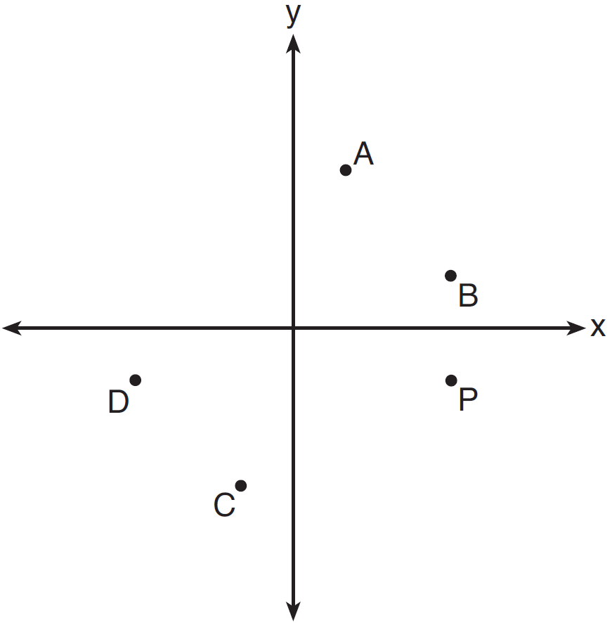
1) | A | 3) | C
2) | B | 4) | D

6 In , where is a right angle, 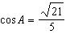. What is ?
1) | 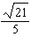 | 3)
2) | 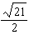 | 4) | 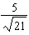

7 Quadrilateral ABCD with diagonals and is shown in the diagram below.

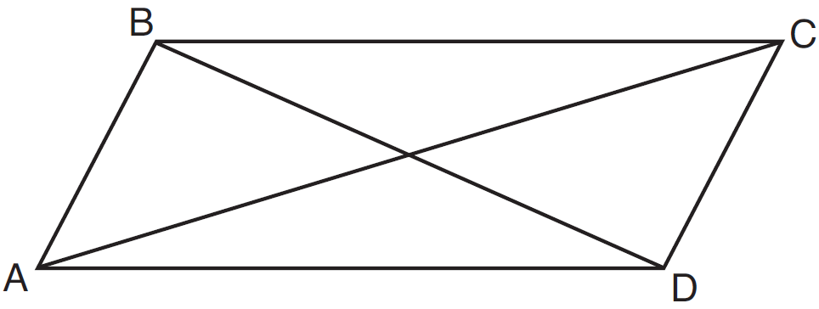

Which information is not enough to prove ABCD is a parallelogram?
1) | and | 3) | and
2) | and | 4) | and

8 An equilateral triangle has sides of length 20. To the nearest tenth, what is the height of the equilateral triangle?
1) | 10.0 | 3) | 17.3
2) | 11.5 | 4) | 23.1

9 Given: , , and
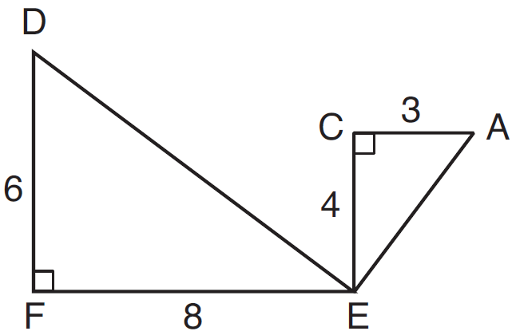
What is a correct sequence of similarity transformations that shows ?
1) | a rotation of 180 degrees about point E followed by a horizontal translation | 3) | a rotation of 180 degrees about point E followed by a dilation with a scale factor of 2 centered at point E
2) | a counterclockwise rotation of 90 degrees about point E followed by a horizontal translation | 4) | a counterclockwise rotation of 90 degrees about point E followed by a dilation with a scale factor of 2 centered at point E

10 In the diagram of right triangle ABC, intersects hypotenuse at D.
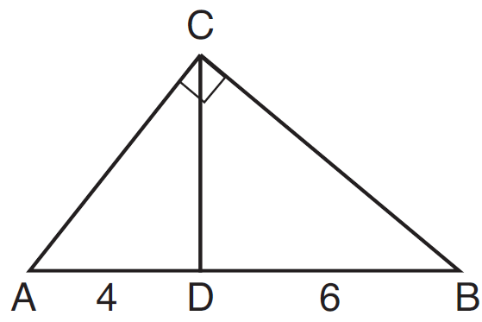

If and , which length of makes ?
1) |  | 3)
2) |  | 4)

11 Segment CD is the perpendicular bisector of at E. Which pair of segments does not have to be congruent?
1) |  | 3)
2) |  | 4)

12 In triangle CHR, O is on , and D is on so that .

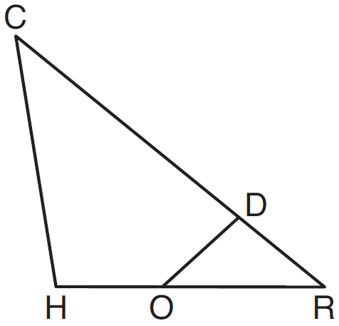

If , , and , what is the length of ?
1) |  | 3) | 11
2) |  | 4) | 15

13 The cross section of a regular pyramid contains the altitude of the pyramid. The shape of this cross section is a
1) | circle | 3) | triangle
2) | square | 4) | rectangle

14 The diagonals of rhombus TEAM intersect at . If the equation of the line that contains diagonal is , what is the equation of a line that contains diagonal EM?
1) |  | 3)
2) |  | 4)

15 The coordinates of vertices A and B of are and . If the area of is 24 square units, what could be the coordinates of point C?
1) |  | 3)
2) |  | 4)

16 What are the coordinates of the center and the length of the radius of the circle represented by the equation ?
1) | center and radius 3 | 3) | center and radius 9
2) | center and radius 3 | 4) | center and radius 9

17 The density of the American white oak tree is 752 kilograms per cubic meter. If the trunk of an American white oak tree has a circumference of 4.5 meters and the height of the trunk is 8 meters, what is the approximate number of kilograms of the trunk?
1) | 13 | 3) | 13,536
2) | 9694 | 4) | 30,456

18 Point P is on the directed line segment from point to point and divides the segment in the ratio . What are the coordinates of point P?
1) | 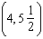 | 3) | 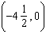
2) | 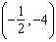 | 4) | 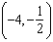

19 In circle O, diameter , chord , and radius are drawn, and the measure of arc BC is 108°.

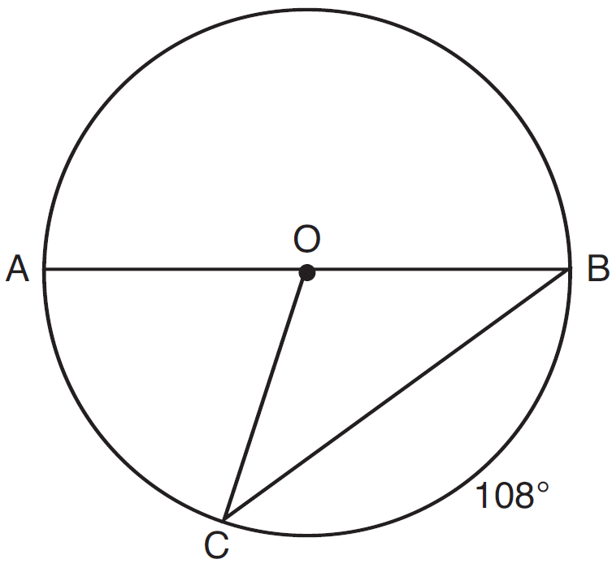

Some students wrote these formulas to find the area of sector COB:
Amy 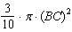
Beth 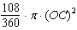
Carl 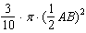
Dex 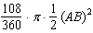
Which students wrote correct formulas?
1) | Amy and Dex | 3) | Carl and Amy
2) | Beth and Carl | 4) | Dex and Beth

20 Tennis balls are sold in cylindrical cans with the balls stacked one on top of the other. A tennis ball has a diameter of 6.7 cm. To the nearest cubic centimeter, what is the minimum volume of the can that holds a stack of 4 tennis balls?
1) | 236 | 3) | 564
2) | 282 | 4) | 945

21 Line segment , whose endpoints are and , is the image of after a dilation of centered at the origin. What is the length of ?
1) | 5 | 3) | 20
2) | 10 | 4) | 40

22 Given: and shown in the diagram below with

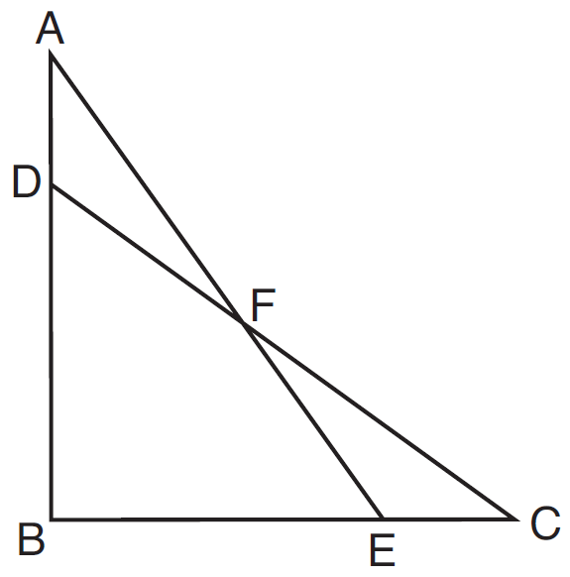

Which statement is needed to prove using only ?
1) |  | 3)
2) |  | 4)

23 In the diagram below, is the diameter of circle A.

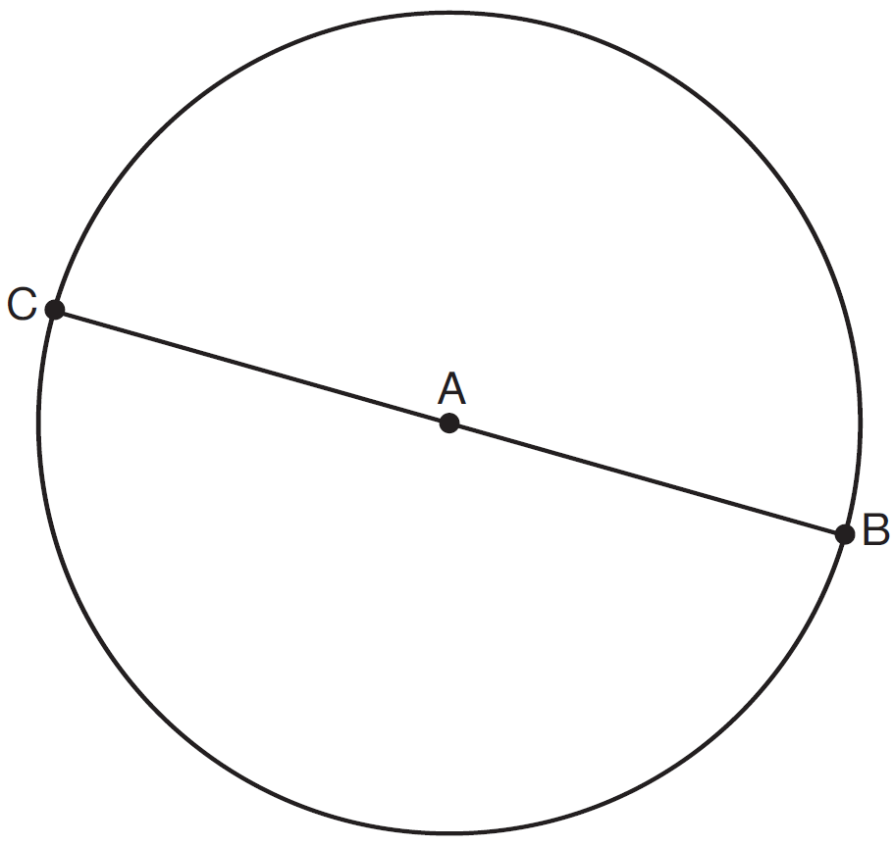

Point D, which is unique from points B and C, is plotted on circle A. Which statement must always be true?
1) | is a right triangle. | 3) | and are similar triangles.
2) | is an isosceles triangle. | 4) | and are congruent triangles.

24 In the diagram below, ABCD is a parallelogram, is extended through B to E, and is drawn.

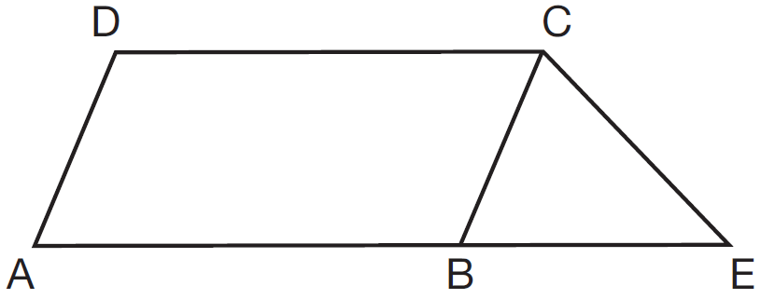

If and , what is ?
1) | 44° | 3) | 68°
2) | 56° | 4) | 112°

25 Lines AE and BD are tangent to circles O and P at A, E, B, and D, as shown in the diagram below. If , and , determine and state the length of .

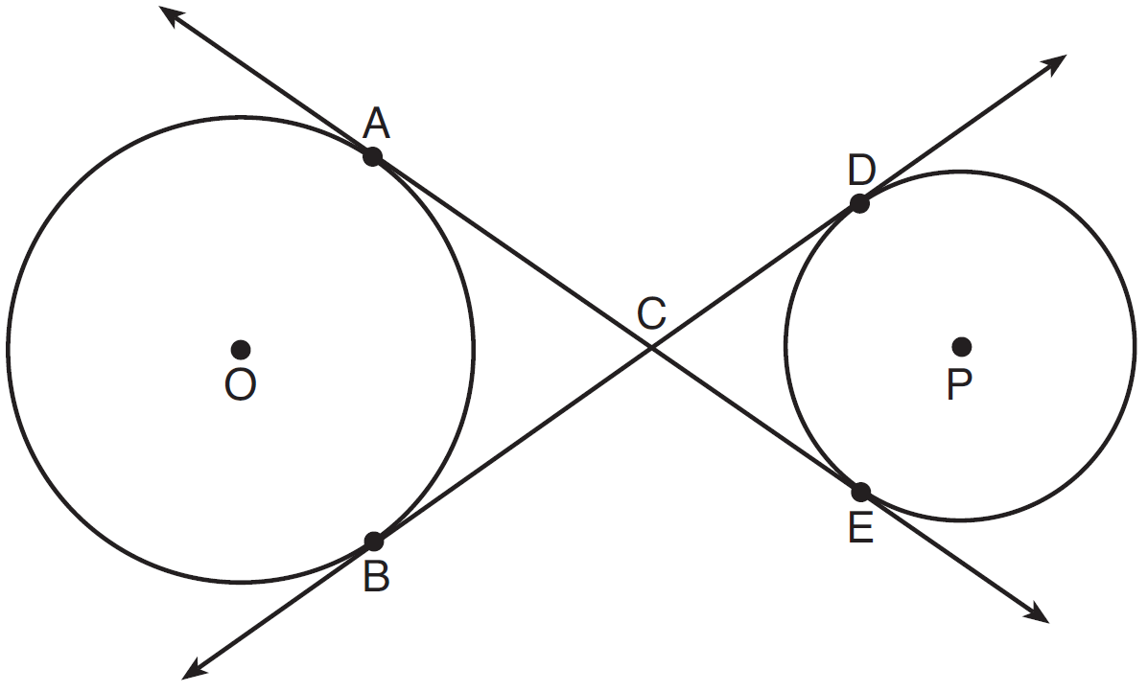

26 In the diagram below, has coordinates , , and . Graph and label , the image of after the translation five units to the right and two units up followed by the reflection over the line .

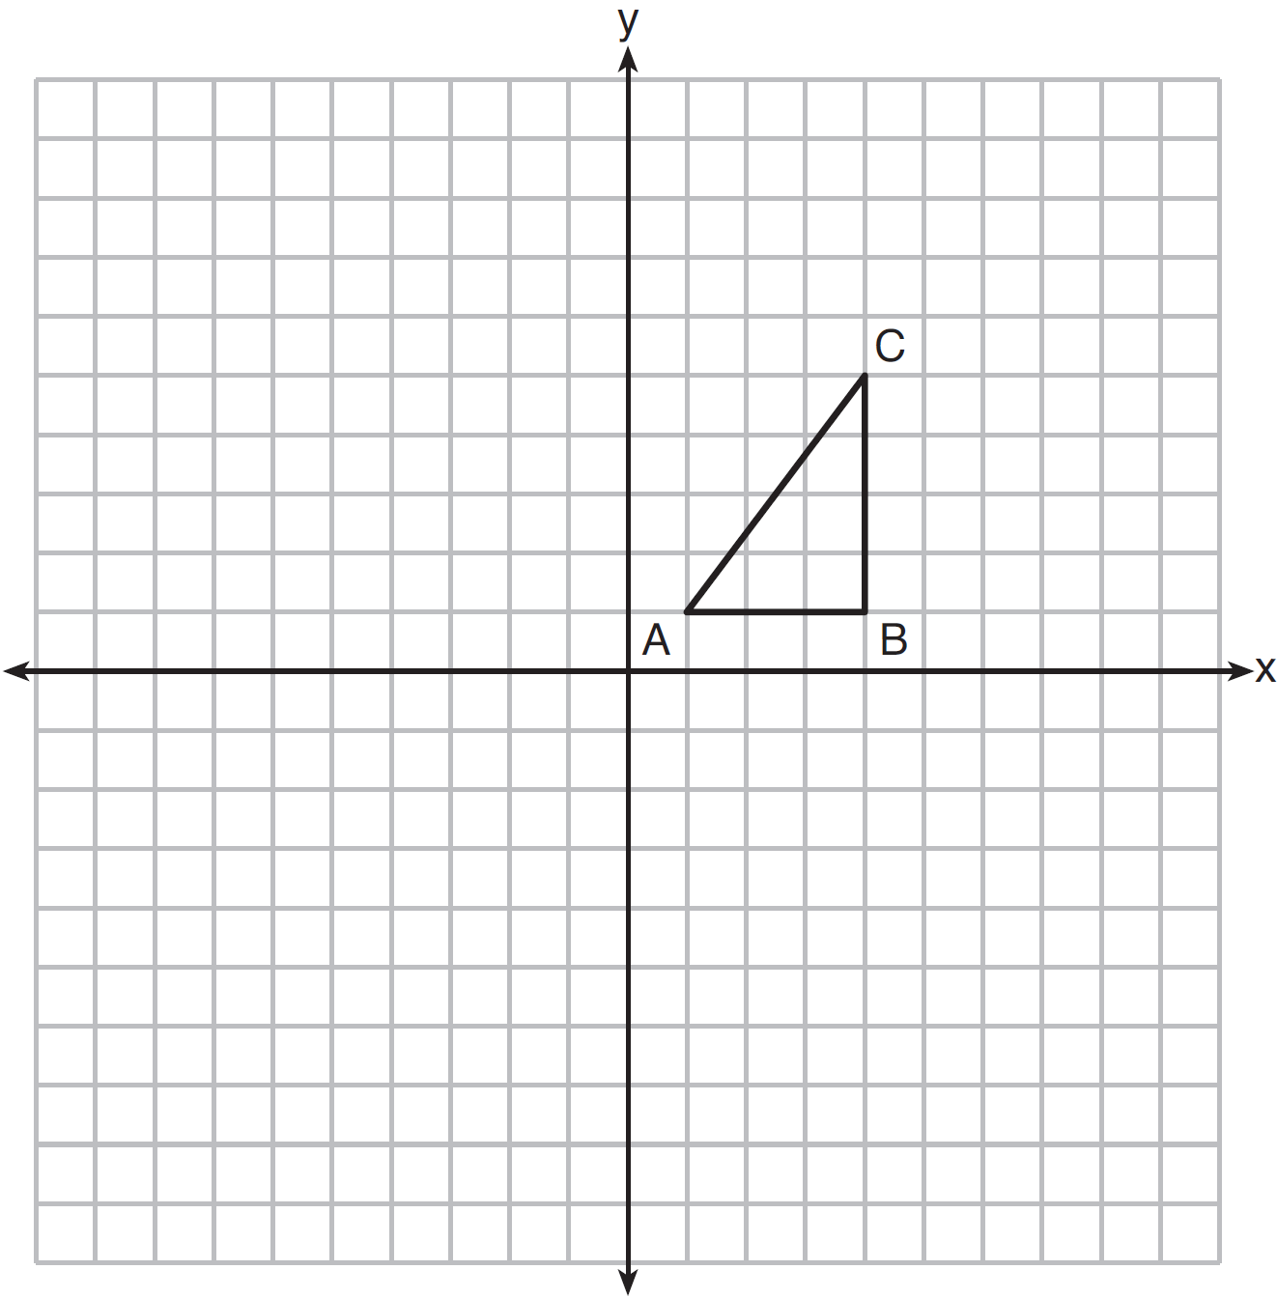

27 A regular hexagon is rotated in a counterclockwise direction about its center. Determine and state the minimum number of degrees in the rotation such that the hexagon will coincide with itself.

28 In the diagram of shown below, use a compass and straightedge to construct the median to . [Leave all construction marks.]

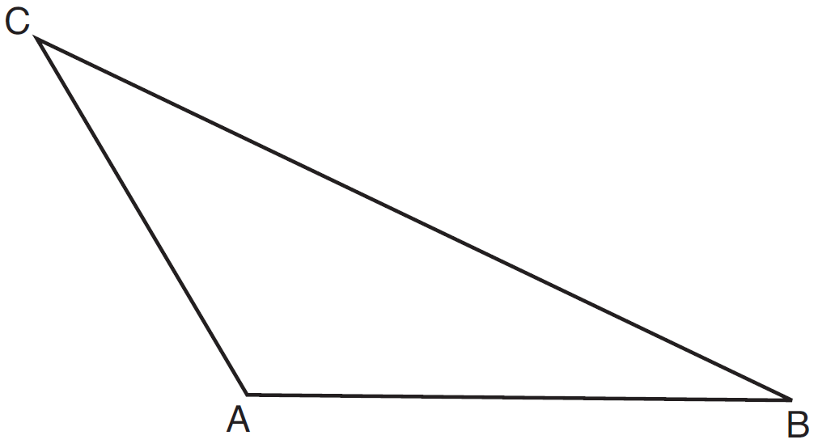

29 Triangle MNP is the image of triangle JKL after a 120° counterclockwise rotation about point Q. If the measure of angle L is 47° and the measure of angle N is 57°, determine the measure of angle M. Explain how you arrived at your answer.

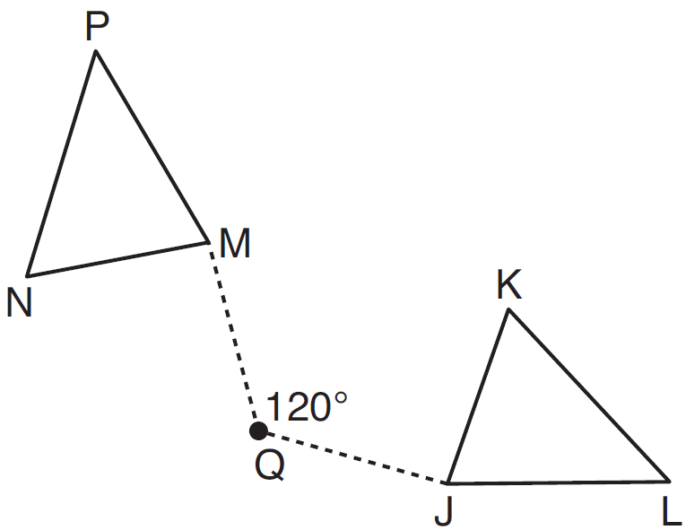

30 A circle has a center at and radius of 4. Does the point lie on the circle? Justify your answer.

31 In the diagram below, a window of a house is 15 feet above the ground. A ladder is placed against the house with its base at an angle of 75° with the ground. Determine and state the length of the ladder to the nearest tenth of a foot.

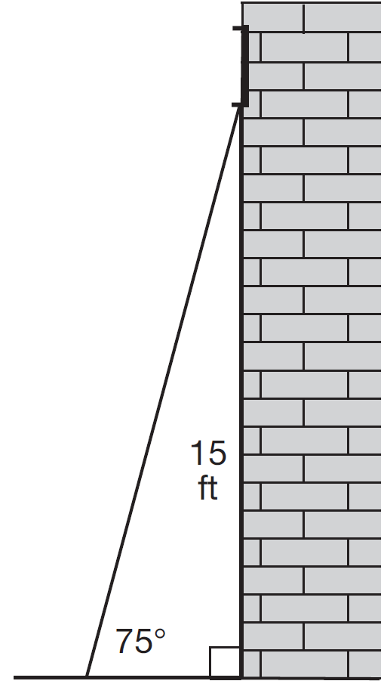

32 Using a compass and straightedge, construct and label , the image of after a dilation with a scale factor of 2 and centered at B. [Leave all construction marks.] Describe the relationship between the lengths of and .

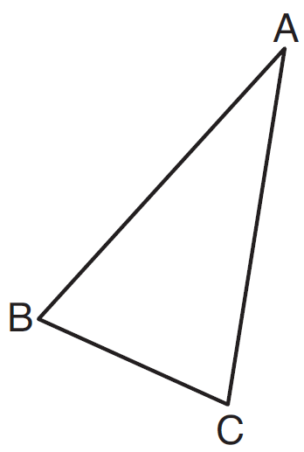

33 The grid below shows and .

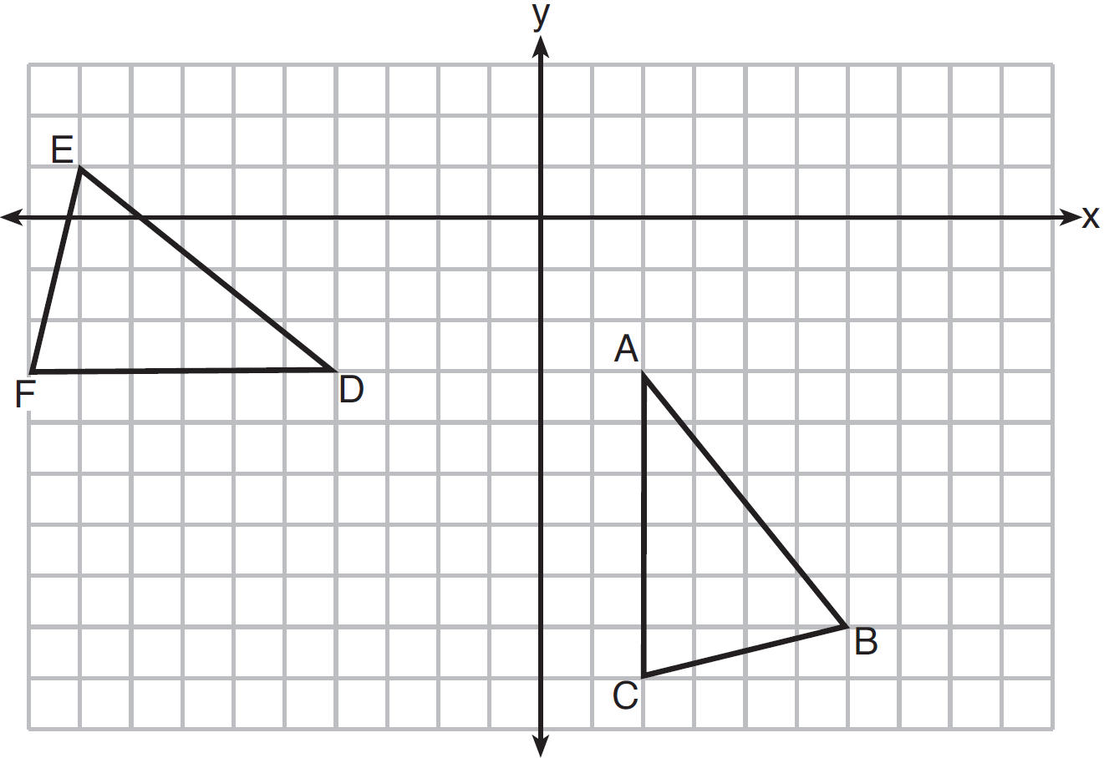

Let be the image of after a rotation about point A. Determine and state the location of B' if the location of point C' is . Explain your answer. Is congruent to ? Explain your answer.

34 As modeled below, a movie is projected onto a large outdoor screen. The bottom of the 60-foot-tall screen is 12 feet off the ground. The projector sits on the ground at a horizontal distance of 75 feet from the screen.

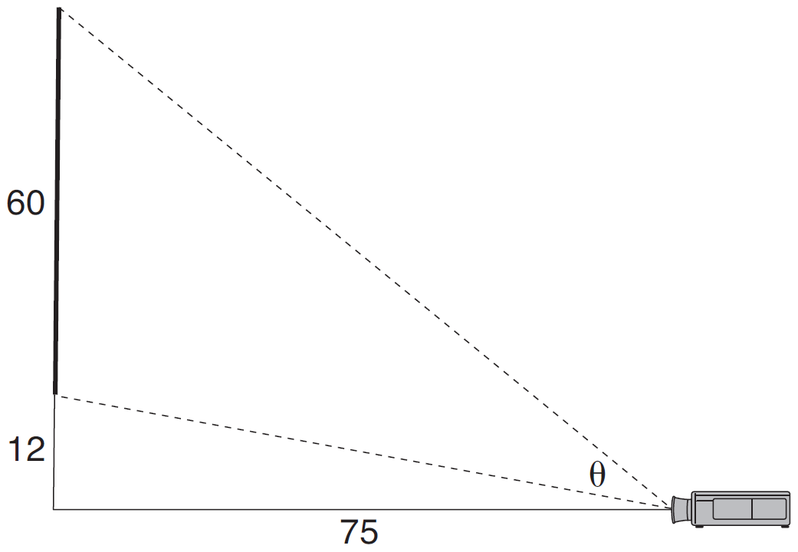

Determine and state, to the nearest tenth of a degree, the measure of , the projection angle.

35 Given: Circle O, chords and intersect at E

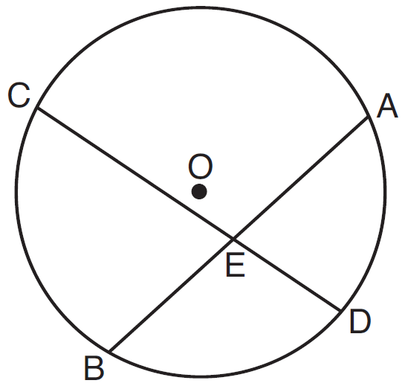

Theorem: If two chords intersect in a circle, the product of the lengths of the segments of one chord is equal to the product of the lengths of the segments of the other chord. Prove this theorem by proving .

36 A snow cone consists of a paper cone completely filled with shaved ice and topped with a hemisphere of shaved ice, as shown in the diagram below. The inside diameter of both the cone and the hemisphere is 8.3 centimeters. The height of the cone is 10.2 centimeters.

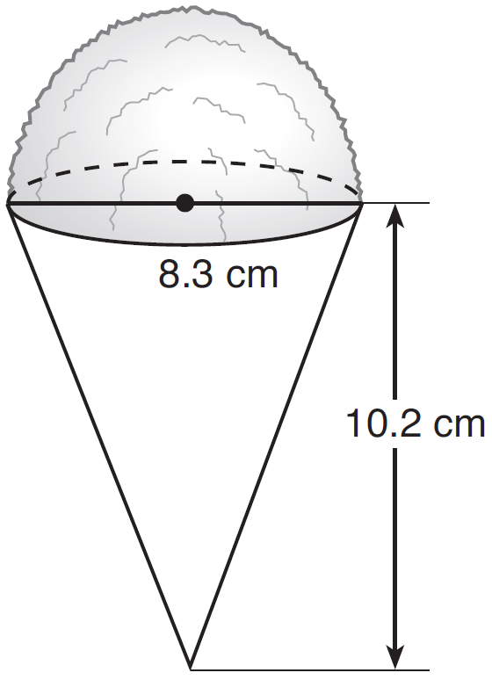

The desired density of the shaved ice is , and the cost, per kilogram, of ice is $3.83. Determine and state the cost of the ice needed to make 50 snow cones.
1 ANS: 2 PTS: 2 REF: 081601geo NAT: G.CO.C.9
TOP: Lines and Angles

2 ANS: 2 PTS: 2 REF: 081602geo NAT: G.CO.A.2
TOP: Identifying Transformations KEY: basic

3 ANS: 1 PTS: 2 REF: 081603geo NAT: G.GMD.B.4
TOP: Rotations of Two-Dimensional Objects

4 ANS: 2
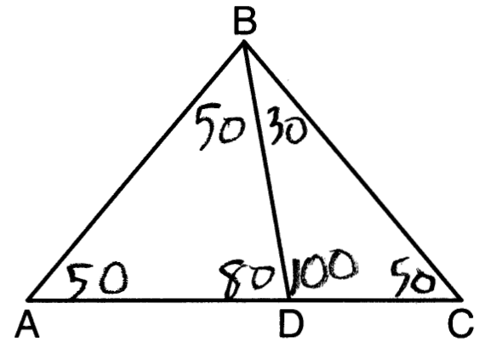

PTS: 2 REF: 081604geo NAT: G.CO.C.10 TOP: Interior and Exterior Angles of Triangles

5 ANS: 1 PTS: 2 REF: 081605geo NAT: G.CO.A.5
TOP: Rotations KEY: grids

6 ANS: 1 PTS: 2 REF: 081606geo NAT: G.SRT.C.7
TOP: Cofunctions

7 ANS: 3
(3) Could be a trapezoid.

PTS: 2 REF: 081607geo NAT: G.CO.C.11 TOP: Parallelograms

8 ANS: 3

PTS: 2 REF: 081608geo NAT: G.SRT.C.8 TOP: Pythagorean Theorem
KEY: without graphics

9 ANS: 4 PTS: 2 REF: 081609geo NAT: G.SRT.A.2
TOP: Compositions of Transformations KEY: grids

10 ANS: 2
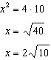

PTS: 2 REF: 081610geo NAT: G.SRT.B.5 TOP: Similarity
KEY: leg

11 ANS: 4 PTS: 2 REF: 081611geo NAT: G.CO.C.9
TOP: Lines and Angles

12 ANS: 3
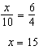

PTS: 2 REF: 081612geo NAT: G.SRT.B.5 TOP: Similarity
KEY: basic

13 ANS: 3 PTS: 2 REF: 081613geo NAT: G.GMD.B.4
TOP: Cross-Sections of Three-Dimensional Objects

14 ANS: 1
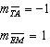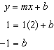

PTS: 2 REF: 081614geo NAT: G.GPE.B.4 TOP: Quadrilaterals in the Coordinate Plane
KEY: general

15 ANS: 3
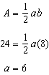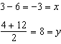

PTS: 2 REF: 081615geo NAT: G.GPE.B.7 TOP: Polygons in the Coordinate Plane

16 ANS: 1
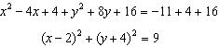

PTS: 2 REF: 081616geo NAT: G.GPE.A.1 TOP: Equations of Circles
KEY: completing the square

17 ANS: 2
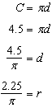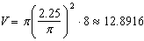

PTS: 2 REF: 081617geo NAT: G.MG.A.2 TOP: Density

18 ANS: 4

PTS: 2 REF: 081618geo NAT: G.GPE.B.6 TOP: Directed Line Segments

19 ANS: 2 PTS: 2 REF: 081619geo NAT: G.C.B.5
TOP: Sectors

20 ANS: 4
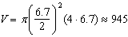

PTS: 2 REF: 081620geo NAT: G.GMD.A.3 TOP: Volume
KEY: cylinders

21 ANS: 4

PTS: 2 REF: 081621geo NAT: G.SRT.A.1 TOP: Line Dilations

22 ANS: 3 PTS: 2 REF: 081622geo NAT: G.SRT.B.5
TOP: Triangle Proofs KEY: statements

23 ANS: 1
The other statements are true only if .

PTS: 2 REF: 081623geo NAT: G.C.A.2 TOP: Chords, Secants and Tangents
KEY: inscribed

24 ANS: 1

PTS: 2 REF: 081624geo NAT: G.CO.C.11 TOP: Interior and Exterior Angles of Polygons

25 ANS:
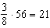

PTS: 2 REF: 081625geo NAT: G.C.A.2 TOP: Chords, Secants and Tangents
KEY: common tangents

26 ANS:
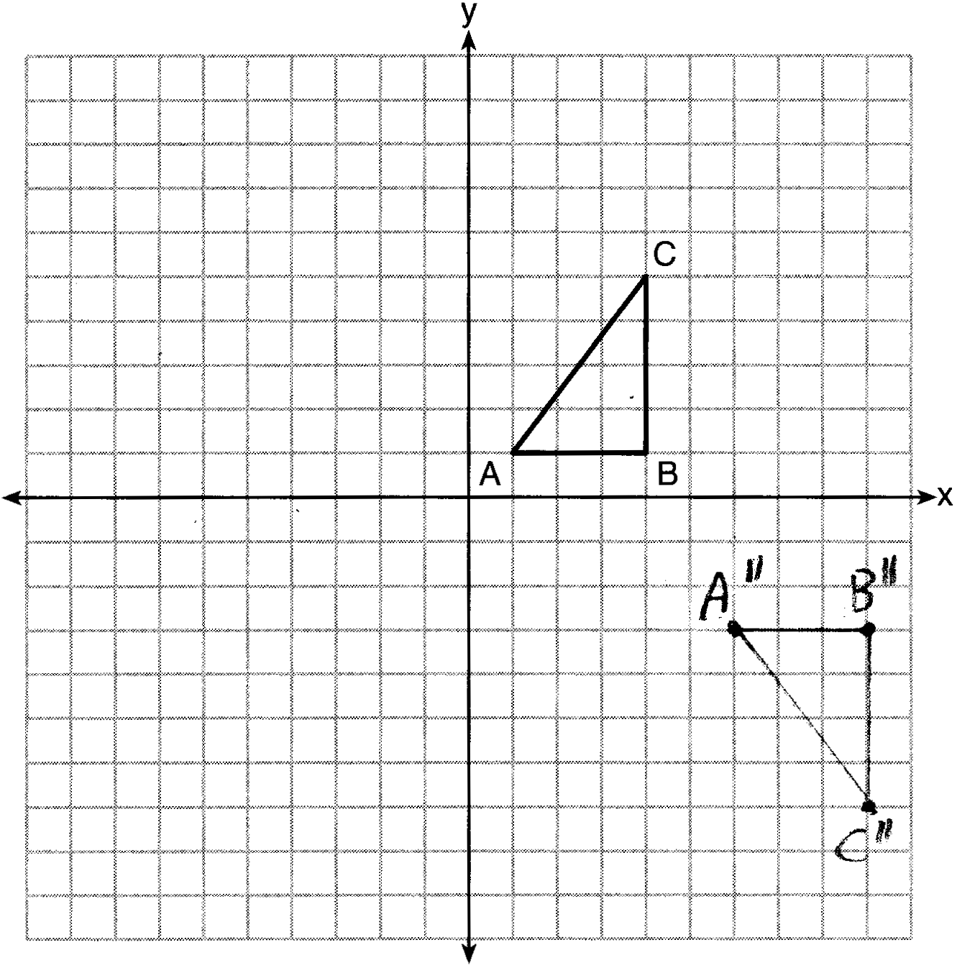

PTS: 2 REF: 081626geo NAT: G.CO.A.5 TOP: Compositions of Transformations
KEY: grids

27 ANS:
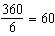

PTS: 2 REF: 081627geo NAT: G.CO.A.3 TOP: Mapping a Polygon onto Itself

28 ANS:
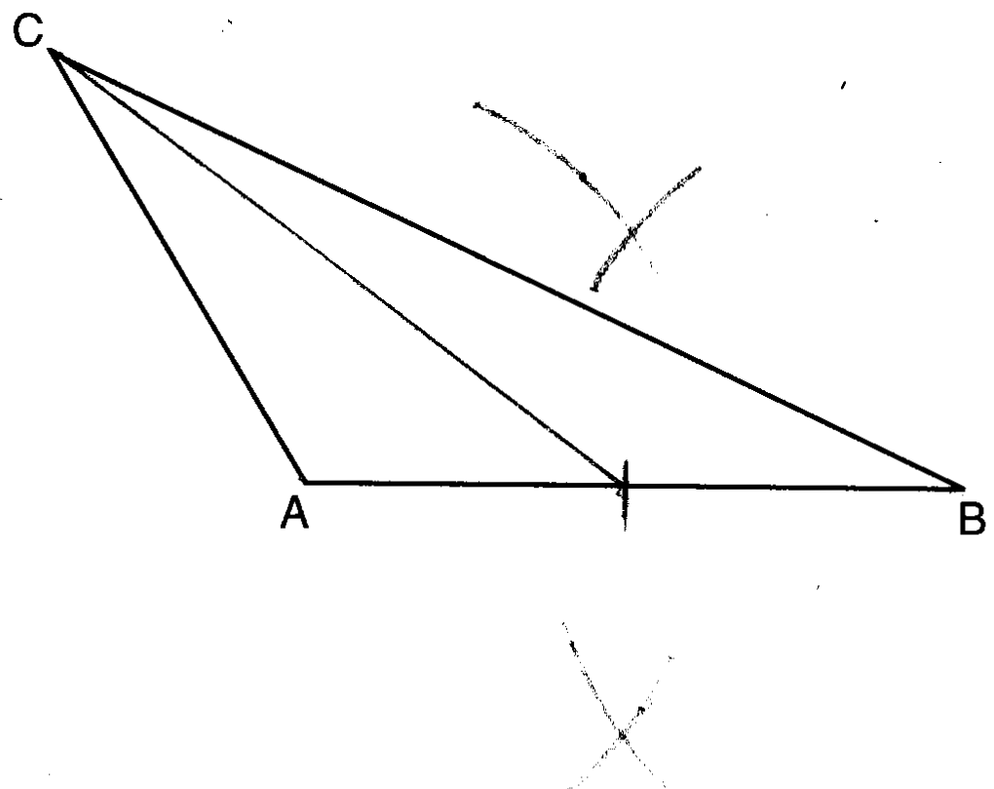

PTS: 2 REF: 081628geo NAT: G.CO.D.12 TOP: Constructions
KEY: line bisector

29 ANS:
Rotations do not change angle measurements.

PTS: 2 REF: 081629geo NAT: G.CO.B.6 TOP: Properties of Transformations

30 ANS:
Yes. 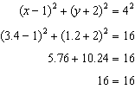

PTS: 2 REF: 081630geo NAT: G.GPE.B.4 TOP: Circles in the Coordinate Plane

31 ANS:
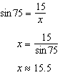

PTS: 2 REF: 081631geo NAT: G.SRT.C.8 TOP: Using Trigonometry to Find a Side
KEY: graphics

32 ANS:
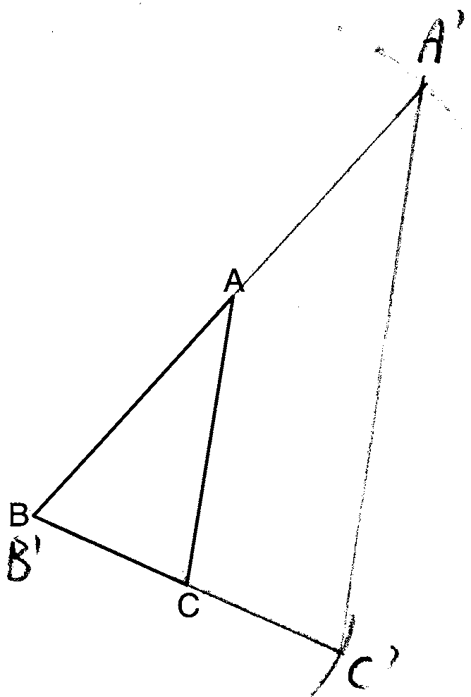 The length of is twice .

PTS: 4 REF: 081632geo NAT: G.CO.D.12 TOP: Constructions
KEY: congruent and similar figures

33 ANS:
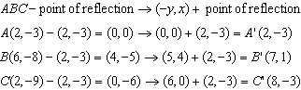 because is a reflection of and reflections preserve distance.

PTS: 4 REF: 081633geo NAT: G.CO.A.5 TOP: Rotations
KEY: grids

34 ANS:
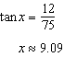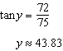

PTS: 4 REF: 081634geo NAT: G.SRT.C.8 TOP: Using Trigonometry to Find an Angle

35 ANS:
Circle O, chords and intersect at E (Given); Chords and are drawn (auxiliary lines drawn); (vertical angles); (Inscribed angles that intercept the same arc are congruent); (AA); 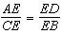 (Corresponding sides of similar triangles are proportional); (The product of the means equals the product of the extremes).

PTS: 6 REF: 081635geo NAT: G.SRT.B.5 TOP: Circle Proofs

36 ANS:
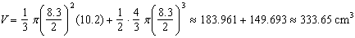

PTS: 6 REF: 081636geo NAT: G.MG.A.2 TOP: Density

